|  |
| --- |
| CSE211 Web Programming 24/25 |
| Assignment#1: Websites conceptual Design and mock-up |
| ID: 222101929 Name: Youssef Ahmed Ibrahim Fathy Mohamed |

|  |
| --- |
|  |

Let’s discuss the developments that occurred on the web, the development of which was observed and began in 1990. It began with Web 1.0 from 1990 to 2000, which was about the search for online viability, it offered read only pages and this is reason why it was called the static web and then Web 2.0 which was called the social web, then web 3.0, called the semantic Web, and finally Web 4.0 the intelligent web. Now, let’s talk about each one of them deeply.

**Web 2.0: (2000 to 2010)**

After web1.0 users suffered a lack of interactivity, dynamic updates and user-generated content so web 2.0 emerged in the early 2000s and represented a significant shift in the way we use the internet. They hoped to fix these problems by enabling users to label the website, videos and photos and it was also dynamic which allowed the user to interact and collaborate through social media. So, the characteristics of Web 2.0 maintained rich user experience and participation, dynamic content, metadata, web standards, scalability and further characteristics. Openness, freedom, and collective intelligence by user participation can also be viewed as essential attributes of Web 2.0, so web 2.0 was aparticipative web and a social web which created very large and powerful networks by allowing many users to publish their own content.

**Key features:**

1. Rich multimedia
2. Dynamic content
3. Interactivity
4. User-generated content

**Examples for web 2.0:**

1. Facebook
2. Wikipedia
3. Instagram

**Web3.0: (2010 to 2020)**

Web 2.0 disadvantages were that people would become heavily dependent on the Internet for networking and a lot of valuable time for people was wasted here and there and there was a very high rate of fraud and hacking occurring then, so they started fixing these problems by improving the security experience and this caused the rise of AI and the ability of machine to understand human language and cloud computing to provide resources to build powerful web applications and highly personalized experiences tailored to individual users, and platforms which enabled more flexibility.

**Key features:**

1. Block chain technology
2. Utilization of private keys for user authentication
3. Reliance on artificial intelligence
4. Decentralization of data and protocols

**Examples for web 3.0:**

1. Netflix
2. Amazon

**Web4.0**:

Web 4.0 marked by a shift from physical to digital technologies. It is still in its early developmental stages, but some key features and changes can be expected in the years to come.

The target of it is to make the internet more efficient, interactive and intelligent. It is also called symbiotic web as it reinforces the contact between humans and machines, and heavily depends on AI.

**Key features:**

1. Collective intelligence
2. Social networking
3. Social media
4. Social marketing

These tools empower current and future business strategies by enhancing decision-making, engagement, and innovation as collective intelligence refers to groups that emerge from the collaboration of multiple entities and social networking and provide insights into the emerging trends and application of modern technology such as Artificial Intelligence (AI) and chatbots in marketing. Within the framework of the project, we are using chatbot in pharmacy management portal system by which a doctor can use it for managing the pharmacy by chatting with the chatbot to view orders and view inventory and give appropriate medications without any conflicts after giving the chatbot the diagnosis or prescriptions.

**References:**

[1] X. Fan, “Social Media Marketing Strategies,” *ResearchGate*, Sep. 13, 2023. https://www.researchgate.net/publication/373896254_Social_Media_Marketing_Strategies

[2] “Collective Intelligence - an overview | ScienceDirect Topics,” *www.sciencedirect.com*. https://www.sciencedirect.com/topics/computer-science/collective-intelligence

[3] “Web 1.0 vs Web 2.0 vs Web 3.0 vs Web 4.0 vs Web 5.0 – Evolution of the World Wide Web,” *Web Solutions Blog*, Jun. 01, 2023. https://acodez.in/evolution-of-the-world-wide-web/

[4] J. Terra, “What is Web 1.0, Web 2.0, and Web 3.0? Definition, Difference & Similarities | Simplilearn,” *Simplilearn.com*, Apr. 25, 2022. https://www.simplilearn.com/what-is-web-1-0-web-2-0-and-web-3-0-with-their-difference-article

[5] Wikipedia Contributors, “Web 2.0,” *Wikipedia*, May 13, 2019. https://en.wikipedia.org/wiki/Web_2.0

[6] “Advantages and Disadvantages of Web 2.0 — Steemit,” Steemit.com, 2021. <https://steemit.com/hive-183397/@amdaad/advantages-and-disadvantages-of-web-2-0>

**Part 2: Website design (Law of Pragnanz):**

**1-** **Simplicity:**

The design is simple and focuses on essential elements for the login, and the chatbot interface and this shows simplicity as we keep the necessary elements only.

**2- Closure:**

The clear boundaries define sections e.g.: chatbot boundaries that separate it from the other parts of the interface.

**3- Symmetry and Order:**

The layout is balanced, the login field on the left size and chats on the right and this helps in allowing users to easily locate each function.

**4- Figure/Ground:**

The white background creates a clear figure and makes principal elements more distinguished which helps users focus on the interactive sections.

**5- Uniform Connectedness:**

Section 2 in page 2 (host, port, password, user) database inputs are visually grouped signaling that they belong to a single process.

**6- Common Region:**

Database inputs field and connect button are visually grouped within a single area and this helps users understand that entering these details is essential for accessing the rest of the system.

**7- Proximity:**

Login fields logically indicate that they are for the same purpose, section 2 (host, port, password, user) are positioned close together.

**8- Continuation:**

This sequential arrangement encourages users to log in first to establish the logical flow.

**9- Common fate:**

Sequential display of messages aligns with user’s expectations.

**10- Parallelism:**

Parallel alignment of the input field and buttons is both horizontally and vertically and this helps with simple navigation and interaction.

**11- Similarity:**

Same style includes font, color, size in input fields and buttons and consistent styling in related functions.

**12- Past Experience:**

Chat interface makes it intuitive for users familiar to those who have experience with chat functions.

**B)** **Additional design concepts:**

**1- Screen resolution:**

Design must be responsive to adapt to different screen sizes from desktops to smart phones and tablets so users can navigate the system comfortably.

**2- Color Palette:**

Choosing colors with harmony and within professional ways is important.

**3- Accessibility:**

Making sure that the text has a contrast with the background is important for readability.

**4- Front-end development technologies:**

Technology like html5, CSS and java scripts are ideal for building this interface to support text and voice functionality.

**5- content management system:**

Helping in managing data dynamically.

**6- Back-end development technologies:**

PHP or python (with Django or flask) would be effective for handling user authentication and managing data and generating chatbot interactions.

**7- Html5 page structure:**

1. <header> elements like title and logo.
2. <main> for central features, including login and chatbot interactions.
3. <aside> for navigation links.
4. <footer> expanding layout.
5. other tools may help in improving organization and accessibility.

**Key features:**

1. Voice interaction.
2. Database connection server indicator.
3. Chatbot.
4. Error handling.

**Part 3: Website planning:**

1. The website is intended for a pharmacy management system that helps the doctor in the pharmacy to view orders, manage inventory, interact with the chatbot for medication assistance.
2. It aims to simplify and make it more dependent on AI which makes it easier and more controlled by allowing the doctor to track orders and provide a chatbot with medication assistance which helps by

* Suggesting medications.
* Preventing potential conflict in prescription.
* Reducing human error.

1. The primary audience are doctors and pharmacists, and it will also help patients expectedly as the system’s purpose is to ensure accurate medical care.
2. The purpose of the site is efficient order tracking and intelligent medical recommendation. It tackles issues like manual inventory tracking and time-consuming diagnoses.
3. the website will include sections such as chatbot, order history and inventory lists.
4. The doctor/pharmacist can manage pharmacy operations using the website which in turn reduces the risk of human error and improves response time for patients.
5. The website is so simple that doctors can navigate to each function and use the chatbot easily. For example, he can use voice or text to help the doctor in medical recommendation.
6. With easy navigation bar and chatbot guidance and helping in answering queries about specific functionalities.
7. Results from the chatbot whether it was text response or prescription, or any medical assistance will be displayed on the screen.
8. As it will be the chatbot’s response so the doctor will use it to adjust or confirm diagnoses or manage inventory.
9. The doctor will act on suggestions or recommendations whether in inventory or order or check prescriptions.

* Regular inventory updates.
* Software maintenance.
* Improve chatbot accuracy.
* Med fusion: as they are focusing on real-time data entry and prescription management, which is somehow close to our goal.
* Phreesia: as they specialize in patient intake and engagement.

Both are effective management and communication solutions in healthcare to improve my project.

* + 1. providing secure effective with ai assistance for managing prescription, orders, and inventory which helps in preventing potential conflict in prescription and reducing human error.
    2. 1- Login Page

2-Chatbot

3-Manage inventory

4-Prescription input

5-view order

6-logout

**1-Login page:** for secure doctor login because of ensuring that only authorized users can access system.

**2-Chatbot**:interactive section for ai assistance through text or voice for diagnoses ,prescription.

**3-Manage inventory:** interface for adding and updating or removing drugs.

**4-Prescription input**: interface designed for doctors to easily input and manage patients’ prescriptions.

**5-view Orders:** list order with dates and details and quantities.

**6-Add Drugs:** adding drugs for patient.

**7-Logout.**

* + 1. Forms will help doctors in entering patient symptoms, managing inventory and interaction with chatbot.

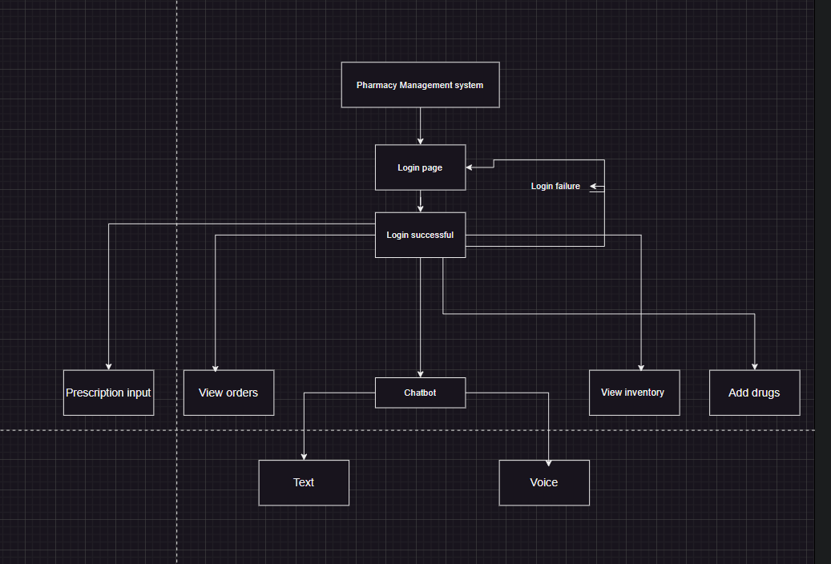

**f)**

2-Chatbot: 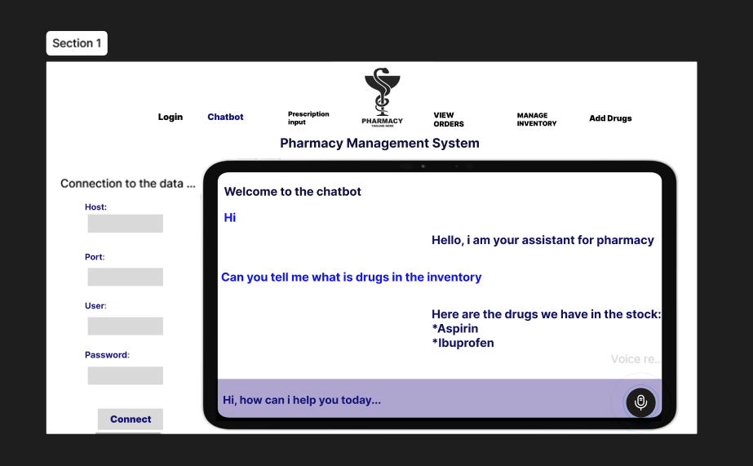

3-Prescription input:

4-View orders:

