TRACKPULSE

Supply Chain & Intelligent Logistics
Samsung Innovation Campus – Graduation Project

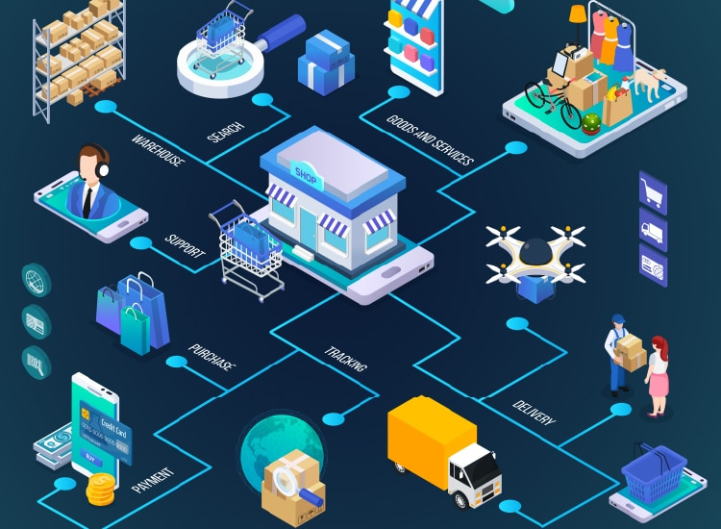
Technical Project Report
Team Members :
Youssef Khaled Youssef
Abdelrahman Mohamed Kewan
Salsabel Osama

Abstract
TrackPulse is a cloud-based supply-chain telemetry and intelligent logistics analytics project. It is designed to ingest vehicle telemetry events, preserve a durable raw history, detect operational risks from incoming events, and provide trusted analytical datasets for business reporting. The proposed platform combines a continuous streaming path with a separately orchestrated batch path. Streaming supports near-real-time monitoring and risk detection, while batch processing performs repeatable historical and incremental transformations on a 12-hour schedule, with an additional manual trigger available when needed. The current implementation phase has established the core Azure resources for event ingestion and raw storage. A 10-million-event synthetic historical dataset is planned; it has not been recorded as completed in this report.

1. Introduction
Modern logistics operations produce high-volume, time-dependent data from vehicles, shipments, routes, and cold-chain sensors. Without a reliable data platform, operational teams may struggle to identify temperature excursions, route deviations, excessive idling, vehicle-performance issues, and delivery delays in a timely and consistent way. TrackPulse addresses this challenge by establishing a common data foundation for continuous monitoring and historical analysis.
The project uses synthetic vehicle telemetry to build and test the end-to-end platform. This makes it possible to control event volume, timestamps, and anomaly scenarios while validating ingestion, storage, processing, data quality, and reporting workflows.

2. Project Overview
TrackPulse is a supply chain and logistics data engineering project designed to collect, process, validate, and analyze vehicle telemetry data. The platform supports real-time event ingestion alongside historical batch processing, enabling fleet monitoring, trip analysis, vehicle performance tracking, and cold-chain monitoring.
TrackPulse represents a fleet of 5,000 delivery vehicles. Each telemetry event may include a vehicle identifier, event timestamp, GPS coordinates, speed, fuel-consumption information, engine RPM, engine temperature, cargo temperature, ignition state, odometer, and related trip/shipment identifiers when available. Synthetic events can be generated with normal operating variation and selected anomaly scenarios.
The solution uses Microsoft Azure services to implement a scalable data pipeline. Streaming events are generated by a Python producer and ingested through Azure Event Hubs. Event Hubs Capture stores incoming data in Azure Data Lake Storage Gen2 (ADLS Gen2). Azure Databricks processes the data using PySpark and Delta Lake, while Azure Stream Analytics provides a separate low-latency streaming analytics path. Azure Data Factory is used to orchestrate the scheduled data-processing workflow
Area | Project approach
Domain | Supply chain, transportation, fleet telemetry, and cold-chain logistics
Data source | Python-based synthetic telemetry generator
Streaming ingress | Azure Event Hubs namespace and the telemetry-events Event Hub
Raw archive | Azure Data Lake Storage Gen2 / Blob Storage container for telemetry raw data
Continuous processing | Azure Stream Analytics for supported event rules; Azure Stream Analytics job for alert
Batch processing | Azure Data Factory orchestration with Azure Databricks / PySpark transformations
Lakehouse layers | Delta Lake tables organized into Bronze, Silver, and Gold layers
Serving and BI | Azure SQL serving layer and Power BI dashboards (planned stages)

2.1 Business Objectives
- Collect real-time vehicle telemetry events.
- Store raw streaming data in a centralized data lake.
- Process both streaming events and historical batch datasets.
- Validate data quality and remove duplicate records.
- Maintain incremental processing without reloading the complete historical dataset.
- Build analytical datasets for trip execution, route performance, vehicle health, and cold-chain monitoring.
- Prepare business-ready data for reporting and visualization.
1.2 Technology Stack
Component | Technology | Purpose
Data generation | Python | Generate synthetic vehicle telemetry
Streaming ingestion | Azure Event Hubs | Receive real-time events
Raw storage | Azure Data Lake Storage Gen2 | Store captured raw events
Stream analytics | Azure Stream Analytics | Process streaming events independently
Distributed processing | Azure Databricks / PySpark | Process batch and incremental data
Data lakehouse | Delta Lake | Store structured data in Bronze, Silver, and Gold layers
Orchestration | Azure Data Factory | Coordinate scheduled pipeline activities
Serving layer | Azure SQL Database | Prepare analytical outputs for downstream consumption
Visualization | Power BI | Present operational KPIs and business insights

3. Source Data Groups
This section documents the synthetic source data designed for TrackPulse, including the purpose of each source, its attributes, expected volume, and relationships. The project uses generated data rather than real vehicle feeds. The 10,000,000-event historical dataset is the target volume; it must be reported as completed only after the generator finishes and its manifest, checkpoint, counts, and checksums have been validated.

3.1 Master - Reference Data
Master data describes the entities used throughout the simulation. It provides stable identifiers and business attributes so each telemetry event can be associated with the correct vehicle, driver, route, shipment, and trip. The current generator produces five CSV files under data/master_data.
Source file | Attributes | Attribute descriptions
vehicles.csv | vehicle_id, vehicle_type, model, manufacture_year, fuel_type, capacity_kg, status | vehicle_id: unique vehicle key; vehicle_type: van/truck/refrigerated category; model: vehicle model; manufacture_year: model year; fuel_type: fuel category; capacity_kg: carrying capacity in kilograms; status: operational status.
drivers.csv | driver_id, driver_label, license_category, employment_status | driver_id: unique driver key; driver_label: generated display label; license_category: license class; employment_status: employment state.
routes.csv | route_id, route_name, origin_name, destination_name, origin_latitude, origin_longitude, destination_latitude, destination_longitude, planned_distance_km, planned_duration_min, deviation_threshold_m, route_note | route_id: unique route key; route_name: route/corridor name; origin_name/destination_name: route endpoints; origin_latitude/origin_longitude and destination_latitude/destination_longitude: endpoint coordinates; planned_distance_km: expected distance; planned_duration_min: expected duration; deviation_threshold_m: permitted route-deviation threshold; route_note: descriptive note.
shipments.csv | shipment_id, cargo_type, required_temp_min_c, required_temp_max_c, delivery_status | shipment_id: unique shipment key; cargo_type: cargo category; required_temp_min_c/required_temp_max_c: permitted cargo-temperature bounds where applicable; delivery_status: shipment status.
trip_plans.csv | trip_id, vehicle_id, driver_id, shipment_id, route_id, planned_start, planned_end, origin, destination, trip_status | trip_id: unique planned trip key; vehicle_id/driver_id/shipment_id/route_id: assigned entities; planned_start/planned_end: planned schedule; origin/destination: trip endpoints; trip_status: trip lifecycle status.

Generated master-data volume: 5,000 vehicles, 1,400 unique drivers, 10 routes, 5,000 shipments, and 5,000 trip plans. These are the counts reported by the successful master-data generation command. A vehicle is assigned a planned trip, and that trip plan connects the vehicle, driver, shipment, and route. Shipment-specific temperature bounds provide the reference values for cold-chain checks.

3.2 Historical Vehicle Telemetry Events
Grain: one record per vehicle per simulated telemetry interval. The Python generator writes these events as chunked JSONL files. Each event captures the vehicle's operational state at a particular simulated UTC timestamp.
Attribute | Description
event_id | Stable unique identifier for a telemetry event; used for deduplication.
event_timestamp | Simulated event time in UTC (ISO-8601); event time is independent of how quickly the generator runs.
vehicle_id | Vehicle that produced the event; references vehicles.csv.
latitude, longitude | Simulated GPS position in decimal degrees.
speed_kph | Vehicle speed in kilometres per hour.
odometer_km | Cumulative distance reading for the vehicle.
rpm | Engine revolutions per minute.
fuel_rate_lph | Approximate fuel-consumption rate in litres per hour; it is a rate, not total trip fuel.
engine_temp_c | Engine temperature in degrees Celsius; supports vehicle-health and overheating analysis.
ignition_on | Boolean indicator of ignition/engine state.
trip_id | Trip associated with the event; references trip_plans.csv.
shipment_id | Shipment being carried, where applicable.
driver_id | Driver assigned to the trip.
route_id | Planned route associated with the trip.
cargo_temp_c | Cargo-compartment temperature in degrees Celsius; null for non-refrigerated vehicles and used for cold-chain monitoring when applicable.

Target historical volume: 10,000,000 telemetry events across 5,000 vehicles, or approximately 2,000 events per vehicle. The configured chunk size is 50,000 events, yielding approximately 200 chunks. With a 60-second simulated interval and 2,000 events per vehicle, the first-to-last event-time span is 1,999 × 60 seconds = 33 hours and 19 minutes. This is simulated time, not the wall-clock time required to generate the dataset. The 10-million-event count is a target, not a confirmed completed result until generation and validation finish.

3.3 Anomaly - Incident Labels
Grain: one label per detected or deliberately injected anomaly associated with a telemetry event. An event may have no labels, one label, or multiple labels. Labels are written separately from telemetry JSONL and are used as reference annotations for testing.
Attribute | Description
event_id | Telemetry event associated with the condition.
event_timestamp | Timestamp associated with the event.
vehicle_id | Vehicle associated with the anomaly.
anomaly_type | Anomaly category, such as engine_overheat, fuel_anomaly, harsh_braking, excessive_idling, route_deviation, cargo_temp_breach, or collision.
severity | Rule-based priority such as medium, high, or critical, where emitted by the generator.
details | Human-readable evidence, observed value, or reason for the label.
incident_id | Optional stable identifier for a multi-event incident, such as a simulated collision.

Anomaly-label volume depends on the generated scenarios and is not the same as the telemetry-event count. Labels are not a fourth fact table and are not equivalent to a consolidated cold-chain breach episode.

3.4 Live Telemetry Stream
After the historical dataset is complete, a separate Python producer will continue from the historical checkpoint and send only new telemetry events to the Azure Event Hub telemetry-events. It will not replay the historical JSONL files. The stream uses the same telemetry attributes and continues event IDs/timestamps from the next interval. A separate streaming checkpoint tracks live progress. Because sending to Event Hubs and saving the checkpoint are not atomic together, downstream consumers should deduplicate by event_id.
Phase 1 operating mode: the live generator runs locally and sends events over the network to Azure Event Hubs. Event Hubs Capture archives the received stream into the configured raw storage container telemetry-raw. The historical JSONL backfill is a separate upload path and should not be confused with live ingestion.

3.5 Relationships Between Sources
Relationship | Meaning
vehicles.csv → trip_plans.csv | vehicle_id identifies the vehicle assigned to a planned trip; one vehicle can have many trips over time.
drivers.csv → trip_plans.csv | driver_id identifies the driver assigned to a planned trip; a driver may be assigned to multiple trips over time.
routes.csv → trip_plans.csv | route_id identifies the planned route; one route may be used by many trips.
shipments.csv → trip_plans.csv | shipment_id connects shipment details and temperature limits to the planned trip.
trip_plans.csv → telemetry events | trip_id and the associated vehicle/driver/shipment/route IDs connect individual sensor events to the business trip.
telemetry events → anomaly labels | event_id and timestamps associate an anomaly label with the telemetry event it describes; labels may be multiple per event.
historical checkpoint → live stream | The final per-vehicle state and next interval let the live producer continue rather than restarting the simulated sequence.
historical and live events → fct_vehicle_telemetry | Validated and deduplicated event records populate the telemetry fact at one row per event.
trip plans + telemetry → fct_trip | Trip plans provide assignments and planned times; telemetry supports derived trip outcomes and measures.
telemetry + shipment limits → fct_cold_chain | Sensor readings and allowed temperature bounds are transformed into one row per continuous breach episode.

Expected source-data volume summary: master/reference data consists of 5,000 vehicles, 1,400 drivers, 10 routes, 5,000 shipments, and 5,000 trip plans. Historical telemetry target is 10,000,000 events (approximately 200 chunks at 50,000 events per chunk). Anomaly labels are additional records and their exact total must be read from the completed generator manifest/output. Derived trip summaries and cold-chain episodes do not have a fixed row count until transformations are executed. File sizes in MB/GB should be reported from actual generated files rather than estimated before the run completes.

4. Project Target and Objectives
- Build a reproducible synthetic dataset representing 5,000 vehicles and 10,000,000 historical telemetry events.
- Preserve event history in Azure storage independently of the continuous alerting path.
- Operate streaming and batch paths in parallel.
- Detect operational risks such as cold-chain temperature breaches, route deviations, and excessive idling.
- Create cleaned, deduplicated, enriched datasets and reusable business aggregates.
- Run incremental batch processing every 12 hours and allow an authorized manual run at any time.
- Deliver trusted KPIs and operational insights through Power BI after data quality and reconciliation checks.
- Demonstrate secure resource access, recoverable processing, observability, and cost-conscious compute usage.

5. Business Questions
Business area | Question
Delivery performance | Which routes, vehicles, and trips experience the highest delays? What proportion of trips are delivered on time?
Cold-chain compliance | How often do shipments exceed their permitted cargo-temperature range? How long do breach episodes last, and how severe are they?
Vehicle health | Which vehicles show abnormal engine temperature, RPM, fuel consumption, or idling patterns?
Route efficiency | Which trips deviate from planned routes, and how do deviations relate to delivery delay and fuel usage?
Fuel and utilization | How do fuel consumption and idle time vary by vehicle, route, and trip?
Operational response | How quickly can a newly detected risk be identified and routed to an alert destination?
Data reliability | Are events complete, valid, unique, and traceable from ingestion through curated analytics?
Trend analysis | How do delivery performance and cold-chain incidents vary by date, route, vehicle, and shipment type?

Test all schemas for generated Data
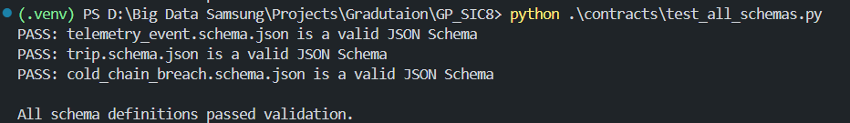
Generate Master Data
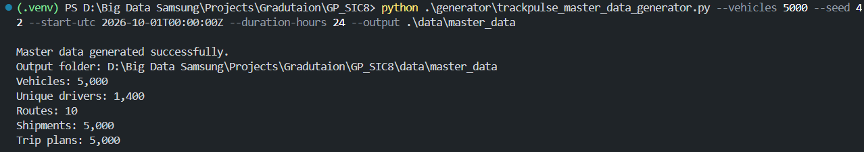

Generate Historical Data
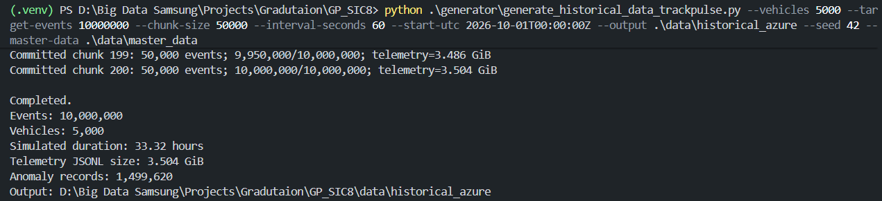
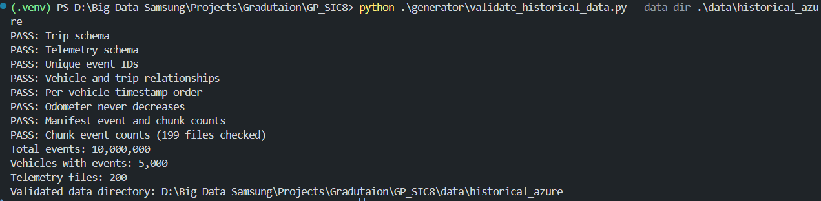
Upload Historical Data to Azure
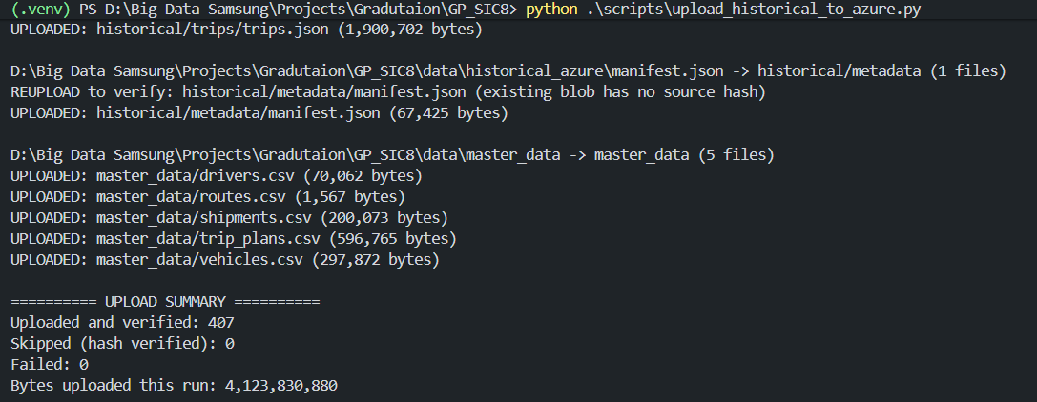

6. High-Level Architecture
The design intentionally separates continuous event processing from historical analytical processing. Azure Event Hubs is the ingress and buffering service. Event Hubs Capture archives raw stream data to the storage account, while the streaming analytics branch evaluates supported rules independently. The batch branch discovers complete raw input intervals, processes only data not yet committed by prior successful runs, and publishes curated results only after validation.
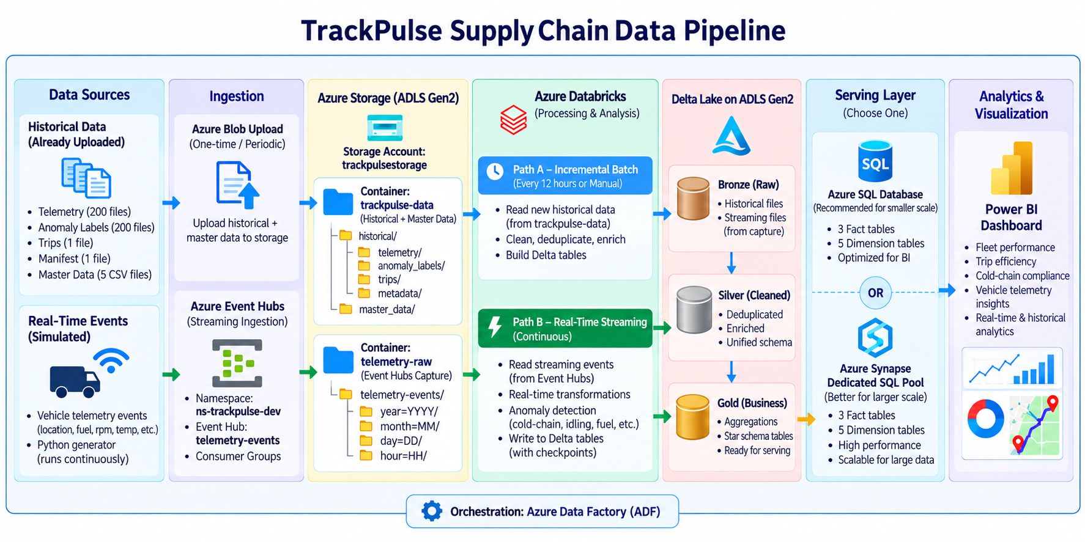
Path | Flow | Operating model
Streaming | Python producer → Event Hubs → Stream Analytics → alert handler / destination | Continuous; not scheduled as a 12-hour batch job
Raw capture | Event Hubs Capture → ADLS Gen2 container telemetry-raw | Durable raw archive; captured files become batch inputs
Batch | ADLS → Data Factory → Databricks/PySpark → Delta Bronze/Silver/Gold → Azure SQL → Power BI | Initial full load, then incremental every 12 hours or manually

7. Azure Infrastructure Setup

Step 1 — Create the Azure Resource Group
Resource: rg-trackpulse-dev
Description: A Resource Group was created to organize the Azure resources associated with the TrackPulse development environment.
Why this step was necessary: The Resource Group provides a centralized location for managing related Azure resources, permissions, monitoring, and project costs
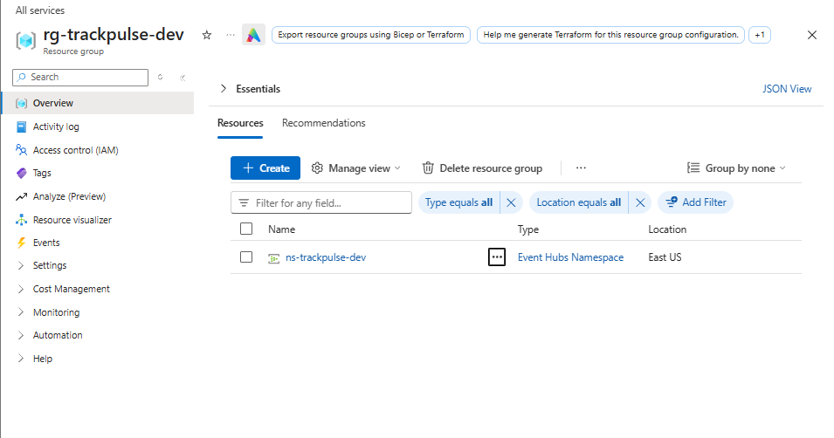
Step 2 — Create Azure Data Lake Storage Gen2
Resource: trackpulsestorage
Description: An Azure Storage Account with hierarchical namespace support was configured to serve as the project's data lake.
Why this step was necessary: ADLS Gen2 provides scalable storage for raw telemetry files, processed Delta tables, historical datasets, schemas, and processing checkpoints.

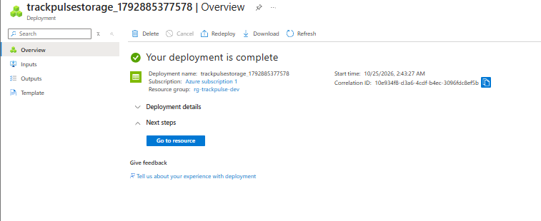

The project uses separate containers to organize raw and processed data:
- telemetry-raw: Captured raw events.
- trackpulse-data: Bronze, Silver, Gold, and checkpoint data.
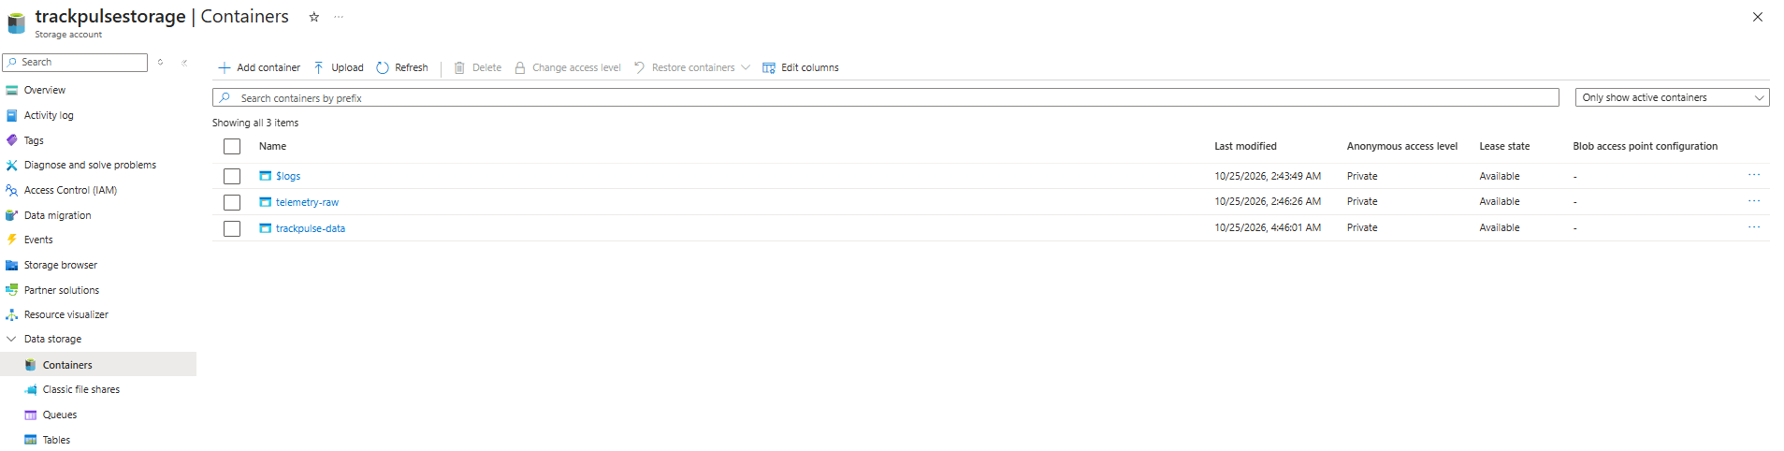
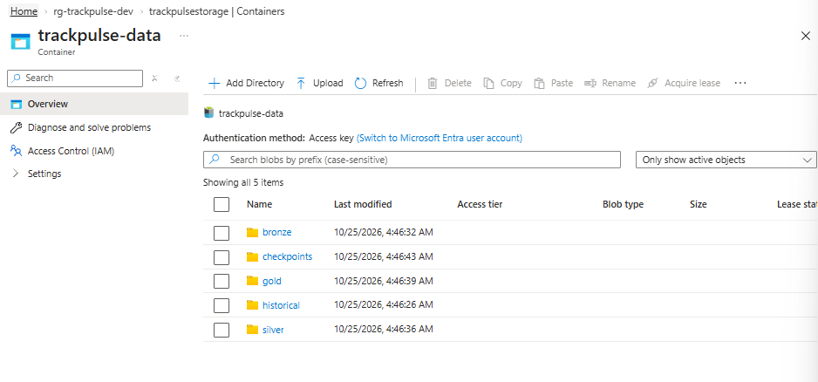

Step 3 — Create the Event Hubs Namespace
Resource: ns-trackpulse-dev
Description: An Azure Event Hubs Namespace was created to host the event streaming infrastructure.
Why this step was necessary: The namespace provides the endpoint, configuration, security, and capacity management required for applications to communicate with the Event Hubs service.
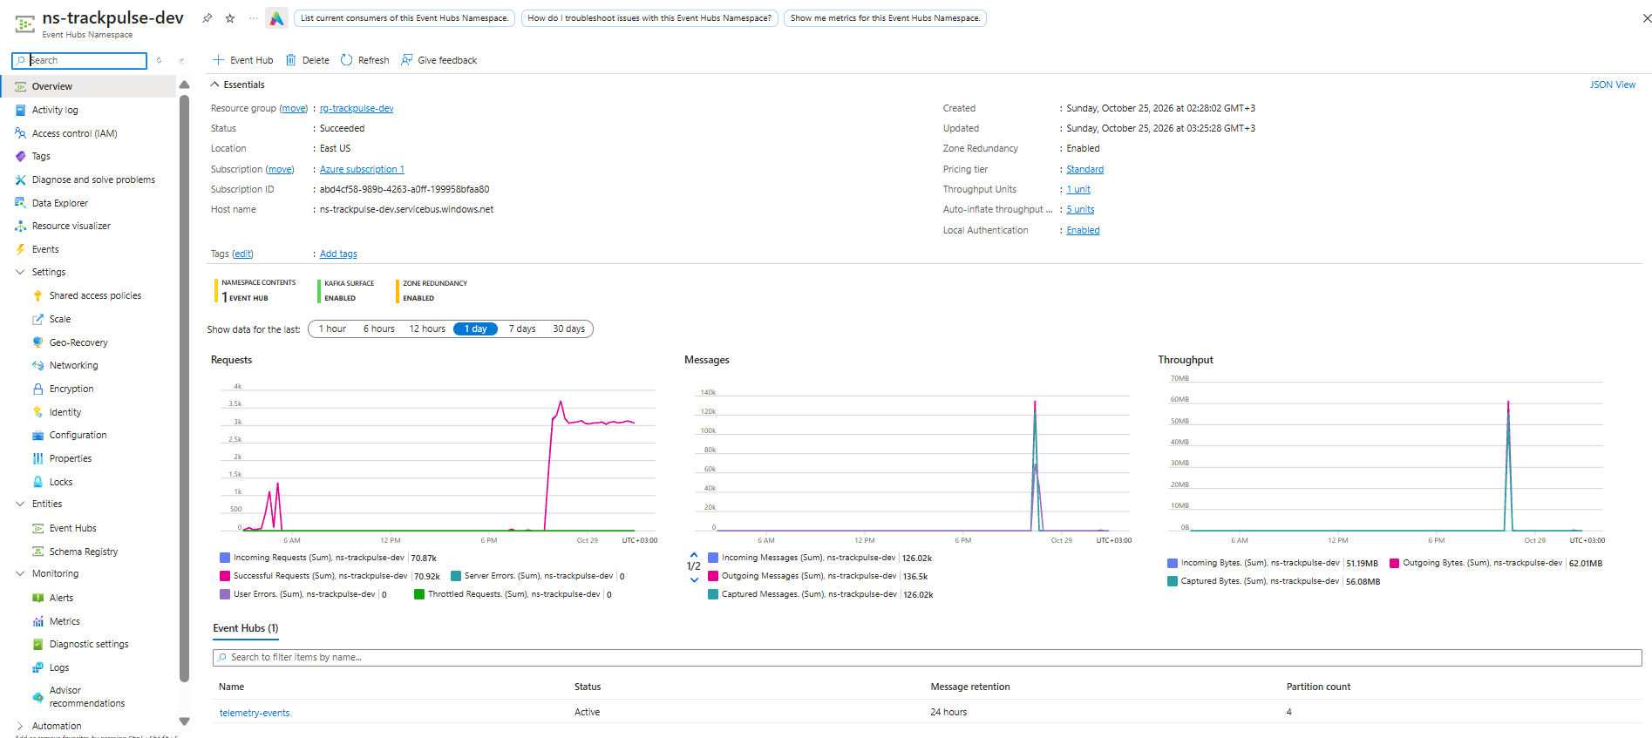
Step 4 — Create the Event Hub
Resource: telemetry-events
Description: An Event Hub named telemetry-events was created inside the namespace.
Why this step was necessary: The Event Hub acts as the ingestion channel through which the Python telemetry producer sends vehicle events. Downstream consumers and Event Hubs Capture can access the incoming stream.
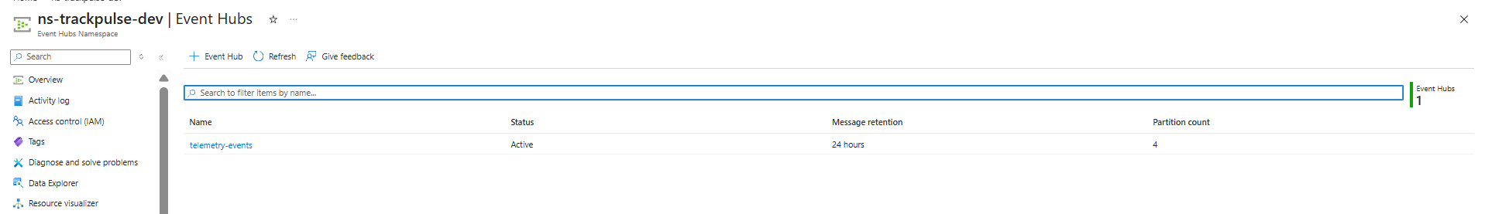
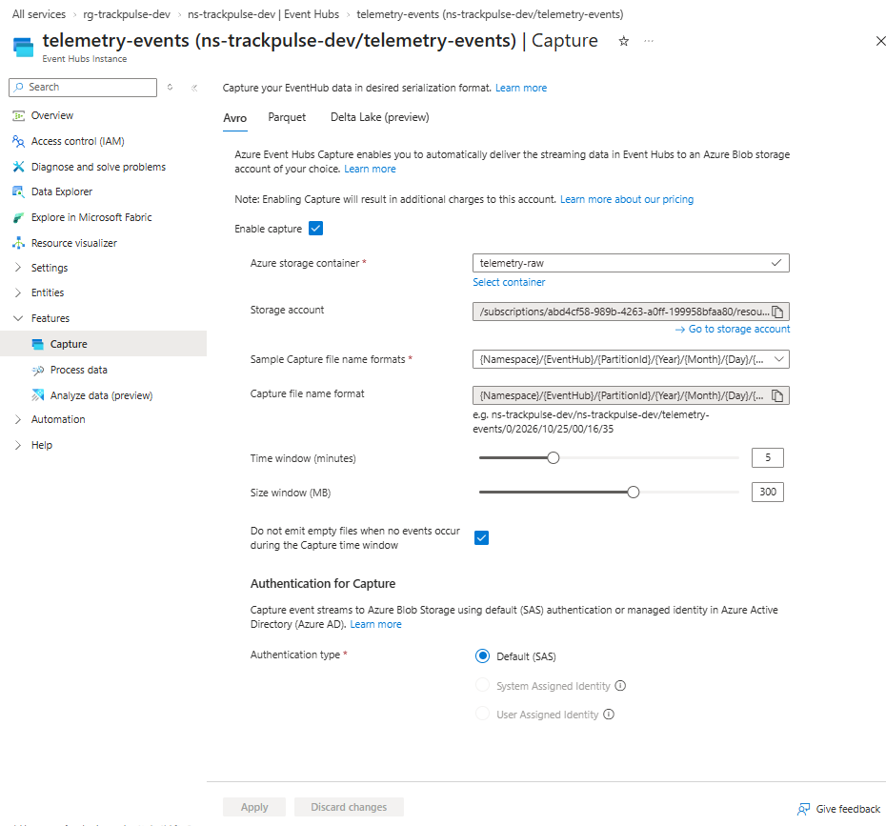
Step 5 — Configure Event Hubs Capture
Description: Event Hubs Capture was configured to persist incoming events in ADLS Gen2 as Avro files.
Why this step was necessary: Event Hubs is the streaming ingestion service, whereas ADLS Gen2 is the durable data lake. Capture connects these two components by continuously writing captured events to storage.
The raw-data location is:
abfss://telemetry-raw@trackpulsestorage.dfs.core.windows.net/ns-trackpulse-dev/telemetry-events/
Expected output: Time-partitioned capture files containing the original event data and Event Hubs metadata.
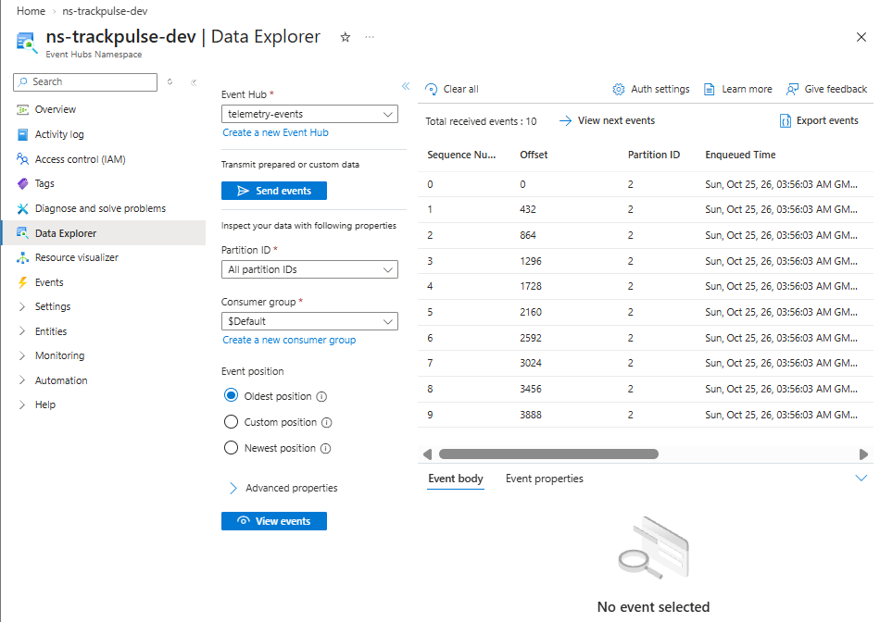

8. Azure Foundation Implemented
The following Azure resources and settings were visible in the setup screenshots available for this report. These indicate that the cloud foundation has been configured; they do not by themselves prove that the full 10-million-event load, streaming alerting, or downstream batch transformations have completed.
Resource / setting | Observed configuration | Status / note
Resource Group | rg-trackpulse-dev | Created
Event Hubs Namespace | ns-trackpulse-dev | Created
Event Hub | telemetry-events | Active; 4 partitions; 24-hour retention shown in setup notes
Storage account | trackpulsestorage | ADLS Gen2 storage foundation created
Raw container | telemetry-raw | Container exists; intended for captured raw telemetry
Event Hubs Capture | Enabled; destination linked to trackpulsestorage / telemetry-raw | Capture settings shown: 5-minute window, 300 MB threshold, empty files disabled
Access/security | Shared access policies and storage access configuration screens reviewed | Use least privilege; keep secrets out of source code and reports
Data Explorer | Event Hub Data Explorer screens captured | Screenshots do not establish that the planned 10M historical dataset has been ingested

9. Real-Time Event Generation and Ingestion
Component: trackpulse_eventhub_streamer_cloud_only.py
Description: A Python producer was prepared to generate synthetic vehicle telemetry events and publish them to Azure Event Hubs.
The generated records represent vehicle activity and sensor measurements. Depending on the event schema, attributes include:
- Event ID and event timestamp.
- Vehicle and trip identifiers.
- Vehicle location, including latitude and longitude.
- Speed.
- Engine temperature.
- Engine RPM.
- Fuel-rate measurements.
- Cargo-temperature readings where applicable.
Why this step was necessary: A telemetry producer simulates the continuous stream of data that a real fleet of connected vehicles would send to a logistics platform.
Using synthetic data also allows controlled testing of ingestion, transformation, validation, and analytics without requiring physical vehicles or an external telemetry provider.

Step 7 — Configure the Producer Connection
Description: The producer was configured to connect to the Event Hubs namespace and send events to the telemetry-events Event Hub.
The connection uses the Azure Event Hubs endpoint and the required authentication configuration.
Why this step was necessary: The producer needs an authenticated connection to the correct ingestion endpoint before any events can enter the pipeline.
Security consideration: Connection strings, access keys, and other credentials must be stored securely and must not be included in source code committed to a public repository.

Step 8 — Start the Streaming Producer
Description: The Python producer was executed to begin sending telemetry events to Event Hubs.
The producer can be operated in a controlled test mode or in production-streaming mode, depending on its configuration.
Why this step was necessary: This step generates the continuous input required to test the streaming ingestion path and downstream processing components.
Validation performed: A controlled test successfully sent 10 events using the test identifier cloud-smoke-20261025-01. Subsequent production-mode execution was also performed.
Important: A successful producer send confirms that events were submitted to the ingestion service. It does not independently prove that every event has been captured, processed, and published to the final analytical layer.
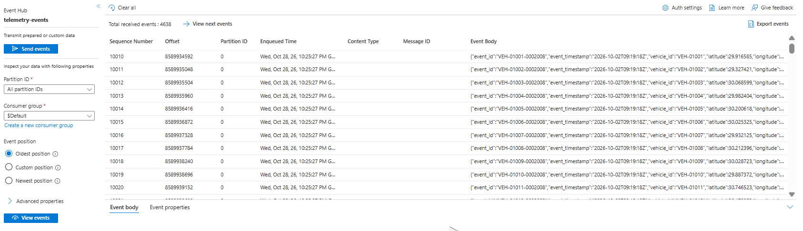

Step 9 — Validate Event Ingestion and Capture
Description: Event ingestion was checked using Event Hubs metrics and the resulting capture files in ADLS Gen2.
Why this step was necessary: This verifies the connection between event generation, cloud ingestion, and durable raw storage.
The expected flow is:
Python Producer → Azure Event Hubs → Event Hubs Capture → ADLS Gen2
Validation criteria:
- The producer successfully sends events.
- Event Hubs reports incoming event activity.
- Capture produces files in the expected storage location.
- The captured records contain the expected event fields.
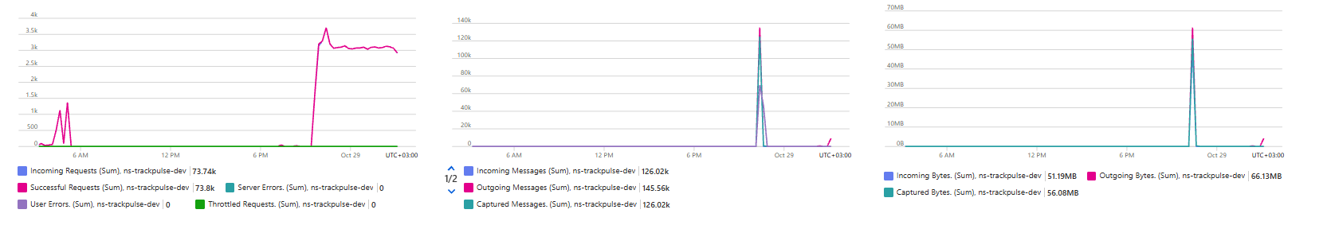

10. Azure Stream Analytics — Real-Time Analytics Path

Step 10 — Create the Azure Stream Analytics Job
Component: Azure Stream Analytics (ASA)
Description: A Stream Analytics job was created to provide a separate, low-latency processing path for incoming telemetry events.
The intended input is the telemetry-events Event Hub. The job can process incoming events continuously and apply streaming SQL transformations, filtering, aggregation, and alert conditions.
Why this step was necessary: Some logistics requirements, such as identifying abnormal sensor readings or excessive vehicle speeds, benefit from processing events as they arrive rather than waiting for a scheduled batch run.

Step 11 — Configure the Stream Analytics Input
Description: The Event Hubs stream was configured as an input to the Stream Analytics job.
The input configuration specifies the namespace, Event Hub, authentication method, and consumer-group settings where applicable.
Why this step was necessary: The job requires access to the incoming telemetry stream before it can execute queries against the events.
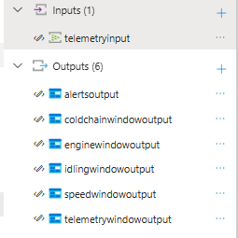

Step 12 — Define the Streaming Query
Description: A streaming query can filter and transform incoming events to produce a low-latency analytics output.
For example, the following is an illustrative Azure Stream Analytics SQL query for identifying events with high speed or engine temperature.
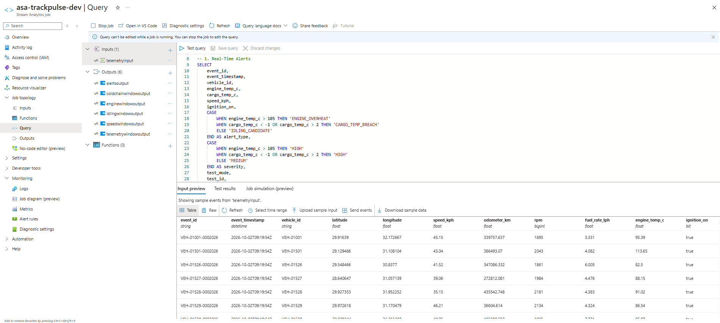
Why this step was necessary: A streaming query enables the platform to identify events that meet defined business conditions as data arrives.

Step 13 — Configure the Stream Analytics Output
Description: An output destination can be configured for the results of the streaming query. Depending on the intended implementation, this could be a supported storage destination, an event stream, or an alerting component.
Why this step was necessary: Processing events is only useful if the resulting alerts or analytical outputs can be consumed by downstream systems.
Implementation note: The configured output destination and the successful execution of the query should be documented using the actual Azure job settings and runtime evidence.

Step 14 — Validate the Streaming Analytics Job
Description: The job should be started and tested with known input events. Its input activity, query results, output activity, and errors should be monitored.
Why this step was necessary: This verifies the low-latency processing path independently of the scheduled Databricks workflow.

11. Azure Databricks Setup
Resource: trackpulse-databricks-dev
Description: An Azure Databricks workspace was created to provide the environment for PySpark-based distributed data processing.
Why this step was necessary: Databricks provides the compute environment for transforming raw telemetry, processing historical datasets, applying data-quality rules, and building Delta Lake tables.
The workspace supports the project's two main processing requirements:
- Historical batch processing.
- Incremental processing of newly captured streaming events.

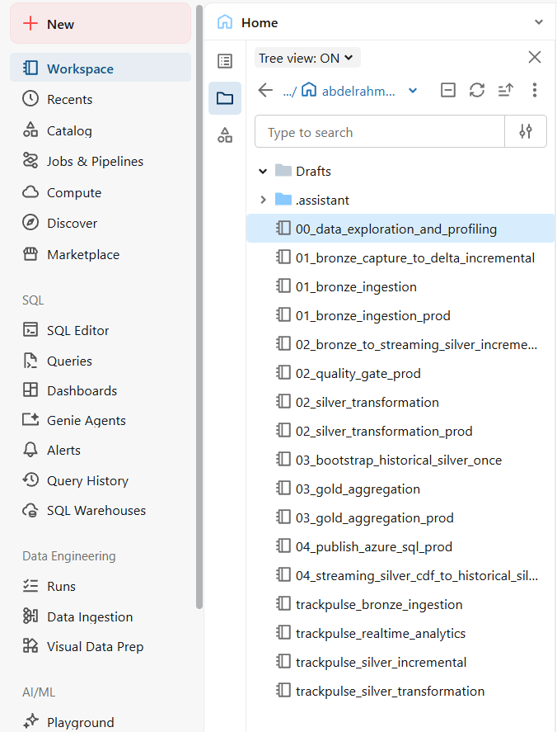

Step 16 — Configure Storage Access
Description: Databricks was configured to access the project's ADLS Gen2 storage locations.
Why this step was necessary: The notebooks need access to raw capture files and the Delta tables stored in the data lake.
Storage access should use an appropriate Azure identity and least-privilege permissions. Secrets should not be hard-coded in notebooks.

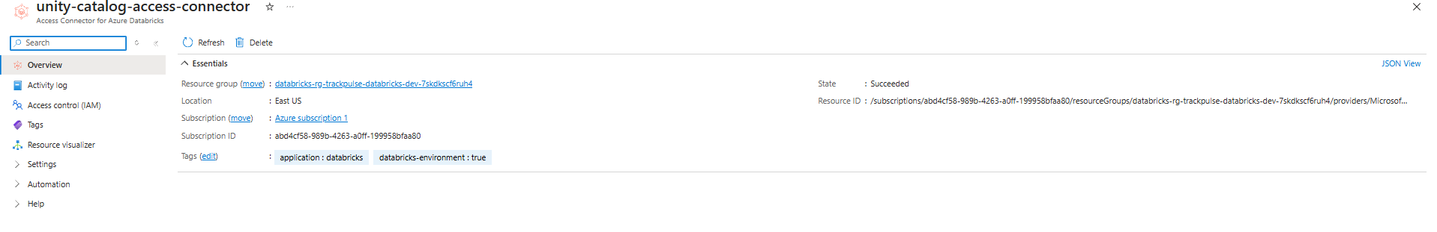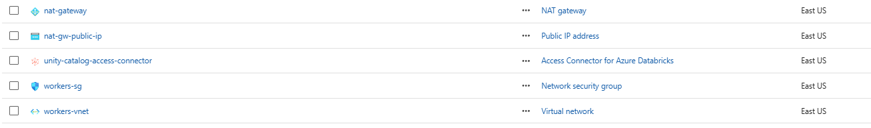

Step 17 — Prepare the Databricks Notebooks
Description: PySpark notebooks were organized to separate processing responsibilities, including Bronze ingestion, Silver transformations, historical integration, and Gold aggregation.
Why this step was necessary: Separating the pipeline into modular notebooks improves maintainability, testing, troubleshooting, and orchestration.

12. Bronze Layer — Raw Data Ingestion

Step 18 — Read Captured Files
Description: Databricks Auto Loader was used to discover and ingest captured files from the raw ADLS Gen2 location.
Auto Loader supports incremental file discovery, allowing new files to be processed without repeatedly listing and reading the entire raw dataset.
Why this step was necessary: It provides an incremental ingestion mechanism between the raw capture zone and the Bronze Delta table.

Step 19 — Write the Bronze Delta Table
Description: The captured telemetry records were stored in Delta format in the Bronze layer.
Storage path:
abfss://trackpulse-data@trackpulsestorage.dfs.core.windows.net/bronze/telemetry_stream/
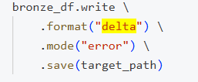
Why this step was necessary: Bronze preserves the captured event records in a queryable Delta table and provides a controlled source for downstream transformations.
Implementation note: The example illustrates the ingestion pattern. The deployed notebook should use the project's actual schema, source path, checkpoint path, and any required metadata transformations.

Step 20 — Configure Auto Loader Checkpoints
Description: A persistent checkpoint location was configured for incremental Bronze ingestion, alongside a schema-tracking location.
Why this step was necessary: Checkpoints allow the ingestion process to track previously processed files and resume from recorded progress after a restart.
The project uses a checkpoint under:
checkpoints/databricks_streaming/telemetry_capture/
The schema-tracking location is under:
checkpoints/schemas/telemetry_capture/

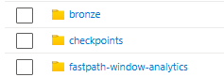

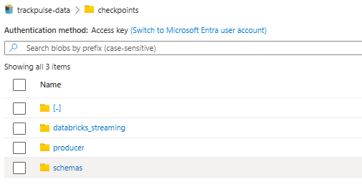

Step 21 — Validate the Bronze Layer
Description: The Bronze dataset was checked for record counts, schema consistency, and repeated event identifiers.
Observed validation snapshot:
- Total Bronze rows: 167,522.
- Distinct event IDs: 166,022.
- Duplicate-ID excess rows: 1,500.
Interpretation: Bronze contains repeated event IDs in the observed snapshot. This is not necessarily a failure of raw ingestion, because Bronze is allowed to preserve repeated source records. Deduplication and idempotent writes are handled in downstream processing.

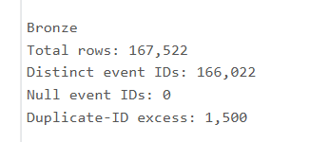

13. Streaming Silver Layer — Data Quality and Transformation

Step 22 — Read Bronze Incrementally
Description: A separate incremental processing notebook reads newly available records from the Bronze Delta table.
The process uses its own persistent checkpoint to track progress independently of Bronze ingestion.
Why this step was necessary: Separating the Bronze and Silver checkpoints allows each processing stage to maintain its own progress and retry behavior.
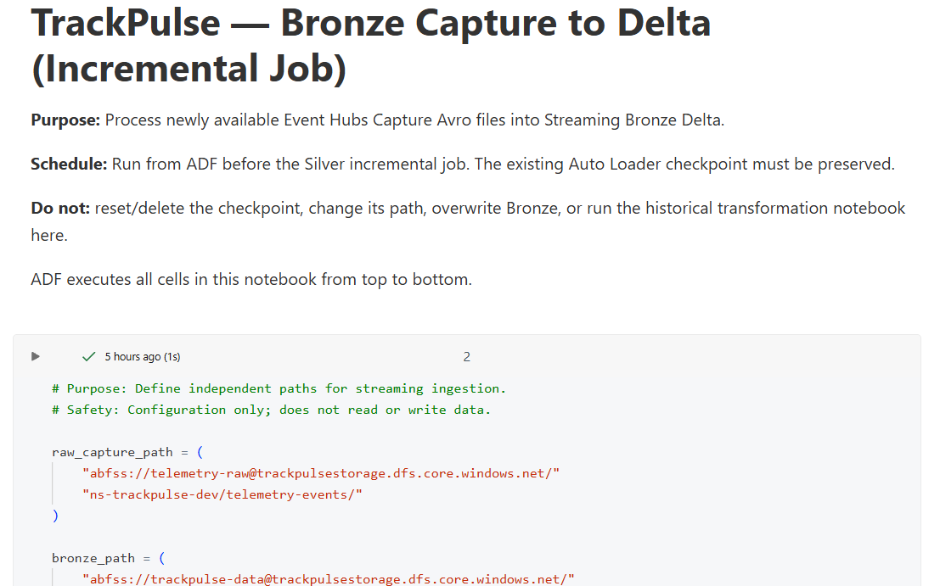
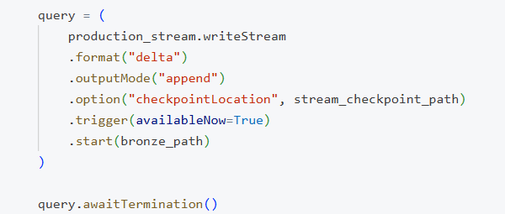

Step 23 — Validate the Input Schema
Description: Required columns and schema compatibility were checked before transforming the data.
The validation process verifies that essential fields, such as event identifiers and timestamps, are available.
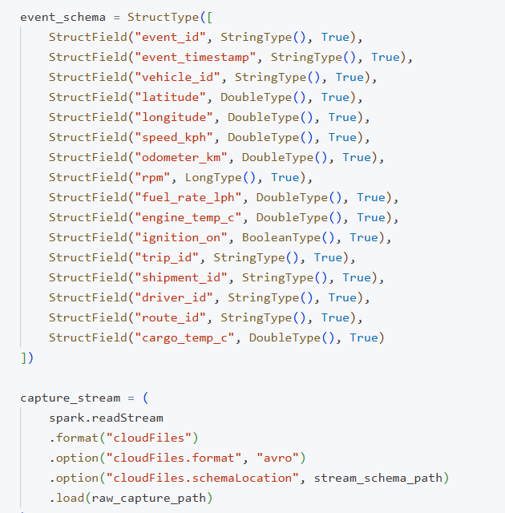
Why this step was necessary: Schema validation prevents incomplete or incompatible records from silently entering the analytical dataset.

Step 24 — Apply Data Quality Rules
Description: Incoming records were validated for required values and data-quality conditions. Records that failed the defined checks were separated from valid records.
Why this step was necessary: Business analytics depend on reliable identifiers, timestamps, and measurements. Invalid records should be identifiable and reviewable rather than silently included in the Silver dataset.
The project uses a quarantine location for invalid records:
abfss://trackpulse-data@trackpulsestorage.dfs.core.windows.net/silver/quarantine/telemetry_stream/
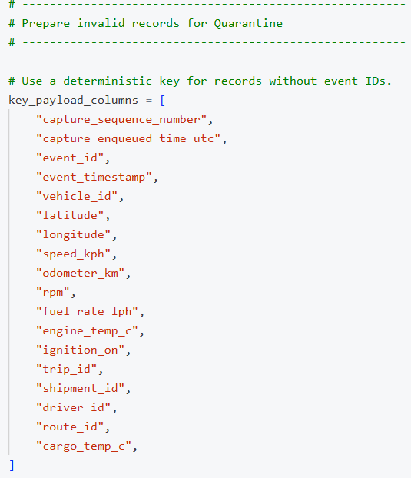

Step 25 — Deduplicate Events
Description: Valid events were deduplicated using event_id as the event-level key.
Why this step was necessary: Duplicate event identifiers can inflate counts, distort averages, and cause incorrect operational KPIs.
Deduplication ensures that the Silver processing path uses one record per event ID within the processed data, subject to the defined event-key and merge logic.

Step 26 — Write Valid Events to Streaming Silver
Description: Valid, deduplicated events were merged into the Streaming Silver Delta table using event_id as the matching key.
The table is stored at:
abfss://trackpulse-data@trackpulsestorage.dfs.core.windows.net/silver/telemetry_stream/
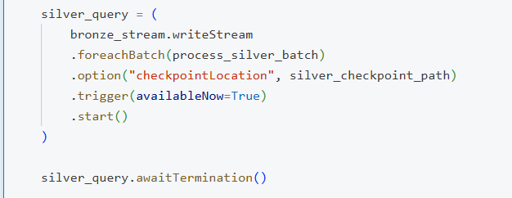
Why this step was necessary: A key-based MERGE prevents previously inserted event IDs from being inserted again when the same batch is retried.
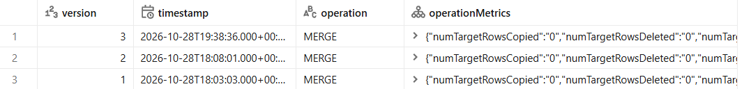

Step 27 — Store Invalid Events in Quarantine
Description: Records that failed validation were written to a separate quarantine Delta location with data-quality reasons.
Why this step was necessary: Quarantine makes data-quality failures visible and allows problematic records to be investigated without contaminating the validated analytical dataset.

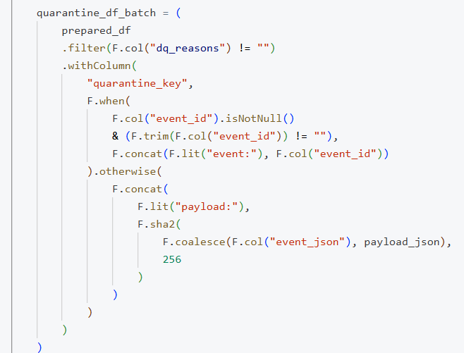

Step 28 — Validate Streaming Silver
Observed validation snapshot:
- Streaming Silver rows: 166,010.
- Distinct event IDs: 166,010.
- Null event IDs: 0.
- Quarantine records: 12.
- Distinct quarantine keys: 12.
The notebook reported successful schema validation and completion of the incremental Bronze-to-Silver processing.
Interpretation: The recorded Silver dataset contained unique event IDs, while the quarantine layer preserved 12 invalid records for further investigation.
These counts describe the validation snapshot and should be refreshed after additional events are processed.

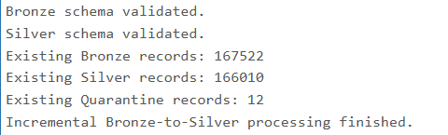

14. Historical Silver — Integrating Streaming and Batch Data

Step 29 — Prepare the Historical Dataset
Description: A historical dataset containing approximately 10 million telemetry events was prepared for large-scale analytics.
The historical Silver table is stored at:
abfss://trackpulse-data@trackpulsestorage.dfs.core.windows.net/silver/telemetry/
Why this step was necessary: Historical data provides the foundation for long-term analysis and allows newly arriving events to be analyzed alongside previous operational records.

Step 30 — Perform the Initial Historical Integration
Description: The historical Silver dataset was initialized by merging the available Streaming Silver records into the historical table.
Why this step was necessary: This established a consistent historical target before subsequent incremental updates were applied.
The initial integration was designed to avoid inserting an event that already existed in the historical table.

Step 31 — Enable Incremental Historical Updates
Description: Delta Change Data Feed (CDF) was used as the planned mechanism for detecting changes in the source Delta table and applying new records to Historical Silver.
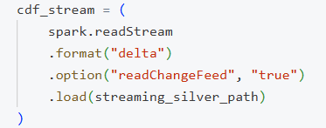
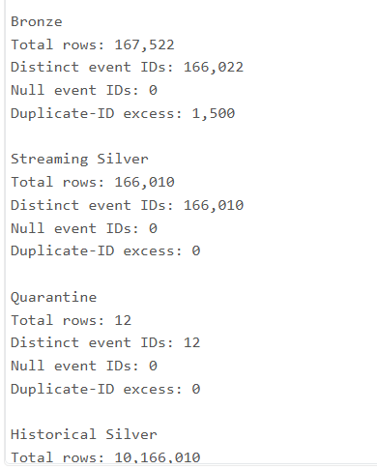
Why this step was necessary: CDF enables incremental integration without rereading and reloading the entire historical dataset whenever new streaming data arrives.
Important implementation detail: CDF must be enabled on the source table, and the starting version must be valid for the available change history. If CDF was enabled after earlier records were written, those earlier records may not appear in the change feed. This is why an initial historical integration is needed before relying on incremental changes.

Step 32 — Merge New Changes into Historical Silver
Description: New eligible records were merged into Historical Silver by event_id, with the intention of preserving existing records and adding previously unseen events.
Why this step was necessary: The MERGE pattern supports incremental updates and idempotent retries while protecting the existing historical dataset.
The implementation must explicitly handle the source change types required by the design. For example, if only inserts are relevant, the logic can process inserts; if updates or deletes must propagate, those operations require corresponding merge conditions.

Step 33 — Validate Historical Integration
Observed validation snapshot:
- Historical Silver rows: 10,166,010.
- Distinct historical event IDs: 10,166,010.
- Streaming Silver event IDs missing from Historical Silver: 0.
- A subsequent recorded MERGE added zero rows.
Interpretation: The historical table contained 10,166,010 unique event IDs in the recorded validation, and all checked Streaming Silver event IDs were present in the historical target. The zero-row MERGE result supports idempotent retry behavior for that tested batch.
The validation snapshot is consistent with a historical dataset of approximately 10 million events integrated with additional streaming data. The exact contribution of each source should be confirmed using the source counts and event-ID overlap for the same validation timestamp.

15. Gold Layer — Business Aggregation and Analytics

Step 34 — Create the Gold Layer
Description: The Gold layer transforms validated operational data into business-oriented Delta datasets suitable for reporting and analytical consumption.
Why this step was necessary: Silver provides validated event-level data, while Gold provides structured aggregates that answer operational and management questions.
The implemented Gold datasets include:
- gold.trip_summary
- gold.route_daily_performance
- gold.vehicle_daily_scorecard
- gold.cold_chain_daily_summary

Step 35 — Build the Trip Summary
Description: The Trip Summary joins operational trip records with trip plans, vehicles, drivers, shipments, and routes.
The transformation preserves planned and operational status values separately, allowing differences between the plan and actual execution records to be investigated.
Why this step was necessary: Logistics managers need to compare planned trips with operational activity and understand the relationship between trips and their associated resources.
Observed findings:
- 5,000 trips were analyzed.
- 5,000 unique trip IDs were present.
- No missing matches were reported for the associated plans, vehicles, drivers, shipments, or routes.
- The saved validation reported 5,000 status mismatches and 5,000 rows with a time difference.
Business interpretation: The source data requires further reconciliation before delay and on-time delivery KPIs can be trusted. A mismatch between planned and operational status is a data observation, not proof that every trip failed.

Step 36 — Build Route Daily Performance
Description: Route performance was aggregated by route and planned start date.
The dataset includes trip counts, operational status counts, and actual-distance metrics where values are available.
Why this step was necessary: Route-level aggregation enables operational managers to compare activity across routes and dates.
Potential business uses:
- Monitor route workload.
- Compare trip activity by date.
- Investigate incomplete or missing distance measurements.
- Identify routes that may need further operational analysis.
Missing distance values are retained as missing rather than automatically converted to zero, preserving the distinction between unavailable measurements and actual zero-distance trips.

Step 37 — Build the Vehicle Daily Scorecard
Description: Vehicle telemetry was aggregated by vehicle and date to calculate event counts, average and maximum speed, average engine temperature, average RPM, and average fuel rate.
Why this step was necessary: The scorecard provides a compact view of daily vehicle operating conditions instead of requiring analysts to inspect every telemetry event individually.
Potential business uses:
- Investigate abnormal engine-temperature patterns.
- Identify unusual speed or RPM measurements.
- Compare recorded fuel-rate patterns.
- Review vehicles with low telemetry coverage.
Fuel rate in litres per hour is a rate, not a total fuel-consumption measurement. Total fuel use requires time-aware integration or a suitable cumulative fuel measurement.

Step 38 — Build the Cold-Chain Daily Summary
Description: Cargo-temperature readings were evaluated against the configured shipment temperature limits, where the required readings and limits were available.
Why this step was necessary: Cold-chain logistics require monitoring whether cargo remains within its permitted temperature range during transportation.
Observed findings:
- Total shipments analyzed: 5,000.
- Shipments with cargo-temperature readings: 1,470.
- Shipments without cargo-temperature readings: 3,530.
- Temperature-reading coverage: 29.4%.
- Recorded compliance among evaluable readings: 98.21%.
- Readings above the maximum temperature limit: 52,660.
Business interpretation: The analysis identifies both temperature excursions and a significant monitoring-coverage gap. Shipments without cargo-temperature readings cannot be classified as compliant merely because no violation was observed.

Step 39 — Validate Gold Tables
Description: The Gold tables were checked for Delta format metadata, file information, and table storage details. Business-level validation should also verify keys, aggregate calculations, missing values, and consistency with the underlying Silver data.
Why this step was necessary: Storage validation alone does not establish that business KPIs are correct. Both technical integrity and business-rule correctness are required before publishing analytical outputs.
Important orchestration safeguard: The legacy Gold aggregation notebook uses overwrite mode. It must not be scheduled as an incremental production job. The separate incremental Gold implementation must be validated before it is used for recurring processing.

16. Azure Data Factory — Pipeline Orchestration

Step 40 — Create the Azure Data Factory Resource
Resource: data-factory-trackpulse-dev
Description: Azure Data Factory was created to coordinate the scheduled data-processing workflow.
Why this step was necessary: The pipeline contains multiple dependent processing stages. ADF provides a centralized way to run these activities in the correct order and monitor their execution.

Step 41 — Fork-Join (Fan-Out / Fan-In) Concurrency Pattern
Description: The entire transformation and loading workflow was unified into an automated, production-grade pipeline within Azure Data Factory named pl_trackpulse_historical_batch. The production canvas is engineered using a Fork-Join topology that maximizes compute parallelism while enforcing transactional barriers:
- Phase 1: Sequential Ingestion & Cleansing — act_01_bronze_ingestion_straming triggers Auto Loader, immediately succeeded by act_02_silver_transformation_streaming for quality checks.
- Phase 2: Parallel Processing Fork (Fan-Out) — Silver branches into two concurrent tasks: act_03_gold_aggregation (computing daily summaries and cold-chain breach episodes) and act_03_sync_stream_to_historical_cdf (syncing the 10M historical table via CDF).
- Phase 3: Synchronization Barrier & SQL Publishing (Fan-In) — act_04_publish_azure_sql executes ONLY when BOTH upstream parallel branches complete successfully.
- Phase 4: Canvas Cleanliness — Legacy batch notebooks (shown in the lower row) were deactivated to eliminate accidental data overwrite risks.
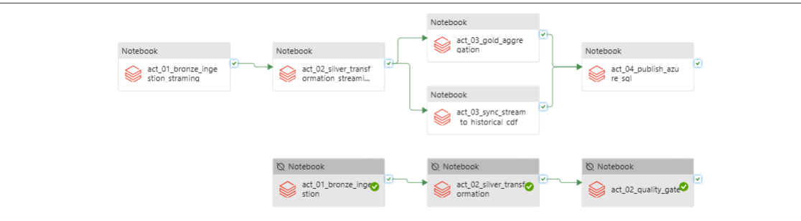
Figure 16.1: Azure Data Factory Fork-Join Pipeline — Canvas layout of pl_trackpulse_historical_batch exhibiting parallel processing and downstream SQL synchronization barrier.

Step 42 — Configure the Autonomous Schedule Trigger
Description: The pipeline was bound to a production schedule trigger named trg_batch_every_12_hours, configured to execute every 12 hours (at 8:05:00 AM and 8:05:00 PM Cairo Time) and published via ADF Publish All.

Step 43 — Production Run Verification
On October 29, 2026, the automated schedule trigger fired precisely at 8:05:00 AM without human intervention:
- Pipeline Run Name: pl_trackpulse_historical_batch
- Invoked By: trg_batch_every_12_hours
- Triggered Start Time: 10/29/2026, 8:05:00 AM EEST
- Completion Time: 10/29/2026, 8:19:14 AM EEST
- Total Execution Duration: 14 minutes 15 seconds
- Final Status: Succeeded (100% green checkmarks across all activities)
Figure 16.2: ADF Monitor Execution Evidence — Successful autonomous pipeline run logged at 8:05:00 AM with a 14m 15s duration.

Step 44 — High-Watermark Logic in act_04_publish_azure_sql
To ensure that repeated pipeline runs do not insert duplicate rows into Azure SQL Database or fail due to Primary Key violations, an intelligent high-watermark mechanism was implemented:
Python / PySpark: Incremental SQL Watermark Publisher
# Dynamic Watermarking for Incremental SQL Publication
import pyodbc

# 1. Fetch current max timestamp from Azure SQL Data Warehouse
conn = pyodbc.connect(connection_string)
cursor = conn.cursor()
cursor.execute("SELECT COALESCE(MAX(event_time), '1970-01-01 00:00:00') FROM dw.fct_vehicle_telemetry")
high_watermark = cursor.fetchone()[0]

# 2. Extract only new records from Gold Delta table
incremental_gold_df = (
spark.table("gold.fct_vehicle_telemetry")
.filter(f"event_time > '{high_watermark}'")
)

row_count = incremental_gold_df.count()

# 3. Safe commit or empty-batch bypassing
if row_count > 0:
print(f"Writing {row_count} new rows to Azure SQL dw.fct_vehicle_telemetry...")
incremental_gold_df.write.format("jdbc").mode("append").options(**sql_options).save()
else:
print("No new records to write to dw.fct_vehicle_telemetry. Skipping safely...")
Orchestration: Azure Data Factory coordinates the scheduled batch and incremental processing activities. It does not replace the continuous Event Hubs ingestion or the independent low-latency Stream Analytics path.
Incremental Processing Strategy
One of the most important design decisions is to process newly available data incrementally rather than reloading the full historical dataset during every scheduled run.
The pipeline uses different progress-tracking mechanisms for different stages:
- Bronze Auto Loader checkpoint: Tracks processed raw files.
- Silver incremental checkpoint: Tracks progress through the Bronze-to-Silver processing stage.
- Historical Silver CDF checkpoint: Tracks progress through source-table changes.
- Delta MERGE keys: Prevent repeated event IDs from being inserted into target tables.
- Gold incremental checkpoint: Supports incremental Gold processing when the validated implementation uses it.
These mechanisms serve different purposes and should not be treated as interchangeable.
For example, an Auto Loader checkpoint tracks file discovery, whereas a Delta CDF checkpoint tracks table changes. Neither one should be reset casually in an established pipeline because doing so may cause previously processed data to be read again.
Why incremental processing matters: It reduces unnecessary computation, avoids repeated processing of the complete historical dataset, and supports more efficient scheduled updates.
Data Quality and Validation Summary
The recorded validation results provide evidence for several important pipeline behaviors.
Validation | Recorded result | Significance
Bronze row count | 167,522 | Records persisted in Bronze
Bronze distinct event IDs | 166,022 | Repeated IDs were present in Bronze
Streaming Silver row count | 166,010 | Validated events stored in Silver
Streaming Silver distinct IDs | 166,010 | No repeated event IDs in the snapshot
Null Streaming Silver event IDs | 0 | Required identifier validation passed
Quarantine records | 12 | Invalid records were isolated
Historical Silver row count | 10,166,010 | Historical and integrated data available
Historical Silver distinct IDs | 10,166,010 | No duplicate event IDs in the snapshot
Streaming IDs missing from Historical Silver | 0 | Checked Streaming Silver IDs were integrated

Security, Reliability, and Operational Considerations
The project should follow these practices when moving from development to a repeatable demonstration or production-style deployment:
- Use secure Azure identity and access controls for storage and ingestion.
- Do not include credentials or access keys in notebooks or reports.
- Keep persistent checkpoints for incremental processing.
- Use idempotent MERGE operations where repeated processing is possible.
- Retain invalid records and their validation reasons for investigation.
- Monitor Event Hubs ingestion, Capture output, Stream Analytics job health, and Databricks notebook execution.
- Prevent overlapping orchestration runs when they may modify the same tables.
- Avoid using overwrite-based Gold notebooks for incremental production scheduling.
- Validate the SQL publication and Power BI refresh stages independently.

17. Data Modeling & BI
The agreed analytical model contains exactly three fact tables and five conformed dimensions. The fact-table grain is deliberately different for trips, cold-chain breach episodes, and individual telemetry events. This avoids mixing event-level readings with trip-level and incident-level measures.
Table | Grain | Representative fields / measures
fct_trip | One row per trip (trip_id) | Trip, vehicle, driver, route, shipment, date keys; planned/actual departure and arrival; distance; fuel used where reliable; duration; delay; on-time flag; status
fct_cold_chain | One row per complete breach episode | Breach episode ID; shipment/vehicle/route/date keys; start/end time; duration; observed min/max temperature; allowed bounds; severity; status
fct_vehicle_telemetry | One row per unique telemetry event (event_id) | Event ID/time; vehicle and related keys; latitude/longitude; speed; fuel rate; RPM; engine/cargo temperature; ignition; odometer
dim_vehicle | One row per vehicle/version | Vehicle ID/type/model/year/fuel type/capacity/status
dim_driver | One row per driver/version | Driver ID/label/license category/employment status
dim_route | One row per route/version | Route/corridor IDs; origin/destination; planned distance/duration; deviation threshold
dim_shipment | One row per shipment/version | Shipment ID; cargo type; required temperature bounds; delivery status
dim_date | One row per calendar date | Date key; full date; day; month; quarter; year; weekday

Relationship | Cardinality | Meaning
dim_vehicle → fct_vehicle_telemetry | 1 to many | A vehicle generates many telemetry events; each event is associated with one vehicle.
dim_vehicle → fct_trip | 1 to many over time | A vehicle can perform many trips; each trip has one assigned vehicle in this model.
dim_driver → fct_trip | 1 to many over time | A driver can be assigned to multiple trips; each trip references its assigned driver.
dim_route → fct_trip | 1 to many | A route can be used by many trips.
dim_shipment → fct_trip | 1 to many or 1 to 1 depending on operating rules | A shipment may be linked to a trip; confirm whether split shipments or multi-trip deliveries are allowed.
dim_vehicle / dim_route / dim_shipment / dim_driver → fct_vehicle_telemetry | 1 to many where identifiers are available | Event context supports slicing sensor readings by business entity.
dim_shipment / dim_vehicle / dim_route → fct_cold_chain | 1 to many | A shipment, vehicle, or route can have multiple breach episodes over time.
dim_date → all three fact tables | 1 to many | The date dimension supports daily/weekly/monthly analysis using the fact's selected reporting date.

A trip has many telemetry events and can have zero, one, or multiple cold-chain breach episodes. A single telemetry event can carry multiple anomaly labels. Anomaly labels should therefore be modelled as an event annotation or separate diagnostic output, not forced into the same grain as the telemetry fact.

Step 45 — Azure SQL Serving Layer & Relational Schema
Description: The serving layer is hosted on Azure SQL Database (sqlsic.database.windows.net / sqldb-trackpulse-gold) under the dedicated dw schema. The database organizes curated data into 3 Fact Tables and 5 Conformed Dimensions:
- Fact Tables (3): dw.fct_vehicle_telemetry (sensor events), dw.fct_trip (trip metrics), dw.fct_cold_chain (breach episodes).
- Dimension Tables (5): dw.dim_date, dw.dim_vehicle, dw.dim_driver, dw.dim_route, dw.dim_shipment.
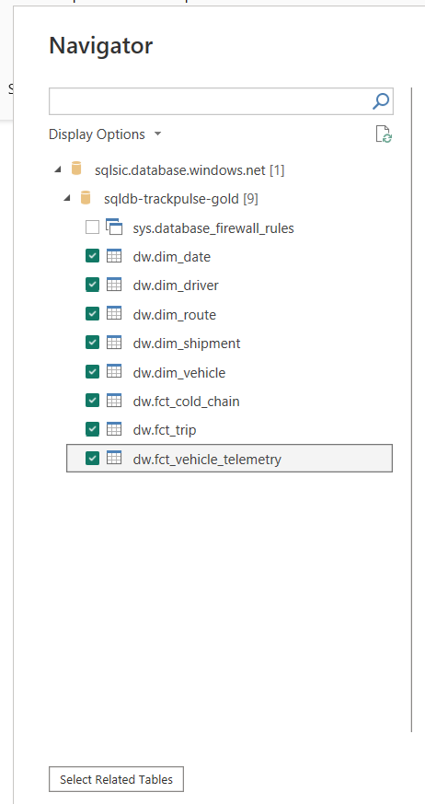
Figure 17.1: Azure SQL Data Warehouse Tables — Power BI Navigator validating the 8 production dimensional tables deployed in sqldb-trackpulse-gold.
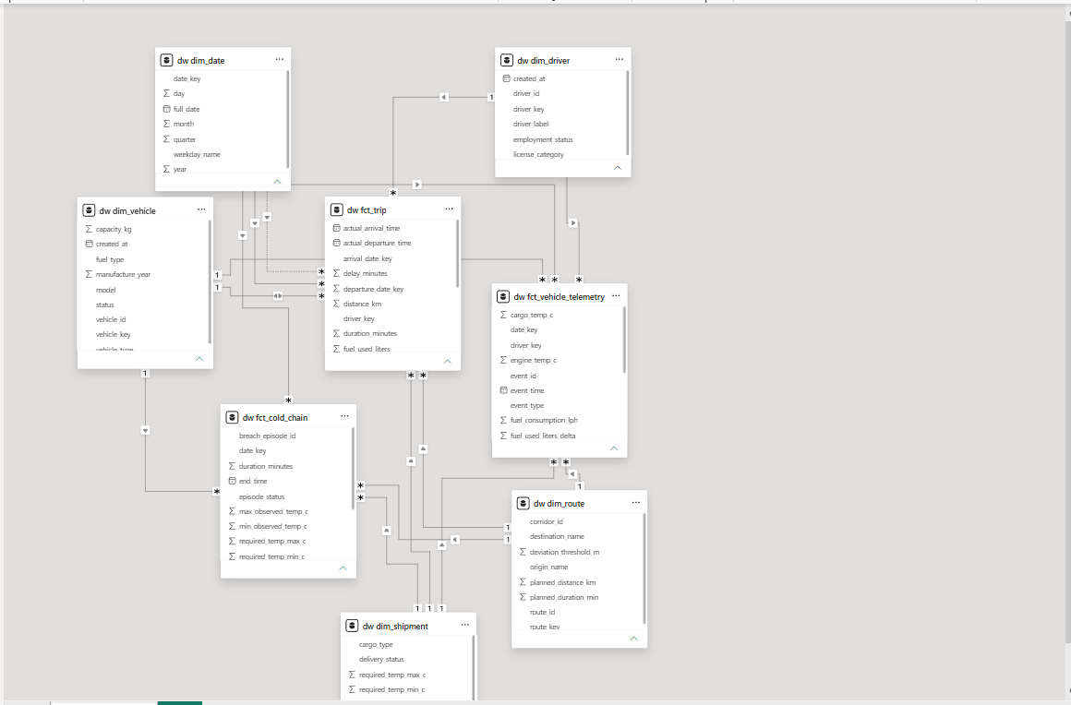
Figure 17.2: Power BI Fact Constellation Model — Complete semantic model showing 5 conformed dimensions serving 3 fact tables with active/inactive role-playing relationships.
18. Dashboard
This chapter presents the Power BI report built on the Azure SQL gold layer. Each page is shown with its KPI cards, the analysis its visuals support, and the business requirements it covers.

18.1 Dashboard Overview
- Report structure: five pages — Fleet Overview, Route & Trip Performance, Cold-Chain Compliance, Vehicle Telemetry & Operations, and Data Quality & Platform Evidence — with a navigation bar at the top of every page.
- Data source: Azure SQL Database (sqlsic.database.windows.net / sqldb-trackpulse-gold), dw schema, using the star schema described in Section 17 (3 fact tables and 5 conformed dimensions).
- Scale: 5,000 vehicles, 5,000 trips, and 10,166,000 gold telemetry facts.
- Intended audience: VP of Supply Chain Operations, fleet directors, and the academic examination committee.
- Visual design: a four-colour palette — Navy #1A3263 for primary values and bars, Steel Blue #547792 for secondary series and labels, Amber #FAB95B for accents, and Beige #E8E2DB for the page background.
- Chart style: no gridlines or axis lines, direct data labels on bars and points, and transparent chart backgrounds that blend with the cards.
- Interactivity: three slicers per page, placed in a single row under the page title, and KPI cards that respond to every slicer.

18.2 Page 1: Fleet Overview
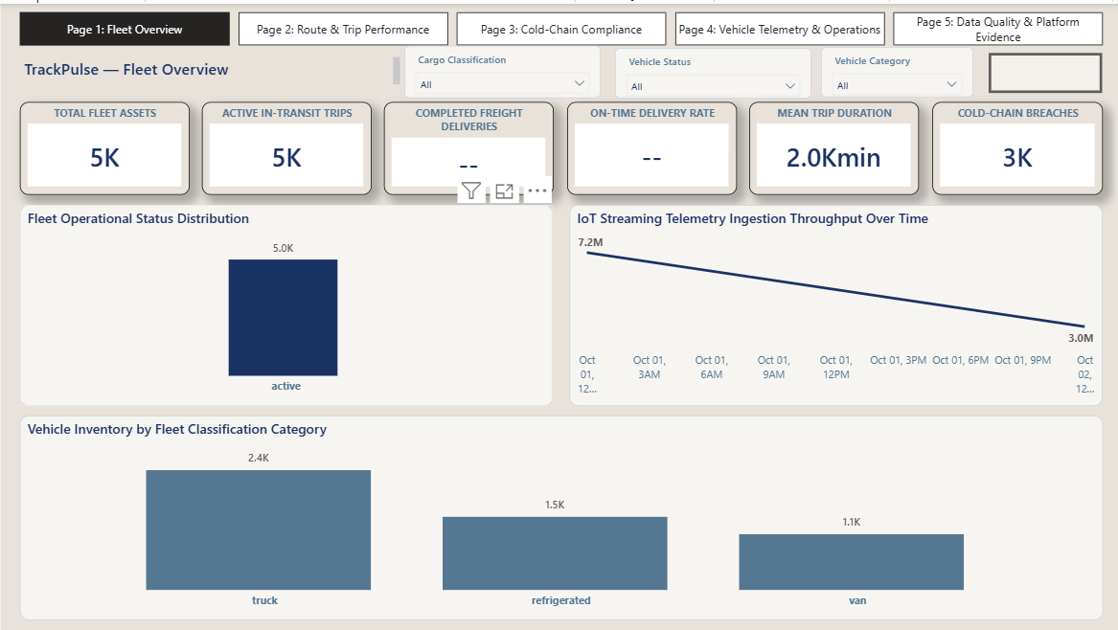
Figure 18.1: Page 1 — Fleet Overview — Fleet size, trip activity, delivery performance, and cold-chain breach count.
KPI Cards
- Total Fleet Assets (5K): all 5,000 vehicles are tracked, which confirms full asset coverage.
- Active In-Transit Trips (5K): every planned trip is active in the current cycle.
- Completed Freight Deliveries: number of trips that reached completed status.
- On-Time Delivery Rate: share of deliveries that arrived within the planned window, used for SLA tracking.
- Mean Trip Duration: average duration of a trip, in minutes.
- Cold-Chain Breaches (3K): total temperature breach episodes recorded in the period.
Analysis
- Fleet Operational Status Distribution: all 5.0K vehicles are in the active status, so there are no inactive or stalled assets.
- IoT Streaming Telemetry Ingestion Throughput Over Time: the line runs from 7.2M at the start of the timeline (Oct 01) to 3.0M at the end (Oct 02), showing how ingestion volume changes across the simulated period.
- Vehicle Inventory by Fleet Classification Category: trucks are the largest group at 2.4K, followed by refrigerated vehicles at 1.5K and vans at 1.1K, adding up to the 5,000-vehicle fleet.
Filters
- Cargo Classification, Vehicle Status, and Vehicle Category.
Business Requirements Covered
- BR-01 Real-Time Fleet Visibility: status, trip activity, and fleet composition are visible on one page.
- BR-05 SLA Performance Auditing: delivery completion, on-time rate, and trip duration cards allow SLA checks against the planned schedule.

18.3 Page 2: Route & Trip Performance
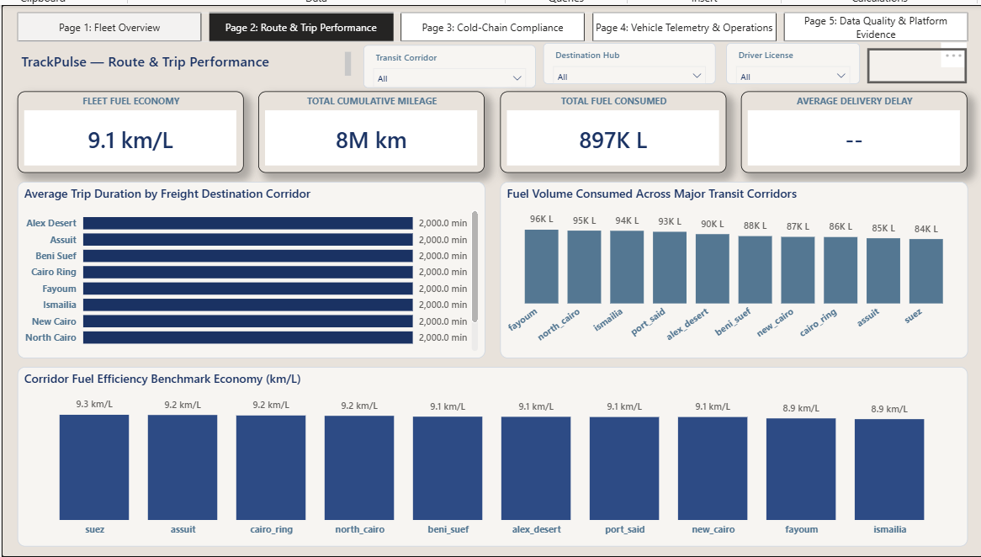
Figure 18.2: Page 2 — Route & Trip Performance — Fuel economy, mileage, fuel use, and corridor-level benchmarks.
KPI Cards
- Fleet Fuel Economy (9.1 km/L): overall distance covered per litre of fuel across the fleet.
- Total Cumulative Mileage (8M km): total distance travelled by all vehicles.
- Total Fuel Consumed (897K L): total fuel burned, used as the fuel cost driver.
- Average Delivery Delay: average lateness of deliveries against the planned arrival time.
Analysis
- Average Trip Duration by Freight Destination Corridor: a horizontal bar per corridor (Alex Desert, Assiut, Beni Suef, Cairo Ring, Fayoum, Ismailia, New Cairo, North Cairo, and others) with the duration printed at the end of each bar, so corridors can be compared directly.
- Fuel Volume Consumed Across Major Transit Corridors: fuel use is fairly even across the top ten corridors, from 96K L in Fayoum down to 84K L in Suez.
- Corridor Fuel Efficiency Benchmark Economy (km/L): Suez is the most efficient corridor at 9.3 km/L, followed by Assiut, Cairo Ring, and North Cairo at 9.2 km/L; Fayoum and Ismailia are the lowest at 8.9 km/L.
- Efficiency spread: the gap between the best and worst corridor is only 0.4 km/L, so no corridor is a major fuel outlier.
Filters
- Transit Corridor, Destination Hub, and Driver License.
Business Requirements Covered
- BR-02 Route Variance Optimization: trip duration and delay are shown per corridor so slow routes can be found.
- BR-06 Corridor Fuel Benchmarking: km/L and litres consumed are compared side by side for every corridor.
- Driver vs. vehicle analysis: the Driver License slicer separates driver effects from vehicle effects on fuel use.

18.4 Page 3: Cold-Chain Compliance
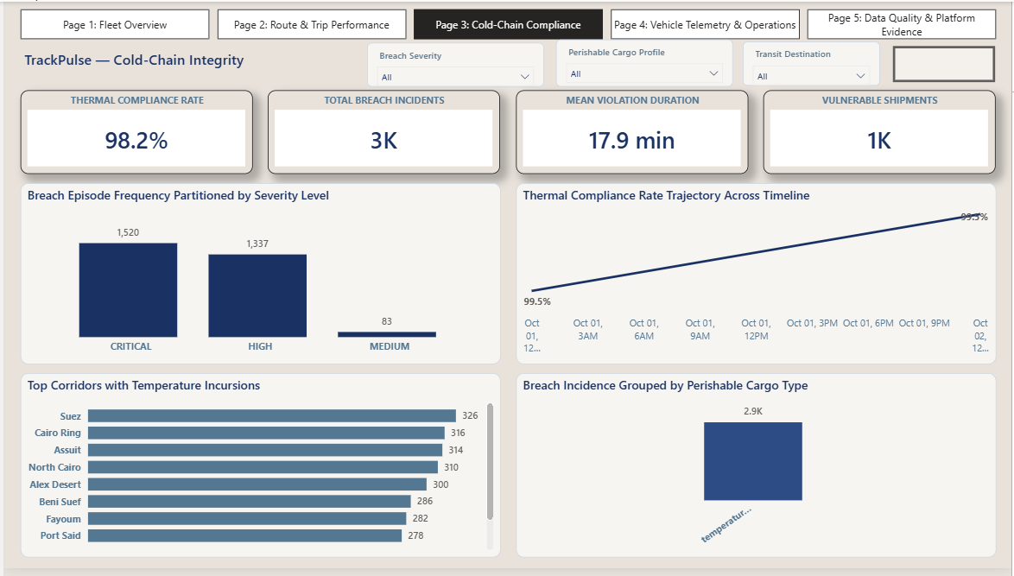
Figure 18.3: Page 3 — Cold-Chain Compliance — Thermal compliance, breach severity, trend, and top affected corridors.
KPI Cards
- Thermal Compliance Rate (98.2%): share of temperature readings that stayed inside the allowed cargo limits.
- Total Breach Incidents (3K): number of breach episodes, which matches the severity chart (1,520 + 1,337 + 83 = 2,940).
- Mean Violation Duration (17.9 min): average length of a breach episode.
- Vulnerable Shipments (1K): shipments that were exposed to at least one breach.
Analysis
- Breach Episode Frequency by Severity Level: Critical has 1,520 episodes, High has 1,337, and Medium has 83; Critical and High together make up about 97% of all breaches.
- Thermal Compliance Rate Trajectory Across Timeline: compliance starts at 99.5% and trends upward over the timeline.
- Top Corridors with Temperature Incursions: Suez leads with 326 breaches, followed by Cairo Ring (316), Assiut (314), North Cairo (310), Alex Desert (300), Beni Suef (286), Fayoum (282), and Port Said (278).
- Breach Incidence by Perishable Cargo Type: about 2.9K breaches are grouped under the cargo profile shown in the chart.
- Corridor pattern: the top eight corridors fall in a narrow band of 278 to 326 breaches, so the problem is fleet-wide rather than tied to one route.
Filters
- Breach Severity, Perishable Cargo Profile, and Transit Destination.
Business Requirements Covered
- BR-03 Cold-Chain Surveillance and Regulatory Compliance: compliance rate, breach count, and severity are tracked continuously.
- BR-07 Quality Audit Trail: breach episodes can be traced by severity, corridor, and cargo profile for audit and follow-up.

18.5 Page 4: Vehicle Telemetry & Operations
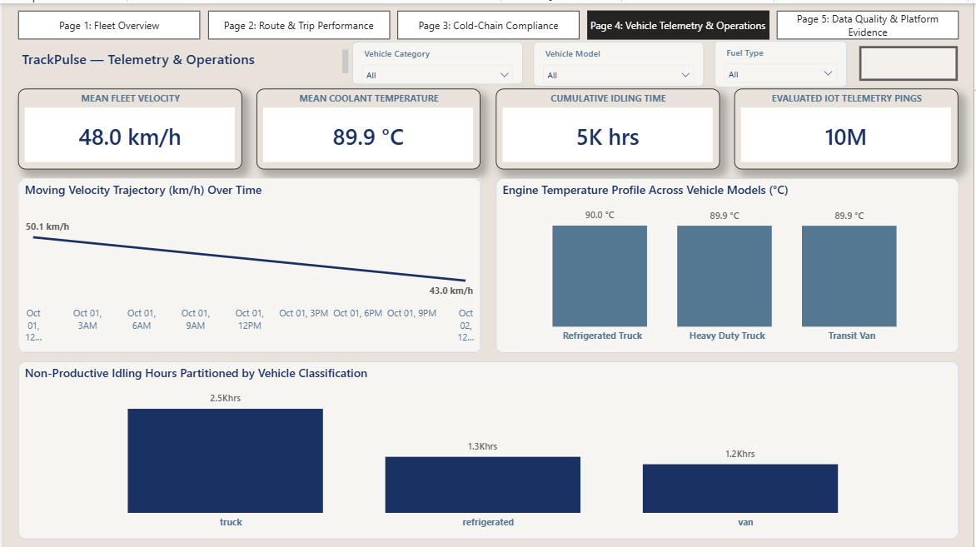
Figure 18.4: Page 4 — Vehicle Telemetry & Operations — Speed, engine temperature, idling, and telemetry volume.
KPI Cards
- Mean Fleet Velocity (48.0 km/h): average speed across all telemetry events.
- Mean Coolant Temperature (89.9 °C): average engine temperature, used as a vehicle health indicator.
- Cumulative Idling Time (5K hrs): total hours with the engine on and the vehicle not moving.
- Evaluated IoT Telemetry Pings (10M): number of telemetry events included in the analysis.
Analysis
- Moving Velocity Trajectory Over Time: average speed starts at 50.1 km/h and ends at 43.0 km/h across the timeline.
- Engine Temperature Profile Across Vehicle Models: Refrigerated Truck is at 90.0 °C, Heavy Duty Truck at 89.9 °C, and Transit Van at 89.9 °C, so all models run at almost the same temperature with no model standing out as overheating.
- Non-Productive Idling Hours by Vehicle Classification: trucks account for 2.5K idle hours, refrigerated vehicles for 1.3K, and vans for 1.2K, so trucks produce about half of all idling.
Filters
- Vehicle Category, Vehicle Model, and Fuel Type.
Business Requirements Covered
- BR-04 IoT Sensor Monitoring: speed, engine temperature, idling, and ping volume are shown from the sensor stream.
- BR-08 Predictive Maintenance Diagnostics: temperature by model and idling by category point to where maintenance and idle reduction should be focused.

18.6 Page 5: Data Quality & Platform Evidence
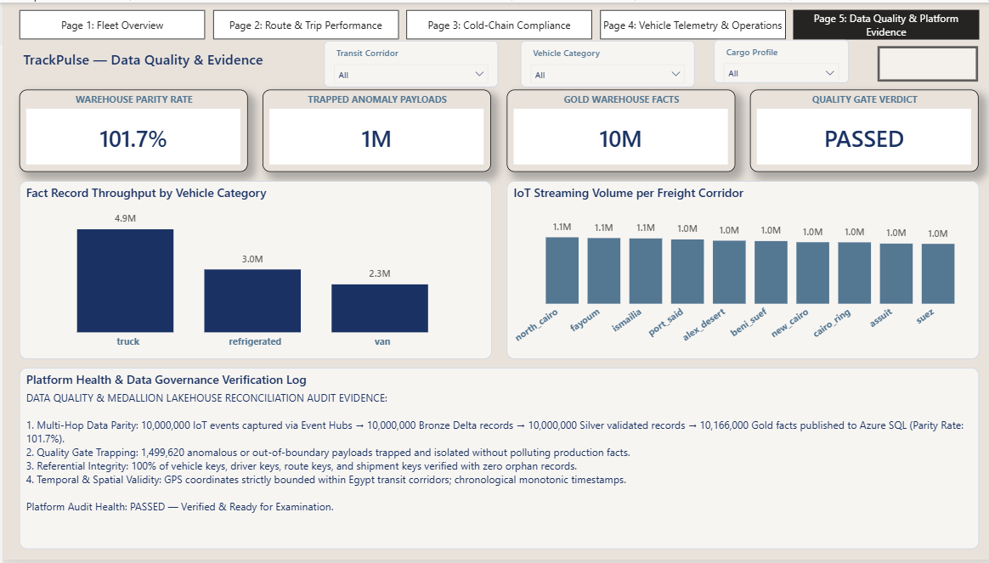
Figure 18.5: Page 5 — Data Quality & Platform Evidence — Warehouse reconciliation, quality gate result, and platform audit log.
KPI Cards
- Warehouse Parity Rate (101.7%): gold fact count compared with the silver record count.
- Trapped Anomaly Payloads (1M): invalid or out-of-boundary records isolated before reaching the gold layer.
- Gold Warehouse Facts (10M): telemetry facts published to Azure SQL.
- Quality Gate Verdict (PASSED): final result of the data quality checks.
Analysis
- Fact Record Throughput by Vehicle Category: trucks contribute 4.9M facts, refrigerated vehicles 3.0M, and vans 2.3M.
- IoT Streaming Volume per Freight Corridor: each of the ten corridors carries between 1.0M and 1.1M events, with North Cairo, Fayoum, and Ismailia at 1.1M, so the load is evenly spread.
- Multi-hop data parity: 10,000,000 events from Event Hubs became 10,000,000 Bronze Delta records, then 10,000,000 Silver validated records, and 10,166,000 Gold facts in Azure SQL.
- Quality gate trapping: 1,499,620 anomalous or out-of-boundary payloads were trapped and isolated without polluting the production facts.
- Referential integrity: 100% of vehicle, driver, route, and shipment keys were verified with zero orphan records.
- Temporal and spatial validity: GPS coordinates stay within the Egypt transit corridors and timestamps increase monotonically.
Filters
- Transit Corridor, Vehicle Category, and Cargo Profile.
Business Requirements Covered
- NFR-01 Data Integrity Assurance: parity, trapped payloads, and key checks show that the numbers in the dashboard are reconciled.
- NFR-03 Auditability and Lineage: the verification log traces the data from Event Hubs through Bronze, Silver, and Gold to the report.

18.7 Business Requirements Coverage Summary
- BR-01 Real-Time Fleet Visibility: Page 1.
- BR-02 Route Variance Optimization: Page 2.
- BR-03 Cold-Chain Surveillance and Regulatory Compliance: Page 3.
- BR-04 IoT Sensor Monitoring: Page 4.
- BR-05 SLA Performance Auditing: Page 1.
- BR-06 Corridor Fuel Benchmarking: Page 2.
- BR-07 Quality Audit Trail: Page 3.
- BR-08 Predictive Maintenance Diagnostics: Page 4.
- NFR-01 Data Integrity Assurance and NFR-03 Auditability and Lineage: Page 5.

