Fruit Ninja

Developers:

-Youssef Nawar ID->6602

-Youssef Khafaga ID->6326

- Mahmoud Raslan ID->6535

-Abdelrahman Hisham ID->6529

Design Analysis:

We designed a fruit ninja game that allows the user to choose between to different modes, Arcade and Normal mode. In the normal mode the user has 3 lives that are lost individually if the user misses a fruit or slices through a dangerous bomb. In both modes there are 3 different difficulties that are adjusted dynamically according to the score of the player through the game, starting with an easy difficulty working your way to the hardest level.

Design Patterns:

1. Singleton:

Singleton pattern was used in creating the render class which is used to generate the game itself creating the path transition and the duration to which the fruits are ejected, this allowed the control of object creation, making the creation of game only done by one render object.

1. State:

The state design pattern allowed the automatic change of the difficulty according to a certain factor which is the player’s score.

1. Decorator:

The decorator pattern was used in the creation of the special fruits that had extra functions than normal standard fruits, like the freeze banana which pauses the game temporarily, allowing easier slicing to the fruits.

1. Factory:

Factory pattern is used to design all the projectiles. By creating an abstract class gameobject that is extended by fruits and designing an object factory class which is responsible for creating all the projectiles.

1. Memento:

Allowing the save of the score after each individual life is lost.

Snapshots of the application:

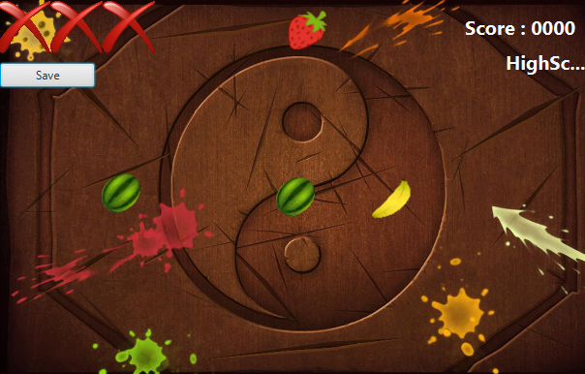

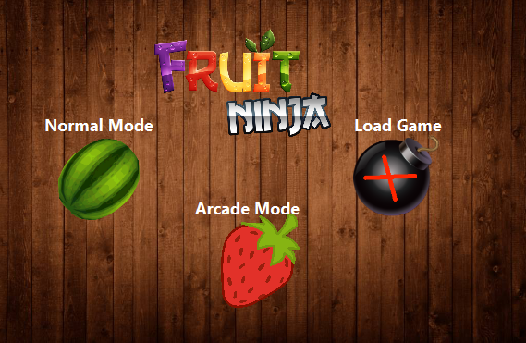

Sequence Diagram:

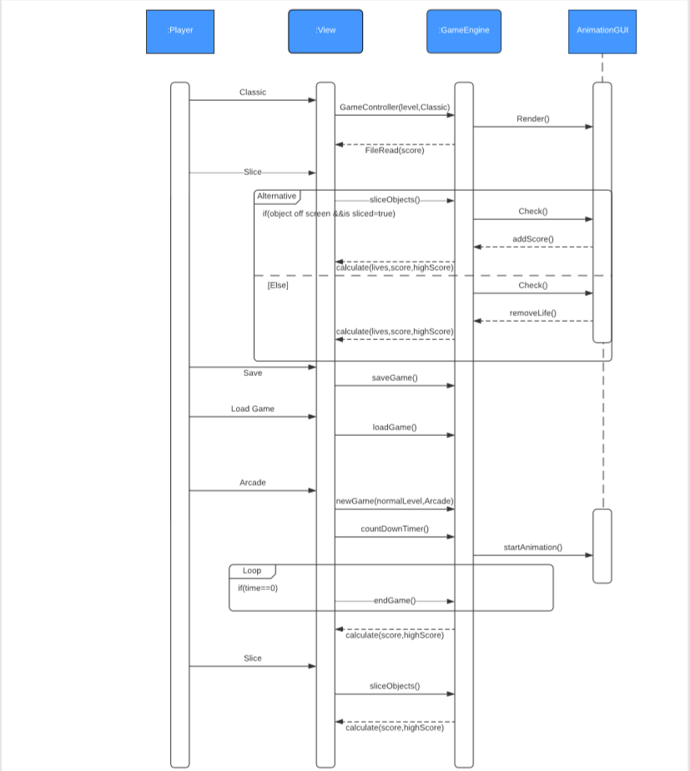

Class Diagram:

