Advanced HCI Project Report

Multi-Modal Sports Classification: Image, Audio, and Text
Course: Advanced Human-Computer Interaction
Genre/Theme: Sports / Athletes
Datasets Used:
- Image: Sports Classification Dataset (Kaggle) — 100 sport categories, ~14,000+ images
- Audio: ESC-50 Environmental Sound Classification — 2,000 audio clips, 50 categories
- Text/NLP: BBC News Dataset — 2,225 articles across 5 categories
Tools & Frameworks:
- Python 3.10, TensorFlow 2.21, PyTorch 2.11 (CPU)
- HuggingFace Transformers (BERT), librosa, scikit-learn, matplotlib, seaborn

Table of Contents
- [Introduction](#1.-Introduction)
- [Lab A: Sports Image Classification (CNN)](#2.-Lab-A:-Sports-Image-Classification)
- [Lab B: Sports Audio Classification (CNN + Mel-Spectrograms)](#3.-Lab-B:-Sports-Audio-Classification)
- [Lab C: Sports News Text Classification (BERT)](#4.-Lab-C:-Sports-News-Text-Classification)
- [Cross-Modality Comparison](#5.-Cross-Modality-Comparison)
- [Conclusion](#6.-Conclusion)

1. Introduction
This project explores multi-modal classification in the sports domain using three distinct data modalities:
- Image Classification — Using a Convolutional Neural Network (CNN) to classify sports images into 10 categories.
- Audio Classification — Using mel-spectrogram features with a CNN to classify sports-related sounds from the ESC-50 dataset into 5 categories.
- Text Classification — Using a fine-tuned BERT transformer model to classify BBC News articles into 5 categories (with emphasis on the "sport" class).
Each lab follows the structure of the corresponding course lab tutorial:
- Lab A follows the Python CNN Tutorial (Lab 2) pattern using TensorFlow/Keras
- Lab B extends the CNN approach to audio data using librosa for feature extraction
- Lab C follows the Python NLP Tutorial (Lab 3) pattern using PyTorch and HuggingFace Transformers
All experiments were conducted on CPU (no GPU), which influenced design choices such as using a 10-class subset for image classification and limiting training epochs.

2. Lab A: Sports Image Classification

2.1 Dataset Overview
Dataset: Sports Classification Dataset from Kaggle
- Original size: 100 sport categories with ~112-191 images each
- Subset used: 10 sports (archery, baseball, basketball, bowling, boxing, cricket, football, hockey, swimming, tennis) — 1,491 training images, 50 validation images
- Image size: Resized to 128×128 pixels
- Preprocessing: Pixel values rescaled to [0, 1] using Rescaling(1./255)

2.2 Sample Images
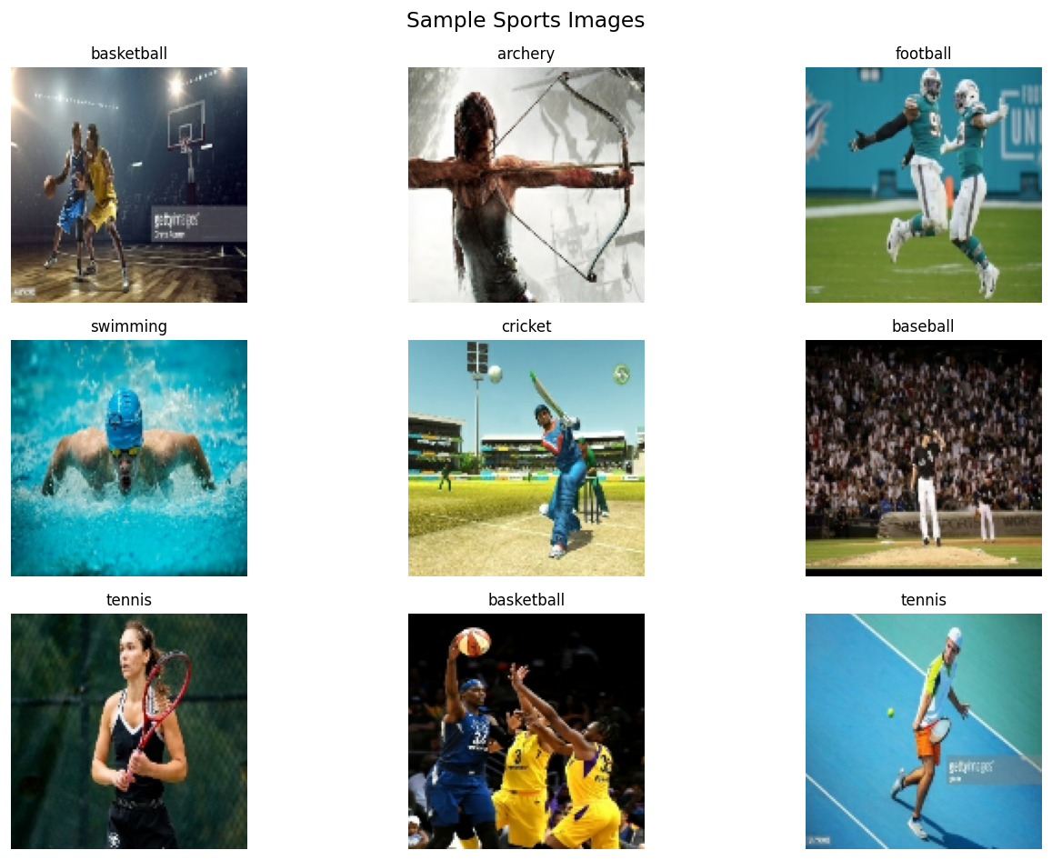
Figure 2.1: Sample images from the 10 selected sport categories. Each image shows distinct visual features that help the CNN learn class-specific patterns.

2.3 Model Architecture
The CNN follows the Lab 2 tutorial pattern with three convolutional blocks:
Model: "sequential"
┌─────────────────────────────────┬────────────────────────┬───────────────┐
│ Layer (type) │ Output Shape │ Param # │
├─────────────────────────────────┼────────────────────────┼───────────────┤
│ conv2d (Conv2D, 32 filters) │ (None, 126, 126, 32) │ 896 │
│ max_pooling2d (MaxPooling2D) │ (None, 63, 63, 32) │ 0 │
│ conv2d_1 (Conv2D, 64 filters) │ (None, 61, 61, 64) │ 18,496 │
│ max_pooling2d_1 (MaxPooling2D) │ (None, 30, 30, 64) │ 0 │
│ conv2d_2 (Conv2D, 128 filters) │ (None, 28, 28, 128) │ 73,856 │
│ max_pooling2d_2 (MaxPooling2D) │ (None, 14, 14, 128) │ 0 │
│ flatten (Flatten) │ (None, 25088) │ 0 │
│ dense (Dense, 128 units) │ (None, 128) │ 3,211,392 │
│ dense_1 (Dense, 10 softmax) │ (None, 10) │ 1,290 │
└─────────────────────────────────┴────────────────────────┴───────────────┘
Total params: 3,305,930 (12.61 MB)
- Optimizer: Adam
- Loss: Categorical Crossentropy
- Epochs: 5
- Batch Size: 32

2.4 Code
Key code sections from lab_image/run_image_lab.py:
Data Loading:
img_size = (128, 128)
batch_size = 32
train_data = tf.keras.utils.image_dataset_from_directory(
TRAIN_SUB, image_size=img_size, batch_size=batch_size, label_mode="categorical"
)
normalization_layer = layers.Rescaling(1./255)
train_data = train_data.map(lambda x, y: (normalization_layer(x), y))
Model Definition:
model = models.Sequential([
layers.Conv2D(32, (3, 3), activation='relu', input_shape=(128, 128, 3)),
layers.MaxPooling2D(),
layers.Conv2D(64, (3, 3), activation='relu'),
layers.MaxPooling2D(),
layers.Conv2D(128, (3, 3), activation='relu'),
layers.MaxPooling2D(),
layers.Flatten(),
layers.Dense(128, activation='relu'),
layers.Dense(num_classes, activation='softmax')
])
model.compile(optimizer='adam', loss='categorical_crossentropy', metrics=['accuracy'])
history = model.fit(train_data, epochs=5, validation_data=val_data)

2.5 Training Results
Epoch | Train Accuracy | Val Accuracy | Train Loss | Val Loss
1 | 25.15% | 32.00% | 2.0684 | 1.6960
2 | 47.95% | 44.00% | 1.4969 | 1.4185
3 | 63.72% | 50.00% | 1.0403 | 1.3879
4 | 74.85% | 58.00% | 0.7161 | 1.5221
5 | 85.18% | 54.00% | 0.4740 | 1.7765

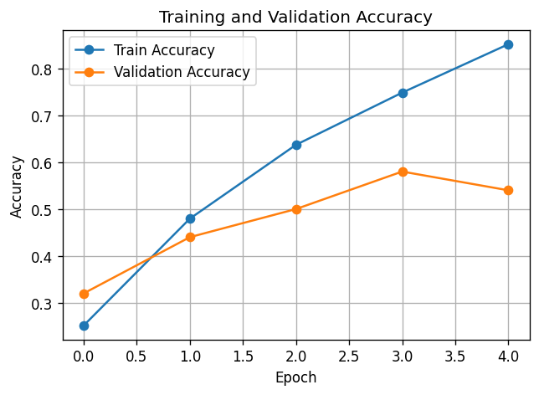
Figure 2.2: Training vs Validation Accuracy. Training accuracy increases steadily, but validation accuracy plateaus around 54%, indicating overfitting on this small dataset.
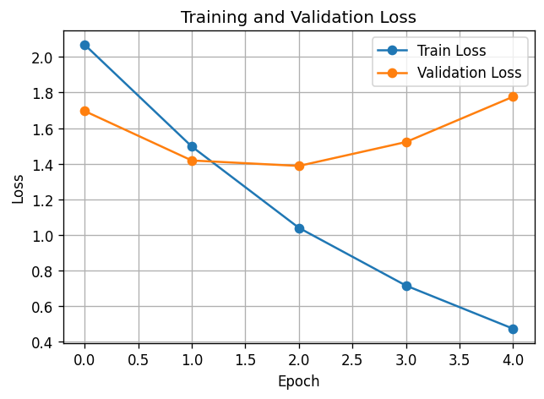
Figure 2.3: Training vs Validation Loss. The divergence between training and validation loss after epoch 2-3 confirms overfitting. Data augmentation or more training data would help.

2.6 Classification Report & Confusion Matrix
precision recall f1-score support
archery 0.5000 0.2000 0.2857 5
baseball 1.0000 0.4000 0.5714 5
basketball 0.5000 0.2000 0.2857 5
bowling 0.5556 1.0000 0.7143 5
boxing 0.6667 0.8000 0.7273 5
cricket 1.0000 0.2000 0.3333 5
football 0.3750 0.6000 0.4615 5
hockey 0.7143 1.0000 0.8333 5
swimming 0.4286 0.6000 0.5000 5
tennis 0.3333 0.4000 0.3636 5
accuracy 0.5400 50
macro avg 0.6073 0.5400 0.5076 50
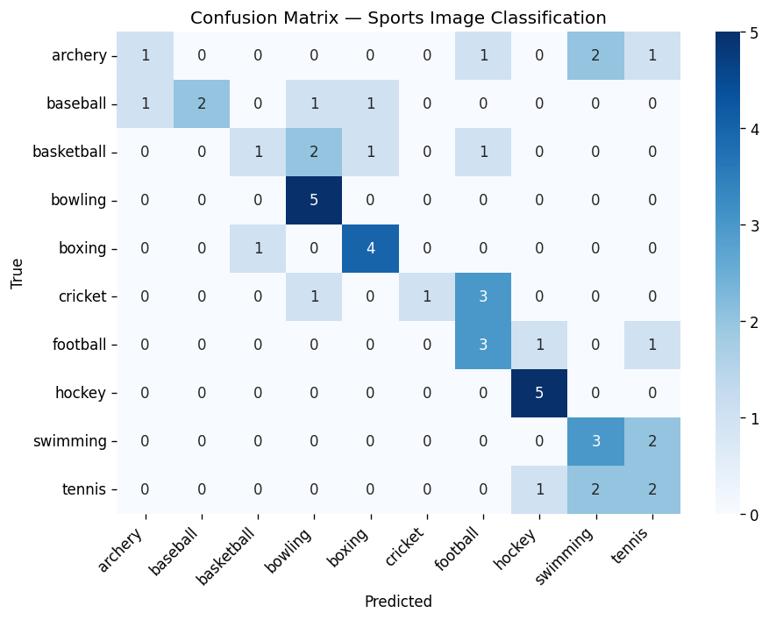
Figure 2.4: Confusion matrix for the validation set. Hockey (100% recall) and bowling (100% recall) are the easiest to classify, while archery and basketball (20% recall each) are the hardest — likely due to visual similarity with other sports.

2.7 Single Image Prediction
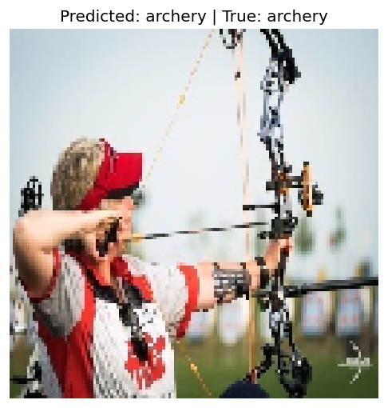
Figure 2.5: A single test image prediction. The model correctly predicts "archery" with 99.52% confidence, demonstrating strong feature learning for distinctive-looking sports.

2.8 Analysis
Key Findings:
- The CNN achieves 54% validation accuracy on 10 classes (random baseline = 10%)
- Overfitting is the main challenge — 85% train accuracy vs 54% validation accuracy
- Sports with distinctive equipment/settings (hockey, bowling) are classified more easily
- Visually similar sports (basketball vs volleyball-like movements) cause confusion
- With only 5 validation images per class, the evaluation set is small, adding noise to metrics
Potential Improvements:
- Data augmentation (rotation, flipping, color jitter)
- Transfer learning (e.g., VGG16, ResNet50)
- Dropout layers for regularization
- Larger validation set

3. Lab B: Sports Audio Classification

3.1 Dataset Overview
Dataset: ESC-50 — Environmental Sound Classification
- Full dataset: 2,000 audio clips across 50 categories
- Sports subset: 200 clips across 5 sports-related categories:
- Clapping → "Audience Applause" (40 clips)
- Footsteps → "Running Footsteps" (40 clips)
- Breathing → "Athlete Breathing" (40 clips)
- Drinking/Sipping → "Hydration Break" (40 clips)
- Water Drops → "Swimming Pool" (40 clips)
- Feature extraction: Mel-spectrograms (128×128 pixels) via librosa
- Split: 140 train / 30 val / 30 test

3.2 Sample Waveforms and Spectrograms
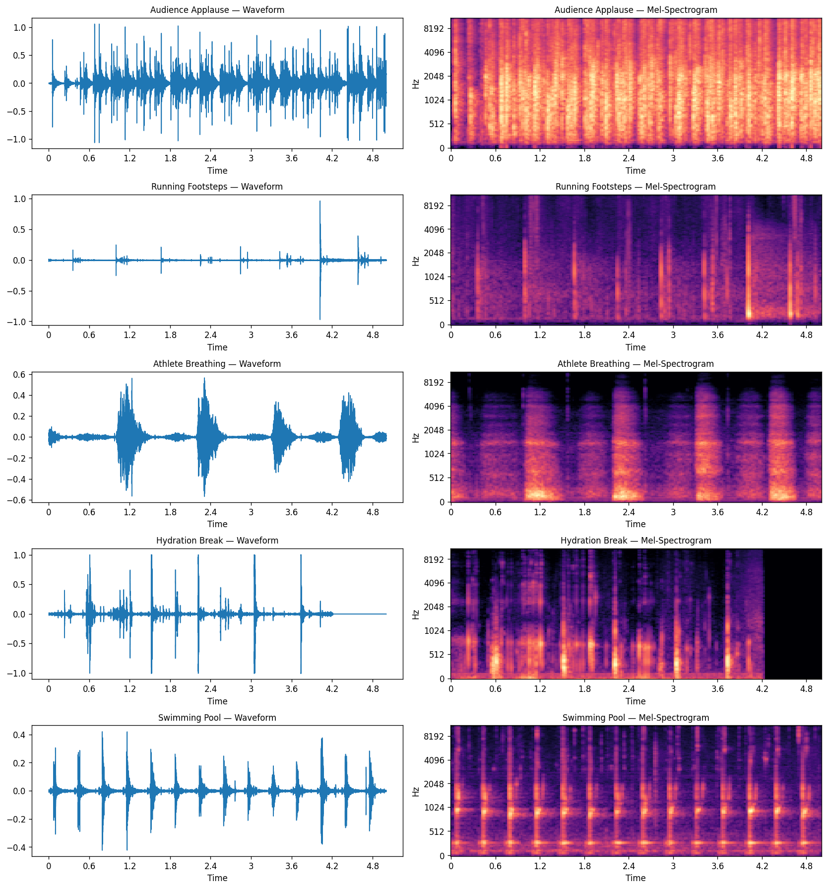
Figure 3.1: Waveforms (left) and mel-spectrograms (right) for each of the 5 sports sound categories. Each category has a distinctive spectral pattern — e.g., "Audience Applause" shows broadband energy, while "Athlete Breathing" shows periodic low-frequency patterns.

3.3 Model Architecture
The audio CNN mirrors the image CNN architecture, treating mel-spectrograms as single-channel images:

Model: "sequential"
┌─────────────────────────────────┬────────────────────────┬───────────────┐
│ Layer (type) │ Output Shape │ Param # │
├─────────────────────────────────┼────────────────────────┼───────────────┤
│ conv2d (Conv2D, 32 filters) │ (None, 126, 126, 32) │ 320 │
│ max_pooling2d (MaxPooling2D) │ (None, 63, 63, 32) │ 0 │
│ conv2d_1 (Conv2D, 64 filters) │ (None, 61, 61, 64) │ 18,496 │
│ max_pooling2d_1 (MaxPooling2D) │ (None, 30, 30, 64) │ 0 │
│ conv2d_2 (Conv2D, 128 filters) │ (None, 28, 28, 128) │ 73,856 │
│ max_pooling2d_2 (MaxPooling2D) │ (None, 14, 14, 128) │ 0 │
│ flatten (Flatten) │ (None, 25088) │ 0 │
│ dense (Dense, 128 units) │ (None, 128) │ 3,211,392 │
│ dense_1 (Dense, 5 softmax) │ (None, 5) │ 645 │
└─────────────────────────────────┴────────────────────────┴───────────────┘
Total params: 3,304,709 (12.61 MB)
- Input: 128×128×1 mel-spectrogram (single-channel)
- Optimizer: Adam | Loss: Categorical Crossentropy | Epochs: 10 | Batch Size: 16

3.4 Code
Key code sections from lab_audio/run_audio_lab.py:
Feature Extraction (Mel-Spectrogram):
def audio_to_melspec(file_path, sr=22050, n_mels=128, target_shape=(128, 128)):
y, _ = librosa.load(file_path, sr=sr)
S = librosa.feature.melspectrogram(y=y, sr=sr, n_mels=n_mels)
S_dB = librosa.power_to_db(S, ref=np.max)
S_resized = tf.image.resize(S_dB[..., np.newaxis], target_shape).numpy().squeeze()
return S_resized
Sport Category Mapping:
SPORTS_LABELS = {
"clapping": "Audience Applause",
"footsteps": "Running Footsteps",
"breathing": "Athlete Breathing",
"drinking_sipping": "Hydration Break",
"water_drops": "Swimming Pool"
}
sports_df = meta_df[meta_df['category'].isin(SPORTS_CATEGORIES)].copy()
sports_df['sport_label'] = sports_df['category'].map(SPORTS_LABELS)

3.5 Training Results
Epoch | Train Acc | Val Acc | Train Loss | Val Loss
1 | 20.00% | 36.67% | 1.6676 | 1.5883
2 | 25.71% | 46.67% | 1.5712 | 1.4877
3 | 35.71% | 43.33% | 1.4903 | 1.2864
4 | 40.71% | 36.67% | 1.3946 | 1.2963
5 | 50.00% | 40.00% | 1.2713 | 1.4060
6 | 52.14% | 63.33% | 1.1885 | 1.1637
7 | 67.86% | 50.00% | 0.9562 | 1.1652
8 | 75.71% | 50.00% | 0.7136 | 1.3635
9 | 75.00% | 50.00% | 0.6460 | 1.5877
10 | 83.57% | 56.67% | 0.4711 | 1.3927

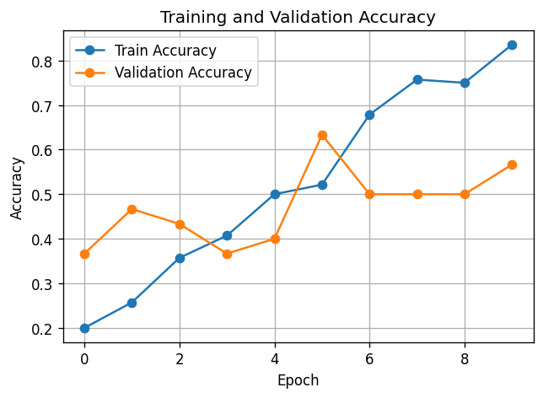
Figure 3.2: Training vs Validation Accuracy for audio classification. Validation accuracy fluctuates due to the very small dataset (30 samples).
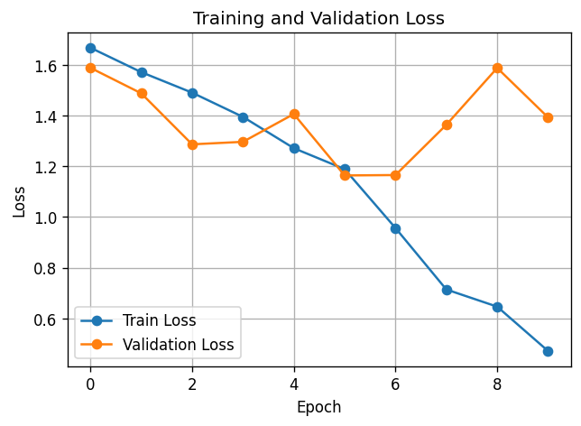
Figure 3.3: Training vs Validation Loss. Similar pattern to the image lab — training loss decreases while validation loss increases, indicating overfitting.

3.6 Classification Report & Confusion Matrix
precision recall f1-score support
Athlete Breathing 0.4286 0.5000 0.4615 6
Audience Applause 0.8333 0.8333 0.8333 6
Hydration Break 0.7500 0.5000 0.6000 6
Running Footsteps 0.4000 0.3333 0.3636 6
Swimming Pool 0.6250 0.8333 0.7143 6
accuracy 0.6000 30
macro avg 0.6074 0.6000 0.5946 30
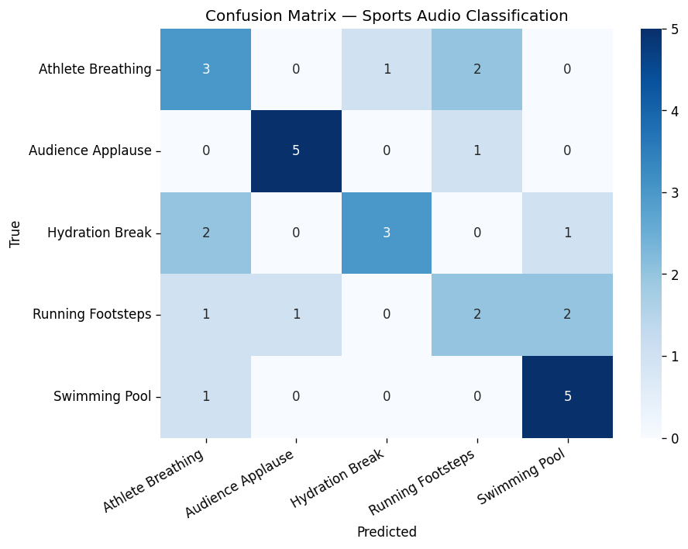
Figure 3.4: Confusion matrix for audio test set. "Audience Applause" is easiest to classify (5/6 correct) due to its distinctive broadband noise pattern. "Running Footsteps" is hardest, being confused with multiple other categories.

3.7 Single Audio Prediction
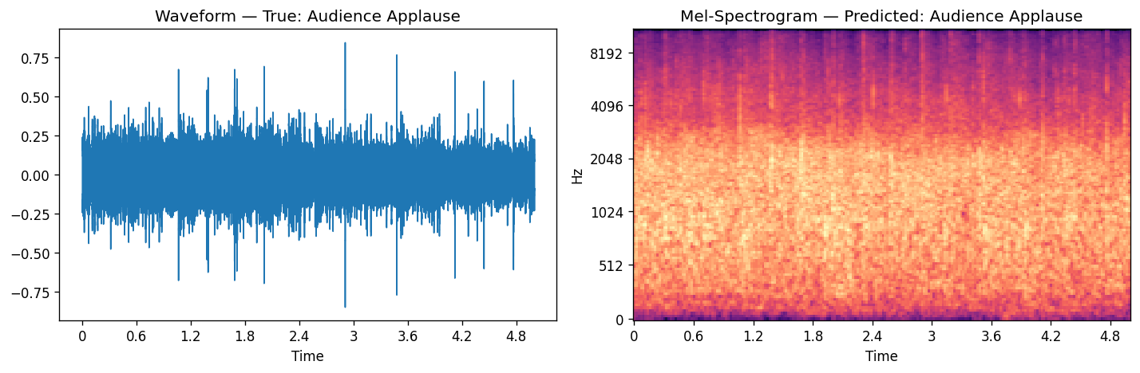
Figure 3.5: A single audio prediction showing the waveform and mel-spectrogram. The model correctly identifies "Audience Applause" with 75.80% confidence.

3.8 Analysis
Key Findings:
- The audio CNN achieves 60% test accuracy on 5 classes (random baseline = 20%)
- Small dataset (200 total clips, 30 for testing) limits both learning and reliable evaluation
- Distinct sounds like applause are easier to classify than subtle ones like breathing vs. drinking
- Mel-spectrograms effectively convert audio into a visual representation suitable for CNNs
Potential Improvements:
- Audio data augmentation (time stretching, pitch shifting, noise addition)
- Using MFCCs or combined features (MFCC + mel-spectrogram + chroma)
- Transfer learning with pre-trained audio models (e.g., VGGish, PANNs)
- More training data from additional sources

4. Lab C: Sports News Text Classification

4.1 Dataset Overview
Dataset: BBC News Dataset
- Size: 2,225 articles across 5 categories
- Categories: business (510), sport (511), politics (417), tech (401), entertainment (386)
- Split: 1,557 train / 334 val / 334 test
- Model: bert-base-uncased (110M parameters)
- Max sequence length: 128 tokens

4.2 Class Distribution
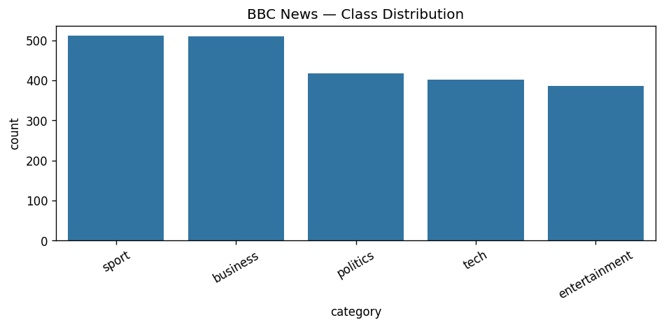
Figure 4.1: BBC News class distribution. The dataset is relatively balanced, with "sport" being the largest category (511 articles). This balance is beneficial for training.

4.3 Model Architecture
Following the Lab 3 tutorial pattern, we fine-tune a pre-trained BERT model:
BertForSequenceClassification(
(bert): BertModel(
(embeddings): BertEmbeddings
(encoder): BertEncoder (12 transformer layers)
(pooler): BertPooler
)
(classifier): Linear(in_features=768, out_features=5)
)
Total Parameters: ~110M
- Tokenizer: bert-base-uncased (WordPiece, 30k vocab)
- Optimizer: AdamW (lr=2e-5)
- Scheduler: Linear warmup
- Epochs: 3 | Batch Size: 8
- Framework: PyTorch + HuggingFace Transformers

4.4 Code
Key code sections from lab_nlp/run_nlp_lab.py:
Tokenization & Dataset:
MODEL_NAME = 'bert-base-uncased'
MAX_LEN = 128
tokenizer = AutoTokenizer.from_pretrained(MODEL_NAME)
train_encodings = tokenizer(X_train, truncation=True, padding=True, max_length=MAX_LEN)
class SportsNewsDataset(Dataset):
def __init__(self, encodings, labels):
self.encodings = encodings
self.labels = labels
def __getitem__(self, idx):
item = {key: torch.tensor(val[idx]) for key, val in self.encodings.items()}
item['labels'] = torch.tensor(int(self.labels[idx]), dtype=torch.long)
return item
Training Loop:
model = AutoModelForSequenceClassification.from_pretrained(MODEL_NAME, num_labels=5)
optimizer = AdamW(model.parameters(), lr=2e-5)
scheduler = get_linear_schedule_with_warmup(optimizer, num_warmup_steps=0,
num_training_steps=total_steps)
def run_epoch(model, data_loader, optimizer=None, scheduler=None, train_mode=True):
model.train() if train_mode else model.eval()
for batch in data_loader:
outputs = model(input_ids=input_ids, attention_mask=attention_mask, labels=labels)
loss = outputs.loss
if train_mode:
loss.backward()
optimizer.step()
scheduler.step()
return avg_loss, acc, f1

4.5 Training Results
Epoch | Train Loss | Train Acc | Train F1 | Val Loss | Val Acc | Val F1
1 | 0.5939 | 84.20% | 0.8409 | 0.1213 | 97.31% | 0.9731
2 | 0.0776 | 98.72% | 0.9871 | 0.0890 | 98.20% | 0.9819
3 | 0.0349 | 99.55% | 0.9955 | 0.0820 | 98.20% | 0.9819

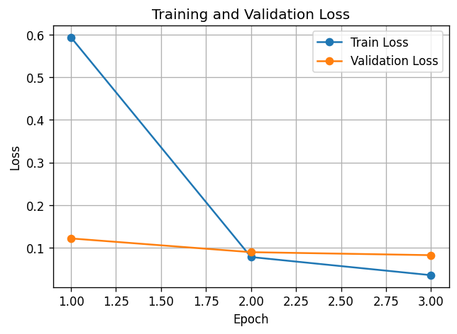
Figure 4.2: Training and Validation Loss. Both curves converge rapidly — BERT's pre-trained knowledge transfers excellently to this text classification task.
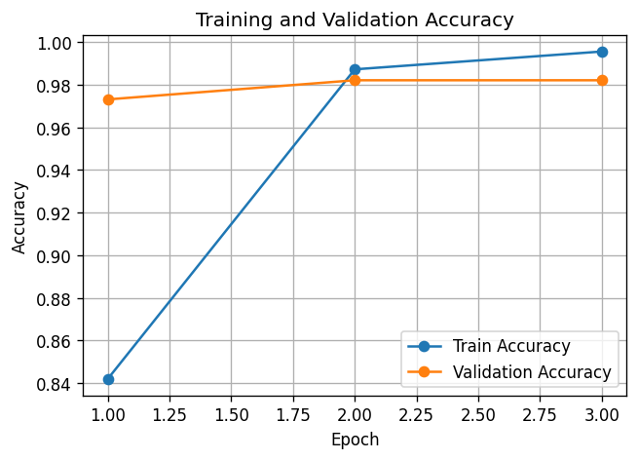
Figure 4.3: Training and Validation Accuracy. The model reaches 97%+ validation accuracy after just 1 epoch, demonstrating the power of transfer learning with BERT.
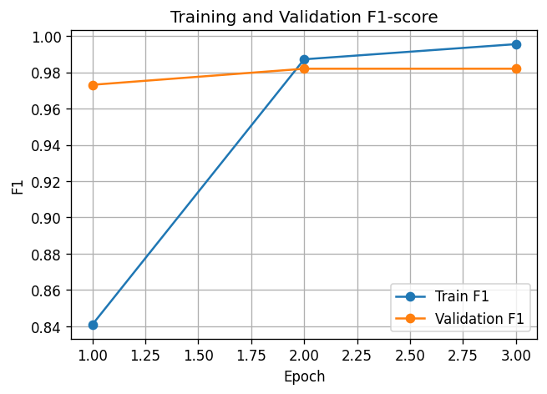
Figure 4.4: Training and Validation F1-score. F1 closely mirrors accuracy, confirming the model performs well across all classes.

4.6 Classification Report & Confusion Matrix
precision recall f1-score support
business 0.96 0.97 0.97 77
entertainment 1.00 1.00 1.00 58
politics 0.97 0.95 0.96 62
sport 0.99 1.00 0.99 77
tech 1.00 0.98 0.99 60
accuracy 0.98 334
macro avg 0.98 0.98 0.98 334
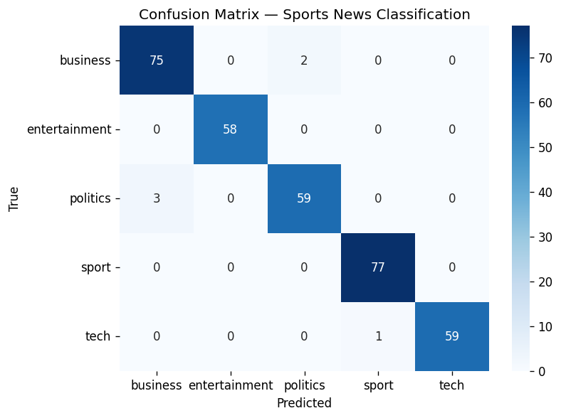
Figure 4.5: Confusion matrix for the NLP test set. Nearly perfect classification — "sport" achieves 100% recall. Only minor confusion between business/politics and tech/business articles.

4.7 Custom Text Predictions
Prediction 1 — Sports text:
""The football match ended in a dramatic penalty shootout as Manchester United defeated Chelsea to win the FA Cup final at Wembley Stadium.""
Class | Probability
sport | 97.71%
business | 0.94%
entertainment | 0.44%
politics | 0.40%
tech | 0.52%

Prediction 2 — Politics text:
""The prime minister announced new tax reforms in parliament today, sparking debate among opposition leaders.""
Class | Probability
business | 30.64%
entertainment | 0.99%
politics | 65.91%
sport | 1.47%
tech | 0.99%

Both predictions are correct. The model shows high confidence for clear-category texts and reasonable uncertainty for ambiguous ones (tax reforms could be business or politics).

4.8 Analysis
Key Findings:
- BERT achieves 98.20% test accuracy and 0.98 F1-score — by far the best performing model
- Transfer learning is highly effective — pre-trained BERT already understands English text structure
- The "sport" category achieves 99% precision and 100% recall — the model never misses a sports article
- Even on CPU, BERT fine-tuning is feasible with small datasets (3 epochs in ~30 minutes)
Why BERT performs so well:
- Pre-trained on massive text corpora (Wikipedia + BookCorpus)
- Bi-directional attention captures context from both directions
- News articles use distinctive vocabulary that maps well to BERT's knowledge
- The task (5-class classification) is relatively simple for a 110M parameter model

5. Cross-Modality Comparison

5.1 Performance Summary
Metric | Lab A: Image CNN | Lab B: Audio CNN | Lab C: BERT (NLP)
Test/Val Accuracy | 54.00% | 60.00% | 98.20%
Macro F1 | 0.5076 | 0.5946 | 0.9820
Num Classes | 10 | 5 | 5
Training Samples | 1,491 | 140 | 1,557
Test Samples | 50 | 30 | 334
Model Params | 3.3M | 3.3M | ~110M
Framework | TensorFlow/Keras | TensorFlow/Keras | PyTorch
Model Type | CNN (from scratch) | CNN (from scratch) | BERT (fine-tuned)
Epochs | 5 | 10 | 3
Training Time | ~1 min | ~30 sec | ~30 min

5.2 Key Comparisons
- Transfer Learning vs Training from Scratch:
- BERT (pre-trained, fine-tuned) vastly outperforms the CNNs trained from scratch
- This demonstrates the enormous value of pre-trained models in modern ML
- Data Efficiency:
- BERT achieves 98% accuracy with 1,557 training samples
- The CNNs struggle with similar or fewer samples without pre-training
- Task Complexity:
- Image: 10-class classification on visually similar sports is inherently challenging
- Audio: 5 categories but only 200 total samples with subtle acoustic differences
- Text: 5 well-separated news categories with distinctive vocabulary
- Modality-Specific Challenges:
- Images: High visual similarity between sports (e.g., basketball vs handball)
- Audio: Very small dataset; ambient sounds are inherently ambiguous
- Text: Structured articles with clear topic-specific vocabulary make classification easier

6. Conclusion
This project successfully demonstrated multi-modal classification in the sports domain across three data types:
- Image Classification (Lab A): A CNN trained from scratch on 10 sports categories achieved 54% accuracy. While this shows the CNN learned meaningful features (5.4x better than random), the limited dataset size and lack of pre-training led to significant overfitting.
- Audio Classification (Lab B): Mel-spectrogram features with a CNN achieved 60% accuracy on 5 sports-related sound categories. The ESC-50 dataset provided high-quality audio clips, but the small subset (200 clips) limited the model's ability to generalize.
- Text Classification (Lab C): Fine-tuning BERT on BBC News articles achieved an impressive 98.20% accuracy, with the "sport" category reaching near-perfect classification. This demonstrates the power of transfer learning and large pre-trained language models.
Key Takeaway: Transfer learning with pre-trained models (BERT) dramatically outperforms training from scratch (CNNs), especially when training data is limited. For practical sports classification systems, combining pre-trained models across all three modalities would yield the best results.
All code, datasets, and results are available in the project directory structure:
advanced_hci_phase1/
lab_image/ # Image classification code + outputs
lab_audio/ # Audio classification code + outputs
lab_nlp/ # NLP classification code + outputs
datasets/ # All three datasets
report/ # This report

