  Informatics and Computer Science | Examination Paper Proofing & Printing Confirmation Sheet
Module Title Advanced Human Computer Interaction |  | Module Code  Module code bold
Module Leader Assoc. Prof. Ann Nosseir |  | Semester  Two
Proofed by Assoc. Prof. Doaa El Zanfaly

I hereby confirm that:

- This examination paper has been proof-read (spelling and grammar errors)

- This examination paper follows the approved template

- All questions (and sub questions) have their marks specified

- Appropriate model answers were provided with breakdown of marks

- This examination paper assesses the ILOs for the module

Signed (Proof Reader):

Printing instructions & stationery requirements

Number of copies of examination paper to be printed

Date of examination
 |  | Number required per student
Stationery Requirement(s) | 8 page answer book
 | 12 page answer book
 | Graph paper
 | Other
Signed (Module Leader) Dr. Ann Nosseir
  Informatics and Computer Science | Module Code  Final Examination,  2015-2016
Module Title Advanced Human Computer Interaction

Module Leader Assoc. Prof. Ann Nosseir |  | Semester  Two
Equipment allowed
(calculator)

Instructions to Students
- The exam paper is 4 pages long
- You should attempt all questions
- The allocation of marks is shown in brackets by the questions
- The total mark of the exam is 100 marks

This examination is 2 hours long
Answer all Questions

- SoftCOM decided to evaluate their new app interface in natural environment to test its usability. What type of study would they use and why? (Explain in details the advantage and disadvantage of this study type). Describe as well the appropriate evaluation technique they can use.
[Q1 Total: 10 marks]
- Compare and contrast between the usability and User experience

[Q2 Total: 10 marks]
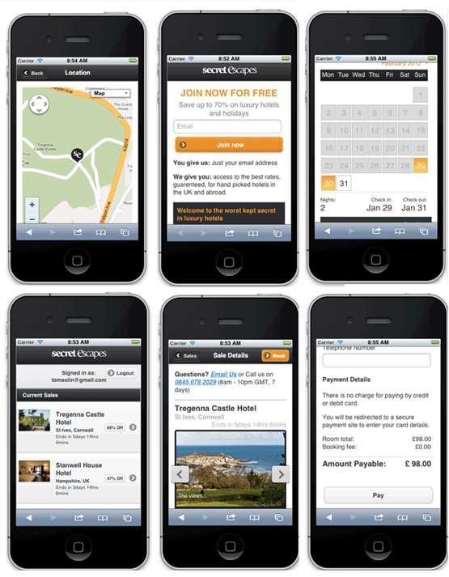
Figure 1
- Describe the general steps for creating an inductive interface and use these steps to redesign the interface in the Figure 1 above. Use drawing when necessary
[Q3 Total: 15 marks]

- Compare and contrast between the usability and User experience
[Q4 Total: 10 marks]

- Di- Beauty is a new Beauty Salon. They are in the process in developing a new Website. The aim of this Website is to attract more customers. Use two of the persuasive patterns to increase the number of customers. Justify your choice and draw the suggested pattern.
[Q5 Total: 15 marks]
- Discuss emotions in light of the Paul MacLean human brain model
[Q6 Total: 10 marks]
- A mobile device typically has direct access to many different sensors and data, such as a microphone, camera and GPS receiver, together with the user's combined data including email, SMS messages and contacts. There are many different app configurations possible, and it is not necessarily obvious how an app deals with personal information behind its user interface. Suggest a design to protect your personal data on your mobile. Use low fidelity technique.
[Q7 Total: 15 marks]

