Predictive Maintenance Architecture Design

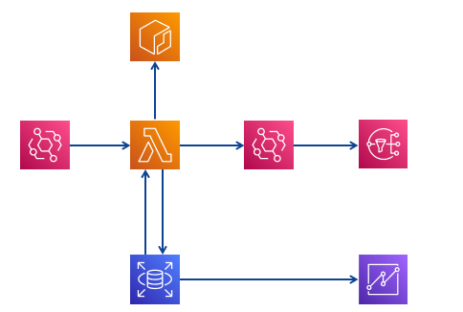

* Relational Database (RDS)
  + Two tables in database are required:
    1. Table to store sensor readings (1 reading per minute)
    2. Table to store reading along with prediction and prediction probability to visualize it in dashboard.
* Elastic container registry (ECR)
  + Store the code, model, and dependencies to run by lambda function.
  + The dependencies exceed 200 MB so it’s necessary to run it through container.
* Simple Notification Service (SNS)
  + Sent a notification topic whenever a failure is detected.
  + Topic subscribers should be (Managers, Engineers, and technicians)
* Lambda Function
  + Has trigger event that triggers the function every 1 minute.
  + The function runs container code which does the following:
    1. Retrieve last sensor’s reading.
    2. Make prediction on it.
    3. Insert the prediction in the database.
    4. Sends notification topic if prediction = “Failure”
* Quicksight
  + Visualize predictions in the form of interactive dashboard.

**Notes about implementation:**

* Lambda function should have the role to:
  1. Access SNS and send topic.
* RDS should allow access for:
  1. Lambda function: read and write.
  2. Quicksight: read only.