Verification Plan
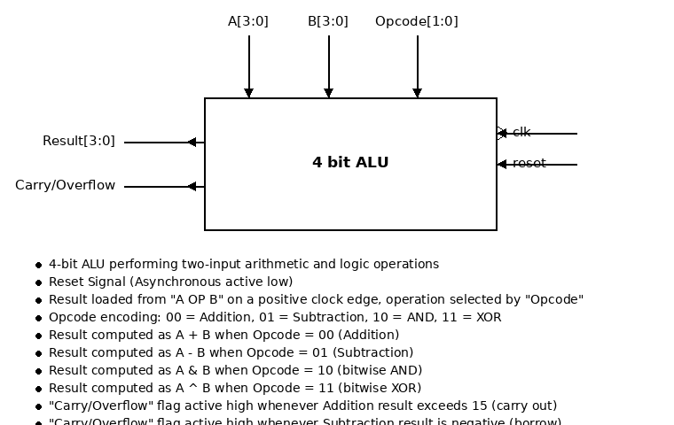
• 4-bit ALU performing two-input arithmetic and logic operations
• Reset Signal (Asynchronous active low)
• Result loaded from "A OP B" on a positive clock edge, operation selected by "Opcode" • Opcode encoding: 00= Addition, 01 Subtraction, 10 = AND, 11 = XOR
• Result computed as A + B when Opcode = 00 (Addition)
• Result computed as A - B when Opcode = 01 (Subtraction)
• Result computed as A & B when Opcode = 10 (bitwise AND)
• Result computed as A ^ B when Opcode = 11 (bitwise XOR)
• "Carry/Overflow" flag active high whenever Addition result exceeds 15 (carry out)
"Carry/Overflow" flag active high whenever Subtraction result is negative (borrow)

Signals
1] RST → Asynchronous active low "All Output Signals Must be Zero"
2] 4 bit inputs A , B → Valid or Invalid (cover full range 0000 to 1111)
3] Opcode[1:0] → - @ Posedge CLK "Selects the ALU Operation"
Set to 00 → Result = A + B (Addition)
Set to 01 → Result = A - B (Subtraction)
Set to 10 → Result = A & B (bitwise AND)
Set to 11 → Result = A ^ B (bitwise XOR)
4] Result → - @ Posedge CLK "Updated only when RST == 1"
Checker: Result == expected value of the selected operation on the previous A , B
5] Carry/Overflow (Addition) → Checker: if Opcode == 00 and (A + B) > 15 → Carry/Overflow == 1 else == 0
6] Carry/Overflow (Subtraction) → Checker: if Opcode == 01 and A < B → Carry/Overflow == 1 else == 0
7] Carry/Overflow (AND / XOR) → Checker: if Opcode == 10 or Opcode == 11 → Carry/Overflow == 0 always
8] Result (AND) → Checker: if Opcode == 10 → Result == (A & B) bitwise, else check invalid
9] Result (XOR) → Checker: if Opcode == 11 → Result == (A ^ B) bitwise, else check invalid
10] Opcode → Checker: undefined / reserved opcode values are invalid regardless of A , B
11] Carry/Overflow → Checker: if Result == 15 in Addition → Check Carry == 1 else == 0
12] Carry/Overflow → Checker: if Result == 0 in Subtraction → Check Borrow == 1 else == 0
→ Pulse or All the time
Created by: Fady Samy Nabil Verification Plan

Functional Coverage
We need to cover all output signals:
Result → cover all values (0 to 15)
→ Toggling only
Result\Add → Result overflow / carry generated (A + B > 15)
Result\Sub → Result underflow / borrow generated (A < B)
Result\AND → cover all-zero result and all-one operands
Result\XOR → cover all-zero result and all-one result
Carry/Overflow → 1 iff (Opcode == Add and A + B > 15)
Carry/Overflow → 1 iff (Opcode == Sub and A < B)
Carry/Overflow → 0 always when Opcode == AND or XOR
Opcode → cover all 4 operations (Add , Sub , AND , XOR)
A , B → cover corner values 0000 and 1111 for both operands
Opcode\A\B → cross coverage of operation with operand corner cases
Created by: Fady Samy Nabil Verification Plan

Sequences & Constrained Randomization
1] Reset Sequence → with RST == 0
2] Addition Sequence → with Opcode == 00
3] Subtraction Sequence → with Opcode == 01
4] AND Sequence → with Opcode == 10
5] XOR Sequence → with Opcode == 11
6] Corner Sequence → with A , B == 0000 or 1111 (randomized per operation)

Test Scenarios
Scenario 1 : Addition Sequence for random number transaction range [5:10]
-- Goal : testing addition functionality and carry generation (overflow from 15)
Scenario 2 : Subtraction Sequence for random number transaction range [5:10]
-- Goal : testing subtraction functionality and borrow generation (underflow below 0)
Scenario 3 : AND Sequence for random number transaction range [5:10]
-- Goal : testing bitwise AND functionality, covering all-zero result
Scenario 4 : XOR Sequence for random number transaction range [5:10]
-- Goal : testing bitwise XOR functionality, covering all-one and all-zero result
Scenario 5 : Addition → Subtraction → AND → XOR → Addition … etc.
-- Goal : mixing the order of operations across back-to-back transactions
Scenario 6 : Opcode Sequence → random for at least 10 times
-- Goal : covering all 4 operations with fully randomized operands
Created by: Fady Samy Nabil Verification Plan

