ANALOG DEVICES

Digital Design and Verification Team — Summer Internship 2026

Design of SPI-Slave with Register Map
Architecture, Finite-State-Machine, and Functional Verification Report

Report by: Youssef Bassem Lamey
Submitted to: Eng. Fatma Ali
ADI Summer Internship 2026 — Digital Design and Verification Team
July 2026

Contents
1. Introduction 3
2. Architecture 3
2.1 Transaction Framing 4
2.2 Clock Gating — IGC Cell 4
2.3 Register Map 5
3. Features 5
4. Finite State Machine 6
5. Test Cases 7
5.1 Test Case 1 — 4 Write Bursts 7
5.2 Test Case 2 — 2 Reads 8
6. Conclusion 8

1. Introduction
This report documents the design of a 4-wire SPI slave interface (CSB, SCLK, SDI, SDO) that provides read and write access to an internal 32,768 × 8 register map. The interface, its transaction framing, and its verification plan follow the design frame prepared for this assignment; this document describes the resulting RTL architecture, its finite-state machine, and the functional test cases used to verify single- and multi-byte write bursts and single-address reads.

2. Architecture
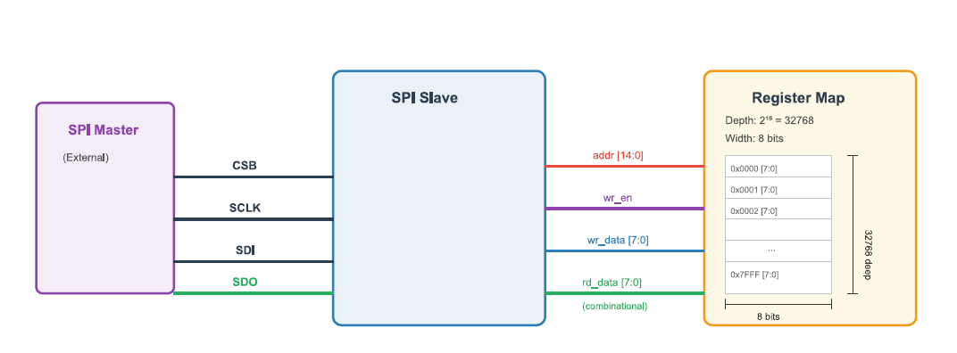
The design is organized as a top-level wrapper, spi_slave_wrapper, that instantiates two blocks:
- spi_slave — the protocol engine. It deserializes SDI into a command bit, a 15-bit address and 8-bit data bytes, drives the FSM, and serializes register-map read data back out on SDO.
- reg_map — the storage array (DEPTH = 2¹⁵ = 32,768 locations × 8 bits). Writes are synchronous to SCLK and combinationally readable on rd_data.
Port list of the spi_slave / spi_slave_wrapper interface:
Signal | Dir. | Width | Description
SCLK | In | 1 | Serial clock from the SPI master.
rst_n | In | 1 | Asynchronous, active-low reset.
CSB | In | 1 | Active-low chip select; frames a transaction.
SDI | In | 1 | Serial data in (MSB-first: R/W, address, write data).
SDO | Out | 1 | Serial data out (read data, MSB-first).

2.1 Transaction Framing
Every transaction begins with a 16-bit header — a single R/W bit followed by a 15-bit address — shifted in MSB-first, followed by one or more 8-bit data bytes:
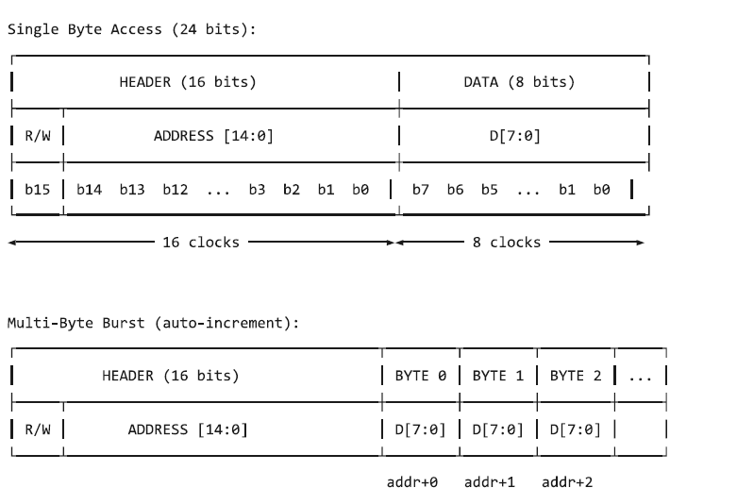
Field | Bits | Description
R/W | [15] | 0 = Write (master drives data on SDI); 1 = Read (slave drives data on SDO).
ADDRESS | [14:0] | Starting register address; auto-increments by 1 after every complete write byte.
DATA | 8 per byte | Register data, MSB-first. One or more bytes may follow the header.

A single register access is therefore 24 clocks (16 header + 8 data). Additional back-to-back data bytes within the same CSB assertion form a burst: reg_map auto-increments its internal write offset after every completed byte, so consecutive bytes land in consecutive addresses without the master having to resend the header.

2.2 Clock Gating — IGC Cell
Internally, spi_slave does not run its counters and shift registers directly from SCLK. Instead it generates a gated internal clock, CLK, through an integrated-clock-gating (IGC) cell:
- A level-sensitive latch (en_latch) is transparent while SCLK is low and captures ~CSB at that time.
- The gated clock is then formed combinationally as CLK = SCLK & en_latch.
Because the enable is captured in a latch that is only transparent during the SCLK-low phase, any change on CSB while SCLK is high cannot ripple through and create a runt or glitched pulse on CLK — the new enable value is held off until the next SCLK-low window, so every pulse that does reach CLK is a full, clean SCLK pulse. This is the standard latch-based ICG (Integrated Clock Gating) structure used in ASIC design specifically to gate a clock safely, as opposed to gating it with a plain combinational AND of SCLK and CSB, which would be glitch-prone. All of the address/data counters, wr_en, and the write-data/address registers are clocked from this gated CLK rather than from raw SCLK.

2.3 Register Map
reg_map implements the storage array as ram[0:32767], each entry 8 bits wide. On every asserted wr_en pulse it writes wr_data into ram[addr + offset] and increments offset by one, which is the mechanism that realizes burst auto-increment. rd_data is a continuous combinational read, ram[addr], satisfying the half-clock read-turnaround requirement (the slave has only half a SCLK period after the last address bit to present the first read bit on SDO). An asynchronous active-low reset clears the entire array and the offset counter.

3. Features
- 4-wire SPI slave (CSB, SCLK, SDI, SDO), MSB-first serial framing.
- 15-bit address bus — 32,768 × 8-bit internal register map.
- 16-bit header (1 R/W bit + 15-bit address) followed by any number of 8-bit data bytes.
- Single-byte access and multi-byte burst access share the same framing — burst mode is inferred purely from continued CLK activity after the first data byte, with no dedicated burst bit.
- Write-side auto-increment: the target address advances by one for every completed data byte in reg_map.
- Combinational read path: read data is valid on SDO within half a CLK period of the last address bit, meeting the read-turnaround requirement.
- Latch-based IGC (integrated clock gating) cell derives the internal CLK from SCLK and CSB, avoiding combinational glitches on the gated clock.
- Asynchronous, active-low reset clears the full register array and all internal counters/registers.
- CSB framing with defined t_lead / t_lag margins around the SCLK burst (t_lag assumed equal to t_lead).

4. Finite State Machine
The protocol engine is a 6-state Moore-style machine (ps/ns) clocked on the posedge of SCLK, with an asynchronous active-low reset returning it to IDLE:
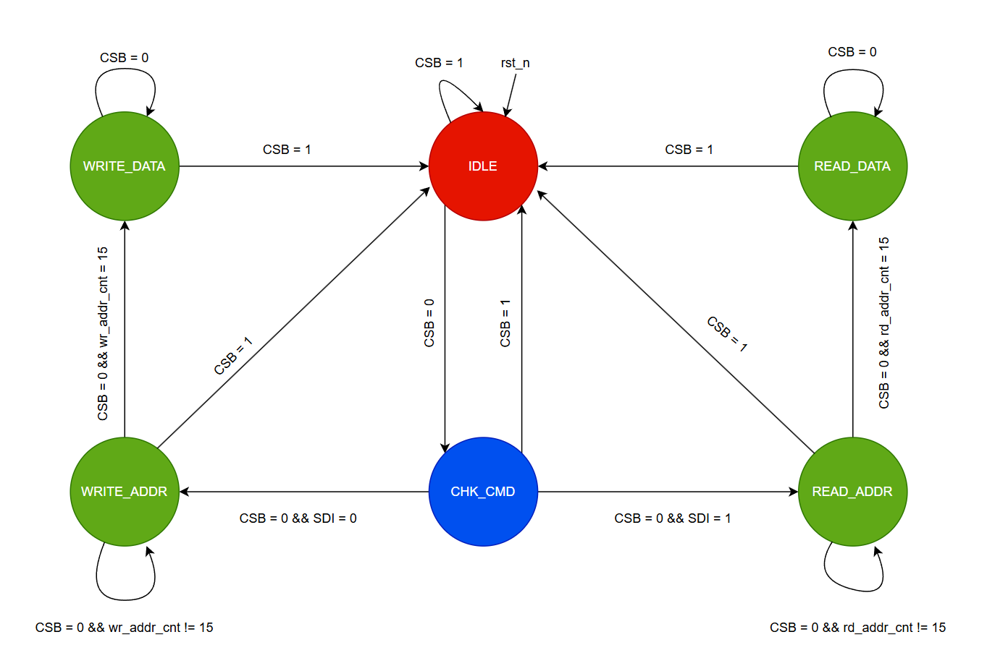
State | Function | Next-state condition
IDLE | Reset / waiting state. No transaction in progress. | CSB = 0 → CHK_CMD
CHK_CMD | Samples the first SDI bit after CSB asserts to decide the transaction type. | SDI = 0 → WRITE_ADDR; SDI = 1 → READ_ADDR
WRITE_ADDR | Shifts in the 15-bit register address (wr_addr_cnt counts 0–14). | wr_addr_cnt = 15 → WRITE_DATA
WRITE_DATA | Shifts in 8-bit data bytes; pulses wr_en once per completed byte. Stays in this state — and keeps consuming bytes — for as long as CSB remains low, which is how burst writes are formed. | CSB = 1 → IDLE
READ_ADDR | Shifts in the 15-bit register address for a read (rd_addr_cnt counts 0–14). | rd_addr_cnt = 15 → READ_DATA
READ_DATA | Drives rd_data onto SDO, MSB-first, combinationally. | CSB = 1 → IDLE

CSB is the master control signal for the FSM: from any of the four active states, CSB = 1 forces an immediate return to IDLE (ending the transaction), while CSB = 0 keeps the machine progressing through the header and data phases. CHK_CMD is a single-cycle decode state that reads SDI once to route the transaction to the write or read branch.

5. Test Cases
The testbench exercises the design with two functional scenarios: a 4-byte write burst starting at address 34, and two single-address reads at addresses 36 and 37 that read back bytes written during the burst.

5.1 Test Case 1 — 4 Write Bursts
A single CSB assertion sends the header (W = 0, address = 34) followed by four consecutive 8-bit data bytes. reg_map's offset increments after each byte, so the four bytes land in four consecutive addresses without re-sending the header:
Byte # | SDI Data | Target Address (addr + offset) | reg_map offset after write
1 | 0x5A (90) | 34 | 1
2 | 0xA1 (161) | 35 | 2
3 | 0xB2 (178) | 36 | 3
4 | 0xC3 (195) | 37 | 4

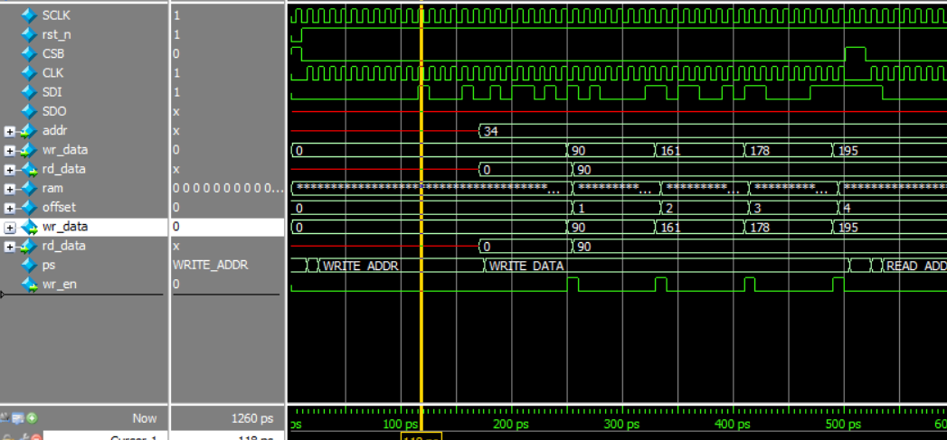

5.2 Test Case 2 — 2 Reads
After the write burst, two independent read transactions are issued — each with its own header (R = 1) — to addresses 36 and 37, i.e. the third and fourth locations written in Test Case 1:
Read # | Address | Expected Data | Captured on SDO | Result
1 | 36 | 0xB2 (178) | 178 | Match
2 | 37 | 0xC3 (195) | 195 | Match

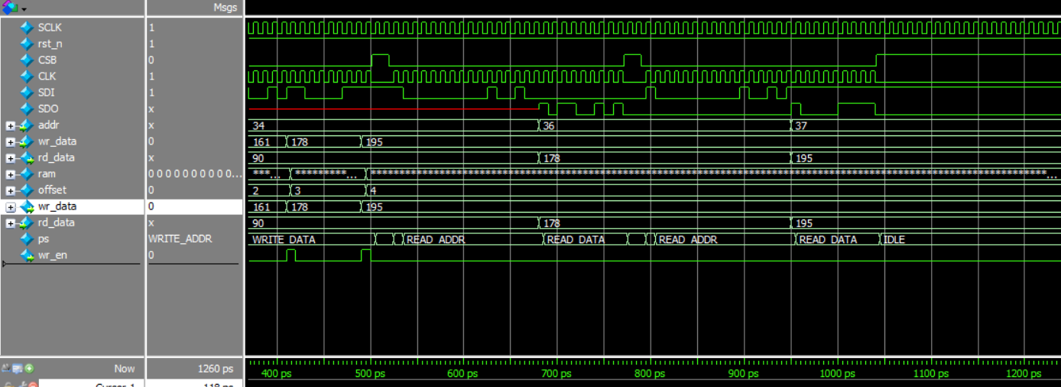

6. Conclusion
The waveform evidence in Test Cases 1 and 2 confirms that the spi_slave / reg_map pair correctly implements the specified 4-wire protocol: the header is decoded once per transaction, write bursts auto-increment through reg_map's offset counter without re-sending the address, and single-address reads correctly return the byte previously written at that location. The latch-based IGC cell keeps the internal CLK glitch-free while gating it with CSB, and the FSM cleanly returns to IDLE on CSB de-assertion between transactions, matching the t_lead / t_lag framing defined for the interface.

