Diagram:
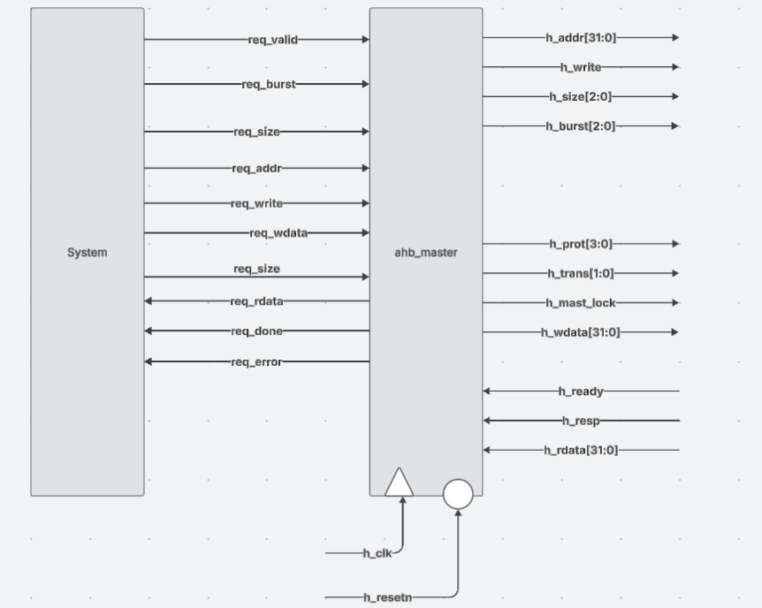
Ahb_master FSM:
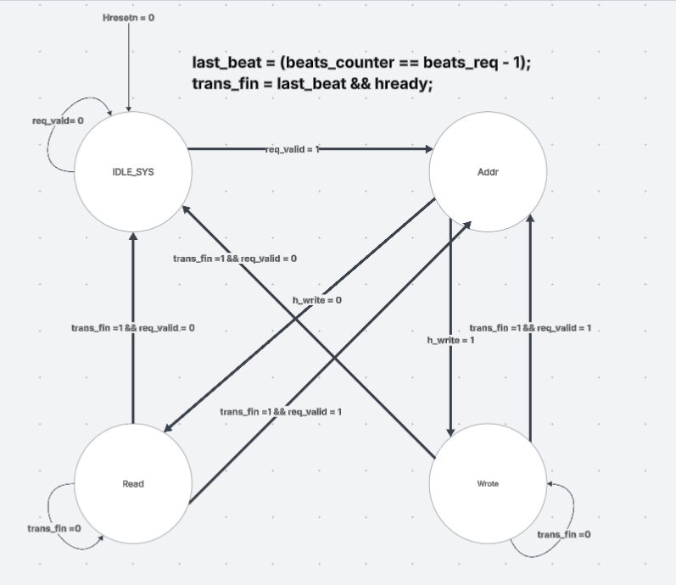
Ahb_master_tb:
in this case we verify the master by having the testbench be the slave memory and who sends requests to master.
TC 1,2,3
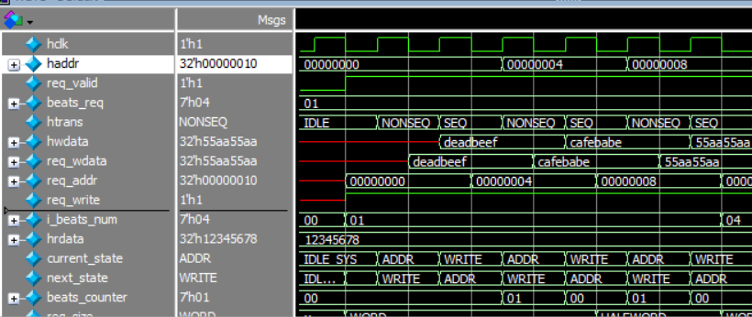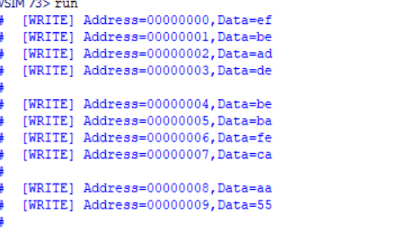
// TC1: Single word write, basic NONSEQ transfer with no wait states
// TC2: Single word write immediately following TC1, back-to-back NONSEQ transfers
// TC3: Single halfword write, checks HSIZE=halfword
TC1 and TC2 are simple enough we just make sure the memory saves data correctly according to size of data written word or half word or byte
TC3 increments by 2 only since it’s a half word case
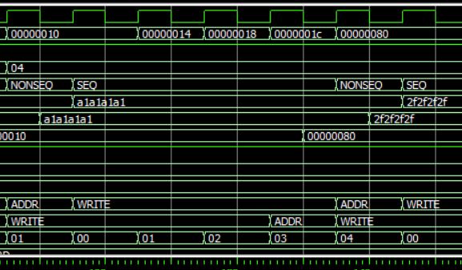 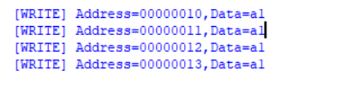
// TC4: 4-beat incrementing burst (INCR4), verifies fixed-length burst must complete with SEQ transfers
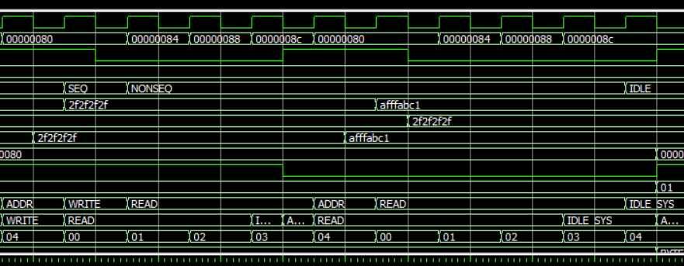
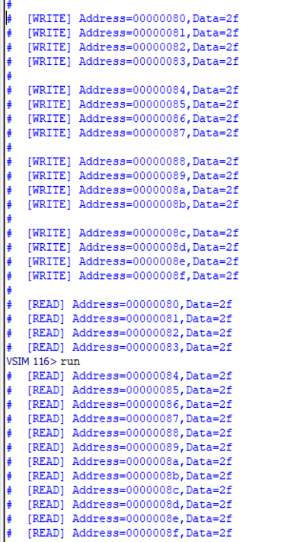
// TC5: Back to Back incrementing read after write
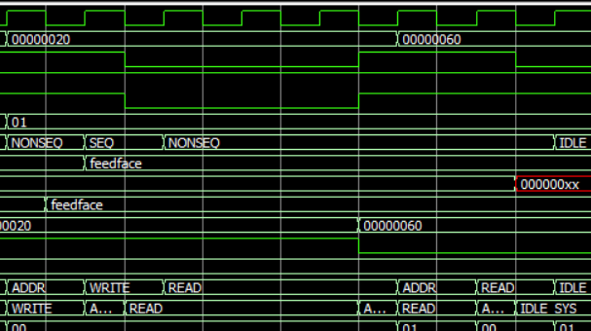
[WRITE] Address=00000020,Data=ce
// TC6: INCR4 byte write with Subordinate-inserted wait states (HREADY low), checks HTRANS held constant while waited
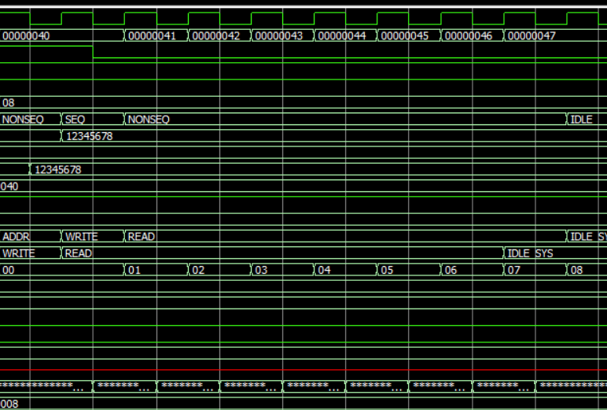

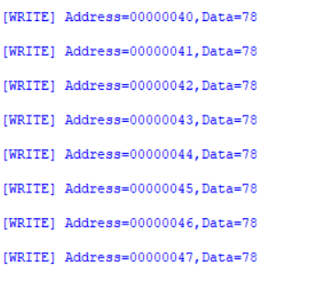
// TC7: 7-beat incrementing burst (INCR) of halfwords of undefined length, verifies burst length and address increments by transfer size

