Report
Introduction
This report analyses a dataset containing customer order details, including payment values, delivery times, and pricing information. The objective is to identify key insights such as payment trends, delivery performance, and potential data inconsistencies. The analysis involves handling missing values, removing duplicates, and ensuring data accuracy. The report also highlights statistical findings and observations that can help improve business decisions.
Data Cleaning

Missing Value Handling
To ensure data integrity, we checked for missing values in the dataset. The results showed the following:
- Columns with Missing Values:
  - payment_value: 3 missing values
  - payment_type: 3 missing values
  - price: 830 missing values
  - freight_value: 830 missing values
  - delivered_date: 3,373 missing values
Since the number of missing values in price was only 0.7% of the total dataset, we decided to remove rows containing missing values in critical fields such as price, payment_type, and delivered_date. After cleaning, the dataset size was reduced to 112,909 rows, with all missing values successfully removed.

Zero Values Handling
We analyzed columns for zero values, and the results showed:
- payment_value: 6 zero values
- freight_value: 363 zero values
- late_delivery: 104,030 zero values
While zero values in payment_value and freight_value might indicate valid transactions with free shipping, the large number of zeros in late_delivery confirms that most orders were delivered on time.

Duplicate Handling
Upon inspecting the dataset, we found 1,335 duplicate rows. Duplicate records can cause biases in analysis and affect the accuracy of insights. To ensure data integrity, we removed all duplicate rows.
- Initial dataset size: 118,434 rows
- After removing duplicates: 117,099 rows
By eliminating duplicate records, we improved the reliability of the dataset, ensuring that each row represents a unique transaction.

Outlier Detection
Outliers were detected using the Interquartile Range (IQR) method. Below are the findings:

1. Payment Value (payment_value)
- Number of outliers: 9,001
- Distribution: Right-skewed
- Action Taken: No removal, as high payments could represent legitimate high-value orders.

Visualizations:
- Box Plot: Shows extreme values beyond the upper whisker.
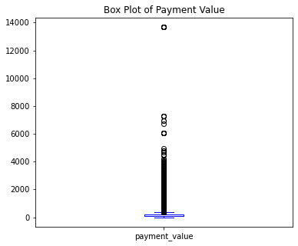
- Histogram: Right-skewed distribution with a concentration of lower payment values.
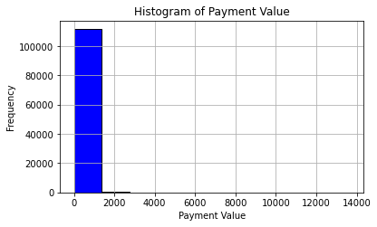

2. Price
- Number of outliers: 8,541
- Distribution: Right-skewed
- Action Taken: Outliers were retained as they may represent high-cost orders.

Visualizations:
- Box Plot: Highlights extreme price values.
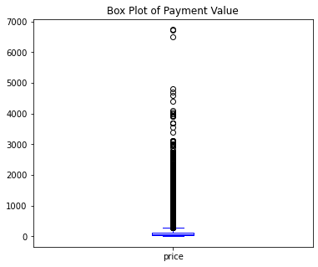
- Histogram: Confirms right-skewed distribution.

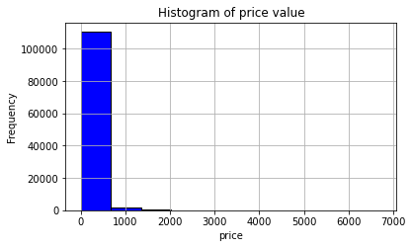

3. Freight Value
- Number of outliers: 12,180
- Distribution: Skewed due to high shipping costs for some orders.
- Action Taken: Outliers were retained as shipping costs can vary significantly.

Visualizations:
- Box Plot: Highlights extreme freight values.
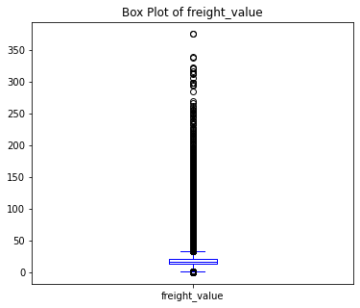
- Histogram: Shows that most freight values are concentrated in lower ranges.
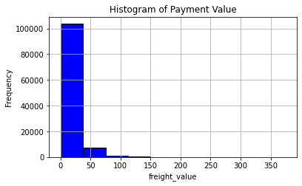

Basic Statistics
- Total Orders: 96,175
- Total Revenue: $19,307,861.56
- Average Order Value: $171.00
- Average Freight Cost: $20.06
Business Insight:
The high total revenue indicates strong sales performance, with an average order value of $171.00, suggesting that customers are making substantial purchases per order. However, the average freight cost of $20.06 represents nearly 12% of the order value, which could impact customer satisfaction and profitability. Reducing shipping costs or offering free shipping above a certain threshold may help increase conversion rates and customer retention.

Trend Analysis
- Orders Per Month:
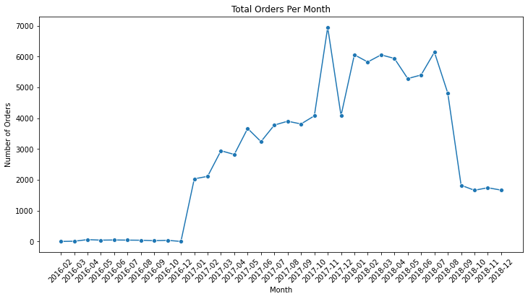

Business Insight:
- There was a significant increase in orders starting from early 2017, suggesting strong growth in customer demand or successful marketing efforts.
- A sharp peak in late 2017 (October-November) could indicate a seasonal shopping event, such as Black Friday or holiday sales.
- Orders remained consistently high throughout most of 2018 but dropped sharply after mid-2018. This decline may indicate market saturation, changes in customer preferences, or operational challenges.
- The low order volume at the end of 2018 suggests potential issues such as reduced marketing efforts, supply chain disruptions, or loss of customer interest. Further investigation into customer retention strategies may be needed.

- Revenue Per Month:
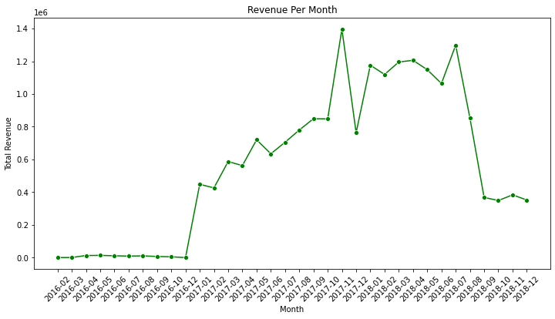

Business Insight:
- Growth Phase (2017 Onwards):
Orders surged from early 2017, indicating a period of rapid business expansion—likely due to increased customer acquisition, better marketing, or platform growth.
- Peak Activity (Late 2017 – Early 2018):
The sharp peak in late 2017 aligns with major shopping events (Black Friday, holiday sales) and suggests a strong seasonal impact on sales.
- Sustained Performance (2018):
Order volume remained high and stable during most of 2018, indicating strong customer retention and consistent demand.
- Sudden Decline (Mid-to-Late 2018):
A steep drop in orders after mid-2018 could indicate:
  - Market saturation or increased competition.
  - Operational issues such as supply chain disruptions.
  - Changes in customer behavior or demand shifts.

Actionable Recommendations:
- Investigate the sharp decline in late 2018—Identify whether it was due to external factors (e.g., economic conditions) or internal inefficiencies.
- Leverage Seasonal Trends—Since late 2017 showed high sales, plan aggressive marketing campaigns for similar periods in the future.
- Customer Retention Strategies—Implement promotions, loyalty programs, or re-engagement campaigns to sustain order volume.

Order Status Analysis
- Canceled Orders: 538
- Expected Revenue from Approved Orders: $302.70

Total late Orders
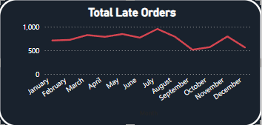
- The total number of late orders fluctuated slightly but remained above 500 for most months.
- A notable peak in July suggests potential delivery inefficiencies or increased demand during this period.
- After August, the number of late orders declined sharply, indicating possible logistics improvements or reduced order volume.
- A spike in November suggests seasonal factors affecting delivery efficiency.

Business Insight:
- Investigate the July peak—was it due to logistics delays, supplier issues, or a sudden increase in orders?
- The November increase might be due to holiday season demand, so improving fulfillment strategies for peak months can enhance customer satisfaction.
- The steady decline post-August is a positive sign, suggesting operational optimizations.

