Student Performance Project Summary: Classification
Applied Statistics Group
2026-06-22

Project Aim
This project explores university student performance and study habits.
The main goal is to summarize the dataset compare simple classification methods for predicting GPA-based performance categories.

Load Data
## Rows Columns
## 1 10000 27

Dataset Overview
## student_id age gender country major university_year GPA
## 1 S00001 23 Female Germany Law 4 3.81
## 2 S00002 26 Female USA Economics 2 3.46
## 3 S00003 18 Female Canada Medicine 3 4.00
## 4 S00004 20 Male Australia Physics 4 3.77
## 5 S00005 28 Female Australia Medicine 2 4.00
## 6 S00006 18 Male France Medicine 2 4.00
## study_hours_per_day class_attendance_percent sleep_hours screen_time_hours
## 1 4.2 96 6.2 3.9
## 2 3.3 94 6.6 4.9
## 3 4.5 100 6.3 3.7
## 4 5.8 97 7.1 6.9
## 5 3.1 96 8.4 4.8
## 6 3.1 96 6.1 5.6
## social_media_hours gaming_hours exercise_hours_per_week part_time_job
## 1 3.3 0.0 2.1 Yes
## 2 3.2 2.7 5.0 No
## 3 1.4 0.0 2.6 Yes
## 4 3.7 2.1 3.2 No
## 5 0.6 0.0 4.4 Yes
## 6 1.8 3.9 2.9 No
## relationship_status family_income_level internet_quality mental_stress_level
## 1 Single High Average 4.8
## 2 Single Low Average 3.9
## 3 In a Relationship High Average 4.8
## 4 Single High Good 5.9
## 5 In a Relationship Middle Good 3.1
## 6 In a Relationship Low Good 5.0
## AI_tool_usage_hours favorite_AI_tool note_taking_method exam_preparation_days
## 1 1.5 Claude Digital 15
## 2 2.3 Gemini Mixed 11
## 3 0.0 None Mixed 12
## 4 2.9 Gemini Mixed 11
## 5 1.5 ChatGPT Handwritten 15
## 6 1.3 Claude Digital 13
## coffee_consumption_per_day extracurricular_hours_per_week final_exam_score
## 1 3 7.6 100
## 2 3 5.2 100
## 3 3 4.6 100
## 4 1 4.0 100
## 5 4 1.4 100
## 6 3 1.7 96
## assignment_score
## 1 100
## 2 83
## 3 100
## 4 98
## 5 94
## 6 94

Missing Values and Duplicates
## [1] Variable Missing_Values
## <0 rows> (or 0-length row.names)
## Duplicate_Rows
## 1 0

Performance Categories
Students were divided into three GPA-based performance groups: Low, Medium, and High.
##
## Low Medium High
## 3377 3352 3271
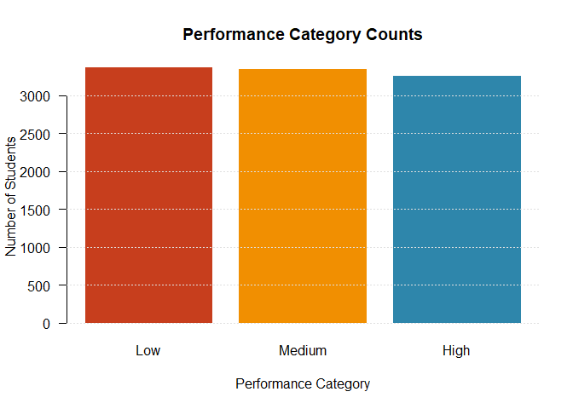

Data Leakage Controls
The target variable is based on GPA, so GPA must not be used as a predictor. In addition, final exam score and assignment score are direct academic outcome variables, so they are also removed before modeling. Student ID is removed because it is only an identifier.
These leakage-control variables are removed from the numeric dataset used for PCA, nearest-centroid classification, and kNN. They are also removed separately in the decision tree and Naive Bayes sections, because those sections begin again from the full dataset in order to include categorical predictors.

Numeric Variables Used
## [1] "age" "study_hours_per_day"
## [3] "class_attendance_percent" "sleep_hours"
## [5] "screen_time_hours" "social_media_hours"
## [7] "gaming_hours" "exercise_hours_per_week"
## [9] "mental_stress_level" "AI_tool_usage_hours"
## [11] "exam_preparation_days" "coffee_consumption_per_day"
## [13] "extracurricular_hours_per_week"

Variable Distributions
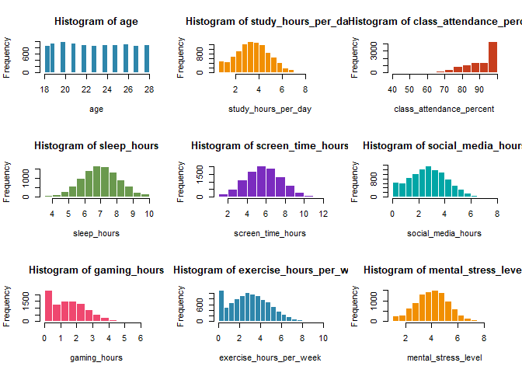

PCA Method
The numeric predictor variables were standardized before PCA. GPA, final exam score, assignment score, and student ID were excluded to avoid leakage or non-informative identifiers. The numeric PCA-based models use the cleaned numeric predictor set created above.
## PC Eigenvalue Proportion Cumulative
## 1 PC1 2.1764 0.1674 0.1674
## 2 PC2 1.6386 0.1260 0.2935
## 3 PC3 1.2584 0.0968 0.3903
## 4 PC4 1.0536 0.0810 0.4713
## 5 PC5 1.0166 0.0782 0.5495
## 6 PC6 1.0054 0.0773 0.6268
## 7 PC7 0.9970 0.0767 0.7035
## 8 PC8 0.9935 0.0764 0.7800
## 9 PC9 0.9824 0.0756 0.8555
## 10 PC10 0.9527 0.0733 0.9288
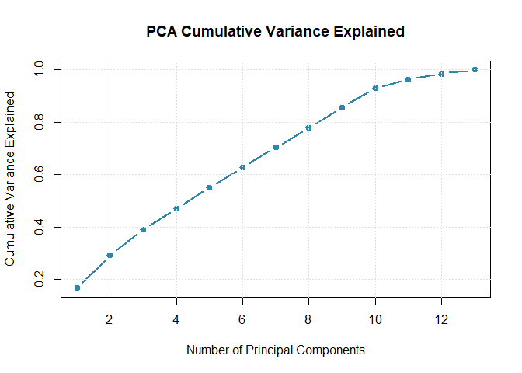

Shared Train/Test Split
The same train/test split was used for all classification methods to make model comparisons fair.
## Training_Rows Testing_Rows
## 1 8000 2000

Nearest-Centroid Classifier
The nearest-centroid classifier assigns each test student to the performance group whose average position, or centroid, is closest.
This section compares two versions:
- A nearest-centroid classifier using PCA scores.
- A nearest-centroid classifier using the original standardized numeric variables.

Centroid Classifier Functions

PCA-Based Centroid Accuracy by Number of PCs
## Number_of_PCs Accuracy Cumulative_Variance
## 1 1 0.5190 0.1674
## 2 2 0.6735 0.2935
## 3 3 0.6825 0.3903
## 4 4 0.6870 0.4713
## 5 5 0.6865 0.5495
## 6 6 0.6865 0.6268
## 7 7 0.6840 0.7035
## 8 8 0.6825 0.7800
## 9 9 0.6835 0.8555
## 10 10 0.6835 0.9288
## 11 11 0.6820 0.9633
## 12 12 0.6875 0.9846
## 13 13 0.6920 1.0000
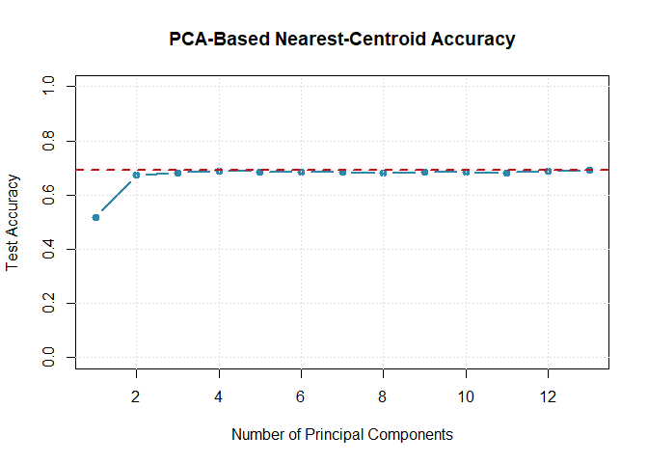

PCA-Centroid Elbow Plot
This plot helps choose a practical number of principal components by comparing test accuracy with cumulative variance explained.
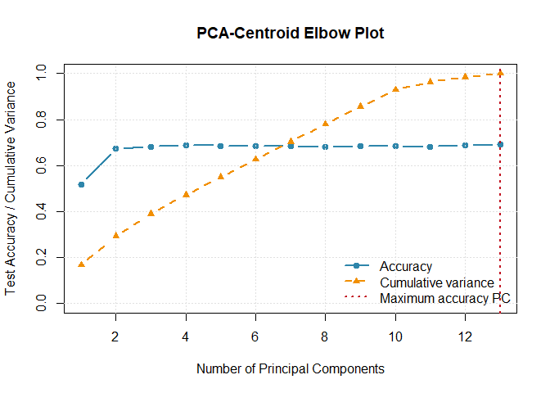

Best PCA-Based Centroid Model
The PCA-based centroid classifier was tested using different numbers of principal components.
This shows whether the model needs many dimensions or whether most of the useful classification information is already captured by the first few principal components.
## Best_Number_of_PCs Best_PCA_Centroid_Accuracy Cumulative_Variance
## 1 13 0.692 1

Confusion Matrix for Best PCA-Based Centroid Model
## Predicted
## Actual Low Medium High
## Low 493 151 7
## Medium 139 395 163
## High 5 151 496

Nearest-Centroid Classifier Using Original Standardized Variables
This version uses the original standardized numeric variables instead of PCA scores.
It helps show whether PCA improved or reduced centroid classification accuracy.
## Model Accuracy
## 1 Nearest centroid, original standardized variables 0.692

Confusion Matrix for Original-Variable Centroid Model
## Predicted
## Actual Low Medium High
## Low 493 151 7
## Medium 139 395 163
## High 5 151 496

Centroid Model Comparison
## Model Accuracy
## 1 PCA centroid 0.692
## 2 Original-variable centroid 0.692
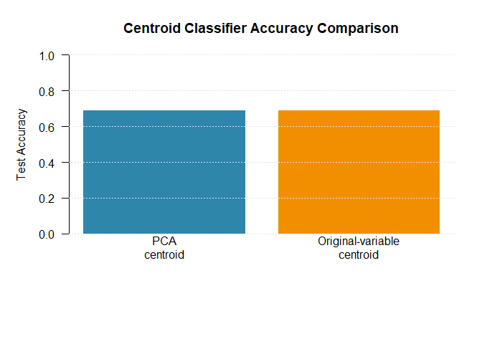 ## PCA Dimension Reduction Result
Although the original-variable centroid model uses all standardized numeric predictors, the PCA-based centroid model may achieve similar accuracy using far fewer dimensions.
This is important because PCA is mainly a dimension-reduction method.
If one or a few principal components give similar accuracy to the full original-variable model, then PCA has successfully compressed most of the useful classification information into a smaller number of variables.
## Model Dimensions_Used Accuracy
## 1 PCA centroid using 1 PC 1 0.519
## 2 Best PCA centroid using 13 PCs 13 0.692
## 3 Original-variable centroid 13 0.692

Accuracy Compared with Number of Dimensions
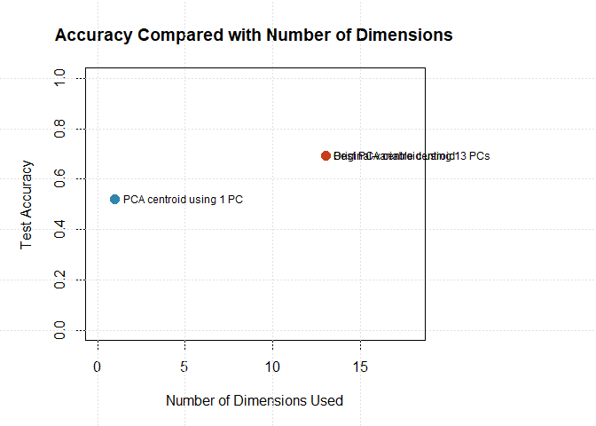 The centroid results show that PCA can match the original-variable centroid model when all principal components are retained. However, 2 PCs are already very close to having all PCs.

PC1 vs PC2 Plot with Class Centroids
This plot shows how the performance categories are positioned in the first two principal components.
The star-shaped points represent the class centroids calculated from the training data.
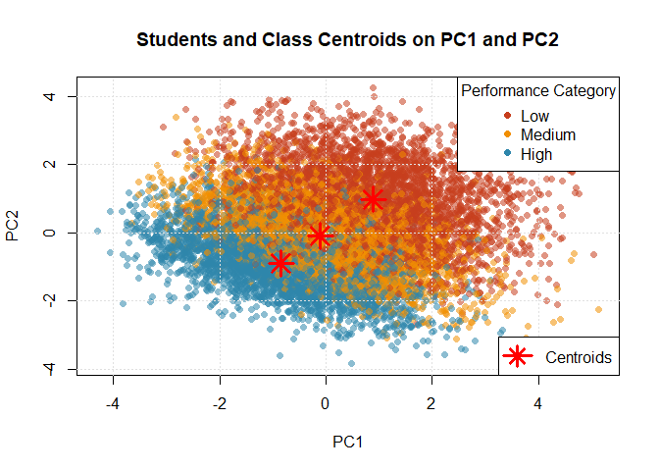

kNN Classifier
The kNN classifier predicts each test student’s performance category based on the most similar students in the training set.
Because kNN is distance-based, the model was tested in two ways:
- kNN using the original standardized numeric variables.
- kNN using PCA scores.
This allows us to compare whether PCA can reduce the number of dimensions while preserving or improving classification accuracy.

Original-Variable kNN Tuning
This version uses all standardized numeric predictor variables.
## k Accuracy
## 1 1 0.5845
## 2 3 0.5955
## 3 5 0.6165
## 4 7 0.6340
## 5 9 0.6280
## 6 11 0.6465
## 7 15 0.6585
## 8 21 0.6540
## 9 31 0.6655
## 10 51 0.6645
## 11 75 0.6755
## 12 101 0.6835
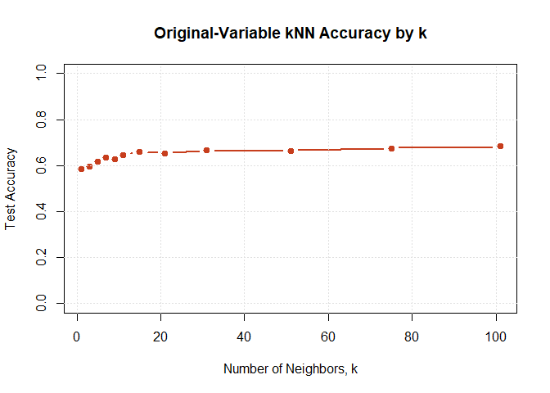
## Model Best_k Dimensions_Used Accuracy
## 1 Original-variable kNN 101 13 0.6835

Confusion Matrix for Best Original-Variable kNN
## Predicted
## Actual Low Medium High
## Low 492 147 12
## Medium 123 403 171
## High 4 172 476

PCA-Based kNN Tuning
This version uses PCA scores instead of the original standardized variables.
Both the number of principal components and the number of neighbors are tuned.
## Number_of_PCs k Accuracy
## 1 1 1 0.4150
## 2 2 1 0.6010
## 3 3 1 0.6220
## 4 4 1 0.6200
## 5 5 1 0.5970
## 6 6 1 0.5805
## 7 7 1 0.5660
## 8 8 1 0.5710
## 9 9 1 0.5685
## 10 10 1 0.5805
## 11 11 1 0.5725
## 12 12 1 0.5780
## 13 13 1 0.5845
## 14 1 3 0.4335
## 15 2 3 0.6265
## 16 3 3 0.6470
## 17 4 3 0.6265
## 18 5 3 0.6210
## 19 6 3 0.6140
## 20 7 3 0.5995
## 21 8 3 0.6105
## 22 9 3 0.6020
## 23 10 3 0.5985
## 24 11 3 0.6045
## 25 12 3 0.6015
## 26 13 3 0.5960
## 27 1 5 0.4395
## 28 2 5 0.6455
## 29 3 5 0.6530
## 30 4 5 0.6565
## 31 5 5 0.6470
## 32 6 5 0.6415
## 33 7 5 0.6290
## 34 8 5 0.6255
## 35 9 5 0.6135
## 36 10 5 0.6175
## 37 11 5 0.6180
## 38 12 5 0.6235
## 39 13 5 0.6210
## 40 1 7 0.4600
## 41 2 7 0.6560
## 42 3 7 0.6670
## 43 4 7 0.6675
## 44 5 7 0.6560
## 45 6 7 0.6430
## 46 7 7 0.6415
## 47 8 7 0.6230
## 48 9 7 0.6200
## 49 10 7 0.6235
## 50 11 7 0.6265
## 51 12 7 0.6230
## 52 13 7 0.6355
## 53 1 9 0.4540
## 54 2 9 0.6745
## 55 3 9 0.6700
## 56 4 9 0.6680
## 57 5 9 0.6535
## 58 6 9 0.6450
## 59 7 9 0.6455
## 60 8 9 0.6380
## 61 9 9 0.6300
## 62 10 9 0.6325
## 63 11 9 0.6315
## 64 12 9 0.6310
## 65 13 9 0.6290
## 66 1 11 0.4715
## 67 2 11 0.6645
## 68 3 11 0.6750
## 69 4 11 0.6710
## 70 5 11 0.6620
## 71 6 11 0.6470
## 72 7 11 0.6545
## 73 8 11 0.6450
## 74 9 11 0.6315
## 75 10 11 0.6315
## 76 11 11 0.6430
## 77 12 11 0.6350
## 78 13 11 0.6450
## 79 1 15 0.4835
## 80 2 15 0.6645
## 81 3 15 0.6735
## 82 4 15 0.6805
## 83 5 15 0.6630
## 84 6 15 0.6600
## 85 7 15 0.6590
## 86 8 15 0.6580
## 87 9 15 0.6435
## 88 10 15 0.6475
## 89 11 15 0.6490
## 90 12 15 0.6500
## 91 13 15 0.6560
## 92 1 21 0.4850
## 93 2 21 0.6720
## 94 3 21 0.6805
## 95 4 21 0.6930
## 96 5 21 0.6705
## 97 6 21 0.6640
## 98 7 21 0.6680
## 99 8 21 0.6620
## 100 9 21 0.6525
## 101 10 21 0.6510
## 102 11 21 0.6570
## 103 12 21 0.6590
## 104 13 21 0.6595
## 105 1 31 0.4880
## 106 2 31 0.6860
## 107 3 31 0.6875
## 108 4 31 0.6940
## 109 5 31 0.6785
## 110 6 31 0.6745
## 111 7 31 0.6670
## 112 8 31 0.6585
## 113 9 31 0.6615
## 114 10 31 0.6605
## 115 11 31 0.6560
## 116 12 31 0.6590
## 117 13 31 0.6645
## 118 1 51 0.4960
## 119 2 51 0.6820
## 120 3 51 0.6915
## 121 4 51 0.6915
## 122 5 51 0.6805
## 123 6 51 0.6805
## 124 7 51 0.6725
## 125 8 51 0.6650
## 126 9 51 0.6775
## 127 10 51 0.6640
## 128 11 51 0.6635
## 129 12 51 0.6660
## 130 13 51 0.6635
## 131 1 75 0.5000
## 132 2 75 0.6885
## 133 3 75 0.6895
## 134 4 75 0.6960
## 135 5 75 0.6835
## 136 6 75 0.6755
## 137 7 75 0.6775
## 138 8 75 0.6660
## 139 9 75 0.6740
## 140 10 75 0.6620
## 141 11 75 0.6700
## 142 12 75 0.6810
## 143 13 75 0.6755
## 144 1 101 0.4995
## 145 2 101 0.6885
## 146 3 101 0.6890
## 147 4 101 0.6875
## 148 5 101 0.6830
## 149 6 101 0.6740
## 150 7 101 0.6790
## 151 8 101 0.6785
## 152 9 101 0.6740
## 153 10 101 0.6640
## 154 11 101 0.6725
## 155 12 101 0.6800
## 156 13 101 0.6835
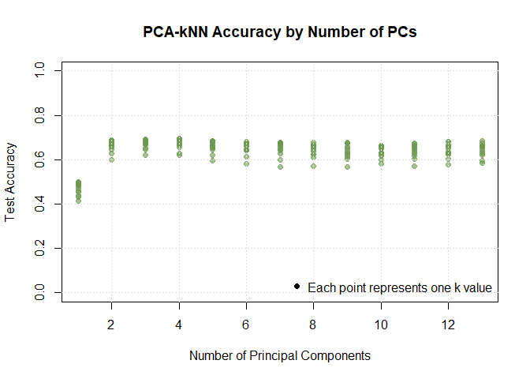

PCA-kNN Elbow Plot
Because PCA-kNN is tuned using both the number of PCs and the number of neighbors, this summary keeps the best kNN accuracy for each PC count.
This makes it easier to choose a practical number of PCs by looking for where accuracy begins to level off.
## Number_of_PCs Best_Accuracy k Cumulative_Variance
## 1 1 0.5000 75 0.1674
## 2 2 0.6885 75 0.2935
## 3 3 0.6915 51 0.3903
## 4 4 0.6960 75 0.4713
## 5 5 0.6835 75 0.5495
## 6 6 0.6805 51 0.6268
## 7 7 0.6790 101 0.7035
## 8 8 0.6785 101 0.7800
## 9 9 0.6775 51 0.8555
## 10 10 0.6640 51 0.9288
## 11 11 0.6725 101 0.9633
## 12 12 0.6810 75 0.9846
## 13 13 0.6835 101 1.0000
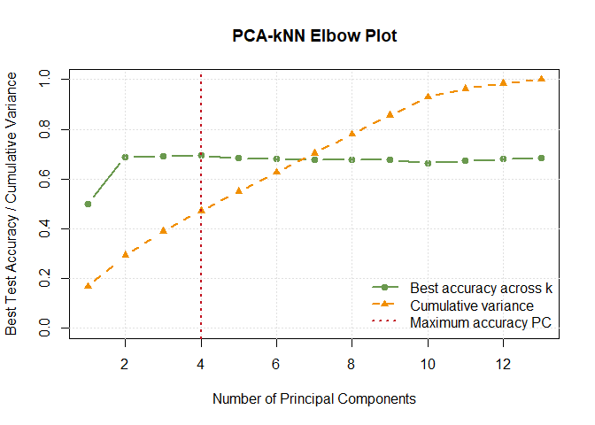
## Model Best_k Best_Number_of_PCs Accuracy
## 1 PCA-based kNN 75 4 0.696

Confusion Matrix for Best PCA-Based kNN
## Predicted
## Actual Low Medium High
## Low 510 133 8
## Medium 134 388 175
## High 6 154 492

kNN Model Comparison
## Model Best_k Dimensions_Used Accuracy
## 1 Original-variable kNN 101 13 0.6835
## 2 PCA-based kNN 75 4 0.6960
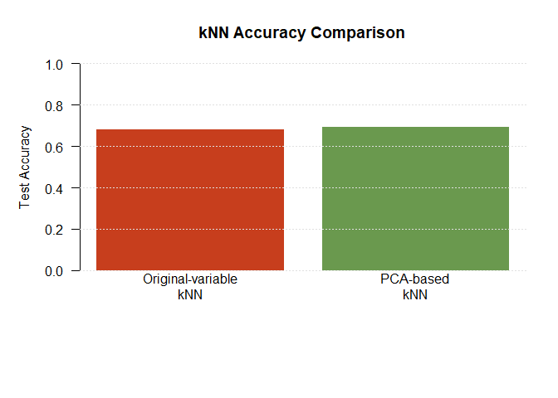

kNN Dimension Reduction Result
The PCA-based kNN model can be compared with the original-variable kNN model in terms of both accuracy and number of dimensions used.
## Model Dimensions_Used Accuracy
## 1 Original-variable kNN 13 0.6835
## 2 PCA-based kNN 4 0.6960
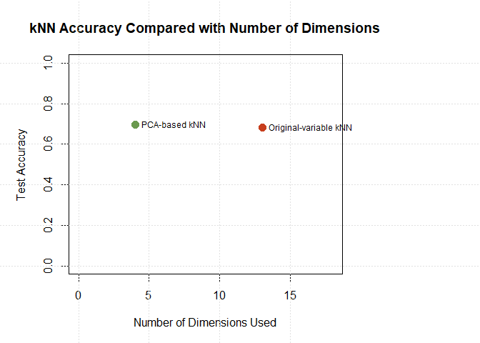
The kNN results show whether PCA can reduce the predictor space while preserving classification accuracy.
If PCA-based kNN performs similarly to original-variable kNN using fewer dimensions, then PCA provides a simpler distance-based classification model.

Decision Tree Classifier
A decision tree was added because it can use both numeric and categorical predictors.
This allows the analysis to include variables that were not used in centroid classification or kNN.
GPA, final exam score, assignment score, and student ID were removed from the predictors. GPA was removed because it was used to create the performance category, while final exam score and assignment score were removed because they are direct academic outcome variables. Student ID was removed because it is only an identifier.
## Predictors_Used Removed_High_Cardinality_Categorical_Variables
## 1 22 country
## Model Predictors_Used Accuracy
## 1 Decision tree Numeric and low-cardinality categorical variables 0.6665

Decision Tree Plot
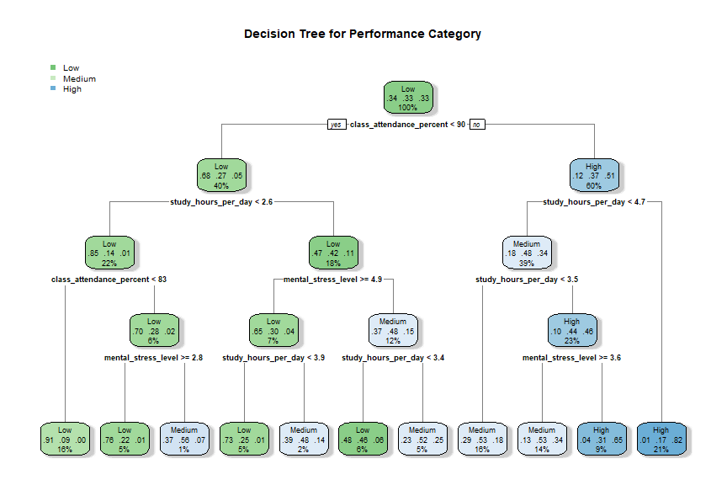

Decision Tree Variable Importance
## Variable Importance
## 1 class_attendance_percent 1042.5465
## 2 study_hours_per_day 691.9976
## 3 mental_stress_level 124.5932
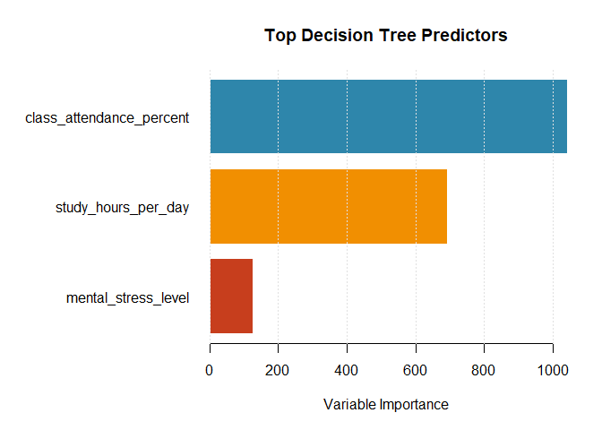
The decision tree provides an interpretable model that can use both numeric and categorical predictors.
This makes it useful as a comparison against the PCA-based and distance-based methods, which only used numeric predictors.

Bayesian Classifier
A Bayesian classifier was added as another comparison model.
This model uses Bayes’ theorem to predict the most likely performance category for each student.
The Naive Bayes classifier assumes that predictors are conditionally independent within each class.
Although this assumption is often simplified, Naive Bayes can still perform well and provides a useful comparison against centroid, kNN, and decision tree classifiers.
GPA, final exam score, assignment score, and student ID were removed to avoid data leakage.
## Predictors_Used Removed_High_Cardinality_Categorical_Variables
## 1 22 country
## Model Predictors_Used
## 1 Naive Bayes classifier Numeric and low-cardinality categorical variables
## Accuracy
## 1 0.671

Confusion Matrix for Bayesian Classifier
## Predicted
## Actual Low Medium High
## Low 492 148 11
## Medium 126 337 234
## High 4 135 513
The Bayesian classifier provides another interpretable comparison model.
It uses probability-based classification and can include both numeric and categorical predictors, making it useful to compare with the decision tree.

PCA-Based Bayesian Classifier
A PCA-based Naive Bayes classifier was also tested.
This version uses principal component scores instead of the original predictor variables.
The purpose is to check whether PCA can reduce the number of dimensions while still preserving enough information for probability-based classification.
## Number_of_PCs Accuracy Cumulative_Variance
## 1 1 0.5165 0.1674
## 2 2 0.6770 0.2935
## 3 3 0.6855 0.3903
## 4 4 0.6845 0.4713
## 5 5 0.6815 0.5495
## 6 6 0.6815 0.6268
## 7 7 0.6790 0.7035
## 8 8 0.6775 0.7800
## 9 9 0.6770 0.8555
## 10 10 0.6775 0.9288
## 11 11 0.6810 0.9633
## 12 12 0.6940 0.9846
## 13 13 0.6995 1.0000
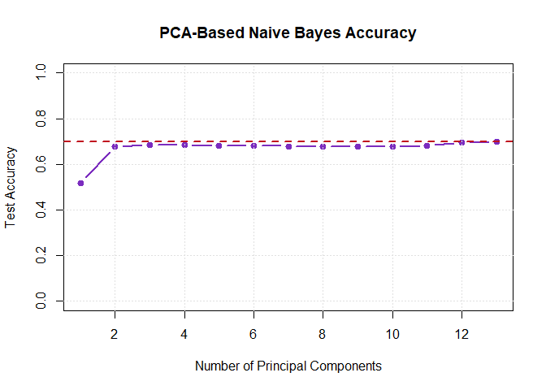

PCA-Naive Bayes Elbow Plot
This plot helps choose a practical number of PCs for the PCA-based Bayesian classifier.
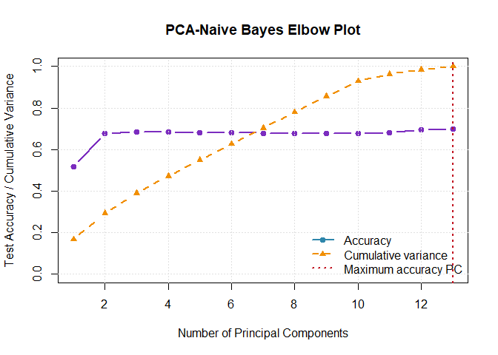
## Model Best_Number_of_PCs Accuracy Cumulative_Variance
## 1 PCA-based Naive Bayes 13 0.6995 1

Confusion Matrix for Best PCA-Based Bayesian Classifier
## Predicted
## Actual Low Medium High
## Low 489 155 7
## Medium 138 419 140
## High 6 155 491

Bayesian Classifier Comparison
## Model Predictors_Used Accuracy
## 1 Original-variable Naive Bayes Numeric and categorical variables 0.6710
## 2 PCA-based Naive Bayes 13 principal component(s) 0.6995
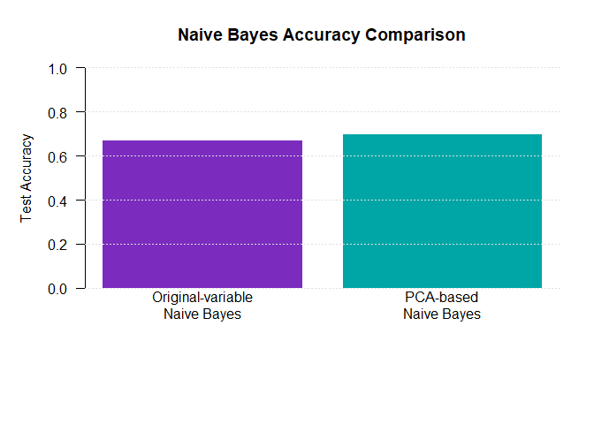
The PCA-based Bayesian classifier shows whether dimensionality reduction can preserve classification accuracy for a probability-based model.
If the PCA-based version performs similarly to the original-variable Naive Bayes classifier while using fewer dimensions, then PCA provides a simpler Bayesian classification model.

Final Classifier Comparison
## Model Predictors_Used
## 1 PCA centroid 13 principal component(s)
## 2 Original-variable centroid Original standardized numeric variables
## 3 Original-variable kNN Original standardized numeric variables
## 4 PCA-based kNN 4 principal component(s)
## 5 Decision tree Numeric and categorical variables
## 6 Original-variable Naive Bayes Numeric and categorical variables
## 7 PCA-based Naive Bayes 13 principal component(s)
## Accuracy
## 1 0.6920
## 2 0.6920
## 3 0.6835
## 4 0.6960
## 5 0.6665
## 6 0.6710
## 7 0.6995
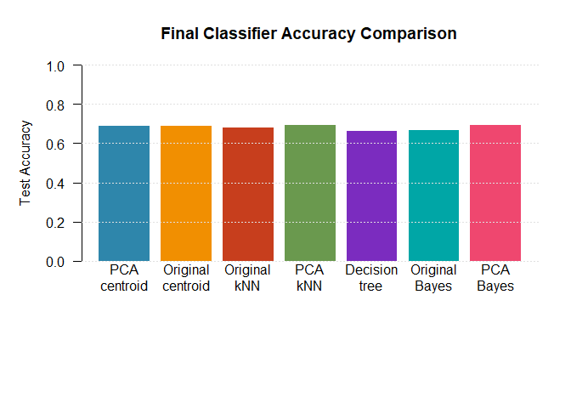

Final Conclusions
This project compared several simple classifiers for predicting GPA-based student performance categories. The same 80/20 train/test split was used throughout, which makes the model comparisons fair. Leakage was controlled by removing GPA, final exam score, assignment score, and student ID from the predictor sets.
The best overall test accuracy was achieved by the PCA-based Naive Bayes classifier. However, this model used 13 principal components, so its advantage is mainly predictive accuracy rather than dimensionality reduction.
The best balance between accuracy and simplicity came from the PCA-based kNN model. It achieved accuracy very close to the best model while using only 4 principal components instead of the full 13 original numeric dimensions. This suggests that PCA was most useful for kNN, where reducing the distance-based feature space can remove noise and preserve the most useful structure.
The nearest-centroid model achieved the same accuracy with PCA scores and with the original standardized numeric variables when all 13 dimensions were used. This means PCA did not improve the centroid classifier, but it also did not reduce performance when the full PCA representation was retained.
The decision tree was not the most accurate model, but it was the most interpretable. Its variable importance results showed that class attendance percentage and study hours per day were the strongest predictors, followed by mental stress level. These variables provide the clearest practical explanation of the performance categories.
Overall, PCA was useful, but its benefit depended on the classifier. PCA-based kNN gave the strongest dimensionality-reduction result, PCA-based Naive Bayes gave the highest accuracy, and the decision tree gave the clearest explanation of which student habits mattered most.
## Conclusion
## 1 Highest accuracy
## 2 Best accuracy-simplicity tradeoff
## 3 Most interpretable model
## 4 Most important tree predictor
## 5 Main methodological control
## Finding
## 1 PCA-based Naive Bayes, accuracy = 0.6995
## 2 PCA-based kNN, 4 PCs, accuracy = 0.696
## 3 Decision tree, accuracy = 0.6665
## 4 class_attendance_percent
## 5 Removed GPA, final exam score, assignment score, and student ID from predictors

Key Points for Poster
- GPA was converted into three balanced performance categories: Low, Medium, and High.
- Numeric predictor variables were standardized before PCA and kNN.
- GPA was excluded from predictors to avoid using the target variable as an input.
- The same 80/20 train/test split was used for all classification models.
- PCA was used to summarize variation in the numeric predictors.
- The nearest-centroid classifier was tested using different numbers of principal components.
- The PCA-based centroid model was compared with a centroid model using the original standardized variables.
- Classification performance was evaluated using test-set accuracy and confusion matrices.
- kNN was tested using both original standardized variables and PCA scores.
- PCA-based kNN was tuned using both the number of neighbors and the number of principal components..
- PCA compressed the numeric predictors into a smaller number of dimensions while preserving similar classification accuracy.
- The first few principal components captured enough structure for some models, especially PCA-based kNN, but the strongest PCA centroid and PCA Naive Bayes results used all 13 PCs.
- A decision tree was added to include both numeric and categorical predictors.
- The decision tree provides an interpretable comparison model with a visual tree structure.
- A Naive Bayes classifier was added as a probability-based Bayesian comparison model.
- 2 Principal Components were almost just as good as more!!! In the poster we can compare accuracy between just 2 PCs, and the “optimal” (most accurate) number of PCs

