Section 1

Hello world

Newwwwwww
Normal
line 2
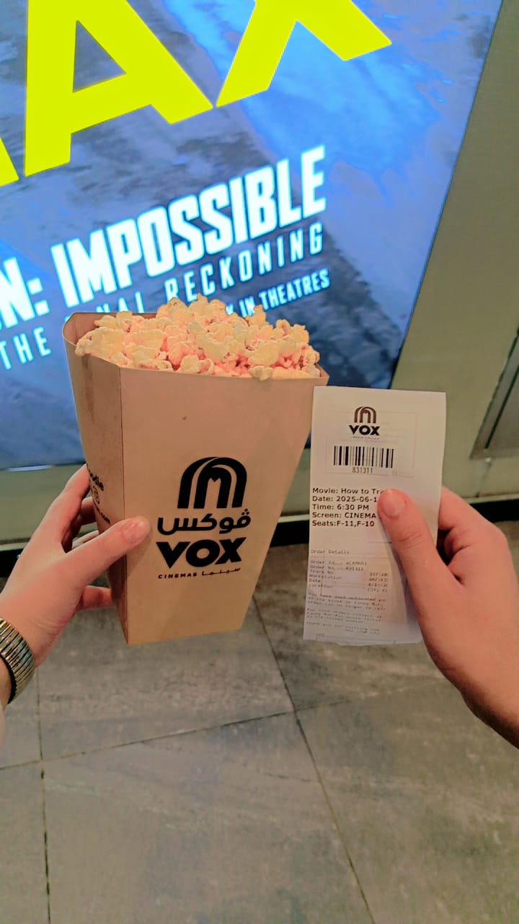

Section 2

Thanks

Section 3

Jupiter2000

