Cairo University  
Faculty of Computers and Information



**CS251**

**Software Engineering I**

Social Network

Software Design

Shadow/Coders

November/2019

Contents

Team 3

Document Purpose and Audience 3

System Models 3

I. System Decomposition 4

II. Class diagrams 5

III. Sequence diagrams 7

Class - Sequence Usage Table 11

Ownership Report 11

**Team**

|  |  |  |  |  |
| --- | --- | --- | --- | --- |
| **ID** | **Name** | **Email** | | **Mobile** |
| 20170349 | Youssef Mohamed Mohamed |  | Y0uss3fm0ham3d@gmail.com | 01016496627 |
| 20170171 | Ali Samy Mohamed |  |  | 01149751613 |
| 20170288 | Moustafa Khaled Moustafa |  | Moustafa.mkms@gmail.com | 01149324996 |
| 20170139 | Abdelrahman Ibrahim Ibrahim |  | Abdelrahman.elbatal19@gmail.com | 01063925141 |

**Document Purpose and Audience**

# Purpose

The result of the design activities based on the requirements analysis done in the previous phaser. the design activities are documented in this software Design document (SDD). This document contains the System decomposition, class diagram and several sequence diagram examples for the system ordered by the client (the TA).

# Audience

The audience includes the TA (the customer), the system analysts and designers (which is our team), the project manager (the team leader) and may include the professor.

# **System Models**

## **I. System Decomposition**

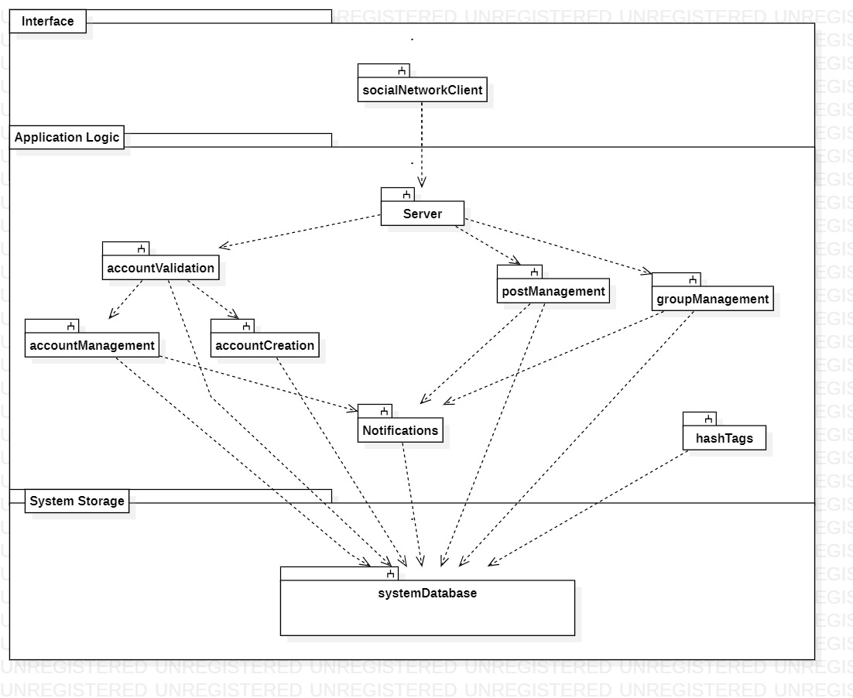

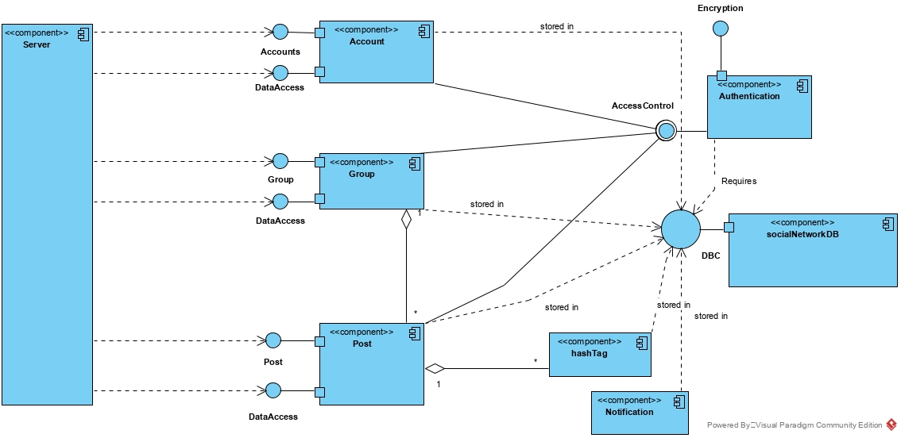

## **II. Class diagrams**

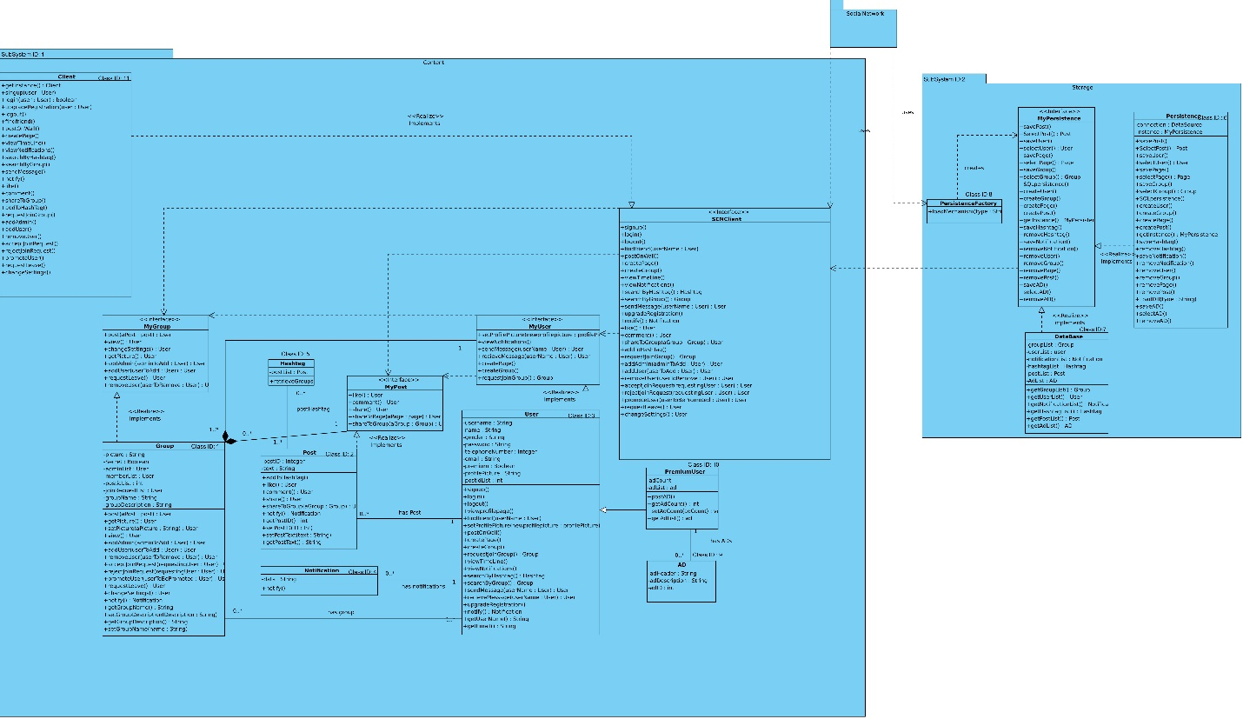

| **Class ID** | **Class Name** | **Subsystem ID** | **Description & Responsibility** |
| --- | --- | --- | --- |
| 1 | Group | 1 | The group class represents groups in our social network and it is responsible for changing the picture of the group and controlling the users inside the group in relation to the group. Groups have 3 types : private , public and secret. |
| 2 | Post | 1 | The Post class controls posts and enables us to share them across the social network and make likes or comments |
| 3 | User | 1 | The User class in in control of the account , it enables us to sign up, login , logout show our timeline and add friends and send and receive messages as well as control our information |
| 4 | Notification | 1 | The Notification class is simply responsible for showing notifications as string we have made a specific class for notifications to help distinguish them. |
| 5 | Hashtag | 1 | The Hashtag class is a part of the Post class and it allows us to have posts with specific hashtags so that they could be related to a certain topic |
| 6 | Persistence | 2 | The persistence class is responsible for manipulating the database and getting any data needed from it and must be used first in the sequence diagrams before accessing the data from the database, |
| 7 | Database | 2 | the database class is responsible for keeping all the data from in lists from users to posts to groups and so forth. |
| 8 | PersistenceFactory | 2 | The PersistenceFactory class is used to initialize an Instance of the database |
| 9 | AD | 1 | The AD class is responsible for the ads that premium users can make every ad has an id |
| 10 | PremiumUser | 1 | The premium user class is a child of the user class and has special extra features like posting advertisements |
| 11 | Client | 1 | The client class is basically what the user will interact with most of the time it also enables the user to upgrade his/her account |

**III. Sequence diagrams**

**ID :1 Name : Sign up**

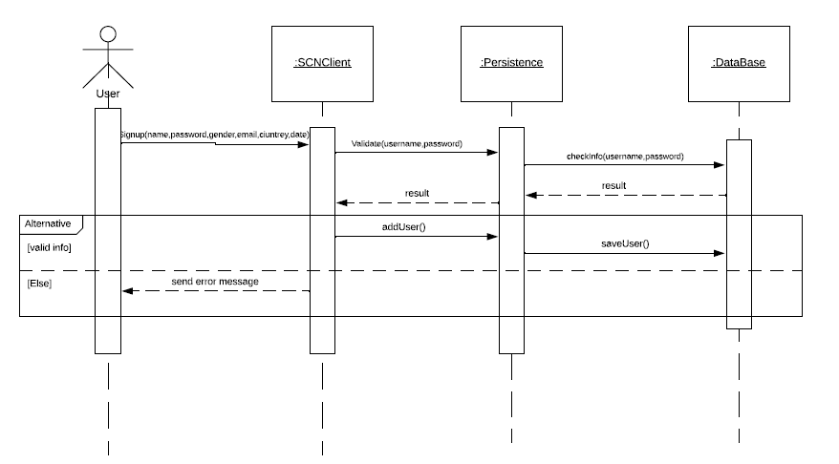

**ID : 2 Name: find friend**

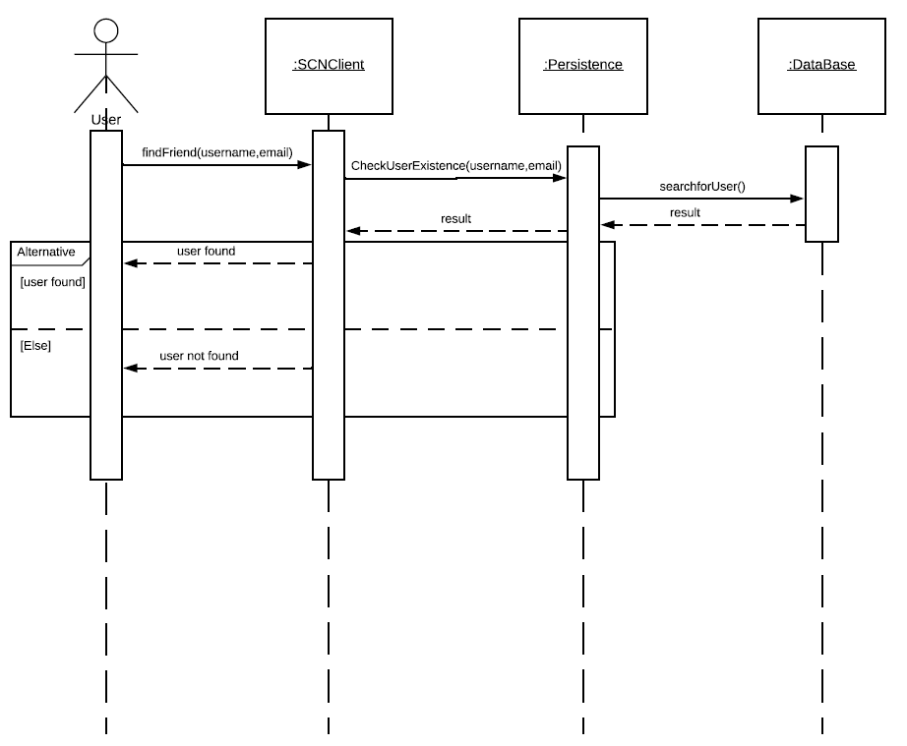

**ID : 3 Name : send friend request**

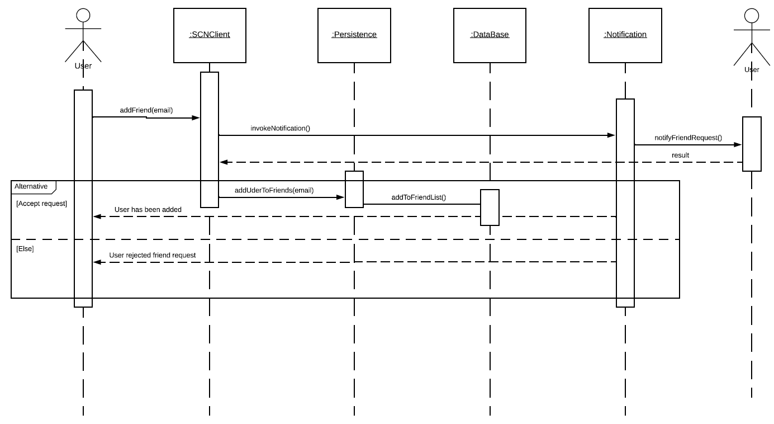

**ID : 4 Name : Search By Hashtag**

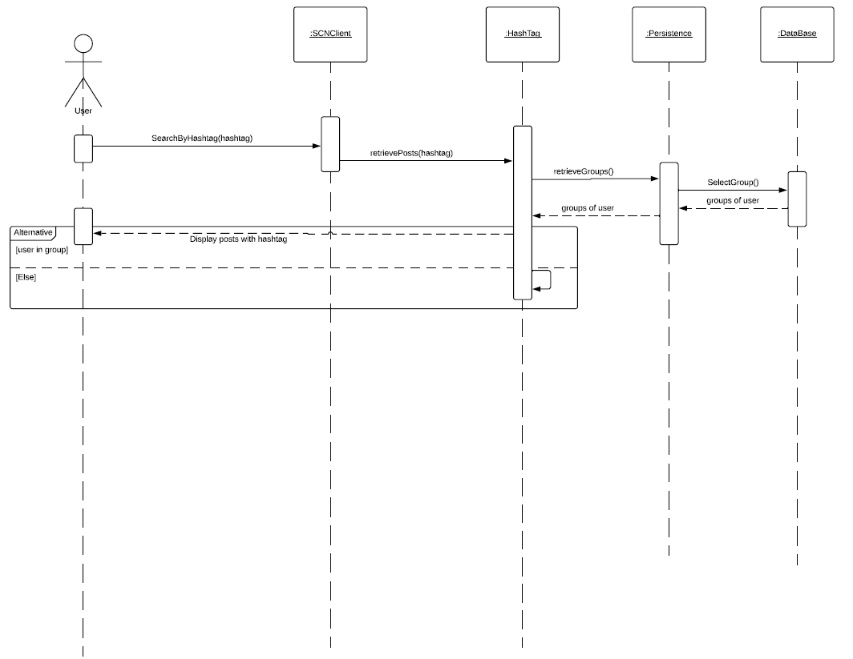

**ID : 5 Name : Request Join Group**

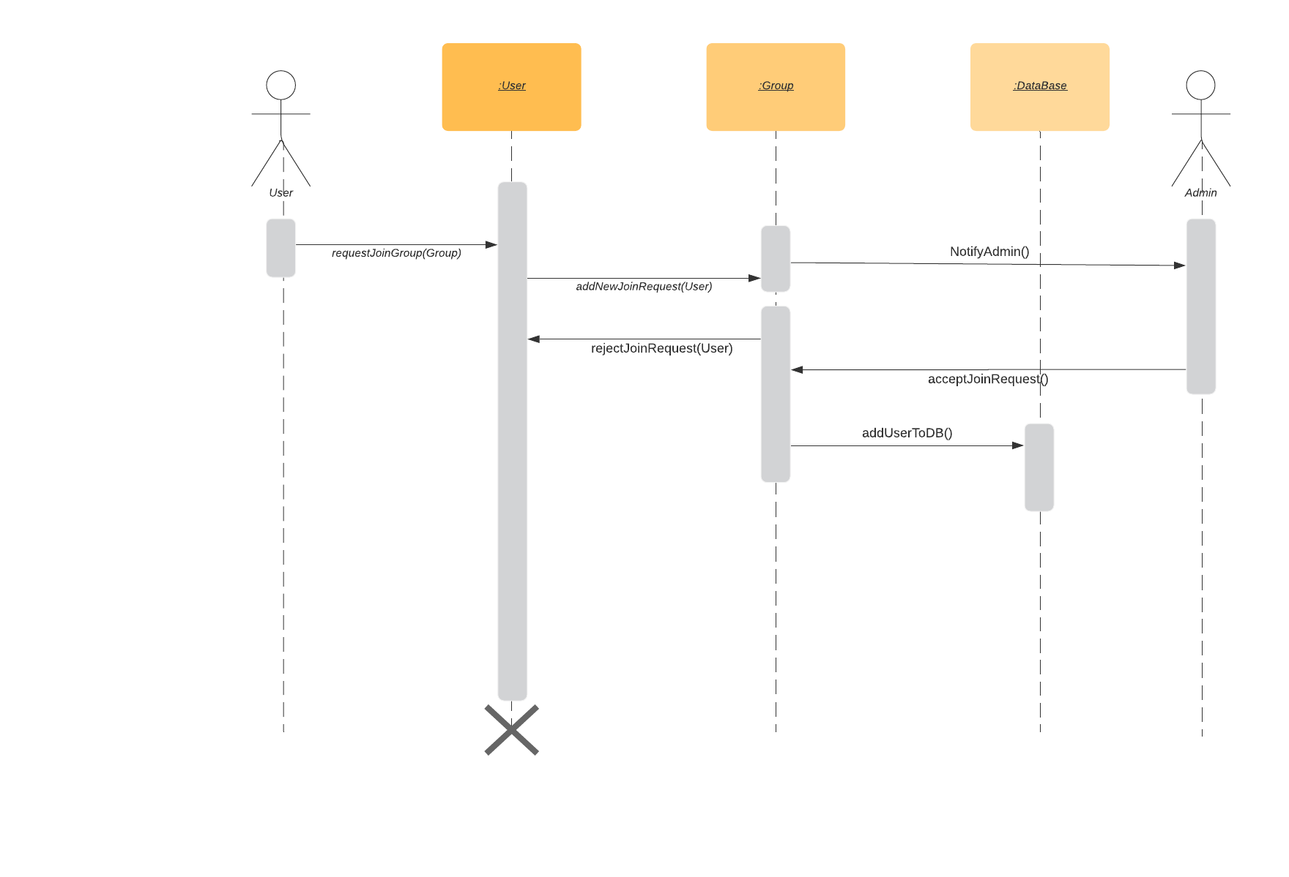

**ID : 6 Name : request Leave group**

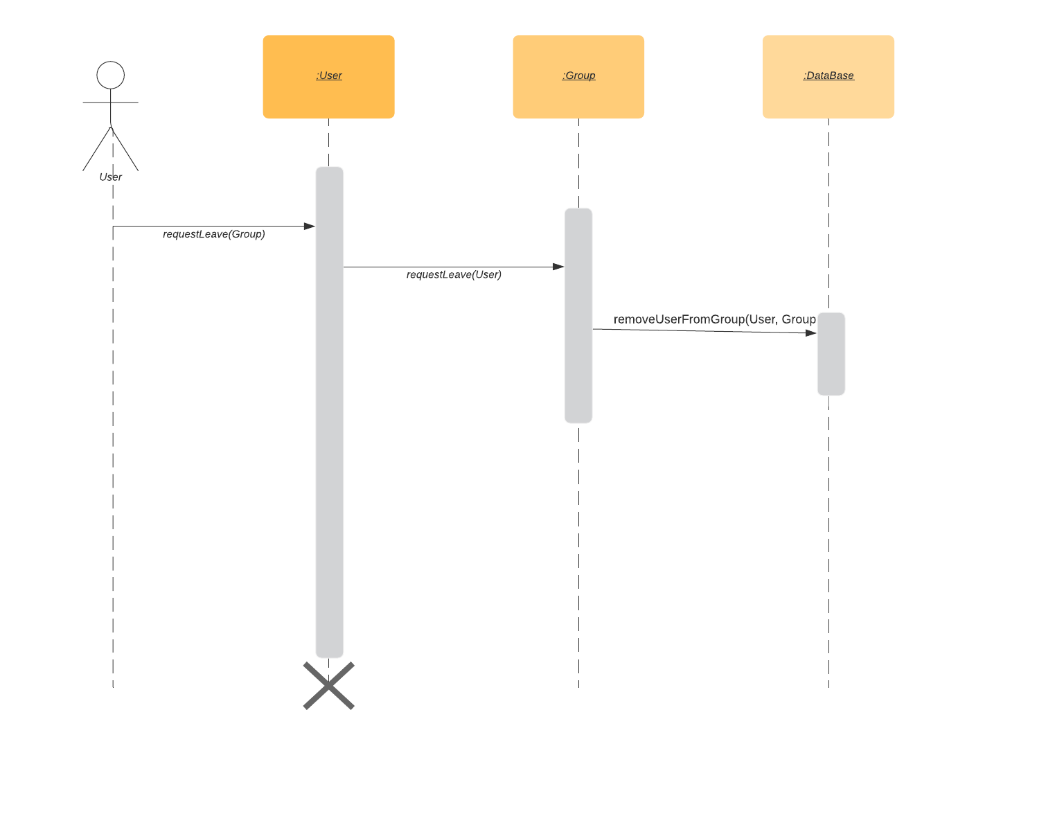

**ID : 7 Name : View Page**

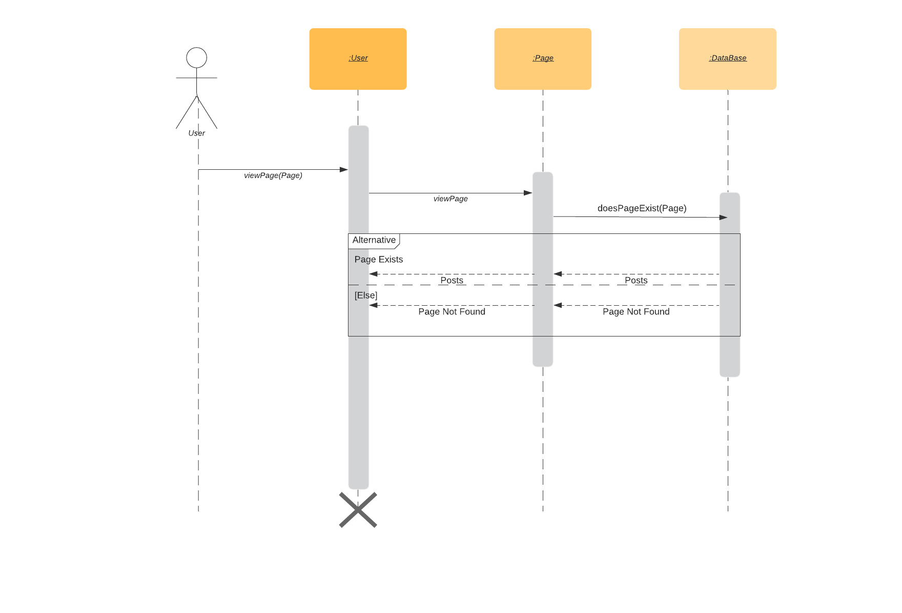

**ID : 8 Name : View timeline**

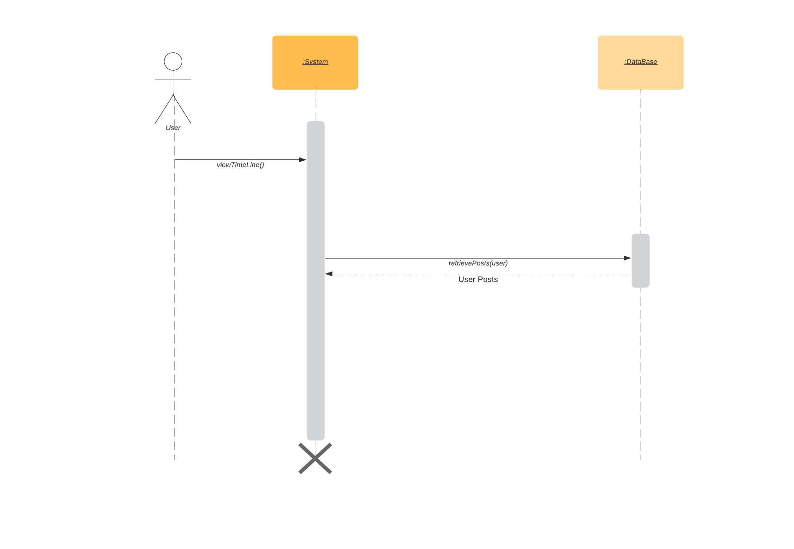

**Sequence Usage Table**

|  |  |  |
| --- | --- | --- |
| Class Name | Sequence Diagrams | Overall used methods |
| User | 1,2,3,4 | Signup, findFriend, addFriend, searchByHashtag |
| Notification | 3 | notifyFriendRequest |
| HashTag | 4 | retrieveGroups |
| User | 5,6, 7, 8 | Save, GetData |
| Group | 5, 6 | requestLeaveGroup, requestJoinGroup, viewTimeLine |
| Persistence | 1,2,3,4 |  |
| Database | 1,2,3,4 |  |

# Ownership Report

|  |  |
| --- | --- |
| **Item** | **Owners** |
| Component Diagram | Ali |
| Class Diagram | Youssef |
| Sequence Diagrams | Abdelrahman and Moustafa |
| Sequence Tables | Abdelrahman and Moustafa |

