**1- Convolutional Neural Network**

It is a type of deep learning model that is widely used for analyzing visual data, such as images and videos. CNNs are particularly effective in tasks like image classification, object detection, and image recognition.

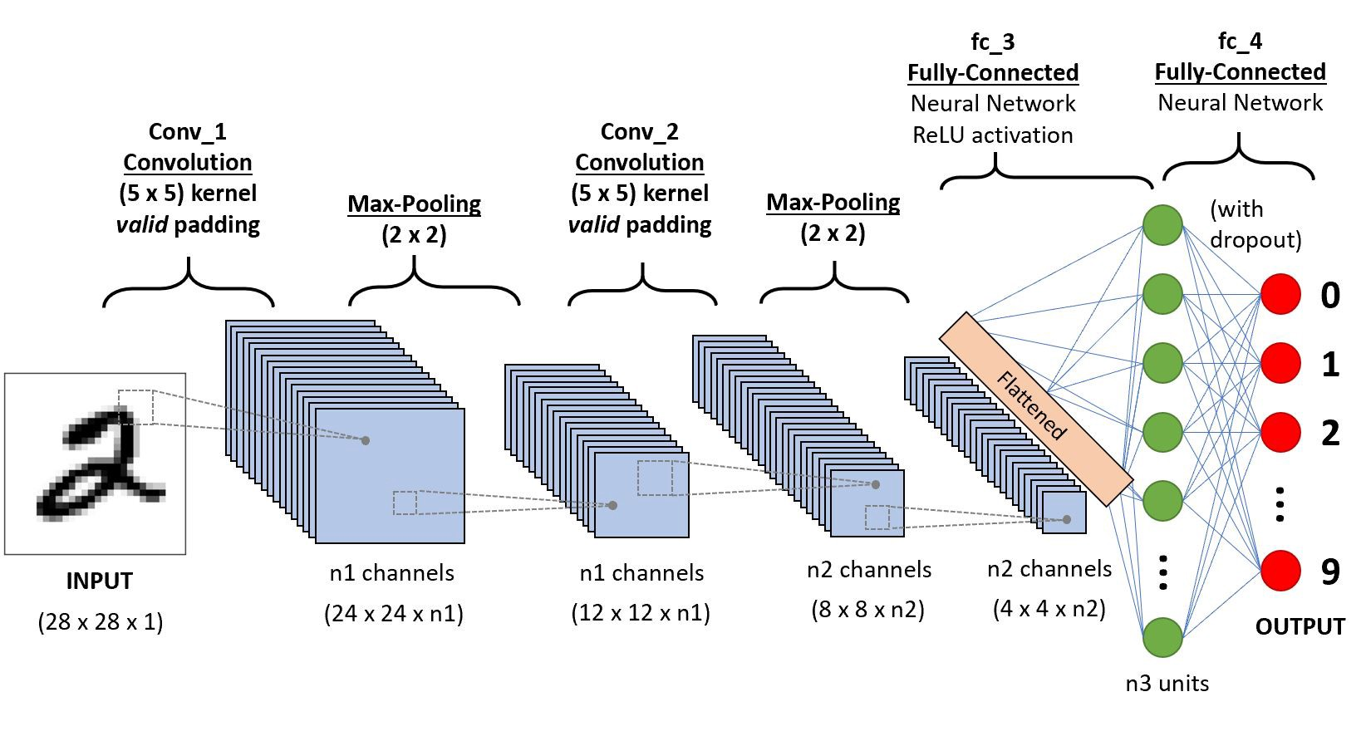

* Convolutional Layers: These layers perform convolution operations on the input image using learnable filters/kernels. Each filter extracts specific features from the input image. Convolutional layers are responsible for capturing local spatial patterns in the data.
* Activation Function: Typically, an activation function like ReLU (Rectified Linear Unit) is applied after each convolutional layer to introduce non-linearity into the model.
* Pooling Layers: Pooling layers (such as Max Pooling or Average Pooling) reduce the spatial dimensions (width and height) of the feature maps while retaining important information. This helps in reducing the computational complexity and making the model more robust to variations in input.
* Fully Connected Layers: After multiple convolutional and pooling layers, the output is flattened and passed through fully connected layers. These layers act as a traditional neural network and combine the learned features to make predictions. The last fully connected layer usually has a softmax activation function for multi-class classification tasks.
* Output Layer: The final layer of the CNN represents the output layer, which produces the predicted class probabilities based

**2- Results**

