Vaishall Pradeepkumar

02/13/2020

Pandemic Propagation Proposal

As coronavirus continues its inexorable spread across the globe, this valiant team of researchers has decided to contribute to the effort to stop it. We have thus decided to analyze live coronavirus data. However, aware of our history and willing to take lessons from the past, we have also decided to analyze other respiratory viruses and their spreads over time.

Datasets:

* Coronavirus: <https://github.com/CSSEGISandData/COVID-19/>
* SARS: <https://www.who.int/csr/sars/country/table/en/>
* H1N1: <https://www.kaggle.com/de5d5fe61fcaa6ad7a66/pandemic-2009-h1n1-swine-flu-influenza-a-dataset>

Inspiring Visualizations: 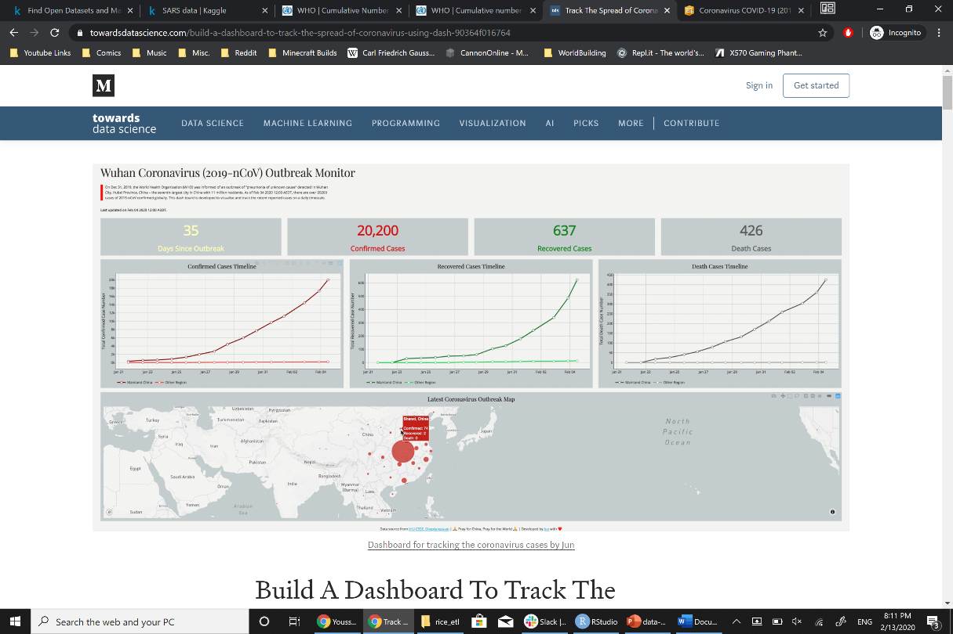

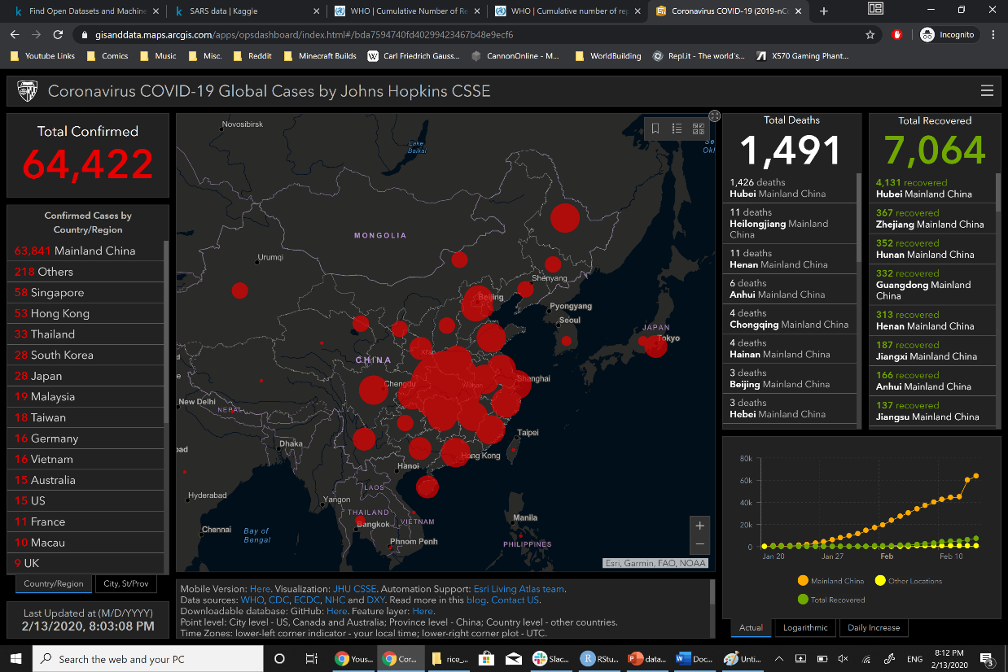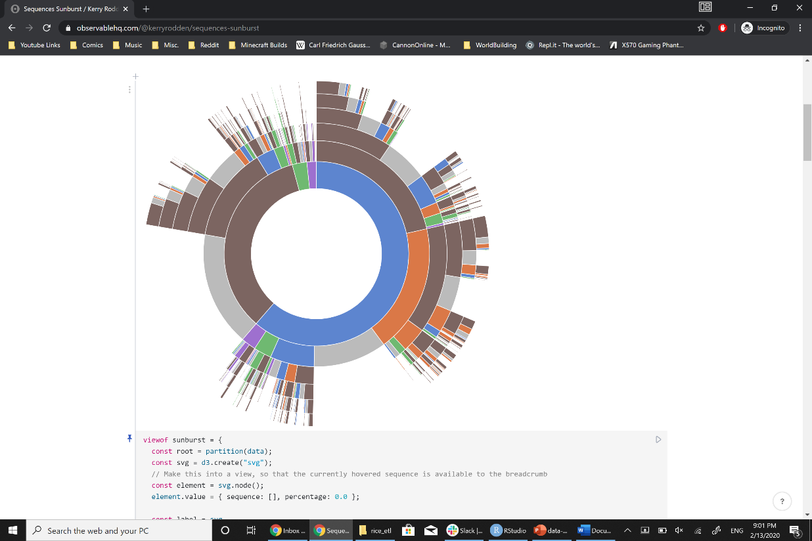

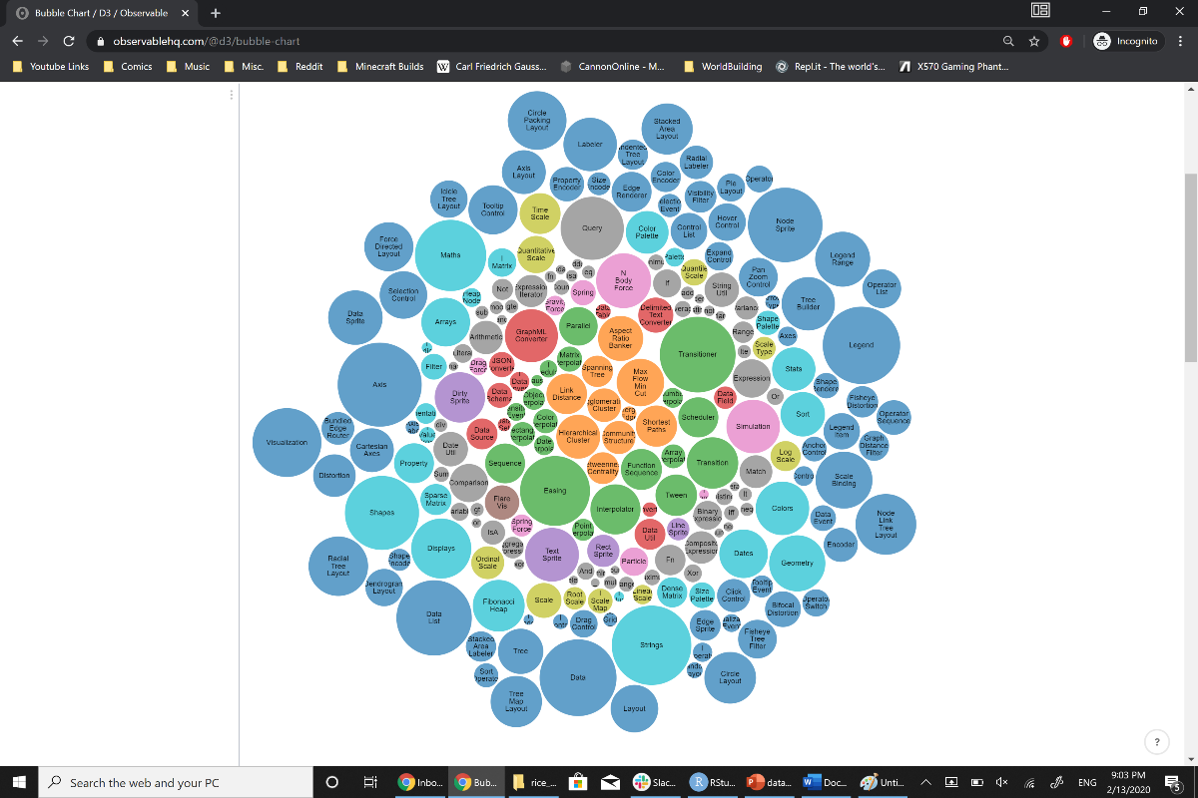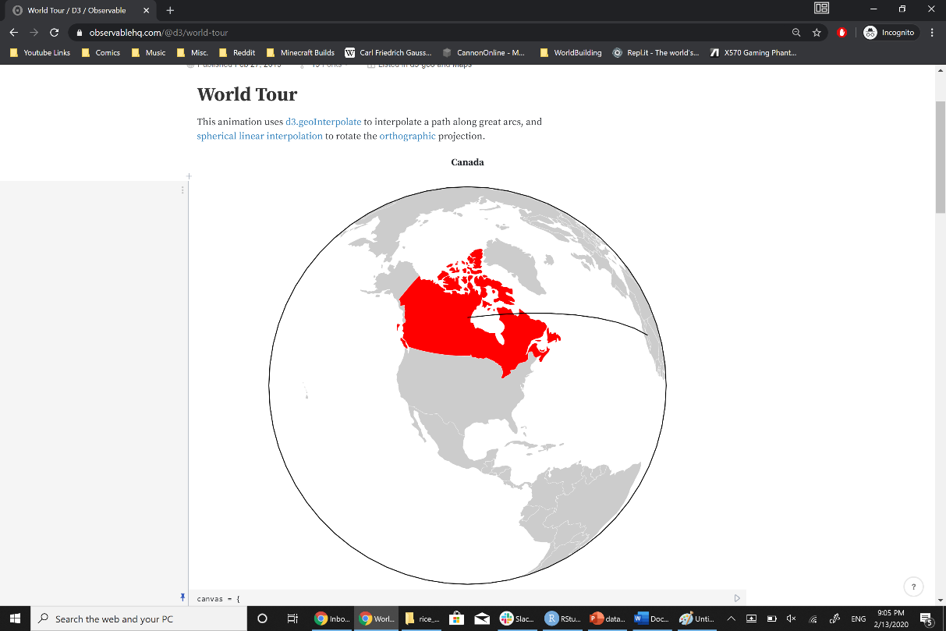

Sketch of potential final design: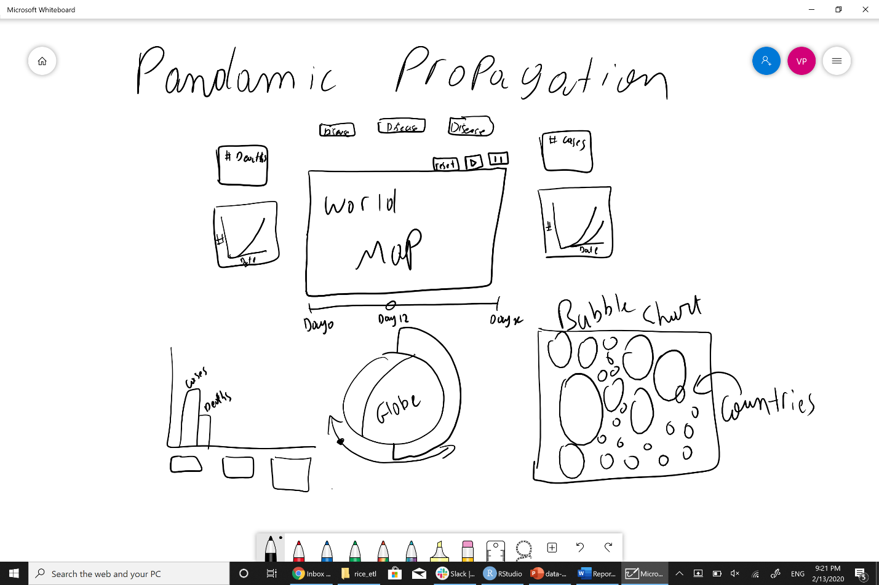

Github repo: <https://github.com/YoussefMroue/Pandemic-Propagation>