**On-demand Traffic light control**

**Documentation**

1. 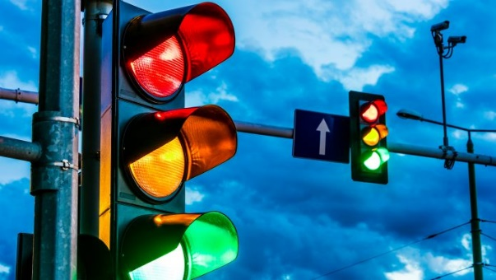**System description**

This system simulates on demand traffic light , this system regulates the crossing of cars and pedestrians; the system gives the priority for pedestrians to cross as soon as possible by adding on demand button for the pedestrians

1.Image of traffic light

Source : www.innovationnewsnetwork.com

1. **System design**
2. **Hardware design**

the system simulate on demand traffic light, it has 6 LED lights; 3 of the LED lights are to guide the crossing cars when to move and when to stop while the other 3 LED lights are to guide the pedestrians when to stop and when to start crossing , the structure of the system is shown in figure 2.

2.system diagram on proteus

Generated on proteus software

The project has a button which help the pedestrians to wait less as if they pressed the button the system will immediately start to use yellow lights for crossing cars to prepare them to stop to allow the pedestrians to start crossing.

The whole project is controlled using ATMEGA 32 microcontroller with 8MHZ operating frequency .

1. **Software design**

This project software is designed using layered model in coding , figure 3 shows the structure of the used layered model in the project

Application Layer

**APP**

drivers Layer

**push button Driver**

**GPIO Driver**

**Timer1 Driver**

Hardware layer

**Hardware timer**

**LEDS**

**Button**

3.layerd model diagram

pushbutton response is triggered using INT0 as shown in figure 2 , also delays are managed using timer1 interrupts

1. **system flow chart**

the system is divided into 4 different states

1. cars move : in this state green light is turned on for the cars to move while pedestrians is waiting as their red light is turned on
2. cars will stop : this is a transitional state as it prepare the cars to stop by flashing yellow lights for the cars and also flashing yellow lights for the pedestrians to prepare themselves to start moving
3. cars stop : in this state red lights in turned on for the cars to stop while pedestrians are crossing as their green light Is turned on

4.flowchart of the code

1. Cars will move : this is a transitional state as it prepare the cars to move by flashing yellow lights for the cars and also flashing yellow lights for the pedestrians to prepare themselves to stop moving

The following flowchart (figure 4) shows the flowchart that shows how system moves from one state to another