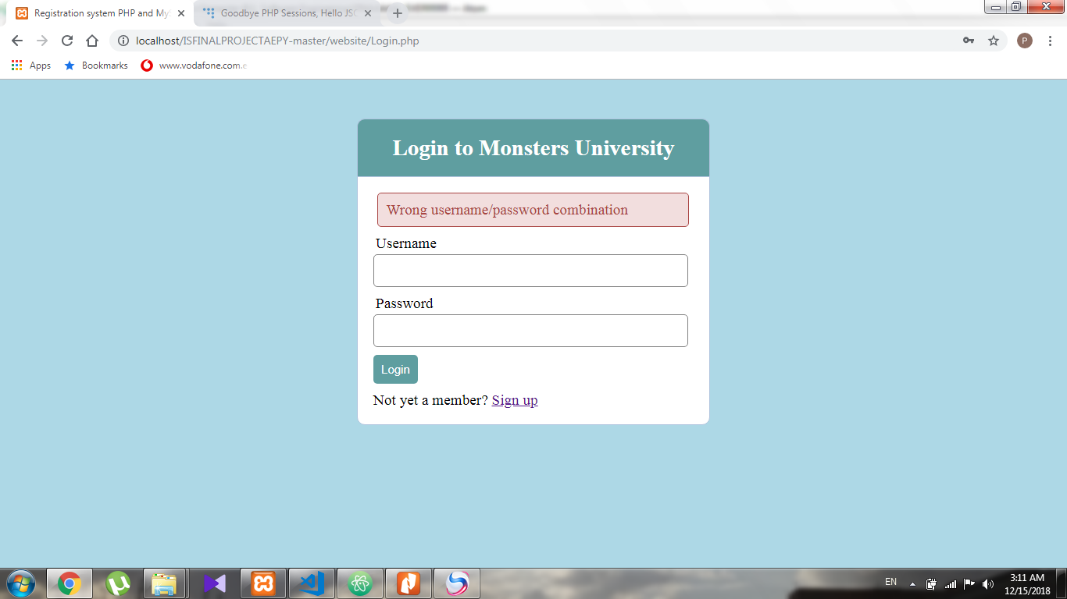

This message appears whenever the username or password is entered incorrectly by the user.

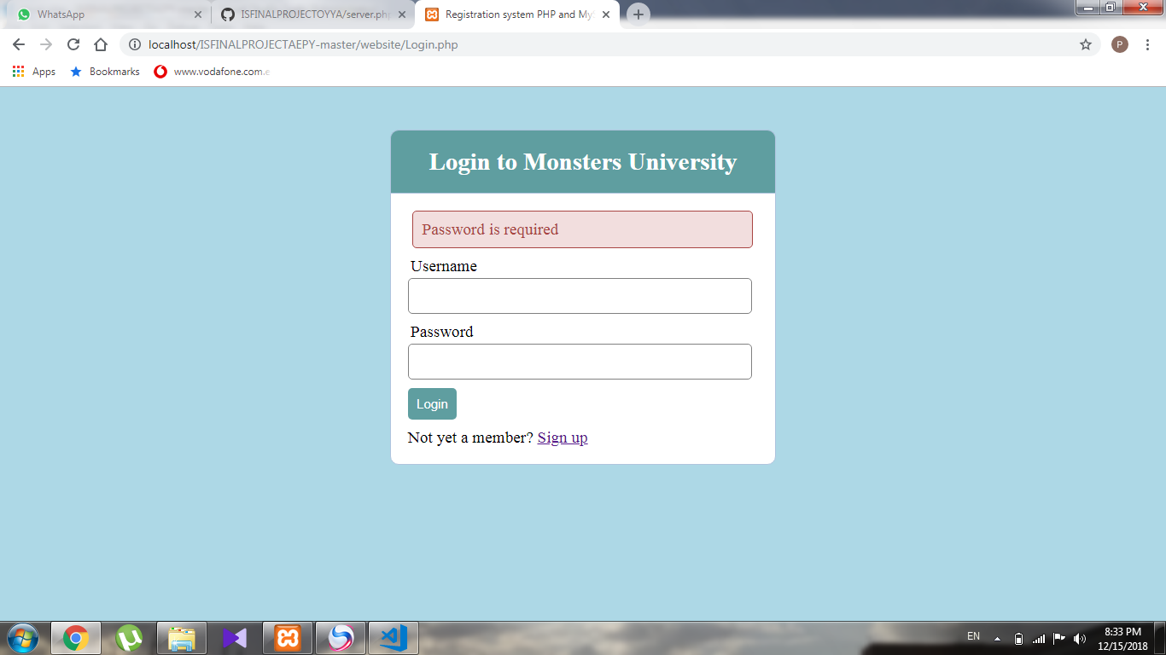

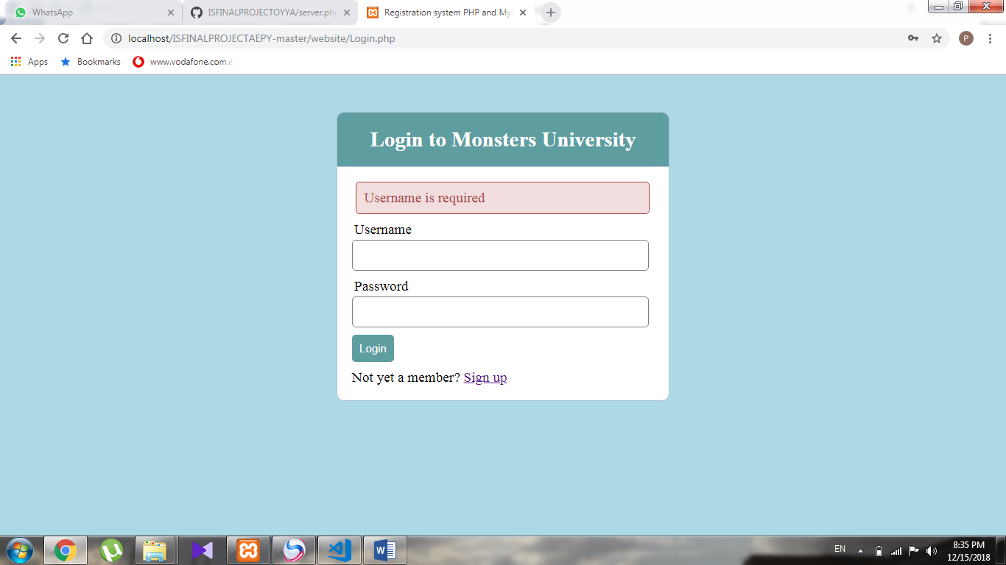

These messages appear when the user doesn’t enter his username or password when logging in.

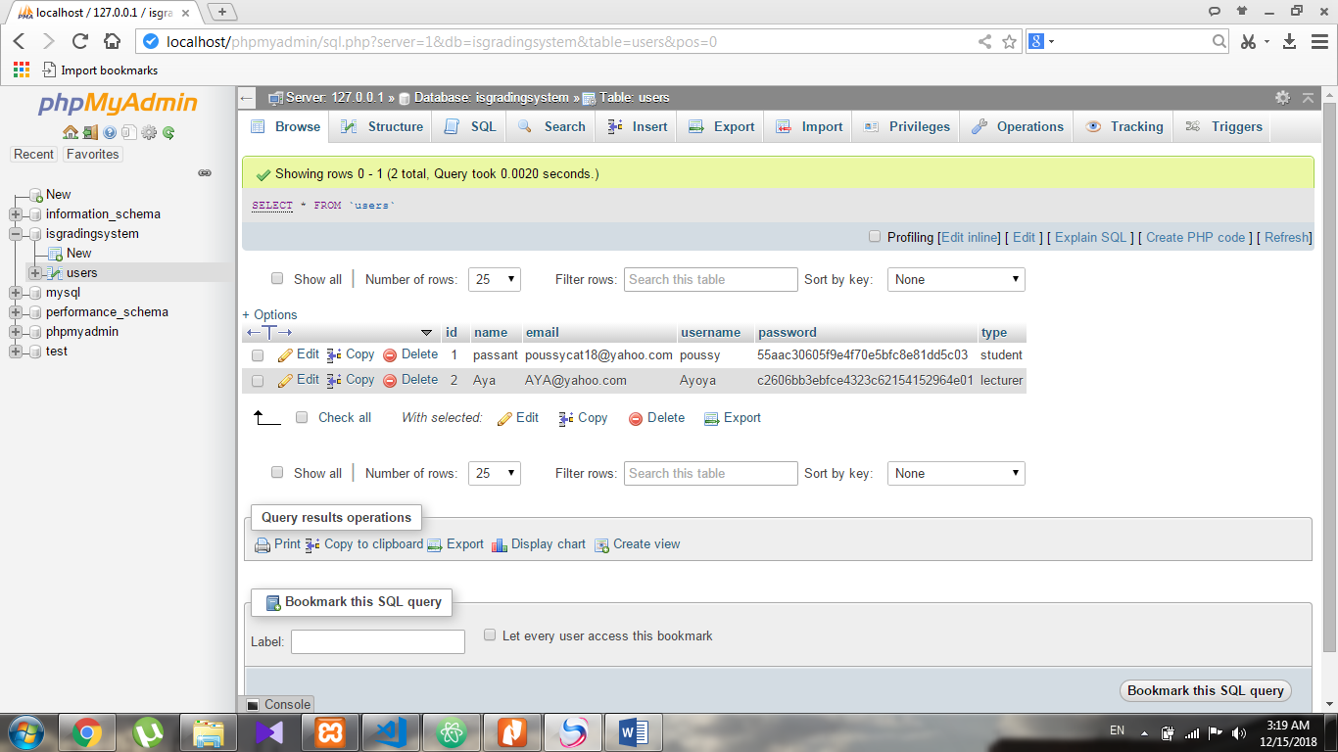

Here in the database the encryption process is shown as the passwords of the users are stored in a hash form.

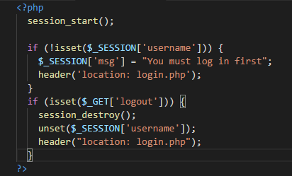 This part of the code guarantees that the user is still in his session which makes him navigate from one page to the other. This replaces the need for a token.