**Technical Report**

 Technology Ministry of Communications and Information (MCIT) Egypt

 Digital Egypt Pioneers Initiative DEPI

**Supervised by**

Dr. Maged Magdy

**Prepared by: CLS QAL2_DAT1_S1**

Mohamed Magdy Goda

Belal Mohamed Abd Al Fattah

Abdelrahman Mohamed Ahmed

Ahmed Magdy Ali

Mohamed Mostafa Abdel Moneim

Yossef Mohamed Mohamed

 Digital Egypt Pioneers Initiative DEPI

 Technology Ministry of Communications and Information (MCIT) Egypt

|  |  |  |  |  |
| --- | --- | --- | --- | --- |
| **No.** | **Full name** | **Student id** | **Education Background** | **Governorate** |
| 1 | **Mohamed Magdy Goda** | 21075992 |  |  |
| 2 | **Belal Mohamed Abd Al Fattah** | 21070061 |  |  |
| 3 | **Abdelrahman Mohamed Ahmed** | 21089849 |  |  |
| 4 | **Ahmed Magdy Ali** | 21089651 |  |  |
| 5 | **Mohamed Mostafa Abdel Moneim** | 21086028 |  |  |
| 6 | **Yossef Mohamed Mohamed** | 21065928 |  |  |

**Project Idea: Store Sales Dataset Analysis**

* Team Name: CLS QAL2_DAT1_S1
* Selected Project: Store Sales Dataset Analysis

**The group:**

**By Using those tools (**Excel, Power Bi**) we**

* Build Data Model
* Data Cleaning and Preprocessing

**Step 1:** import data file (Store Sales Dataset Analysis) into power bi

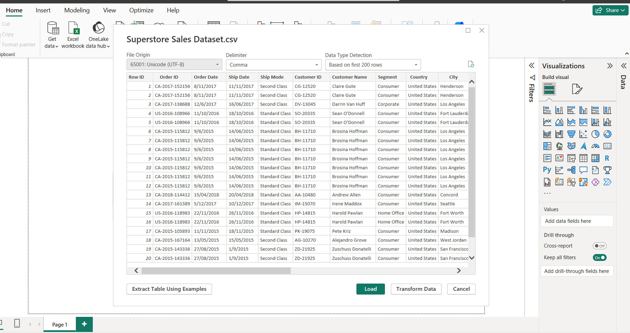

**Step 2**: select transform data to open power query for data cleaning.

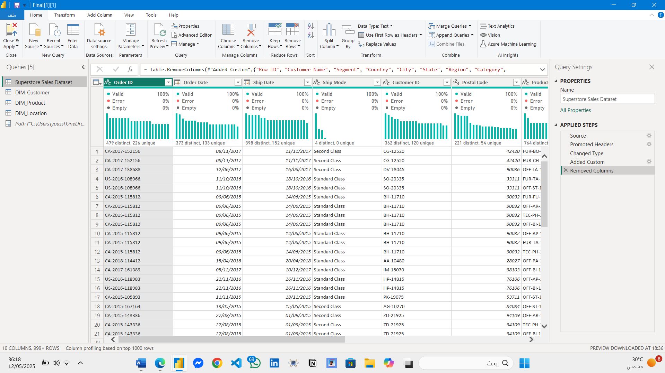

**Step** 3: We made a dimension for (customer and product)

**Step** 4: adding a new column (location ID) to collect all location data in Location _DIM

**Step** 5: **Close & Apply**

**Step 6**: Creating Calendar table for all dates data:



**Step 7:** create data modeling to join all tables : 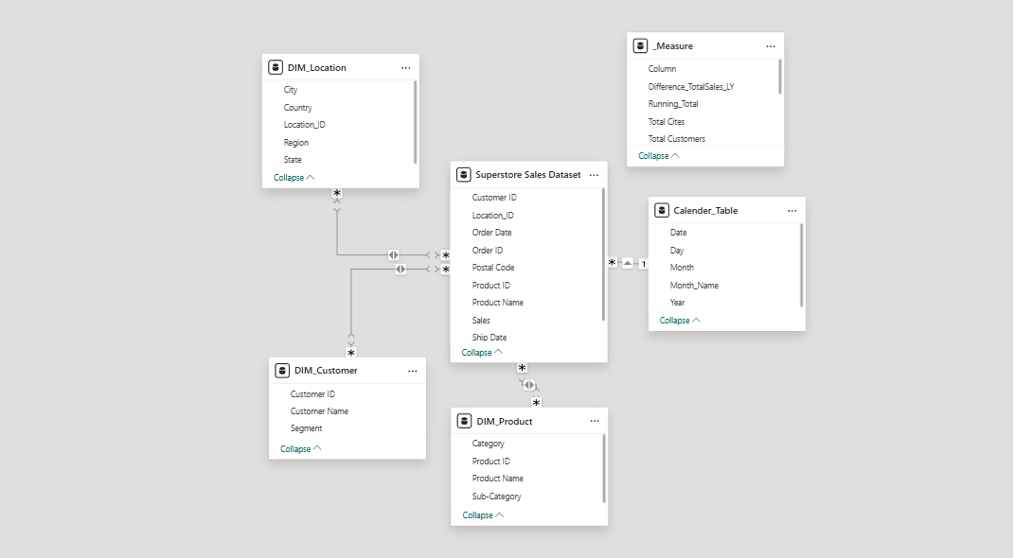

1. Which geographic zone delivers the highest revenue, and what is its market share?
2. Are product sales evenly distributed across regions, or are there imbalances?
3. Which cities consistently outperform others in revenue generation?
4. Does the density of cities in a region correlate with its sales performance?
5. Where are the highest revenue clusters located across states?
6. How has revenue distribution across states changed over recent years?

* **Regional & Geographical Analysis**

1. Which 10 clients contribute most significantly to total revenue?
2. Which customer groups (e.g., Corporate, Home Office) generate the largest share of income?
3. How do sales vary by region within each customer segment?
4. What product categories are prioritized by different customer groups?
5. How has customer activity shifted between 2015 and 2018, and which months show spikes?

* **Customer Segmentation & Behavior**

1. What is the total revenue, product volume?
2. Which product divisions and sub-divisions drive the highest and lowest income?
3. How do delivery methods (e.g., Standard, Second Class) affect revenue distribution?
4. Which 10 products dominate sales rankings?
5. Which months/years mark revenue peaks and declines?

* **Sales Performance**



**What is the total revenue, product volume?**

* **Sales Performance**
* First, we made measures table



* **Then we create measures like:**
* **Total Sales**



* **Total Products**



* **Total Orders**



* **Total Customers**



* **Total Cites**



**Then we create a new card**



**Which product divisions and sub-divisions drive the highest and lowest income?**

* Here we create a stacked column chart and it shows that phones is the highest selling sub category and lowest one is appliances

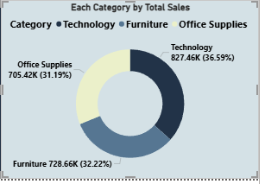

* And also created a donut chart to show the highest and lowest category and it shows that technology is the best selling and lowest one is office supplies

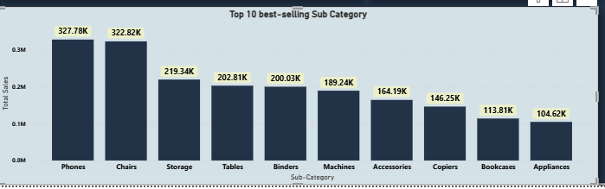

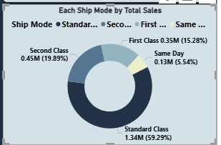

* To answer this one, we create a donut chart and it shows that standard class having the highest revenue

**How do ship mods (e.g., Standard, Second Class) affect revenue distribution?**

**Which months/years mark revenue peaks and declines?**

* **We add slicer for (months- year – category)**

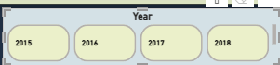

* **we made a new table (Calender_Table)**



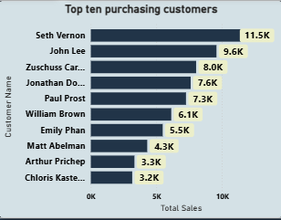**Who are the top 10 customers contributing to overall sales**

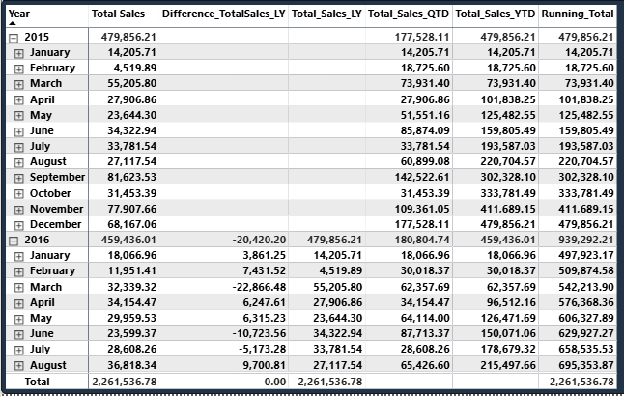

* **And created new measures**:
* **Total_Sales_LY**



* **Total_Sales_QTD**



* **Total_Sales_YTD**



* **Running_Total**

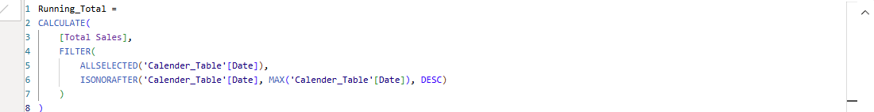

* **Difference_TotalSales_LY**



* + Axis: Customer Name
  + Values: Revenue
  + Filter to Top 10

ـــــــــــــــــــــــــــــــــــــــــــــــــــــــــــــــــــــــــــــــــــــــــــــــــــــــــــــــــــــــــــــــــــــــــــــــــــــــــــــــــ

**Which customer segments contribute the most to total revenue?**

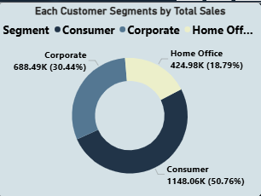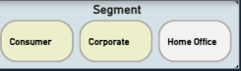

* Axis: Customer Segment
* Values: Revenue

**Which regions contribute most to each customer segment’s sales?**

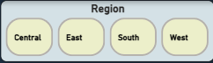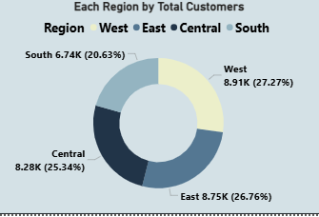

* + Axis: Region
  + Legend: Customer Segment
  + Values: Revenue

ـــــــــــــــــــــــــــــــــــــــــــــــــــــــــــــــــــــــــــــــــــــــــــــــــــــــــــــــــــــــــــــــــــــــــــــــــــــــــــــــ

**Which product categories are most popular among different customer segments?**

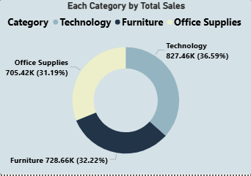

**How have customer numbers changed over time (from 2015 to 2018) & Which months show the highest new customer acquisition or activity?**

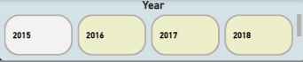

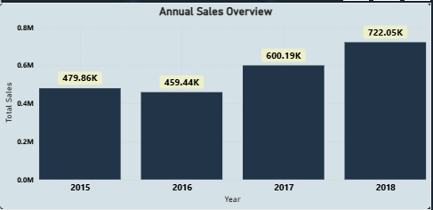

* + Axis: Date (hierarchy to month/year)
  + Values: Revenue or # Orders

ـــــــــــــــــــــــــــــــــــــــــــــــــــــــــــــــــــــــــــــــــــــــــــــــــــــــــــــــــــــــــــــــــــــــــــــــــــــــــــــــــــــــــــــ

**📍 Regional & Geographical Analysis**

* A black text on a white background

  AI-generated content may be incorrect.We duplicate the page of customer insights & change the title of the page to be (Regional Dashboard) and add icon to represent region.
* We add a slicer for regions.

**Which region achieved the highest total sales, and what percentage does it represent of overall sales?**

* + 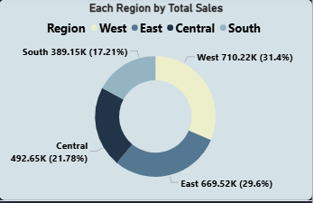 Use a Pie Chart or Map.
  + Group by Zone/Region and sum Revenue.

ــــــــــــــــــــــــــــــــــــــــــــــــــــــــــــــــــــــــــــــــــــــــــــــــــــــــــــــــــــــــــــــــــــــــــــــــــــــــــــــــــــــ

**How balanced are category sales across different regions?**

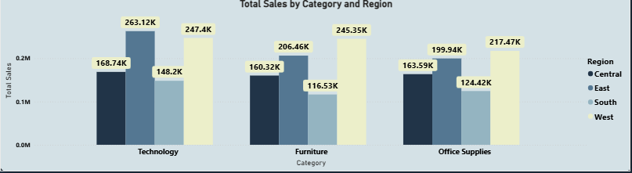

* + Axis: Region
  + Values: Revenue
  + Compare heights visually

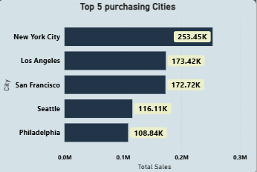**Which cities generate the highest sales, and are there any cities consistently outperforming others?**

* + Axis: City
  + Values: Revenue
  + Filter: Top 5

ـــــــــــــــــــــــــــــــــــــــــــــــــــــــــــــــــــــــــــــــــــــــــــــــــــــــــــــــــــــــــــــــــــــــــــــــــــــــــــــــ

**How are cities distributed across regions, and does the number of cities correlate with regional sales performance?**

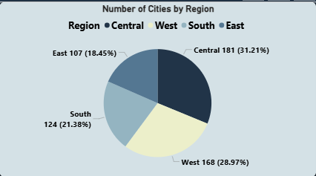

**How are sales distributed geographically across states and regions, and where are the sales hotspots?**

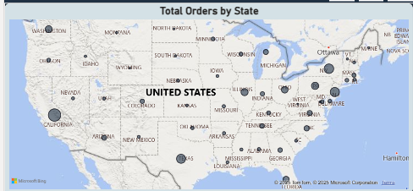

* Location: State
* Values: Revenue

ـــــــــــــــــــــــــــــــــــــــــــــــــــــــــــــــــــــــــــــــــــــــــــــــــــــــــــــــــــــــــــــــــــــــــــــــــــــــــــــــ

**How has the sales distribution changed across states over the years?**

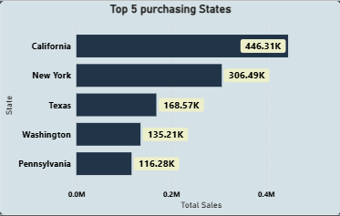

* Axis: Date (Year)
* Values: Revenue
* Legend or Filter: State

**Then we Tried to use AI Chatbot to answer questions related to our dashboard**

**But tokens**