CSE 625 Term Project Report

Digits Prediction of MNIST Dataset using Multithreading

Youssef Sheta

07-29 -2023

**Objective**

The goal of this project is to utilize multithreading of Julia language and use it in training models in MNIST dataset. I am using Flux.jl library to parallelize training process of CNN (Convolutional Neural Network) for digit classification. Moreover, I am comparing the difference between sequentially training a model with using multithreaded model to evaluate the efficiency of using multithreading.

**General Description of the Approach**

This project using Julia programming language, utilizing its capabilities in multithreading, and using it in training process of a deep learning model, which is detecting what digit is written in an image in MNIST dataset. Julia language is a great choice for this project due to its high-performance and scientific computing tasks beside providing distributed parallel execution, and an extensive mathematical function library.

**Platforms**

Flux.jl: A machine learning library.

MLDatasets.jl: A package that offers common machine learning datasets like MNIST dataset, which is used in this project.

Base.Threads.jl: Library to use threads in training my model.

**Implementation Details**

**Data Loading and Preprocessing**

Firstly, MNIST dataset is loaded and preprocessed. Images and labels are loaded using MNIST.traindata function. An extra dimension is added to the images and labels, which are values from 0 to 9, are converted into one hot format. Then I divided the data in to batches using ‘DataLoader’ function, I divided the data into mini batches because it is an efficient way when training neural networks because it speeds up training and also to optimize the memory usage as large datasets may not fit into the computer’s memory, so you will have to load a small portion of the data into the memory at a time. 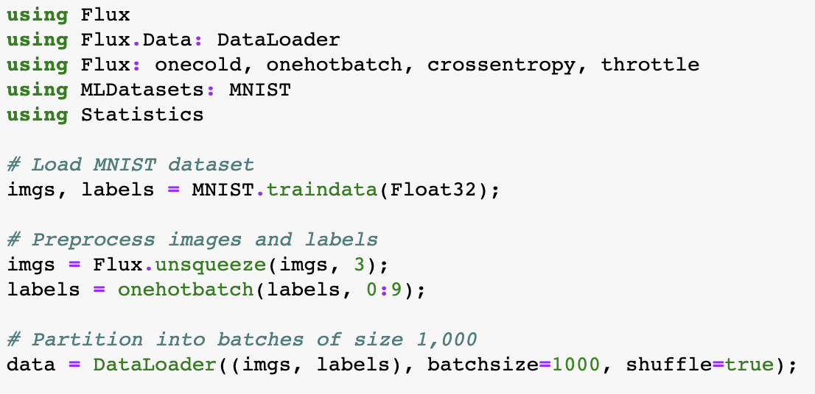

**Model Definition**

The model has two convolutional layers with ReLU activation functions and two max-pooling layers. The output for the last max-pooling layer is reshaped to 2d tensor that is passed to a dense layer. The softmax activation function is used to output the probability of each class, in which it outputs the probabilities of each digit.

**Training the Model Sequentially**

The train! function is used to train the model.

**Training the model with Multithreading**

Here the data is split into chunks and then separate threads train each chunk.

Chunks are trained separately, and their number is equal to the available number of threads, which is 4 in this project.

**Time performance analysis**

The total elapsed time for sequential approach is 109.65 seconds and using threads is 60 seconds.

The time saved by using threads is approximately 49.5 seconds, which means that multithreading was able to reduce the training time and optimize machine learning workflows. The speedup is approximately 1.82 faster than the sequential approach. This project managed to achieve the expected speedup using threads although it was expected to be 4 times faster, but in practice, due to overheads, the ideal speedup is not often possible.

**Result Presentation**

As mentioned before the goal for this project is to compare two different methods for training a machine learning model to predict handwritten digits from MNIST dataset. When testing the trained model with actual images of MNIST dataset, I get the same result which is 8, but faster in the multithreading approach.

This code shows how I load the image from the downloaded dataset and preprocess it to pass it to the model to make a prediction for the handwritten image to a certain number between 0 and 9. 

This is the output for the sequential approach and give us a good accuracy.

While this output was using multithreading approach.

They both have approximately the same accuracy and they also have the same output in most of the images, the only difference is that the multithreading approach shows how threads can be useful in speeding up the process when dealing with large datasets and can lead to substantial performance improvements, so it reduce computation time while maintaining the same level of prediction accuracy.

**Contributions**

I preprocessed the MNIST dataset and applied one hot encoding to the labels to get the data in correct form. Then I constructed a CNN using Flux package in Julia. I performed model training using two approaches as stated previously in the results part. Moreover, I applied multithreading to speed up the training process of the model. Lastly, I validated the model’s performance using a test dataset from the MNIST dataset and ensured that both models gave the same result with better execution time.

**References**

Svaksha. “SVAKSHA/Julia.Jl: Curated Decibans of Julia Programming Language.” *GitHub*, github.com/svaksha/Julia.jl. Accessed 27 July 2023.