

Design of a 2-element array of circular polarized microstrip patch operating at 30 GHz



BY:

|  |  |  |  |
| --- | --- | --- | --- |
| Name | ID | SEC | BN |
| Ahmed Meme Sayed | 9220114 | 1 | 20 |
| Vivianne Emad Ghattas | 9220585 | 3 | 7 |
| Mariam Mamdouh Mohamed | 9220830 | 4 | 2 |
| Yahia Ebrahim Sayed | 9220964 | 4 | 30 |
| Youssef Samir Eid | 9220988 | 4 | 40 |

Presented to:

*Dr. I Islam Abdel-Sattar Eshrah*

December 30, 2024

Table of Contents

Table of figures III

1 Design of a Circularly Polarized 1x2 Patch Antenna at 30 GHz 5

1.1 Abstract 5

1.2 Introduction 5

2 Problem Definition 6

3 Design Methodology 8

3.1 Design A (substrate thickness = .81mm) 11

3.2 Design B (substrate thickness = .254mm) 12

4 Simulation Results 13

4.1 Verification 13

4.1.1 Conclusion of Verification 15

4.2 Results 16

4.2.1 Design A (Substrate Thickness = 0.81 mm) 16

4.2.2 Design B (Substrate Thickness = 0.254 mm) 21

4.2.3 Comparison of Design A and Design B (results discussions) 25

5 Bonus: Mutual coupling and Gain vs Element Spacing 26

6 Circuit Model 30

6.1 ADS Circuit model and Verification 30

6.1.1 Transmission line model 31

7 Conclusion and future work 33

7.1 conclusion 33

7.2 Future work 33

8 References 34

# Table of figures

Figure 1: Rectangular and circular patch arrangements for circular polarization 7

Figure 2: Single-feed arrangements for circular polarization of rectangular microstrip patches. 7

Figure 3: Circular polarization for square patch with thin slots on patch 7

Figure 4: Circular polarization by trimming opposite corners of a square patch and by making circular patch slightly elliptical and adding tabs. 7

Figure 5: De-embedding Setup for Edge Impedance Calculation 9

Figure 6: Design A (thickness = 0.81mm) 11

Figure 7: Design B (thickness = 0.254mm) 12

Figure 8: Design layout from the paper 13

Figure 9: Design layout in HFSS 13

Figure 10: Return Loss vs freq. (Paper results) 14

Figure 11: Return Loss vs freq. (simulation results) 14

Figure 12: VSWR versus freq. (Paper results) 14

Figure 13: VSWR versus freq. (simulation results) 15

Figure 14: Radiation pattern (paper results) 15

Figure 15: Radiation pattern (simulation results) 15

Figure 16: S11 of design A 16

Figure 17: Axial ratio of design A 17

Figure 18: Gain of design A 18

Figure 19: E-Plane Co and Cross Radiation Gain of design A 18

Figure 20: H-Plane Co and Cross Radiation Gain of design A 19

Figure 21: LHCP gain of design A 19

Figure 22: Input Impedance of design A 20

Figure 23: Input Impedance of patch A 20

Figure 24: Radiation Efficiency of design A 21

Figure 25: Gain of Design B 21

Figure 26: E-Co and cross radiation gain of design B 22

Figure 27: H-Co and cross radiation of design B 22

Figure 28: LHCP of design B 22

Figure 29: Axial Ratio of Design B 23

Figure 30: Return Loss of Design B 23

Figure 31: Input Impedance of design B 24

Figure 32: Input Impedance of patch B 24

Figure 33: Radiation Efficiency of design B 25

Figure 34: Setup for sweeping the element spacing 26

Figure 35: S21 vs Element spacing 26

Figure 36: Gain Vs Element spacing 27

Figure 37: Gain total with Element spacing 28

Figure 38: 3D plot at the proposed element spacing 28

Figure 39: Single Dual fed antenna 30

Figure 40: S11 of Single Dual fed ant. 30

Figure 41: Single Antenna model on ADS 31

Figure 42: S11 ADS model BLUE is HFSS results, and Red is ADS results 31

Figure 43: Equivalent circuits for a reciprocal two-port network. (a) T equivalent. (b) π equivalent 31

Figure 44: Voltage and current definitions and equivalent circuit for an incremental length of transmission line. (a) Voltage and current definitions. (b) Lumped-element equivalent circuit network as follows 32

Figure 45: Patch ADS setup 32

Figure 46: S11 2-patch ADS, BLUE is HFSS results, and Red is ADS results 33

# Design of a Circularly Polarized 1x2 Patch Antenna at 30 GHz

## Abstract

This report presents the design and analysis of a 1×2 antenna array operating at 30 GHz with circular polarization, aimed at applications in satellite communication, millimeter-wave wireless networks, and radar systems. The antenna array is designed to offer enhanced gain, improved directivity, and robust performance.

The design incorporates a single-layer substrate with an optimized feed network to ensure circular polarization across the array elements. Simulations are performed to optimize critical parameters, including axial ratio, gain, and return loss. The array configuration enhances the antenna’s radiation characteristics while maintaining a low axial ratio (<3 dB) over the desired frequency band.

## Introduction

he rapid advancements in communication technologies have heightened the demand for antennas operating efficiently at millimeter-wave frequencies. The 30 GHz band has emerged as critical for applications such as satellite communication, radar systems, and millimeter-wave wireless networks. Designing antennas for this frequency requires overcoming challenges such as achieving high gain, precise directivity, and robust polarization performance.

Circular polarization is particularly advantageous for high-frequency applications as it mitigates polarization mismatches, reduces signal degradation, and ensures reliable communication. In satellite systems, circularly polarized antennas enhance performance by accommodating dynamic spatial conditions and eliminating the need for precise alignment between transmitting and receiving antennas.

This report presents the design and analysis of a 1×2 circularly polarized patch antenna array operating at 30 GHz. The array configuration combines the radiation patterns of two patch elements, enhancing gain and directivity while maintaining a low axial ratio for consistent polarization. A single-layer substrate simplifies the design and reduces cost, while an optimized feed network ensures proper phase and amplitude distribution, enabling circular polarization and minimizing losses.

Simulation tools such as HFSS are used to analyze and optimize the antenna's performance parameters, including gain, return loss, axial ratio, and radiation pattern. The proposed design demonstrates robust performance, with an axial ratio below 3 dB across the operating frequency band, making it a promising candidate for various high-frequency communication systems.

# Problem Definition

* Problem Statement

**Design a 2-element array of circularly polarized microstrip patch antenna operating at 30 GHz.**

Circularly polarized (CP) patch antennas have garnered significant attention in high-frequency applications, particularly at 30 GHz. This frequency band supports diverse technologies, including automotive radar systems for collision avoidance, industrial sensing for automation, and short-range communication networks like WiGig (802.11ad). Additionally, CP patch antennas are integral to the rapidly growing Internet of Things (IoT), enabling reliable wireless communication in compact and efficient designs. These antennas are also instrumental in 5G networks, leveraging their operation within the 24.25–52.6 GHz range to address bandwidth congestion at lower frequencies.

* **Significance of CP Antennas**

Circularly polarized antennas offer robustness against signal degradation due to object orientation changes, making them ideal for automotive radar and other critical applications. Their ability to ensure at least half the transmitted power is received—irrespective of receiver orientation—positions them as a preferred choice in communication systems. This property enhances reliability across various scenarios, from daily communication devices to advanced radar systems.

* **Challenges in Design**

Circularly polarized antennas are indispensable in scenarios where signal robustness is essential. In applications like automotive radar, circular polarization aids in minimizing signal degradation due to changes in object orientation, enhancing reliability in detection and ranging. The need for circular polarization in the 30 GHz band is underscored by the critical nature of these applications, where maintaining a consistent and dependable signal is imperative. Also, CP antennas even in other frequency bands are used in our daily life, the main advantage of them is that the receiver will receive at least half of the transmitted power, and this case will happen if it receives horizontally or vertically only, aka “linearly”. For example, many radio channels transmit through CP antennas, so the receivers will definitely receive half of the signal power at least, regardless of its orientation. Thus, the features of CP antennas make the designers and researchers put prominent efforts, trying to achieve better performance

As explained previously, the decision to operate at high frequency is driven by various factors and applications. Unfortunately, designing a CP antenna at this frequency demands meticulous attention to challenging considerations, including miniaturization to meet specific requirements and space constraints. The design process must navigate a multitude of specifications crucial for optimal performance. For instance, achieving high gain is imperative to enhance communication range, ensuring that the signal strength remains above the sensitivity level of the receiving antenna; in other words, antenna gain is an important parameter in terms of link budget and system level. Impedance matching is also a constrain that influences antenna’s ability to transmit and receive signal effectively since mismatches reduce the efficiency due to reflection of power. Maintaining a low axial ratio is crucial for circular polarization quality, directly affecting the degree of circularity. The radiation pattern, which dictates directional characteristics based on the application and receivers' motion, and maximizing radiation efficiency, is essential for precise signal emission and optimal energy conversion. The use of a power splitter network on the same substrate, if needed, may impact radiation efficiency negatively. Balancing these factors while ensuring cost-effectiveness in practical applications poses a significant design challenge. Each specification is critical not only at the antenna level but also at the broader system level and link budget. Any failure to achieve one of these specifications will reflect directly in the amount of the power received or transmitted, which affects the link budget and degrade the performance of the system. All these factors and tradeoffs highlighting the need for a comprehensive and systematic approach in the design. In summary, the basic specifications that should be taken into consideration while designing the antenna are antenna gain, impedance matching, axial ratio, and radiation efficiency; each one has its importance as explained before

* Types of CP antennas

Circular and elliptical polarizations can be obtained using various feed arrangements or slight modifications made to the elements. We will discuss here some of these arrangements [1] [2]

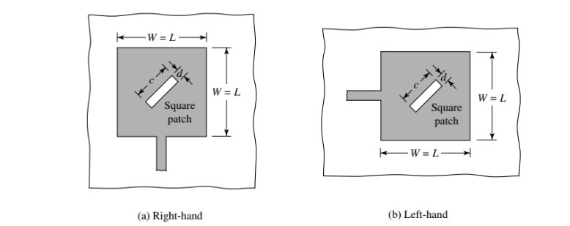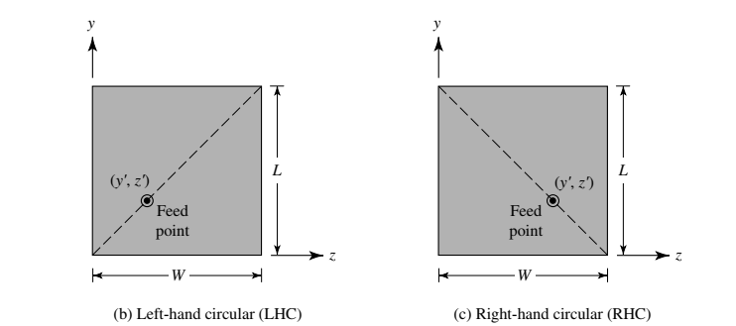

Figure 1: Rectangular and circular patch arrangements for circular polarization

Figure 2: Single-feed arrangements for circular polarization of rectangular microstrip patches.

Figure 3: Circular polarization for square patch with thin slots on patch

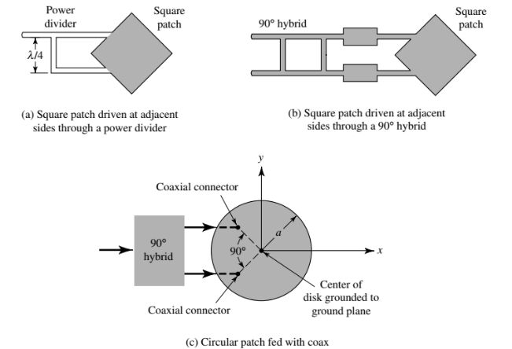

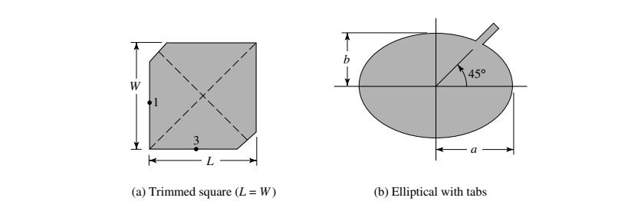

Figure 4: Circular polarization by trimming opposite corners of a square patch and by making circular patch slightly elliptical and adding tabs.

# Design Methodology

In this design, a 50 Ω source is used to feed the entire antenna array, with T-junctions employed to distribute the signal and ensure proper impedance matching throughout the array. The signal originates from the 50 Ω source and is initially split using a T-junction that divides the power into two branches, each with an impedance of 100 Ω. The impedance doubles at this stage to balance the power distribution. Each 100 Ω branch is then used to feed an individual antenna patch.

The design of a single circularly polarized antenna patch was executed using a dual-feed approach to achieve the required phase difference and impedance matching. A T-junction power divider splits the signal from the input port into two output ports. For impedance matching between the input and output ports, there were two options: either double the characteristic impedance of each output port relative to the input port, or keep the same characteristic impedance and introduce a λ/4 transformer for matching. Since the feeding lines for each antenna were 100 Ω, using 200 Ω lines for the output ports would result in extremely narrow traces, making them physically impractical. Therefore, the second option was chosen, and λ/4 transformers were used for impedance matching, based on the following equation:

Equation 1: Input impedance of lambda/4 section

Here, Zin represents the equivalent impedance of the output ports, Zload is the impedance of the input port, and Zo is the characteristic impedance of the λ/4 section.

To introduce the required 90° phase difference between the two output ports, the feeding point was adjusted so that one output arm of the T-junction was extended by λ/4. Each output port of the T-junction was then connected to an adjacent side of the antenna patch.

To further ensure impedance matching, λ/4 transformers were inserted between each T-junction output port and its respective patch side. The characteristic impedance of these transformers was calculated using Equation 1, where Zo is the impedance of the T-junction output port, and Zload is the input impedance of the antenna patch. The input impedance of the patch was determined by separating the patch and connecting it to a wave port through a 50 Ω line, then applying de-embedding to get the S11 at the edge of the patch.

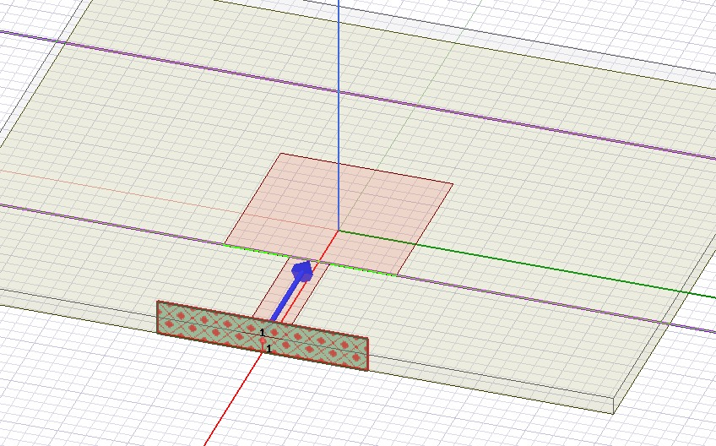

Figure 5: De-embedding Setup for Edge Impedance Calculation

For the patch design, equations governing microstrip patch antennas were used to calculate the optimal width (W) and length (L) of the patch at the operating frequency of 30 GHz. The substrate material had a relative permittivity εr of 3.55. Choosing the substrate thickness was a difficult task because of the contradicting requirements for antennas and transmission lines: for effective radiation, the thickness should ideally be greater than λ/8, while for transmission lines, the thickness should generally be less than λ/10. For this reason, we implemented two designs with two different thickness.

Due to the finite dimensions of the patch, the electric field at its edges generates fringing effects. While the majority of the electric field lines are concentrated within the dielectric substrate, some extend into the surrounding air. These fringing effects effectively increase the physical dimensions of the patch, as noted in [2]. Since they influence the resonance frequency, it is essential to account for them in the design process. To address this, the effective dielectric constant εreff is utilized.

Initial sizing of the patch was determined using the equations [2]:

Equation 2: Width of the microstrip patch for a resonance frequency fr

Equation 3: Effective dielectric constant of the dielectric substrate

Equation 4: Effective length of the patch

Equation 5: Effective length extension

Equation 6: Length of the microstrip patch for a resonance frequency fr

To ensure that the T-junction output ports encountered similar input impedances from the antenna, the width was designed to be approximately equal to the length. This approach facilitated consistent power distribution and effective matching within the patch.

This structured methodology ensured the successful integration of the T-junction, λ/4 transformer, and patch elements, culminating in a high-performance antenna array optimized for circular polarization and efficient operation at 30 GHz.

After deriving the initial starting points from the equations, we refined the dimensions through a series of iterative trial-and-error steps and optimizations to achieve the final design.

## Design A (substrate thickness = .81mm)

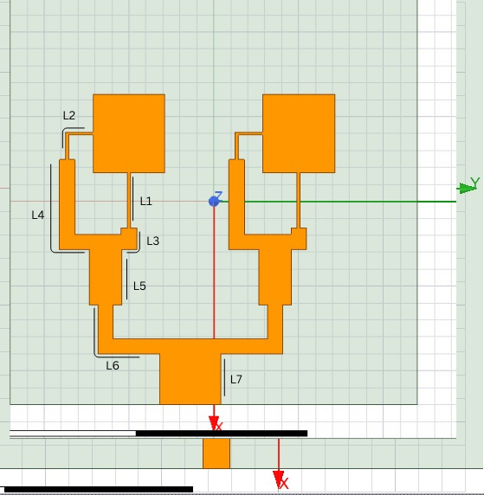

Figure 6: Design A (thickness = 0.81mm)

|  |  |  |  |
| --- | --- | --- | --- |
| Parameter | Dimension | Parameter | Dimension |
| Lpatch | 2.3274 mm | Wpatch | 2.12 mm |
| L1 | 1.62 mm | W1 | 0.0908132663 mm |
| L2 | 1.625968 mm | W2 | 0.0908132663 mm |
| L3 | 1.073067357 mm | W3 | 0.45 mm |
| L4 | 3.532120649 mm | W4 | 0.45 mm |
| L5 | 1.637337802 mm | W5 | 0.955 mm |
| L6 | 3.26481981 mm | W6 | 0.4395 mm |
| L7 | 1.5032327 mm | W7 | 1.789437 mm |

Table 1: Final Dimensions of Design A

## Design B (substrate thickness = .254mm)

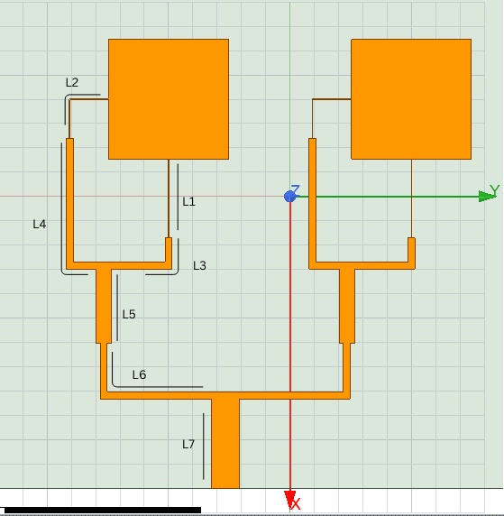

Figure 7: Design B (thickness = 0.254mm)

|  |  |  |  |
| --- | --- | --- | --- |
| Parameter | Dimension | Parameter | Dimension |
| Lpatch | 2.465mm | Wpatch | 2.456mm |
| L1 | 1.62mm | W1 | 0.0124mm |
| L2 | 1.6076mm | W2 | 0.0124mm |
| L3 | 1.8822276mm | W3 | 0.143mm |
| L4 | 3.302227649mm | W4 | 0.143mm |
| L5 | 1.53mm | W5 | 0.316mm |
| L6 | 3.4305mm | W6 | 0.143mm |
| L7 | 1.838272351mm | W7 | 0.568mm |

Table 2: Final Dimensions of Design B

# Simulation Results

## Verification

We want to verify the tool, Using Rectangle Microstrip Patch Antenna (RMPA) with inset feeding by checking that the results in paper [3] and the actual results obtained from simulation is close to each other.

We make the design with the same dimension and directivity constant to be sure when we simulate it the result will be the same as in paper.

Figure 8: Design layout from the paper

Figure 9: Design layout in HFSS

We chose some parameters that we care about in this project like return loss, bandwidth and the gain to make the comparison between it, not all parameters in the paper .

Simulated results in paper:

|  |  |  |  |  |  |
| --- | --- | --- | --- | --- | --- |
| Resonant.  Freq(GHZ) | Return Loss (dB) | VSWR  (dB) | -10 dB Bandwidth  (MHZ) | Gain  (dBi) | Directivity  (dB) |
| 10 | -19.61 | 1.82 | 226.2 | 6.58 | 6.83 |

Actual simulated results:

|  |  |  |  |  |  |
| --- | --- | --- | --- | --- | --- |
| Resonant.  Freq(GHZ) | Return Loss (dB) | VSWR  (dB) | -10 dB Bandwidth  (MHZ) | Gain  (dBi) | Directivity  (dB) |
| 9.96 | -20.49 | 1.645 | 200 | 6.5 | 6.9 |

We can see there are a bit difference in results and that may back to that we use latest version of the HFSS and paper used old version.

Figure 10: Return Loss vs freq. (Paper results)

Figure 11: Return Loss vs freq. (simulation results)

Figure 12: VSWR versus freq. (Paper results)

Figure 13: VSWR versus freq. (simulation results)

Figure 14: Radiation pattern (paper results)

Figure 15: Radiation pattern (simulation results)

### Conclusion of Verification

From the above figures, we can see that the result obtained from the simulation is very close to that obtained from the paper. This indicates that the tool has been successfully verified, demonstrating its accuracy and consistency in reproducing results aligned with theoretical or experimental data. The agreement between the simulation and the reference results confirms the reliability of the tool for performing simulations in similar scenarios. This verification establishes confidence in the tool’s ability to provide credible outputs, making it a dependable choice for further analysis.

## Results

This section provides an in-depth analysis of the simulated antenna designs, focusing on their performance metrics and key observations. The simulations were conducted to compare the impact of varying substrate thicknesses and evaluate the design choices for achieving optimal radiation and impedance matching at the target operating frequency of 30 GHz. Using HFSS, the designs were analyzed for return loss, gain, axial ratio, and radiation efficiency to validate the effectiveness of the proposed methodology.

The simulation setup was configured to ensure accurate and reliable results. The frequency range was centered around 30 GHz, aligning with the antenna's intended operating range. Boundary conditions were defined using a perfect electric conductor (PEC) to accurately model the ground plane and the patch, while lumped ports were employed as the excitation type to simulate real-world feeding conditions. This comprehensive simulation approach allowed for a detailed evaluation of the designs and identification of the optimal configuration.

### Design A (Substrate Thickness = 0.81 mm)

#### Return Loss (S11)

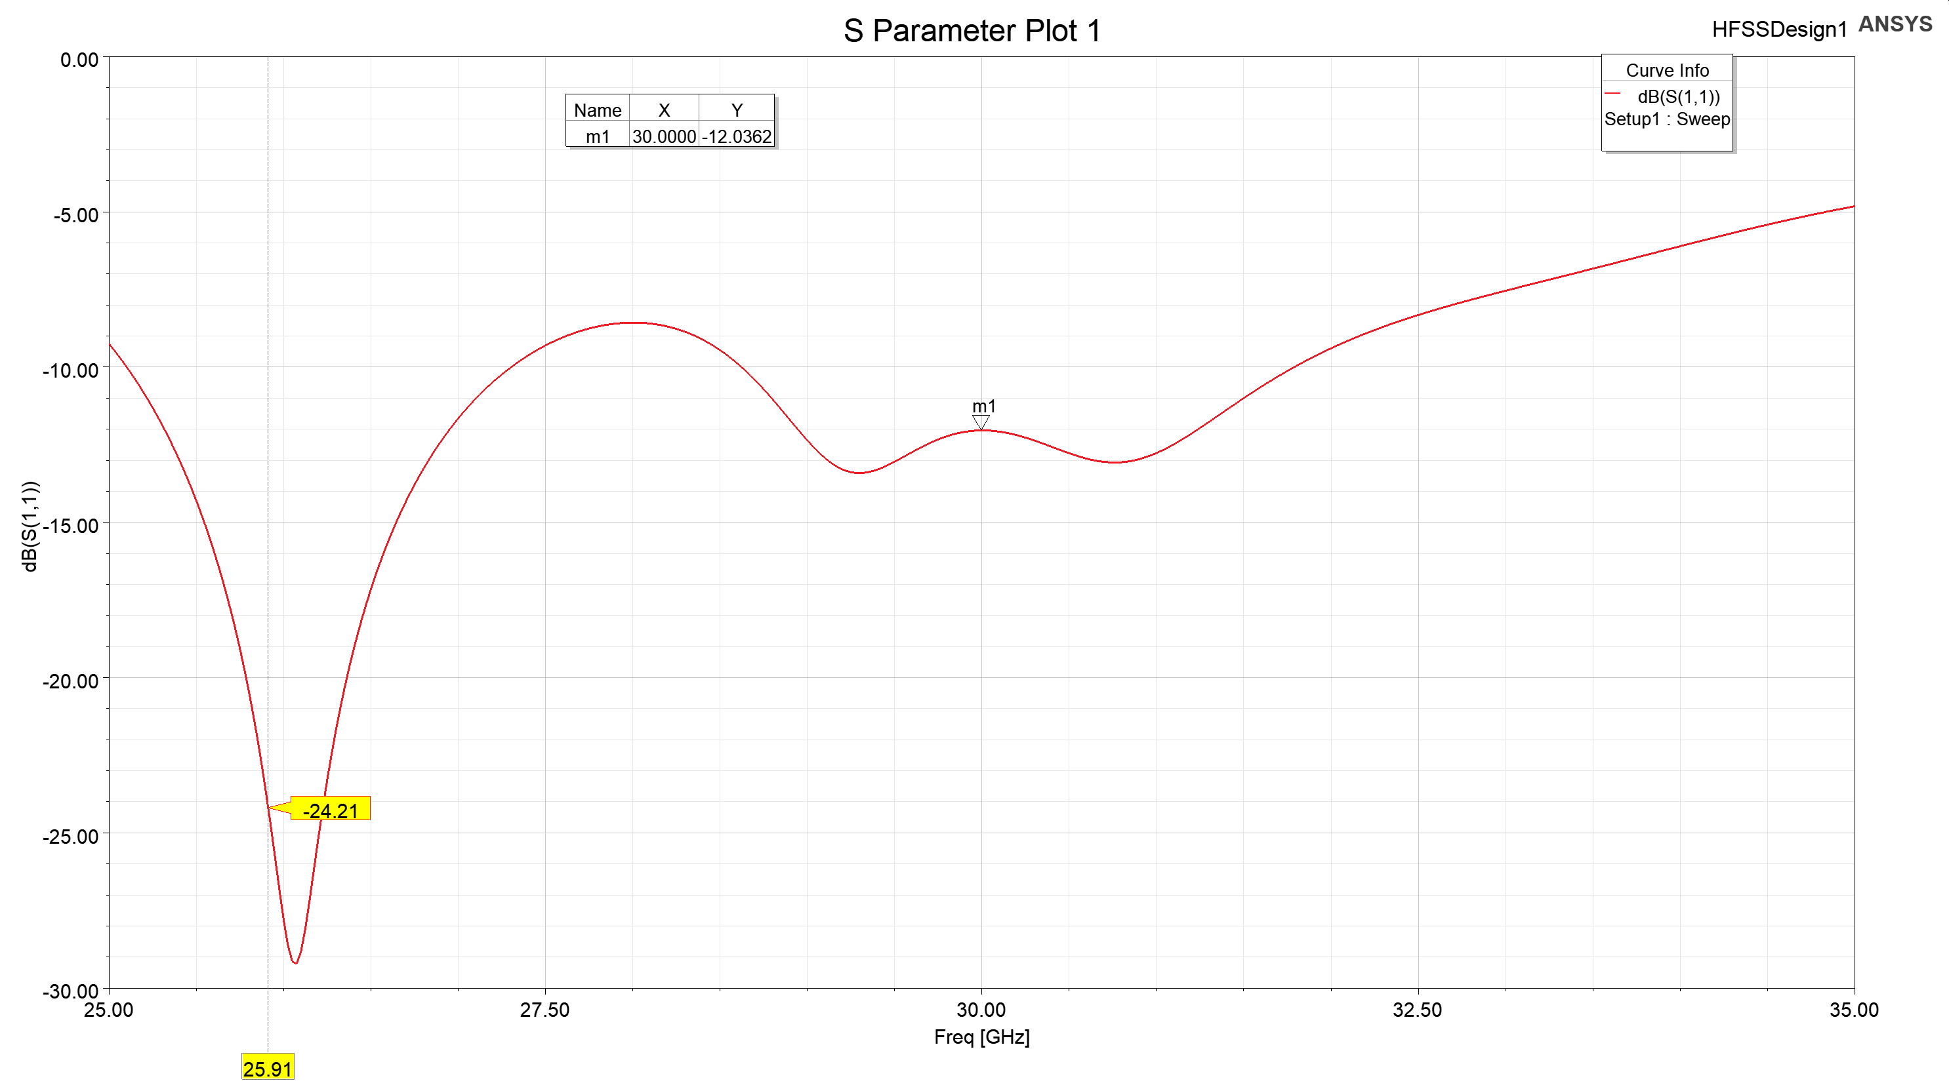

Figure 16: S11 of design A

* **Observation**: The return loss achieved was -12 dB (below the -10 dB threshold) across the operating bandwidth, indicating satisfactory impedance matching. However, the minimum return loss was observed at 26 GHz, slightly deviating from the target frequency of 30 GHz.
* **Analysis**: This shift suggests a need for further optimization of the feed network or patch dimensions to align the resonance with the intended operating frequency.

#### Axial Ratio

|  |
| --- |
| Figure 17: Axial ratio of design A |

* **Observation**: The axial ratio achieves a value of 1.88 dB at θ = 0°, satisfying the condition for circular polarization (AR ≤ 3 dB).
* **Analysis**: Circular polarization is effective in the broadside direction, critical for satellite and wireless communication systems.

#### Gain

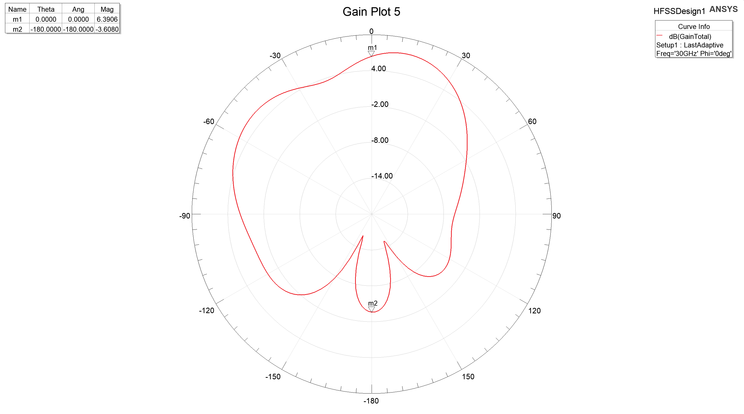

Figure 18: Gain of design A

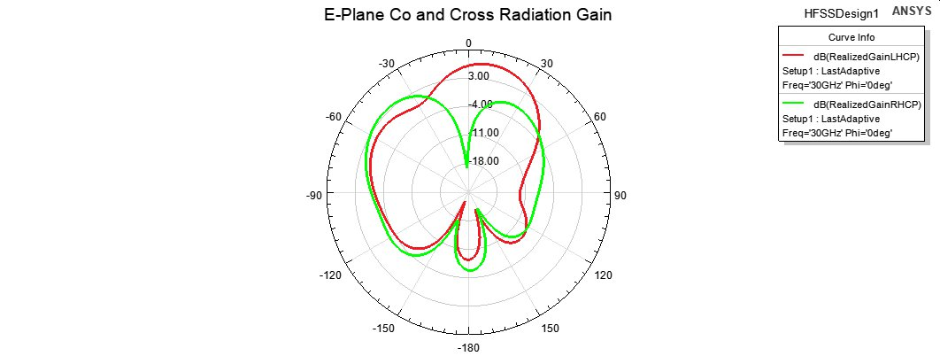

Figure 19: E-Plane Co and Cross Radiation Gain of design A

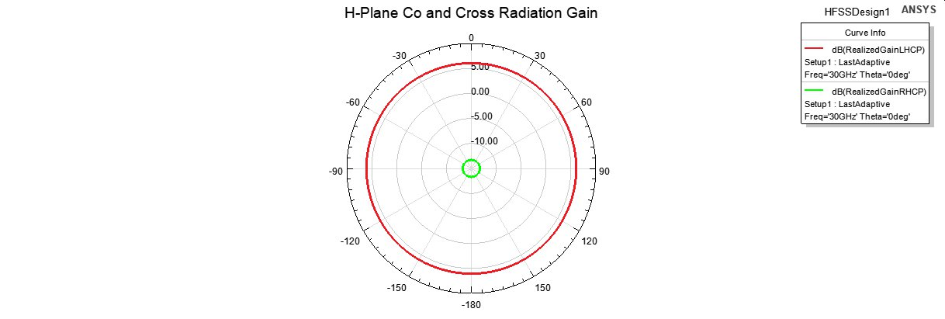

Figure 20: H-Plane Co and Cross Radiation Gain of design A

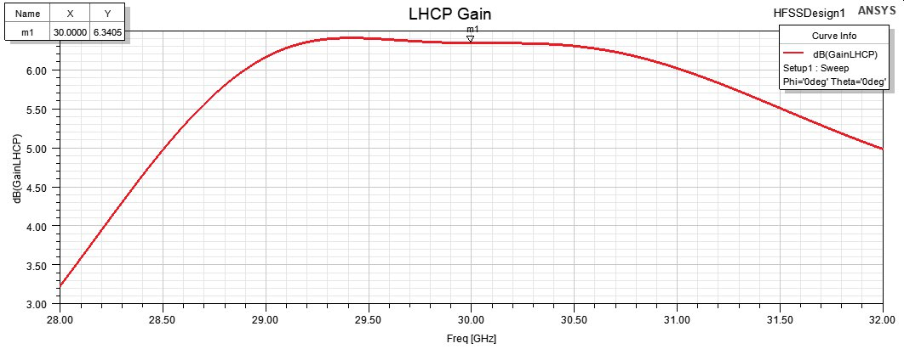

Figure 21: LHCP gain of design A

* **Observation**: The antenna achieves a gain of 6.39 dB at θ = 0°. The back lobe gain is -3.61 dB, this indicates that there is asymmetry in the design. Some deformation can be seen in the radiation pattern, mostly due to the radiation of the transmission lines because of the relatively large thickness.
* **Analysis**: Strong LHCP radiation and suppressed cross-polarization confirm the antenna's polarization purity and efficiency within the operational bandwidth.

#### Input Impedance

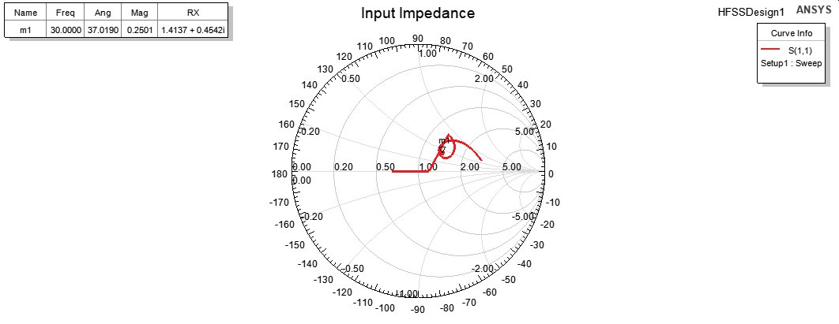

Figure 22: Input Impedance of design A

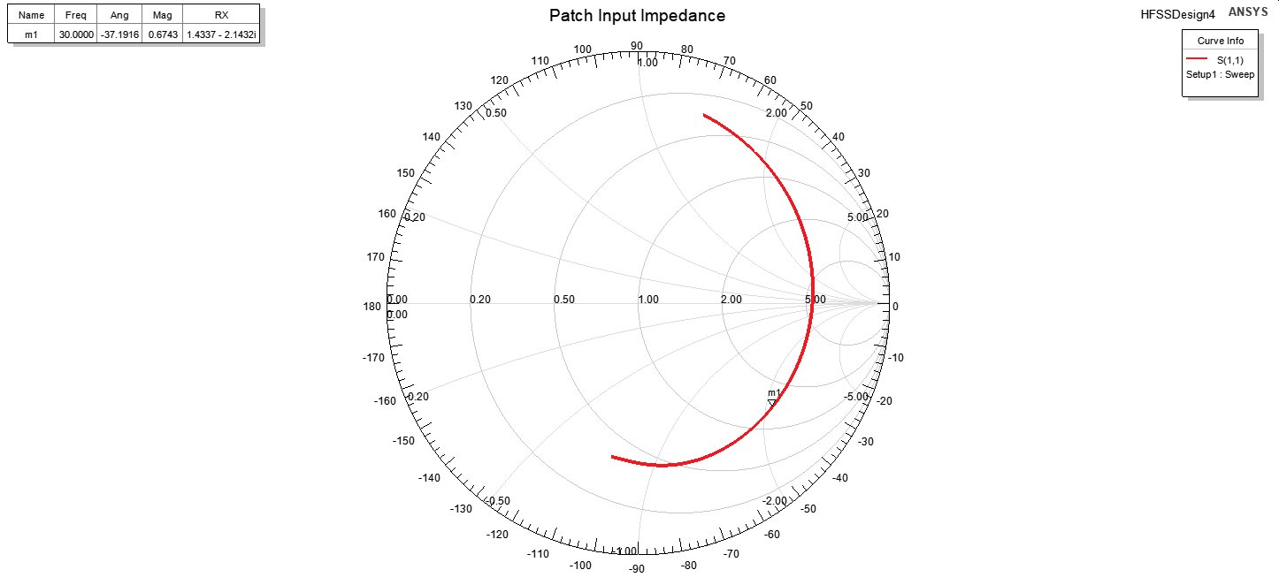

Figure 23: Input Impedance of patch A

* **Observation**: The Smith chart reveals good impedance matching near 30 GHz, with minimized reflection.

#### Radiation Efficiency

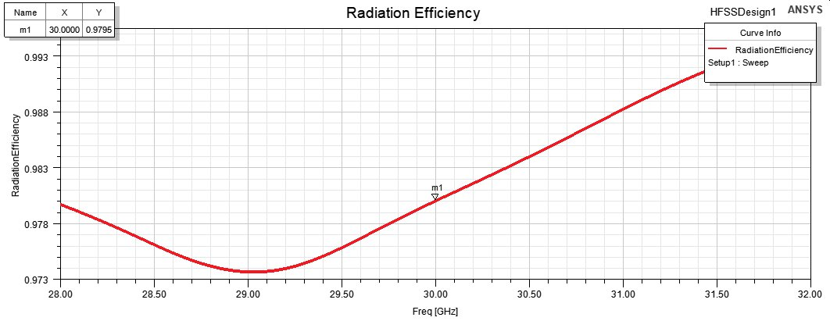

Figure 24: Radiation Efficiency of design A

* **Observation**: The radiation efficiency was measured to be approximately 0.9795 showcasing effective energy conversion.

### Design B (Substrate Thickness = 0.254 mm)

#### Gain

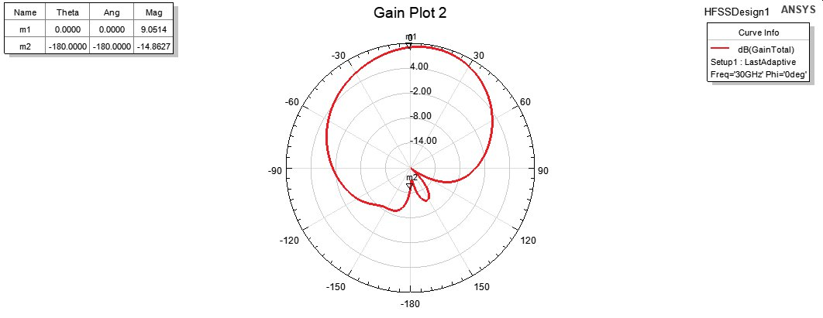

Figure 25: Gain of Design B

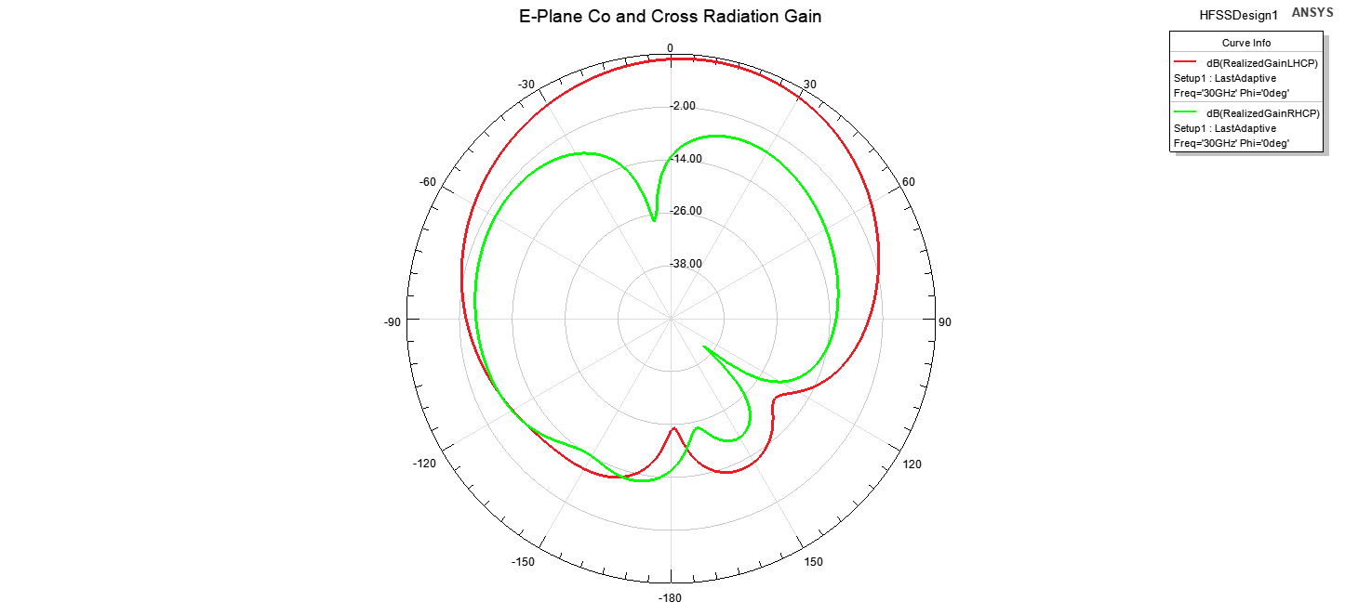

Figure 26: E-Co and cross radiation gain of design B

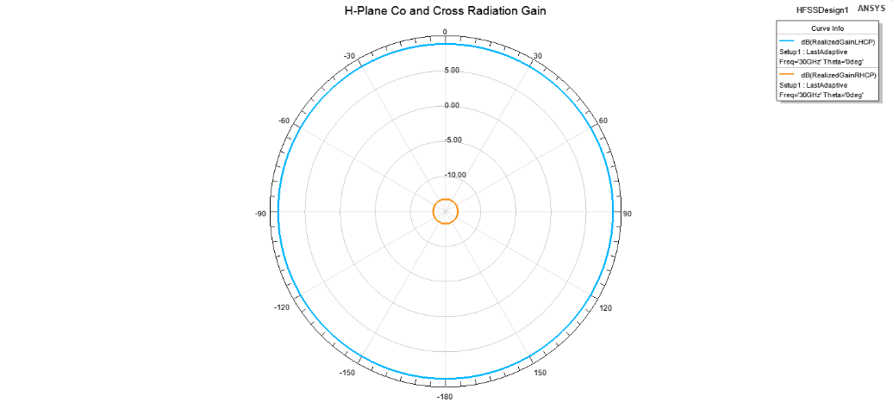

Figure 27: H-Co and cross radiation of design B

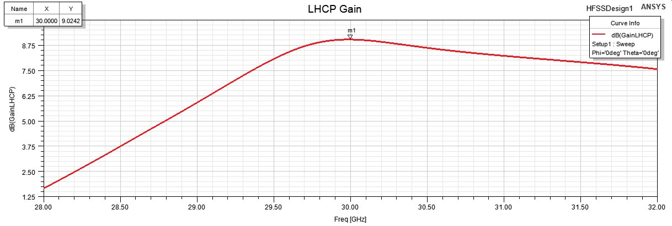

Figure 28: LHCP of design B

* **Observation**: The broadside gain was measured at 9 dB, with a front-to-back ratio of 23 dB. Still, slight deformation in the radiation pattern was observed.
* **Analysis**: The strong directional radiation and high front-to-back ratio highlight the design's efficiency, while the deformation may be due to minor radiation from the transmission lines (much less than design A).

#### Axial Ratio

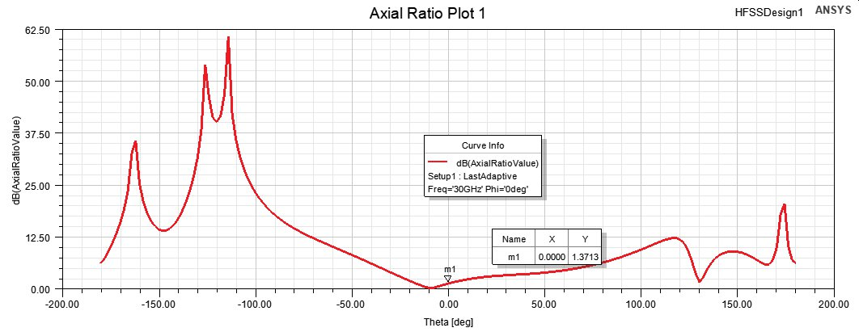

Figure 29: Axial Ratio of Design B

* **Observation**: The axial ratio at broadside was 1.37 dB, well within the acceptable range for circular polarization.
* **Analysis**: This confirms effective polarization generation without significant degradation.

#### Return Loss (S11)

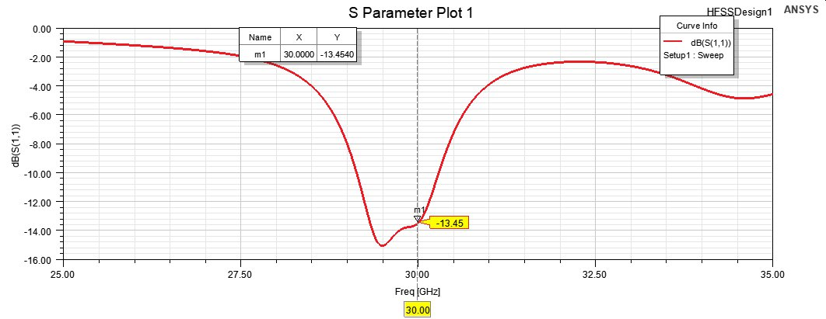

Figure 30: Return Loss of Design B

* **Observation**: The return loss achieved a value of -13.45 dB at 30 GHz, confirming efficient power transfer.
* **Analysis**: The resonance minimum occurred near 29.5 GHz, suggesting further tuning is needed for peak performance at 30 GHz.

#### Input Impedance

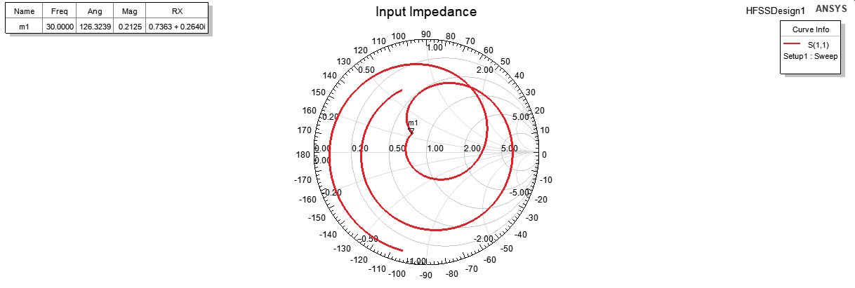

Figure 31: Input Impedance of design B

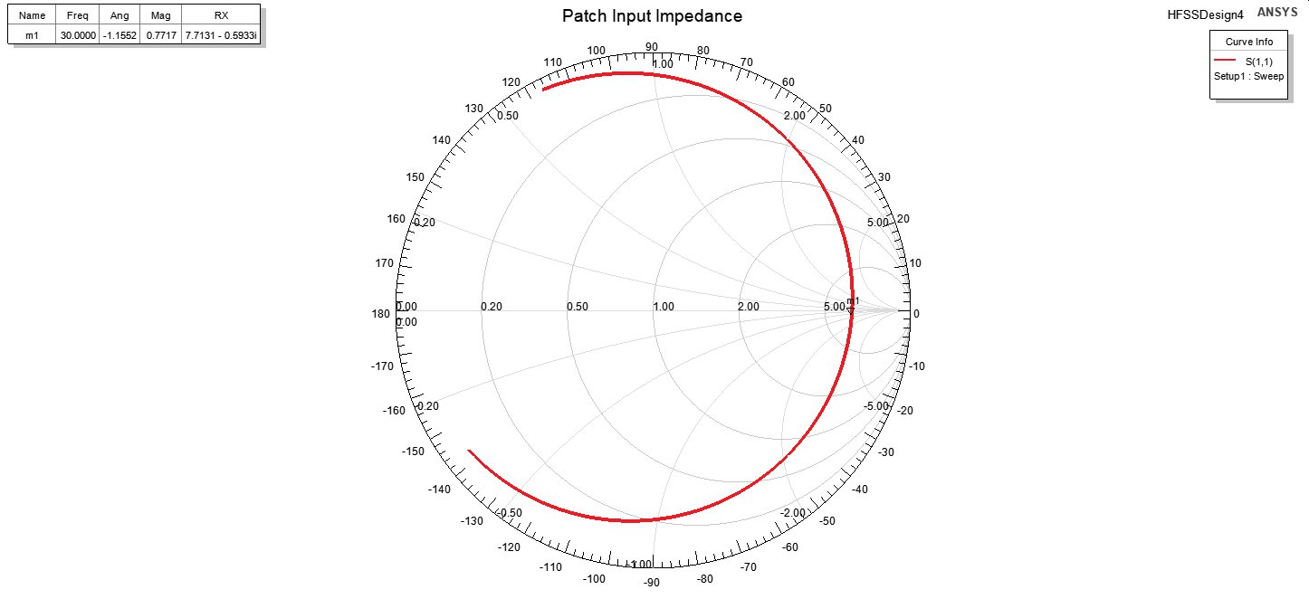

Figure 32: Input Impedance of patch B

* **Observation**: The Smith chart indicates acceptable impedance matching near the target frequency.

#### Radiation Efficiency

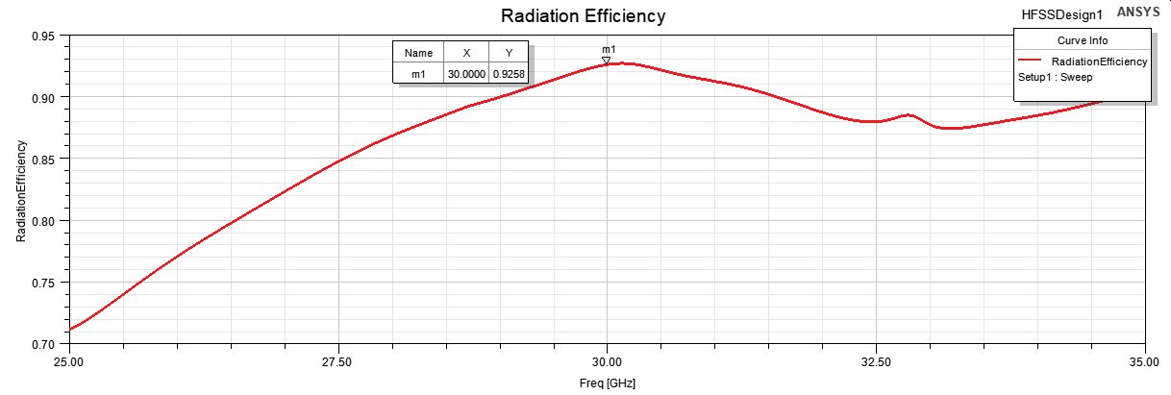

Figure 33: Radiation Efficiency of design B

* **Observation**: The radiation efficiency was approximately 0.9258 demonstrating effective performance.

### Comparison of Design A and Design B (results discussions)

| **Parameter** | **Design A (0.81 mm)** | **Design B (0.254 mm)** |
| --- | --- | --- |
| **Return Loss (S11)** | -12 dB at 26 GHz (shifted) | -13.45 dB at 30 GHz |
| **Axial Ratio** | 1.88 dB at θ = 0° | 1.37 dB at θ = 0° |
| **Gain** | 6.39 dB at θ = 0° | 9 dB at broadside |
| **Radiation Efficiency** | ~0.9795 | ~0.9258 |
| **Front-to-Back Ratio** | 10 dB | 23 dB |
| **Radiation Pattern** | LHCP | LHCP |
| **Resonance Frequency** | Slightly shifted (26 GHz) | Closer to target (30 GHz) |
| **Total Bandwidth** | 2.58% | 3.05% |
| **3dB-Beamwidth** | 48° | 72° |

Table 3: Designs Specifications

Design B better aligns with the performance specifications due to its higher gain, improved return loss, and closer resonance frequency, making it the preferred choice for the target application. Further sections will be focused solely on design B.

# Bonus: Mutual coupling and Gain vs Element Spacing

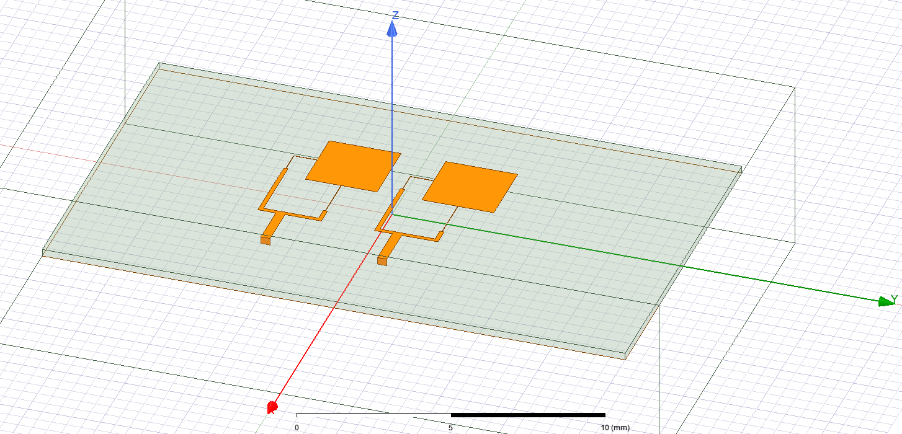

Figure 34: Setup for sweeping the element spacing

* We will first look at by defining two ports and sweeping from the minimum distance between the two patches to nearly to touches each other to a maximum sweep of

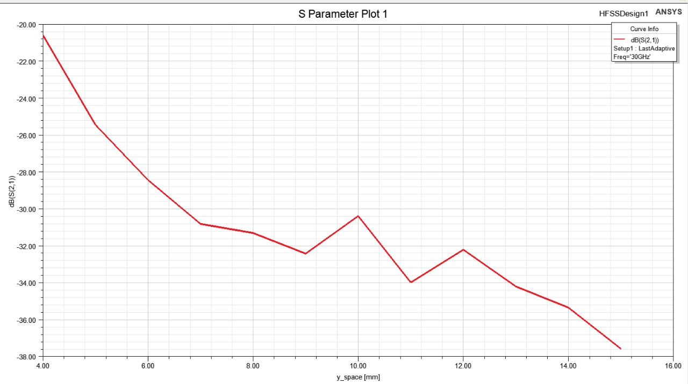

Figure 35: S21 vs Element spacing

From the previous figure we can clearly see clearly decreasing with spacing ideally we don’t want any mutual coupling so we want it as close to as possible so we benefit from big element spacing to minimize the mutual coupling

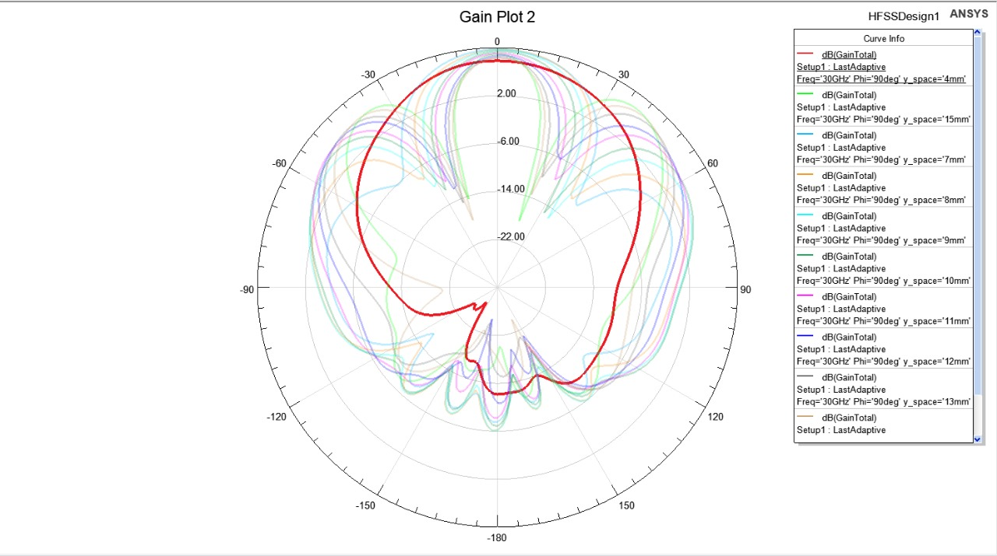

Figure 36: Gain Vs Element spacing

We can see from Figure 34 that at first @y_spacing = 4mm there’s wasn’t any side loops forming

But as we increased the spacing slightly to firstly the 🡪 increased but at the cost of some grating lobes appearing at with -6dB and the pattern continues for a while with increasing Y_space to a point where the grating lobes are really close to the main beam and is decreasing so we can find the optimal spacing to get the biggest gain

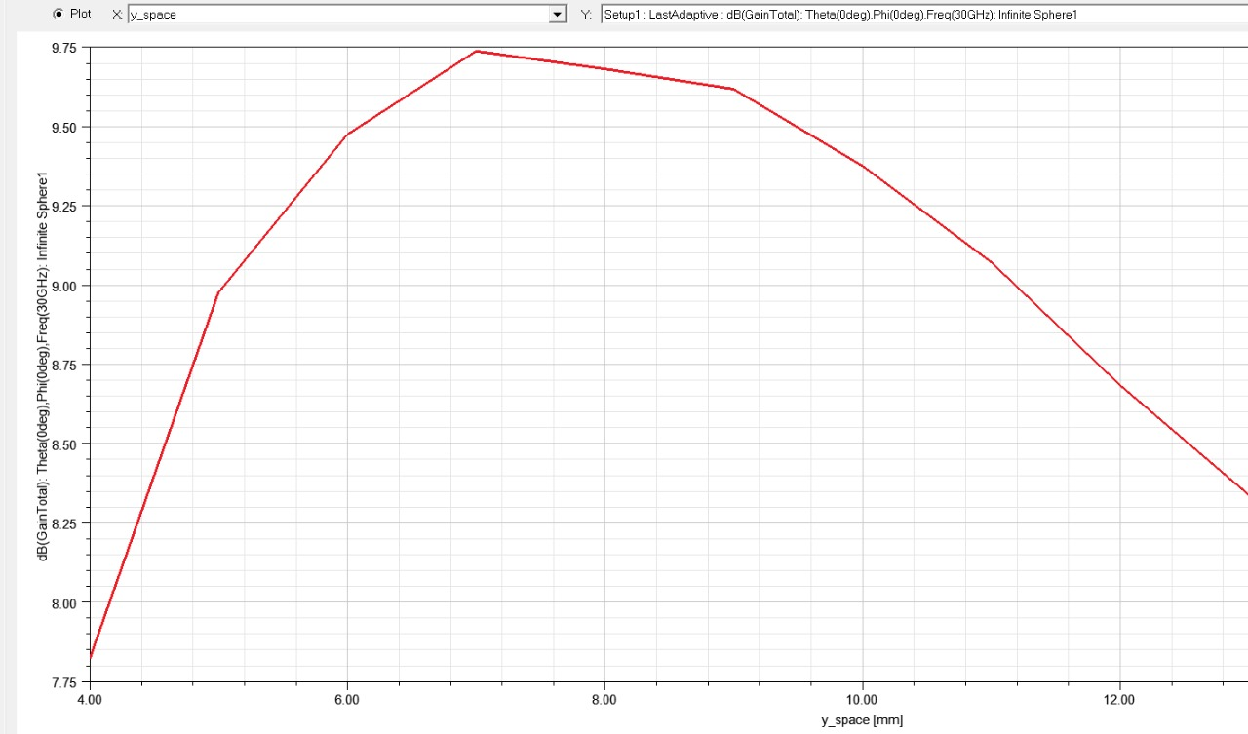

Figure 37: Gain total with Element spacing

From the graph the max occurs at spacing = 7mm which is around 0.7 at that point if there’s was a requirement on the SLL(side lobe level) or the FNBW(First null beam width) we would check and if not satisfied we may decrease the spacing slightly

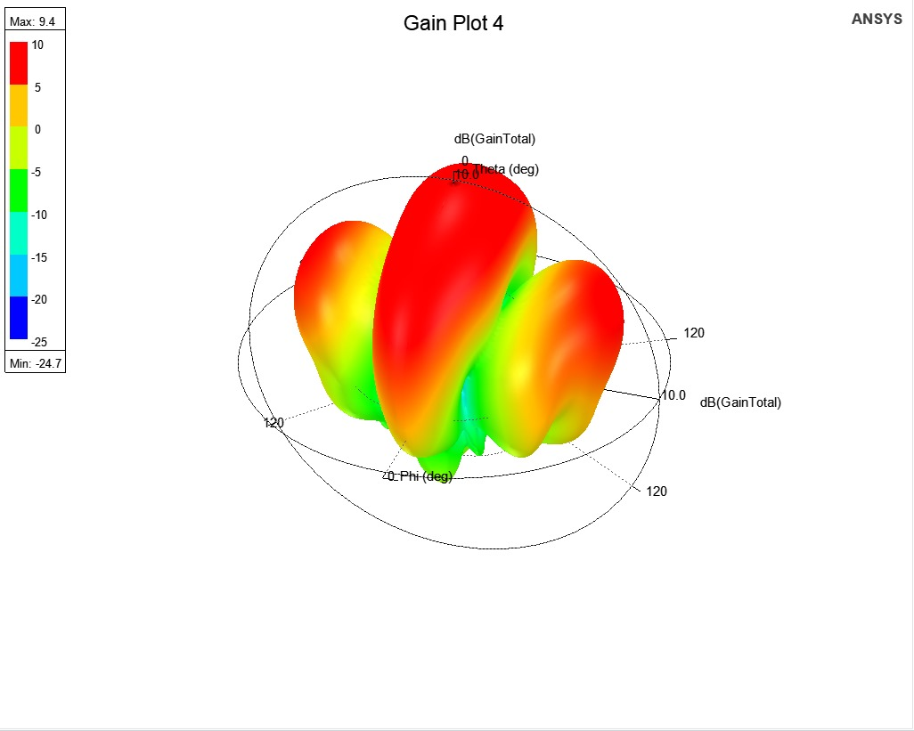

Figure 38: 3D plot at the proposed element spacing

So we conclude that a high spacing introduces grating lobes and may even decrease the broadside gain so that’s a tradeoff between the gain and the mutual coupling

* Key takeaways [3]

1) As inter-element spacing increases, the grating lobes increase in size, number and levels.

2) Increase in inter-element spacing also increases the directivity of the main lobe.

3) Increasing the spacing to 1.0λ, is a bad element spacing as more grating lobes are developed equal in size and level with the main lobe.

4) Therefore, the best directivity (radiation pattern) can only be obtained when the element spacing is within 0.1 - 0.7λ.

# Circuit Model

With the result of a single dual feed antenna, we will get the circuit model for one antenna then for the whole system

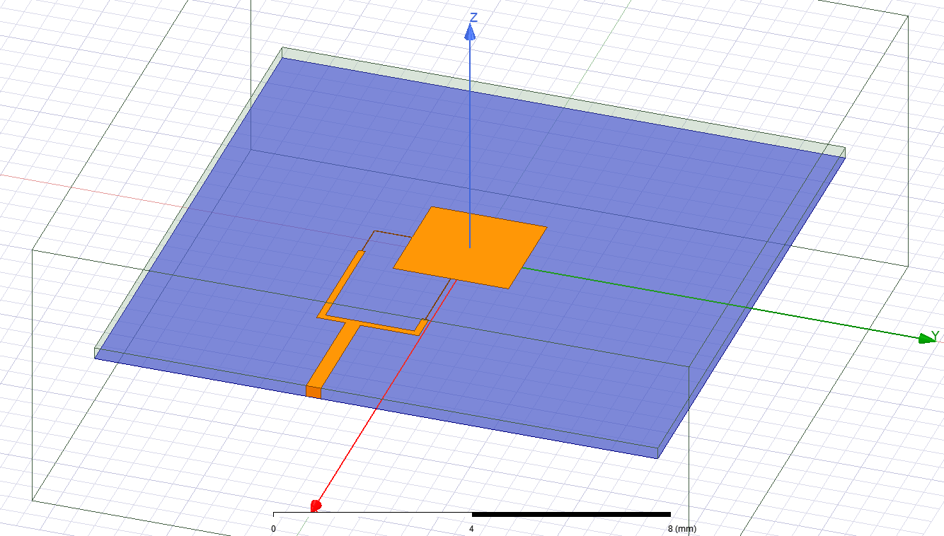

Figure 39: Single Dual fed antenna

With as follows taking the -10dB as a threshold the Figure 40 shows the minimum at the desired (30Ghz) frequency to be -15.884dB and the values at -10db are 29.28 and 30.44 Ghz respectively

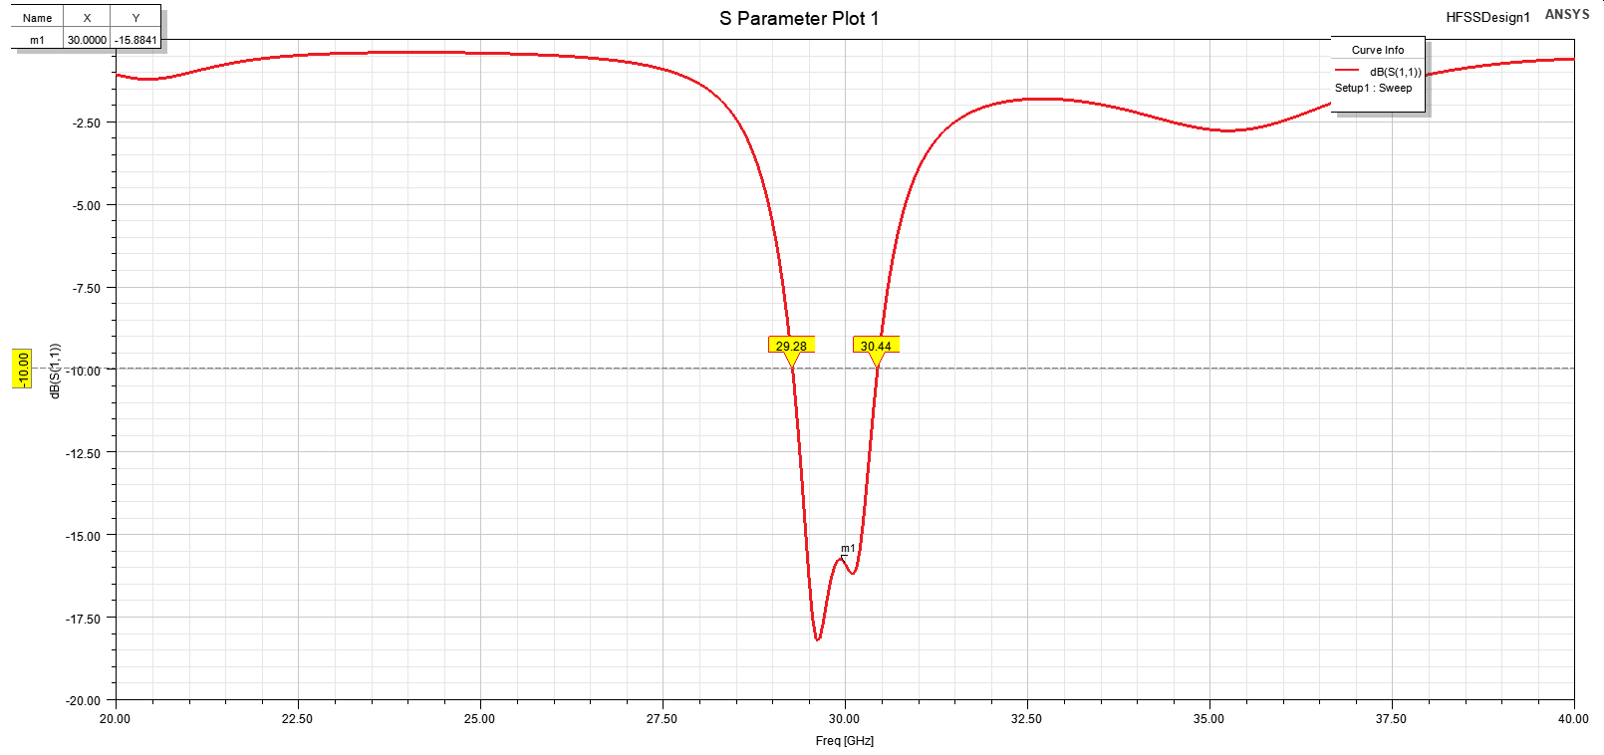

Figure 40: S11 of Single Dual fed ant.

## ADS Circuit model and Verification

To get the desired response is similar to a BPF or a BSF with a high selectivity i.e. Quality factor

so, we will model with a combination of both parallel RLC and Series RLC components and let the optimization get the required values for graph [1].

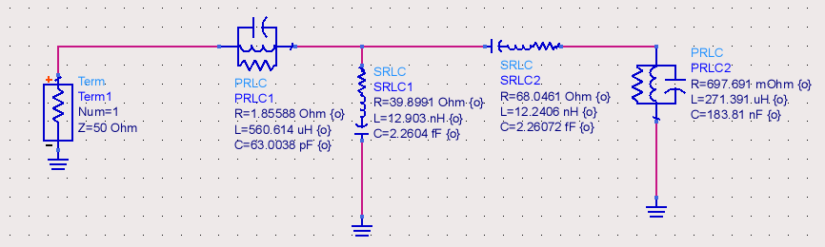

Figure 41: Single Antenna model on ADS

Running the Quasi-newton and Gradient optimization we get the following in Figure 42

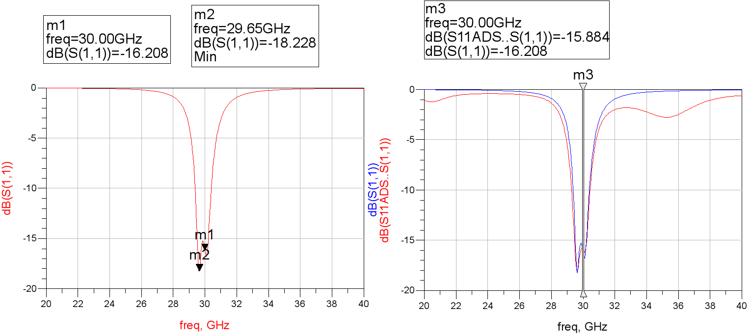

Figure 42: S11 ADS model BLUE is HFSS results, and Red is ADS results

### Transmission line model

Figure 43: Equivalent circuits for a reciprocal two-port network. (a) T equivalent. (b) π equivalent

By taking the model of the transmission line and modifying it to some extent we are going to assume a low loss line

so neglecting both

and using ABCD parameter matrix for a transmission line of length l and characteristic impedance Zo and

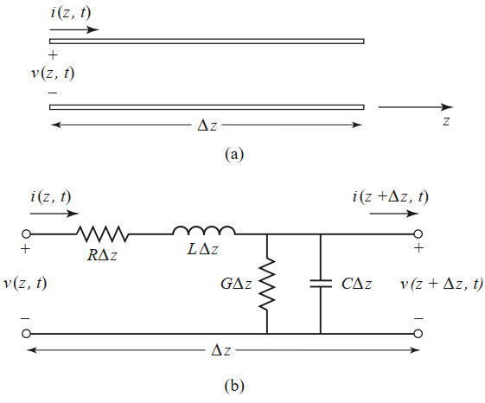

represinting the Transmission line in a Pi config

we get using appendix Table 3 Equivalent Circuits for Two-Port Networks [4]

Figure 44: Voltage and current definitions and equivalent circuit for an incremental length of transmission line. (a) Voltage and current definitions. (b) Lumped-element equivalent circuit network as follows

For the whole antenna setup, we put the model of the transmission line and using ABCD parm of trans. Line network as follows

The block called Ant_model is the same as in Figure 41 but abstracted into a symbol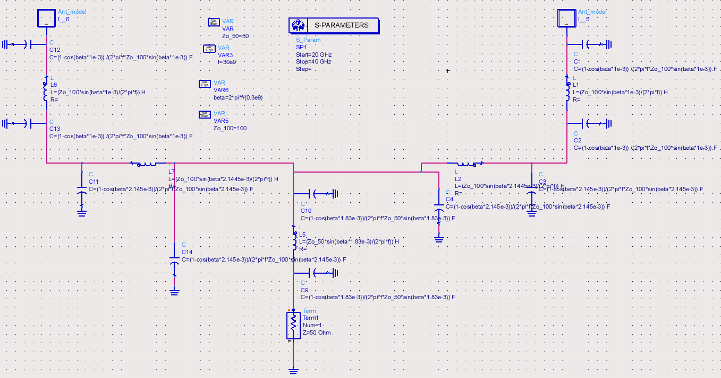

Figure 45: Patch ADS setup

And let’s see in Figure 46 which shows very close values for the equivalent model and the slight inaccuracy maybe due to the model used to model the single antenna so a more complex model will yield more accurate data modelled but on the expense is the complexity and optimization time of ADS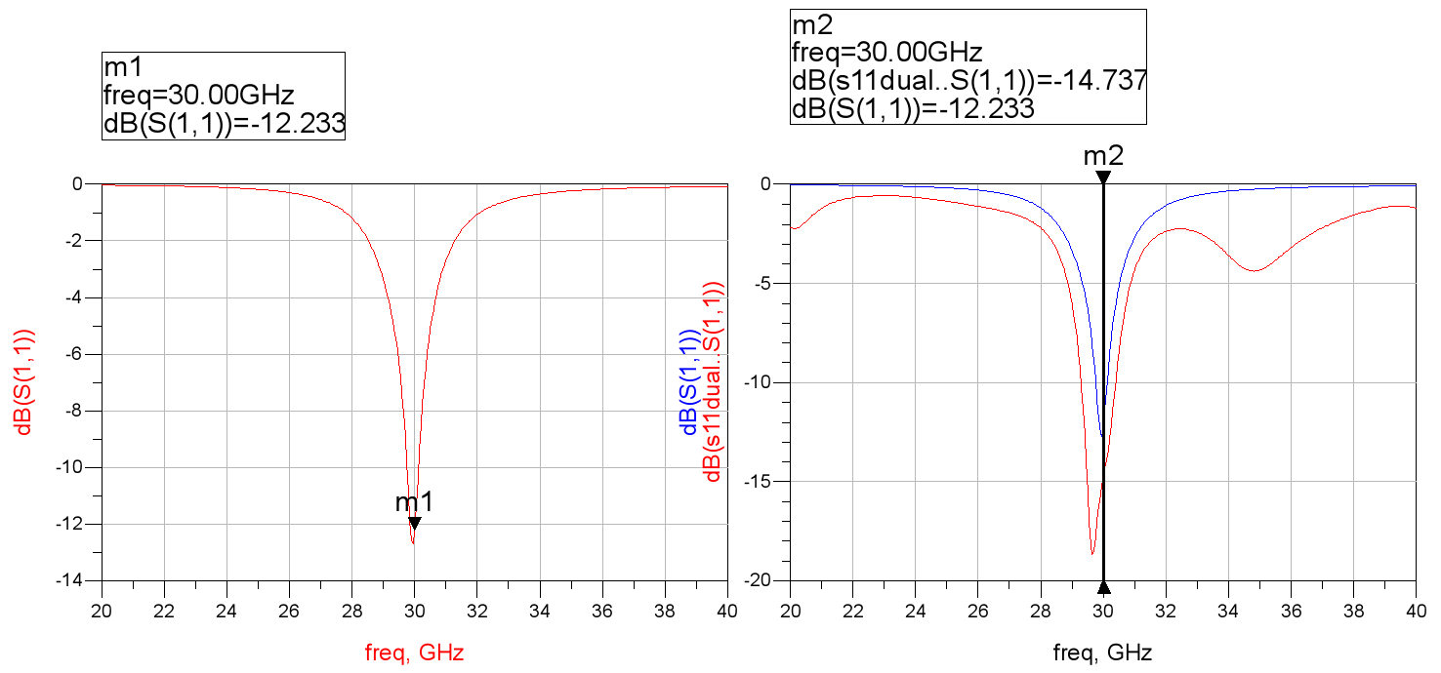

Figure 46: S11 2-patch ADS, BLUE is HFSS results, and Red is ADS results

# Conclusion and future work

## conclusion

This report presented the design, simulation, and analysis of a 2-element circularly polarized microstrip patch antenna array operating at 30 GHz. Two designs, differentiated by substrate thicknesses (0.81 mm and 0.254 mm), were evaluated to optimize performance parameters including return loss, gain, axial ratio, and radiation efficiency.

Design B, with a substrate thickness of 0.254 mm, was identified as the superior configuration, achieving higher gain, improved return loss, and better alignment of the resonance frequency with the target of 30 GHz. It also demonstrated robust circular polarization with an axial ratio well within the acceptable range, making it suitable for high-frequency communication systems.

## Future work

**Substrate Material Assessment:** Further exploration of substrate materials with different dielectric constants (DK) and thicknesses is required to evaluate their effects on radiation efficiency, bandwidth, and polarization quality. A balance between low DK for enhanced bandwidth and adequate thickness for efficient radiation should be prioritized.

**Axial Ratio and Bandwidth Optimization:** Techniques such as introducing additional slots, stubs, or parasitic elements can be investigated to widen the bandwidth and improve the axial ratio for broadband applications.

**Alternative Circular Polarization Methods:** Various feed mechanisms and patch geometries, such as dual-feed arrangements, asymmetrical patches, or novel trimming techniques, can be explored. Comparative studies should assess their effectiveness in improving bandwidth, polarization purity, and manufacturability.

# References

|  |  |
| --- | --- |
| [1] | J.Huang, "Circularly Polarized Conical Patterns from Circular Microstrip Antennas," *IEEE Transactions on Antennas and Propagation,* pp. vol. 32, no. 9, pp. 945-949, Sept. 1984.. |
| [2] | C. A. Balanis, Antenna theory: analysis and design, John wiley & sons, 2015. |
| [3] | N. C. Okoro and L. Oborkhale, "Design and simulation of rectangular microstrip patch antenna for X-Band application," *Global Journal of Research in Engineering,* 2021. |
| [4] | D. E. B. S. A. A. Ofem U. Omini, "Impact of Element Spacing on the Radiation Pattern of Planar Array of Monopole Antenna," *Journal of Computer and Communications.* |
| [5] | b. P. D. M., Microwave Engineering. |

Table 4: Equivalent Circuits for Two-Port Networks [4]

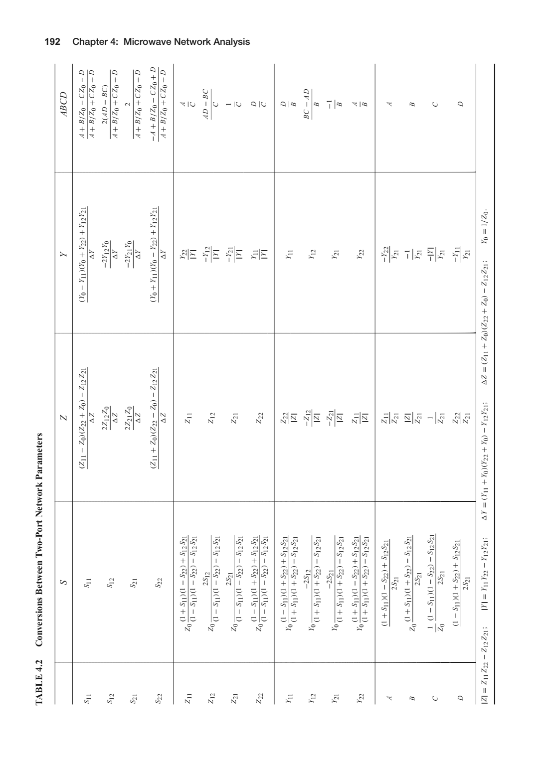

1. It can be calculated by hand but to get the exact shape of the curve is quite hard