|  |
| --- |
| EECE26 |
| Communication Project Super-Heterodyne Receiver |
| Cairo University Faculty of Engineering |

|  |
| --- |
| Youssef Samir Zidan  9220988  Sec 4 |

Contents

1. Discussion 0

a) Discuss how you designed each of the blocks of the system in Figure 1. 0

b) Answer the following in your document: 3

1- In two or three sentences, discuss the role of the RF, the IF and the baseband detector. Indicate why we need the IF stage? 3

2- Suppose you want to demodulate the first station (i.e. at 𝜔0), plot the spectrum of the outputs of the RF, the IF and the baseband stages. Hint: use the ‘fft’ command in MATLAB. You may also find the ‘fftshift’ command useful. 3

3- Use the command ‘sound’ on the demodulated signal and check whether you can successfully listen to the radio station. Please comment about this step in your report 4

4- Add “noise” to your signal and then play “sound” the signal. What is the effect of the noise? 4

5- Repeat parts 2 and 3 but after removing the RF BPF. That is, the RF stage does not exist, what would happen if you try to demodulate the station at 𝜔0? 4

6- What happens (in terms of the spectrum and the sound quality) if the receiver oscillator has frequency offset by 0.2 KHz and 1.2 KHz? 5

Samples (First to run) 6

Modulation (second to run) 7

Demodulation 8

1. Discussion

## a) Discuss how you designed each of the blocks of the system in Figure 1.



AM

Modulator



Baseband Detection

IF Stage

𝜔𝐼𝐹

Oscillator

𝜔𝐶 + 𝜔𝐼𝐹

Mixer

RF Stage

𝜔𝑐

* The first stage is that I extracted the data from the signals getting important parameters like sampling frequency and BWs
* Then it came time for modulating which was as straight forward as just multiplying the signal by .*cos(2pi*Fc*t) in an element wise multiplication
* 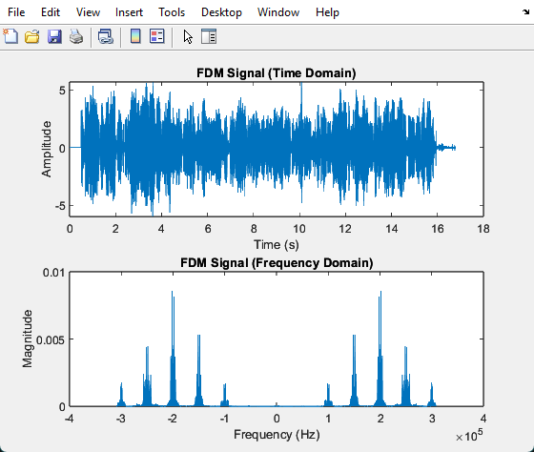
* Then the another function takes the whole receiver part
* At RF stage the user selects the required signal then a BPF is placed at the intended frequency to minimize the image interference
* Then a mixer simply multiplies with. *Cos(2pi*(Fc+IF) *t) to get the band in intermediate frequency which could be an input directly to an ADC (but more BW overhead for ADC)
* Then we put another BPF filter in IF stage to get rid of any interference and other signals
* For the last stage we modulate again with IF only to get the signal to the baseband, then finally we put a LPF to get rid of all noise and interference and hear the signal clearly

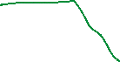

## b) Answer the following in your document:

### In two or three sentences, discuss the role of the RF, the IF and the baseband detector. Indicate why we need the IF stage?

* RF detector selects the desired station from multiple signals when input signal is at Wc

IF detector converts any signal to a fixed intermediate frequency regardless of the original carrier frequency. which simplifies the hardware and improves filtering performance

* Baseband detector is used to demodulate the signal from IF to the original Baseband

### Suppose you want to demodulate the first station (i.e. at 𝜔0), plot the spectrum of the outputs of the RF, the IF and the baseband stages. Hint: use the ‘fft’ command in MATLAB. You may also find the ‘fftshift’ command useful.

* 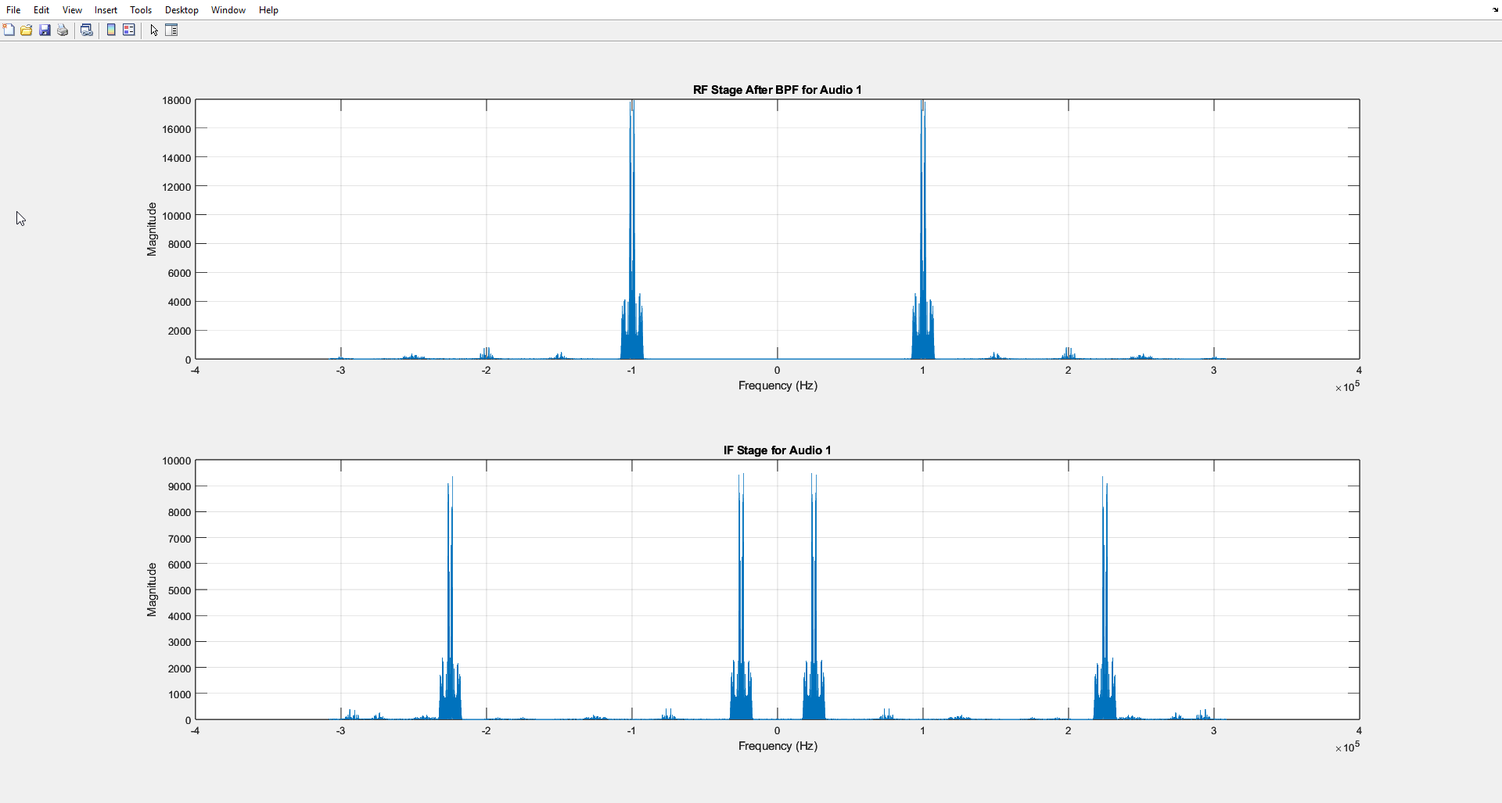
* 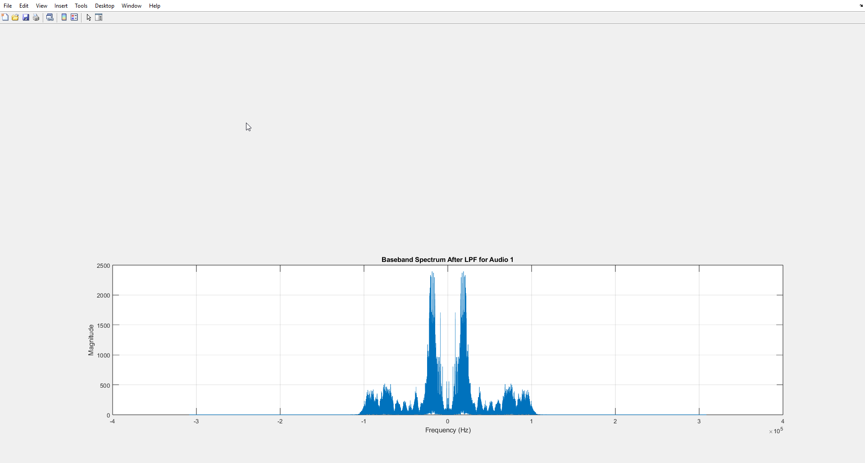

### Use the command ‘sound’ on the demodulated signal and check whether you can successfully listen to the radio station. Please comment about this step in your report

* Yes, I can hear it clearly and I had to down sample again to hear it

### Add “noise” to your signal and then play “sound” the signal. What is the effect of the noise?

* Using received Signal = awgn(sentsignal,10);
* I heard a white noise with the signal وشوشة

### Repeat parts 2 and 3 but after removing the RF BPF. That is, the RF stage does not exist, what would happen if you try to demodulate the station at 𝜔0?

* I only heard the image signal at 150khz completely overlapping and shadowing the intended signal
* And it’s visible in graph 2 IF stage that most of the interfering signals are still there
* I also would like to mention the I didn’t hear any image noise from signal no.5 as there’s no signal at “2*IF” from it
* 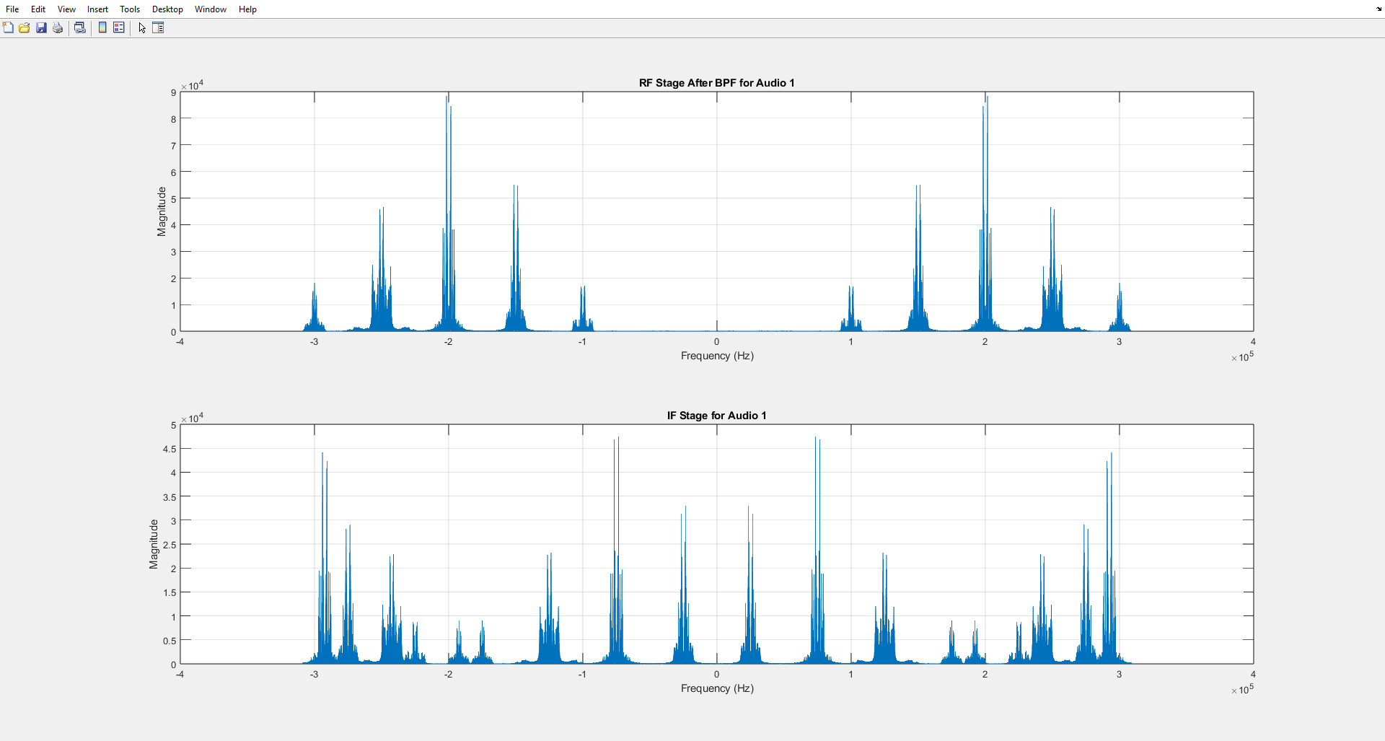
* 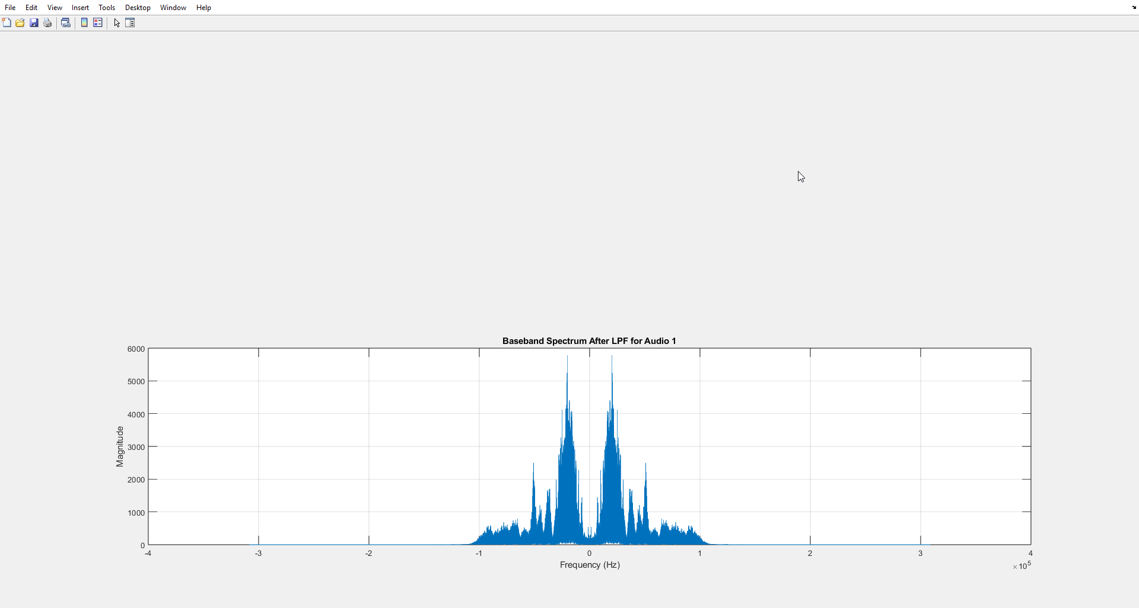

### What happens (in terms of the spectrum and the sound quality) if the receiver oscillator has frequency offset by 0.2 KHz and 1.2 KHz?

* carrier_LO = cos (2 * pi * (fc_mod + IF + offset) * t); % Local oscillator signal
* at 0.2khz I could barely hear the signal with very annoying sound effect
* 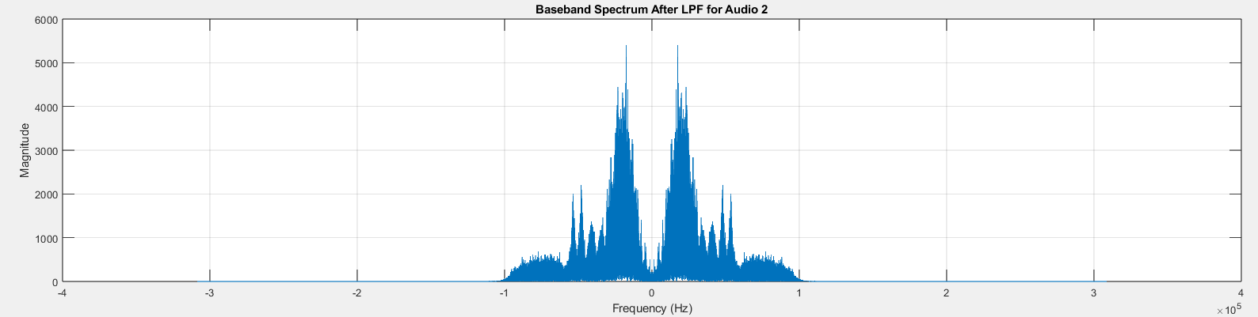
* at 1.2khz I couldn’t hear the signal at all
* 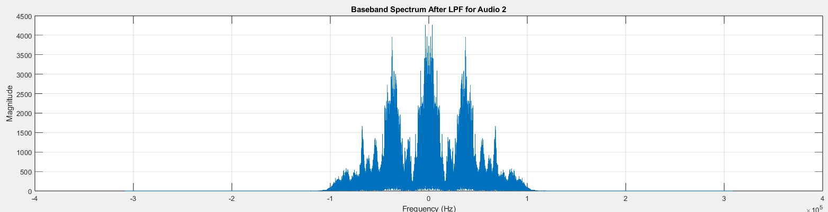
* 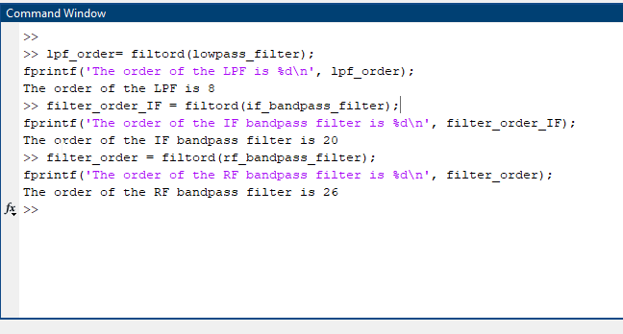Filter order
* Time domain signal after each stage
* 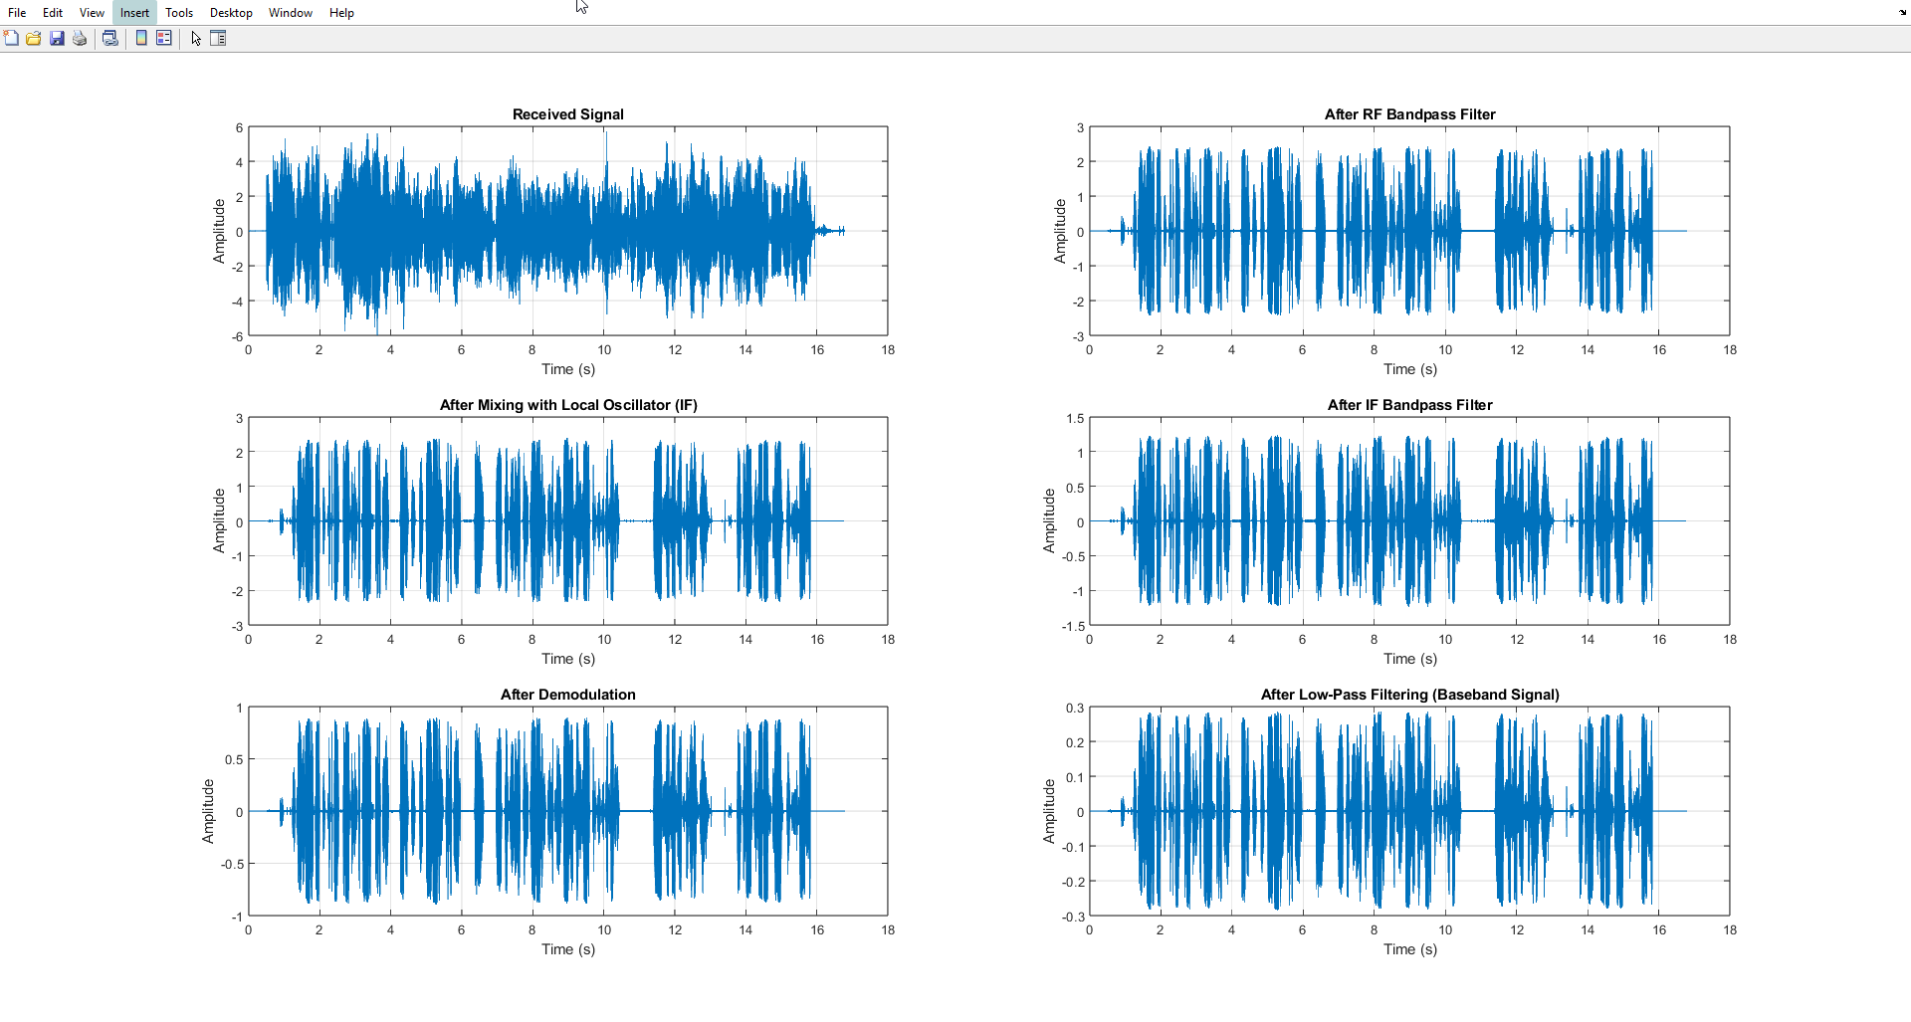

## Samples (First to run)

%% Section 1: Load Data

addpath 'Audio Signals'\

[c1, fs1] = audioread("Short_BBCArabic2.wav");

[c2, fs2] = audioread("Short_FM9090.wav");

[c3, fs3] = audioread("Short_QuranPalestine.wav");

[c4, fs4] = audioread("Short_RussianVoice.wav");

[c5, fs5] = audioread("Short_SkyNewsArabia.wav");

audioSignals = {c1, c2, c3, c4, c5};

samplingRates = [fs1, fs2, fs3, fs4, fs5];

Left_channel = cell(1, length(audioSignals));

Right_channel = cell(1, length(audioSignals));

monoSignals = cell(1, 5);

paddedSignals = cell(1, 5);

maxLength = 0;

% Extract left, right, and mono channels; calculate max signal length

for i = 1:length(audioSignals)

Left_channel{i} = audioSignals{i}(:, 1);

Right_channel{i} = audioSignals{i}(:, 2);

monoSignals{i} = sum(audioSignals{i}, 2); % Combine left and right channels

maxLength = max(maxLength, length(monoSignals{i}));

end

% Pad signals to match the maximum length

for i = 1:length(monoSignals)

paddedSignals{i} = [monoSignals{i}; zeros(maxLength - length(monoSignals{i}), 1)];

end

%% Section 2: Plot and Extract Data

BWs = zeros(1, 5); % Initialize array for bandwidths

% Plot frequency spectra and calculate bandwidths

for i = 1:length(audioSignals)

x = audioSignals{i};

fs = samplingRates(i);

% FFT for frequency spectrum

N = length(x);

X = fft(x, N);

f = (-N/2:N/2-1) * fs / N;

% Calculate bandwidth

BWs(i) = obw(monoSignals{i}, fs);

% Plot frequency spectrum

figure;

plot(f, abs(fftshift(X)) / N);

title(['Frequency Spectrum of Signal ', num2str(i)]);

xlabel('Frequency (Hz)');

ylabel('Magnitude');

grid on;

end

% Convert bandwidths to Hz and kHz

BWs_Hz = BWs;

BWs_kHz = BWs_Hz / 1000;

clearvars -except BWs paddedSignals audioSignals

## Modulation (second to run)

% Constants

fc_mod = zeros(1, 5); % Carrier frequencies

modulated_signal = cell(1, 5); % Modulated signals

sentsignal = []; % Combined FDM signal

interp_factor = 14; % Interpolation factor

fs = 44100; % Sampling frequency

fs_interpolated = interp_factor * fs; % Interpolated sampling frequency

% Modulation process

for i = 1:length(audioSignals)

% Retrieve the padded mono signal

x = paddedSignals{i};

% Take the first portion of the signal

x = x(1:floor(length(x) / 1));

% Carrier frequency (in Hz)

fc_mod(i) = 100e3 + (i - 1) * 50e3;

% Interpolate the signal

x_inter = interp(x, interp_factor);

% Time vector for the interpolated signal

t = (0:1/fs_interpolated:(length(x_inter) - 1) / fs_interpolated)';

% Generate the carrier signal and perform modulation

Mod_carrier = cos(2 * pi * fc_mod(i) * t);

modulated_signal{i} = x_inter .* Mod_carrier;

end

% Combine all modulated signals into the FDM signal

for i = 1:length(modulated_signal)

if isempty(sentsignal)

sentsignal = modulated_signal{i};

else

sentsignal = sentsignal + modulated_signal{i};

end

end

% Plot the combined FDM signal in the time domain

figure;

subplot(2, 1, 1);

t_total = (0:length(sentsignal) - 1) / fs_interpolated; % Time vector for FDM signal

plot(t_total, sentsignal);

title('FDM Signal (Time Domain)');

xlabel('Time (s)');

ylabel('Amplitude');

% Plot the combined FDM signal in the frequency domain

subplot(2, 1, 2);

N = length(sentsignal);

f = (-N/2:N/2-1) * fs_interpolated / N; % Frequency axis

spectrum_fdm = fftshift(fft(sentsignal, N)); % Compute and shift the FFT

plot(f, abs(spectrum_fdm) / N);

title('FDM Signal (Frequency Domain)');

xlabel('Frequency (Hz)');

ylabel('Magnitude');

% Play the FDM signal

%sound(sentsignal, fs_interpolated);

clearvars -except BWs sentsignal interp_factor fs

## Demodulation

% Constants

offset = 0;

IF = 25e3; % Intermediate frequency (25 kHz)

fs_interpolated = interp_factor * fs; % Interpolated sampling rate

receivedSignal = sentsignal; % Received FDM signal

Rf_enable = 0; % Enable/Disable RF filter

% Relaxed Filter Constraints

A_pass = 2;

A_stop1 = 20;

A_stop2 = 20;

fprintf("\nSignal Processing Initialized.\n");

while true

% User input for channel selection

fprintf("\nChoose one of these channels (Enter 0 to Exit):\n");

fprintf("1. Short_BBCArabic2\n");

fprintf("2. Short_FM9090\n");

fprintf("3. Short_QuranPalestine\n");

fprintf("4. Short_RussianVoice\n");

fprintf("5. Short_SkyNewsArabia\n");

i = input("Choose: ");

% Exit condition

if i == 0

fprintf("Exiting program...\n");

break;

elseif i < 1 || i > 5

fprintf("Invalid input! Please choose a number between 1 and 5, or 0 to exit.\n");

continue;

end

% Carrier frequency and bandwidth for the selected channel

fc_mod = 100e3 + (i - 1) * 50e3; % Carrier frequency for the selected channel

bw = BWs(i); % Bandwidth (fixed for all channels)

% Define proper increasing frequencies and cap at Nyquist

F_stop1 = fc_mod - bw ; % Stopband start

F_pass1 = fc_mod - bw/2; % Passband start

F_pass2 = fc_mod + bw/2; % Passband end

F_stop2 = fc_mod + bw ; % Stopband end

% RF Bandpass Filter

if Rf_enable == 1

if F_stop2 > fs_interpolated / 2

error("Filter frequencies exceed Nyquist limit. Increase fs_interpolated.");

end

rf_bandpass_filter = designfilt('bandpassiir', ...

'StopbandFrequency1', F_stop1, 'PassbandFrequency1', F_pass1, ...

'PassbandFrequency2', F_pass2, 'StopbandFrequency2', F_stop2, ...

'StopbandAttenuation1', A_stop1, 'PassbandRipple', A_pass, ...

'StopbandAttenuation2', A_stop2, 'SampleRate', fs_interpolated);

fprintf("RF Filter Order: %d\n", filtord(rf_bandpass_filter));

filtered_signal = filter(rf_bandpass_filter, receivedSignal);

else

filtered_signal = receivedSignal;

end

% Plot RF Stage Spectrum

figure(1); clf;

rf_spectrum = fftshift(fft(filtered_signal, 2^nextpow2(length(filtered_signal))));

N = length(rf_spectrum);

f = (-N/2:N/2-1) * fs_interpolated / N;

subplot(2, 1, 1);

plot(f, abs(rf_spectrum));

title("RF Stage After BPF for Audio " + num2str(i));

xlabel("Frequency (Hz)"); ylabel("Magnitude"); grid on;

% Step 2: Mix with Local Oscillator to Shift to IF

t = (1:length(filtered_signal))' / fs_interpolated; % Time vector

carrier_LO = cos(2 * pi * (fc_mod + IF) * t); % Local oscillator signal

mixed_signal_IF = filtered_signal .* carrier_LO; % Mixer output

% Plot IF Stage Spectrum

IF_spectrum = fftshift(fft(mixed_signal_IF, 2^nextpow2(length(mixed_signal_IF))));

subplot(2, 1, 2);

plot(f, abs(IF_spectrum));

title("IF Stage for Audio " + num2str(i));

xlabel("Frequency (Hz)"); ylabel("Magnitude"); grid on;

% Step 3: Bandpass Filter to Isolate IF

F_stop1_IF = max(0, IF - bw - 5e3); % Stopband start

F_pass1_IF = IF - bw; % Passband start

F_pass2_IF = IF + bw; % Passband end

F_stop2_IF = min(fs_interpolated / 2 - 1, IF + bw + 5e3); % Stopband end

if_bandpass_filter = designfilt('bandpassiir', ...

'StopbandFrequency1', F_stop1_IF, 'PassbandFrequency1', F_pass1_IF, ...

'PassbandFrequency2', F_pass2_IF, 'StopbandFrequency2', F_stop2_IF, ...

'StopbandAttenuation1', A_stop1, 'PassbandRipple', A_pass, ...

'StopbandAttenuation2', A_stop2, 'SampleRate', fs_interpolated);

fprintf("IF Filter Order: %d\n", filtord(if_bandpass_filter));

filtered_signal_IF = filter(if_bandpass_filter, mixed_signal_IF);

% Step 4: Demodulate IF Signal

carrier_IF = cos(2 * pi * IF * t); % IF carrier signal

baseband_signal = filtered_signal_IF .* carrier_IF; % Demodulation

% Step 5: Apply Low-Pass Filter to Recover Baseband Signal

F_pass = bw; F_stop = bw + 5e3;

lowpass_filter = designfilt('lowpassiir', ...

'PassbandFrequency', F_pass, 'StopbandFrequency', F_stop, ...

'PassbandRipple', A_pass, 'StopbandAttenuation', A_stop1, ...

'SampleRate', fs_interpolated);

Base_Band_received_signal_LPF = filter(lowpass_filter, baseband_signal);

% Resample and Playback the Demodulated Signal

Base_Band_received_signal_LPF = 4 * resample(Base_Band_received_signal_LPF, 1, interp_factor);

sound(Base_Band_received_signal_LPF, fs);

% Plot Baseband Spectrum After LPF

figure(2); clf;

baseband_spectrum = fftshift(fft(Base_Band_received_signal_LPF, 2^nextpow2(length(Base_Band_received_signal_LPF))));

N = length(baseband_spectrum);

f = (-N/2:N/2-1) * fs_interpolated / N;

plot(f, abs(baseband_spectrum));

title("Baseband Spectrum After LPF for Audio " + num2str(i));

xlabel("Frequency (Hz)"); ylabel("Magnitude"); grid on;

fprintf("Audio %d processed successfully.\n", i);

end

fprintf("Signal Processing Completed.\n");