3. Requirements Gathering

3.1 Stakeholder Analysis

Identified Stakeholders
- End Users (Non-Technical Users)
  - Individuals receiving suspicious messages (Email, SMS, WhatsApp, Telegram).
  - Needs:
    - Simple and clear verdict (Safe / Suspicious / Scam)
    - No technical complexity
    - Fast results
    - Support for Arabic and English
    - Easy upload or input process
- External Services (e.g., VirusTotal API)
  - Third-party threat intelligence providers.
  - Needs:
    - Proper API integration
    - Controlled and optimized request usage
    - Secure handling of API keys
- System Administrators
  - Responsible for maintaining and monitoring the system.
  - Needs:
    - System monitoring dashboard
    - Logs and alerts
    - Control over storage and data retention
    - Security management (rate limiting, abuse prevention)
- Development Team
  - Engineers building and maintaining the system.
  - Needs:
    - Modular architecture
    - Clear documentation
    - Scalable design
    - Maintainable and testable codebase

3.2 User Stories

User Story 1 – Email Analysis
- As a non-technical user
- I want to upload or paste an email (including headers)
- So that I can know whether it is legitimate or a phishing attempt

User Story 2 – Multi-Channel Scam Detection
- As a non-technical user
- I want to check suspicious messages from WhatsApp, Telegram, SMS, or phone calls
- So that I can verify if they are scams without technical knowledge

3.3 Use Case
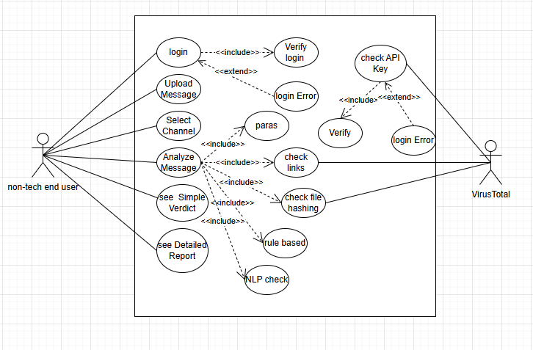

More details https://drive.google.com/file/d/1MrcRybtR3u_zb8zMGGmMjKiIrOhBfusi/view?usp=sharing

3.4 Functional Requirements

Core Features
- Message Input
  - Users can upload or paste messages
  - Support for Email, SMS, WhatsApp, Telegram
- Channel Selection
  - User selects message type before analysis
- Message Parsing
  - Extract headers, links, attachments, and text
- Technical Analysis
  - Email header validation (SPF, DKIM, DMARC)
  - URL inspection
  - Attachment scanning
- NLP Analysis
  - Detect scam language patterns
  - Identify urgency, fear, and manipulation
- Risk Scoring
  - Generate score from 0–100
  - Classify into:
    - Safe
    - Suspicious
    - Scam
- Results Display
  - Simple verdict (non-technical)
  - Detailed technical report
- External API Integration
  - Integration with VirusTotal for threat intelligence

3.5 Non-Functional Requirements

1. Performance
- Analysis time ≤ 5 seconds
- System should handle multiple users concurrently
- Efficient API usage

2. Security
- Secure API key storage
- Input validation (prevent injection attacks)
- Rate limiting to prevent abuse
- Encrypted data handling

3. Usability
- Simple UI for non-technical users
- Clear and readable results
- Multi-language support (Arabic + English)

4. Reliability
- System uptime ≥ 99%
- Graceful failure handling
- Error messages understandable by users

5. Scalability
- Support increasing number of users
- Microservices-ready architecture
- Queue-based processing for heavy loads

6. Privacy
- Messages are not stored permanently
- Auto-deletion after a defined period
- User-controlled data deletion

4.1 software Architecture
Software Architecture – High-level design outlining system components, interactions, and architecture style (e.g., MVC, Micro services).
The Tamenny system adopts a Micro services-based architecture to ensure scalability, maintainability, and independent deployment of system components. The high-level architecture is structured around the following key components:
- Frontend Layer: User-facing web/mobile interface supporting Arabic and English, enabling message submission across all four channels.
- API Gateway: Central entry point that routes requests to the appropriate micro services and handles authentication.
- AI Detection Engine: Core micro service responsible for URL classification, message psychology analysis, and suspicion scoring (0–100).
- Channel Integration Service: Manages connectivity with Email, SMS, WhatsApp, and Telegram APIs.
- Results & Reporting Service: Generates simplified user verdicts (Safe / Suspicious / High Risk) and detailed technical reports.
- Database Layer: Stores analyzed messages, detection logs, and model feedback for continuous improvement.
This architecture ensures that each component can be developed, tested, and scaled independently, aligning with the project's goals of high accuracy (≥ 95%), fast response time (≤ 5 seconds), and multi-channel support.

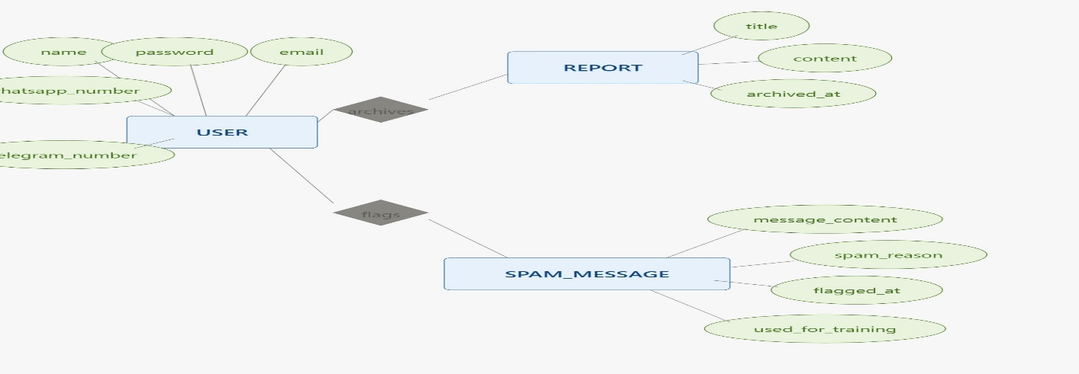
4.2 Database Design & Data Modeling
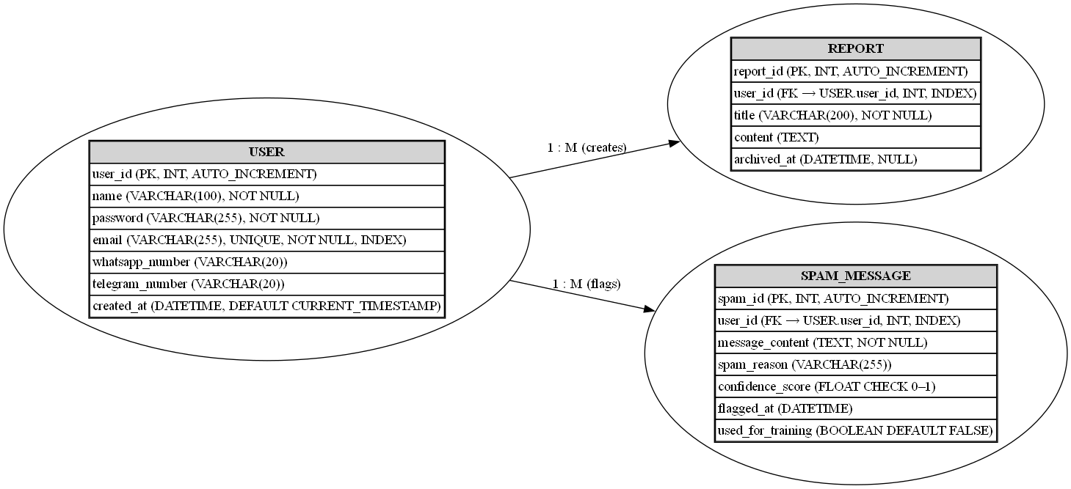
4.3 Data Flow and System Behavior
This section describes the logical progression of data through the Scam Detection System and defines how the system reacts to user inputs and external triggers. The architecture is designed to prioritize speed (≤ 5 seconds) and accuracy through multi-layered analysis.

4.3.1 System Process Sequence (Behavioral Logic)

The system operates as a state-driven pipeline, moving from data ingestion to final verdict delivery through the following stages:
- Input & Channel Validation:
  - The user provides input via raw text or file upload (e.g., .eml files).
  - The system identifies the communication channel (Email, SMS, WhatsApp, Telegram).
  - Behavior: The system validates the input format to ensure it is clean and ready for parsing.
- Message Parsing & Feature Extraction:
  - The system deconstructs the message into core components: headers, body text, URLs, and attachments.
  - Behavior: For emails, specific focus is placed on SPF, DKIM, and DMARC records to verify sender legitimacy.
- Parallel Analysis Execution:

To ensure efficiency, the system triggers three analysis engines simultaneously:
  - Technical Intelligence: Sends extracted URLs and file hashes to VirusTotal for threat assessment.
  - NLP Analysis: Scans text for patterns of urgency, fear-mongering, or manipulation.
  - Rule-Based Check: Compares metadata against known blacklists and phishing patterns.
- Risk Scoring & Verdict Generation:
  - Behavior: The "Risk Scoring Engine" aggregates results from all layers to calculate a final score from 0–100.
  - The message is classified into one of three states: Safe, Suspicious, or Scam.

4.3.2 Data Flow Description (DFD)

The following describes the movement of data between the user, the system, and external providers:
- User → System: Raw message data (Text, Headers, or Attachments) is sent to the application backend.
- System → External API (VirusTotal): Only specific technical indicators (URLs and File Hashes) are transmitted to VirusTotal to preserve user privacy.
- Internal Component Flow: Extracted features flow from the Parser to the NLP Engine and the Technical Scanner. All results converge at the Risk Scoring Engine.
- System → User: The final verdict (Simple Verdict) and a Detailed Technical Report are returned to the user interface.
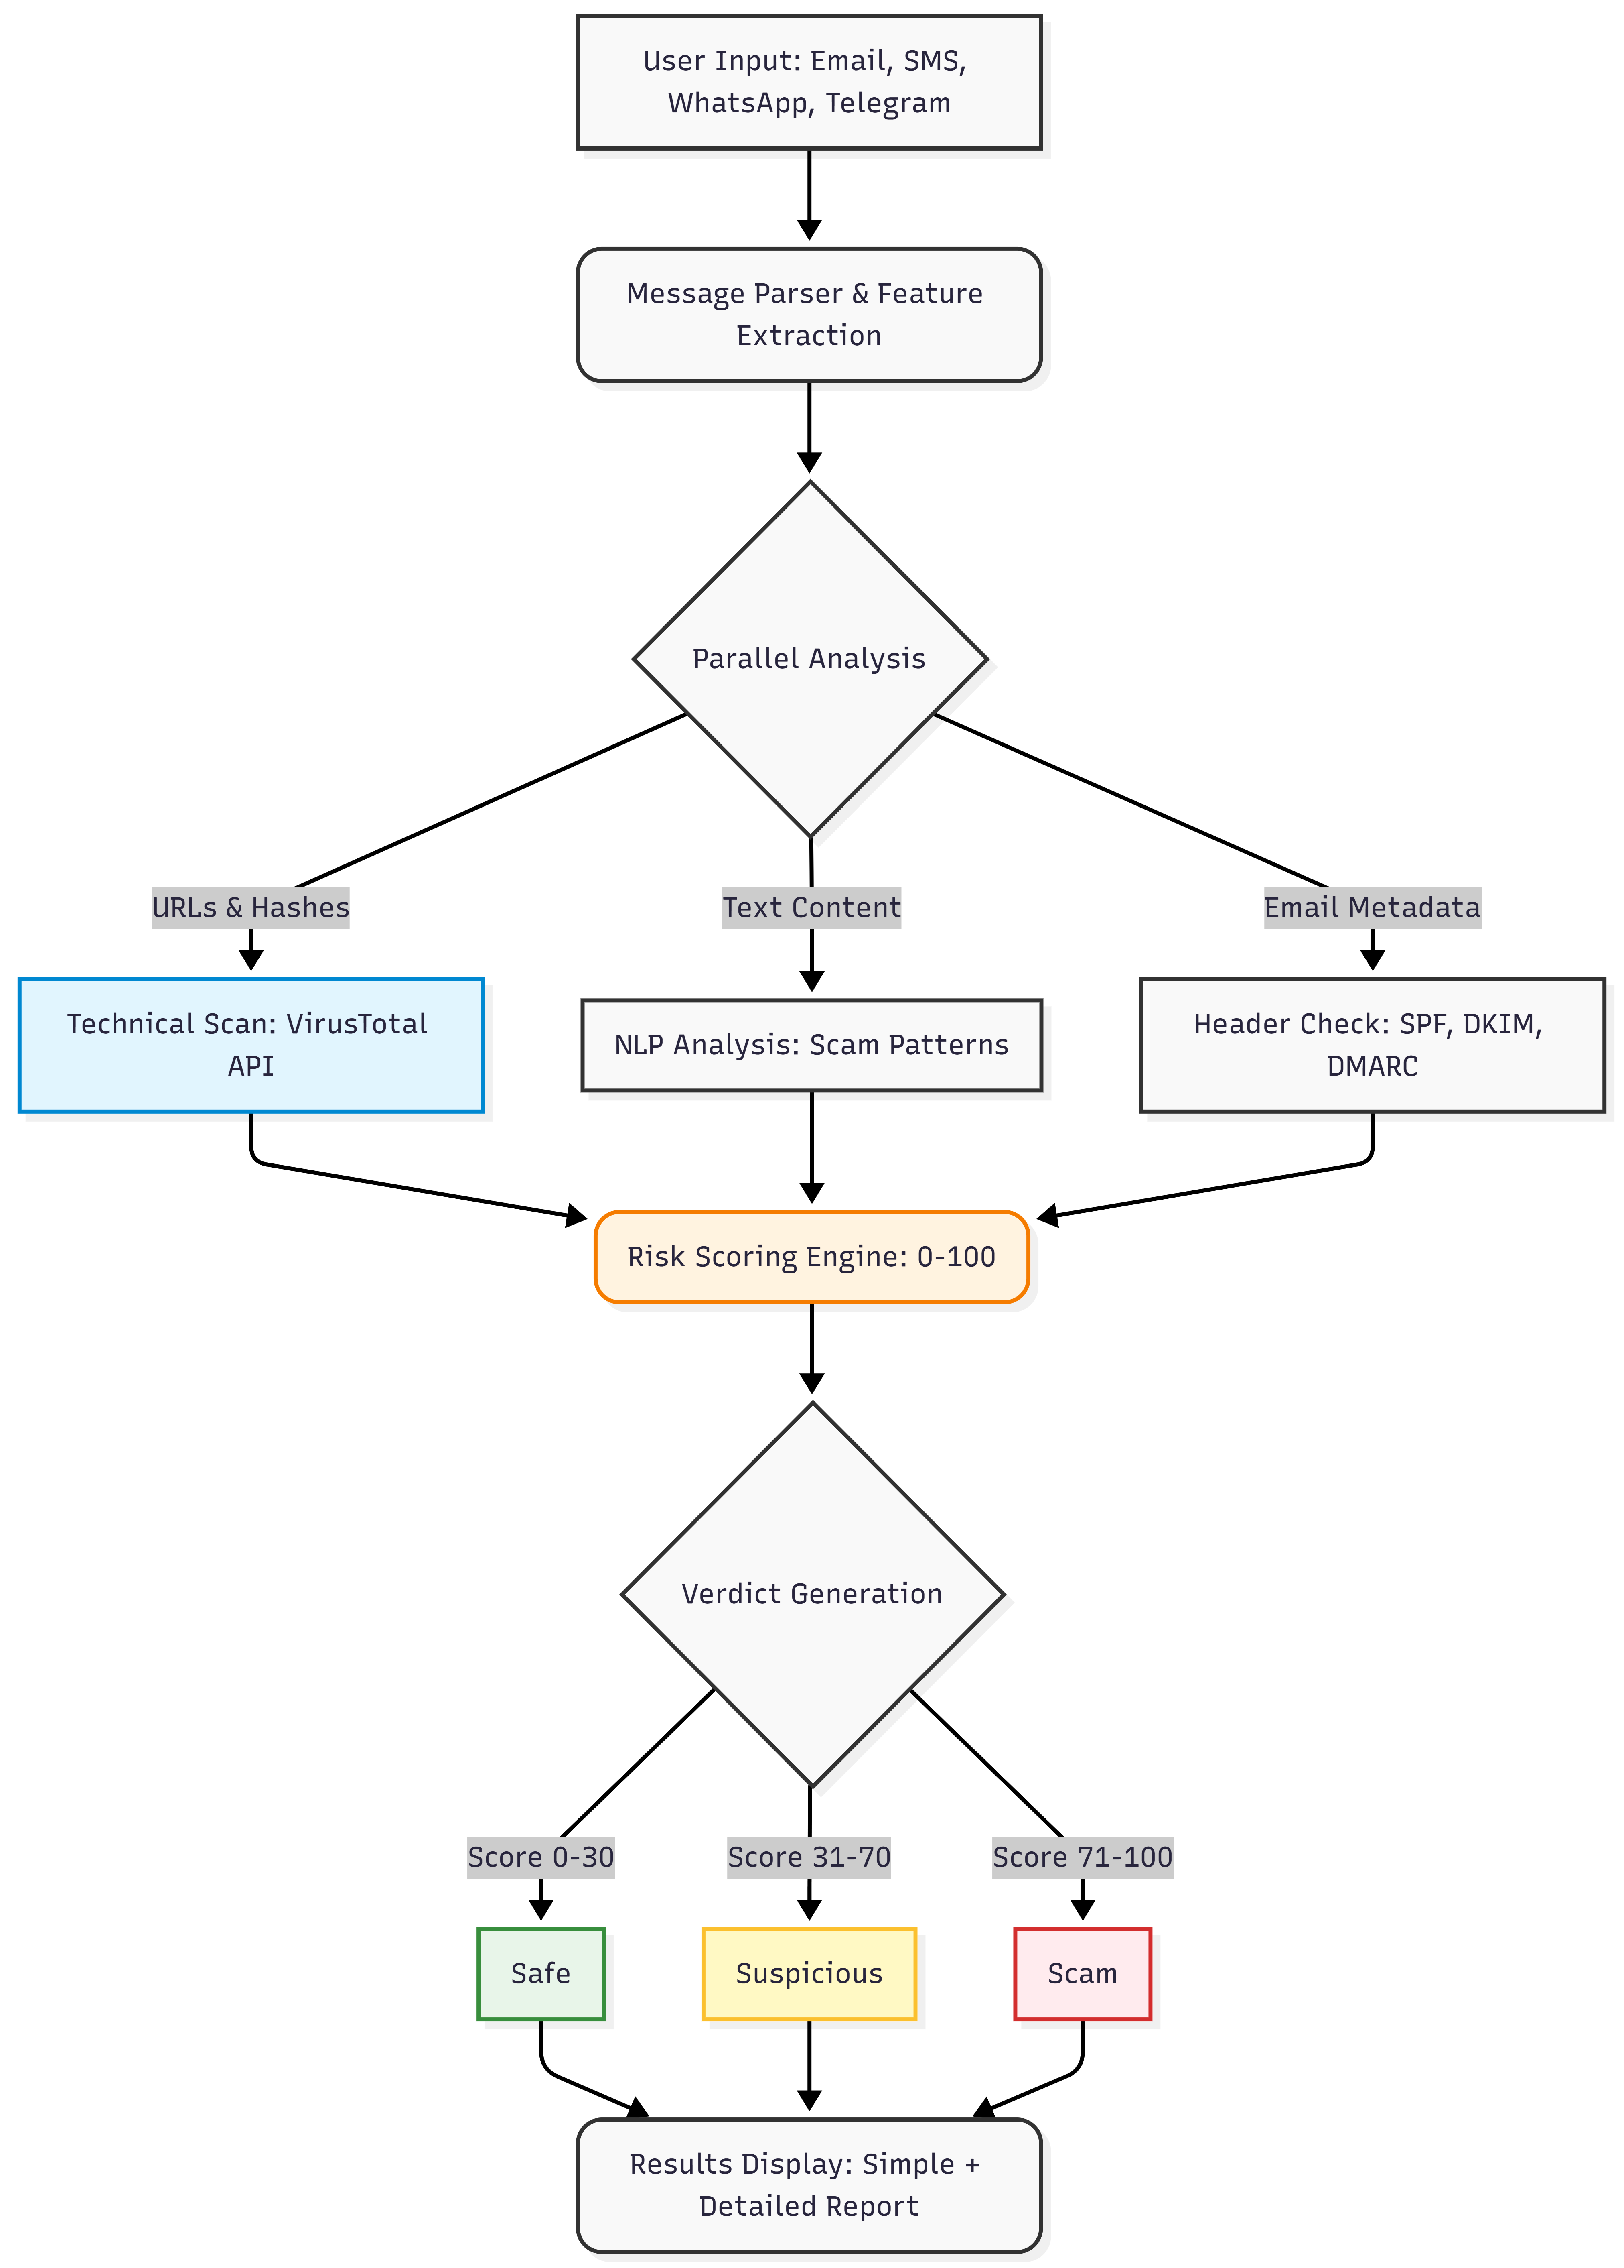
Figure 1 High-Level Data Flow and System Behavior Diagram

4.3.3 Exception Handling & Edge Cases
- API Downtime: If the external VirusTotal service is unavailable, the system relies on local NLP analysis and header validation, notifying the user that the technical link check is limited.
- Unsupported Language: If a message is not in Arabic or English, the system bypasses NLP and relies solely on technical indicators (links and headers) to provide a safety score.
- Privacy Protocol: Data is handled in a temporary cache and is automatically deleted after a defined period to ensure user privacy.

4.3.4 Sequence Diagram
This diagram represents the chronological interaction between the system's components and external services during a typical analysis session. It highlights the parallel execution of tasks to meet the performance requirement of ≤ 5 seconds.
Key Interactions:
- User to System: Submitting the message and selecting the communication channel (Email, SMS, WhatsApp, or Telegram).
- System to VirusTotal: A synchronous API request to fetch reputation data for URLs and file hashes.
- Internal Processing: Concurrent execution of NLP analysis and email header validation (SPF/DKIM/DMARC)

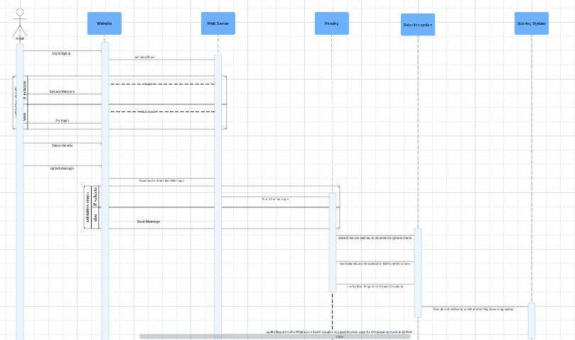
More details => https://lucid.app/lucidchart/631c234d-fcc7-4ebe-aa4f-79de40753c40/edit?viewport_loc=-3900%2C-1216%2C4308%2C2044%2C0_0&invitationId=inv_3f922fe0-3bed-42e3-85a0-f1cf3858b08d

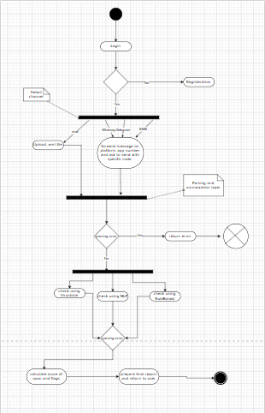
4.3.5 Activity Diagram
More details https://drive.google.com/file/d/1L4YPB8W7U9-ZBAiR9JBSQhcJ00g6s8lG/view?usp=sharing

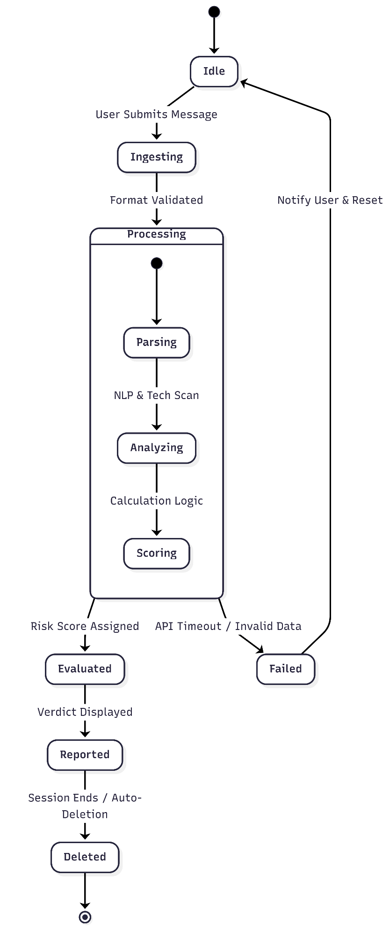
4.3.6 State Diagram
This diagram describes the lifecycle of a Message Object as it transitions through different operational states. It specifically addresses the privacy requirement by ensuring data deletion after the session ends.
States:
- Processing: The message undergoes parsing, NLP analysis, and technical scanning.
- Evaluated: A final risk score and verdict have been assigned.
Deleted: To maintain privacy, message data is purged from the system after the results are delivered.

4.3.7 Class Diagram
The Class Diagram defines the static structure and relationships between core system entities, ensuring a modular and maintainable design for the development team.
Core Classes:
- Message: Contains the raw content and channel type provided by the user.
- ScoringEngine: Implements the algorithm to generate a verdict based on multi-channel data.
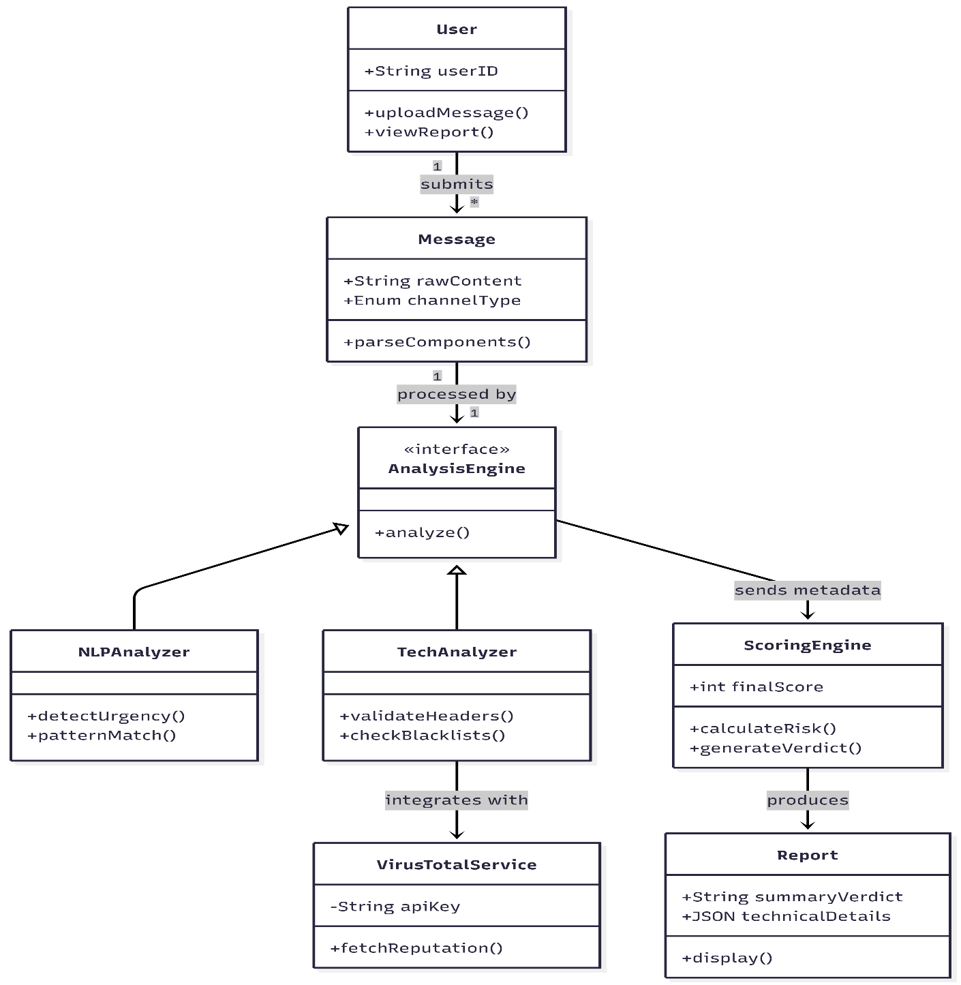
- VirusTotalService: Manages secure communication with external threat intelligence providers.

5. UI/UX Design and prototype

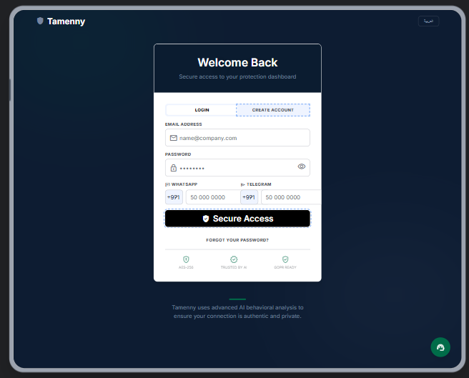
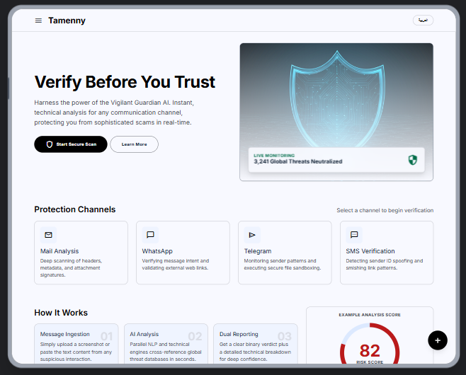

For more details https://stitch.withgoogle.com/preview/9205259598251257783?node-id=ecb26746696a424689ba9df68921f715

6. System deployment and integration

5.1 Technology Stack
The Tamenny system adopts a modular, microservices-ready architecture using modern, scalable technologies:

Backend
- Language: Python
- Framework: FastAPI
- Responsibilities:
  - Message parsing & normalization
  - Rule-based detection engine
  - NLP model inference
  - VirusTotal API integration
  - Risk scoring aggregation

Frontend
- Framework Options:
  - Web: React.js / Next.js)
- Responsibilities:
  - User input interface (multi-channel messages)
  - Display verdict and technical report
  - Session handling

Database
- Primary DB: PostgreSQL
- Usage:
  - Analysis logs
  - Risk scores
  - Model feedback data
- Optional:
  - Redis (for caching + queue management)

AI / NLP Layer
- Model: Transformer-based (BERT multilingual / Arabic fine-tuned)
- Libraries: HuggingFace Transformers, PyTorch
- Tasks:
  - Scam classification
  - Psychological pattern detection

External Services
- VirusTotal API
  - URL reputation
  - File hash analysis

DevOps & Infrastructure
- Docker (containerization)
- Nginx (reverse proxy)
- Cloud Provider: AWS / Azure / GCP
- CI/CD: GitHub Actions

