Digital Forensics – Assignment 2
Youssef Adel – 2305546
Reference: https://regseek.github.io/
Application used : Registry Explorer v2026.10.2

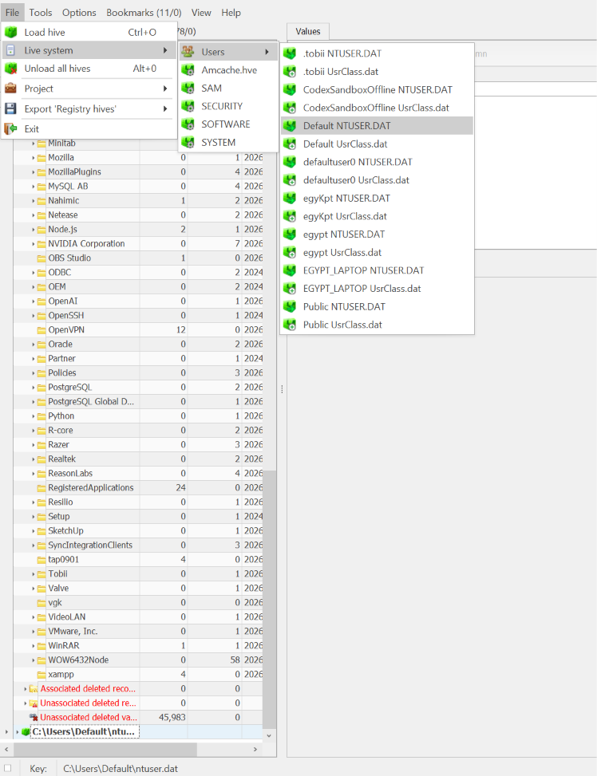

Question (1)
Reference RegSeek : ComputerName
Hive: SYSTEM
Key: ControlSet001\Control\ComputerName\ComputerName

Answer: ADEL. Registry Explorer shows ComputerName = ADEL under the SYSTEM computer-name key.
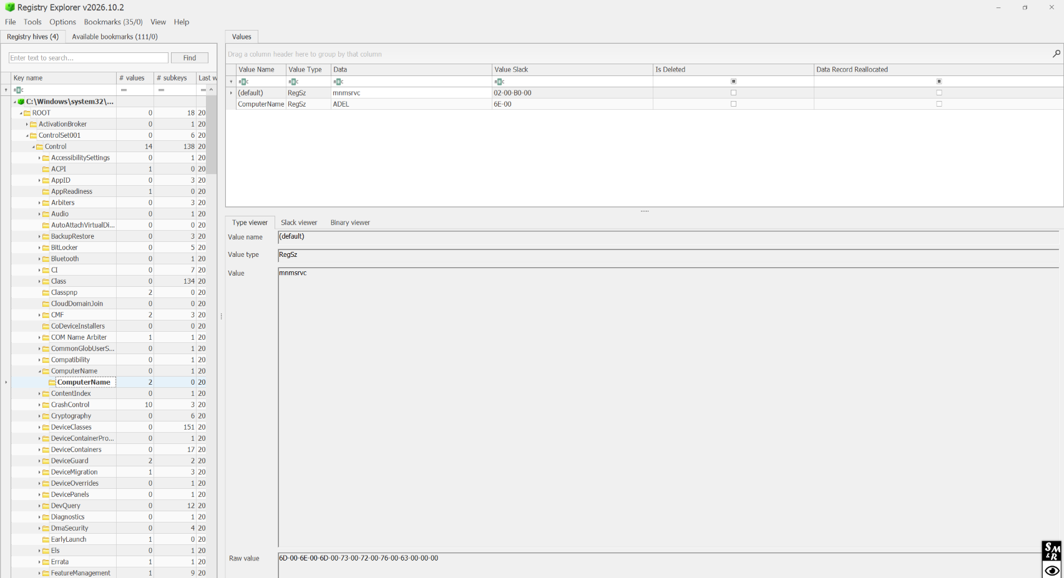
Question (2)
Reference RegSeek : CurrentVersion
Hive: SOFTWARE
Key: Microsoft\Windows NT\CurrentVersion

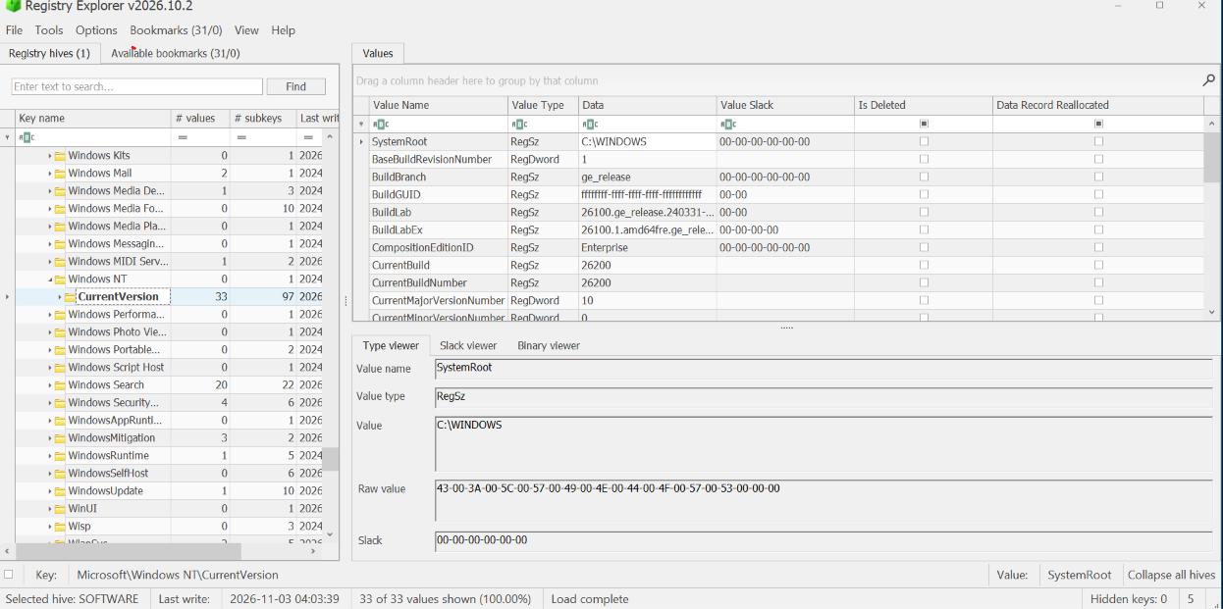
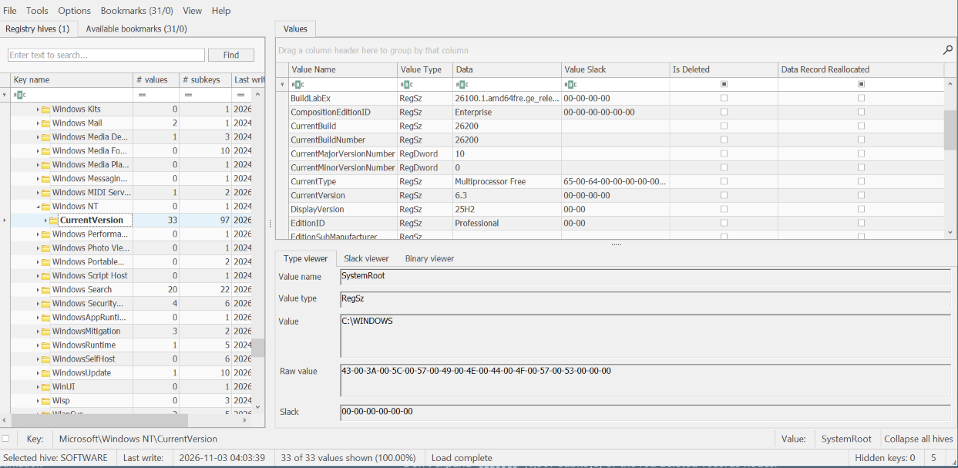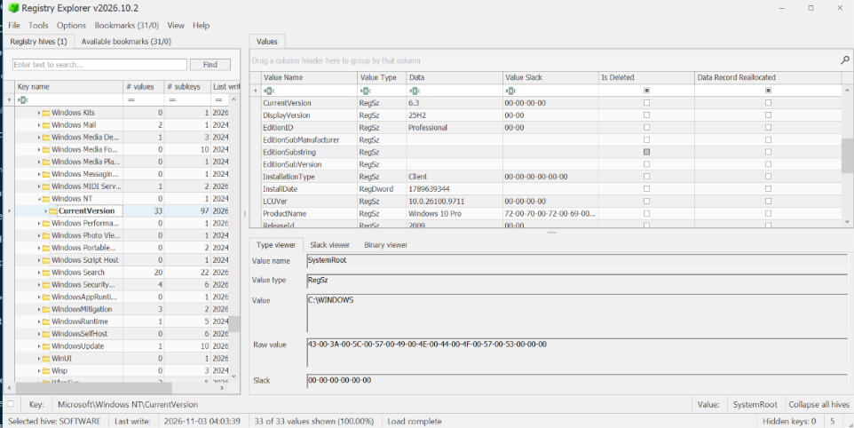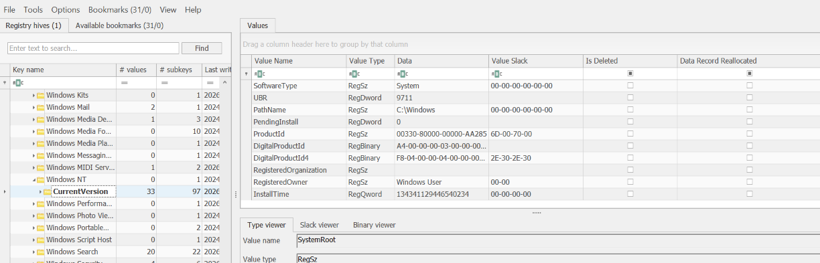
Question(3)
Reference RegSeek : Uninstall
Hive: SOFTWARE
Key: Microsoft\Windows\CurrentVersion\Uninstall
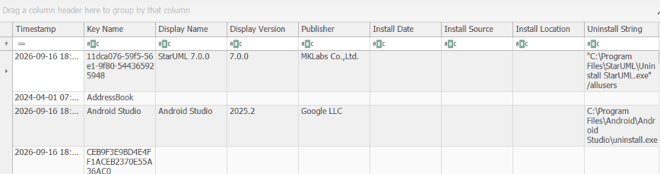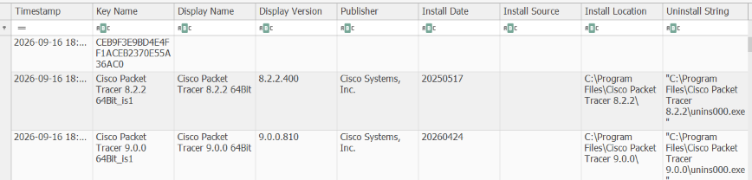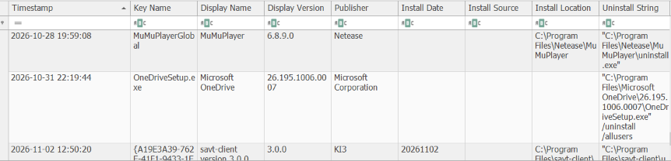

Question(4)
Reference RegSeek: TypedPaths
Hive: NTUSER.DAT (egypt)
Key: Software\Microsoft\Windows\CurrentVersion\Explorer\TypedPaths
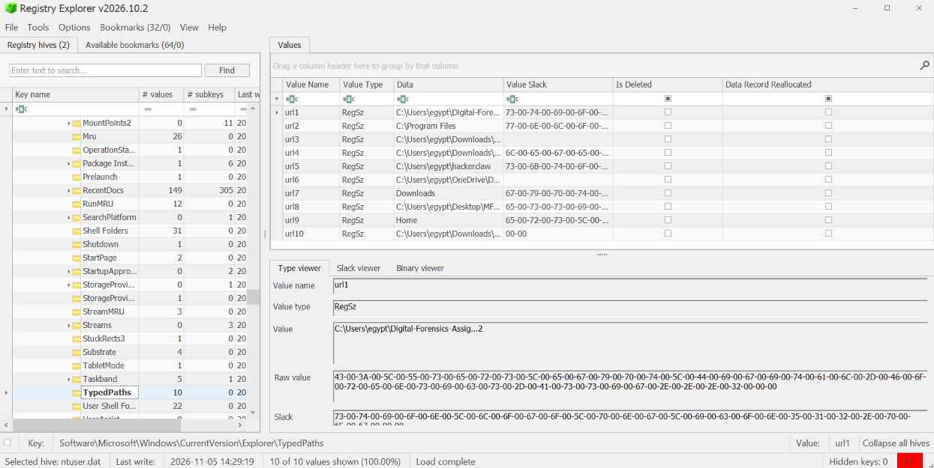

Question(5)
Reference RegSeek : WordWheelQuery
Hive: NTUSER.DAT (egypt)
Key: Software\Microsoft\Windows\CurrentVersion\Explorer\WordWheelQuery
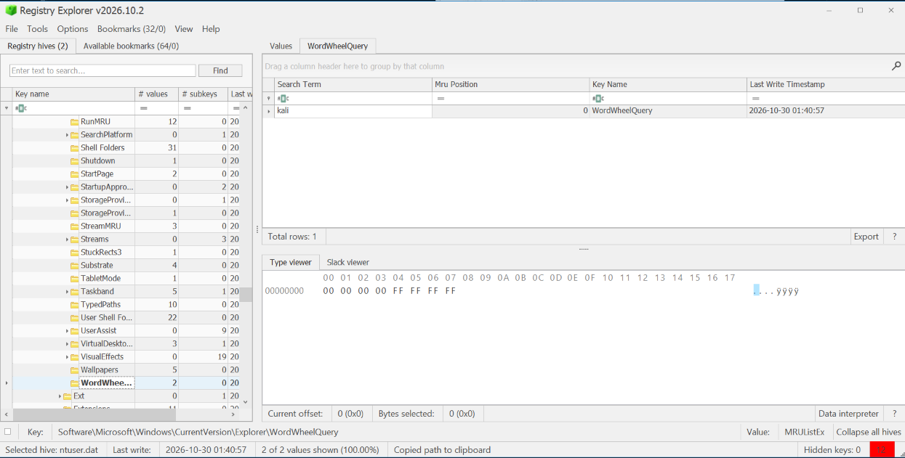
Question(6)
Reference RegSeek : ShutdownTime
Hive: SYSTEM
Key: ControlSet001\Control\Windows
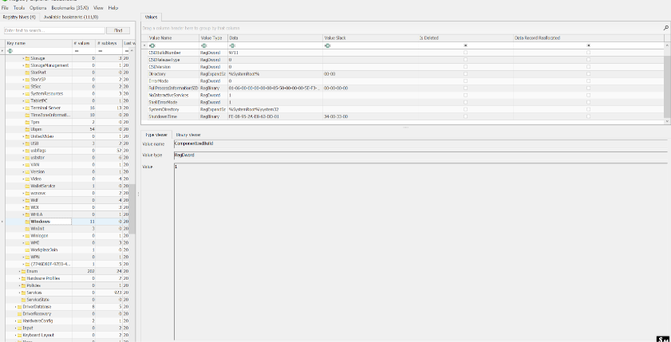
Question(7)
Reference RegSeek : Interfaces / DHCP

Hive: SYSTEM
Key: ControlSet001\Services\Tcpip\Parameters\Interfaces\{GUID}

The network-interface show:

DHCP IP address: 192.168.1.23
DHCP server: 192.168.1.1
Default gateway: 192.168.1.1
Gateway MAC address: 30:42:40:99:47:58 (the DhcpGatewayHardware byte sequence includes the six MAC bytes at its end)

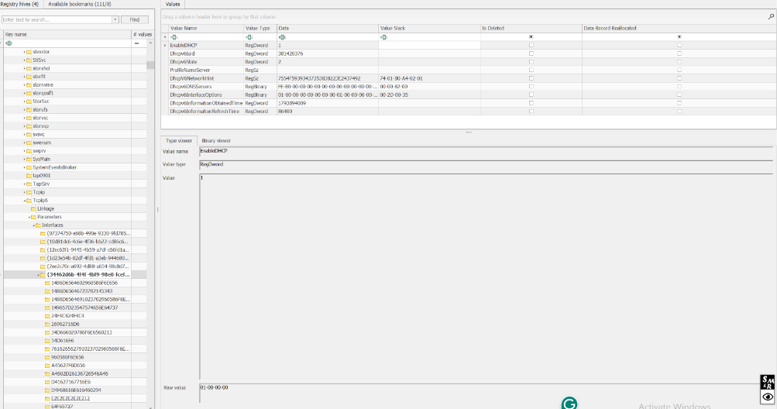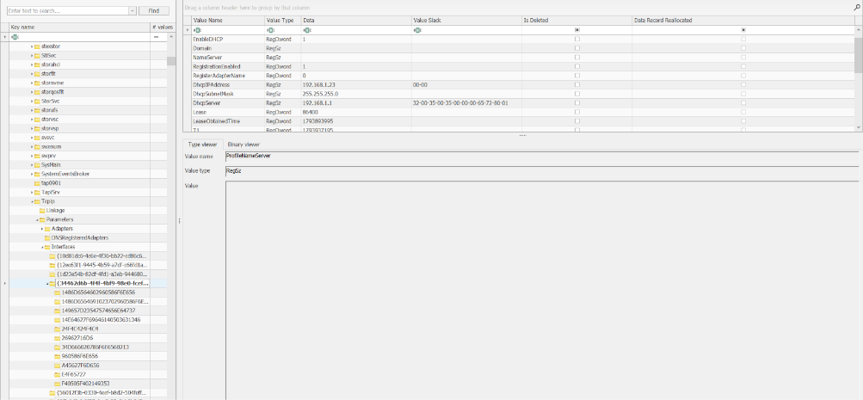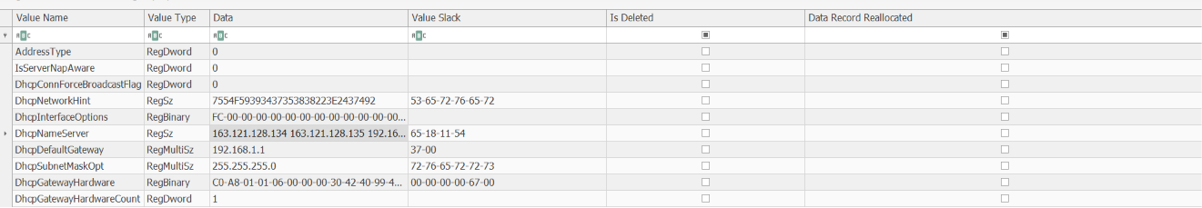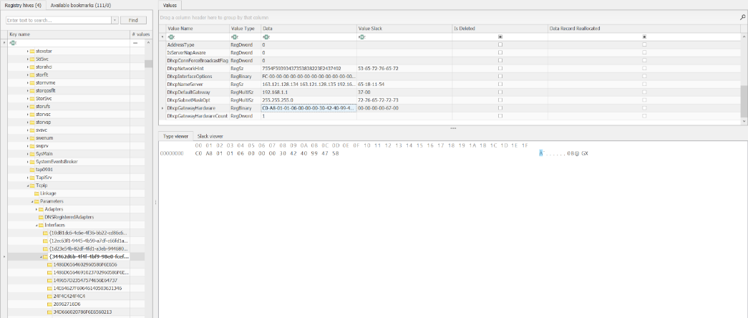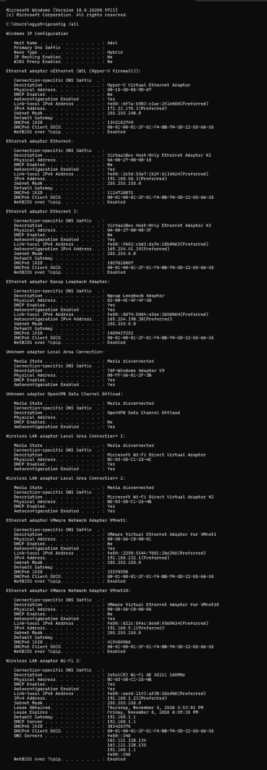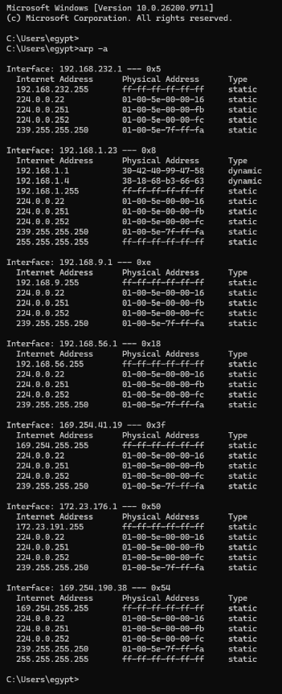

Question(8)
Reference RegSeek : Run
Hive: SOFTWARE
Key: Microsoft\Windows\CurrentVersion\Run (+ RunOnce, WOW6432Node\...\Run)

Machine Run key

SecurityHealth - %windir%\system32\SecurityHealthSystray.exe
RtkAudUService - Realtek audio service under C:\Windows\System32\…
Riot Vanguard - Riot Vanguard under C:\Program Files\Riot Vanguard\…
AdobeGCInvoker-1.0 - Adobe component under C:\Program Files (x86)\…
RazerCortex - Razer Cortex under C:\Program Files (x86)\…
Autodesk Access Service Autodesk Access under C:\Program Files\…
Autodesk Access - Autodesk Access under C:\Program Files\…

32-bit machine Run key (WOW6432Node)

TeamsMachineInstaller - Teams Installer command
Adobe CCXProcess - Adobe Creative Cloud component
vmware-tray.exe - VMware tray process
Autodesk Genuine Service - Autodesk service
SunJavaUpdateSched - Java update scheduler
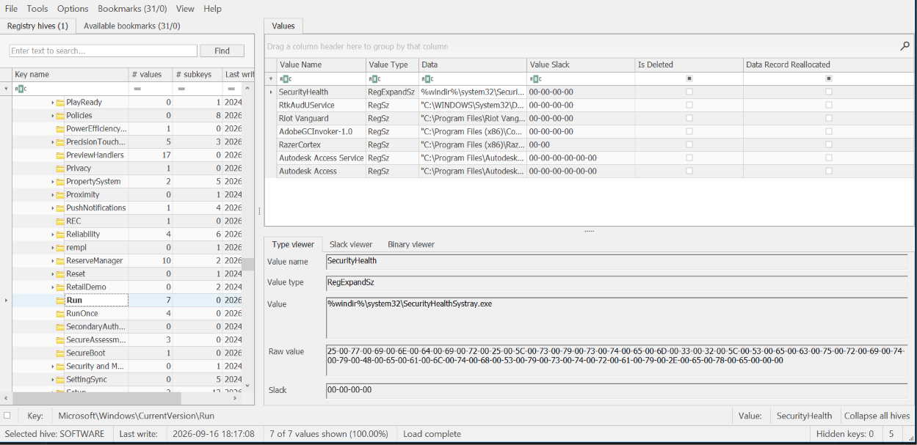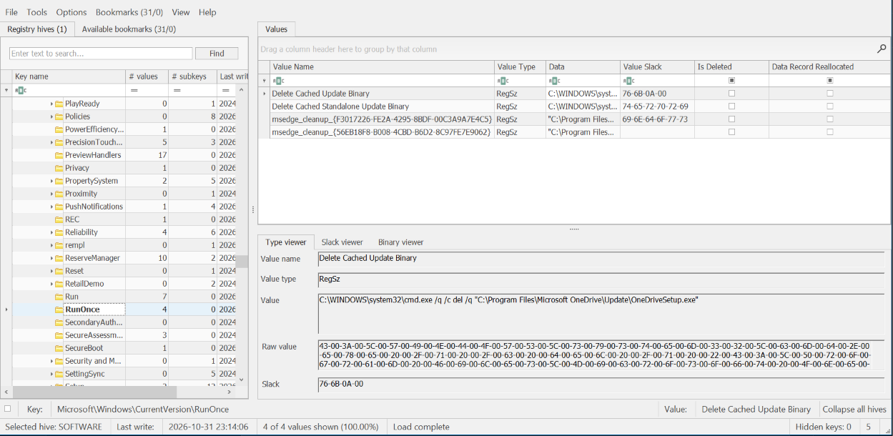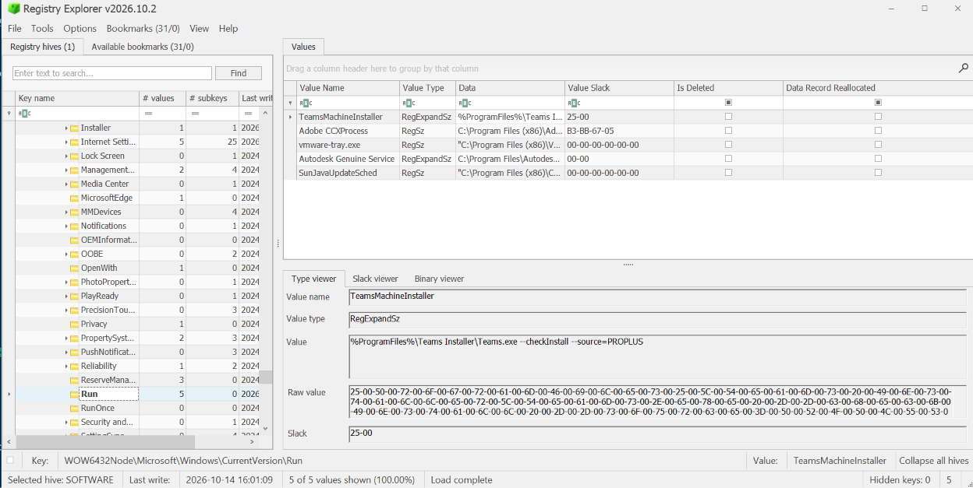

Question(9)
Reference RegSeek: Run
Hive: NTUSER.DAT (egypt)
Key: Software\Microsoft\Windows\CurrentVersion\Run (+ RunOnce)

OneDrive - C:\Program Files\Microsoft OneDrive\OneDrive.exe /background
Upwork - path begins under C:\Users\egypt\… (remainder clipped)
Docker Desktop - path under C:\Program Files\…
Teams - path under C:\Users\egypt\…
MicrosoftEdgeAutoLaunch_{…} - Edge auto-launch entry
OpenVPN-GUI -path under C:\Program Files\…
ut - executable command is clipped/not shown in the supplied screenshot
GoogleChromeAutoLaunch_{…} - Chrome auto-launch entry
Grammarly - path under C:\Users\egypt\…



