Pcap analysis

(Google authenticator incident)

Name: Youssef Mahmoud Elsaeed

Required:

* What is the IP address of the infected Windows client?

>10.1.17.215

* What is the mac address of the infected Windows client?

>00:d0:b7:26:4a:74

* What is the host name of the infected Windows client?

> DESKTOP-L8C5GSJ

* What is the user account name from the infected Windows client?

> shutdownson

* What is the likely domain name for the fake Google Authenticator page?

> dyngate.com

* What are the IP addresses used for C2 servers for this infection?

>5.252.153.241

Steps:

* So the first step was answering our first question which is the ip of the infected host.
* After applying the filter to narrow our lan segment, and search for the http requests with method get because in our scenario he did download a file so get was our solution “ip.src == 10.1.17.0/24 &&http.request.method == "GET"” this filter helped us suspect the first question which is our infected machine.
* Then we’ve gone to the statistics -> enpoints found the same suspected ip with super high traffic so we considered that ip as the infected machine:
  + A screenshot of a computer

    AI-generated content may be incorrect.
  + A screenshot of a computer

    AI-generated content may be incorrect.
  + Infected host: 10.1.17.215
* Now to the second question which is mac address of that same infected host.
  + 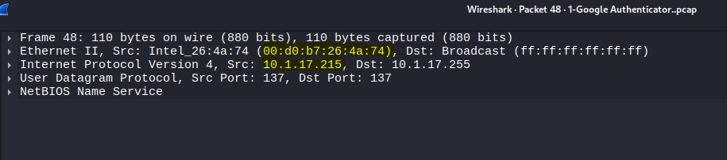
  + Our infected host’s mac address: 00:d0:b7:26:4a:74
* Now that we have both IP address and mac address we wanna answer the third question which is our host name.
* In the host name we did use another filter which is smb || smb2 and tried to follow the tree view which led us into our domain controller connection, and we’re looking more to find the session setup start of the smb request from our infected machine to the domain controller so we’re moving right.
* So after inspecting more I’ve managed to find the hostname which is DESKTOP-L8C5GSJ
  + A screen shot of a computer

    AI-generated content may be incorrect.
  + 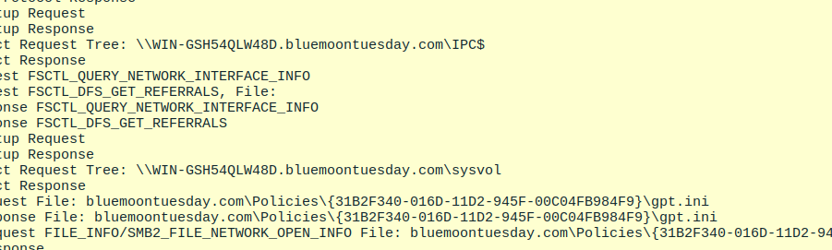
* Now that we’ve managed to get the hostname to the upcoming task which is find the account name.
* At first I’ve tried to look for the session setup sessions with the smb2 filter as the last if the account name could be there but failed
* After trying and learning some filters I learnt that Kerberos authentication packets could be having the account name as Cname and Sname, so applied that filter “kerberos.msg_type == 10 && ip.src == 10.1.17.215” after a couple of packets inspected found it in the cname string key.
  + A screen shot of a computer

    AI-generated content may be incorrect.
  + Account name: shutdownson
* Now we are approaching the last two steps which is the fake google authenticator domain, and the c2 server(any external connection ip suspected)
* Now let’s go through the first which is finding the domain of the fake site, and at the first glance we could think that it could be looked up for after we suspect an ip, but this lab could be solved using only wireshark so that means that we could find the domain name somewhere.
* So our basic beginning with the first filter the http requests to which our infected ip is the src “http && ip.src == 10.1.17.215” I tried to look for malicious get (download) files or any host headers in those requests.
* While inspecting those requests I already suspected the C2 ip which had so much traffic with our infected machine suspected : 5.252.153.241.
* Suspected this domain as the fake google authentication page: dyngate.com while was using another filter which “dns && ip.src == 10.1.17.215” to see the names that of the domains the dns redirected us to. Probably dyngate.com is the domain name answer because there was enormous traffic with our infected machine.
  + A screen shot of a computer

    AI-generated content may be incorrect.
  + A computer screen with text

    AI-generated content may be incorrect.
  + Wanted to be more sure that that domain had so much traffic outgoing from our infected machine to it so applied that filter “dns.qry.name contains "dyngate.com"&& ip.src == 10.1.17.215” and looked the results:
    - A screenshot of a computer

      AI-generated content may be incorrect.
    - So now we are kinda sure it’s the suspected domain.
    - We also have another clue that this site is connected to our machine on an unused port number :
      * 
    - Now used the dns filter but without checking if our infected ip is the source to be so so sure:
      * A screen shot of a computer

        AI-generated content may be incorrect.
* So as we want atleast to make sure of the last question which is the C2 (command and control center) (The puppet controller), as I had suspected already an ip address to be a C2 and the idea of a c2 ip is that It would be an ip that our machine connects to and sends traffic to that isn’t on our system so applied the following filter “ip.src == 10.1.17.215 && !ip.dst == 10.117.0.0/16” and I did find interesting finding:
  + A screenshot of a computer

    AI-generated content may be incorrect.
  + It shows relation between our suspected domain and suspected c2 server.
* Now we can be more sure but also skeptical that this is our c2 server: 5.252.153.241

Final:

Now we did finish the whole lab with our intuition and basic inspection technique learning more and more about the analysis using wire shark and learnt so much new filters and filtering techniques that really did benefit me, but am still not totally sure that my answers is right.