Pcap analysis

(Suspicious Psexec lateral movement)

Name: Youssef Mahmoud Elsaeed

Scenario:

An alert from the Intrusion Detection System (IDS) flagged suspicious lateral movement activity involving PsExec. This indicates potential unauthorized access and movement across the network. As a SOC Analyst, your task is to investigate the provided PCAP file to trace the attacker’s activities. Identify their entry point, the machines targeted, the extent of the breach, and any critical indicators that reveal their tactics and objectives within the compromised environment.

First let’s talk about psexec:

* **PsExec** is a command-line tool from Microsoft’s **Sysinternals Suite**
* Its purpose: allows an administrator (or attacker) to execute processes on a remote Windows machine as if sitting at its console.
* Example Usage: psexec \\target -u user -p password cmd.exe

How it works under the hood?

* Authentication via SMB
  + PsExec connects to the target machine using the Server Message Block (SMB) protocol, specifically port 445.
  + It authenticates with valid username/password or NTLM hash (Pass-the-Hash attacks).
* File Transfer
  + PsExec copies a service executable (psexesvc.exe) over to the target system’s ADMIN$ share (hidden administrative SMB share).
* Service Creation
  + It creates and runs a Windows service (psexesvc) on the target system using the Service Control Manager (SCM).
  + This service executes the command you specified.
* Output Redirection
  + PsExec redirects the standard input/output between your console and the target system’s process.
  + This is how you see the remote cmd.exe on your local machine

Now what could blue team /defenders do with that info:

* Detect PsExec by monitoring for:
  + Creation of psexesvc.exe.
  + Event IDs related to remote service creation (Windows Event 7045).
  + SMB session traffic between workstations.

To the final info (studying) needed: what is C$, IPC$, Admin$?

* default administrative shares in Windows
* C$
  + Refers to the root of the C: drive.
  + The $ at the end makes it a hidden share (not visible when browsing shares).
  + Example: \\MACHINE_NAME\C$
  + lets an administrator remotely access the C: drive.
  + Purpose: allows system administrators (and sometimes attackers) to manage the entire filesystem remotely.
* IPC$ (Inter-Process Communication Share)
  + A special share used for named pipes.
  + Doesn’t map to a real folder — it’s virtual.
  + Used for:
    - Remote management
    - Authentication
    - Communication between processes
  + Attackers often abuse IPC$ for null sessions (unauthenticated access) in older Windows systems.
  + Example usage: net use \\TARGET\IPC$ /u:Administrator password
* ADMIN$
  + Refers to the Windows system root directory (usually C:\Windows).
  + Used by remote administration tools (PsExec, SCCM, etc.).
  + When PsExec runs:
    - It connects to \\TARGET\ADMIN$
    - Drops psexesvc.exe there
    - Then executes it as a service

Required:

1) can you identify the IP address of the machine from which the attacker initially gained access?

>10.0.0.133( Initially gained access), 10.0.0.130(Attacker’s machine)

2) can you determine the machine's hostname to which the attacker first pivoted?

>10.0.0.133(HR-PC)

3) What is the username utilized by the attacker for authentication?

>SSales

4) After figuring out how the attacker moved within our network, we need to know what they did on the target machine. What's the name of the service executable the attacker set up on the target?

>Psexec.exe

5)Which network share was used by PsExec to install the service on the target machine

>ADMIN$

6) We must identify the network share used to communicate between the two machines. Which network share did PsExec use for communication?

>$IPC

7) Now that we have a clearer picture of the attacker's activities on the compromised machine, it's important to identify any further lateral movement. What is the hostname of the second machine the attacker targeted to pivot within our network?

>10.0.0.131(MARKETING-PC)

Steps:

* After I’ve opened the pcap file that involves a lateral movement through the psexec, I’ve learnt some stuff during the research we’ve made during the training which is the smb protocol and it’s relation to psexec, and the smb filters in wireshark, so that is the first idea I thought of but before even filtering I applied what I learnt too, to check statistics tab first for any anomaly:
  + Checked the statistics > endpoints first.
  + Noticed anomaly ofcourse that two ips was suspected of data exfilteration maybe, there was huge data transmitted through traffic:
  + A screenshot of a computer

    AI-generated content may be incorrect.
  + The suspected Ips: 10.0.0.130, 10.0.0.133.
* Then checked the second statistic wanted to check which is the protocol hierarchy to even make sure that there was smb protocol used.
  + A screenshot of a computer

    AI-generated content may be incorrect.
  + 93.5 percent of the packets were moved using smb protocol so this is certainly our filter to go to and as the scenario said psexec potentially used by an attacker and I suspect that he exfilterated a lot of data maybe accessing the root of the directories $C, $D or something just an intuition.
* So now to our go to filter which is “smb” version 2.
  + Look at that fine results that is so rich with info:
  + A computer screen with text

    AI-generated content may be incorrect.
  + 
  + Notice first that our two suspected IPs from the statistics is the two that is contacting through smb protocol, so we are moving right, but the question who is the attacker? The one who initiated the protocol request which is 10.0.0.130
  + The second fine info is the hidden directories that the attacker is seeking to view as I highlighted them: $IPCS, ADMIN$.
  + The third note is the creation of the PSEXEC.exe.
* Now before we dive in answered the first question which is 10.0.0.130 the first machine the attack was initiated from, and the victim was 10.0.0.133.
* And while inspecting the ntlmssp_auth packet to check for more info found in the packet details our answer for question 2 which is the machine’s hostname:
  + 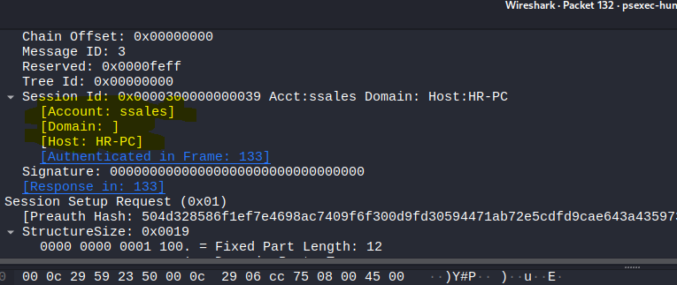
  + But that didn’t end in question 2 it took us to question 3 which is the username utilized by attacker for authentication which is SSales.
* Now with question 4, 5 and 6 which we all conducted through our study and analyses for only those initial parts of the file as we know the shares: ADMIN$, The $IPC and what exactly does Psexec do which is launching psexec.exe executable through smb on ADMIN$, and $IPC share is used for communicating and as we saw in the packets it came $IPC tree request, then ADMIN$ tree request then creation of psexec.exe so we have the answer to Q4, Q5 and Q6 now, but let’s keep going inspecting the other traffic.
* Now with our final question which is what was the second machine’s host name that the attacker pivoted to?
* Noticed many stdout and stdin requests which means ofcourse data exfilteration happened.
* Okay there was a bit of confusion because I found the second ip address the attacker pivoted too and was with another username which is “J.doe” and the third was “IEUSER” with ip 10.0.0.131 but the confusion was that the host name were always HR-PC so after a bit research I found out that this can happened cause of cloning : The metadata for the psexec.exe service (like the "Host" name in its description) can sometimes be inherited from the machine it was compiled on or the machine from which it was launched. If the attacker initially compromised HR-PC (10.0.0.133), downloaded PSEXESVC.exe from it, and then used *that same file* to attack 10.0.0.131, the file itself might still contain the original hostname HR-PC in its metadata.
  + A screen shot of a computer

    AI-generated content may be incorrect.
  + 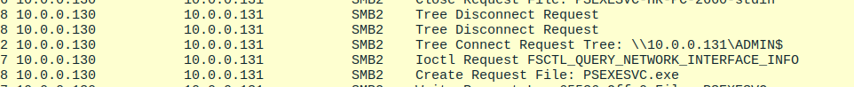
* OOOOOOOOPssssss!!!
* Sorry after a bit of inspection found out that I was looking in the wrong place because as I said earlier the host name was inherited from the previous machine psexec.exe ran on but as I inspected the ntlm authentication headers down I found out that the second machine’s host name was MARKETING – PC
  + A screen shot of a computer

    AI-generated content may be incorrect.
  + A screen shot of a computer

    AI-generated content may be incorrect.
  + With account name JDOE as we said upthere .
* So now we’ve finished the lab tasks and had a full picture of that attack.

Final:

Now to a lesson learnt and implications as a security defender:

* Monitor for access to these shares → especially ADMIN$.
* Disable administrative shares when not needed.
* Restrict SMB (port 445) to only trusted management networks.