NGINX DOCUMENTATION

Youssef Mahmoud Elsaeed

Information about NGINX:

* is an HTTP web server, reverse proxy, content cache, load balancer, TCP/UDP proxy server, and mail proxy server.

What is WAF(web application firewall):

* is a security tool specifically designed to protect web applications. It operates at the application layer (Layer 7 of the OSI model). Its job is to inspect, filter, and block malicious HTTP/HTTPS traffic *before* it reaches your web application(so it can clean the traffic from malicious payloads in a request or whatever).
* WAF looks for and protects against attacks like:
  + SQL Injection (SQLi): Where an attacker tries to execute malicious database commands.
  + Cross-Site Scripting (XSS): Where an attacker tries to inject malicious scripts into web pages viewed by other users.
  + Local/Remote File Inclusion (LFI/RFI): Where an attacker tries to trick the application into exposing or running files on the server.
  + Cross-Site Request Forgery (CSRF): And many other OWASP Top 10 vulnerabilities.

So let’s discuss the relation and integration between both:

* Nginx itself is not a WAF. However, its modular and extensible architecture allows you to integrate a WAF directly into it. This is the most common and powerful way they are used together.
* ModSecurity is the WAF that integrates with Nginx.

How does they work together:

* Request sent, a user's web browser sends an HTTP request to your website. This request goes to your server, where Nginx is listening.
* Nginx receives the request. Because the WAF (ModSecurity) is integrated as a module, Nginx passes the entire request—headers, body, and all—to the ModSecurity engine for inspection before deciding what to do with it.
* ModSecurity scrutinizes the request against its rule set (e.g., the OWASP Core Rule Set). It asks: "Does this look like a SQL injection?" "Is this a known malicious user agent?" "Is this an attempt to access a sensitive file?"
* IF request is clean:
  + ModSecurity gives it the all-clear. Nginx then proceeds with its normal job—serving the static file or passing the request to the PHP, Python, Node.js, etc., application in the backend.
* Else (request is malicious or contains a payload of any kind that matches the ruleset):
  + ModSecurity tells Nginx to block it. Nginx then immediately stops processing and returns a 403 Forbidden error to the user's browser. The malicious request never even touches your vulnerable web application.
* And finally the logging:
  + Both Nginx and ModSecurity log the event. The Nginx error log will show that a request was denied, and the ModSecurity audit log (modsec_audit.log) will contain incredibly detailed information about why it was blocked, which specific rule was triggered, and the exact part of the request that was malicious.

Information about ModSecurity:

* is primarily a rule-based (or signature-based) WAF, not one that relies primarily on behavioral analysis or heuristics.
* ModSecurity's core operational model. It works by checking every incoming request against a giant list of predefined patterns (rules) that are known to be malicious.
* But while researching foung out that modsecurity contained a part that could be considered heuristics: OWASP CRS which contains anomaly scoring system.

ASSIGNMENT:

* Required:
  + install nginx, modsecurity.
  + Setup and configure.(WAF)
* Deliverables:
  + Report with every single step setup step.
  + Screen shot of the website before and after the web attack.
  + screenshot of attack on the website <http://localhost/?attackxss> without waf, and with waf and identify the usage of NGINX.

So let’s roll in to our setup of both NGINX with modsecurity 3:

* Okay first of all the basic update and upgrade to check for all packages and libraries for modsecurity 3 that we need would be there and we are right on track:
  + <sudo apt update && sudo apt upgrade>
  + <sudo apt install gcc make build-essential autoconf automake libtool libcurl4-openssl-dev liblua5.3-dev libfuzzy-dev ssdeep gettext pkg-config libgeoip-dev libyajl-dev doxygen libpcre++-dev libpcre2-16-0 libpcre2-dev libpcre2-posix3 zlib1g zlib1g-dev -y>
* Then went to modsecurity installation in the /opt directory:
  + <sudo git clone https://github.com/owasp-modsecurity/ModSecurity.git>
  + 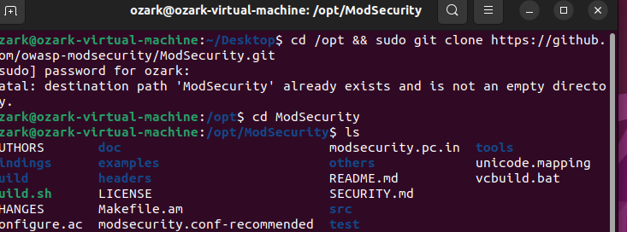
  + A screen shot of a computer screen

    AI-generated content may be incorrect.
* Then let’s build to complete installation:
  + <sudo ./build.sh>
  + <sudo ./configure>
  + A computer screen shot of a program

    AI-generated content may be incorrect.
  + A computer screen with white text

    AI-generated content may be incorrect.
  + <sudo make>
  + <sudo make install>
  + A computer screen with text

    AI-generated content may be incorrect.
  + A computer screen shot of a program

    AI-generated content may be incorrect.
* Now we’ve completed the installation of modsecurity 3 from source but we are missing it’s connectors so let’s install it in the /opt directory:
  + <sudo git clone <https://github.com/owasp-modsecurity/ModSecurity-nginx.git>>
  + A computer screen with white text

    AI-generated content may be incorrect.
* Now to our web server (NGINX) 1.28 installation, important note: the ppa:ondrej branch follows latest NGINX Stable packages compiled against latest OpenSSL for HTTP/2 and TLS 1.3 support:
  + A computer screen with white text

    AI-generated content may be incorrect.
  + <sudo apt install nginx -y>
  + A screenshot of a computer program

    AI-generated content may be incorrect.
* According to the documentation nginx is enabled using systemctl command:
  + A computer screen shot of a program

    AI-generated content may be incorrect.
  + Checked the status of nginx, active well done!
* Now let’s download the source code of nginx of our intended version 1.28:
  + <Sudo wget <https://nginx.org/download/nginx-1.28.0.tar.gz>>
  + A computer screen with white text and numbers

    AI-generated content may be incorrect.
  + Extracted the file
* Now we need to build nginx with module on modsecurity that we successfully installed above.
  + So let’s run the config script in our source directory:
  + <sudo ./configure --with-compat --add-dynamic-module=/opt/ModSecurity-nginx>
  + A computer screen shot of a computer code

    AI-generated content may be incorrect.
  + <Sudo make>
  + <Sudo make modules>
* Now let’s copy the modsecurity modules to nginx modules-enabled, also copy configuration of modsecurity and Unicode:
  + <sudo cp objs/ngx_http_modsecurity_module.so /etc/nginx/modules-enabled/>
  + <sudo cp /opt/ModSecurity/modsecurity.conf-recommended /etc/nginx/modsecurity.conf>
  + <sudo cp /opt/ModSecurity/unicode.mapping /etc/nginx/unicode.mapping>
  + And made sure it’s done:
  + A screenshot of a computer program

    AI-generated content may be incorrect.
* Now we need to enable modsecurity in the nginx.conf file so let’s edit it to load the modsec module:
  + load_module /etc/nginx/modules-enabled/ngx_http_modsecurity_module.so;
  + Loaded this line into the configuration file of nginx
    - A screenshot of a computer

      AI-generated content may be incorrect.
  + also need to modify the server block to activate modsecurity:
    - <sudo nano /etc/nginx/sites-enabled/default>
    - Then add those lines:
    - A screenshot of a computer screen

      AI-generated content may be incorrect.
  + And, edit /etc/nginx/modsecurity.conf to change SecRuleEngine to On:
    - <sudo nano /etc/nginx/modsecurity.conf>
    - A screenshot of a computer

      AI-generated content may be incorrect.
    - Change the SecRuleEngine field to On instead of DetectionOnly.
* Now we’ve walked many steps so let’s check with -t and we need to restart nginx server.
  + <sudo nginx -t>
    - A computer screen shot of a program

      AI-generated content may be incorrect.
  + <sudo systemctl restart nginx>
    - A screen shot of a computer

      AI-generated content may be incorrect.
* Finally, we can test the nginx server with browser on its public ip address.
  + A screenshot of a computer

    AI-generated content may be incorrect.
* Remember the Core Rule Set (CRS) we talked about earlier in the information about ModSecurity section?
  + This is our next step is to add those (CRS) and if we remember well:
    - ModSecurity scrutinizes the request against its rule set (e.g., the OWASP Core Rule Set). It asks: "Does this look like a SQL injection?" "Is this a known malicious user agent?" "Is this an attempt to access a sensitive file?"
  + Also side note: owasp crs could give modsecurity heuristic nature cause of the anomaly scoring system.
  + Let’s add that rule set:
  + We need firstly to download core rule set from owasp, owasp crs provide rule to check if the client request has malicious code or not.
  + We will download owasp crs to nginx configuration directory:
    - < sudo git clone https://github.com/coreruleset/coreruleset.git /etc/nginx/owasp-crs>
    - A screenshot of a computer screen

      AI-generated content may be incorrect.
  + Then we copied the configuration:
    - < sudo cp /etc/nginx/owasp-crs/crs-setup.conf{.example,}>
  + Then we need to update our modsecurity configuration to load owasp crs:
    - Opened /etc/nginx/modsecurity.conf
    - A screenshot of a computer

      AI-generated content may be incorrect.
    - Added two lines to load owasp crs configuration.
  + Restarted nginx again
* Now finally for the final result, our test of NGINX + modsecurity on our web browser:
  + A screenshot of a computer

    AI-generated content may be incorrect.
  + Now let’s try some shell code and see the results:
    - A screenshot of a computer

      AI-generated content may be incorrect.



* + Okay testing logs:
    - 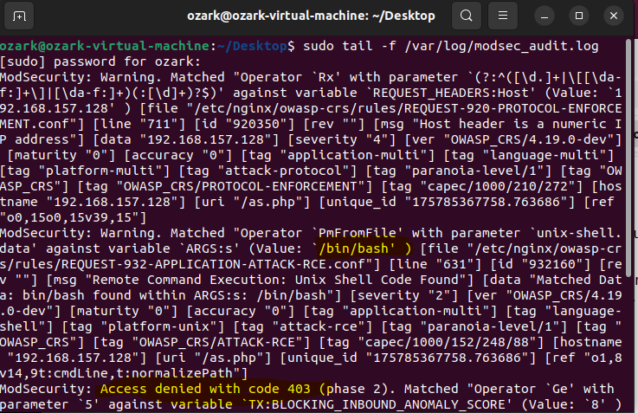
    - Looks like it’s working pretty well.
    - A screenshot of a computer screen

      AI-generated content may be incorrect.
    - Working well, saw the anomaly score we’ve talked about earlier?
    - Request parameter is our shell code and the host is our targeted web server too, so PERFECT.
  + One more check, let’s turn modsecurity off from the /etc/nginx/sites-enabled/default
    - A screenshot of a computer

      AI-generated content may be incorrect.
    - A screenshot of a computer

      AI-generated content may be incorrect.
  + Now we are sure that our modsecurity was working just fine and perfect.
* Now after we’ve successfully deployed NGINX web server, Installed ModSecurity (WAF) to our web server, configured and adder the OWASP (CRS) we’ve managed to successfully acquire new skills and learn more about how WAFs works, what is the configuration files and how can we deal with it, what is NGINX web server and why it’s widely used.

During research found installation documentation but this time with a super easier guide because we’ll download the module integrated from the beginning:

* [Installation Documentation](https://docs.nginx.com/nginx-waf/admin-guide/nginx-plus-modsecurity-waf-installation-logging/)
* Check it out

Refrences:

* [Splitted Installation Documentation](https://dev.to/henri_sekeladi/install-nginx-with-modsecurity-3-owasp-crs-on-ubuntu-2204-5d6l)
* [One module Installation Documentation](https://docs.nginx.com/nginx-waf/admin-guide/nginx-plus-modsecurity-waf-installation-logging/)
* [Configuration Documentation](https://nginx.org/en/docs/configure.html)