ELK Stack

(Elastic + Kibana only)

Installation & Setup

Name: Youssef Mahmoud Elsaeed

Let’s first talk about ELK:

What is ELK (siem solution):

A platform, software used for converting raw logs into something that is parsed, well combined, structured and ease up things for socs(socs weapon number one).

The logs is signing of the system about a certain event that confirms that it happened or not, and set’s somebody to be accountable for that action.

ELK consists of 3 main modules which integrates together to form our siem solution.

ELK nature compared to others: Distributed systems, Harder deployment.

Why ELK:

* Open Source
* Low Cost
* Advanced Search Capabilities

**Components:**

* ElasticSearch
* Logstash
* Kibana

**Roles:**

* **ElasticSearch: a database.**
  + Data Storage: Stores logs and structured data collected by agents.
  + Search Performance
* **LogStash: a heavy weight log shipper.**
  + Data collection
  + Data processing: parsing logs into structured JSON and enrich logs with fields.
  + Data Forwarding: to elasticsearch(db)
* **Kibana: the Siem Visualization.**
  + Data visualization: the UI
  + Dashboards: control panel that shows important info in one place.
  + Alerting and monitoring: integrates elasticsearch’s alerting features, enabling users to set up notifications based on specific conditions.

In our installation we’ll use only the siem & search engine(db):

* Elastic search
* Kibana
* We’ll also use light weight agents for log shipping:
  + Beats
    - File Beat
    - Winlog Beat

So, Let’s roll to our Installation Guide:

* First things first we’ll use the formal documentation on ELK website installing Elastic first with a Debian package:
* So we’ve made sure first that we have the GPG key:
  + A computer screen with text

    AI-generated content may be incorrect.
  + Overwritten to make sure.
  + The resulting elasticsearch-keyring.gpg will serve as the signing key for apt.
* Then we intalled the needed apt-transport-https package:
  + A screenshot of a computer program

    AI-generated content may be incorrect.
  + Saved the repository definition to /etc/apt/sources.list.d/elastic-9.x.list
  + A screenshot of a computer program

    AI-generated content may be incorrect.
* Now to the Elastic installation:
  + A screenshot of a computer screen

    AI-generated content may be incorrect.
* Elasticsearch has three configuration files:
  + elasticsearch.yml for configuring Elasticsearch
  + jvm.options for configuring Elasticsearch [JVM settings](https://www.elastic.co/docs/reference/elasticsearch/jvm-settings)
  + log4j2.properties for configuring [Elasticsearch logging](https://www.elastic.co/docs/deploy-manage/monitor/logging-configuration/elasticsearch-log4j-configuration-self-managed)
  + For our config we want to configure elasticsearch itself main settings so we’ll only need .yml file:
  + So now let’s go to the configuration file:
  + Sudo nano /etc/elasticsearch/elasticsearch.yml
    - 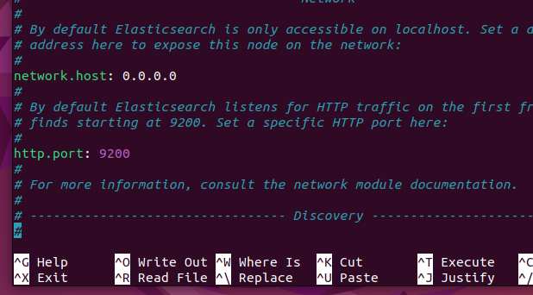
    - Network.host: 0.0.0.0 -> to listen on all interfaces.
    - A screenshot of a computer

      AI-generated content may be incorrect.
    - Commented cluster.initial because we’re not gonna use it.
      * Update!!!: uncommented that line It didn’t work and after research understanded that elastic cannot run without an initial cluster, in a single-node mode.
    - Uncommented transport.host.
      * the line #transport.host: The 0.0.0.0 setting enables Elasticsearch to listen for connections on all available network interfaces.
    - Saved the configuration file.
  + So now let’s start elastic and check the status:
    - <sudo systemctl start elasticsearch.service>
    - 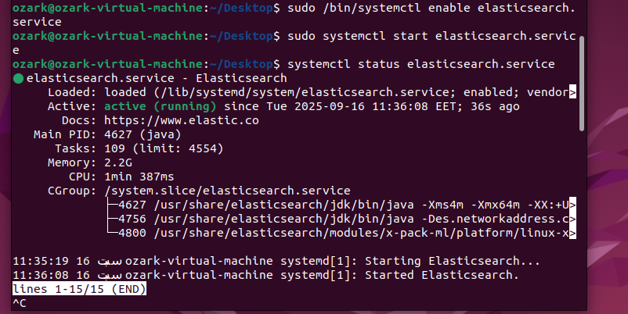
  + Okay now we’re going to set our new password to be able to check and be clear with elastic search:
    - Used the following command:
    - <sudo /usr/share/elasticsearch/bin/elasticsearch-reset-password -u username>
    - 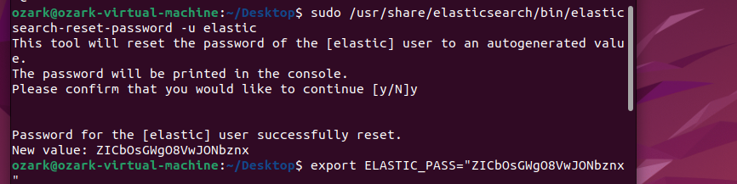
  + Now that elasticsearch supposed to be runnin then let’s go check from our web browser after logging with the default username and our generated new password:
    - A screenshot of a computer

      AI-generated content may be incorrect.
  + Okay great now that we’ve confirmed that elastic is running all good let’s roll to kibana.
  + Side not had many trials with kibana and after many and many trials decided to purge it and restart ( half an hour gone)
    - A screenshot of a computer program

      AI-generated content may be incorrect.
  + Decided to save everything in a text file to not get distracted again.(I’ll explain later that enrollement key)
    - A screenshot of a computer

      AI-generated content may be incorrect.
  + Let’s start our download:
    - 
    - Installing kibana following the elk website documentation.
  + Rolled to the configuration file of kibana in /etc/kibana/kibana.yml to adjust two variables:
    - A screenshot of a computer

      AI-generated content may be incorrect.
    - Server.host: the 0.0.0.0 is as we said to make it accessible to all interfaces I think we’ve got familiar with it by now.
    - And uncommented the server.port: 5601 which is the default port for kibana.
    - !!discovered that the first time I had a problem with kibana because I did uncomment another line which was the setting the localhost of elastic which made problem with the setup of kibana because we did give 0.0.0.0 to both hosts of kibana and elastic so when I did uncomment that line kibana froze.
  + Now let’s start and check the status of kibana:
    - A computer screen shot of a program

      AI-generated content may be incorrect.
  + Okay all set up, gone to our web browser checked our localhost:5601 and kibana requested an enrollment key:
    - <sudo /usr/share/elasticsearch/bin/elasticsearch-create-enrollment-token -s kibana>
    - The past command according to the documentation runs the script that generates the enrollement key for us.
      * A screenshot of a computer screen

        AI-generated content may be incorrect.
    - Saved that key to our txt file up there.
  + Pasted that key into the webpage that requested it:
    - A screenshot of a computer

      AI-generated content may be incorrect.
    - The site wanted the verification code and I did find it by surprise in my <systemctl status kibana> terminal.(although it was mentioned in the documentation)
      * A screenshot of a computer screen

        AI-generated content may be incorrect.
  + Waited for a bit then a login page appeared:
    - Elastic search username
    - Elastic search password
    - A screenshot of a computer

      AI-generated content may be incorrect.
    - And finalyyyy our kibana is done(side note: I purged the whole elastic stack once more for the second time because something was wrong with my whole virtualmachine it could’nt handle elastic as I didn’t provide enough resources)
  + Now let’s install our lightweight agent filebeat:(Logshipper)
    - In order to deliver logs to kibana our visualization we need to deliver logs to elastic and in order to do so we need a log shipper.
    - So let’s install it first:
    - A screenshot of a computer screen

      AI-generated content may be incorrect.
  + Let’s now roll to the configuration of it in /etc/filebeat/filebeat.yml:
    - A screenshot of a computer screen

      AI-generated content may be incorrect.
    - Followed the site’s documentation and my personal notes from the session.
    - Saved the file and exited.
  + After testing the configuration and finishing it’s setup now to kibana to view results.
    - 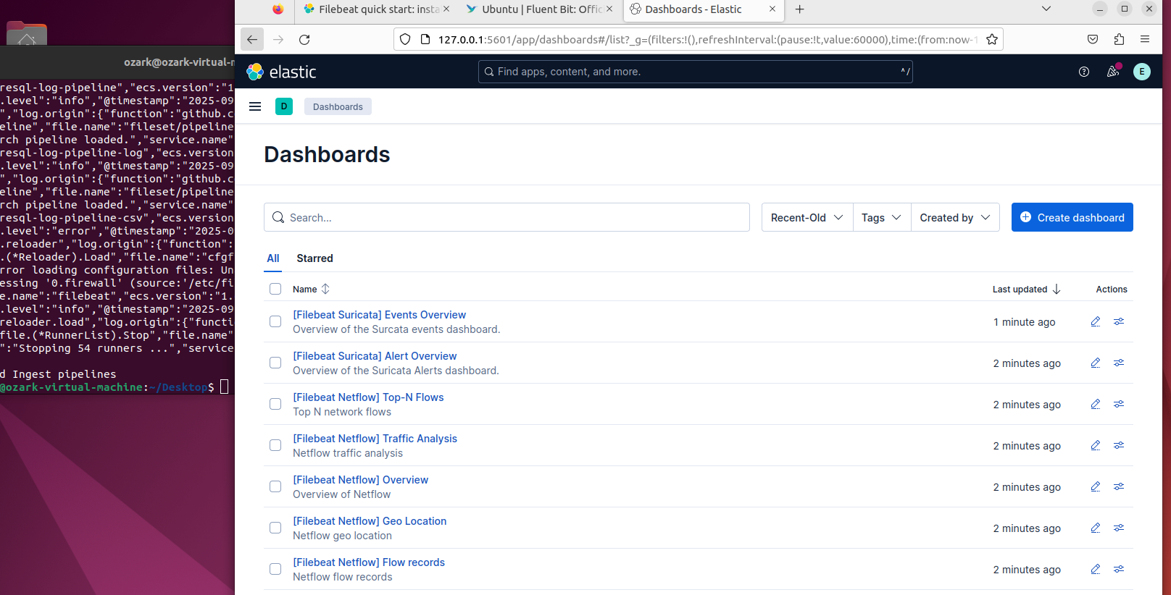
    - Oh greattt, finally we’ve got a full siem system that we can partially use.
* Now our task is done, and we’ve learnt many lessons through that task which was all about soc engineering and how to install ELK stack (without logstash).

References:

* [Elastic documentation](https://www.elastic.co/docs/deploy-manage/deploy/self-managed/installing-elasticsearch) (Configuration is covered in other directories there)
* [ElasticSearch installation](https://www.elastic.co/docs/deploy-manage/deploy/self-managed/install-elasticsearch-with-debian-package)
* [Kibana installation](https://www.elastic.co/docs/deploy-manage/deploy/self-managed/install-kibana)