Inter-VLAN Routing with DHCP (Router-on-a-Stick)

Youssef Mahmoud Elsaeed

First the required was:

Create VLANs for the following departments:

* HR (VLAN 10)
* Sales (VLAN 20)
* DEV (VLAN 30)
* PR (VLAN 40)
* Finance (VLAN 50)

Assign 5 PCs to each VLAN.

Configure a trunk link between the router and the switch to allow VLAN-tagged traffic.

Set up Router-on-a-Stick on the router to enable inter-VLAN routing.

Topology Requirements

* 1 Router
* 1 Switch
* 25 PCs (5 for each of the 5 VLANs)
* 1 Trunk Link between the router and switch

So now let’s dive in on what we did:

First things first the topology

* 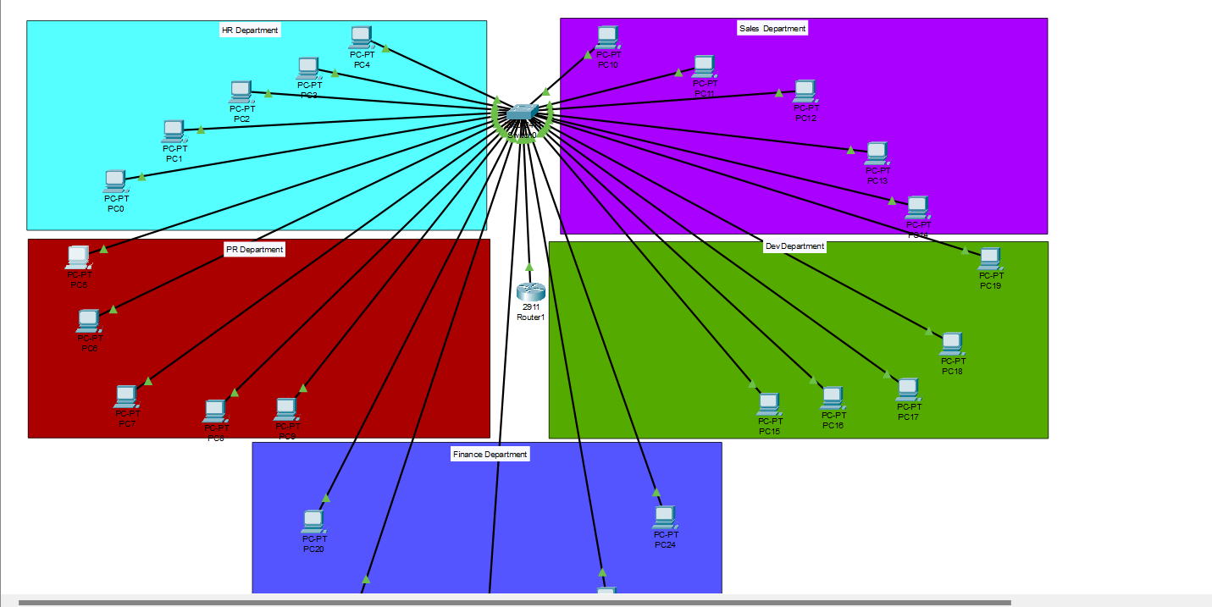

1. created 5 VLANs to separate departments:

* VLAN 10 → HR
* VLAN 20 → Sales
* VLAN 30 → DEV
* VLAN 40 → PR
* VLAN 50 → Finance

Each PC port on the switch was assigned to its respective VLAN using:

switchport mode access

switchport access vlan <ID>

1. **Router-on-a-Stick Configuration**

The router’s g0/0 interface was divided into **subinterfaces**, one for each VLAN.  
Example for VLAN 10:

interface g0/0.10

encapsulation dot1Q 10

ip address 192.168.10.1 255.255.255.0

1. We configured the router to provide IPs dynamically using **DHCP pools**.

-although we could ve used a server as the past lab but I though it’s required to use only router and a switch.

1. And finally testing:

PCs were set to **DHCP** mode.

Each PC received an IP from the correct VLAN range:

* HR → 192.168.10.x
* Sales → 192.168.20.x
* DEV → 192.168.30.x
* PR → 192.168.40.x
* Finance → 192.168.50.x

1. Now to the pinging:

1. Notice I pinged two differect vlans from pc 5 in vlan 30 (PR department) and it did ping so we are done.