campus-hub
Student User Guide
How to buy and sell, find lost items, join study groups, share course files and more, step by step.
For Fanshawe College students · Built by Binary Minds · Fall 2026
Screenshots use sample accounts and made-up content.

Contents
1. What is campus-hub?
2. Create your account and log in
3. Your home page and the menu
4. Your profile
5. Marketplace
6. Lost & Found
7. Campus events
8. Study groups
9. Messages
10. Course files
11. Find students
12. Reporting a problem
13. For administrators
14. Troubleshooting

1. What is campus-hub?
campus-hub is a website just for Fanshawe College students. In one place you can buy and sell items, post about lost or found belongings, see campus events, join a study group for your course, share notes, and message other students.
Only people with a @fanshaweonline.ca email address can join, so everyone you meet on campus-hub is a verified Fanshawe student.
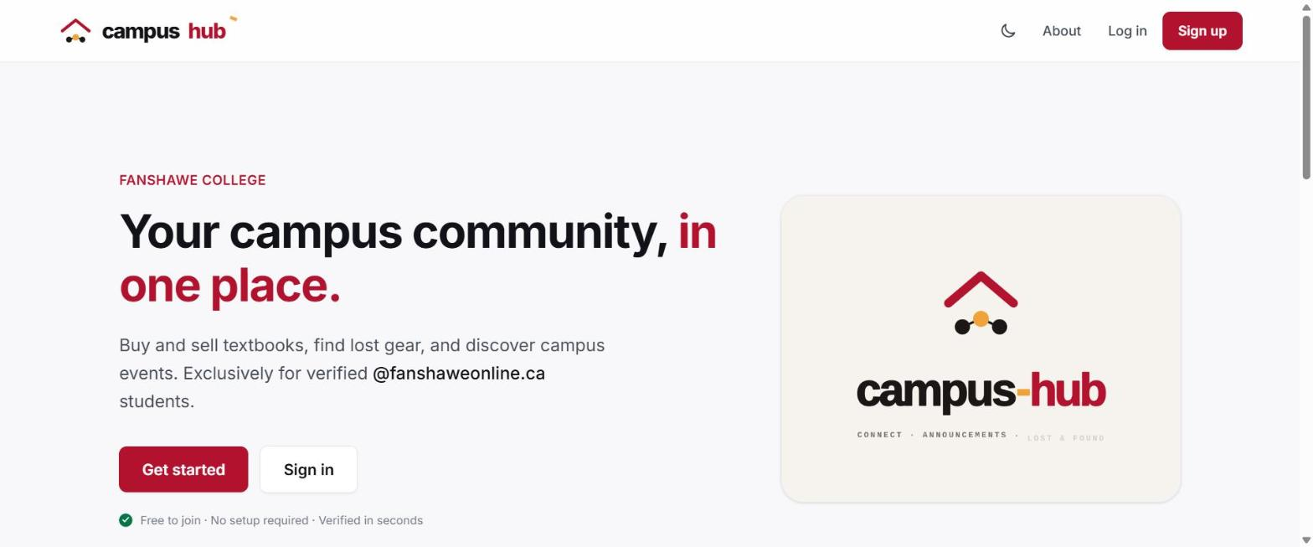
Figure 1. The campus-hub home page before you sign in.

2. Create your account and log in

Create your account
- Go to the campus-hub home page and select Sign up (top right) or Get started.
- Enter your first and last name.
- Enter your Fanshawe email address. It must end in @fanshaweonline.ca; other addresses are not accepted.
- Choose a password. It needs at least 8 characters, one uppercase letter, one number and one symbol. The checklist under the field turns green as you meet each rule.
- Type the password again in Confirm password. Use the eye button beside either field to show or hide what you typed.
- Read the Terms and Conditions, tick the box to accept them, and select Sign up.
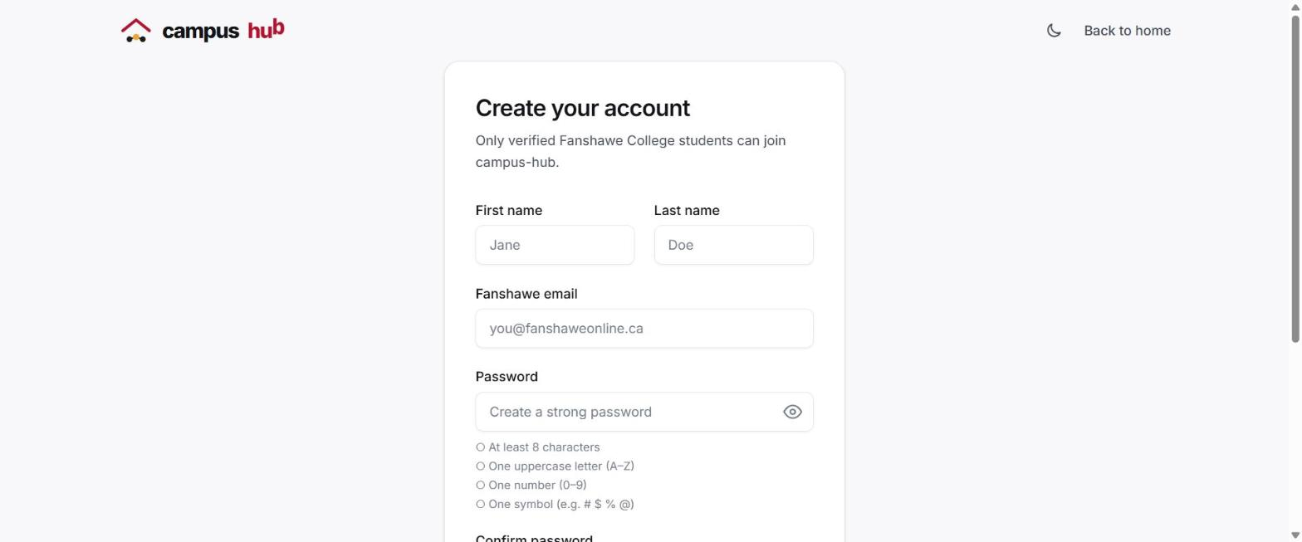
Figure 2. The Create your account form.

Verify your email
- Check your Fanshawe inbox for an email from campus-hub with a 6-digit code. Check your junk folder if you don't see it.
- Enter the code on the verification page. The code works for 15 minutes.
- If the code expired or never arrived, select Resend code and use the newest one.
Once your email is verified, your account is active and you can log in.

Log in
- Select Log in at the top of any page.
- Enter your Fanshawe email and password, then select Log in.
- Forgot your password? Select Forgot password?, enter your email, and follow the code sent to you to choose a new one.
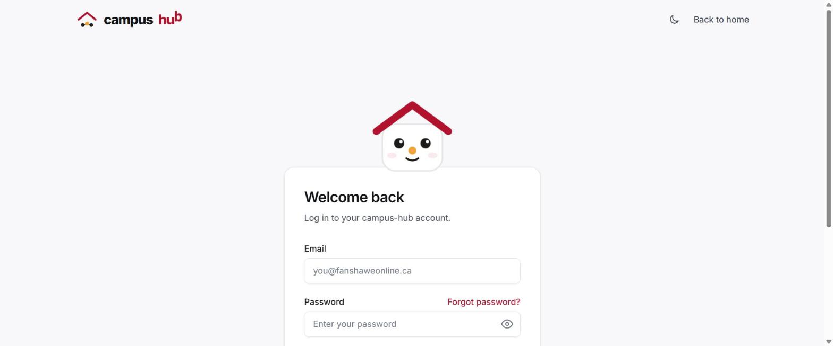
Figure 3. The log-in page.
Tip: For your safety, campus-hub signs you out after 10 minutes without activity. Just log in again to continue.

3. Your home page and the menu
After you log in, the home page shows Jump back in shortcuts to the main areas of the site. The menu at the top of every page takes you anywhere:
Menu item | What it's for
Study groups | Find, join or create a group for your course.
Course files | Notes and documents shared in study groups.
Messages | Your chats. A red number shows how many unread messages and new requests you have.
Marketplace | Buy and sell items with other students.
Lost & Found | Post or search for lost and found items.
Events | Upcoming campus events and your RSVPs.
Students | Search for classmates by name, program, course or interest.
Your initials | Opens your profile.
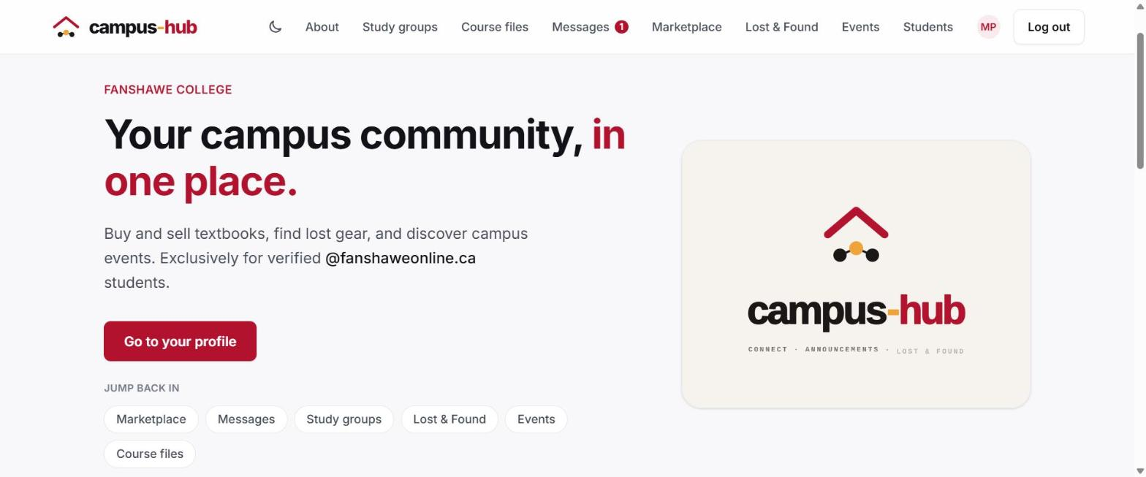
Figure 4. The home page after logging in, with quick links and an unread-message badge on Messages.
Tip: On a phone or small screen, the menu is behind the ☰ button at the top right. Keyboard users can press Tab once on any page and choose Skip to content to jump past the menu.

4. Your profile
Your profile is what other students see when they find you or open a chat with you.
- Select your initials (or photo) at the top right of the menu.
- Select Upload photo to add a profile picture.
- Select Edit profile to add your program, year of study, a short bio, your courses and your interests. Courses and interests help classmates find you in Students.
- Select Save profile when you're done.
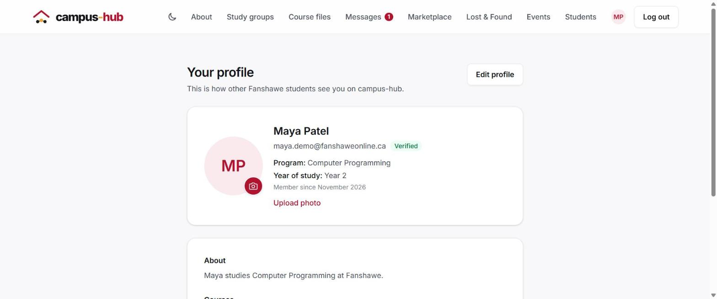
Figure 5. Your profile page.

5. Marketplace

Browse and search
- Select Marketplace in the menu.
- Type in Search listings to find items by name, or narrow the list by category, condition and price (Min $ and Max $).
- Tick My listings to see only the items you are selling.
- Select any listing to see its details.
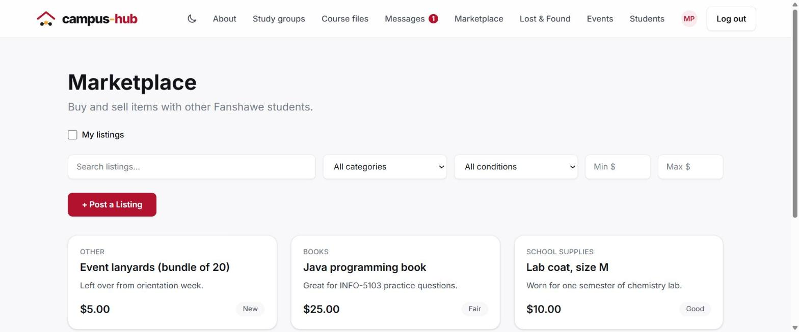
Figure 6. The Marketplace with search and filters.

Contact a seller
- Open the listing you're interested in.
- Select Message Seller. A chat opens with the listing shown at the top, so the seller knows which item you mean.
- Agree on a price and a safe place on campus to meet.
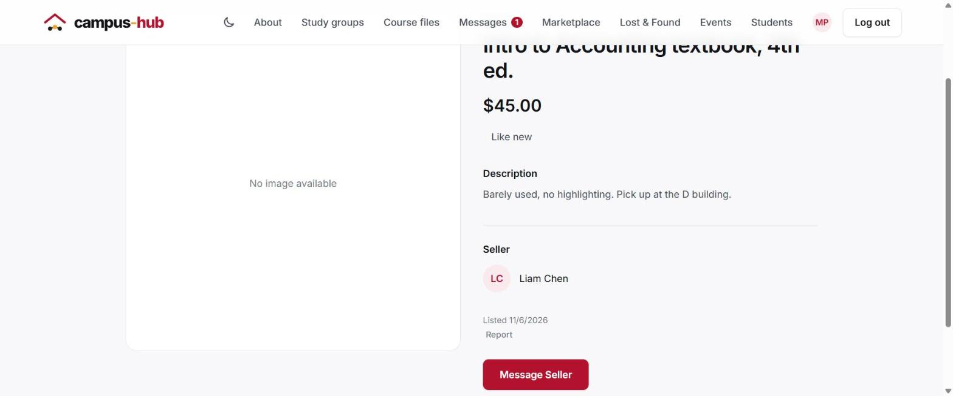
Figure 7. A listing's details, with Message Seller and Report.
Tip: Meet in a public place on campus and never pay before you see the item. If a seller asks for payment up front, report the listing (see section 12).

Sell an item
- On the Marketplace page, select + Post a Listing.
- Enter a title, a description, the price, a category and the item's condition.
- Add up to 5 photos (optional, but listings with photos get more interest).
- Select Create listing to publish it.
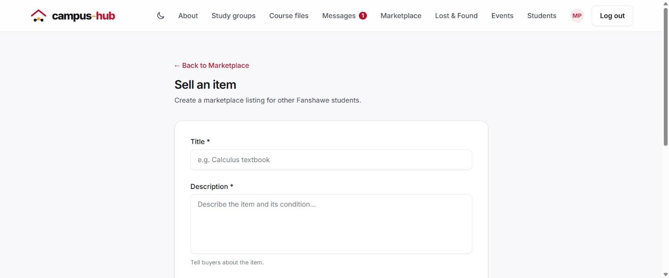
Figure 8. The Sell an item form.
When you open one of your own listings you can Edit it, Mark as Sold when it's gone, or Delete it.

6. Lost & Found
- Select Lost & Found in the menu.
- Search by keyword, or filter by type (Lost or Found), category, location and date.
- Found something that might be yours? Select Message poster on the post.
- To post about something you lost or found, select + Report an item, fill in what it is, where and when, add a photo if you have one, and select Create post.
- When your item is returned, open your post and select Mark as Resolved.
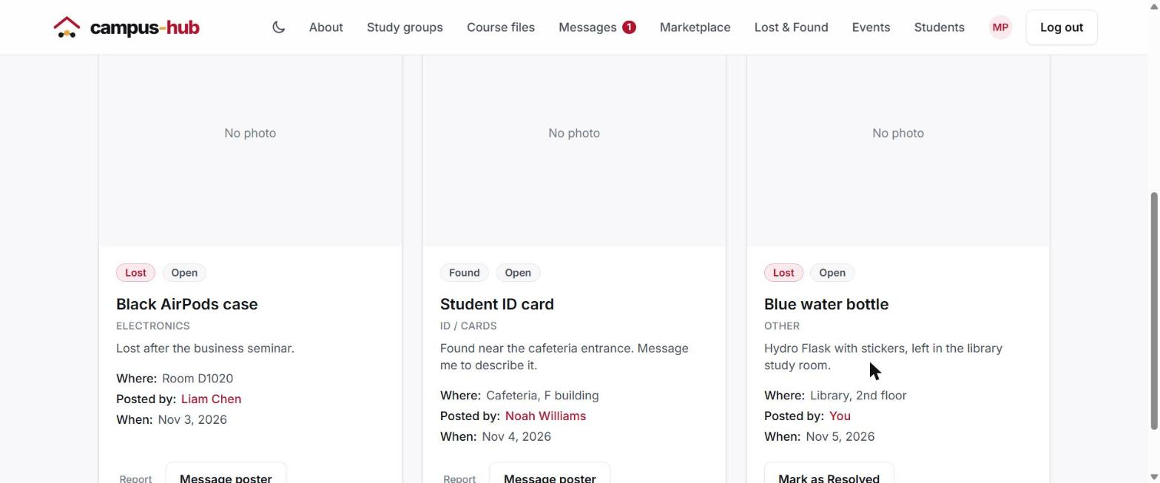
Figure 9. Lost & Found posts. Your own posts show Mark as Resolved.

7. Campus events
- Select Events in the menu to see what's coming up. Times are shown in your own time zone.
- Select RSVP on an event you plan to attend. Select it again to cancel.
- Select Saved Events to see every event you've RSVP'd to.
- Have a question? Select Message organizer.
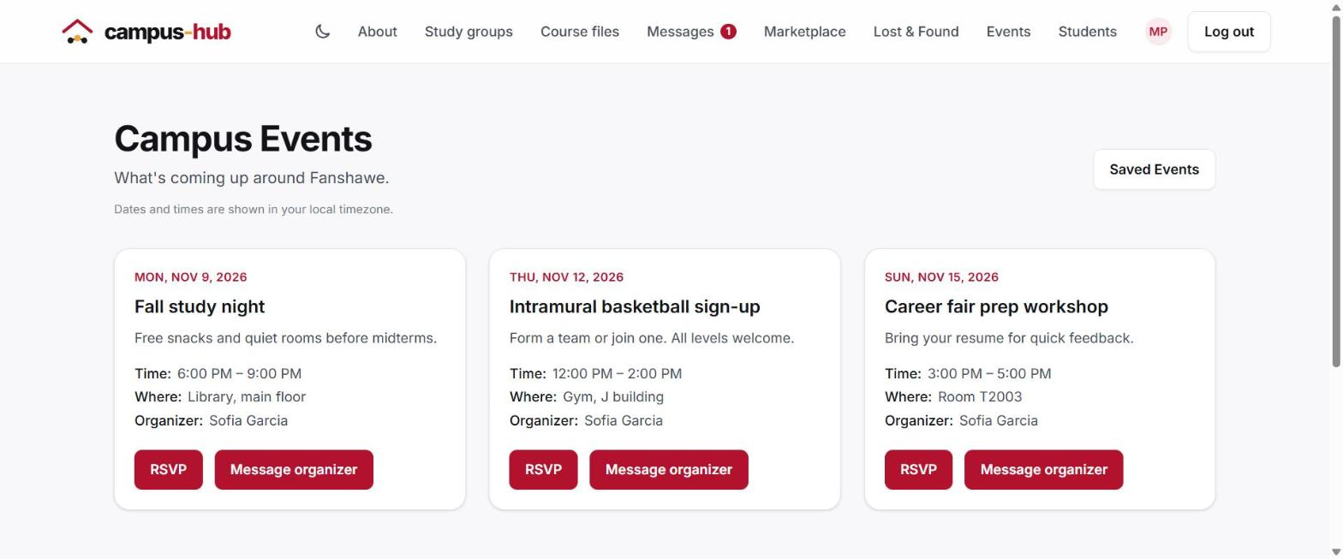
Figure 10. Upcoming campus events.
Students with the Organizer role also see Event Management in the menu, where they can create, edit and cancel their events.

8. Study groups
Every study group belongs to a course and comes with its own group chat.

Find and join a group
- Select Study groups in the menu.
- Select View details & members to see a group's description and who is in it.
- Select Join to become a member. The group chat is added to your Messages straight away.
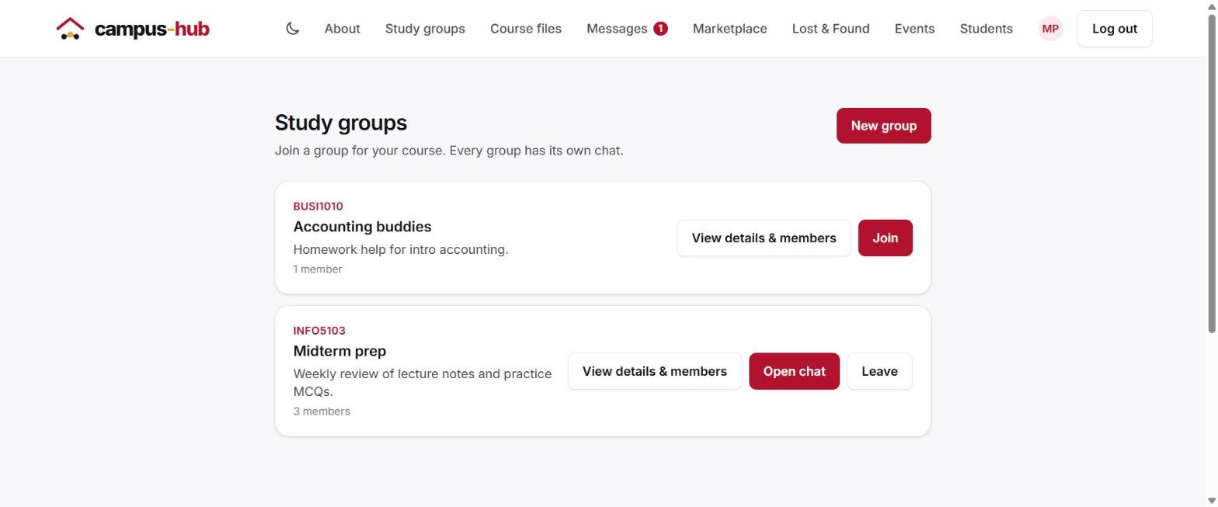
Figure 11. Study groups. Groups you belong to show Open chat and Leave.

Create a group
- Select New group.
- Enter the course code, such as INFO-5103 or INFO5103. Use the subject letters followed by the course number; a number on its own (for example 1105) isn't accepted.
- Give the group a name and a short description of what it will study and who should join. All three fields are required.
- Select Create group. You become its first member and its chat is ready to use.
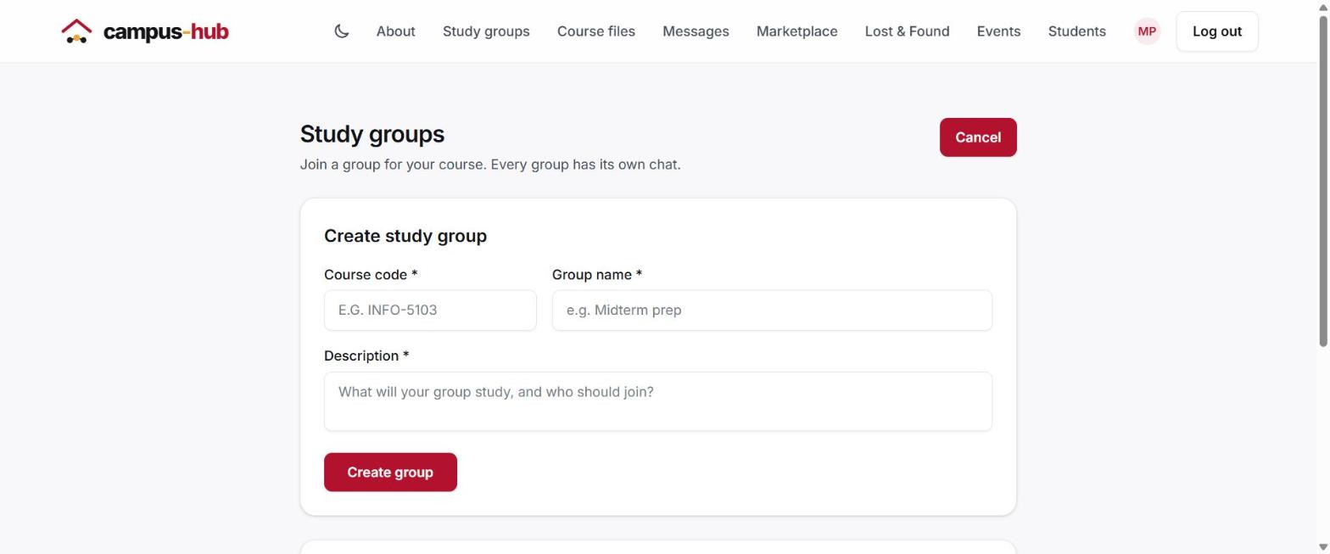
Figure 12. The Create study group form.

Group details and leaving a group
A group's page shows its course, description, member count and member list, with buttons to Open chat, see its Course files, or Leave group. If you are the last member to leave, the group and its chat are deleted.
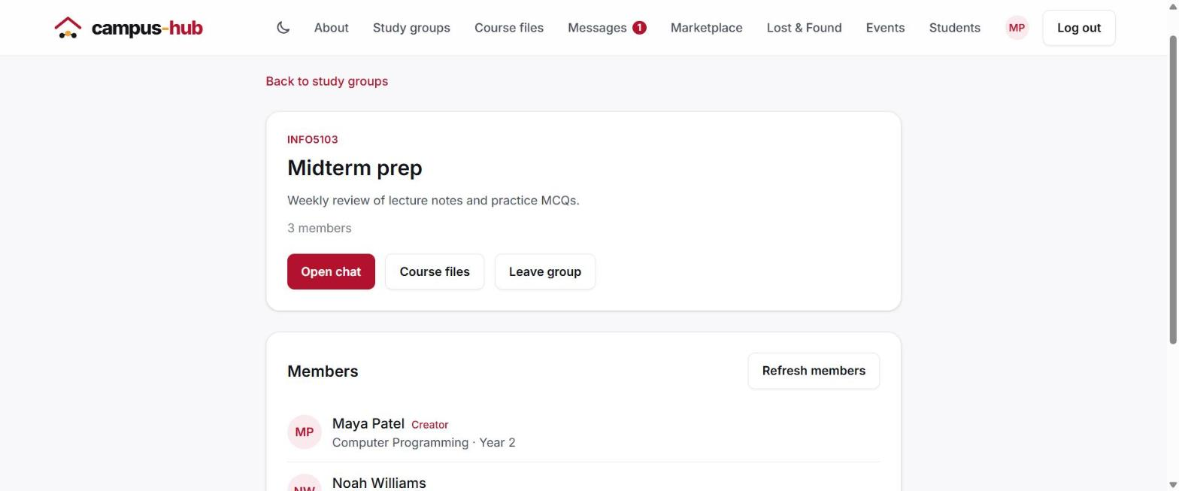
Figure 13. A study group's details and members.
Tip: Older groups created before descriptions were required may show "No description added."

9. Messages
Select Messages in the menu. Your chats are on the left and the open conversation is on the right.
- Inbox holds your conversations. A number beside a chat shows its unread messages.
- Requests holds first messages from students you haven't chatted with before. Choose Accept to reply, Ignore to dismiss it, or Block to stop that person messaging you.
- In a study group chat, select Attach to share a file (PDF, Word, PowerPoint, Excel, text or image, up to 5 MB). Files shared in a group also appear in Course files.
- Chats started from a listing or an event show it at the top, so everyone knows what the conversation is about.
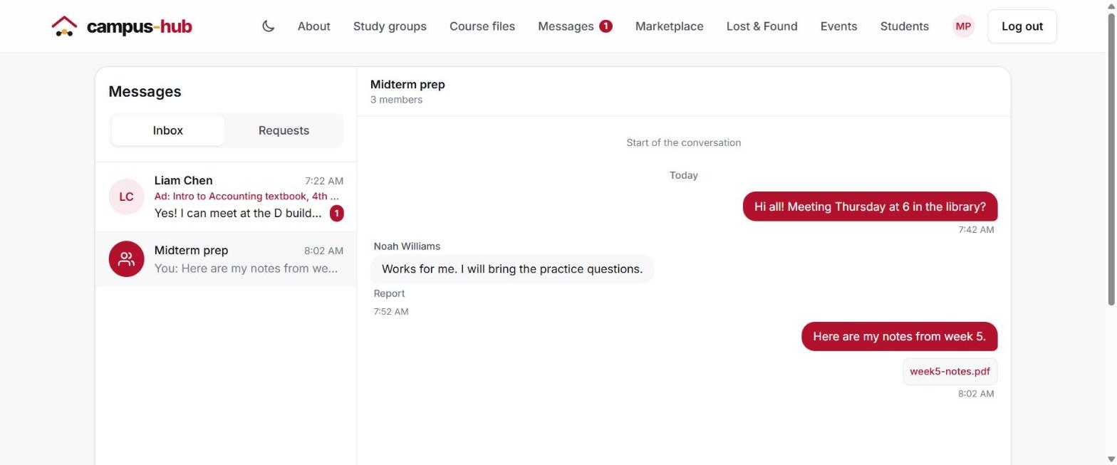
Figure 14. A study group chat with a shared file.
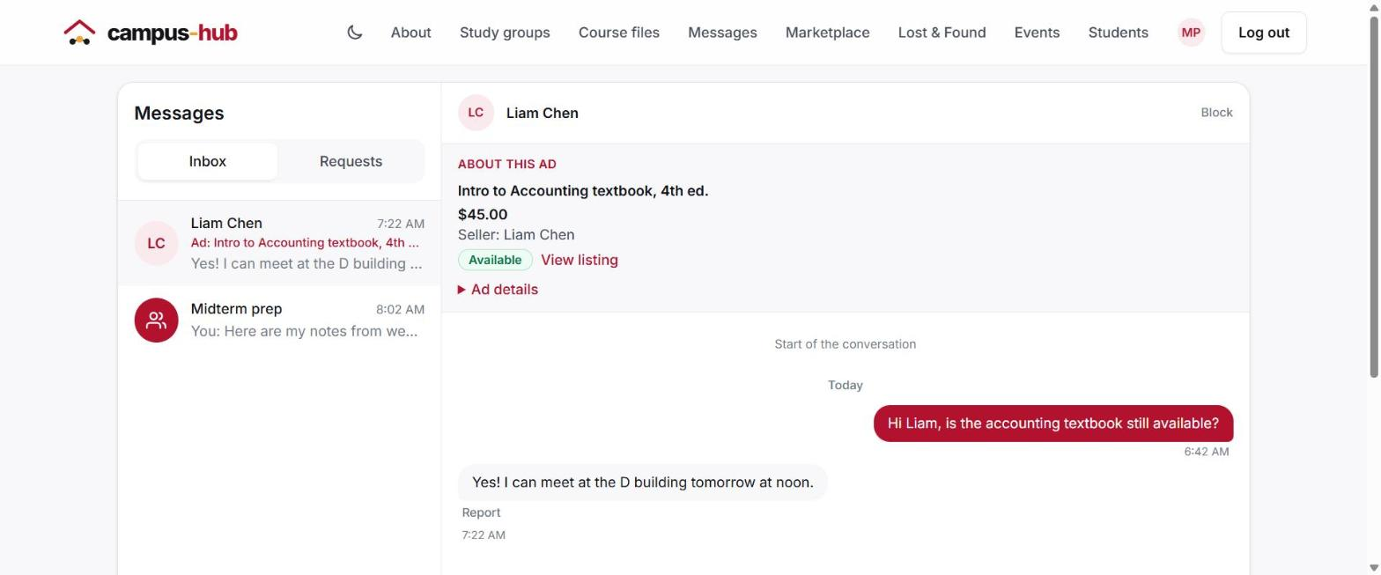
Figure 15. A chat with a seller about a Marketplace listing.

10. Course files
- Select Course files in the menu.
- Choose a course, or type part of a file name in File name.
- Select a file's name to download it.
- To add a file, open your study group's chat and use Attach.
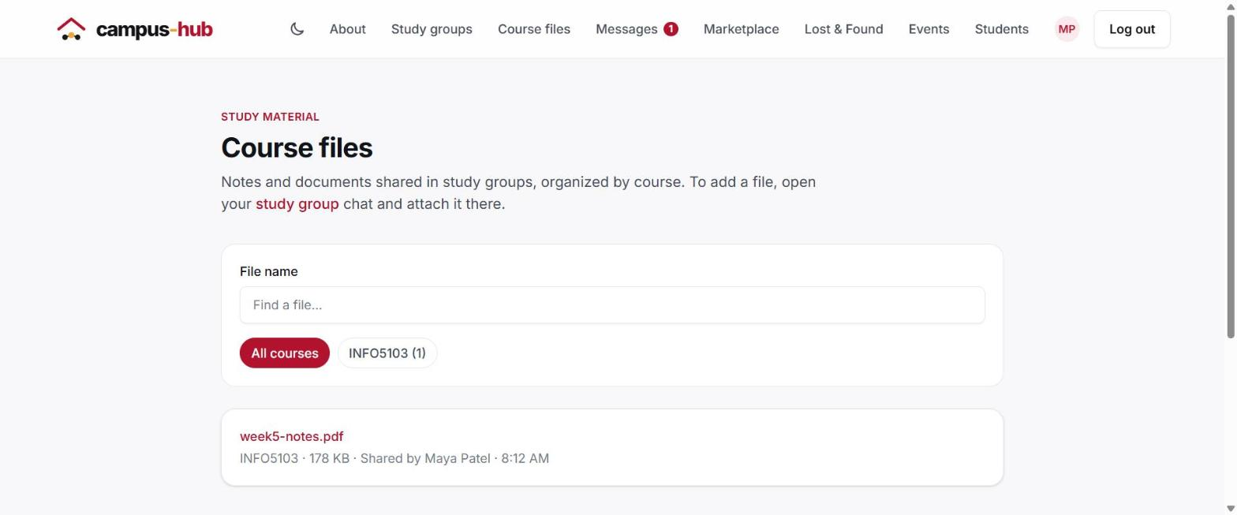
Figure 16. Course files, filtered by course.

11. Find students
- Select Students in the menu.
- Search by name, or fill in program, course or interest. You can combine filters.
- Select a student to see their profile, or select Message to start a chat.
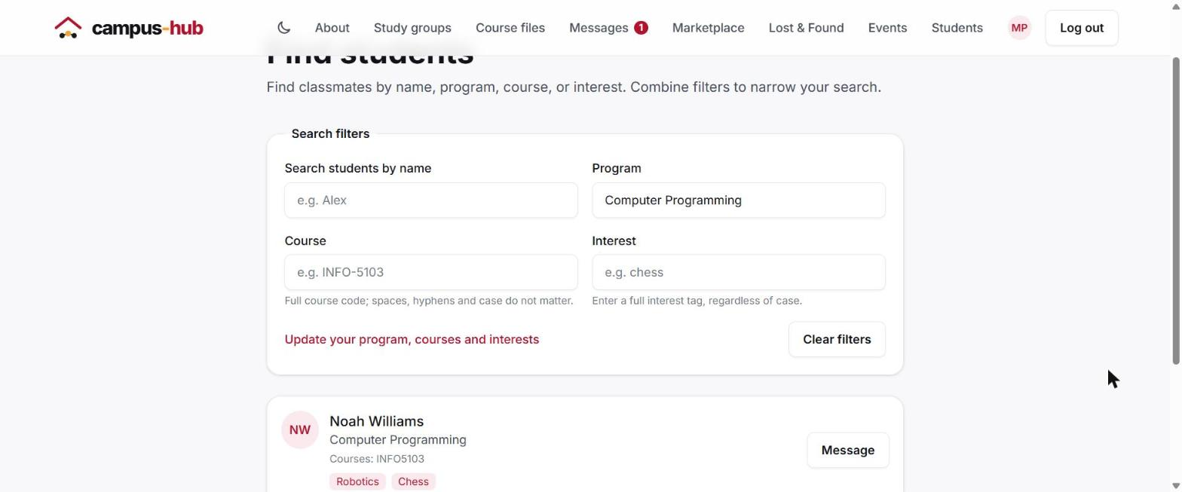
Figure 17. Finding classmates in the same program.

12. Reporting a problem
If you see a scam, harassment, spam or anything inappropriate, report it. Reports go privately to campus-hub administrators; the person you report is not told who reported them.
You can report a Marketplace listing, a Lost & Found post, a message, or a shared file (in a chat or in Course files).
- Select Report next to the content.
- Choose a reason, and add a note if it helps explain the problem.
- Select Submit report. You'll see "Report sent. An administrator will review it."
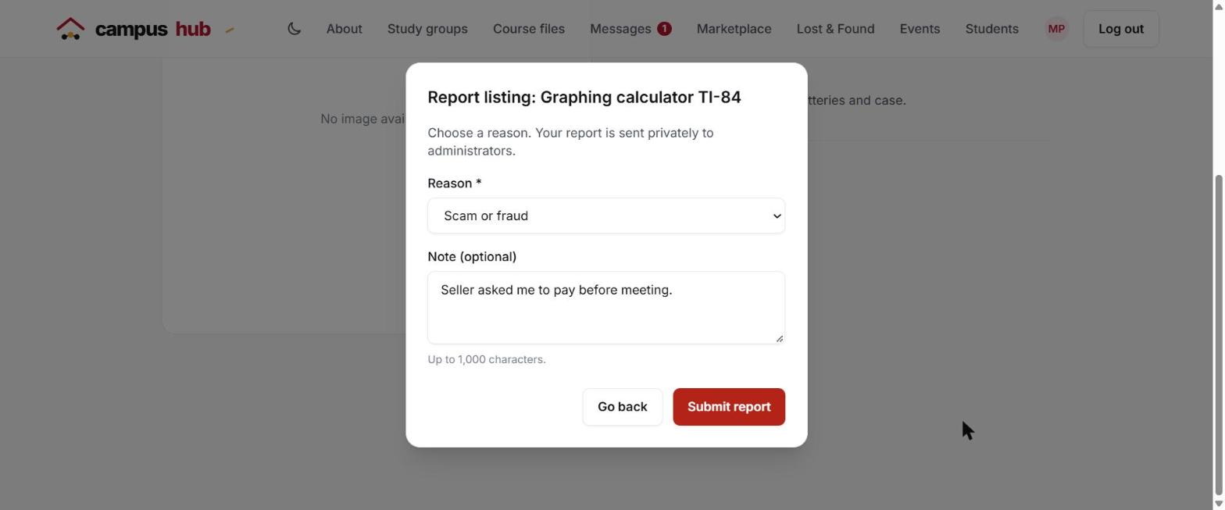
Figure 18. Reporting a listing.
You can report each item once. If you select Report again on something you already reported, campus-hub tells you "You already reported this" instead of sending a duplicate.

13. For administrators
Accounts with the Administrator role see Admin in the menu. Students can't open these pages.

Review reports
- Select Admin in the menu to open Reports.
- Use Status to switch between Open, Content removed, Dismissed, and Resolved reports, and Content type to narrow by listing, post, message or file.
- Each report shows what was reported, a preview, who reported it, the reason, their note and the date. Select View details for the full snapshot.
- Choose Remove content to hide it from everyone and close the report, Resolve report to close it without removing anything, or Dismiss report if nothing is wrong. You can add a review note.
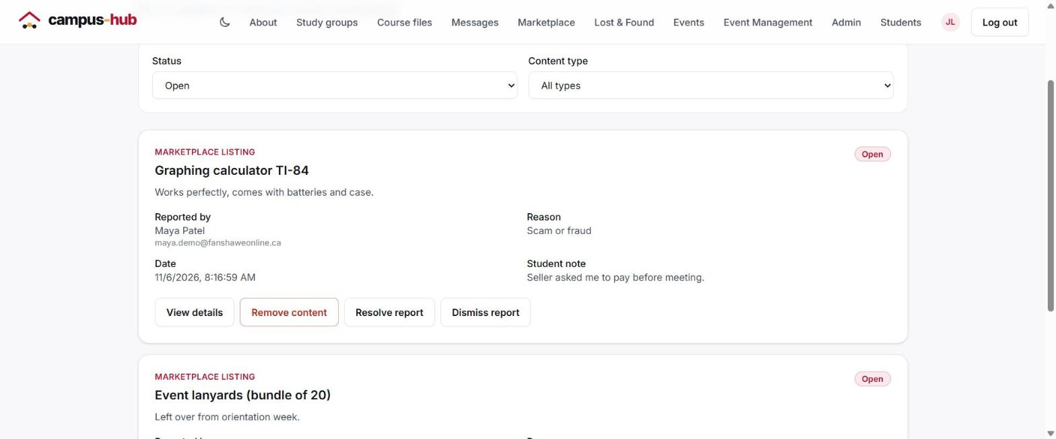
Figure 19. Open reports waiting for review.
Every decision records which administrator made it and when, and that record is shown on the report.

Manage users
- On the Reports page, select Manage users.
- Search by name or email, or filter by role.
- Change a member's role (Student, Organizer or Administrator) and select Save role.
- Select Suspend to block an account. You can enter a reason; the student sees it when they try to log in. Select Reactivate to restore the account.
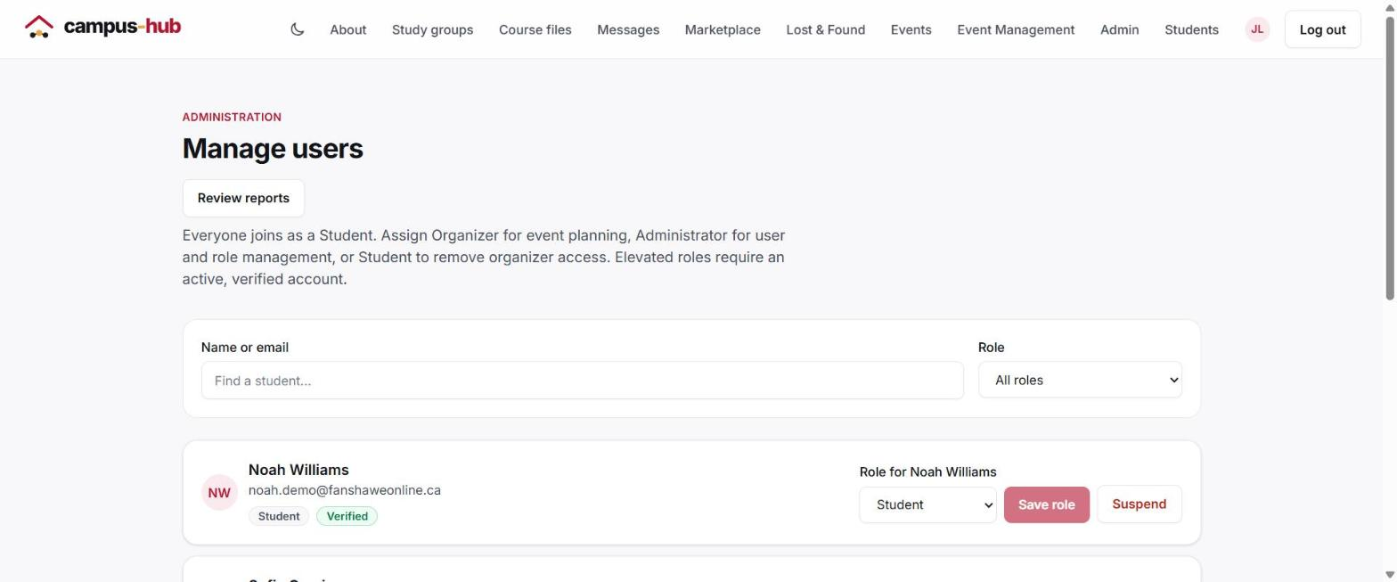
Figure 20. Managing users and roles.
A suspended student is signed out on their next action and can't log in until an administrator reactivates them. Administrators can't suspend their own account or another administrator's.

14. Troubleshooting
Problem | What to do
"Only Fanshawe student email addresses are allowed" | Sign up with your @fanshaweonline.ca address.
The verification code didn't arrive | Check your junk folder, wait a minute, then select Resend code.
"Verification code has expired" | Codes last 15 minutes. Request a new one or sign up again.
"Your session expired" | You were inactive for 10 minutes. Log in again.
"Your account is suspended" | An administrator suspended your account. The message includes their reason, if they gave one. Contact a campus-hub administrator if you think it's a mistake.
"Use a course code such as INFO-5103" | Enter the subject letters and the course number together, e.g. INFO-5103.
"Page not found" | The link is wrong or the item was removed. Use the button on the page to go back.
"You already reported this" | Your earlier report is still with the administrators; there's no need to send another.

