SMART SECURITY DOOR LOCK SYSTEM
Project Documentation — 3-Phase Arduino Development
Phase 1: Tinkercad Prototype | Phase 2: Wokwi Simulation | Phase 3: Real Implementation
Project Title | Smart Security Door Lock System
Development Stages | 3 Phases (Prototype → Simulation → Real Build)
Microcontrollers | Arduino UNO (Phase 1 & 3), Arduino Mega (Phase 2)
Simulation Tools | Tinkercad (Phase 1), Wokwi (Phase 2)
Key Technologies | RFID RC522, SPI, I2C LCD, Keypad, Servo, EEPROM
Languages / Libraries | C++ (Arduino IDE), SPI, MFRC522, LiquidCrystal_I2C, Keypad

Table of Contents
1. Project Overview 3
2. Phase 1 — Basic Prototype (Tinkercad) 4
2.1 Components & Wiring 4
2.2 How It Works 5
2.3 Code Highlights 5
3. Phase 2 — Full Simulation (Wokwi / Arduino Mega) 6
3.1 Components & Wiring 6
3.2 System Features 7
3.3 State Machine 8
3.4 Code Highlights 9
4. Phase 3 — Real-Life Implementation (Arduino UNO) 10
4.1 Hardware Components 10
4.2 UNO Adaptations 11
4.3 Real Build Photo 12
4.4 Code Highlights 12
5. Phase Comparison 13
6. Conclusions & Future Work 14

1. Project Overview
This project documents a progressive three-phase development of an Arduino-based Smart Security Door Lock. Each phase builds upon the previous, adding features, authentication methods, and real-world robustness.

Phase | Platform | Controller | Auth Method | Key Features
Phase 1 | Tinkercad | Arduino UNO | Push Button | Single-user, LED, Servo, Auto-lock
Phase 2 | Wokwi | Arduino Mega | RFID + PIN | Multi-user, LCD, EEPROM, Admin Menu
Phase 3 | Real Hardware | Arduino UNO | RFID + PIN | Full features on physical build

2. Phase 1 — Basic Prototype (Tinkercad)
The first phase established the core concept: a push-button-controlled door lock simulated entirely in Tinkercad with an Arduino UNO. It proves the servo-as-bolt mechanism and LED feedback loop in a zero-risk environment.

2.1 Components & Wiring
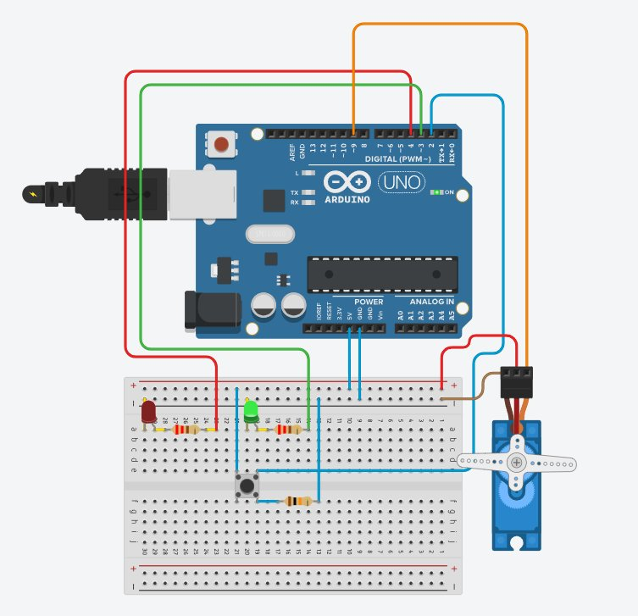
Arduino UNO | Main microcontroller
Push Button | Digital Pin 2 — lock/unlock trigger
Red LED | Digital Pin 4 — locked indicator
Green LED | Digital Pin 3 — unlocked indicator
Servo Motor | Digital Pin 9 — 0° = Locked, 90° = Unlocked
Resistors | 220 Ω for each LED; 10 kΩ pull-down for button

2.2 How It Works
- System starts in LOCKED state: Red LED ON, servo at 0°.
- A LOW → HIGH transition on Pin 2 triggers the unlock sequence.
- Servo rotates to 90°, Red LED turns OFF, Green LED turns ON.
- After 3 000 ms the system automatically re-locks (servo back to 0°).
- A second button press while unlocked immediately re-locks the door.
- All state changes are logged to the Serial Monitor at 9600 baud.

2.3 Code Highlights
// Key constants
const int BUTTON_PIN = 2; const int GREEN_LED = 3;
const int RED_LED = 4; const int SERVO_PIN = 9;
const int AUTO_LOCK_DELAY = 3000; // 3 seconds

// Unlock → auto-lock flow
if (currentButton == HIGH && lastButtonState == LOW) {
isLocked = false; updateLockState();
delay(AUTO_LOCK_DELAY); // hold door open
isLocked = true; updateLockState(); // auto-lock
}

// updateLockState() drives LEDs + servo
doorLock.write(isLocked ? 0 : 90); // 0°=LOCKED 90°=UNLOCKED

3. Phase 2 — Full Simulation (Wokwi / Arduino Mega)
Phase 2 elevated the project to a fully-featured security system simulated in Wokwi. The Arduino Mega provided ample I/O for RFID, a 4×4 keypad, LCD, and buzzer — all integrated with EEPROM persistence and multi-user role management.

3.1 Components & Wiring
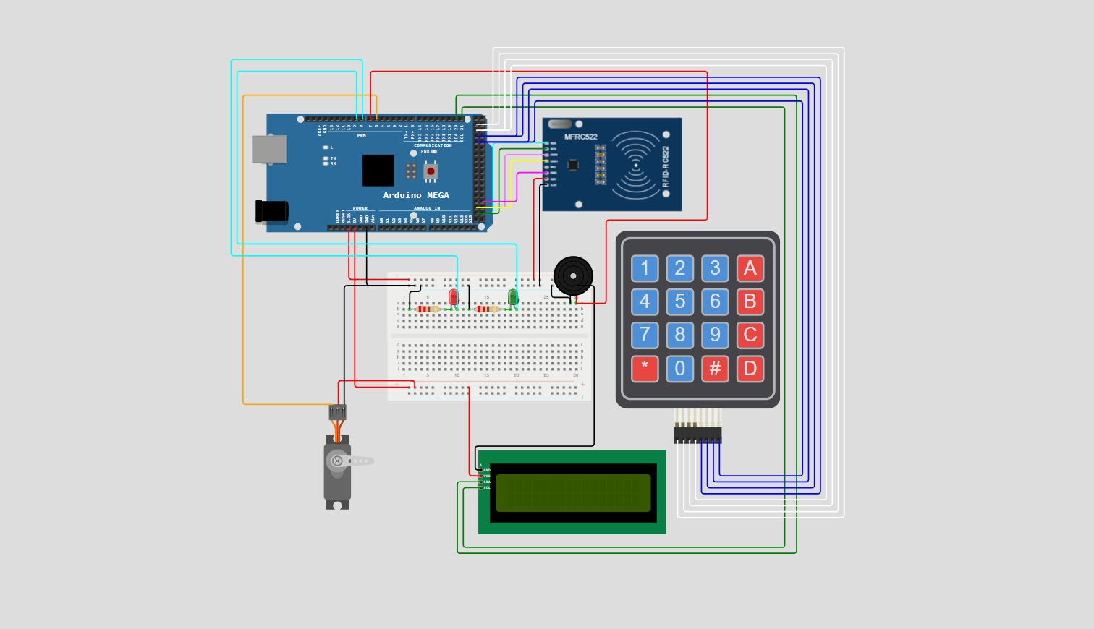
Arduino Mega 2560 | Main microcontroller (SPI + I2C + ample digital I/O)
MFRC522 RFID | SS=53, RST=49 via SPI bus
4×4 Keypad | Rows: pins 22–25 Cols: pins 26–29
LCD 16×2 (I2C) | I2C address 0x27
Servo Motor | Pin 6 — LOCK_POS=0° UNLOCK_POS=90°
Buzzer | Pin 7 — differentiated tones per user role
Red LED | Pin 5 — access denied / locked
Green LED | Pin 4 — access granted / unlocked

3.2 System Features
RFID Authentication: Scan any of 4 registered cards; UID match triggers access.
PIN Entry: 4–8 digit PIN via keypad; # confirms, * clears buffer.
4 User Roles: Admin (Youssef) · User Ahmed · User Karim · Guest — each with unique PIN & card UID.
Lockout System: 6 consecutive failed attempts triggers a 30-second lockout with alarm sound and flashing Red LED.
Admin Override: Pressing * during lockout enters Admin Login mode; correct Admin PIN unlocks the system.
EEPROM Persistence: PINs, UIDs, lockout state, and silent-mode preference saved across power cycles.
Admin Menu: 1 = Reset lockout | 2 = Edit users | 3 = Toggle sound | * = Exit
Panic Code (911): Entering '911' as a PIN fires an emergency alarm sequence without unlocking the door.
Silent Mode: Admin can mute all buzzer feedback via the menu.
Auto-lock: Door re-locks automatically after DOOR_OPEN_TIME (3 000 ms).

3.3 State Machine
The system operates across seven distinct states, each handling a specific mode of user interaction:

State | Description | Entry Condition
SYS_IDLE | Awaiting RFID scan or PIN input | Default / access granted
SYS_LOCKED | Lockout active — input blocked | 6 failed attempts
SYS_ADMIN_LOGIN | Admin PIN entry | * pressed (idle or lockout)
SYS_ADMIN_MENU | Admin control menu (1/2/3/*) | Correct Admin PIN
SYS_ROLE_SELECT | Choose Admin/User/Guest to edit | Admin menu → 2
SYS_USER_EDIT | Edit PIN or toggle user active | Role selected
SYS_CHANGE_PIN | New PIN input for selected user | User edit → 1

3.4 Code Highlights
// User struct — role-based access control
struct User { byte uid[4]; const char* name; char pin[9]; Role role; bool active; };

// Grant access
void grantAccess(byte userIndex) {
openDoor(); flashGreen(2); loginSound(userIndex);
delay(DOOR_OPEN_TIME); closeDoor();
failedAttempts = 0; saveSystemEEPROM();
}

// Trigger lockout after MAX_FAILED_ATTEMPTS
void triggerLockout() {
lockedOut = true; lockoutEnd = millis() + LOCKOUT_TIME;
currentState = SYS_LOCKED; alarmSound();
}

// EEPROM persistence
EEPROM.update(EEPROM_ATTEMPTS, failedAttempts);
EEPROM.update(EEPROM_LOCKED, lockedOut ? 1 : 0);

4. Phase 3 — Real-Life Implementation (Arduino UNO)
Phase 3 brings the simulation to life on physical hardware. The Arduino UNO's limited resources required several adaptations, while new features were added: smooth servo motion, LCD custom characters, RFID card assignment via menu, and an RFID card override during lockout.

4.1 Hardware Components
Arduino UNO | Main microcontroller (2 KB SRAM, 32 KB Flash)
RFID RC522 | SS=10, RST=9 via SPI bus
3×4 Keypad | Rows: 2,3,8,A0 Cols: A1,A2,A3
LCD 16×2 (I2C) | Address 0x27 — lock/unlock custom icons
Servo Motor | Pin 6 — LOCK_POS=90° UNLOCK_POS=0° (reversed from Phase 2)
Buzzer | Pin 7 — differentiated melodies per user role
Red LED | Pin 5 — access denied / locked state
Green LED | Pin 4 — access granted / door open
Breadboard | Houses LEDs, resistors, wiring

4.2 UNO Adaptations vs Mega

Feature | Phase 2 (Mega) | Phase 3 (UNO) | Reason / Notes
Keypad layout | 4×4 (A–D row) | 3×4 (no letter keys) | UNO pin count
Pin routing | Ports 22–29 | Analog A0–A3 as digital | Only 14 digital I/O
Servo motion | Instant write() | Smooth ramp ±2° | Realistic door feel
LCD icons | None | Custom lock/unlock chars | lcd.createChar()
Card assignment | UID hardcoded | Admin menu → Set Card | Dynamic registration
User selection | Direct key | Role → User 2-step | Extra SYS_USER_SELECT state
Memory | 8 KB SRAM | F() macro for strings | Prevents SRAM overflow
Lockout override | PIN only | PIN + RFID card | Faster admin recovery

4.3 Real Build Photo
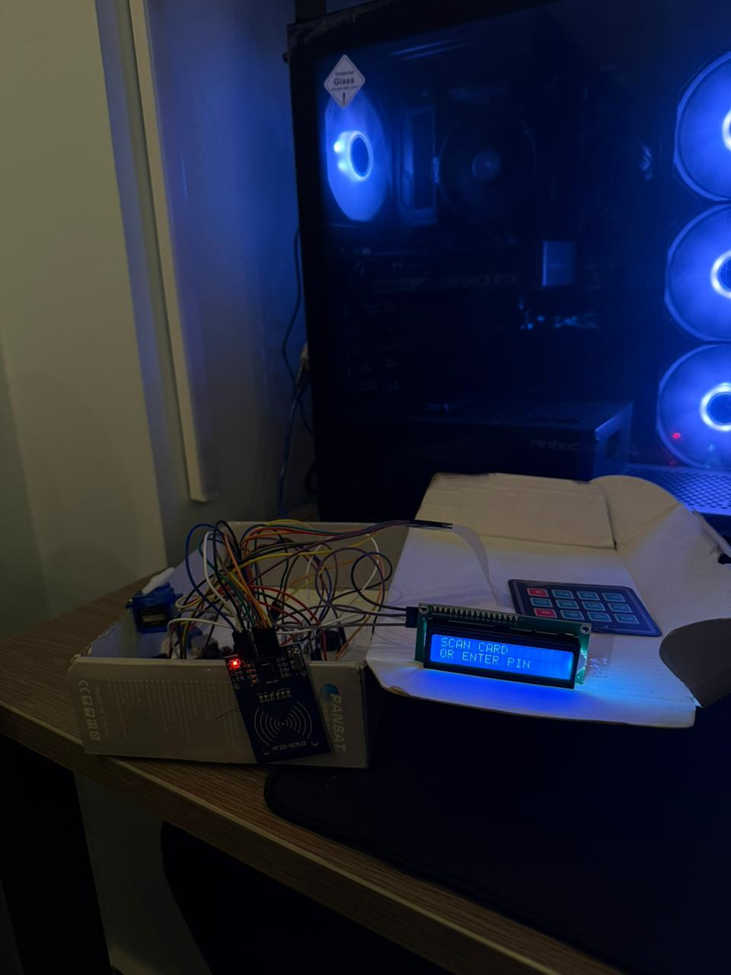
LCD showing 'SCAN CARD / OR ENTER PIN' — the system idle state.

4.4 Code Highlights
// Smooth servo ramp — unique to Phase 3
void openDoor() {
doorServo.attach(SERVO_PIN);
for (int p = LOCK_POS; p >= UNLOCK_POS; p -= 2) {
doorServo.write(p); delay(10);
}
delay(200); doorServo.detach();
}

// F() macro saves 2 KB SRAM
show(F("SCAN CARD"), F("OR ENTER PIN"));

// RFID admin card override during lockout
if (uidBelongsToAdmin(mfrc522.uid.uidByte, mfrc522.uid.size)) {
clearLockout();
show(F("RFID OVERRIDE"), F("LOCK CLEARED"));
}

// Custom LCD lock icon
byte lockIcon[8] = {B01110,B10001,B10001,B11111,B11011,B11011,B11111,B00000};
lcd.createChar(0, lockIcon);

5. Phase Comparison

Feature | Phase 1 | Phase 2 | Phase 3
Microcontroller | Arduino UNO | Arduino Mega | Arduino UNO
Platform | Tinkercad | Wokwi Simulator | Real Hardware
Auth Method | Push Button | RFID + PIN | RFID + PIN
Display | Serial Monitor | LCD 16×2 I2C | LCD 16×2 I2C
Keypad | None | 4×4 Matrix | 3×4 Matrix
Users | 1 (implicit) | 4 (Admin/User/Guest) | 4 (Admin/User/Guest)
EEPROM Persist | No | Yes | Yes
Lockout | No | Yes (30 s) | Yes (30 s)
Admin Menu | No | Yes | Yes
Panic Code | No | Yes (911) | Yes (911)
Card Assignment | No | No | Yes (via menu)
RFID Lockout Override | No | No (PIN only) | Yes (PIN or card)
Smooth Servo | No | No | Yes (2° ramp)
Custom LCD Icons | No | No | Yes (lock/unlock)
Flash Strings (F()) | No | No | Yes (SRAM saving)

6. Conclusions & Future Work

6.1 What Was Achieved
- Phase 1 validated the core servo-and-LED lock mechanism with minimal components.
- Phase 2 proved the full security architecture — RFID, PIN, roles, lockout, admin menu — in a zero-risk simulated environment on the more capable Mega.
- Phase 3 successfully migrated the full feature set to real hardware on a resource-constrained UNO, requiring SRAM optimisation, pin remapping, and creative I/O multiplexing via analog pins.
- EEPROM persistence ensures PINs, UIDs, and system state survive power cycles.
- Role-based access, layered lockout, admin override, and panic code provide defence-in-depth.

6.2 Key Lessons Learned
- Simulation-first development (Tinkercad → Wokwi) dramatically reduced debugging time on real hardware.
- The UNO's 2 KB SRAM requires disciplined use of the F() macro for string literals.
- Smooth servo motion significantly improves perceived build quality with no functional trade-off.
- RFID lockout override (Phase 3) makes the system more practical in a real security setting.

6.3 Future Work
- WiFi/BLE integration: remote unlock via smartphone app (e.g., ESP32 upgrade).
- OTA PIN management: change PINs without physical keypad access.
- Access logging: store timestamped access events to SD card or cloud.
- Camera module: capture photo on failed access attempts.
- Biometric auth: fingerprint sensor as third authentication factor.
- Enclosure design: 3D-printed housing to protect electronics and servo mechanism.

Smart Security Door Lock System — End of Documentation

