**PROJECT DOMAIN DESCRIPTION:**

***Social & Sports Club***

We will design database system for social & sports club.

The club will have several sports each sport has only one team that participate in leagues (competition) and we will record their statistics (trophies) that is for specific competition.

Every team has players, and a coach.

The club also has social activities such as travels, restaurants, swimming-pools, movie nights, libraries… etc.

The Person (in the club) is divided into members (pay the fees per year) and employees (work in the club including the team players, coach and other working employees such as security guards, library officer,  swimming pool lifeguards… etc)

The club has departments such as planning, financial, HR, and the club has division managers.

The club has employees such as workers, managerial, team (players, coach, and manager),

And each employee takes monthly salary.

And we have a contract for the players or the coach

**Assumptions:**

- Member cannot be employee  
 - Employees are divided into (sports, organizational)

- Each sport has **only one** team which participate in m leagues

-Sports type is either individual or team sport (even the individual sport have team of different players playing the same sport)

- Each team has a maximum number of players (different for each sport)

- Each competition provides (multiple trophies like winner team, most scored goal by a team… etc) (the trophies are per team)

- Employee works for **only one** department

-Each department has **only one** manager

-For a sportive employee we have a contract and a status (the status is wherever he is from a loan club or he is the son of the club)

- Each department **must** have only one manager

- Departments are divided into two categories (social, management)

-Each team in the club **must** participate in at least one competition

-We may have a sport that does not have a team yet

- Social departments provide many activities such as trips, movie nights, playgrounds renting, etc…

**SQL(create tables, insert data)**

* Create

CREATE TABLE Person  
(  
  National_ID INT NOT NULL,  
  P_name CHAR(30) NOT NULL,  
  address CHAR(100),  
  join_date DATE NOT NULL,  
  PRIMARY KEY (National_ID)  
);  
  
CREATE TABLE Employee  
(  
  Role CHAR(100) NOT NULL,  
  Salary FLOAT NOT NULL,  
  National_ID INT NOT NULL,  
  PRIMARY KEY (National_ID),  
  FOREIGN KEY (National_ID) REFERENCES Person(National_ID)  
);  
  
CREATE TABLE Activity  
(  
  A_ID INT NOT NULL,  
  place CHAR(100),  
  A_name CHAR(30) NOT NULL,  
  fees FLOAT NOT NULL,  
  PRIMARY KEY (A_ID)  
);  
  
CREATE TABLE Department  
(  
  D_ID INT NOT NULL,  
  D_name CHAR(30) NOT NULL,  
  Job_description CHAR(100) NOT NULL,  
  PRIMARY KEY (D_ID),  
  UNIQUE (D_name)  
);  
  
CREATE TABLE Phone_number  
(  
  Phone_number INT NOT NULL,  
  National_ID INT NOT NULL,  
  PRIMARY KEY (Phone_number, National_ID),  
  FOREIGN KEY (National_ID) REFERENCES Person(National_ID)  
);  
  
CREATE TABLE Organizing_Employee  
(  
  working_hours FLOAT NOT NULL,  
  National_ID INT NOT NULL,  
  D_ID INT NOT NULL,  
  PRIMARY KEY (National_ID),  
  FOREIGN KEY (National_ID) REFERENCES Employee(National_ID),  
  FOREIGN KEY (D_ID) REFERENCES Department(D_ID)  
);  
  
CREATE TABLE manages  
(  
  D_ID INT NOT NULL,  
  National_ID INT NOT NULL,  
  PRIMARY KEY (D_ID, National_ID),  
  FOREIGN KEY (D_ID) REFERENCES Department(D_ID),  
  FOREIGN KEY (National_ID) REFERENCES Organizing_Employee(National_ID)  
);  
  
CREATE TABLE Sport  
(  
  S_name CHAR(30) NOT NULL,  
  type CHAR(30) NOT NULL,  
  PRIMARY KEY (S_name)  
);  
  
CREATE TABLE Team  
(  
  T_ID INT NOT NULL,  
  max_no_of_members INT,  
  sport CHAR(30) NOT NULL,  
  PRIMARY KEY (T_ID),  
  FOREIGN KEY (sport) REFERENCES Sport(S_name)  
);  
  
CREATE TABLE Competition  
(  
  C_name CHAR(30) NOT NULL,  
  start_date DATE NOT NULL,  
  end_date DATE NOT NULL,  
  T_ID INT NOT NULL,  
  PRIMARY KEY (C_name),  
  FOREIGN KEY (T_ID) REFERENCES Team(T_ID)  
);  
  
CREATE TABLE Trophy  
(  
  T_name CHAR(30) NOT NULL,  
  date DATE NOT NULL,  
  Trophy_ID INT NOT NULL,  
  T_ID INT NOT NULL,  
  PRIMARY KEY (Trophy_ID),  
  FOREIGN KEY (T_ID) REFERENCES Team(T_ID)  
);  
  
CREATE TABLE offered_from  
(  
  Trophy_ID INT NOT NULL,  
  C_name CHAR(30) NOT NULL,  
  FOREIGN KEY (Trophy_ID) REFERENCES Trophy(Trophy_ID),  
  FOREIGN KEY (C_name) REFERENCES Competition(C_name)  
);  
  
CREATE TABLE Member  
(  
  Annual_fees FLOAT NOT NULL,  
  National_ID INT NOT NULL,  
  PRIMARY KEY (National_ID),  
  FOREIGN KEY (National_ID) REFERENCES Person(National_ID)  
);  
  
CREATE TABLE Provides  
(  
  D_ID INT NOT NULL,  
  A_ID INT NOT NULL,  
  PRIMARY KEY (D_ID, A_ID),  
  FOREIGN KEY (D_ID) REFERENCES Department(D_ID),  
  FOREIGN KEY (A_ID) REFERENCES Activity(A_ID)  
);  
  
CREATE TABLE joins  
(  
  A_ID INT NOT NULL,  
  National_ID INT NOT NULL,  
  PRIMARY KEY (A_ID, National_ID),  
  FOREIGN KEY (A_ID) REFERENCES Activity(A_ID),  
  FOREIGN KEY (National_ID) REFERENCES Member(National_ID)  
);  
  
CREATE TABLE Sportive_Employee  
(  
  Status CHAR(50) NOT NULL,  
  Contract array of strings NOT NULL,  
  National_ID INT NOT NULL,  
  T_ID INT NOT NULL,  
  PRIMARY KEY (National_ID),  
  FOREIGN KEY (National_ID) REFERENCES Employee(National_ID),  
  FOREIGN KEY (T_ID) REFERENCES Team(T_ID)  
);

* Insert

insert into activity (A_ID, place , A_name , fees) values (0,'aswan','aswan trip' , 3000),

(1,'luxor','luxor trip' , 5000),(2,'dreampark','dreampark trip' , 500),(3,'club','cairokee concert',200),

(4,'club','masar egbary concert' , 300),(5,'club','recruitment wedding' ,0),(6,'club','building day' ,200),

(7,'club','conference' ,0),(8,'club','opening' ,0);

================================================================

insert into competition (C_name,start_date,end_date,T_ID) values ('A','11-OCT-18','11-DEC-18',0),

('B','12-NOV-17','12-JAN-18',1),('C','02-MAY-18','02-JUL-18',2),('D','10-OCT-10','10-DEC-10',2),

('E','02-OCT-15','02-DEC-15',3),('F','06-MAY-16','06-JUL-16',4),('G','25-MAR-08','26-JUN-08',5);

=================================================================

insert into Team (T_ID , max_no_of_members,sport) values (0 , 10 , 'basketball'),

(1 , 15 , 'football'),(2 , 10 , 'squash'),(3 , 20 , 'swimming'),

(4 , 30 , 'tennis'),(5 , 15 , 'volleyball');

================================================================

insert into sport(S_name , type) values('basketball','team'),

('football','team'),('squash','individual'),('swimming','individual'),

('tennis','individual'),('volleyball','team');

================================================================

insert into department (D_ID , D_name , Job_description) values (0,'social','social'),

(1,'HR','HR'), (2,'FR','FR'), (3,'PR','PR');

================================================================

insert into person (National_ID,P_name,address,join_date) values ( 0, 'manar' , 'naser_city' , '02-OCT-12'),

( 1, 'younan' , 'new_cairo' , '01-JAN-10'),( 2, 'youssef' , 'elrehab' , '01-DEC-13'),( 3, 'menna' , 'elzamalek' , '01-DEC-10'),

(4 , 'mayar' , 'elzamalek' , '01-DEC-10'),(5 , 'ahmed' , 'elrehab' , '01-MAY-10'),(6 , 'nader' , 'new_cairo' , '10-MAY-17'),

(7 , 'merna' , 'naser_city' , '25-MAY-17'),( 8, 'hady' , 'maady' , '25-MAR-17'),( 9, 'hany' , 'maadi' , '16-JAN-17'),

(10 , 'amir' , 'maady' , '16-JAN-10'),(11 , 'mohamed' , 'naser_city' , '16-JAN-13'),(12 , 'noor' , 'eltayaran' , '26-FEB-10'),

(13 , 'manar ahmed' , 'eltayaran' , '26-MAR-10'),(14 , 'yehia' , 'naser_city' , '26-MAR-09'),(15 , 'fahd' , 'naser_city' , '16-MAR-11'),

(16 , 'mahmoud' , 'madinty' , '16-MAY-11'),(17 , 'saly' , 'naser_city' , '01-OCT-18'),(18 , 'hayam' , 'lkorba' , '09-FEB-10'),

(19 , 'abdelrahman' , 'elabasya' , '15-Jan-00'),(20 , 'maher' , 'el3obor' , '03-MAY-01'),(21 , 'nehal' , 'elharam' , '29-AUG-09'),(22 , 'menna' , 'eltayran' , '12-OCT-18');

=========================================================================

insert into employee(Role , Salary , National_ID) values ('manager',50000 ,0),

('manager',10000 ,1),('manager',10000 ,2),('PR_member',5000 ,3),('social_member',6000 ,4),('HR_member',3000 ,5),('manager',20000 ,6),('PR_member',5000 ,7),('FR_member', 7000,8),

('football_player',1000000 ,9),('football_player',2000000 ,10),('football_player',2500000 ,11),('tennis_player',1000000 ,12),('squash_player',200000 ,13),

('basket_player',250000 ,14),('swimming_player',20000 ,15),('volley_player',2000000 ,16);

=========================================================================

insert into joins (A_ID,National_ID) values (0,17) ,(0,18) ,(0,20) ,(0,22) ,(1,17) ,(2,19) ,

(3,18) ,(4,18) ,(4,20) ,(5,21) ,(6,21) ,(7,22) ,(8,17);

=========================================================================

insert into member (Annual_fees , National_ID) values (100000 , 17),(200000 , 18),

(100000 , 19),(100000 , 20),(200000 , 21),(150000 , 22);

=========================================================================

insert into organizing_employee (working_hours , National_ID , D_ID) values (8 , 0 , 3),

(8 , 1 , 0),(8 , 2 , 1),(7 , 3 , 3),(7 , 4 , 0),(8 , 6 , 2),(7 , 7 , 3),(7 , 8 , 2);

=========================================================================

insert into manages (D_ID,National_ID) values (0 ,1),(1,2),(2,6),(3,0);

========================================================================

insert into offered_from (Trophy_ID,C_name) values (0,'A'),(1,'A'),(2,'A'),(3,'B'),(4,'D'),

(5,'E'),(6,'F'),(7,'G');

========================================================================

insert into trophy (T_name , date , Trophy_ID, T_ID) values ('best player','11-DEC-18',0,0),

('best teamwork','11-DEC-18',1,0), ('best attitude','11-DEC-18',2,0), ('best player','12-JAN-18',3,1),

('best attitude','10-DEC-10',4,2), ('best leader','02-DEC-15',5,3), ('golden cup','06-JUL-16',6,4),

('bronze cup','26-JUN-08',7,5);

========================================================================

insert into phone_number(phone_number,National_ID) values (10000,6),

(10101,7),(11111,0),(22222,0),(33333,1),(44444,1),(55555,2),(66666,3),

(77777,4),(88888,4),(92929,8),(99999,5);

========================================================================

INSERT INTO provides (D_ID,A_ID) values (0,0),(0,1),(0,2),(0,3),(0,4),(1,5),(1,6),

(2,7),(3,8);

========================================================================

insert into sportive_employee(Status , Contract , National_ID,T_ID) VALUES ('internal','football player',9 ,1 ),

('internal','football player',10 ,1 ),('external','football player',11 ,1 ),('internal','tennis player',12 ,4 ),

('internal','squash player',13 ,2 ),('external','basket player',14 ,0),('external','swimmer',15 ,3 ),

('external','volley player',16 ,5);

**Data in Tables**

Activity

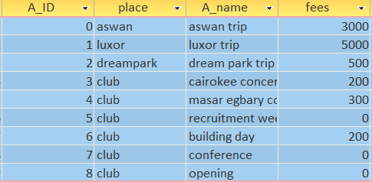

Competition

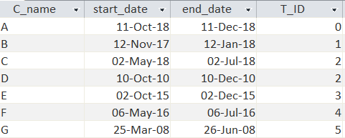

Department

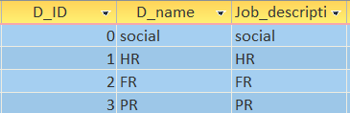

Employee

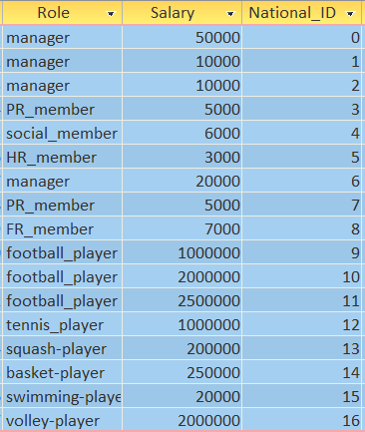

Joins

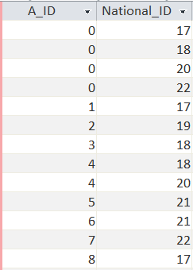

manages

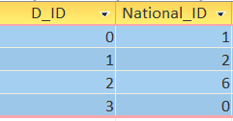

Member

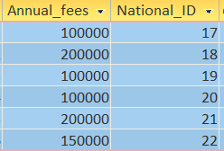

Offered from

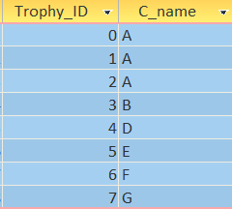

Organizing_Employee

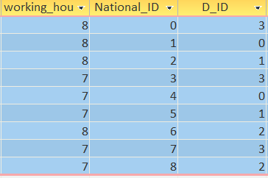

**Sport**

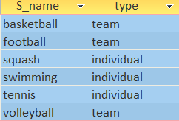

Person

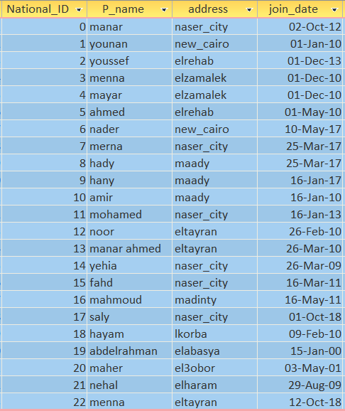

Phone_number

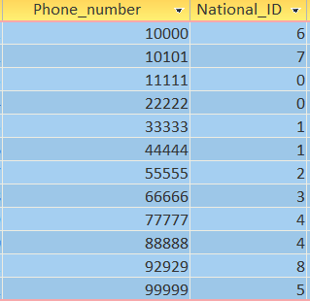

provides

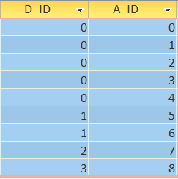

**Sportive_Employee**

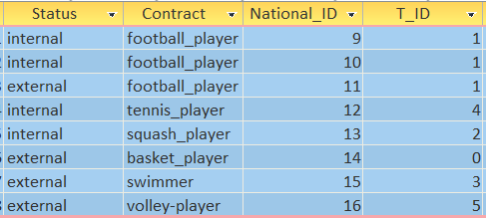

**Team**

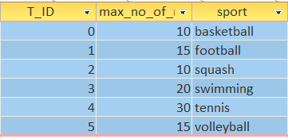

**Trophy**

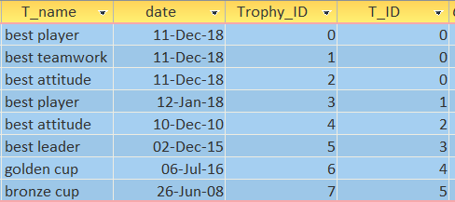

**Queries**

“We want to get the address of all the Person with the name had”

**select address**

**from Person**

**where P_name='hady';**

**https://lh6.googleusercontent.com/KGVjSrnUxUV_Df-6CPJZS9qIyXHGZ3OjXld8edA5GAabrsnNjpPmYNsDRf1Vw2giMHrVpZu5KATk97Rwg21FrNABloWFOP10z5iYc-wCPq3wn5WO7IAZYT6E18rjAsoc6BzAXmjC**

“We want to count the activities provided by different departments”

**select  Department.D_name,count(*) as count**

**from Activity ,Department ,Provides**

**where Department.D_ID=Provides.D_ID AND**

**Activity.A_ID=Provides.A_ID**

**group by Department.D_name;**

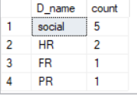

“We want to get the max annual fees for the members”

**SELECT Person.P_name,Member.Annual_fees  
FROM Person,Member  
WHERE Member.National_ID=Person.National_ID  
AND Annual_fees=(SELECT MAX(Annual_fees) FROM**

**Member);**

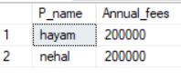

**4)**

“We want to get the max salary for the employees”

**SELECT Person.P_name,Employee.Salary**

**FROM Person,Employee**

**WHERE Employee.National_ID=Person.National_ID**

**AND Salary=(SELECT MAX(salary) FROM Employee);**

**https://lh6.googleusercontent.com/1gmAU4HNqjBQIdj2zCS8H6lIa_JBP4cXFjNmXF-Fwye3bVWZBJjfz7Wej74PaOoxBvYmjqFFSgRGE8gpQV1AHx7xHlyyJ02EUHLaAw7uhrnEdGWV9J9TeEgVWhl4fq-xg4YIB_GR**

**5)**

“We want to get the teams who achieved the ‘best attitude’ trophy”

**Select \***

**from[dbo].[Team],[dbo].[Trophy]**

**where T_name='best attitude' And**

**Team.T_ID=Trophy.T_ID**

