**Sample input and output**

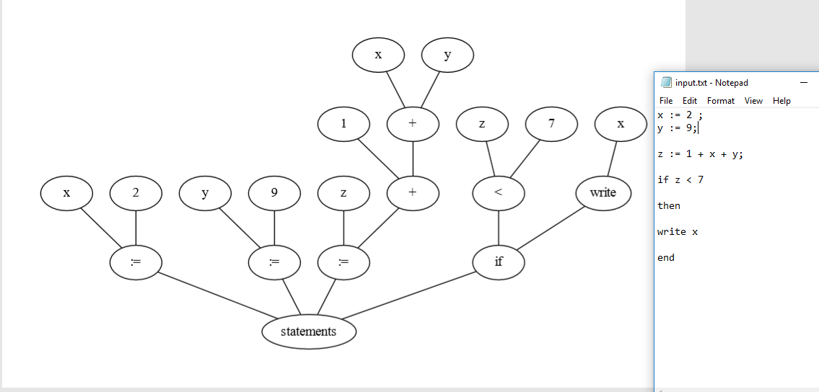

**(We are different than others :’D)**

**How to Use**

-Just add the example in the “input.txt” file

And just double click the .exe then a pdf will open with the tree or u can find it in the test-output folder

-Also “output.txt” file will be generated with the tokens from the scanner

**\*Extra feature we can check the syntax is valid or not the program will return false in the console and will not generate the pdf if a not valid syntax is inputted**