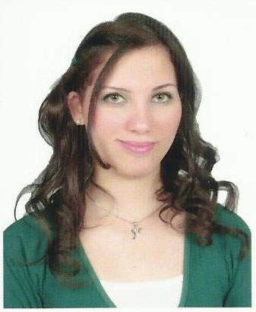
Nancy Nazih Aziz
Address: The 5th settlement, Cairo, Egypt
Mobile : 010 31 77 44 11
E-mail: hr.nancy.eas@gmail.com

- Objective
Seeking for a challenging career opportunity in a local, international or multi-national corporation, in a domestic or international level where I can apply & develop my academic background and interpersonal skills also aim to teamwork & cooperate so as to achieve my targets, which are perfection in all the assigned jobs.

- Educational Background

  - University Degree
License of Arts from faculty of Arts, Ain Shams University, Tour guidance major,
English section in May 2011.

- Work Experience

Admin. & HR Specialist at ” Egyptian Aviation Services” from April 2013 till July 2021

Job Description:

- Responsible for Administration aspects and Recruitment.
- Being actively involved in recruitment by preparing job description, posting ads and managing the hiring process.
- Filing and maintaining database of all incoming and outgoing correspondence.
  - Evaluating employees and porters .
  - Updates & maintains employees database.
  - Responsible for Training department as a Group Coordinator and making Certificates for employees & porters.
  - Completes Timesheets & monitor employees attendance.

HR/ Recruiter at “DEALS HR and Recruitment Consultants” from November 2011 till March 2013

Job Description:
- Making phone & meeting presentations for recruitment & outsourcing services.
- Dealing with multinational, international & local companies in several fields.
- Receiving client's recruitment requests
- Getting the best candidates by using all sources including the head hunting if asked so Matching the requested experience with the qualifications on CVs on the company's database by screening them
- Interviewing the selected candidates in order to make sure that they are qualified enough for the position
- Set the interviews for the short listed candidates in the client's company.
- Follow up all recruitment activities till final selection and hiring.
- Filing the offline CVs & companies’ contracts etc…..
- Also responsible for executing any more duties assigned by the managing director related to the scope of work.
- Courses & Training

  - Course MOS 2010 “Microsoft office specialist‘’ at “Yat Education Center” form 25th February 2014 till end of May 2014
  - Has trained for Ticketing processing at “Captain Tours” from beginning of July 2010 till end of July 2010.
  - Has trained for Ticketing processing at “Thomas Cook Overseas L.td” during September 2010 in call center branch.
- Computer Skills

  - Very good performance under various Pc operating systems (XP – Vista – win.7, 8 ).
  - Excellent user of Microsoft office applications (Ms-Word, Ms-Excel, Ms-PowerPoint, and fair in using Ms-Access , outlook)
  - Very good knowledge in hardware maintenance & PC assembling.
  - Professional internet user.
  - Excellent in multimedia presentation.
  - Professional in using Amadeus System and world SPAN.

- Personal Skills

  - Quick learner, Attention to details.
  - Good team worker and able to work under stress.
  - Very organized & problems solving abilities.
  - Hard Worker & Dynamic personality with a desire for new & challenging duties.

- Language Skills

  - Arabic Native (Mother Tongue)
  - English Reading, Speaking & Listening are Very Good.
  - French Reading, Speaking & Listening are Fair.

- Personal Information

  - Date of Birth 15th of July 1989
  - Place of Birth Cairo, Egypt
  - Nationality Egyptian
  - Marital Status Married

References are available upon request

