Page de grade

Devotion

To all those who are dear to me.
Thank you for your encouragement, support, sacrifice and love.

Acknowledgements

First and foremost, I would like to express my deepest gratitude to God for his guidance and blessings throughout the completion of this work.
I would love to extend my sincere thanks to Mr. Bouzouita, my industrial supervisor at Bouzouita group trading & Marketing, for his invaluable support and insightful advice throughout the drafting of this report. His guidance has been a key element in the successful completion of this work. I am proud to have carried out this project under his mentorship and deeply appreciate the time and attention he dedicated to my progress.
My profound thanks go to Mrs. Bouzid Amna, for her meaningful contribution, and her thoughtful guidance.
I also wish to thank the members of the jury for honoring me with their presence and for kindly agreeing to evaluate my work.

Table of contents

General introduction 5

General Introduction
The digital age has brought forth a new era of interaction, allowing us to engage in ways we never thought possible. The use of technology in our everyday lives is an advanced, so business has changed in order not to be in the dust. The fashion business has officially moved digitally, what once was a fad is now a must.
The modern-day digital era, hosting a web presence is an absolute must now as oppose to desirable, as it expands market reach, engages customers, and drives sales. If a brand doesn't have an online store, it cannot reach its visibility potential nor access a wider clientele base, especially in the international market.
Furthermore, they provide an opportunity for businesses to leverage this digital ecosystem by exposing their products to a much larger and more diverse customer base.
This thesis focuses on the development of a web application for an e-commerce platform dedicated to a clothing brand operating both nationally and internationally. Despite its strong presence in the physical market, the company does not yet have an online sales platform. This project was undertaken within the framework of a final-year internship and is primarily aimed at the design and development of a web-based e-commerce application. The application is intended to facilitate and optimize the commercialization of clothing products on behalf of the company MGM NEGOCE SARL.
The project is carried out by Bouzouita group trading & Marketing as part of a final-year internship, with the primary objective of designing and developing a web-based e-commerce application to facilitate and optimize the commercialization of clothing products for MGM NEGOCE SARL.
Six appropriately structured chapter make up this report, which summarizes the work completed during the project:
The host company is introduced in Chapter One, along with an analysis of the current system
and the methodology used for web application development.
The application’s stakeholders, functional and non-functional requirements, technical requirements, and overall system architecture are all outlined in chapter Two.
The analysis and implementation of Sprint One will be clarified in Chapter Three.
The analysis and implementation of Sprint Two are further explained in Chapter Four.
The analysis and implementation of Sprint Three are explained in Chapter Five.
The analysis and implementation of Sprint Four are covered in Chapter Six.
The report concludes with a broad summary of the project's major accomplishments and a discussion of its prospects for the future.

Chapter 1: General overview of the project

- Introduction:
The preliminary section provides a thorough synopsis in our senior project, which was put together via critical reflection with in-depth analysis. It essentially starts via outlining the central issue that the project mostly aims to resolve as well as placing it within its larger context. A broad study of present methods is done, plus a review showing their limits. A suitable solution is suggested with regard to these findings, and the project's aims and implementation method are shown in a clear manner.
- Academic Context:
As part of our final-year project for the completion of a Bachelor's degree in Multimedia and Web Development, I undertook an internship at the company Bouzouita Group Trading & Marketing, with the objective of developing a web-based e-commerce application.
- Host Organization:

- Presentation of the Host Organization:
Bouzouita group trading & Marketing
- Table
- Hosting organization logo

- Service of the Host Organization:

- Problem Statement:
Even though MGM NEGOCES SARL is well established in the offline market, it has not yet established itself in the online platform that would enable it to reach a wider market and address the increasing demand for online shopping. Without an online presence highly restricts the potential of the company to interact with an increased and diversified number of clients, especially at the national and international levels, in an age where e-commerce is fast becoming the dominant mode of consumption.
This situation raises an important question :
How can MGM NEGOCES SARL successfully market and sell its products online while enhancing customer experience and boosting brand visibility through the creation of a reliable, scalable, and user-friendly web application?
Identifying the right e-commerce solution is not just a matter of setting it up and running; it is a matter of balancing what customers want, technical capabilities, and business objectives.
In this regard, our project entails creating an e-commerce web-based application that will enable the business to manage customer orders, showcase its products online, and produce critical sales and customer behavior reports. Through improved operational effectiveness, improved customer engagement, and increased commercial reach of the firm, this solution aims to further the digitalization of the business.

- Study of existing systems:
Analysis of current systems is a major process in developing any project. It is a learning exercise of studying and examining current solutions to determine their strengths and weaknesses. By such analysis, we are able to draw relevant knowledge that determines the specific needs of our project. With the taking into account of these factors in design and implementation, we can come up with a more effective, user-friendly, and technologically sound solution.

- Presentation of Existing Systems – Examples:
We reviewed a few popular systems that are widely adopted in the industry to gain better insight into the architecture and design of contemporary e-commerce platforms. The aim of this review was to identify common processes, UI guidelines, and technical details that might guide and inspire the development of our solution.
In our research, we looked at the two primary platforms. The first is Kids Around, an international online marketplace for children's clothing shopping. The second is Gimel Tunisie, a popular Tunisian brand that is very anchored in the local market. By studying these two platforms, we could point out important factors, the way their interface is designed, and some possible areas of improvement. We can make good use of these findings. They will be guiding us into the construction of our own site. Our objective in this case is to ensure that it conforms to the industry standards and the users' local and international requirements.

The Kids Around logo reflects a modern, elegant visual identity, highlighting a high-end children's universe in line with the brand's premium positioning.


- Kids around Logo
The Gimel Tunisie logo adopts a simple, warm approach, embodying the brand's authenticity, proximity and accessibility to the local Tunisian children's fashion market.



- Gimel Logo

- kidsaround.com:
Description:
Kids Around is a leading online store selling an exclusive selection of high-quality children's clothing from renowned designer labels. The website provides an easy and enjoyable shopping experience. The website is available in a variety of languages, making it easy for those who speak different languages worldwide.
- gimel-tunisie.com:
Description:
Gimel Tunisie is a popular online shop for children’s garments in Tunisia. It is designed Specifically for clients in the region, emphasizing the provision of stylish and affordable outfits for families. The platform is accessible and designed with the requirements of the local clientele in min.
The Table Below is an analysis of how each platform's UX compares to each other, and how they can be improved (UX Benchmarking).
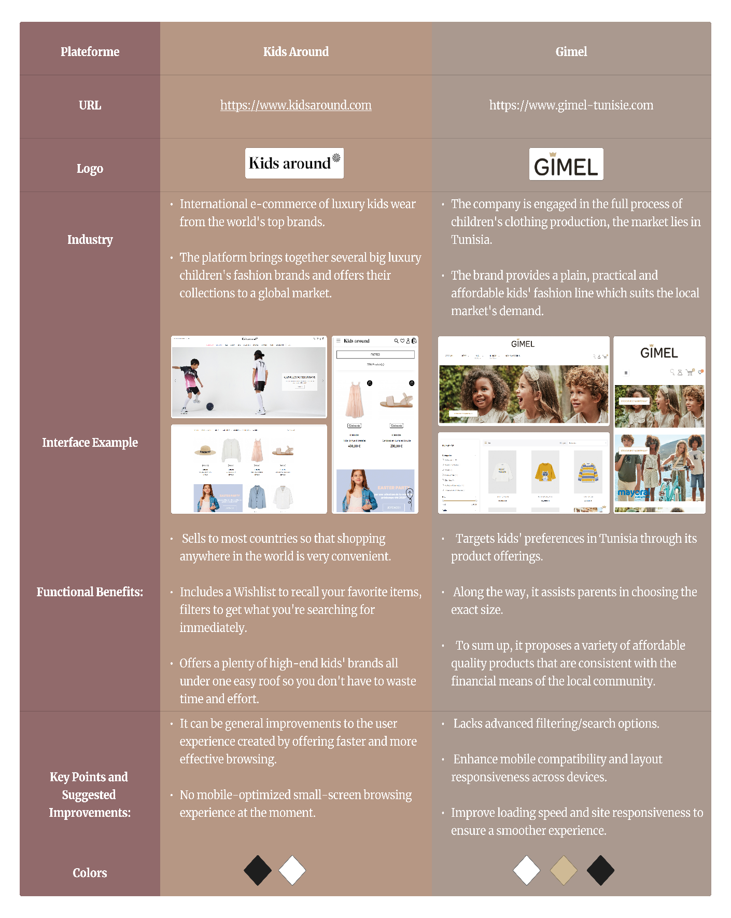
- UX Benchmarking Table

- Proposed approach:
There is a growing need for more online shopping and visibility in the fashion industry. To address this, we aim to create a dedicated website for our clothing brand. This site will highlight the brand's unique image, facilitate online sales, and increase its popularity both nationally and internationally.
The website will function as an online store with a wide range of clothing items available. Each product will feature clear descriptions, attractive photos, and easy search options. Customers can find clothes by age, size, style, or color, making shopping straightforward.
Our goal is for our customers to feel confident and satisfied when they shop with us.
Our website allows users to create personal accounts and will automatically invoice all purchases. Users can track orders easily and store favorite products in Wishlist via these accounts. Users will receive personalized product suggestions relevant to their interests as well.
For our business, the website will have easy tools to manage orders, monitor inventory, and efficiently communicate with customers—all from one place. This plan will help solve the current challenges our brand is facing and strengthen our position in the online fashion market. Our goals include boosting sales, building customer loyalty, and increasing the brand's visibility online.
- Objective of “MGM store”:
The objective of this project is to build an advanced multi-functional e-commerce website for MGM NEGOCE Sarl which is a brand dealing in fashion clothing targeting all demographics focusing on both national and international brands that is modern, appealing, easy to use, and has exceptional performance features.
- The platform provides the following services:

- Be employed to enhance the brand’s online professionalism and boost effectiveness to automate the organization’s business activity.
- Allow customers to find the offered products by providing the simplest, most easy-to-use, intuitive interface, smooth navigation, and effective filter options.
- Facilitate maximized user experience through personalization by giving advanced account creation functions, order tracking, and crucial recommendations.
- Increase visibility of the brand by profound emphasis on product diversity and quality blended with elegant, dependable design.

- Methodology Adopted:
- Overview of Development Methodology:
Within software development, a methodology is defined as a sequential approach for managing, designing and executing a project. This also includes the planning, organizing, controlling, and management of all activities pertinent to delivering the solution successfully. Out all available methodologies, frameworks based on agile principles are the most preferred because they allow for adaptability and reiteration.
- The Scrum Methodology:
For the development of our web application, the adopted methodology was Scrum – an agile framework focused on collaboration, iterative development, and customer feedback. Scrum steers onto the principles of transparency, inspection, and adaptation. It allocates work into iterations that are time-bound (time boxes) called Sprints. This enables teams to regularly deliver functional increments of the product.
- Key Parts of Scrum (Roles):
To use Scrum well, we need to know about some important roles and items.
      - Product Owner Role:
The Product Owner makes sure the product is as valuable as it can be. They handle the Product Backlog, which is the list of tasks to do. The Product Owner acts for stakeholders, or people with an interest in the product, and decides what tasks are most important. They look at what is best for the business and what customers need the most.
      - Scrum Master's Role:
The Scrum Master is rather a guide and a helper of the team. His main responsibility is to make sure that everyone within the team follows the Scrum principles. He also helps eliminate any problems that might disrupt the team's progress. Moreover, he protects the team from external interference. This allows the team to function properly and focus on their work.
      - Development Team Role:
The Development Team is organized and consists of members who possess different abilities. They work together to create parts of the product such that they have something deliverable at the end of every Sprint. The members independently prepare what they must deliver and make sure what they produce is of good quality and operational. Daily Stand-Ups, Sprints Planning, Sprint Reviews, and Retrospectives: Enable continuous enhancement and realignment.
      - Comparison with Traditional Waterfall Methodology:

- Description of the V-Model:
The V-Model operates virtually with sequential development and the corresponding testing phase for each development stage. It has rigid documentation and verifications in each phase, and it is usually applied in the industries where compliance and precision mean a lot, for example, in healthcare or automobile systems.

- Major Contrasts Between the V-Model and Scrum:
Aspect | Scrum (Agile) | V-Model (Traditional)
Development Approach | It's about developing within short periods of replicable iterations. | The development process is absolutely linear-it starts when one phase of completion is done.
Flexibility | Changes may be made during the development itself or pretty late. | It's rigid. Once the development begins, changing requirements are very tough and expensive.
Project Phases | Sprints-meaning small, time-boxed cycles to deliver small increments. | It follows particular stages, like requirement analysis, design, coding, and testing.
Client Involvement | The client takes part continuously in the process and gives feedback at different times. | Not much involvement of the client occurs at the beginning and the end of the project.
Testing | Integrated into every Sprint, resulting in early detection and resolution of issues | Testing is delayed to just after the development phase, which means that problems are found later than is desirable.
Delivery | Advances in lively product increments. | The whole final product is delivered after finishing all stages.

- Comparison Between the V-Model and Scrum

- Scrum Tools:

- Product Backlog:
It is a list containing all the features, improvements, and bug fixes that must be made in the product. The Product Owner orders it according to the priorities and updates it continuously as the development process progresses. This is to inform everyone what is needed to improve the product.
- Sprint Backlog:
A short part of the product backlog for which the team commits to working on during a given Sprint. A Sprint is a window of time that allows the teams to commit to work on tasks of their own choosing to be completed by the end of that designated period. This keeps the team on target and allows them to organize their workload properly.

- Burndown Chart:
Very simple chart to track what work is left to be done by the end of a Sprint. Visually represents how the team progress over time and indicates to them if they are ahead of schedule or behind meeting their Sprint goals. It makes it simple to see when they are behind schedule and easily recover. (Scrum.org)
- Scrum Board:
A board that is used for physically displaying task progress throughout the course of a Sprint. The tasks are divided into three columns: "To Do," "In Progress," and "Done." Thanks to this, everybody can see the state of task status at a glance and works better where everything is visible and clear.
- Project Timeline (Chronogram):
It is the calendar indicating all the Sprints scheduled throughout the whole project. This will give an overview of the project course in making sure that all the deadlines and expectations of the client are met. The calendar really makes it easy to manage the time rightly and to keep pace with the project.

- Conclusion:
This first chapter introduces our host organization, Bouzouita Group Trading & Marketing, as well as the general context of the project: the design of a modern, high-performance e-commerce site for MGM NEGOCE Sarl, a company specializing in the sale of all categories of clothing. The next chapter will be devoted to a detailed analysis of the functional and technical requirements of the web application, in order to precisely define the expectations to be met to guarantee the success of the project.

Chapter 2: Needs analysis and specification

- Introduction:
This chapter brings forward the requirements necessary to create MGM's e-shopping website. Knowing the functional and non-functional requirements is crucial in order to provide a product satisfying the expectations of the customers and end-users alike.
We will begin with the users involved and design their roles within the system, making clear who does what. we will discover the functional requirements in order to discover what the platform is required to do, and the non-functional requirements in order to discover how it should operate. This will be the blueprint for creating it. Next, we will also discuss how to run the project through the Scrum method.
- Requirements Specification:
This step is about identifying and clearly defining what the project needs to achieve (functional requirements) and the qualities it should meet (non-functional requirements). This ensures everyone knows what to expect from the system. Additionally, it involves figuring out who will interact with the application and understanding each person's role. By doing this, we set a clear direction for what the system will do and who will use it.
- Identification of Actor:
This part focuses on identifying and explaining the key people or groups connected to the e-commerce platform. It will cover who they are, what roles they play, and what they expect to achieve or get from using the platform.

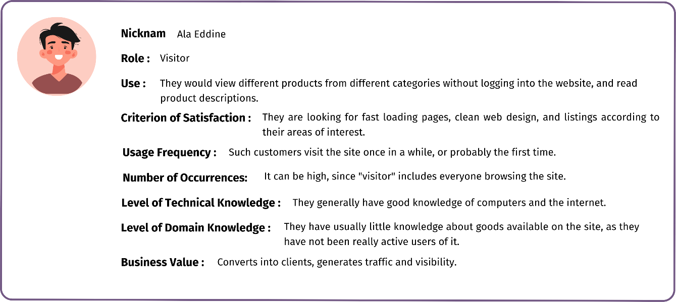
- Visitor:
- Visitor Persona Card​

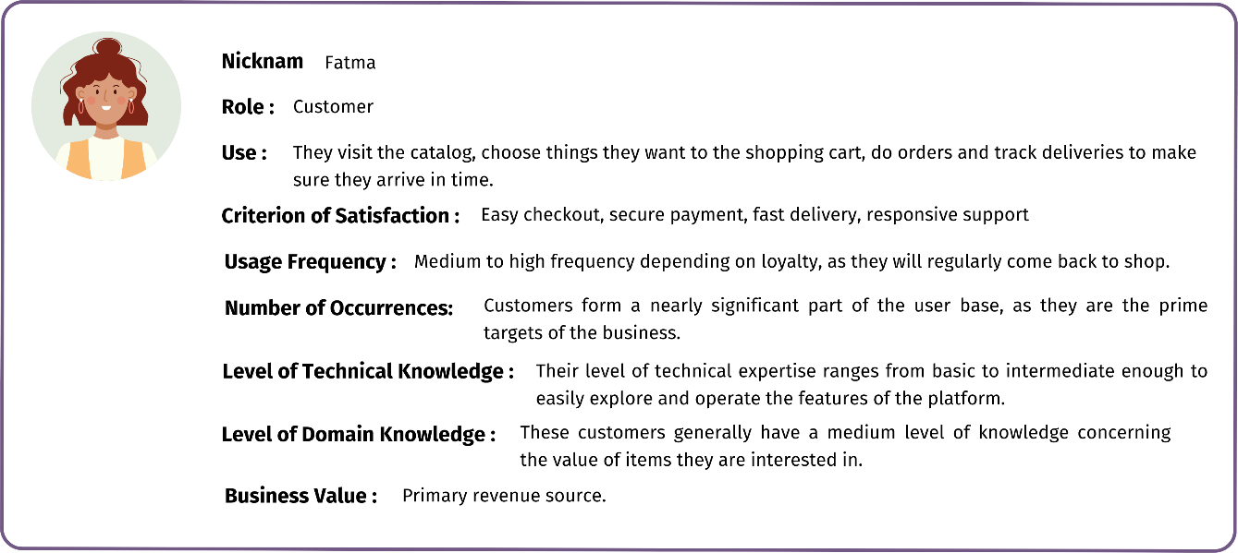
- Customer:

- Customer Persona Card​

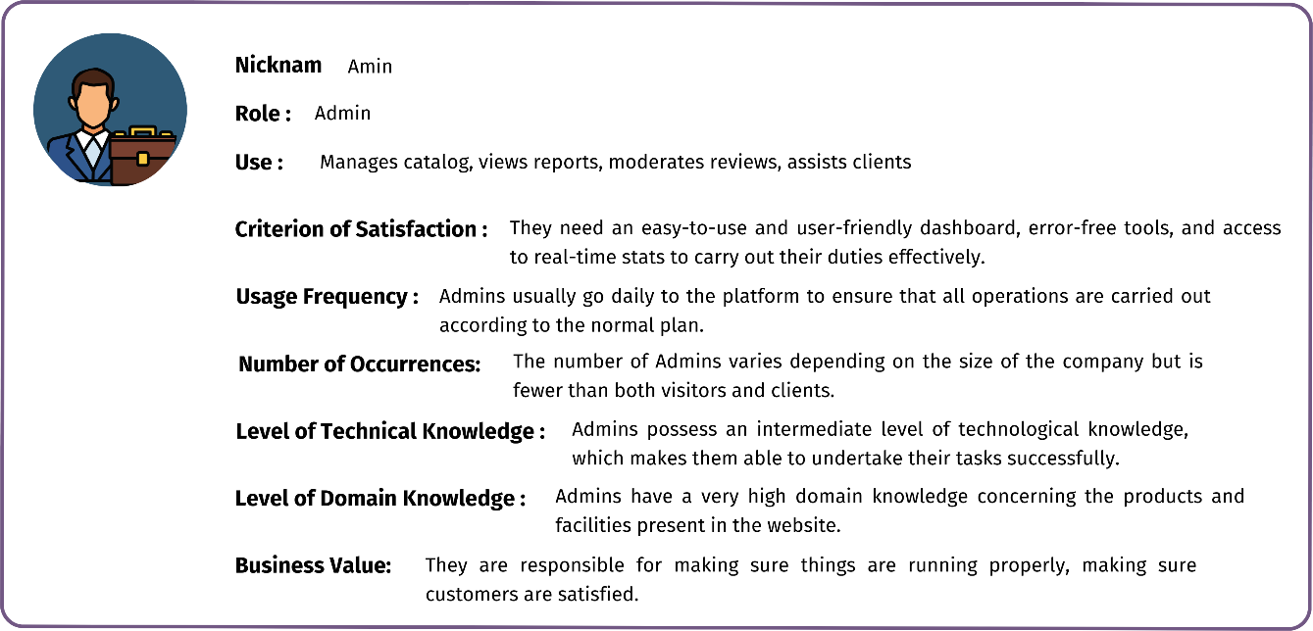
- Admin:

- Admin Persona Card​

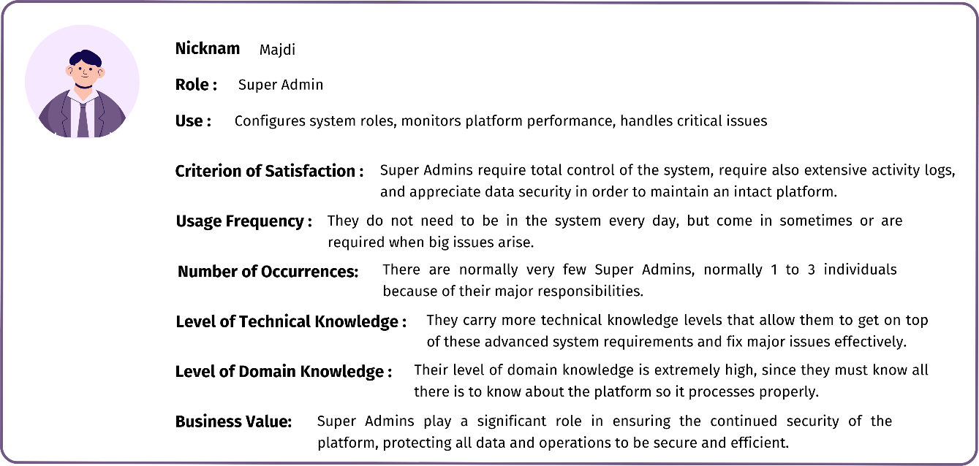
- Super Admin:

- Super Admin Persona Card​

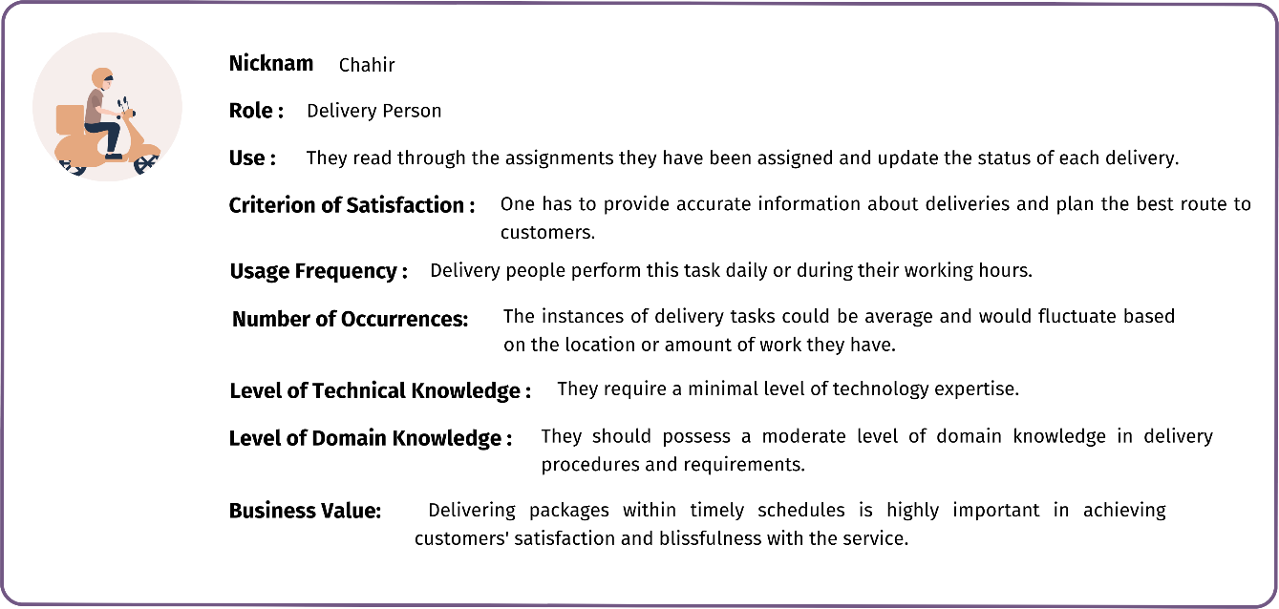
- Delivery Person:

- Delivery Persona Card​

- Requirements Identification:
Functional requirements outline the features and functionalities the e-commerce system should have. They are very important to ensure that users can use the system efficiently and effectively. They take into consideration everything the system needs to do so that users experience a smooth ride while shopping or browsing.
- Functional Requirements:
Functional requirements describe what a system must do and how it should behave in order to satisfy the needs of its users. Functional requirements specify how users expect the system to behave, thus forming a very important linkage between what the user requires and what the system is supposed to do. Upon thorough definition of functional requirements, developers can specify what problems an application is supposed to solve and keep the solution intact and traceable through the entire product build.
For the Visitor actor, our application must meet the following requirements:

- Explore Products and Their Offers:
- They can check for all products and listed offers. Use the filters such as price range, brand, the color of the product, and types of products to find what you are looking for.

- Register on the Platform:
- You will need to register the very first time you think about placing an order. After registration, you need to log in with your username and password to your account.

- Shopping Basket:
- Add products into their shopping basket when shopping.
- They can still adjust the number of products as a quantity change or take them out of the basket completely before finishing their order.

- Make a Favorite List:
- Use it by adding your favorite items to the list. That way, it can be an easy task locating them later on. You can add or delete any items on the list at any time.

- Contact the site administrator:
- Customers can send messages to the administrator via a contact form, or interact with a chatbot to get help or ask questions.

For the Connected Client actor (registered user), in addition to the visitor functionalities, the application must enable:
- Account Management:
- They may see and amend the personal profile. This means they can anytime alter their contact information or reset their password.

- Product Feedback:
- They can express their opinion by writing product reviews or by giving a rating (or both). This feedback is available for the whole world to see, thus aiding other users in making a decision.

- Download Their Invoice:
- Once the order goes through the administrator for review and approval, the invoice will be available for download under their account area. These eases tracking of their purchases and payments.

for the administrator actor, our application must meet the following requirements:
- Product Management:
- Add New Items: Add new products with all their description details such as image, price, and color features.
- Update Items Already in List: Keep existing products' details up to date when needed.
- Remove Items: Delete items that are no longer part of the catalog.
- Manage Items: Update product status and thus, its availability, i.e. in stock, out of stock, or on promotion.

- Categorization and Sub-categorization Management:
- Add New Categories: Add categories to improve the categorization of products in your product line.
- Edit Existing Categories: Rename or restructure existing categories under new parent categories, if necessary.
- Delete Categories: Remove redundant or unnecessary categories.

- Order Validation & Management:
- Orders: Full representation of all customer orders.
- Order Validation: Validate orders when to begin processing them for delivery.
- Order Status Updates: Have all orders status updates such as In Progress, Shipped, Delivered, etc.
- Assign an order to a delivery driver.
- View a delivery driver's deliveries.

- User Management:
- View Accounts: This list will be filled with every customer, delivery staff, and other admins.

- Message and Contact Management:
- See Customer Messages: View customer and visitor messages from the contact form.
- Answer Questions: Offer quality service by answering customers' questions or concerns appropriately.

- Analysis and Statistics - Access to Dashboard:
- Track some of the performance indicators of the site including figures in sales and volumes in visiting traffic.
- Report Creation: Create detailed reports according to your data analysis needs.
- Data-Informed Decision-Making: Influence key business enhancements through the use of best practices in data.

The app must fulfill the following conditions for the Delivery Person:
- Address a list of orders to be delivered:
- The delivery person will have an interface displaying him assignments of orders and ready to be delivered.

- View Order Details:
- They can see all the necessary information for delivery: customer addresses and phone numbers, package information, selected delivery options, etc.

- Update Delivery Status:
- The delivery agent is able to mark an order to a particular status separately (e.g., "delivered", "delivery failed"), enabling real-time tracking.

- View Delivery History:
- The deliverer can see a list of previous deliveries performed by him with dates and statuses.

- Get Notified:
- The deliverer gets notified about a new order being assigned to him or about some major change in the delivery.

- Non-functional Requirements:

- Performance:
Our application must be able to respond fast, even during multiple concurrent users. Opening any page should ideally take less time than 3 s, so the experience for the users could remain pleasant.
- Scalability:
As the system scales, it should be able to accommodate more users and transactions without a reduction in speed or performance.
- Maintainability:
The application code should be easily readable and well structured. This allows for easy update, fast fixing of any bugs, and ready addition of any new enhancements if needed.
- Compatibility:
The application should run on multiple web browsers, including (e.g., Chrome, Firefox, Safari...). It should additionally be accommodated for all devices: desktops, tablets, and smartphones so that everyone can access it easily on their preferred devices.

- Project Management Using Scrum:
The organizing of the Scrum team as follows for the project's sake:
- Product Owner: Mr. Bouzouita, who happens to be the Managing Director of Bouzouita Group Trading & Marketing. He collects all the to-dos, prioritizes them by importance, and ensures that whatever we deliver is in line with business goals.

- Scrum Master: Professor Chiheb Chaieb ensures that the team adheres to Agile principles and Scrum methodology. He facilitates communication, removes obstacles, and promotes an efficient and collaborative work environment.

- Development team: Yosr El Hamdouni is responsible for executing the solution. This includes delivering parts of the product that work by the end of each sprint and making sure the product meets technical standards. Continuous improvement is a key part of the process, ensuring the product gets better over time.

- Product Backlog:

ID | User Story | Priority
 | As visitor, the application allows me to browse products with advanced filters (price, brand, color, subcategories, etc.). | High
 | As visitor, the application allows me to manage my cart: change the quantity of a product or remove it. | High
 | As visitor, the application allows me to register when placing my first order to create an account. | High
 | As visitor, the application allows me to contact the administrator via a contact form or chatbot.
 | As client, the application allows me to manage my wish list: change the quantity of a product or remove it.
 | As client, the application allows me to confirm my order and choose the delivery method (standard or express).
 | As client, the application allows me to view and edit my personal information and password.
 | As client, the application allows me to leave product reviews visible to all users.
 | As client, the application allows me to download my invoice after the order has been confirmed.
 | The application allows me, as an administrator, to view and manage client and delivery person accounts.
 | As administrator, the application allows me to add, edit, and delete product categories and subcategories.
 | As administrator, the application allows me to manage the product catalog (add, edit, delete products).
 | As administrator, the application allows me to adjust the inventory.
 | The application allows me to assign delivery person for customer orders.
 | As administrator, the application allows me to consult application statistics to support decision-making.
 | As administrator, the application allows me to view messages sent by customers.
 | The application allows me, as a delivery person, to view orders to deliver with customer contact details.
 | The application allows me, as a delivery person, to update the delivery status of an order.

- General Product Backlog
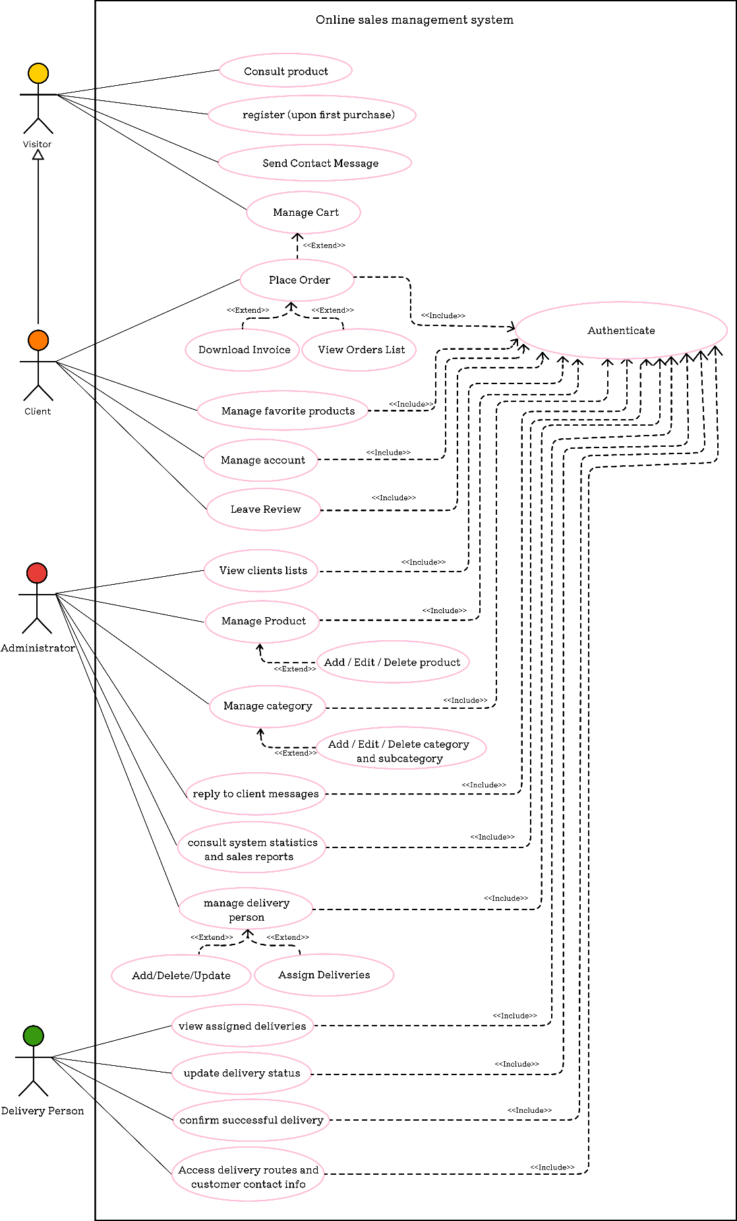
- Use Case Diagram:

- Global use case diagram
- Classe Diagram:

- Sprint Planning:

Sprint | User Story | User Story (Short Summary)
Sprint 1 | User Story 01 | Browse products with filters.
Sprint 1 | User Story 02 | Manage cart (change quantity, remove).
Sprint 1 | User Story 03 | Register when placing first order.
Sprint 1 | User Story 04 | Contact admin (form/chatbot).
Sprint 2 | User Story 05 | Manage wish list (add product, change quantity, remove).
Sprint 2 | User Story 06 | Confirm order & choose delivery method.
Sprint 2 | User Story 07 | View/edit personal info & password.
Sprint 2 | User Story 08 | Leave product reviews.
Sprint 2 | User Story 09 | Download invoice after order.
Sprint 3 | User Story 011 | Manage product categories & subcategories.
Sprint 3 | User Story 012 | Manage product catalog (add/edit/delete).
Sprint 3 | User Story 013 | Inventory adjustment.
Sprint 4 | User Story 010 | Manage client & delivery person accounts.
Sprint 4 | User Story 016 | View customer messages.
Sprint 4 | User Story 015 | View application statistics.
Sprint 5 | User Story 014 | Assign delivery person to orders.
Sprint 5 | User Story 017 | Delivery person views assigned orders with customer info.
Sprint 5 | User Story 018 | Delivery person updates delivery status.

- Sprint Planning
- Sprint 1-Central Visitor Flow-The workflow must have been guided on this side with the basic setup. This allows the visitors to browse the site, sign up for an account, manage their shopping carts, and contact the administrator for help.

- Sprint 2-Client Features-In this round, options are now given for clients that have accounts. These clients could place order, manage their accounts, write reviews about the product, and get to download their invoices when required.

- Sprint 3-Admin Catalog Management In this stage, we tend to provide admins with the capabilities necessary for effective management of products and categorization.
- Sprint 4-Admin & Customer Management A set of tools is developed for an administrator to work with user accounts, respond to messages of customers, and have access to key statistics/results on how the app is performing.

- Sprint 5- Order Delivery Flow In the last stage, we put in place a delivery facility to track an order, assign a delivery agent, and continuously update the status of delivery as the order is processed.

- Technical Requirements:

- Hardware Environment:
This section describes the basic features of the computer on which the application was developed and tested.
Component | Specification
Operating System | Windows 11 Home Single Language (64-Bit)
Version | 24h2
Os Build | 26100.3775
Processor | Amd Ryzen 5 7535hs With Radeon Graphics @ 3.30 Ghz
Ram | 16 Gb (15.3 Gb Usable)
System Type | 64-Bit Operating System, X64-Based Processor
Graphics Card | NVIDIA GEFORCE RTX 2050
Device Type | ASUS TUF GAMING A15

- Hardware Environment Table

- Technology Environment:
These are the main technologies created to build a web application. More or less, they are the programming languages the developers use for coding and the frameworks that provide some structure to the application

Layer | Technology Used | Logo
Frontend | Next.Js | 
Frontend | Tailwind CSS | 
Backend | Node.js | 
Backend | Express.Js | 
Database | PostgreSQL | 
Api Testing | Postman | 
Design Tools | Figma | 

- Technology Environment Table

- Software Environment:
This section provides a list of all software used, e.g. IDE (Integrated Development Environment) for programming, browsers to verify the app look.

Tool Category | Tool Name | Logo
Code Editors / IDE | Visual Studio Code | 
Dev Tools | Node.js
Dev Tools | Npm | 
Dev Tools | GitHub | 
Browsers | Brave | 

- Software Environment Table

- General Architecture of the Application:

- Physical Architecture:
The application is developed on a three-layer architecture in order to separate multiple activities to improve performance, scalability, and maintainability.
- Client Layer (Presentation): This is the user interface component of the system built with Next.js, reachable through web browsers. This is where the client can see all data displayed on the screen and interact with them.
- Application Server Layer (Business Logic): Node.js and Express.js are employed to develop the backend. This layer is in charge of the functioning of the application, interaction with the user, sessions, and database transactions.

- Database Layer (Data Storage): The application data are stored securely in PostgreSQL. This is convenient to store data and retrieve data whenever necessary.

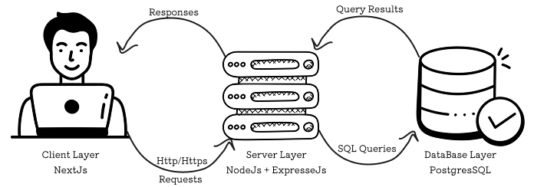

- Three-Tier Architecture Description

- Software Architecture:
The application follows a typical architecture: Model - View - Controller (MVC), where each block is given its assigned task.
- Model: The model pertains to managing data and performs CRUD operations. For this, you can make use of libraries like Prisma or Sequelize, or, if needed, raw SQL queries to PostgreSQL (in our case we used Sequelize).

- View: The view is the user interface part. It consists of React components which are embedded in Next.js pages that output data received from controllers to the user.

- Controller: Application data handling. Built with Node.js and Express.js, these controllers take user requests, work on models to process data, and return results to the views.

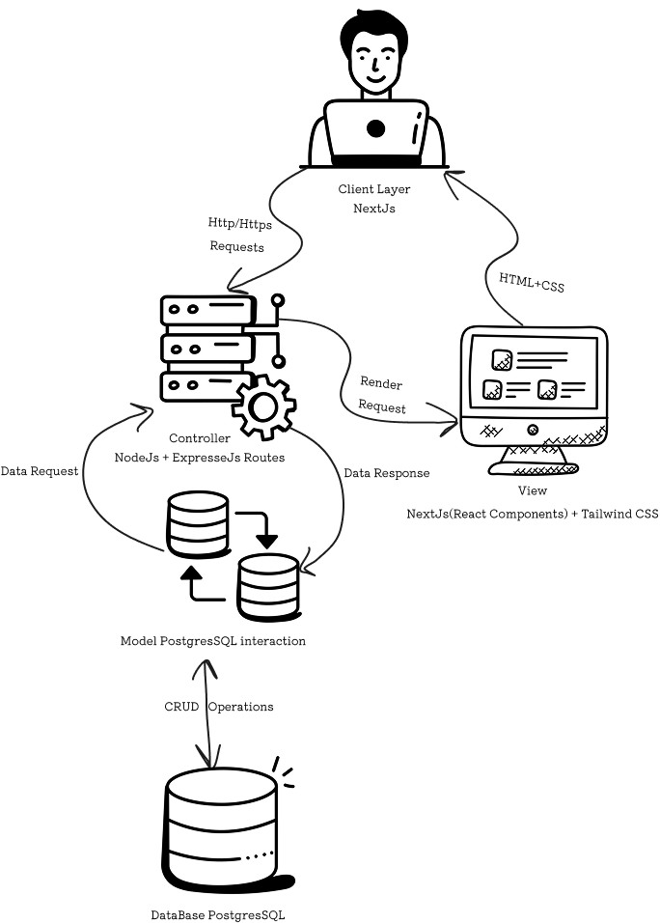

- Application Logic Layering (MVC)

- Conclusion:

This chapter gives a detailed description of what the application must do and what additional features it must have. It explains the roles played by the people engaged and how they assist. It involves implementing the Scrum method, which involves creating lists of work and planning short time slots of work known as sprints. The chapter also describes the technical environments and shows both the physical and software designs, which are a great starting point for development. The next chapter will be spent carrying out the sprints and getting key features off the ground.

Chapter 3: Needs analysis and specification

- Introduction:
The Sprint 1 study and rollout shall be treated in this chapter as part of our Agile process.
The aim of Sprint 1 is to build the basic features that allow customers to use the application for the first time and start shopping.

- Sprint Planification:

- Objectives of the Sprint:
The crucial cornerstones of the customer's experience have been constructed by Sprint 1. New customers can now view the platform and register on it while adding items to their shopping carts. They could also get in touch with support to ask questions. Building such infrastructure by Sprint 1 means further establishing all future online buying behavior by having there be some functional, intuitive way to buy through products and communicate with the shopping cart.
User Story | Short Summary
US01 | Browse products with filters
US02 | Register when placing first order
US03 | Manage cart (change quantity, remove)
US04 | Contact admin (form).
- User Stories Covered:

- Sprint 1 Backlog
- Functional Design:

- Use Case Diagram for Sprint 1:
The diagram displays the interaction of users with the system in Sprint 1. It presents the main features that are available to everyone, including guests and registered users. Guests and registered users are able to view products, register for an account, update their shopping cart, and contact the administrator in case they have questions or need help.

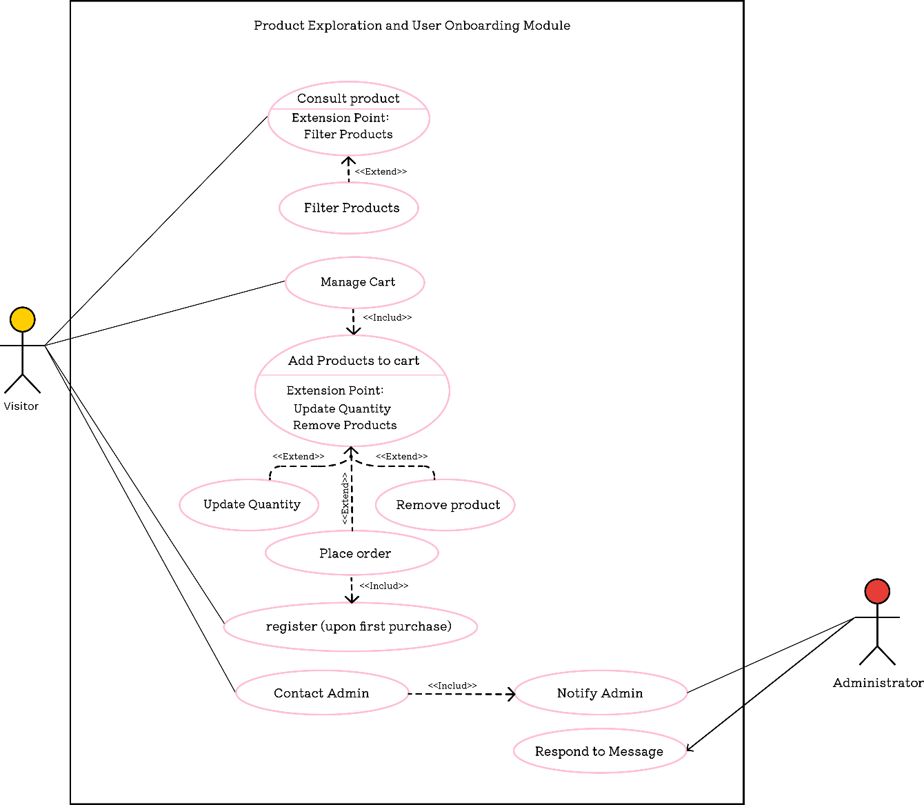

- Sprint1 Use Case Diagram – Product Browsing and Initial Interaction

- Textual Description of Use Cases:
Each use case described below corresponds to a user story from Sprint 1. The textual descriptions define the main actor, the goal, and the flow of events.
- Use Case 1 - Filter-Based Product Browsing:
Product browsing by filtering on category, price, or brand is the use case in the following table.

Element | Details
Use Case Name | Browse Products with Filters
Actor | Visitor/User
Description | The user browses available products and applies filters such as category or price(etc..).
Precondition | Products exist in the database.
Nominal Scenario | 1.User opens the product listing page.  2. Applies filters.  3. Filtered results are shown.
Alternative Scenario | 1. No products match the filters → System displays “No results found.”
Involved Table(s) | Article, Categories, couleur, taille (etc.)

- Textual Description of Use Case – Browse Products with Filters

- Use Case 2 - Manage Cart (Modify Quantity, Remove Items):
The following table illustrates the shopping cart management use case, like changing quantity or deleting items.
Element | Details
Use Case Name | Manage Shopping Cart
Actor | Visitor/Client (registered user)
Description | The user modifies product quantities or removes products from the cart.
Precondition | User has an active cart session.
Nominal Scenario | 1. User add item to cart.  2.User accesses cart.  3. Changes quantity or removes item.  4. System updates cart and totals.
Alternative Scenario | 1. Product becomes unavailable(qty=0) → System show (product out of stock) to the user.
Involved Table(s) | Panier, article_panier, article

- Textual Description of Use Case – Manage Shopping Cart

- Use Case 3 - Register on First Order:
The following table has the use case of a user registering on first order.

Element | Details
Use Case Name | Register During First Order
Actor | Visitor
Description | The visitor registers an account during the checkout process.
Precondition | Visitor has products in the cart.
Nominal Scenario | 1. Visitor proceeds to checkout.  2. Registration form appears.  3. Visitor completes and submits the form.  4. Account is created, cart merged and order proceeds.
Alternative Scenario | 1. Email already exists → System displays error message.
Involved Table(s) | Utilisateur

- Textual Description of Use Case – Register During First Order

- Use Case 4 - Contact Admin (Form):
The following table illustrates a use case where a user communicates with the admin through a form interface.

Element | Details
Use Case Name | Contact Administrator
Actor | Visitor/User
Description | The user sends a message using form to contact admin.
Precondition | Contact form is accessible.
Nominal Scenario | 1. User opens contact page.  2. Fills form.  3. Message is sent/stored.
Alternative Scenario | 1. Message fails to send → System displays an error.
Involved Table(s) | Reclamation, Utilisateur (if logged in)

- Textual Description of Use Case – Contact Admin

- Technical Design:
Here is described the roadmap for the first sprint, Sprint 1, of the app development. We give a basic roadmap that sketches out how the app is structured and works. There is a class diagram explaining the principal data structure we implement, and sequence diagrams illustrating how different components of the system are used for primary tasks.

- Class Diagram:
During Sprint 1, we use a class diagram to identify the most essential components, known as classes. This diagram highlights the functions and attributes of each class while also outlining how these classes relate to one another.

- Class Diagram Sprint 1

- Sequence Diagrams:
Below are the sequence diagrams illustrating how different actors interact with the system components to accomplish key functionalities from Sprint 1:
- Sprint review:

