

**Project Report**

**Course Title** : Operating Systems

**Course Code** : CSE302

**Semester** : Fall 2023

**Section** : 05

**Submitted by:**

(Group - 2)

Junnun Mohamed Karim (2022-1-60-108)

Md. Yousuf Hozaifa (2022-1-60-162)

**Submitted to:**

Md. Mohsin Uddin

Senior Lecturer

Department of Computer Science and Engineering

**Submission Date:**

23rd December, 2023

**Introduction**

The "Scholar Information Management System" (SIMS) is a comprehensive Django-based web application designed to streamline and manage scholarly information within an academic environment. This report provides an in-depth analysis and overview of the key components, functionalities, and underlying structures of the SIMS project.

Scholarly research and academic activities generate a vast amount of information, including user profiles, research papers, subjects, and authorship associations. To effectively manage this information, SIMS serves as a centralized platform, facilitating user authentication, paper registration, profile management, and subject categorization. The system caters to both users, such as researchers and academics, and administrators, offering distinct interfaces and functionalities tailored to their specific needs.

Throughout this report, we delve into the core features of SIMS, examining the models that define the database structure, the views responsible for handling user interactions, and the auxiliary functions ensuring data availability and integrity. The report aims to provide a comprehensive understanding of the SIMS project, emphasizing its significance in enhancing the efficiency of scholarly information management within academic institutions.

**Objectives**

The Scholar Information Management System (SIMS) project is designed with specific objectives aimed at addressing key challenges in scholarly information management within academic institutions. It successfully implements the CRUD (Create, Read, Update, Delete) operations. The primary goals of SIMS are outlined below:

***1. User Authentication and Authorization:***

* Implement a secure and efficient user authentication system to ensure that only authorized individuals can access the system.
* Provide distinct user roles, such as administrators and regular users, with appropriate permissions to perform their designated tasks.

***2. User Registration and Profile Management:***

* Enable users to register their profiles, capturing essential information such as name, contact details, and institutional affiliation.
* Implement a user-friendly interface for users to update and manage their profiles, ensuring the accuracy and completeness of their information.

***3. Paper Registration and Authorship Management:***

* Facilitate the registration of research papers, capturing details such as title, publication date, and subject classification.
* Implement authorship management to associate users with their respective research papers, allowing for clear attribution and recognition.

***4. Subject Categorization:***

* Develop a systematic subject categorization system to classify research papers based on their subject matter.
* Allow administrators to add, edit, and delete subject categories, ensuring flexibility and adaptability to evolving academic disciplines.

***5. User-Friendly Interface:***

* Design an intuitive and user-friendly interface to enhance the overall user experience for both administrators and regular users.
* Prioritize simplicity and clarity in navigation to facilitate efficient use of the system.

***6. Data Integrity and Availability:***

* Implement auxiliary functions to check the availability of subjects, papers, and users, ensuring data integrity.
* Employ error-checking mechanisms to prevent duplicate entries and maintain a consistent and reliable database.

***7. Administrator Functionalities:***

* Provide administrators with specific functionalities to manage users, including the ability to view user profiles and delete user accounts when necessary.
* Enable administrators to oversee and manage the categorization of subjects, ensuring an organized and up-to-date classification system.

By accomplishing these objectives, SIMS aims to streamline scholarly information management, enhance user experience, and contribute to the overall efficiency of academic research endeavors within the institutional context.

**Features**

The Scholar Information Management System (SIMS) is equipped with a range of features designed to meet the diverse needs of scholars, researchers, and administrators. These features contribute to the efficient management of scholarly information and enhance the overall user experience. The key features of SIMS include:

1. **User Authentication and Authorization:**

* Secure login system with account authentication to ensure only authorized users gain access.
* Differentiated user roles, distinguishing between administrators and regular users, each with tailored permissions.

2. **User Registration and Profile Management:**

* Intuitive user registration process capturing essential user details.
* User-friendly interface for users to manage and update their profiles, maintaining accurate and up-to-date information.

3. **Paper Registration and Authorship Management:**

* Seamless registration of research papers with details such as title, publication date, and subject classification.
* Authorship management associating users with their respective research papers for proper attribution.

4. **Subject Categorization:**

* Systematic subject categorization allows classification of research papers based on subject matter.
* Administrative control over subject categories, including the ability to add, edit, and delete subjects.

5. **User-Friendly Interface:**

* Intuitive and responsive interface facilitating easy navigation for both administrators and regular users.
* Clear and concise design elements to enhance the overall user experience.

6. **Data Integrity and Availability:**

* Auxiliary functions to check the availability of subjects, papers, and users, ensuring data integrity.
* Error-checking mechanisms to prevent the creation of duplicate entries, maintaining a consistent and reliable database.

7. **Administrator Functionalities:**

* Administrative tools for overseeing and managing user profiles, including the ability to view and delete user accounts.
* Control over subject categorization to ensure an organized and up-to-date classification system.

9. **Paper List and Subject List Display:**

* Display of a comprehensive list of research papers for users, showcasing titles, publication dates, and associated subjects.
* Subject list display providing an overview of available subject categories.

10. **User and Paper Deletion:**

* Functionality for administrators to delete user accounts and associated papers, maintaining data cleanliness.
* Deletion of research papers and associated authorship entries for users.

These features collectively contribute to SIMS's goal of providing a robust and user-friendly platform for managing scholarly information. Whether facilitating user interactions, ensuring data integrity, or offering administrative control, SIMS offers a comprehensive solution for the dynamic needs of academic institutions.

**E-R Diagram**

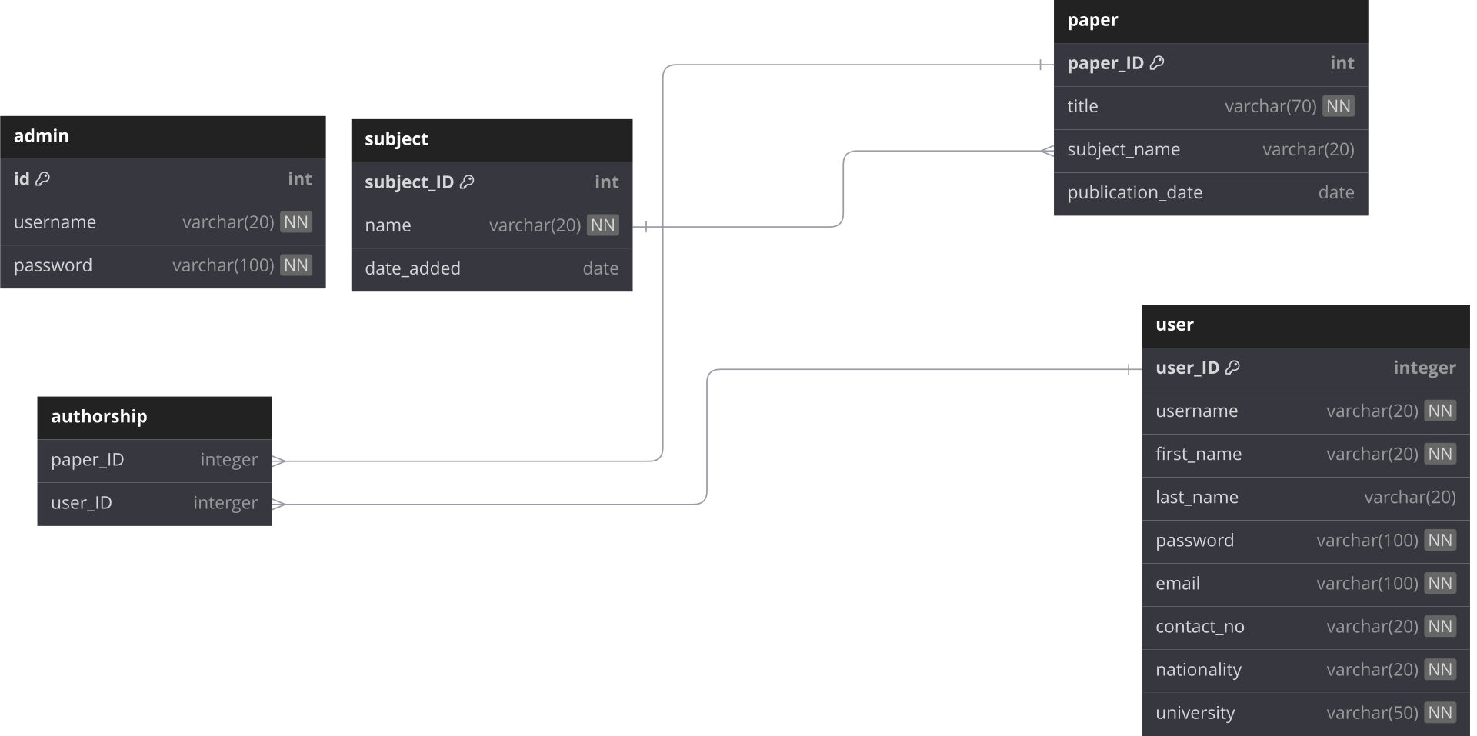

E-R diagram of SIMS (Scholar Information Management System)

**GUI ScreenShots**

***Login Page***

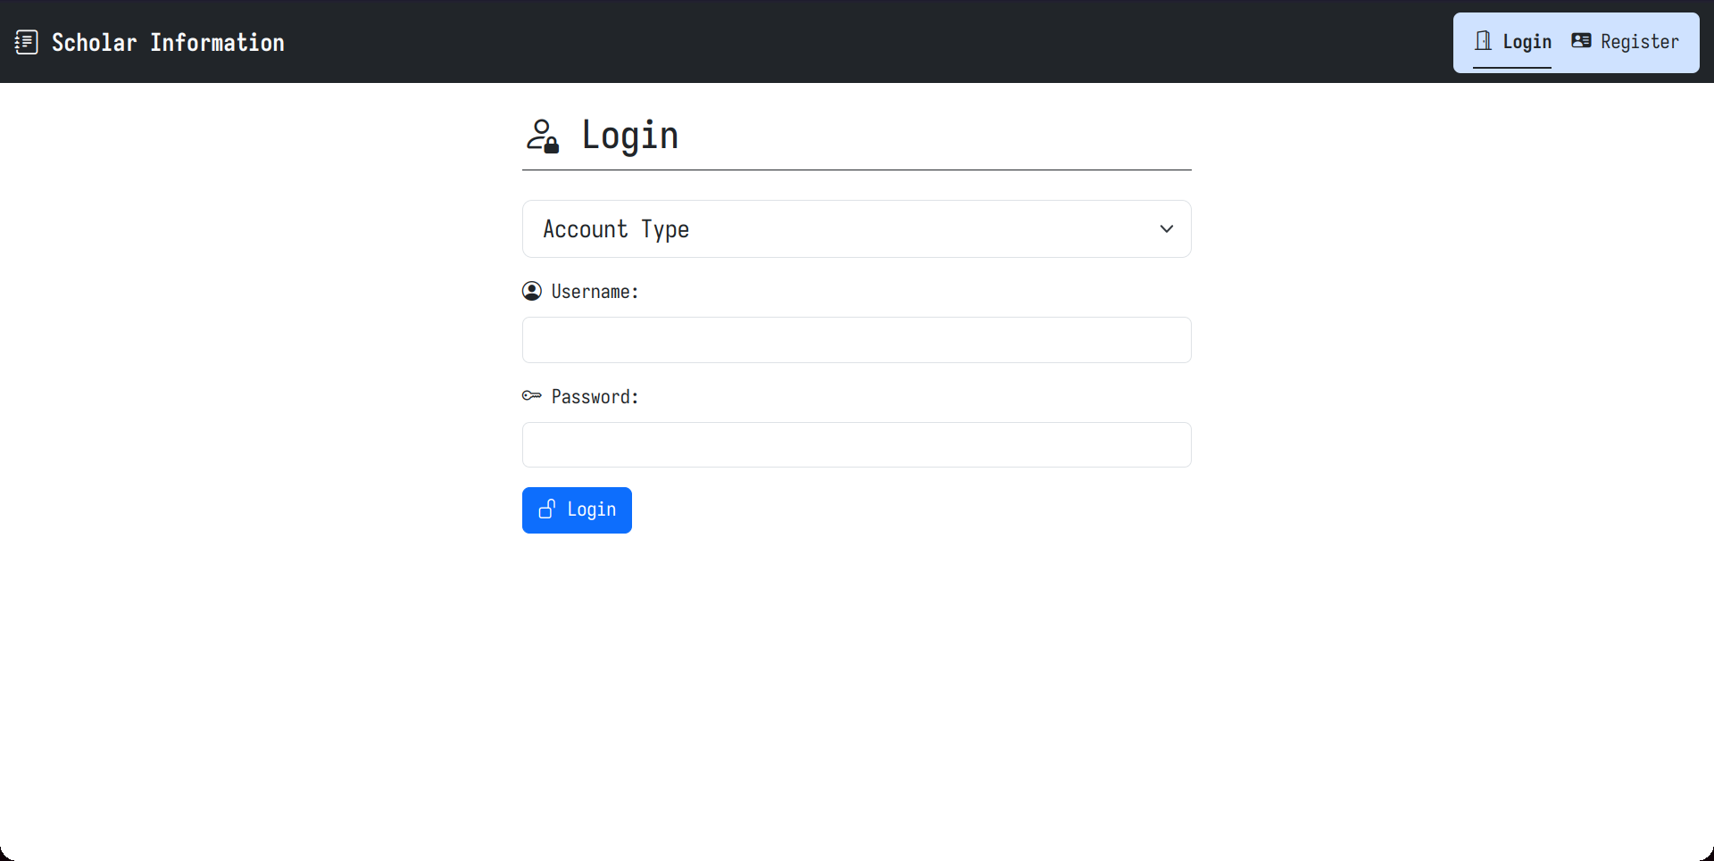

***Registration Page***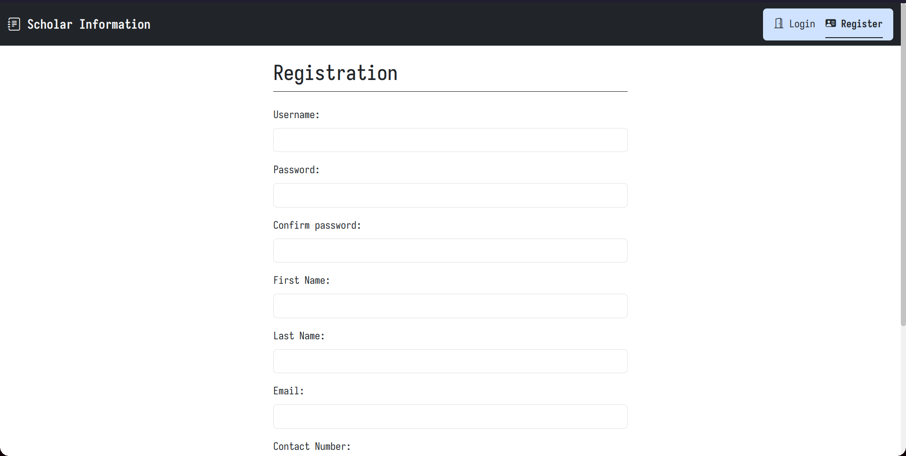

***User Profile Page***

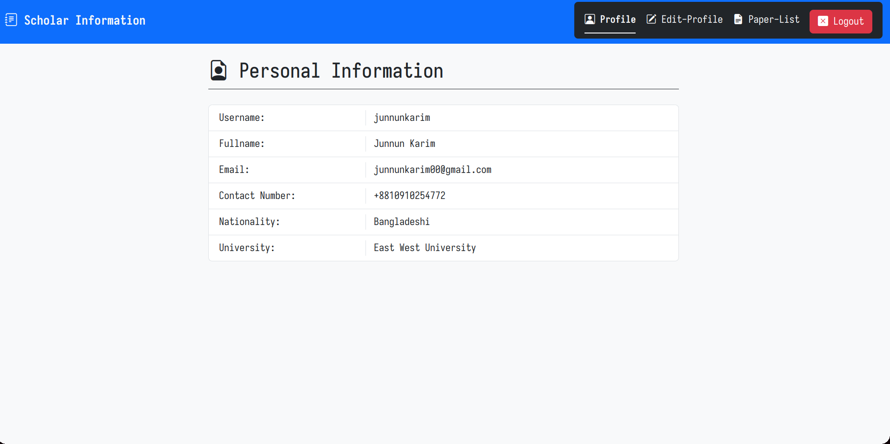

***Edit User Information (User) Page***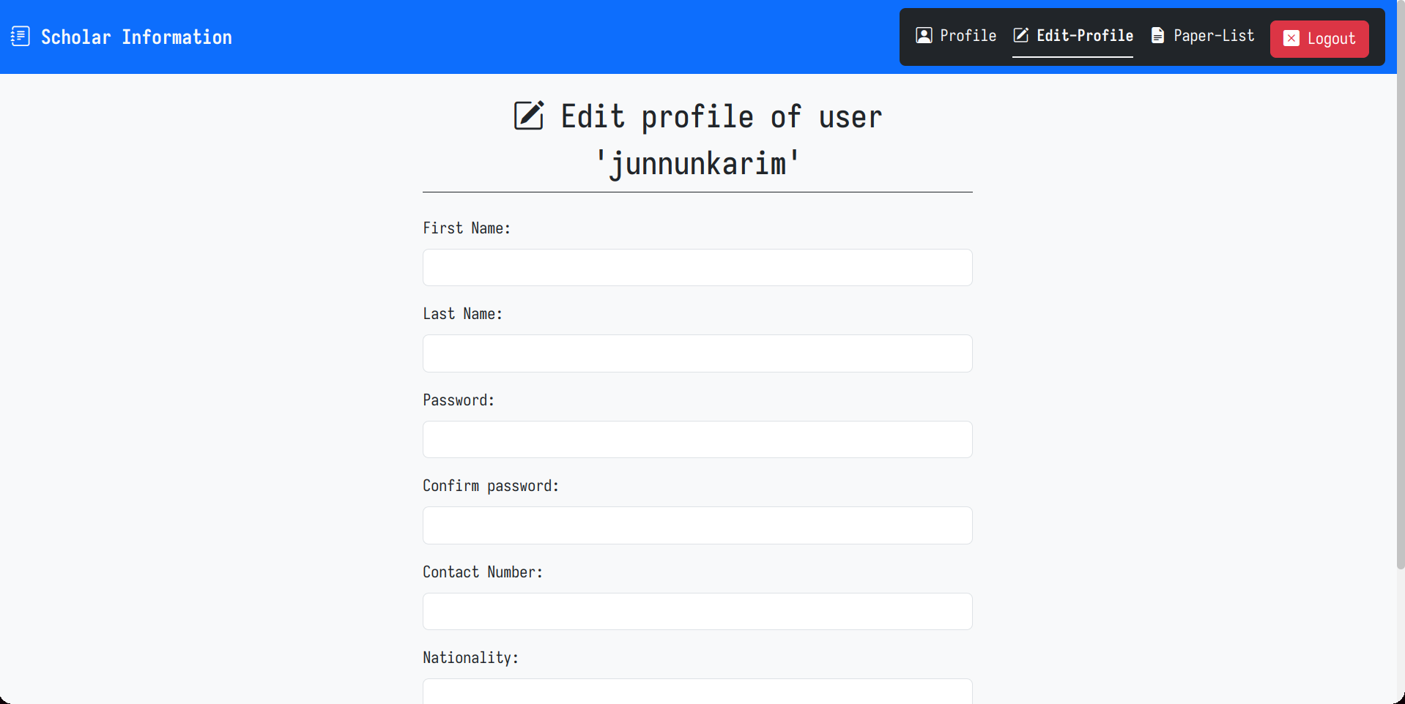

***Paper List (User) Page***

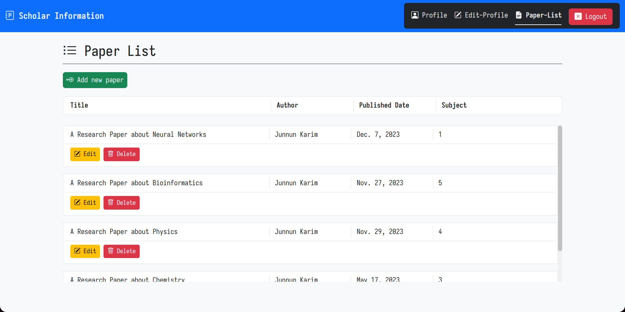

***Add Paper (User) Page***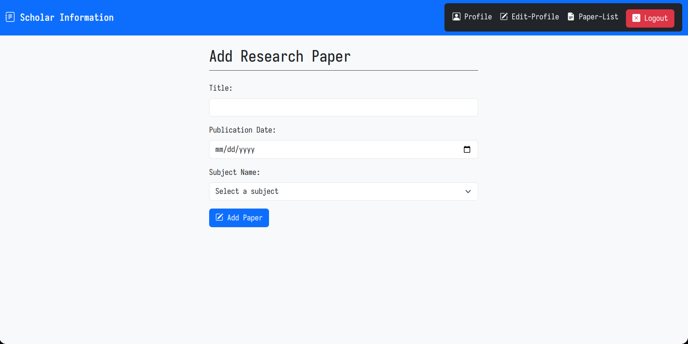

***User List (Admin) Page***

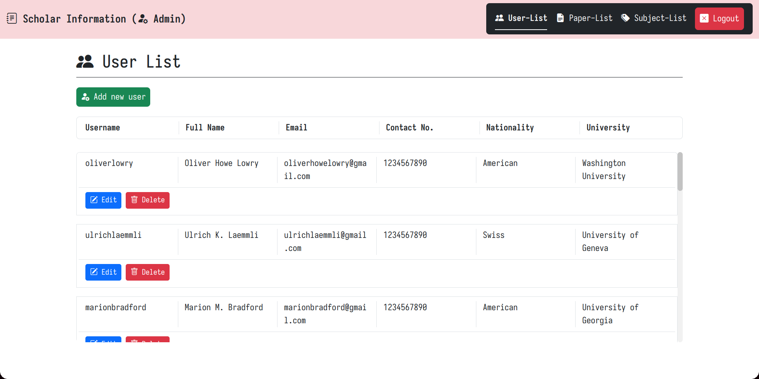

***Edit User Information (Admin) Page***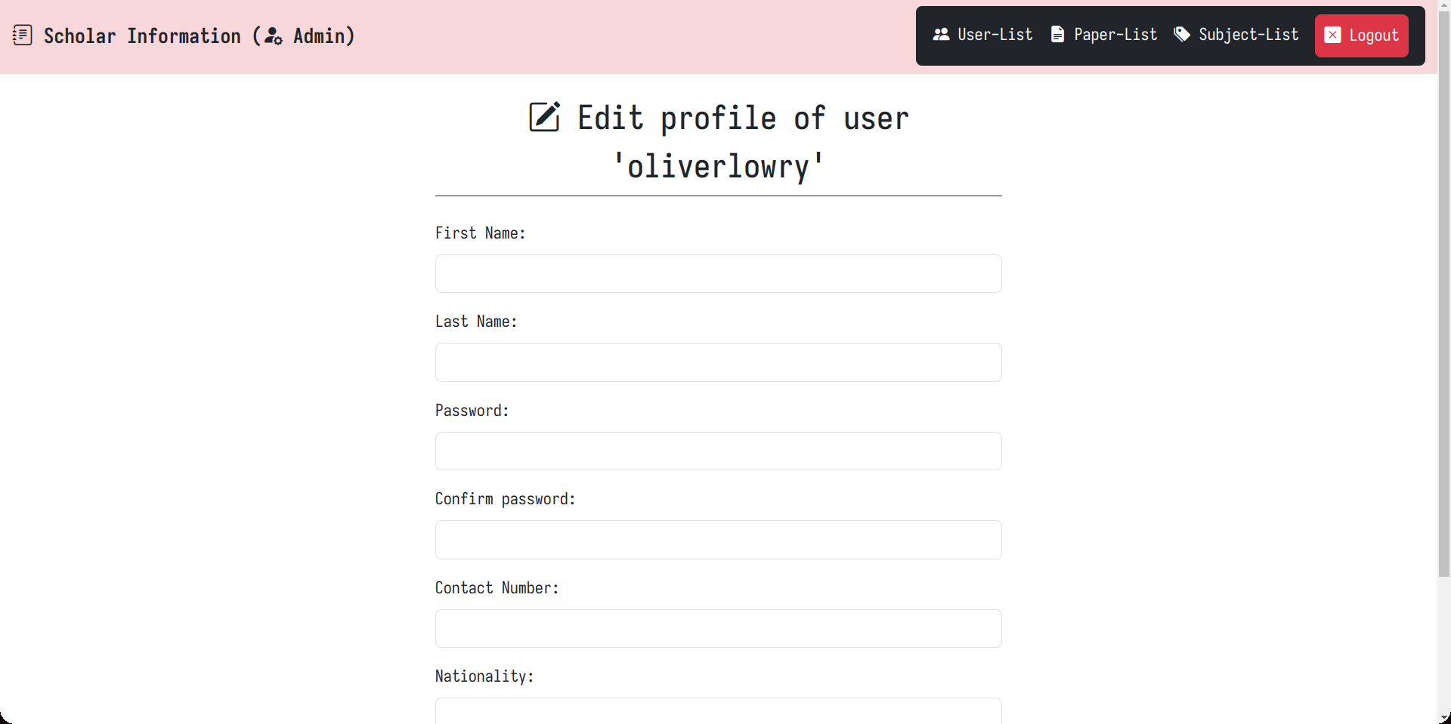

***Paper List (Admin) Page***

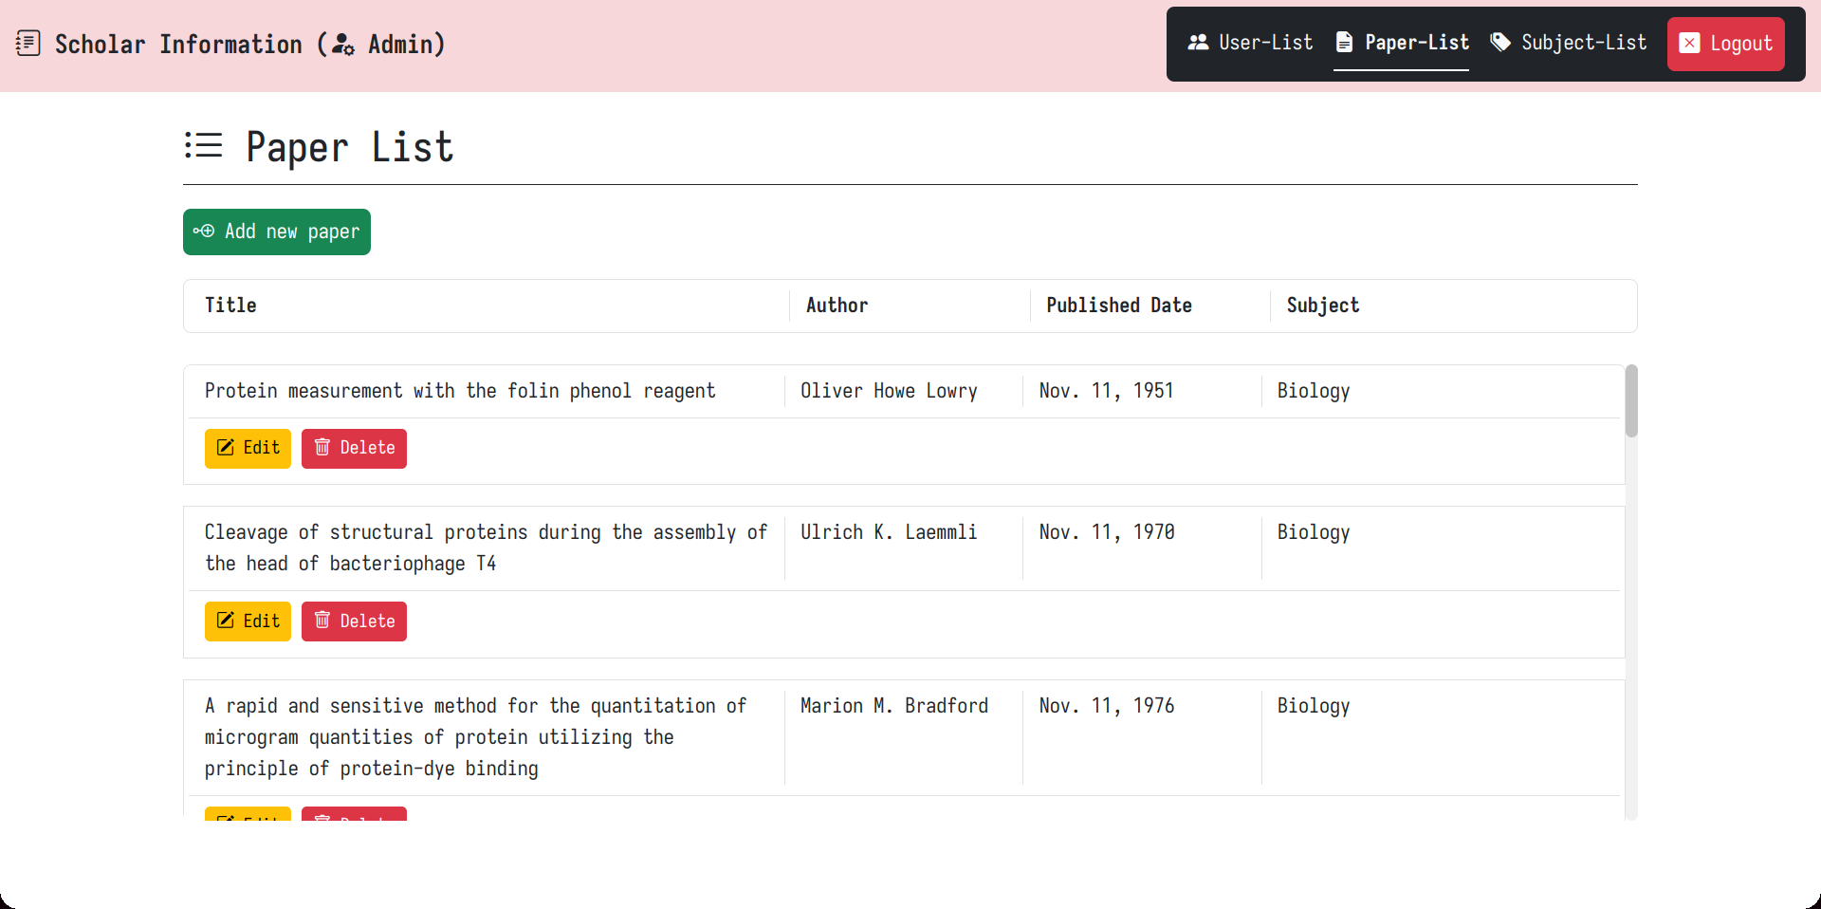

***Edit Paper Information (Admin) Page***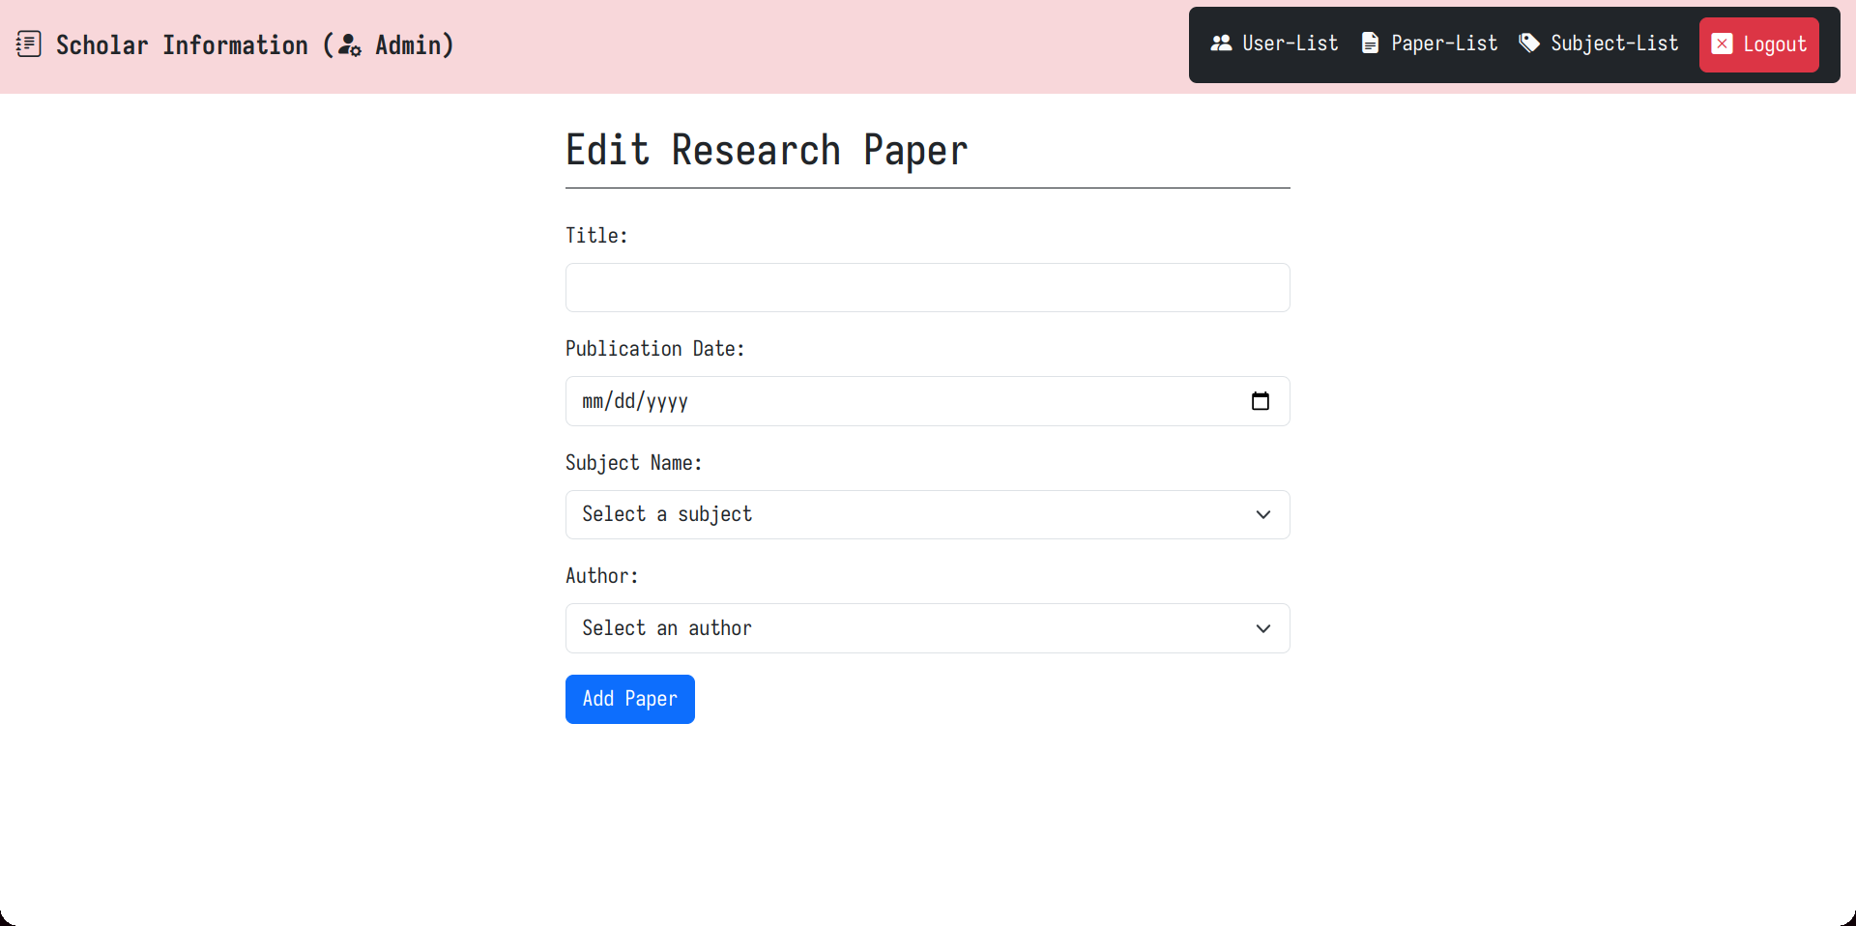

***Subject List (Admin) Page***

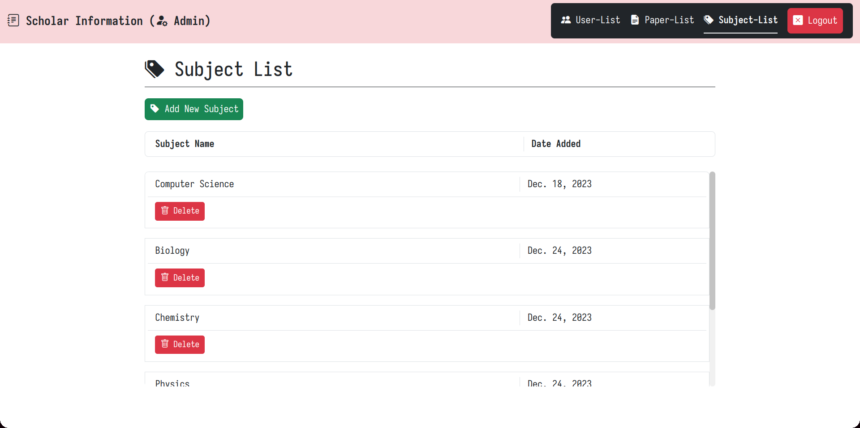

***Add Subject (Admin) Page***