INTERNATIONAL CYBERSECURITY AND DIGITAL FORENSICS ACADEMY (ICDFA)

Lab 2 - HTTP Analysis Using Wireshark: Embedded Image Traffic

Lab Title: | HTTP Analysis Using Wireshark
Student Name: | Yusuf Oluwaseun Dada
Student ID: | 2025/FWSD/11339
Course Code: | SBT-DF203
Course Name: | Basic Networking Skills for Digital Forensics

Instructor: Mr. Aminu Idris, AMCPN

Date: 10/09/2026

Required Tools and Environment
Item | Recommended Tool | Purpose
Operating system | Kali Linux plus optional Windows 10/11 VM | Host the page and generate a browser request
Web server | Apache2 | Serve image.html and the selected image
Capture tools | Wireshark and tshark | Capture and reconstruct HTTP objects
Browser | Firefox, Chrome or Edge | Generate separate HTML and image requests
Utilities | curl, file, identify, sha256sum | Inspect and verify objects
Image | Student-owned non-sensitive JPG/PNG | Embedded evidence object

Step 1 — Lab Folder Structure and Environment Setup
mkdir -p ~/SBT-DF203-Lab2/{evidence,working,exported,reports,screenshots,scripts}
cd ~/SBT-DF203-Lab2
pwd
find . -maxdepth 1 -type d -print
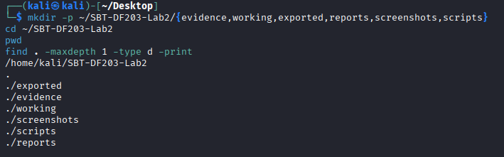

sudo apt update
sudo apt install -y apache2 curl wireshark tshark imagemagick
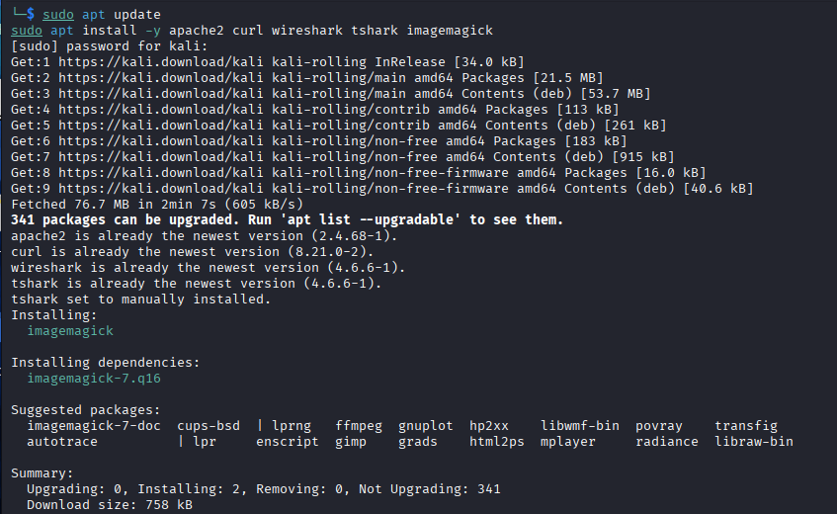
sudo systemctl enable --now apache2
cp /home/kali/SBT-DF203-Lab2/evidence/building.jpg /var/www/html/building.jpg
printf '<!DOCTYPE html>\n<html><body><h1>SBT-DF203 Image Traffic</h1><p>Analyst: Yusuf Oluwaeun Dada</p><img src="building.jpg" alt="Training image"></body></html>\n' | sudo tee /var/www/html/image.html
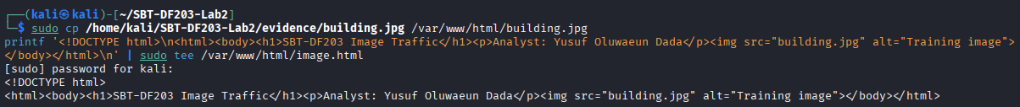
sha256sum /var/www/html/image.html /var/www/html/building.jpg | tee reports/source_object_hashes.txt
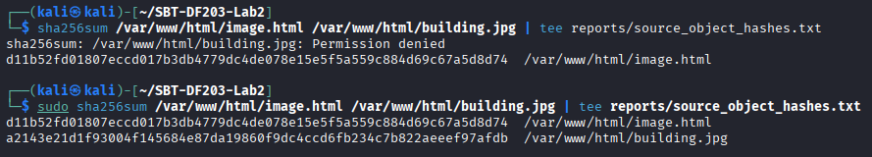

d11b52fd01807eccd017b3db4779dc4de078e15e5f5a559c884d69c67a5d8d74 /var/www/html/image.html
a2143e21d1f93004f145684e87da19860f9dc4ccd6fb234c7b822aeeef97afdb /var/www/html/building.jpg

Mini Evidence and Chain-of-Custody Worksheet
Field | Student Entry
Case/lab identifier | SBT-DF203-Lab2
Trainee name | Yusuf Oluwaseun Dada
Date and time started | 08/09/2026 4:30
Evidence file name(s) | image_traffic.pcapng,curl_only.pcapng
Source or generation method | Browser-generated (private/incognito window) for image_traffic.pcapng; curl-generated for curl_only.pcapng
Original SHA-256 | 43bd5f347d956c43dee4109f5cd257eea8b849fa2d7077d64808fcddc5ae9c16
Working-copy SHA-256 | 43bd5f347d956c43dee4109f5cd257eea8b849fa2d7077d64808fcddc5ae9c16
Analysis workstation/VM | Kali Linux
Notes on any changes | working copy hash matches original

Part A - Verify the Webpage and Eliminate Cache Effects
- Use a non-sensitive image you are authorised to submit.
- Open a private/incognito browser window or clear the cache before capture.
- Confirm that image.html displays both text and the embedded image.
- Record file type, dimensions and size of the source image.
file /var/www/html/building.jpg
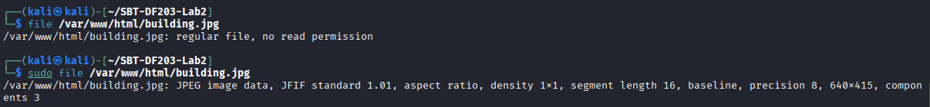
identify /var/www/html/building.jpg
ls -lh /var/www/html/image.html /var/www/html/building.jpg
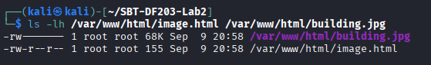
curl -I http://127.0.0.1/image.html
curl -I http://127.0.0.1/building.jpg
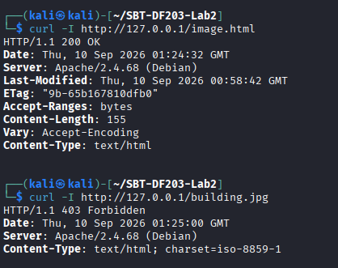

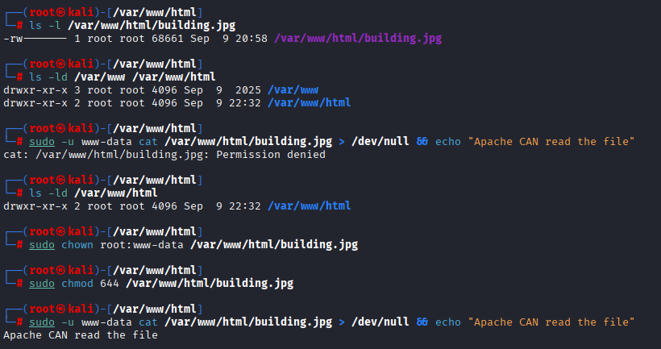
Trying to solve the access denied issue

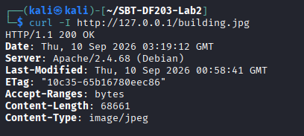
Solved

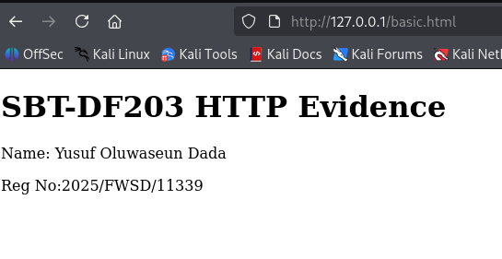
basic.html on browser

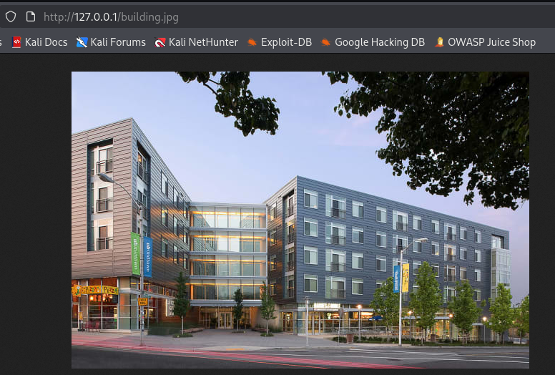
building.jpg

Part B - Capture Browser-Generated HTTP Traffic
# Terminal 1
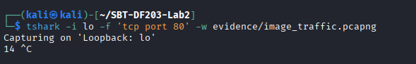
tshark -i lo -f 'tcp port 80' -w evidence/image_traffic.pcapng

In Browser
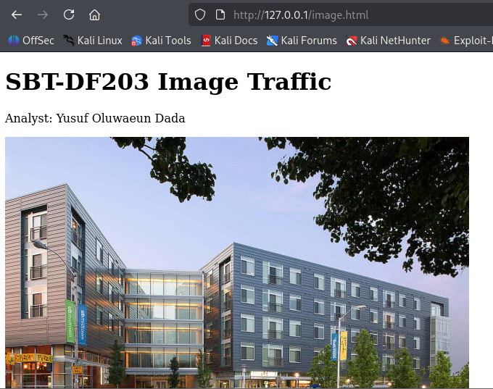
I open a private window and visit:
http://127.0.0.1/image.html
After the image load, then i stopped the capture with Ctrl+C.
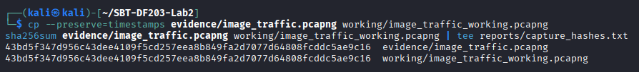
cp --preserve=timestamps evidence/image_traffic.pcapng working/image_traffic_working.pcapng
sha256sum evidence/image_traffic.pcapng working/image_traffic_working.pcapng | tee reports/capture_hashes.txt
43bd5f347d956c43dee4109f5cd257eea8b849fa2d7077d64808fcddc5ae9c16

Part C - Prove That Two Objects Were Requested
To apply http.request. Its normal to see one GET request for image.html and another for building.jpg. A favicon or browser-generated request may also appear; documentation is adviseable rather than deleting it.
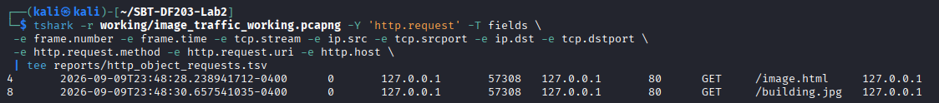
tshark -r working/image_traffic_working.pcapng -Y 'http.request' -T fields \
-e frame.number -e frame.time -e tcp.stream -e ip.src -e tcp.srcport -e ip.dst -e tcp.dstport \
-e http.request.method -e http.request.uri -e http.host \
| tee reports/http_object_requests.tsv
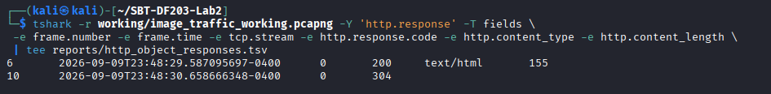
tshark -r working/image_traffic_working.pcapng -Y 'http.response' -T fields \
-e frame.number -e frame.time -e tcp.stream -e http.response.code -e http.content_type -e http.content_length \
| tee reports/http_object_responses.tsv

Part D - Analyze TCP Segmentation and Reassembly
- Select the HTTP response associated with the image request and note Reassembled TCP Segments.
- Record the number and tcp.len value of each contributing segment.
- Add the TCP payload lengths and compare the result with the HTTP header plus object data.
- Explain why the exact segment sizes may differ from those in the slide: interface offloading, operating system buffers, MTU and capture location can change segmentation.
I replace STREAM with the tcp.stream number for the image transfer which is 0
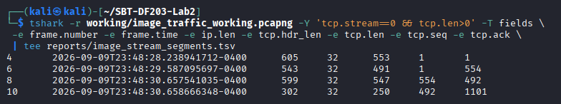
tshark -r working/image_traffic_working.pcapng -Y 'tcp.stream==0 && tcp.len>0' -T fields \
-e frame.number -e frame.time -e ip.len -e tcp.hdr_len -e tcp.len -e tcp.seq -e tcp.ack \
| tee reports/image_stream_segments.tsv
# Summary of conversation sizes
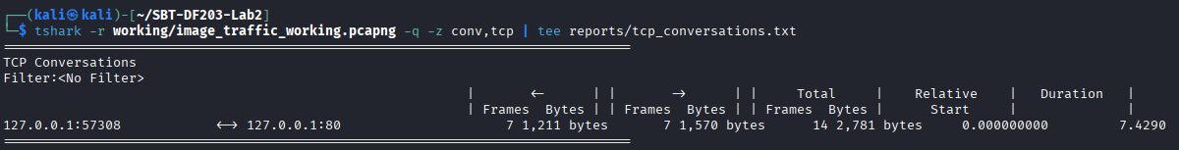
tshark -r working/image_traffic_working.pcapng -q -z conv,tcp | tee reports/tcp_conversations.txt

Part E - Export the Embedded Image
- In Wireshark select File > Export Objects > HTTP.
- Locate building.jpg by hostname, content type or filename and save it under exported.
- Alternatively, use tshark object export as shown below.
- Compare file type, size and SHA-256 hash of the exported image with the source image.
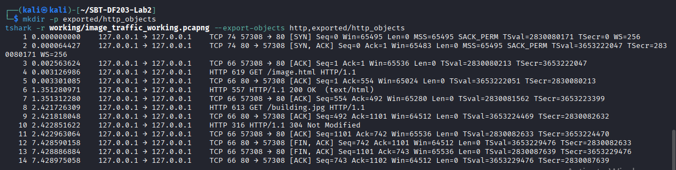
mkdir -p exported/http_objects
tshark -r working/image_traffic_working.pcapng --export-objects http,exported/http_objects
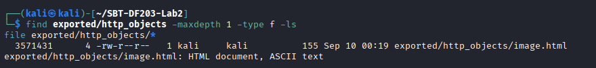
find exported/http_objects -maxdepth 1 -type f -ls
file exported/http_objects/*

sha256sum /var/www/html/building.jpg exported/http_objects/* | tee reports/extracted_object_hashes.txt

a2143e21d1f93004f145684e87da19860f9dc4ccd6fb234c7b822aeeef97afdb /var/www/html/building.jpg
d11b52fd01807eccd017b3db4779dc4de078e15e5f5a559c884d69c67a5d8d74 exported/http_objects/image.html

Integrity Interpretation: matching hashes prove byte-for-byte recovery. A different filename is not a problem if size, type and hash match. A different hash requires investigation of incomplete capture, browser content transformation, a different requested object, or export error.

Part F - Compare curl and Browser Behaviour
Running a curl against image.html in a new capture. By default, curl retrieves the HTML but does not automatically fetch the referenced image. Practically, why the image request is absent? And why we request it separately.
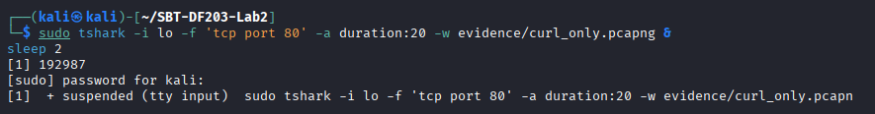
sudo tshark -i lo -f 'tcp port 80' -a duration:20 -w evidence/curl_only.pcapng &
sleep 2

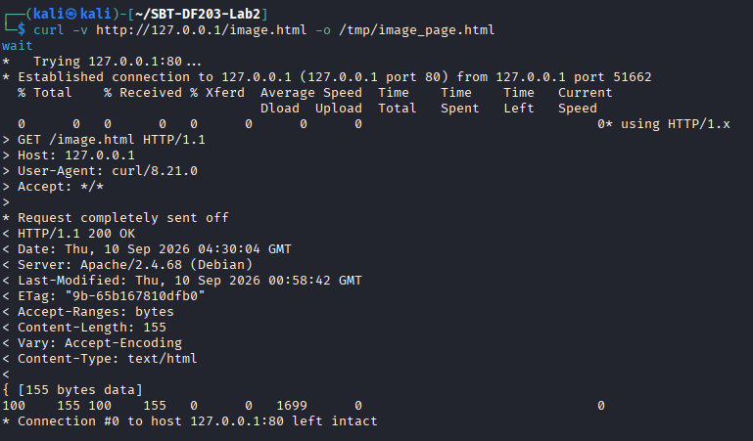
sudo tshark -i lo -f 'tcp port 80' -a duration:20 -w evidence/curl_only.pcapng &
sleep 2
curl -v http://127.0.0.1/image.html -o /tmp/image_page.html
wait
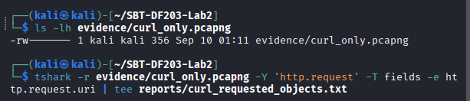
tshark -r evidence/curl_only.pcapng -Y 'http.request' -T fields -e http.request.uri | tee reports/curl_requested_objects.txt
Explanation: curl only fetches the exact URL given to it, it has no HTML rendering engine, so it never parses the response looking for <img> tags the way a browser does. A browser’s rendering engine discovers the image reference and automatically issues a second GET request; curl simply has no equivalent mechanism unless we explicitly request the image as a separate URL.

Required Forensic Findings
Finding | Student Observation
Number of HTTP requests | 2 (GET /image.html, GET /building.jpg), both on tcp.stream 0 (persistent connection)
HTML request URI and timestamp | /image.html - 2026-09-09 23:48:28.238941712
Image request URI and timestamp | /building.jpg - 2026-09-09 23:48:30.657541035
HTTP response codes | 200 (image.html) and (building.jpg)
Image content type | jpeg
Reported Content-Length | 155 bytes (image.html), building.jpg - 68,561 bytes
Number of reassembled TCP segments
Sum of TCP payload lengths
Original image SHA-256 | a2143e21d1f93004f145684e87da19860f9dc4ccd6fb234c7b822aeeef97afdb
Extracted image SHA-256 | d11b52fd01807eccd017b3db4779dc4de078e15e5f5a559c884d69c67a5d8d74
Hash comparison conclusion
curl/browser difference | curl's capture (curl_only.pcapng, 356 bytes) showed only 1 HTTP request (image.html); the browser's capture (image_traffic.pcapng) showed 2 requests

Zip file submission analysis
