Latent Dirichlet Allocation (LDA):
Bayesian Inference in LDA:
Bayesian Inference used as to “reverse engineer” the hidden topics from the observed words in the documents.Techniques like Gibbs sampling or variational Bayes are used to estimate the latent variables:
- The topic proportions in each document.
- The word probabilities in each topic.

Key Model Parameters
- α: Controls per-document topic diversity (high α means documents have many topics).
- β: Controls per-topic word diversity (high β means topics use many different words).

Code:
import nltk
from nltk.tokenize import word_tokenize
from nltk.corpus import stopwords
from gensim.corpora import Dictionary
import pyLDAvis.gensim_models

nltk.download('stopwords')
nltk.download('punkt')

documents = [
"I love machine learning and artificial intelligence",
"Python is used for data science and machine learning",
"Football and cricket are popular sports",
"Messi is a famous football player",
"Data science uses Python and AI"
]

stop_words = set(stopwords.words('english'))

processed_doc = []

for doc in documents:
tokens = word_tokenize(doc)
filtered_words = [word for word in tokens if word.isalpha() and word not in stop_words]
processed_doc.append(filtered_words)

print(processed_doc)

dictionary = Dictionary(processed_doc)

corpus = [dictionary.doc2bow(doc) for doc in processed_doc]

print(corpus)

from gensim.models import LdaModel

lda_model = LdaModel(
corpus=corpus,
id2word=dictionary,
num_topics=2,
random_state=42,
passes=10
)

topics = lda_model.print_topics(num_words=5)

for topic in topics:
print(topic)

new_doc = "Python is important for AI"

new_tokens = word_tokenize(new_doc)

new_bow = dictionary.doc2bow(new_tokens)

print(lda_model.get_document_topics(new_bow))

vis = pyLDAvis.gensim_models.prepare(
lda_model,
corpus,
dictionary
)

pyLDAvis.save_html(vis,"lda_visualization.html")

Output:
[['Apple', 'releases', 'new', 'iPhone'], ['Samsung', 'launches', 'new', 'mobile'], ['Cricket', 'world', 'cup', 'starts'], ['Virat', 'Kohli', 'scores', 'century']]
[[(0, 1), (1, 1), (2, 1), (3, 1)], [(2, 1), (4, 1), (5, 1), (6, 1)], [(7, 1), (8, 1), (9, 1), (10, 1)], [(11, 1), (12, 1), (13, 1), (14, 1)]]
(0, '0.128*"new" + 0.077*"Samsung" + 0.077*"mobile" + 0.077*"launches" + 0.077*"iPhone"')
(1, '0.128*"starts" + 0.128*"world" + 0.128*"cup" + 0.128*"Cricket" + 0.045*"scores"')
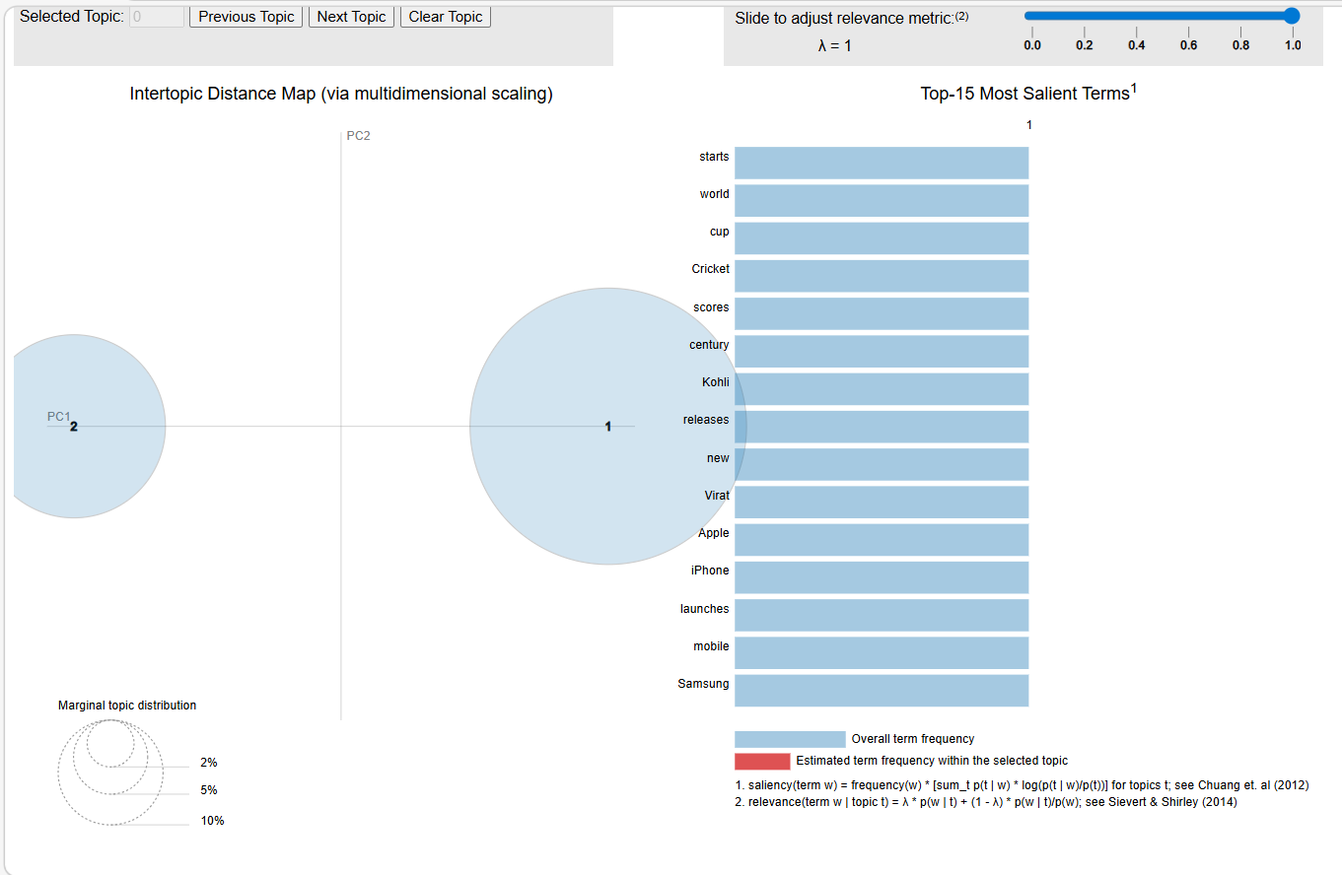
Gensim:
Gensim is a open-source library in Python designed for efficient text processing, topic modelling and vector-space modelling in NLP. It is known for its speed and memory efficiency. It also build word embeddings, discover hidden topics and analyze large text corpora with minimal resources.
- Supports Word2Vec, Doc2Vec, and LDA
- Handles large datasets through streaming and incremental training
- Widely used for semantic analysis, topic discovery, and text similarity tasks

Common Terminologies:
- Corpus – A large and structured set of text documents using for training or analyzing the language models. It can range from a collection of articles, tweets, emails, or any other form of textual data.
- Vector – It is the numerical representation of text data that enables machines to understand and process language.
- Model – It is a machine learning or statistical algorithm that learns from data to make predictions or extract patterns.
- Topic Modelling – It is an unsupervised learning technique used to discover abstract topics within a collection of documents. It assumes that each document is a mixture of various topics, and each topic is a mixture of words.
- Topic – It is a collection of words that frequently appear together and represent a coherent idea or subject. For instance, words like "doctor," "hospital," and "medicine" might form a health-related topic.
Preprocess the Dataset:
Text Prepocessing:
Text preprocessing is the practice of cleaning and preparing text data. For this purpose we will use the simple_preprocess( ) function. This function returns a list of tokens after tokenizing and normalizing them.
Create Dictionary:
A dictionary maps words to unique IDs.
Bag of Words (BoW):
Convert word into numerical format.
Feature Extraction:
TF-IDF Transformation:
TF-IDF gives important scores to words. Important words gets higher weights. Common words gets lower weights.
Word Embeddings (Word2Vec):
Convert words to vectors. Each word becomes a mathematical vector.
Word -> Vector
Topic Modelling in LDA:
Find hidden topics in documents.
Model Saving:
Save Trained Models.
Code:
import gensim

# print(gensim.__version__)
# Step 1: Pre - Processing
from gensim.utils import simple_preprocess

documents = [
"Artificial Intelligence and Machine Learning are transforming the world",
"Python is widely used in Data Science and NLP",
"Gensim is a powerful NLP library",
"Football and Cricket are popular sports",
"Messi is a famous football player"
]

tokens = [simple_preprocess(doc) for doc in documents]
print(tokens)

# Step 2: Create Dictionary and print tokens in tokens to id

from gensim.corpora import Dictionary

dictionary = Dictionary(tokens)

# print(dictionary)
print(dictionary.token2id)

# Step 3: Bag of Words

corpus = [dictionary.doc2bow(token) for token in tokens]

print(corpus)

# Step 4: TF-IDF

from gensim.models import TfidfModel

tfidf = TfidfModel(corpus)

tfidf_corpus = tfidf[corpus]

print(tfidf_corpus)

# Step 5: Word2Vec

from gensim.models import Word2Vec

model = Word2Vec(
tokens,
vector_size=50,
window=3,
min_count=1
)

print(model.wv['python'])
print(model.wv.most_similar('python'))
model.save('word2vec.model')

# Step 6: LDA Model

from gensim.models import LdaModel

lda_model = LdaModel(
corpus=corpus,
id2word=dictionary,
num_topics=2,
passes=10
)

topics = lda_model.print_topics()

for topic in topics:
print(topic)

# Step 7: Doc2Vec

from gensim.models.doc2vec import Doc2Vec,TaggedDocument

tagged_data = []

for i, doc in enumerate(documents):
tokens = simple_preprocess(doc)

tagged_doc = TaggedDocument(
words = tokens,
tags = [str(i)]
)

tagged_data.append(tagged_doc)

print(tagged_data)

model = Doc2Vec(
tagged_data,
vector_size=50,
window=2,
min_count=1,
epochs=100
)

vector = model.dv['0']

print(vector)

similar_docs = model.dv.most_similar('0')
print(similar_docs)

new_doc = "Python and AI are related"

tokens = simple_preprocess(new_doc)

new_vector = model.infer_vector(tokens)

print(new_vector)

# Step 8: Lemmatization and Stopwords

from gensim.parsing.preprocessing import remove_stopwords

import nltk
from nltk.stem import WordNetLemmatizer

nltk.download('wordnet')

lemmatizer = WordNetLemmatizer()

processed_doc = []

for doc in documents:
clean_text = remove_stopwords(doc)

tokens = simple_preprocess(clean_text)

lemmas = []

for word in tokens:
lemma = lemmatizer.lemmatize(word)
lemmas.append(lemma)

processed_doc.append(lemmas)

print(processed_doc)

# Step 9: LSI Model

from gensim.models import LsiModel

lsi_model = LsiModel(
corpus=corpus,
id2word=dictionary,
num_topics = 7,
decay = 0.5
)

print(lsi_model.print_topics(-1))

Output:
[['artificial', 'intelligence', 'and', 'machine', 'learning', 'are', 'transforming', 'the', 'world'], ['python', 'is', 'widely', 'used', 'in', 'data', 'science', 'and', 'nlp'], ['gensim', 'is', 'powerful', 'nlp', 'library'], ['football', 'and', 'cricket', 'are', 'popular', 'sports'], ['messi', 'is', 'famous', 'football', 'player']]
{'and': 0, 'are': 1, 'artificial': 2, 'intelligence': 3, 'learning': 4, 'machine': 5, 'the': 6, 'transforming': 7, 'world': 8, 'data': 9, 'in': 10, 'is': 11, 'nlp': 12, 'python': 13, 'science': 14, 'used': 15, 'widely': 16, 'gensim': 17, 'library': 18, 'powerful': 19, 'cricket': 20, 'football': 21, 'popular': 22, 'sports': 23, 'famous': 24, 'messi': 25, 'player': 26}
[[(0, 1), (1, 1), (2, 1), (3, 1), (4, 1), (5, 1), (6, 1), (7, 1), (8, 1)], [(0, 1), (9, 1), (10, 1), (11, 1), (12, 1), (13, 1), (14, 1), (15, 1), (16, 1)], [(11, 1), (12, 1), (17, 1), (18, 1), (19, 1)], [(0, 1), (1, 1), (20, 1), (21, 1), (22, 1), (23, 1)], [(11, 1), (21, 1), (24, 1), (25, 1), (26, 1)]]
<gensim.interfaces.TransformedCorpus object at 0x000001E7B6F52960>
[ 0.00513854 0.01623337 -0.00277442 0.01615586 0.00743403 -0.01609465
-0.00786723 -0.00494376 0.00978609 -0.00174432 -0.00566182 0.01566741
0.0186458 -0.00322986 -0.0103185 -0.00940352 -0.0096921 -0.01920565
0.00274404 -0.00844983 0.00505342 0.01122897 -0.00813181 -0.01919316
0.0030934 -0.01340024 0.00499035 -0.00756126 0.01415684 0.00128044
0.00712188 -0.00547827 -0.00342109 0.01530559 0.00281536 -0.0117009
-0.01566899 0.00246537 0.01290926 0.0111127 -0.0179541 0.01718433
0.00809396 0.01493921 0.01949267 -0.01457916 -0.01807993 0.011672
0.01878243 0.00701385]
[('widely', 0.17065373063087463), ('transforming', 0.16558517515659332), ('in', 0.16485737264156342), ('and', 0.16086865961551666), ('science', 0.08009938895702362), ('the', 0.07460034638643265), ('used', 0.06329286843538284), ('player', 0.036332838237285614), ('artificial', 0.03296931833028793), ('are', 0.030459685251116753)]
(0, '0.076*"is" + 0.075*"and" + 0.074*"nlp" + 0.045*"python" + 0.045*"science" + 0.045*"widely" + 0.045*"data" + 0.045*"in" + 0.045*"used" + 0.045*"gensim"')
(1, '0.056*"are" + 0.055*"football" + 0.055*"and" + 0.054*"learning" + 0.054*"the" + 0.054*"machine" + 0.054*"transforming" + 0.054*"intelligence" + 0.054*"world" + 0.054*"artificial"')
[TaggedDocument(words=['artificial', 'intelligence', 'and', 'machine', 'learning', 'are', 'transforming', 'the', 'world'], tags=['0']), TaggedDocument(words=['python', 'is', 'widely', 'used', 'in', 'data', 'science', 'and', 'nlp'], tags=['1']), TaggedDocument(words=['gensim', 'is', 'powerful', 'nlp', 'library'], tags=['2']), TaggedDocument(words=['football', 'and', 'cricket', 'are', 'popular', 'sports'], tags=['3']), TaggedDocument(words=['messi', 'is', 'famous', 'football', 'player'], tags=['4'])]
[-0.01926736 -0.01561205 -0.02367006 0.01733719 0.00931821 0.0011247
-0.02198838 -0.00835255 -0.02657632 0.00764343 0.00712448 0.01509255
-0.00825713 -0.01338323 -0.00306654 -0.02267116 0.00459518 0.02215266
-0.02897402 -0.01192876 -0.01216809 0.00645555 -0.01288986 0.00894853
0.01077673 -0.01678493 -0.02405488 -0.0262775 0.0089986 -0.0228396
0.01928311 0.01744322 -0.01785105 -0.01254955 -0.00588619 0.00806659
-0.00517191 -0.02471768 -0.00649201 0.00311769 -0.00439374 -0.01088708
0.01141995 -0.0227897 0.00408677 -0.00652638 0.00550891 -0.00382709
0.01525419 -0.02091313]
[('1', 0.49825337529182434), ('2', 0.2973962724208832), ('3', 0.14748944342136383), ('4', 0.008289238438010216)]
[-0.00338718 0.00804195 -0.00708386 0.00372319 0.00184844 0.00780522
0.00130425 0.00457522 -0.00086753 0.00584847 0.00623205 -0.00312459
0.00940794 0.00022721 0.00526553 -0.00793862 -0.00577316 -0.00488763
0.00181075 -0.00491497 -0.00773576 -0.00846432 -0.00453679 0.0038314
0.00148988 0.00931921 0.00487159 0.00255975 -0.00503025 0.00381522
0.0110745 -0.00164136 0.00217618 -0.00429056 -0.00201538 -0.0058778
-0.0008137 -0.00035562 -0.0048386 0.00676867 0.00957585 0.001018
-0.00485616 0.00246241 -0.00146267 -0.00753368 -0.0063791 -0.00099703
0.00559186 0.00483843]
[['artificial', 'intelligence', 'machine', 'learning', 'transforming', 'world'], ['python', 'widely', 'data', 'science', 'nlp'], ['gensim', 'powerful', 'nlp', 'library'], ['football', 'cricket', 'popular', 'sport'], ['messi', 'famous', 'football', 'player']]
[(0, '0.475*"and" + 0.324*"is" + 0.279*"are" + 0.266*"nlp" + 0.196*"in" + 0.196*"python" + 0.196*"used" + 0.196*"widely" + 0.196*"science" + 0.196*"data"'), (1, '0.361*"is" + -0.312*"are" + 0.302*"nlp" + -0.234*"learning" + -0.234*"transforming" + -0.234*"the" + -0.234*"machine" + -0.234*"world" + -0.234*"intelligence" + -0.234*"artificial"'), (2, '0.541*"football" + 0.276*"popular" + 0.276*"sports" + 0.276*"cricket" + 0.266*"player" + 0.266*"famous" + 0.266*"messi" + 0.152*"are" + 0.148*"is" + -0.129*"widely"'), (3, '-0.334*"is" + -0.296*"powerful" + -0.296*"library" + -0.296*"gensim" + 0.243*"and" + 0.218*"cricket" + 0.218*"popular" + 0.218*"sports" + -0.198*"famous" + -0.198*"messi"'), (4, '-0.349*"library" + -0.349*"powerful" + -0.349*"gensim" + 0.318*"famous" + 0.318*"player" + 0.318*"messi" + -0.251*"nlp" + -0.218*"sports" + -0.218*"cricket" + -0.218*"popular"')]
Embedding Techniques:
Word2Vec:
Word2Vec is a word embedding technique in NLP that represents words as vectors in a continuous space. It captures semantic relationship by assigning similar vectors to words with similar meaning.
- Converts words into numerical vectors for machine learning models
- Words with similar meanings have similar vector representations
Two Main Architectures:
- Continuous Bag of Words (CBOW)
- Skip-Gram

- Continuous Bag Of Words (CBOW):
CBOW is used to predicts the current word using the given context word within a specific window. The input layer contains context words and the output layer contains current word. The hidden layer contains the dimensions we want to represent the current word present at the output layer.
Eg. “I Learning NLP”
Suppose, target word is “Learning” then context words are “I , NLP”
[context words] => center word
[I, NLP] => Learning

- Skip-Gram:
SkipGram is opposite to CBOW because it predicts the surrounding context words using the given current word within the specific window.
Eg. “I Learning NLP”
Suppose, target word is “Learning” then context words are “I , NLP”
[context words] => center word
Learning => [I, NLP]

