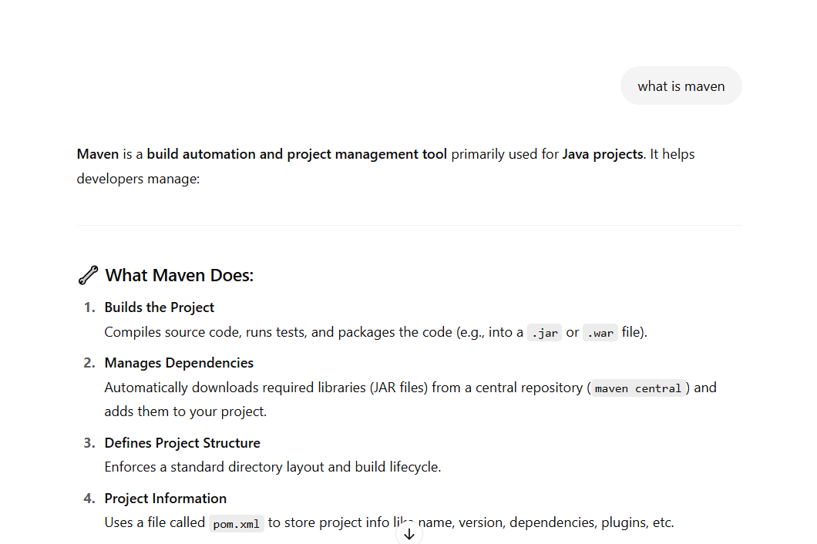

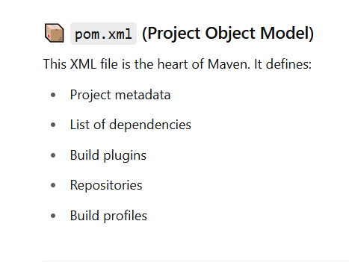

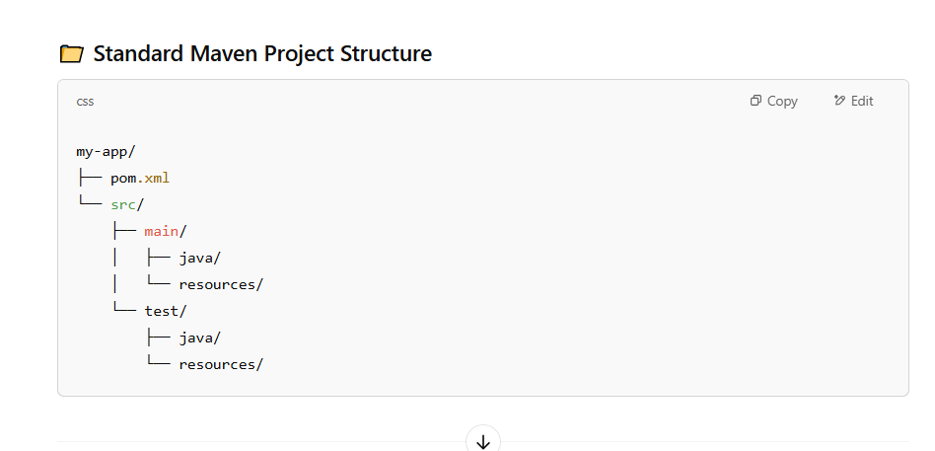

So far we have completed Part1  
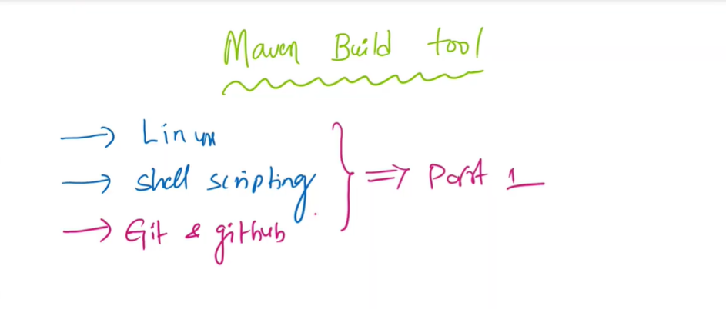

Lets start part2  
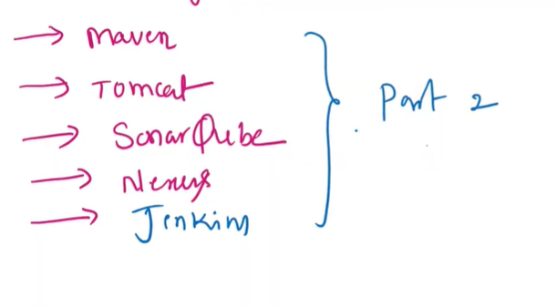

If we try to deploy the source code directly from github repo to Tomcat server It won’t work we have to use Maven Build Tool  
  
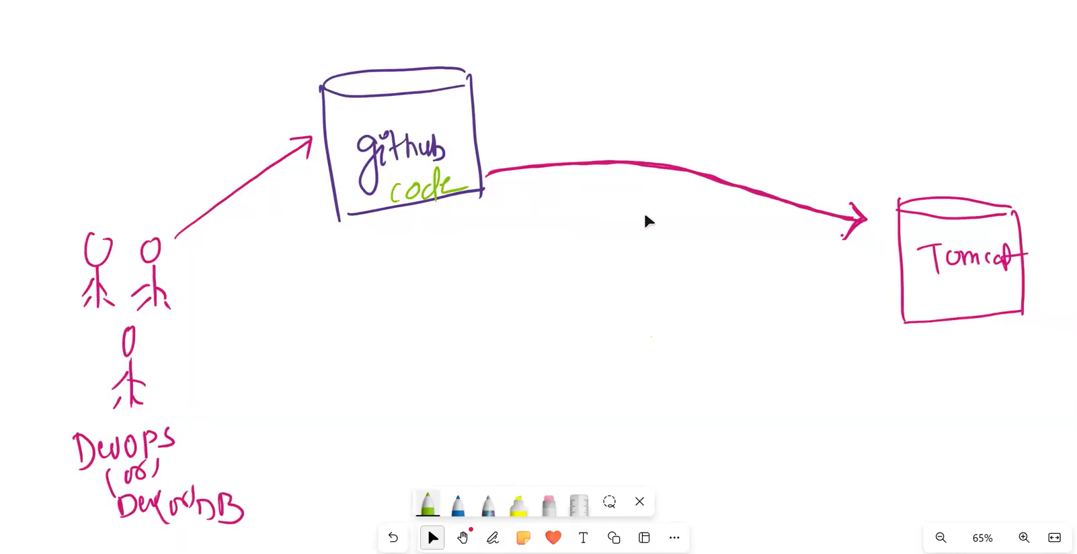

So after collecting the source code from the GitHub repo, the build tool (like Maven or Gradle) compiles the source code and generates artifacts such as (.jar, .war, or .ear ) files, which are then deployed to the Tomcat server for hosting the application.

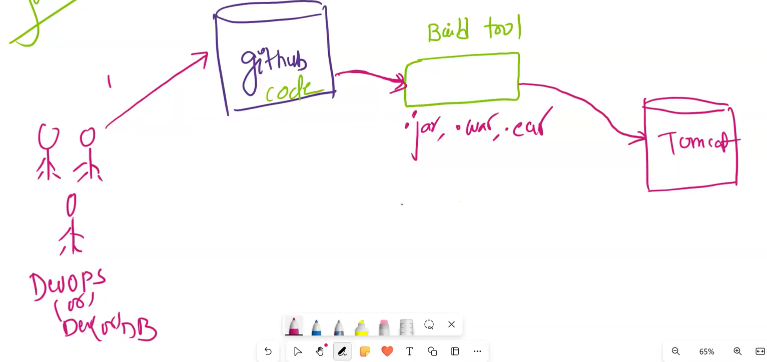

What is the difference between jar file , war file , ear file

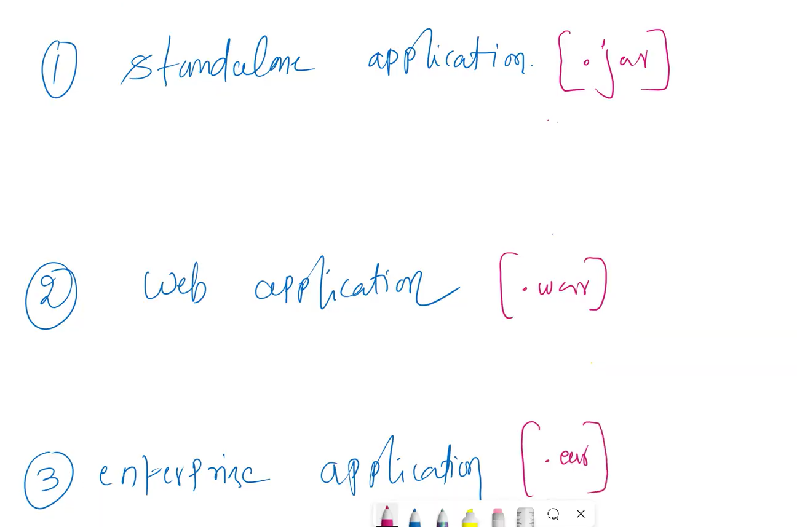  
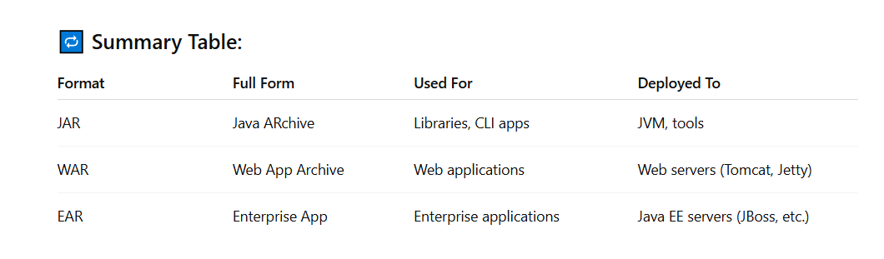

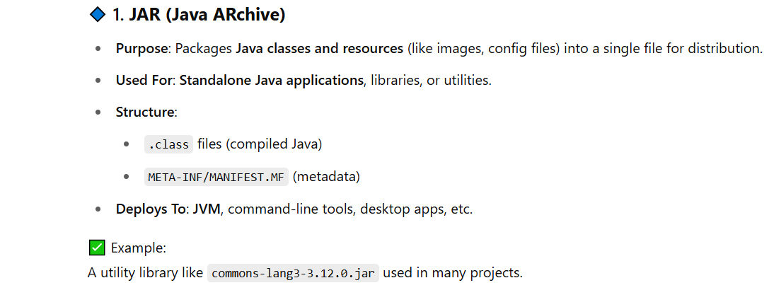

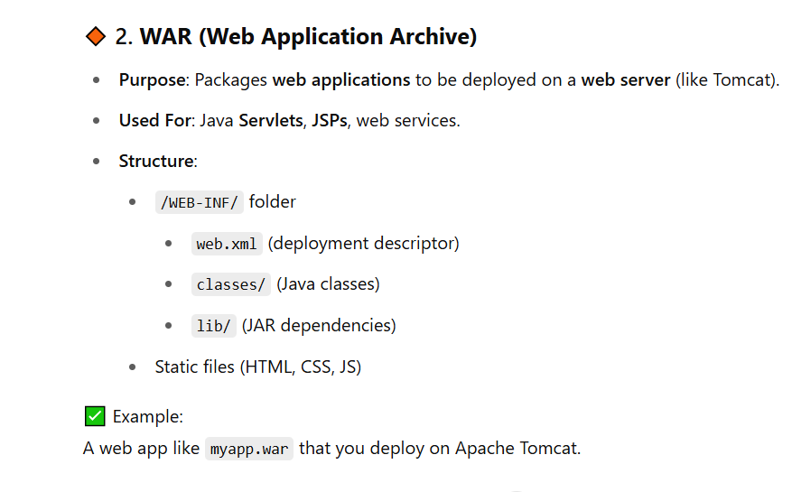

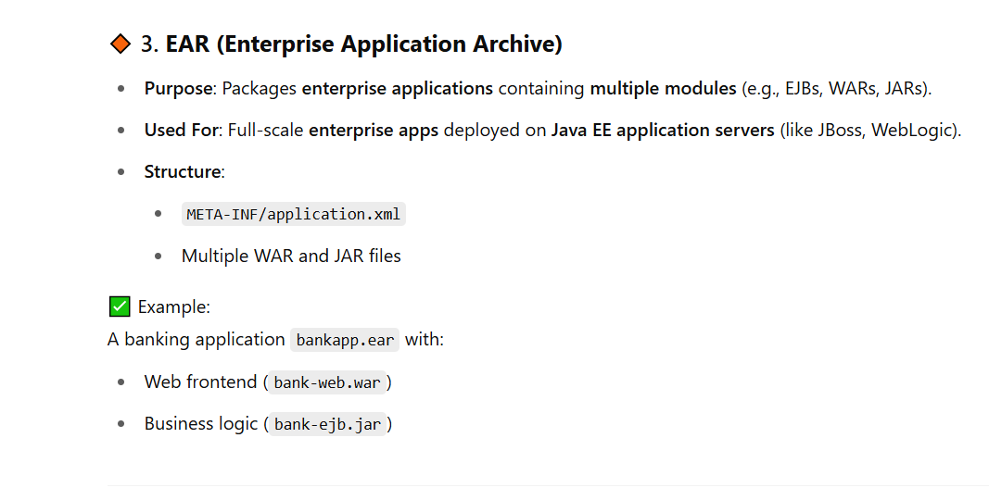

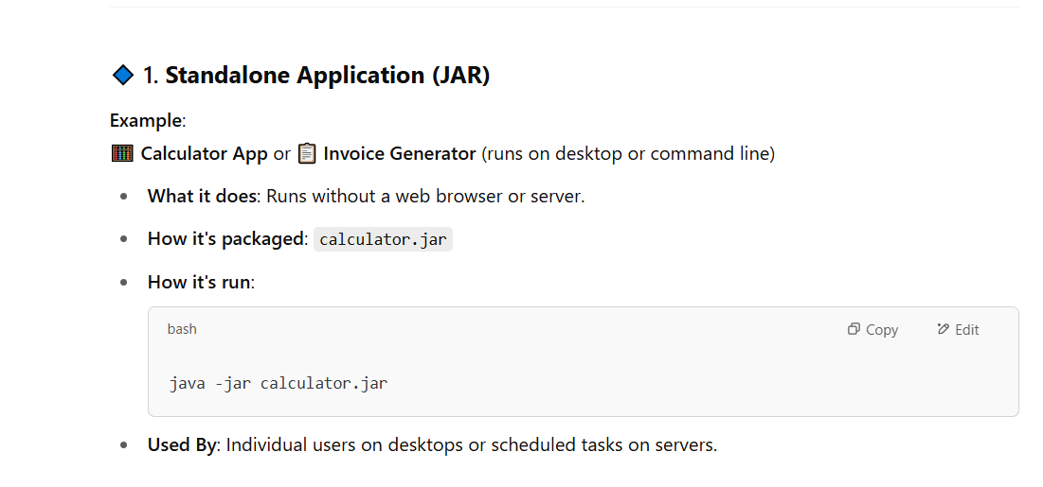

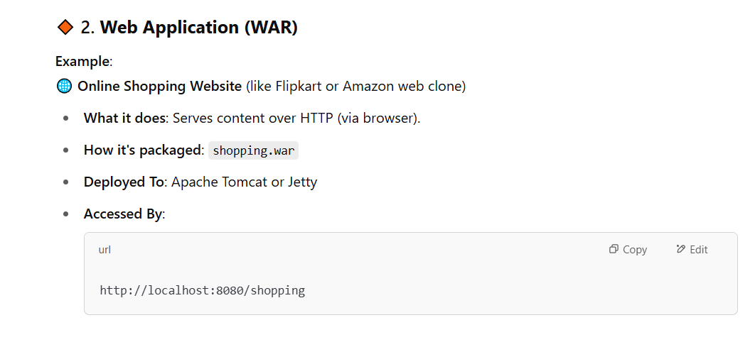

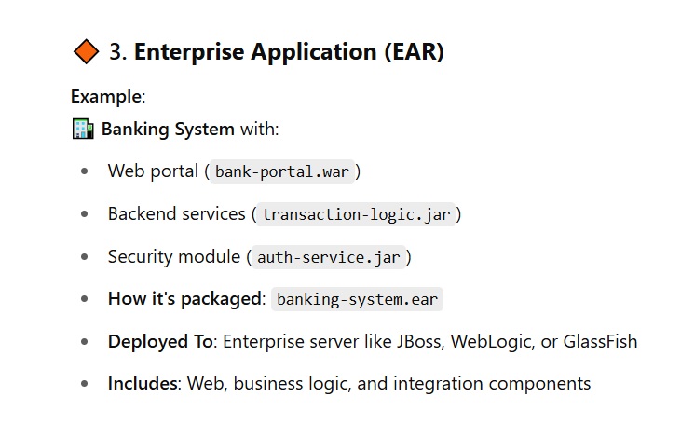

Lets download Maven Zip file and unzip it

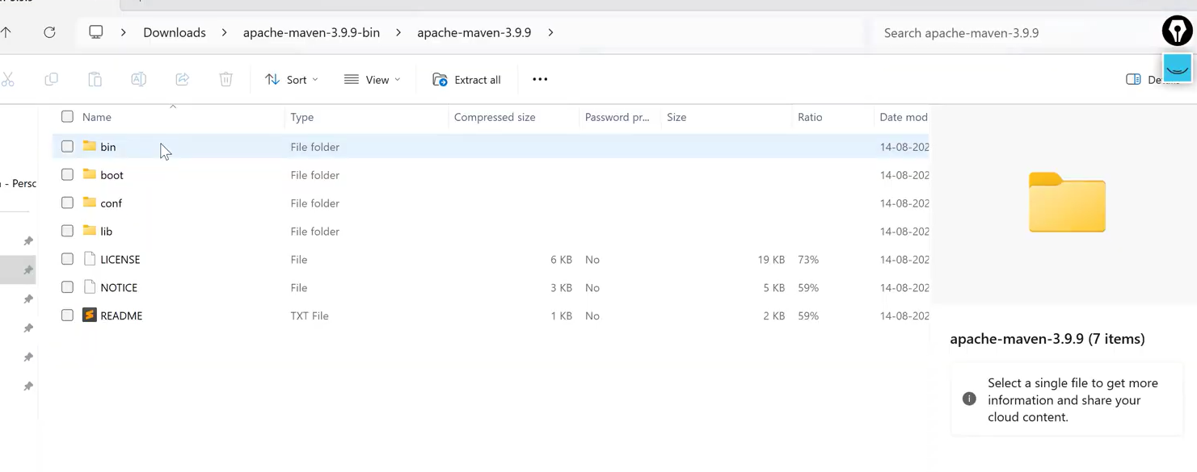

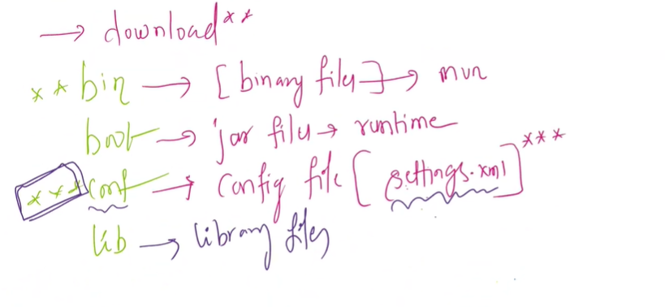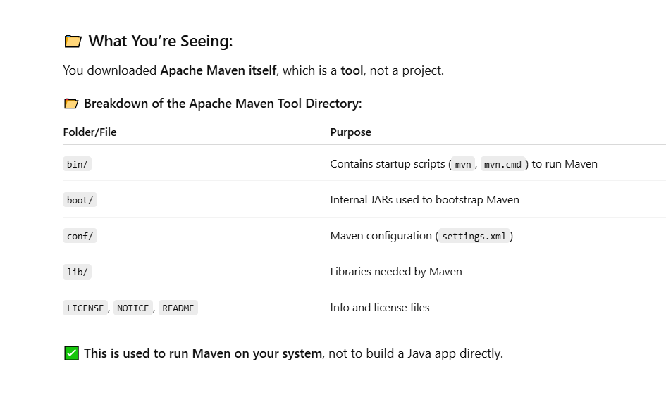

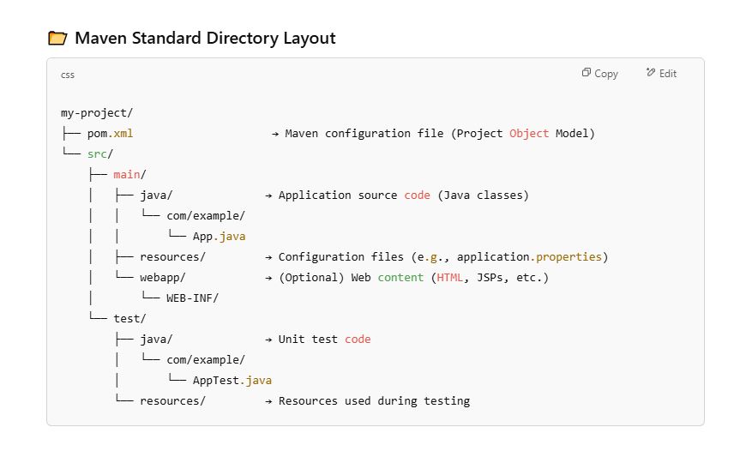

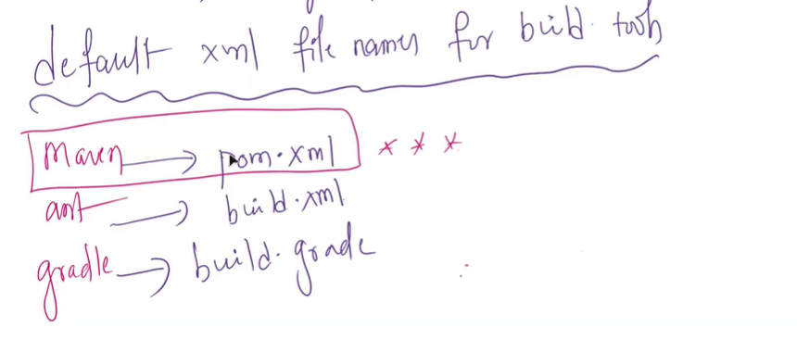

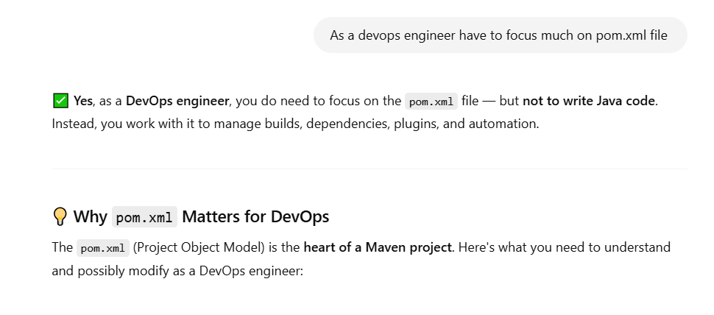

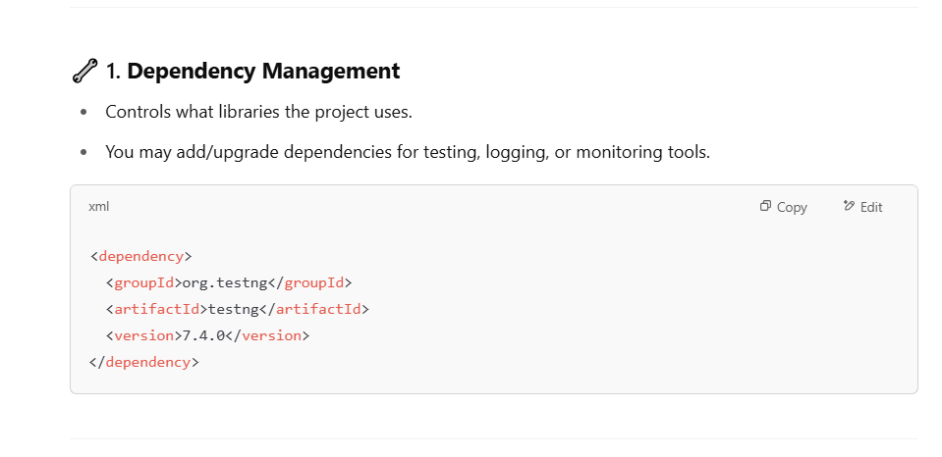

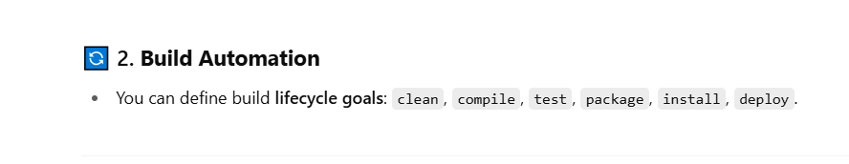

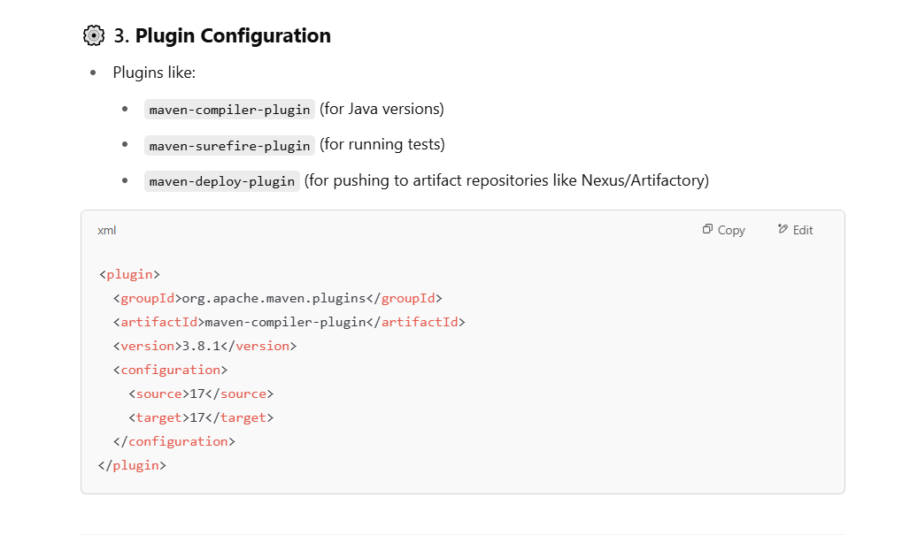

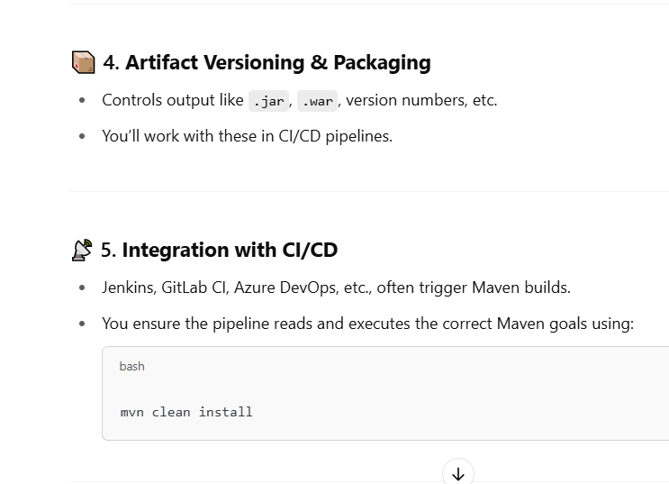

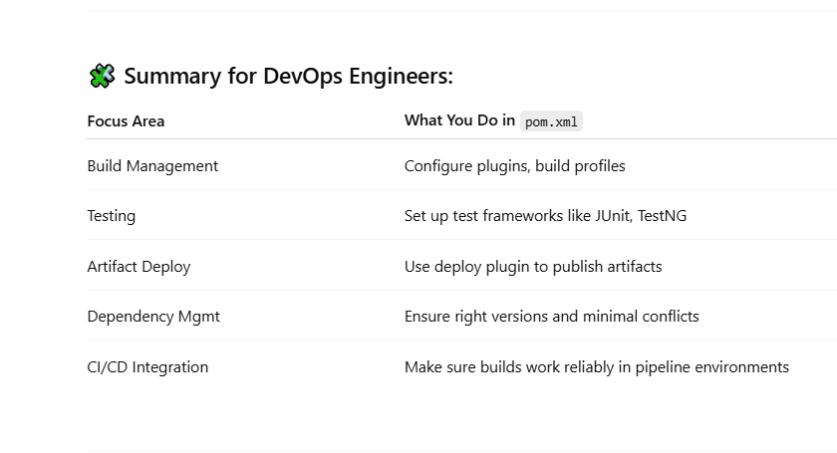

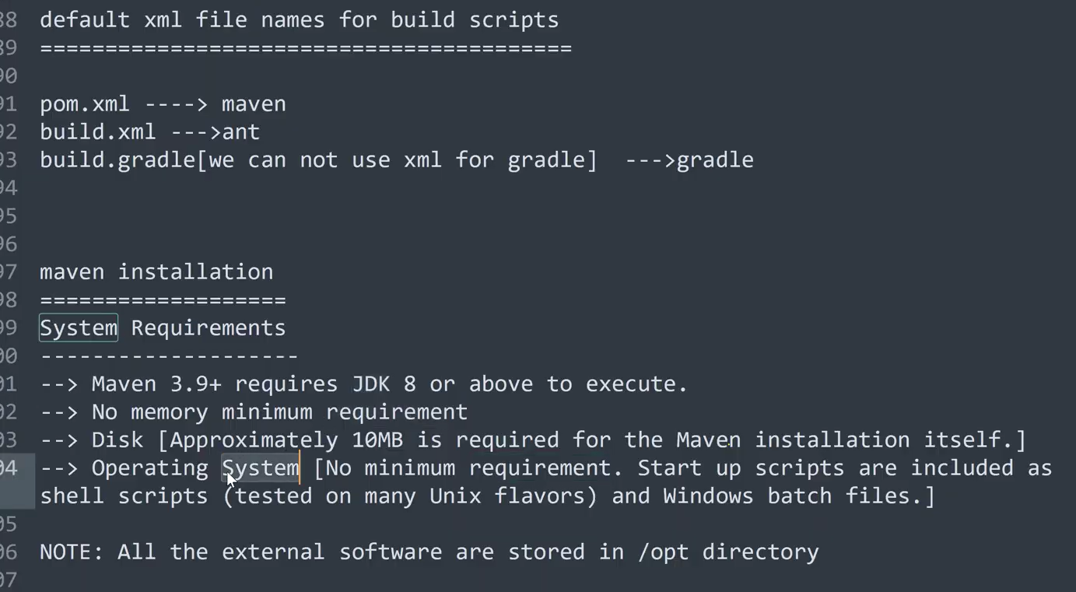

In Linux operating system All the external software is installed in OPT directory same with Maven

Maven(External Software) must be installed in OPT Directory

Download Maven (at 48:00:00)

To Install Maven software in our Laptop we must install Java software first in our computer

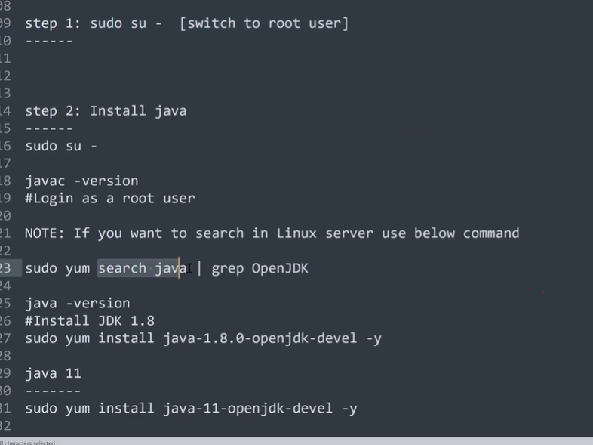

Open the gitbash and switch to root user and install java first using yum command

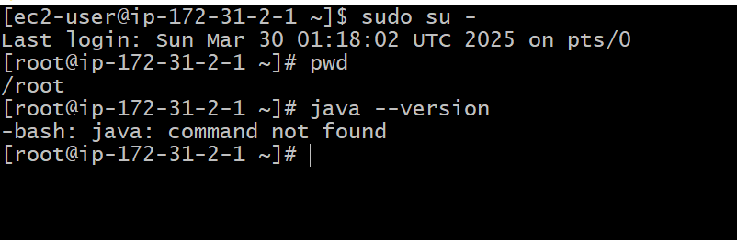

Search java software using yum repository command “yum search java “  
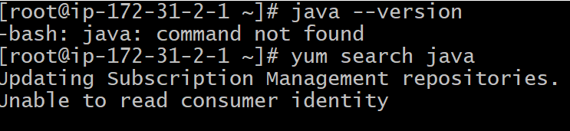

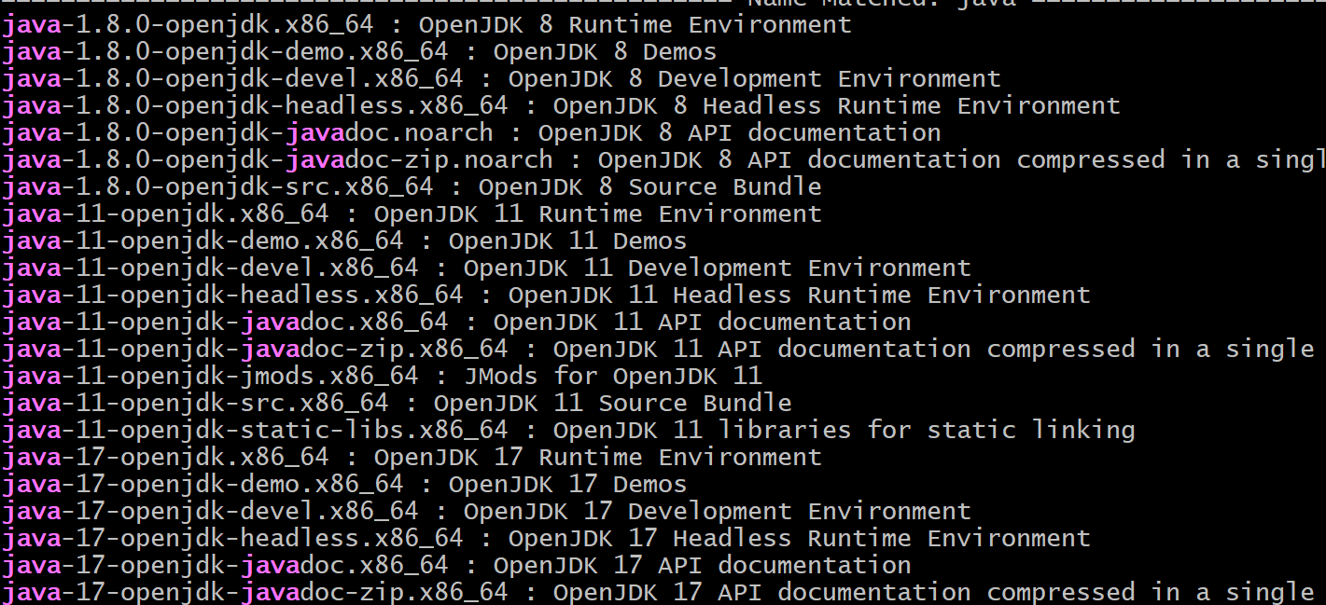

Out of All these java versions search and install the specific java version  


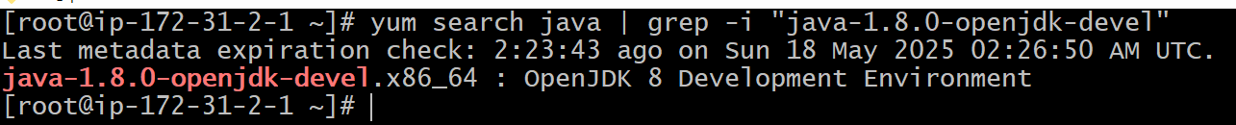

Now install the specific java version - use the below yum command to install the java

yum install java-1.8.0-openjdk-devel -y  
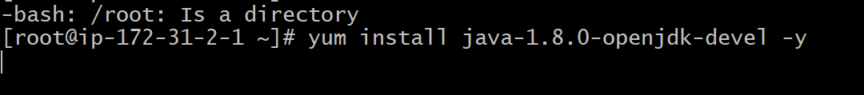

So far we have installed Java software in to my Linux server  
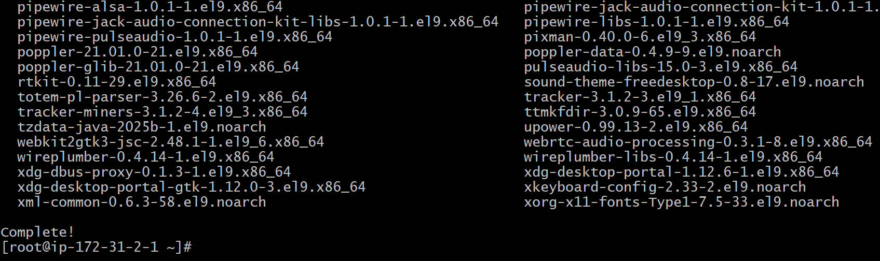

Check the Java version Now



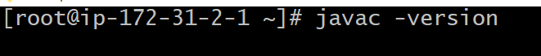

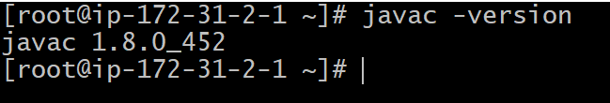

Now Install the Maven Software   
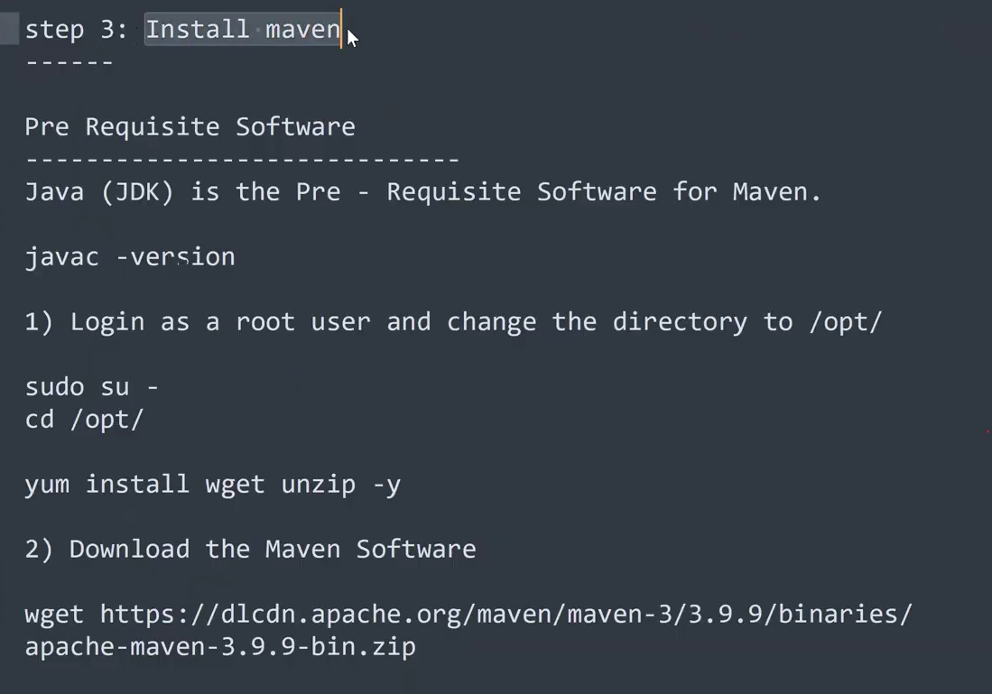

Already we are in Root user (sudo su -)



Now switch to opt directory to install the external software Maven

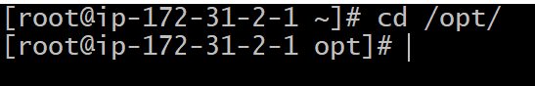

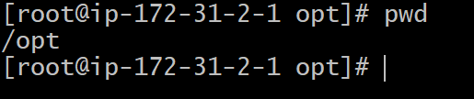

To download any external software from internet or from web we use the wget command  


wget <https://dlcdn.apache.org/maven/maven-3/3.9.9/binaries/apache-maven-3.9.9-bin.zip>  
As shown in the below we don’t have wget software installed in our Linux system so we are unable to download the maven . so first install the wget ,zip,unzip



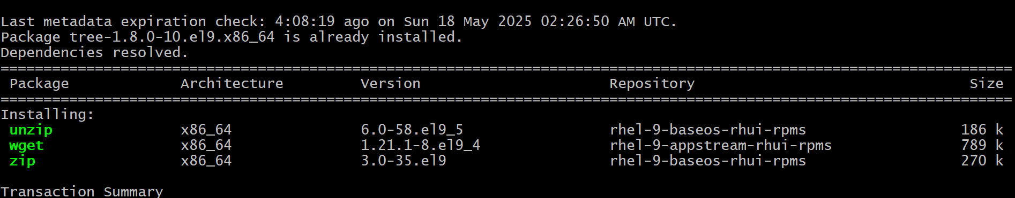

Now download Maven in to opt directory  


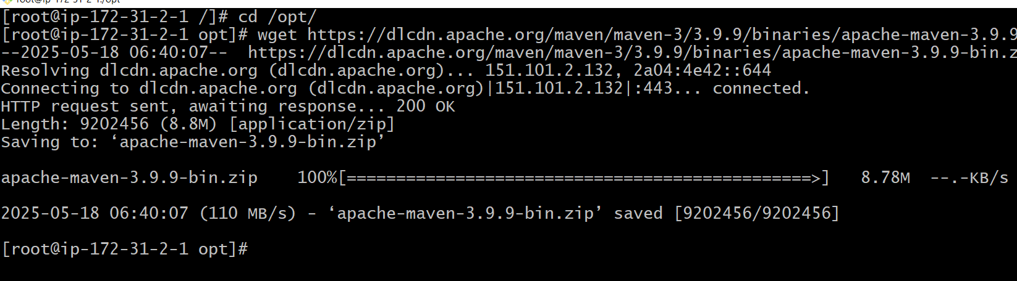

Maven is downloaded

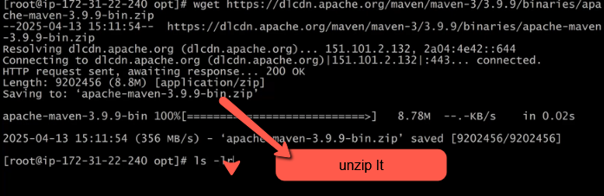

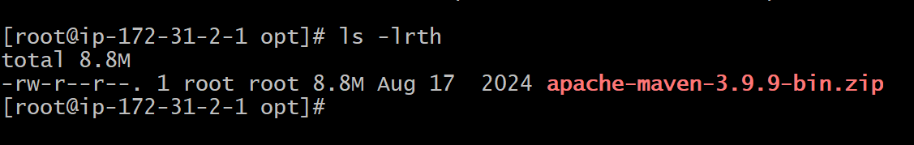

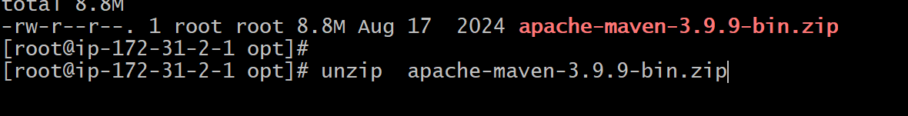

Press Enter Apache Maven will be unzipped and execute the command ls –lrth

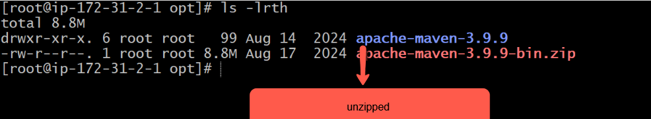

Open the apache-maven-3.9.9 directory and check the folder present in it

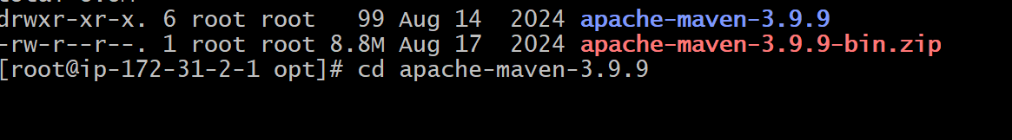

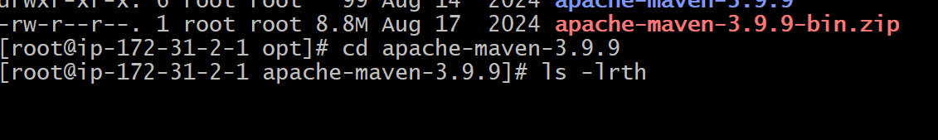

The below is the Maven directory structutre

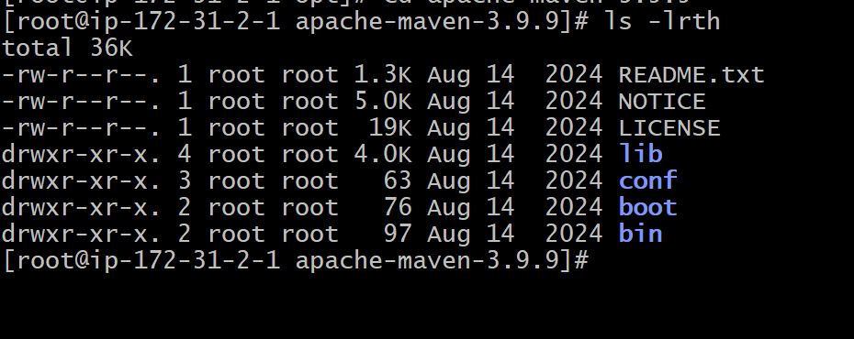

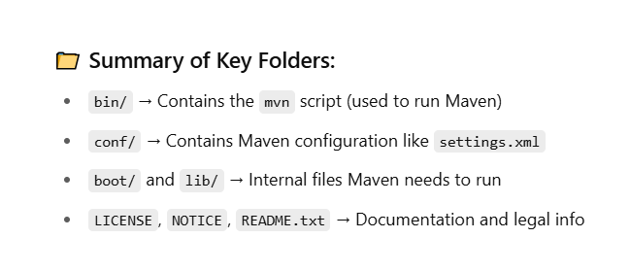

Unable to execute mvn command means mvn command is not found  
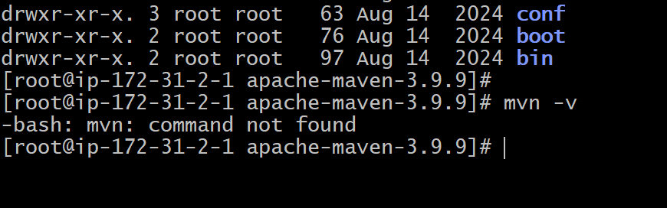

So we have to set Environmental variables before executing the mvn commands

Lets go back to maven directory by executing the command cd..

Open the file ~/.bash_profile and add the statements

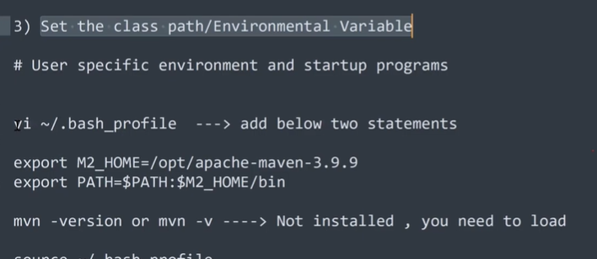

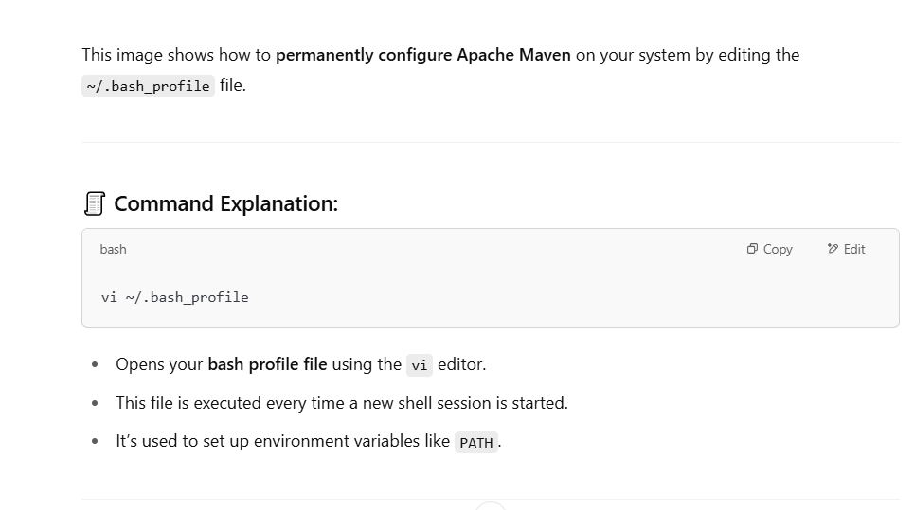

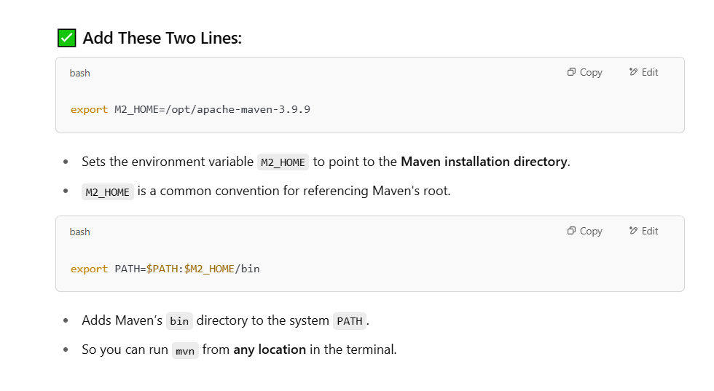

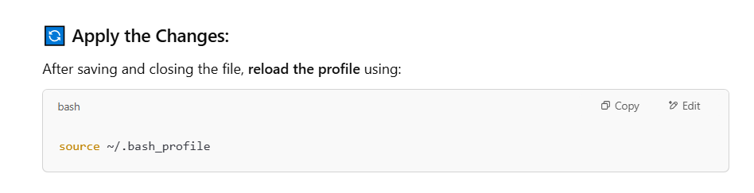

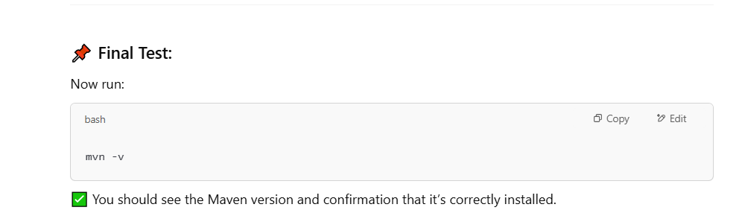

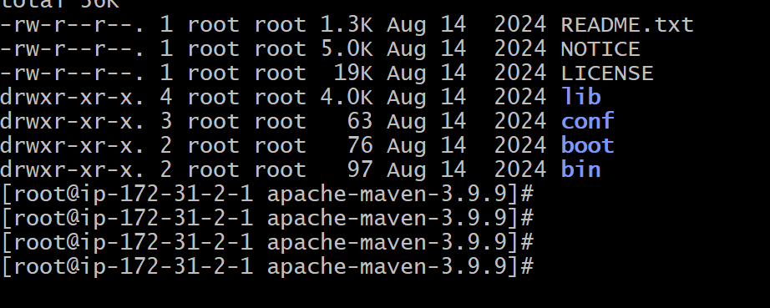

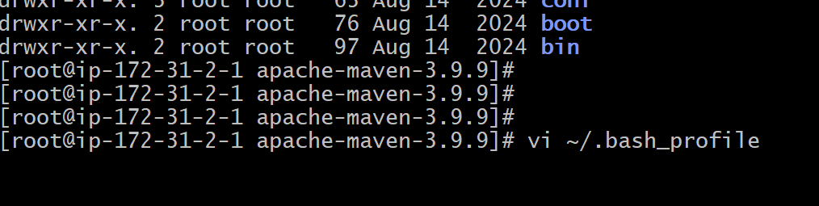

After opening the file .bash_profile  
