In Maven Java project we have a file called pom.xml file written by developer

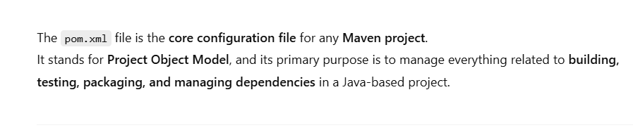

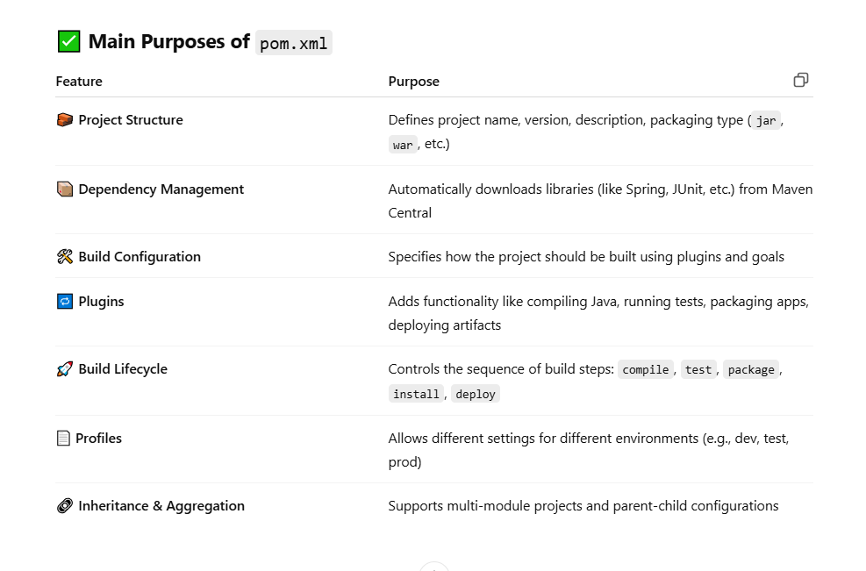

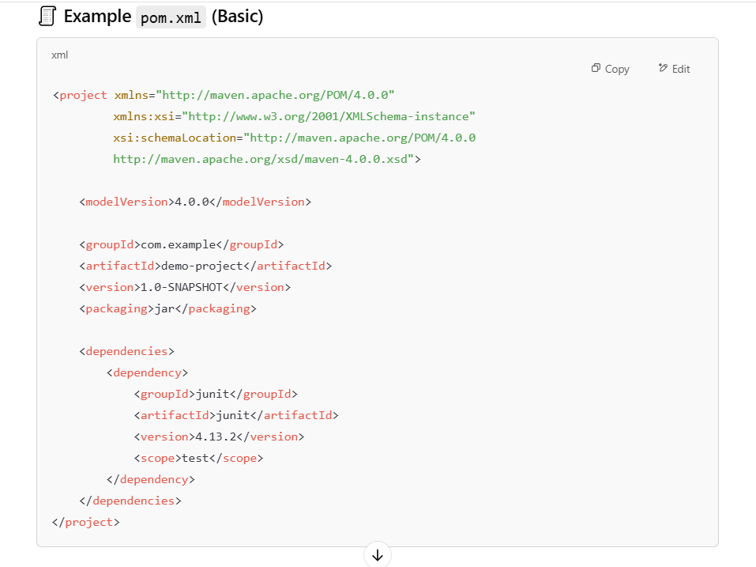

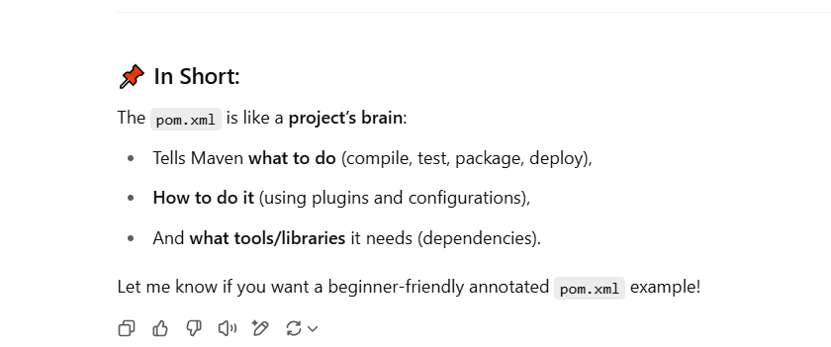

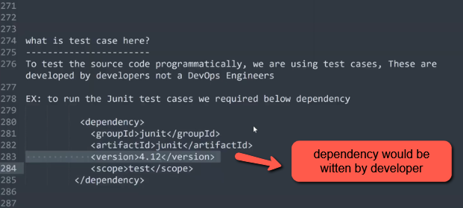

Below is the Interview Question asked in many interview the question is realted with dependencies  
  
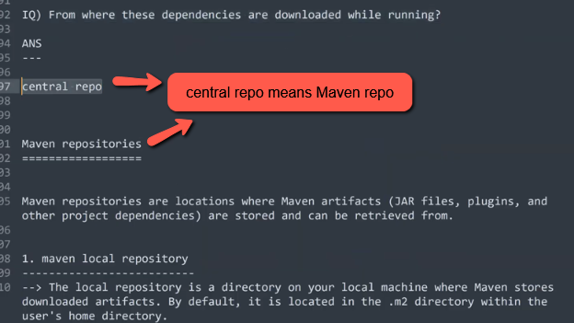

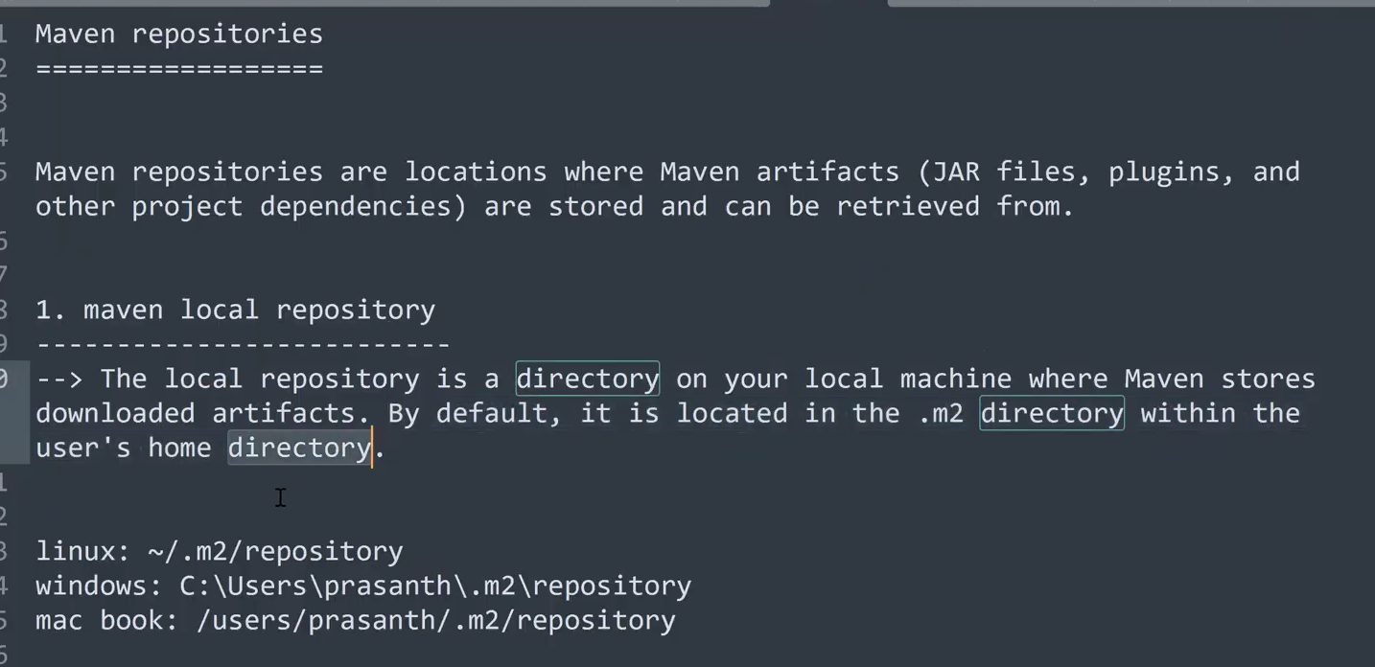

In maven we have three types of Repositories Maven Local repository , Central Repository , Remote repository.

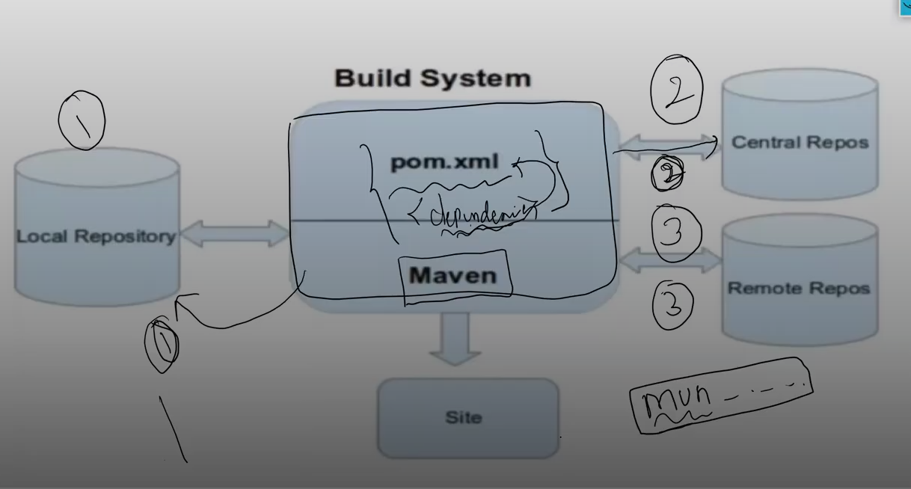

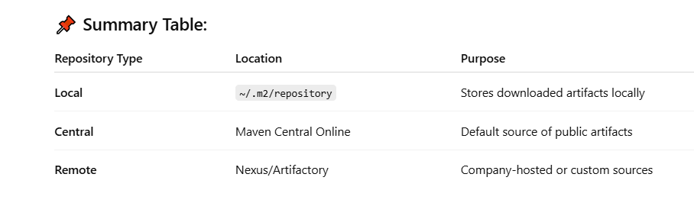

In maven all the dependencies will be stored in a hidden directory .m2/repository

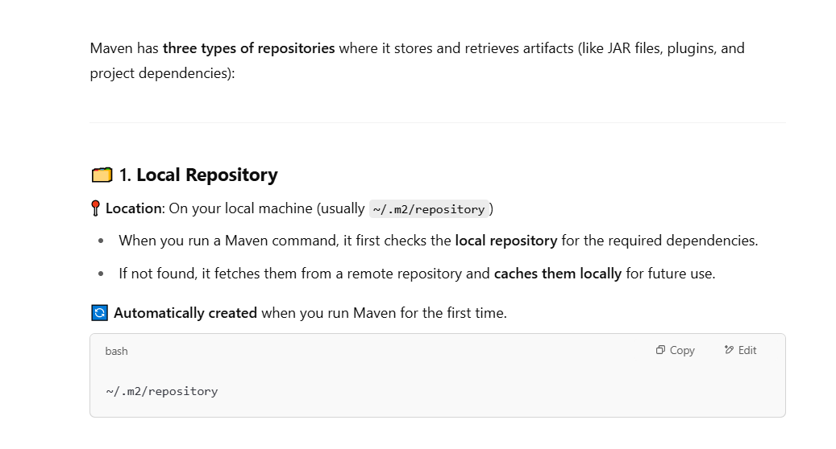

Whenever a Maven command is executed, it checks the pom.xml file for any dependencies.  
It first looks for those dependencies in the **local repository(.m2/repository)**.  
If they are **not found**, Maven will fetch them from the **Central Repository** (or any other configured remote repository) and **store them in the local cache** for future builds.

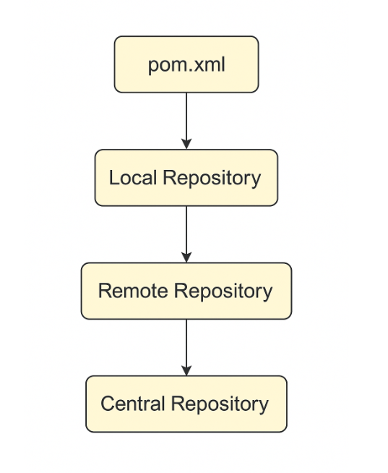

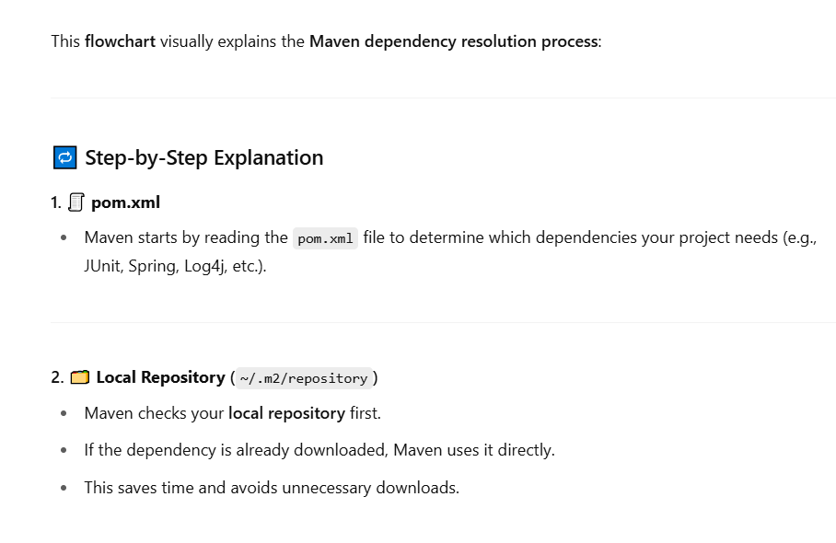

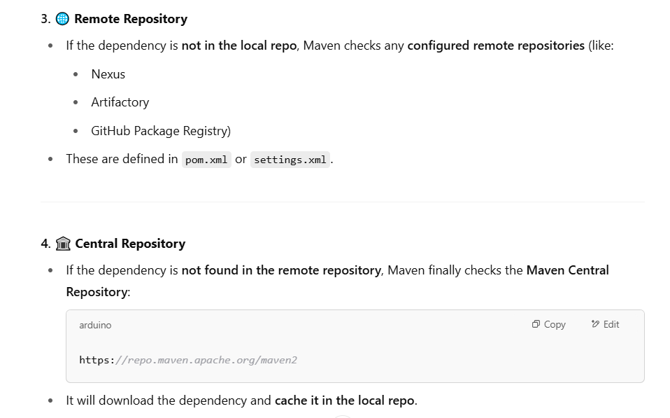

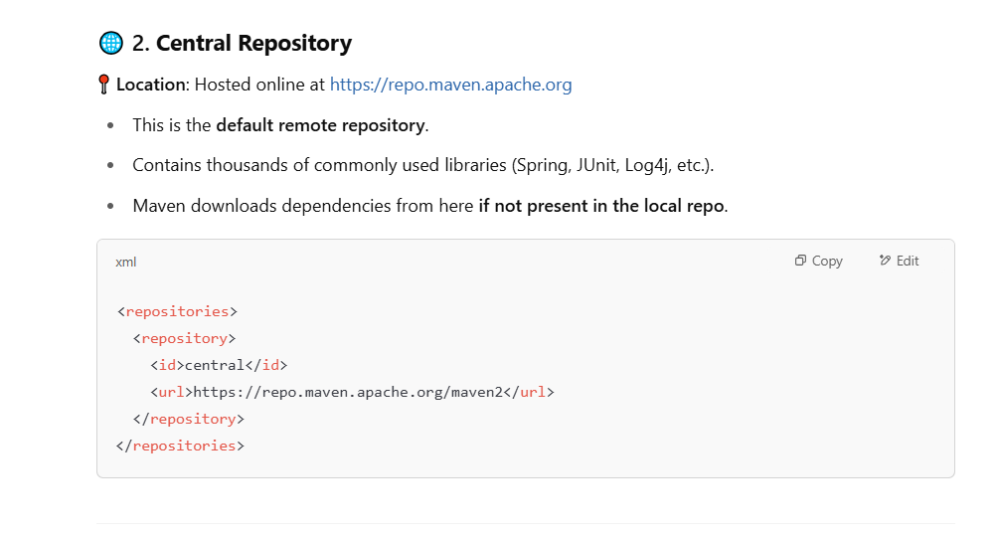

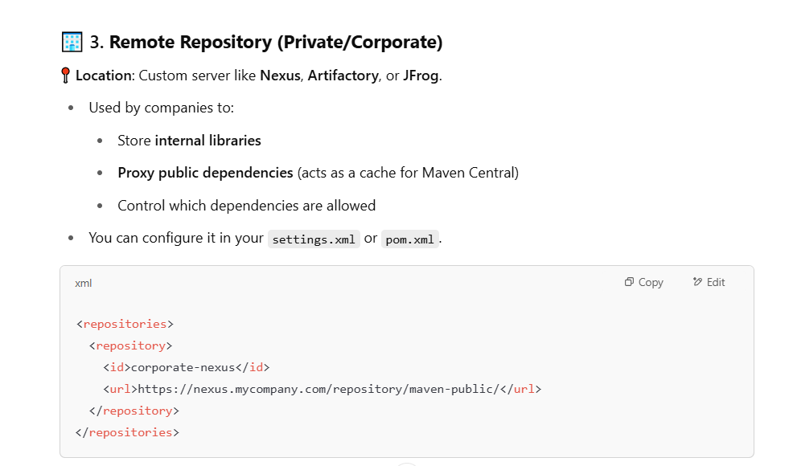



Let’s try to switch to ~/ .m2/repository in our Linux server

Very Important Interview Question

Maven Life Cycle

Explain about Maven Life Cycle

Maven life cycles

=================

