In Todays class we will discuss about Jenkins server Trigger
The class starts from (18:44)
Jenkins Triggers are events or conditions that automatically start a Jenkins job or pipeline without manual intervention.
They help automate the build, test, and deployment process whenever specific actions occur — such as code commits, time schedules, or external notifications.
Triggers tell Jenkins when to start a build.
There are Three Types of Jenkins Triggers
1) Poll SCM
2) Build Periodically
3) GitHub Webhook
Poll SCM
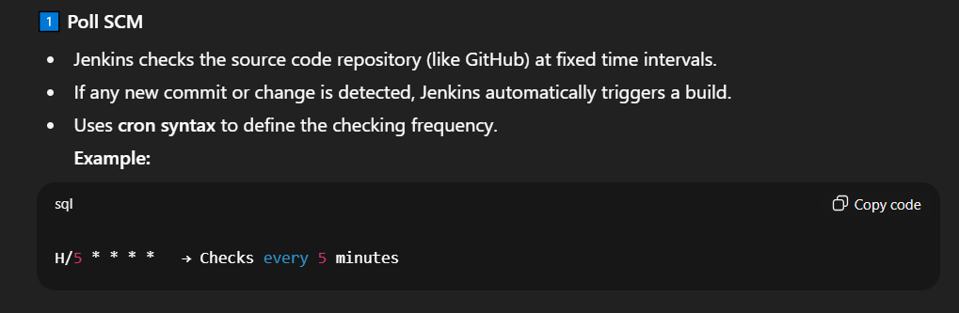
Build Periodically
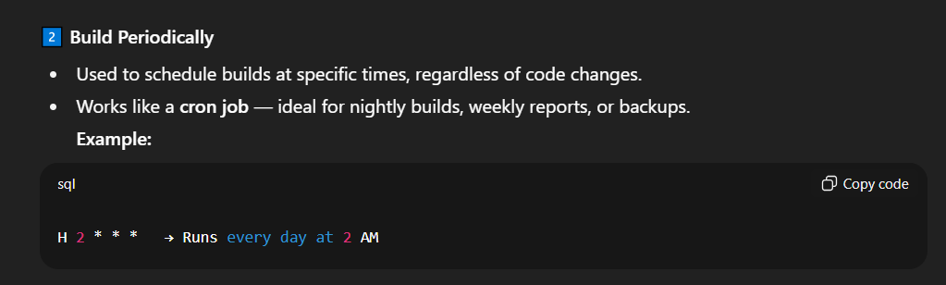
GITHUB Webhook
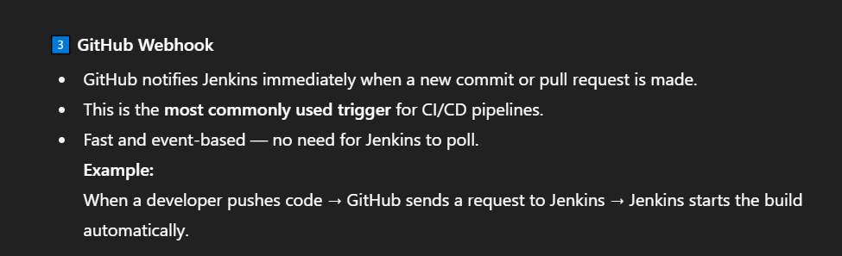
Let’s start with The Poll SCM
