Key points of this notes (Pom.xml , mvn package,target directory , mvn install , ~/.m2 directory )
Before installing Maven make sure Java is preinstalled in the ec2 istance
below you can see the directory structure of Maven build Toll/server and Java Maven project
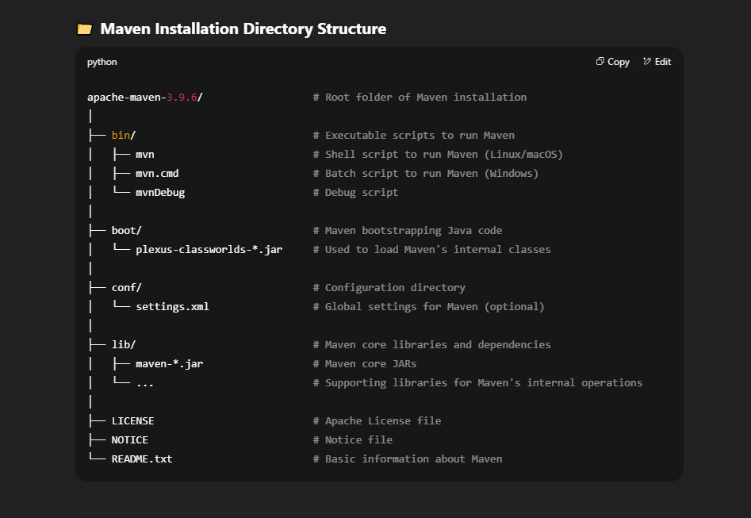
below is the Java maven project directory structure
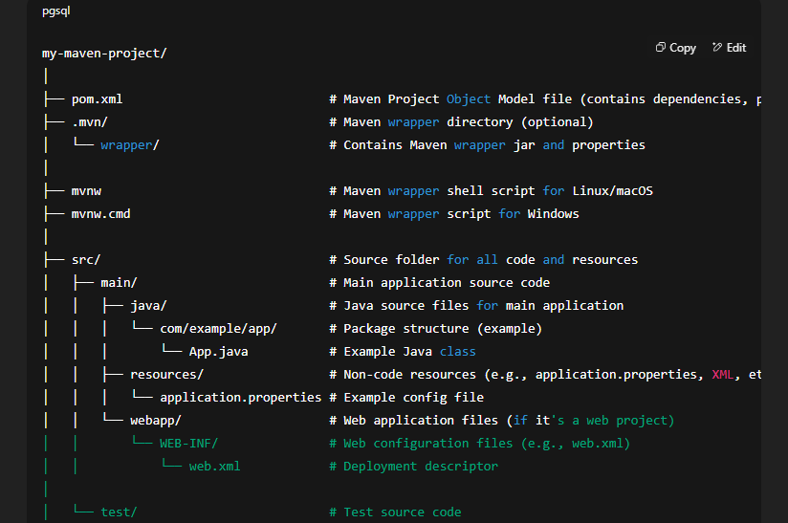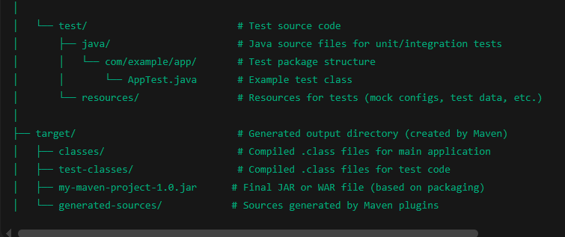
In Maven Java project we have a file called pom.xml file written by developer
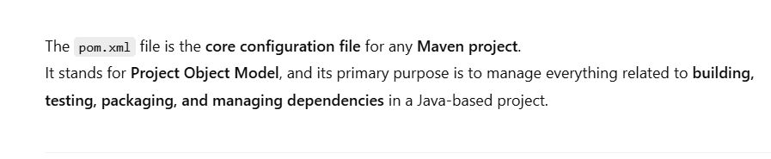
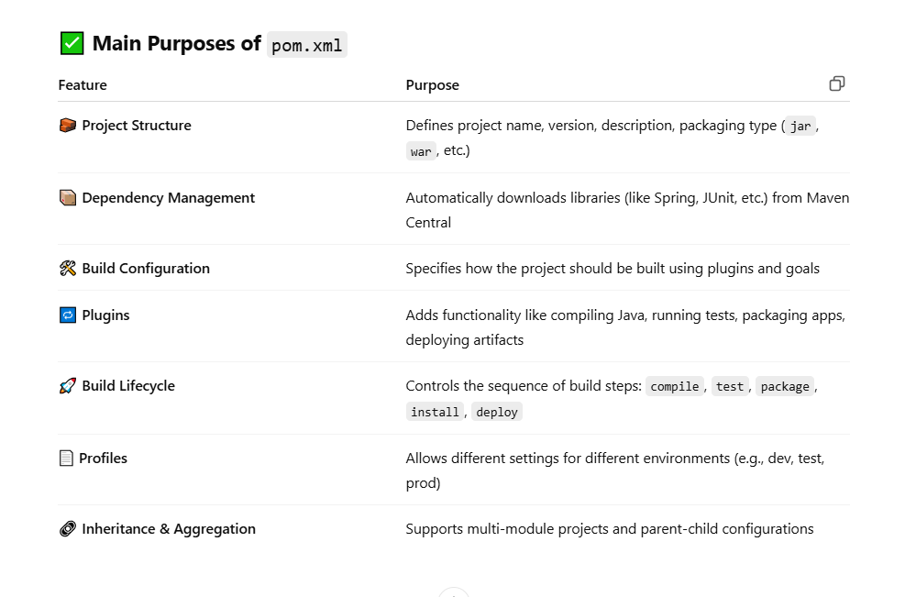
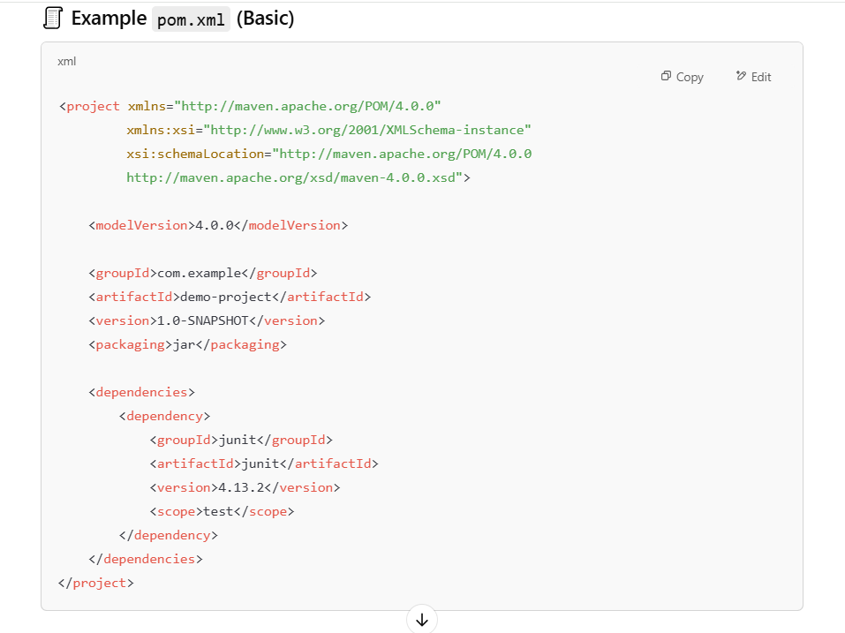
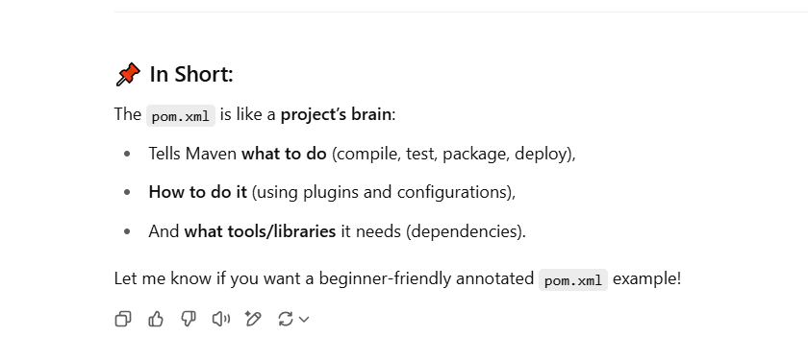

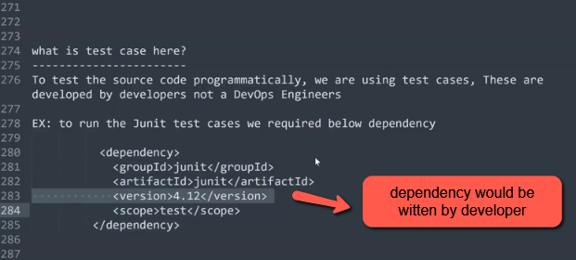
Below is the Interview Question asked in many interview the question is realted with dependencies
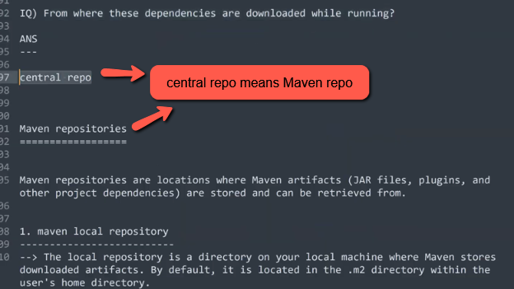
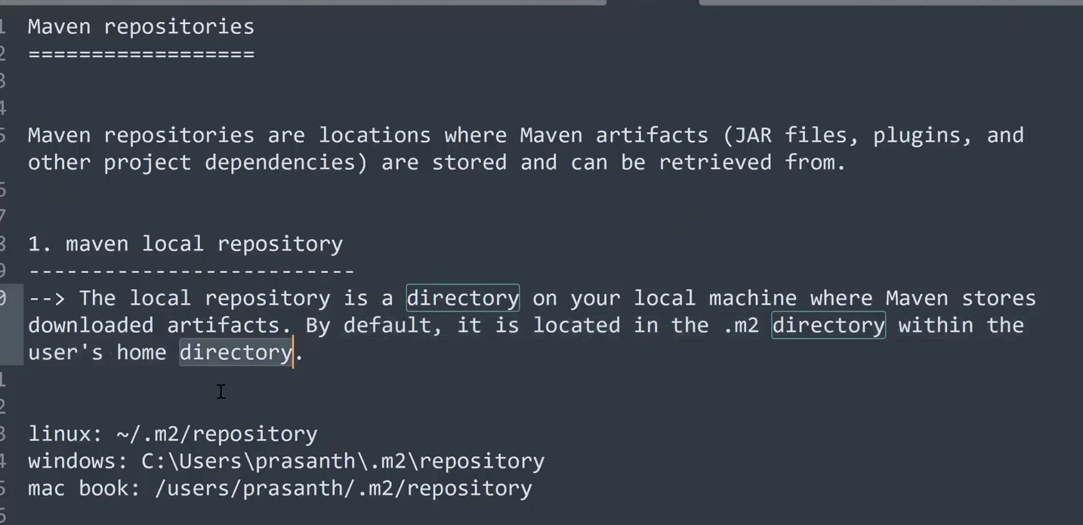
In maven we have three types of Repositories Maven Local repository , Central Repository , Remote repository.
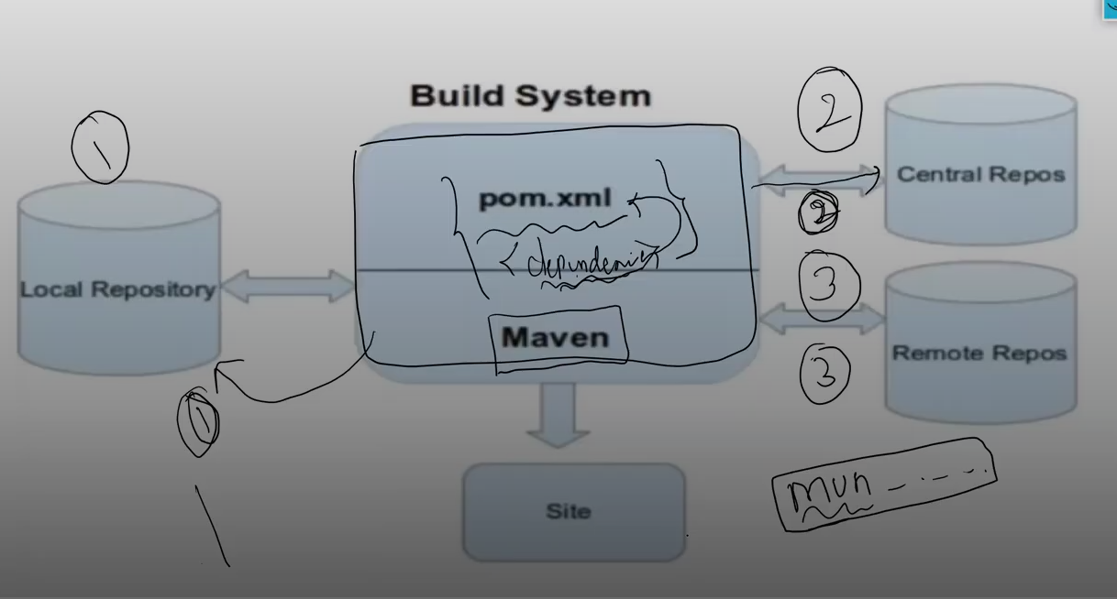
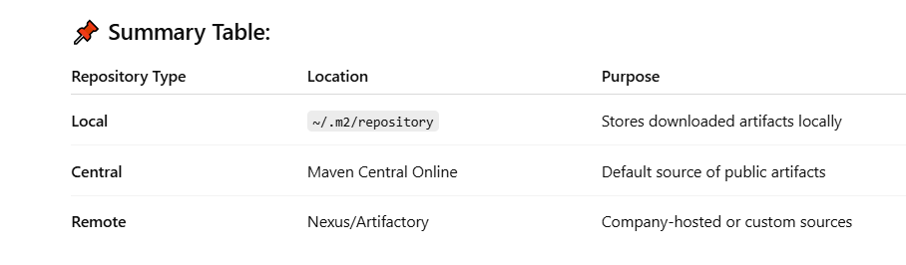

In maven all the dependencies will be stored in a hidden directory .m2/repository
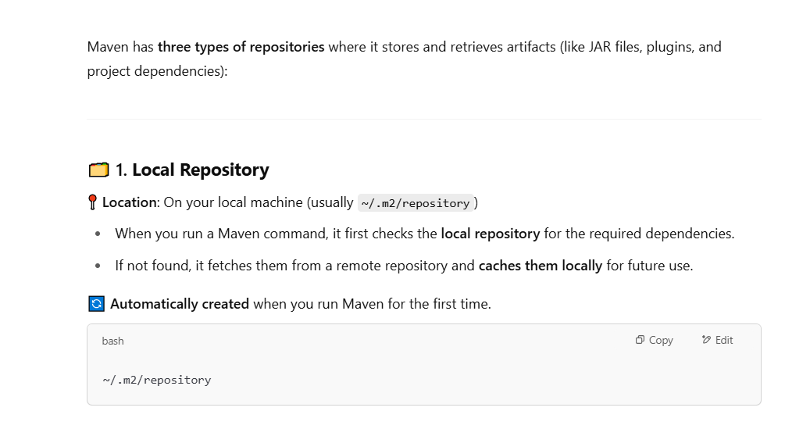
Whenever a Maven command(mvn clean or mvn install) is executed, it checks the pom.xml file for any dependencies.
It first looks for those dependencies in the local repository(.m2/repository).
If they are not found, Maven will fetch them from the Central Repository (or any other configured remote repository) and store them in the local cache for future builds.
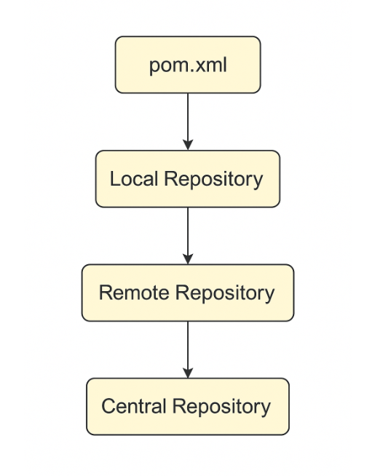
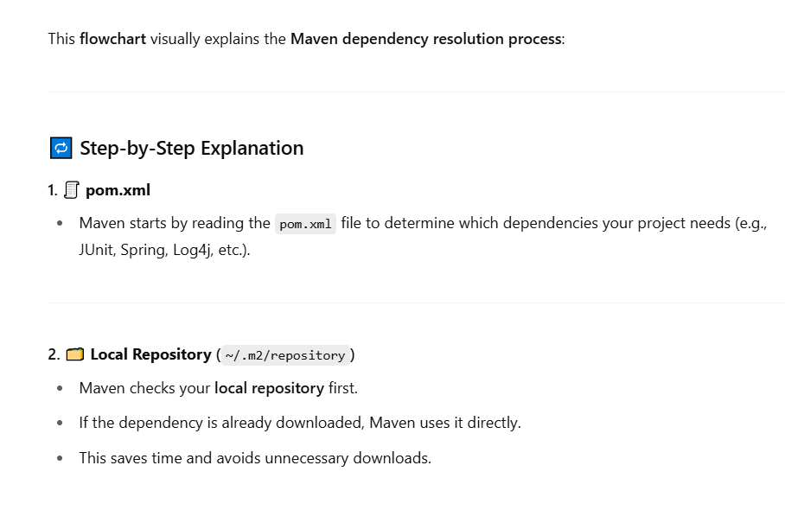
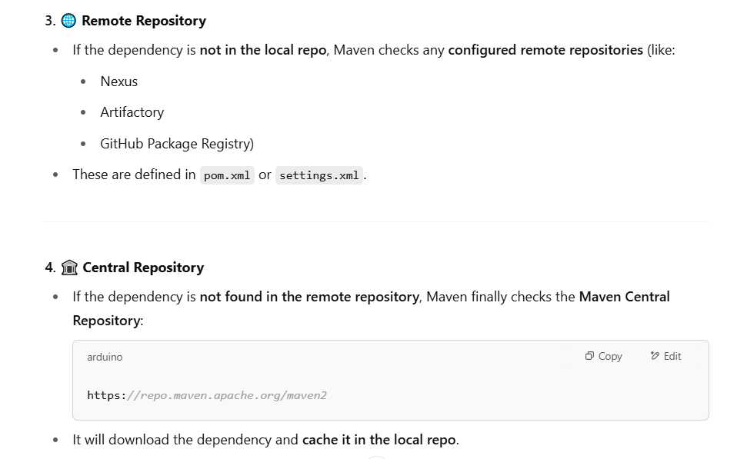
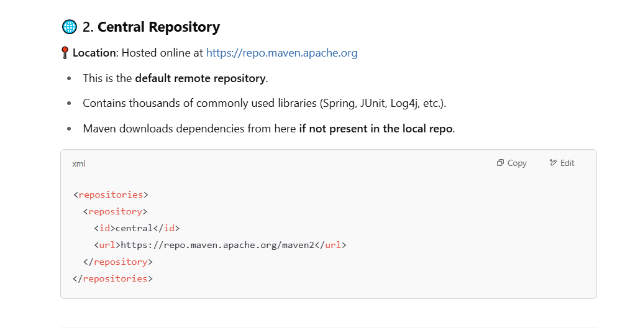
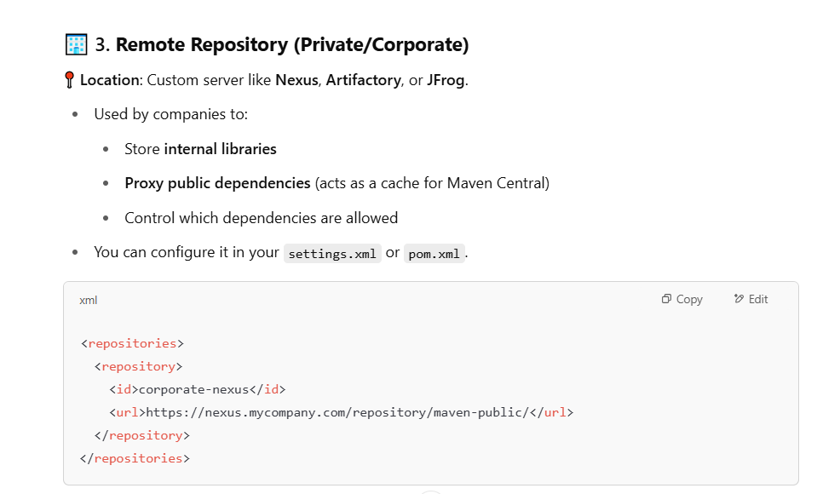

Let’s try to switch to ~/ .m2/repository in our Linux server
Very Important Interview Question
Maven Life Cycle
Explain about Maven Life Cycle
Maven life cycles
=================
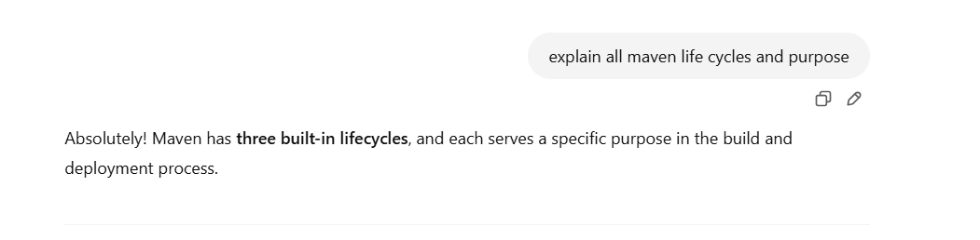
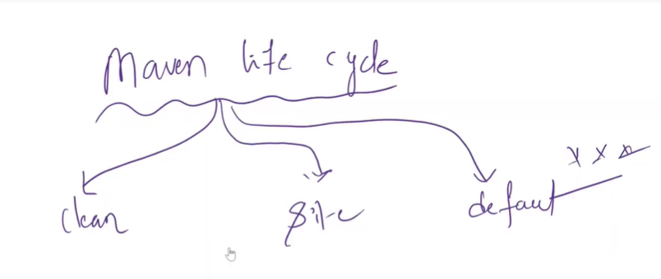

In the below life cycles phase = goals
For example Default LifeCycle has Validate ,compile , Test ,Package,Install,deploy goals
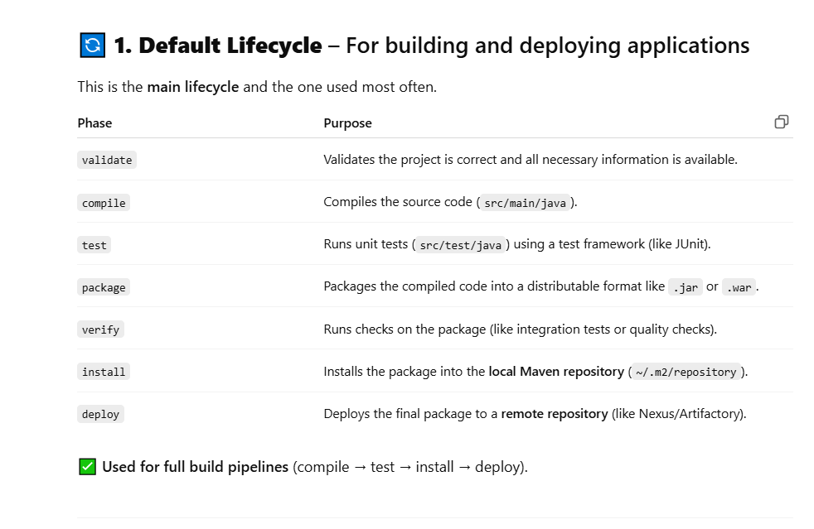
Default life cycle is Very important life cycle for Devops engineer
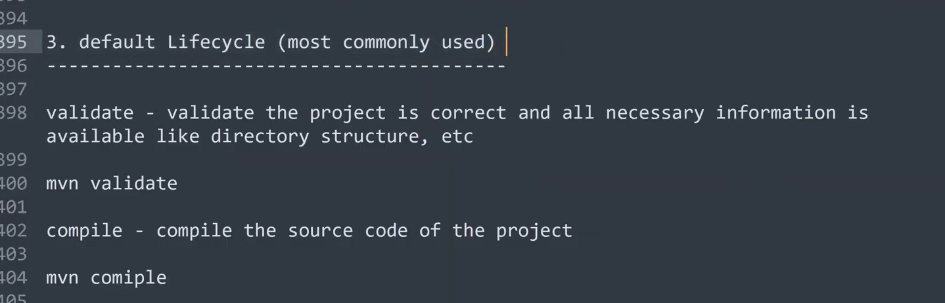
All the goals of the Default Lifecycle will be achieved by executing the the following commands
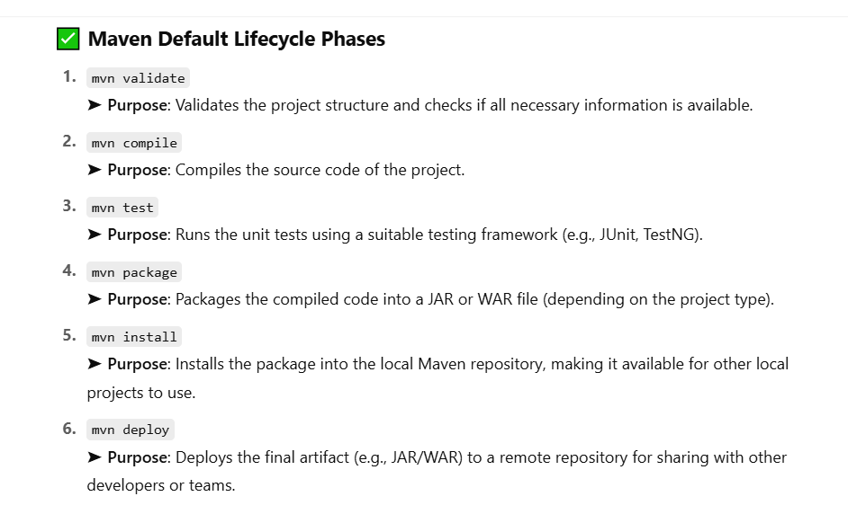
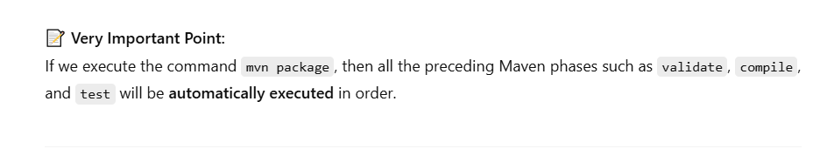
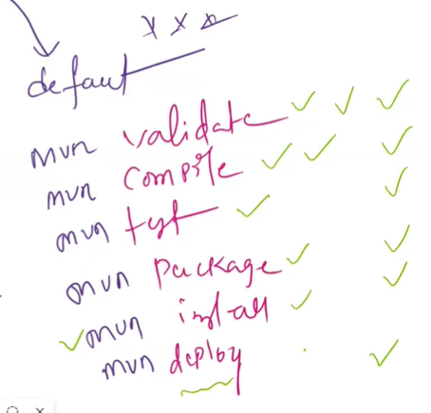
When we execute the command mavenpackage it will create JAR,(or) WAR, (or) EAR in the target directory
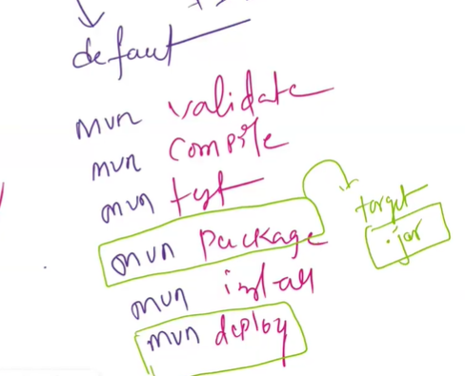

If you execute the command mvn install after executing mvn package command then that jar file(artifact) will get copied or stored in .m2 repository from Target directory
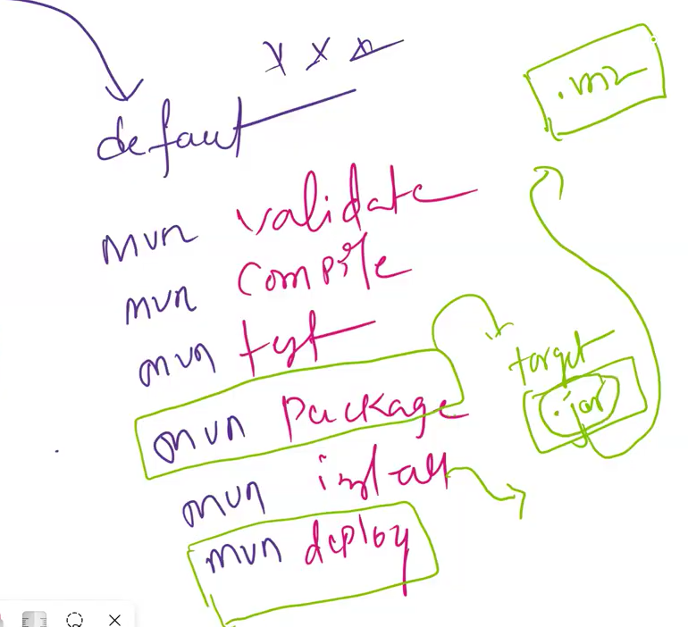
Interview question 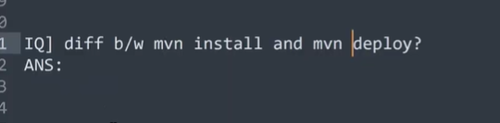
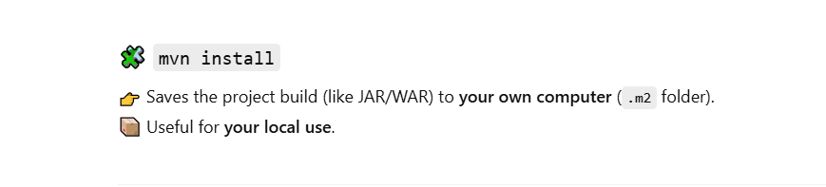
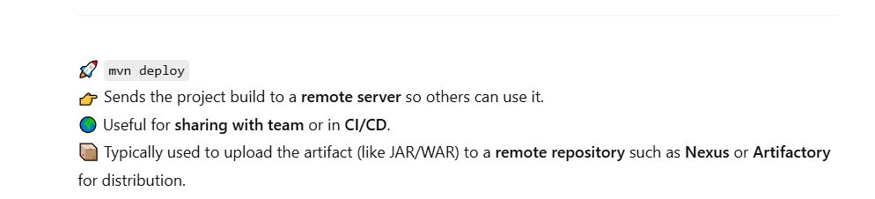

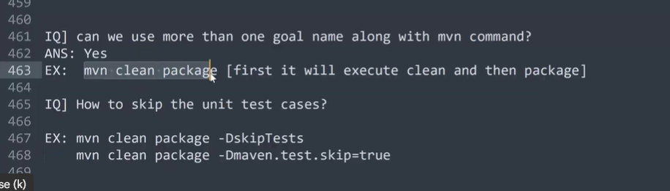

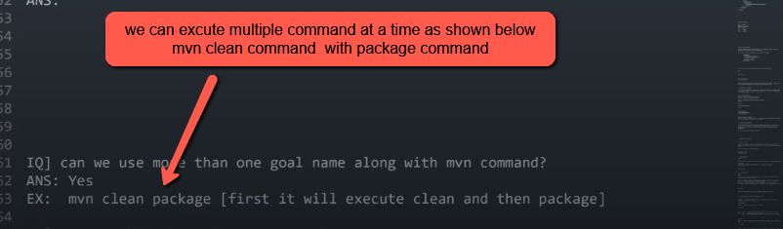

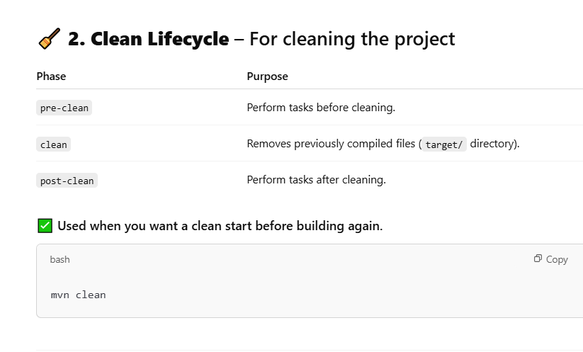

The below Site Lifecycle is already outdated & not using nowadays
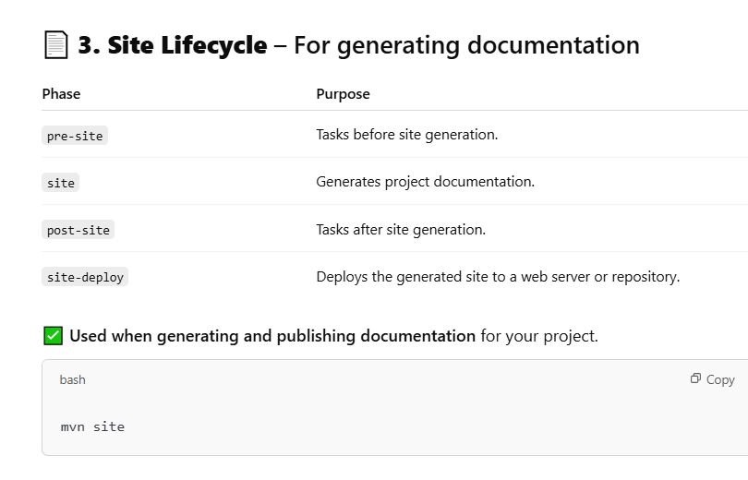
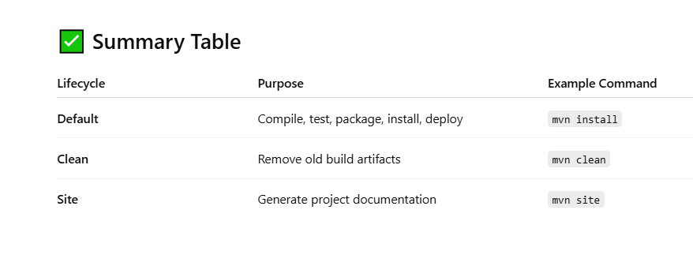
Lets fetch a standalone application from github repository and execute the maven commands on it
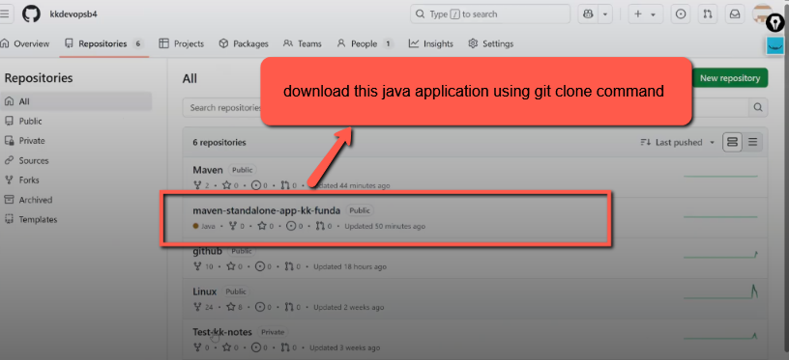

Open the maven-standalone-app-kk-funda repo open src folder
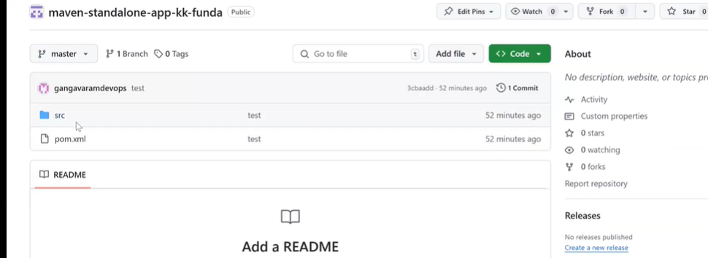

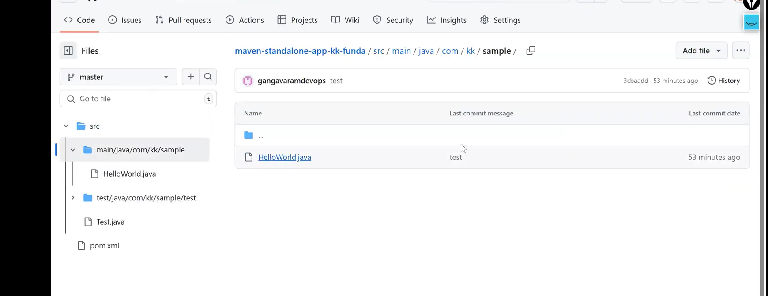

We should not bother about the source code present in the HelloWorld.java file our duty is to create Artifact for this source code HelloWorld.java file
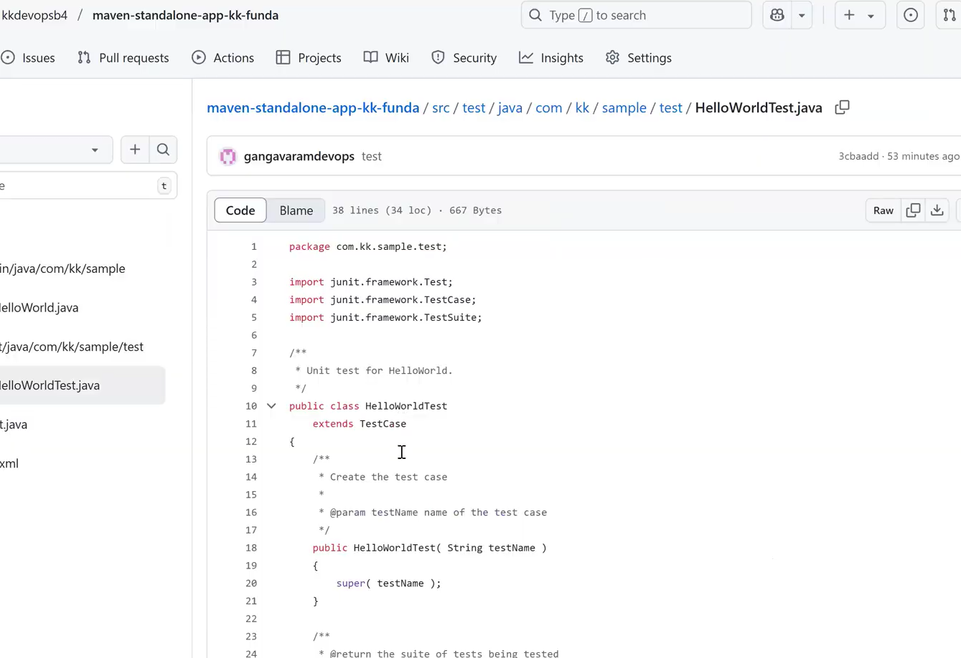

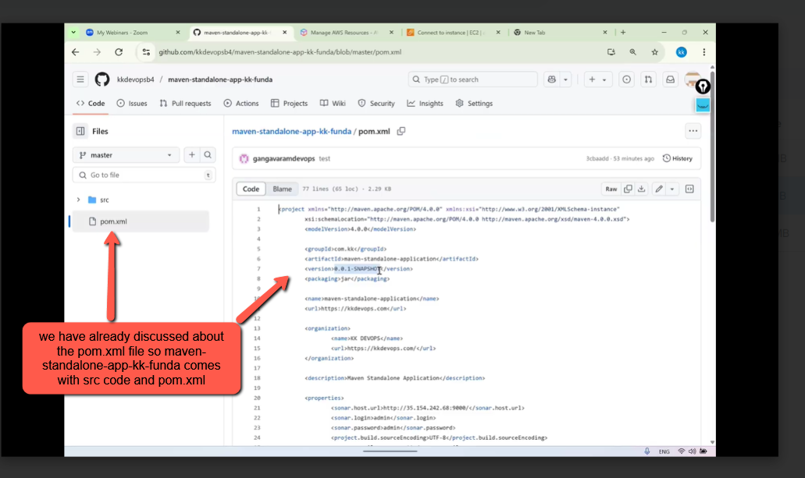

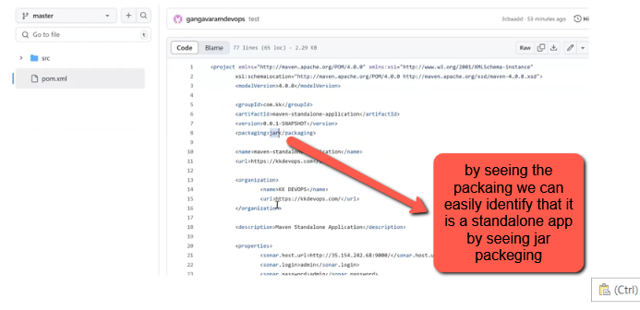

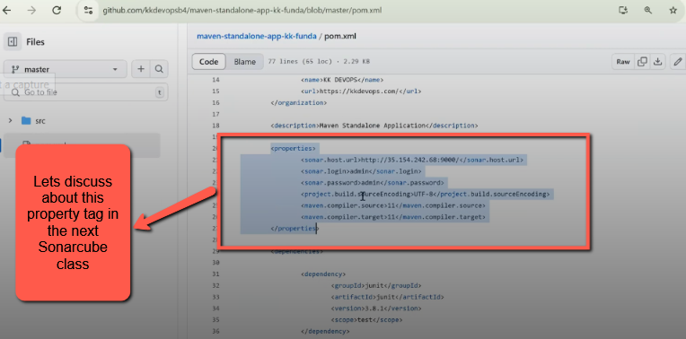

We have pom.xml file and src code file in the github repo so lets download that repo in to our linux server using git clone but before using git command we have to install git and some other softwares in our Ec2 server.

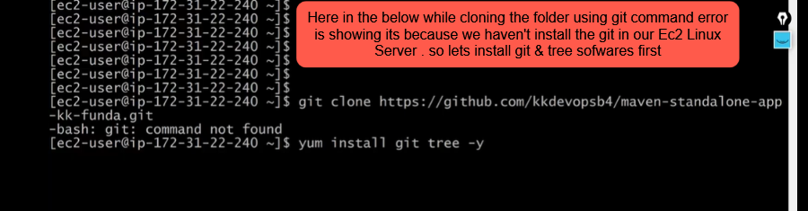

Use sudo yum install git tree –y command

Now let’s switch to Ec2-user and install some external softwares like (git , tree)

Next copy the Https and clone the git repo in to our Linux Ec2 server
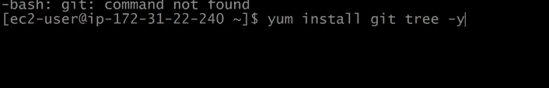

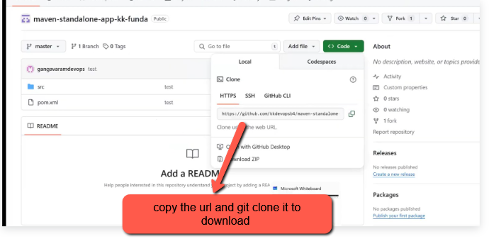

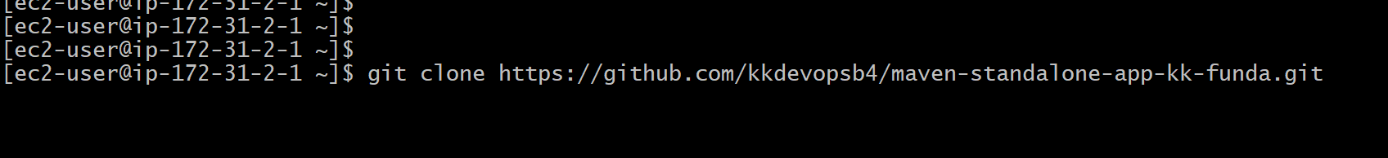

As you can see in the below image we have successfully downloaded
maven-standalone-app-kk-funda folder in to our Ec2 Instance
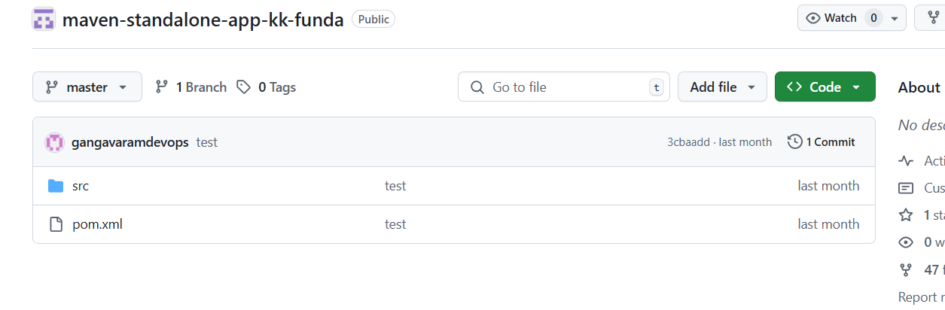
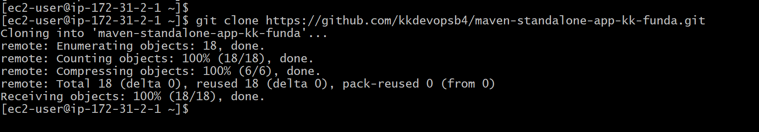

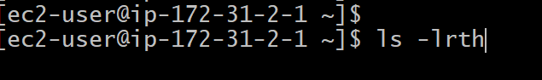
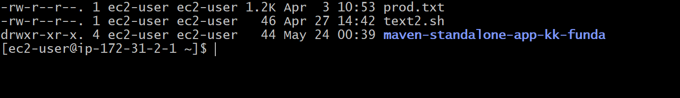

Change directory to maven-standalone-app-kk-funda
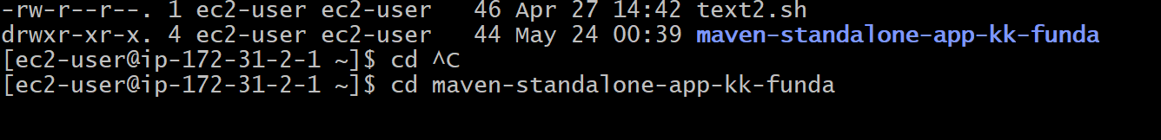

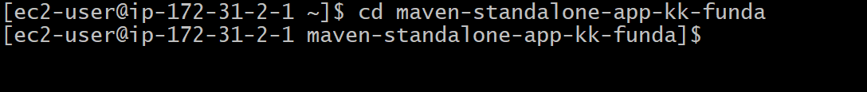
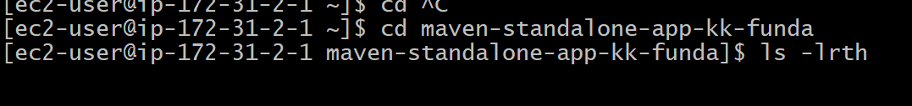

To check the sub folder in src folder we are using tree command as shown in the below image
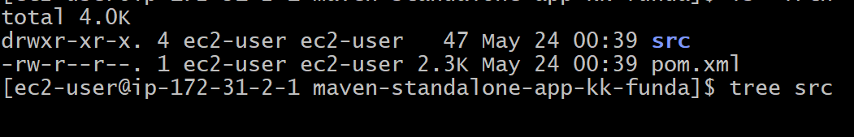
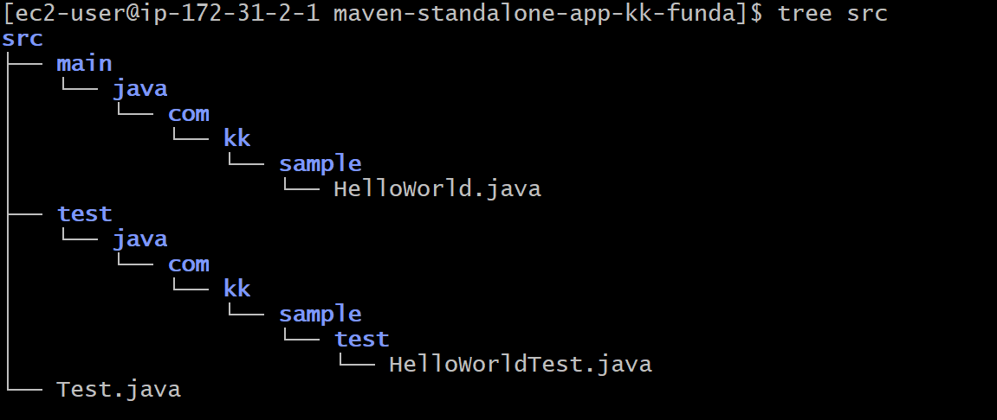

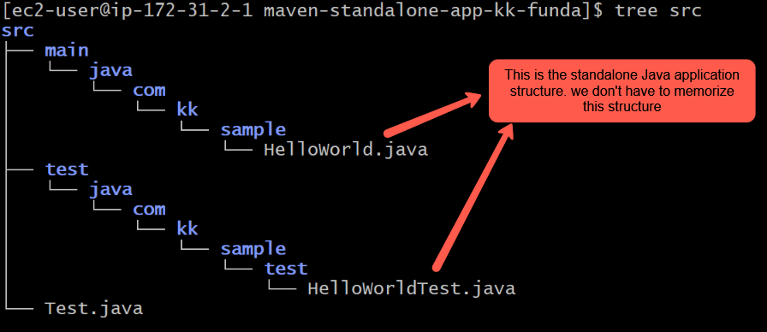
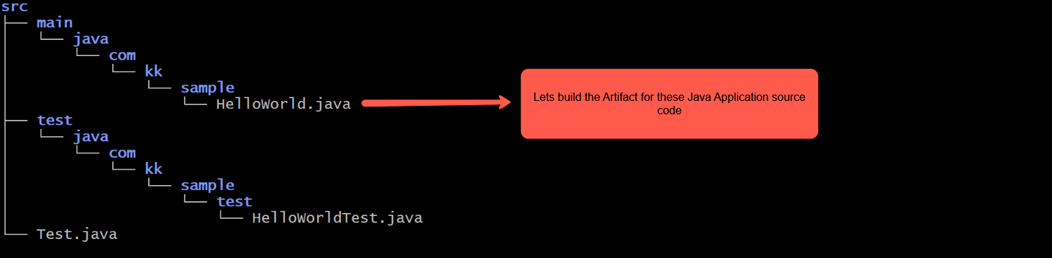

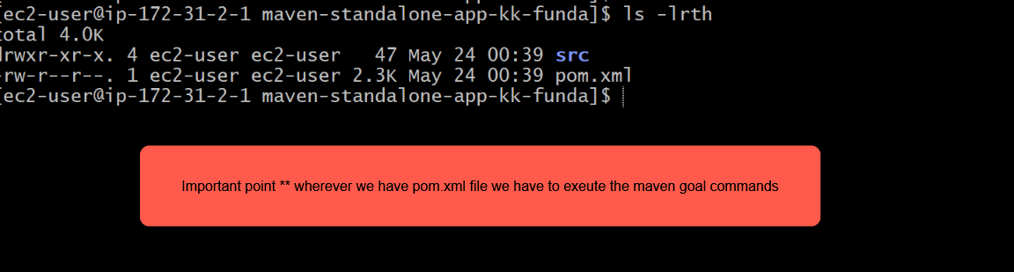

Lets execute the Maven commands in this Maven-standalone-app-kk-funda directory where we src code file and pom.xml file Let’ excute the maven commands
Mvn clean package and Mvn clean install
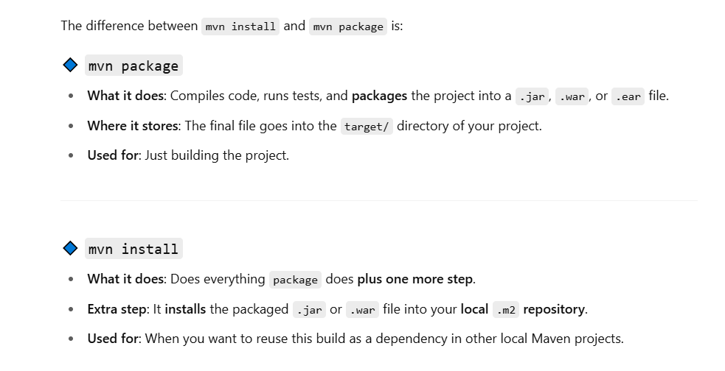
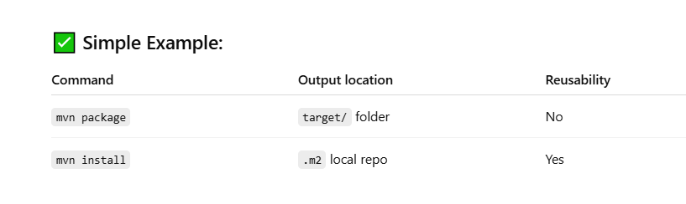
Lets execute the mvn package command first

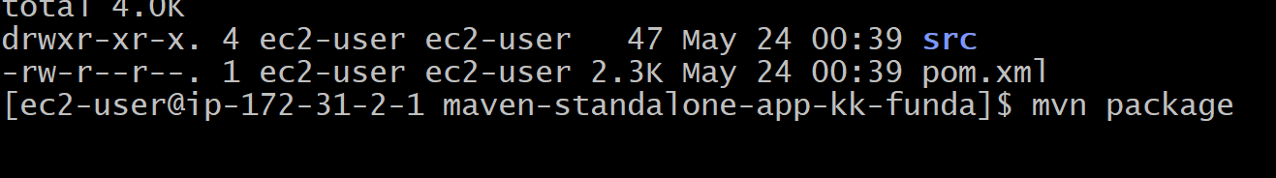

In the below image you can see we are seeing an error due to java version compatability
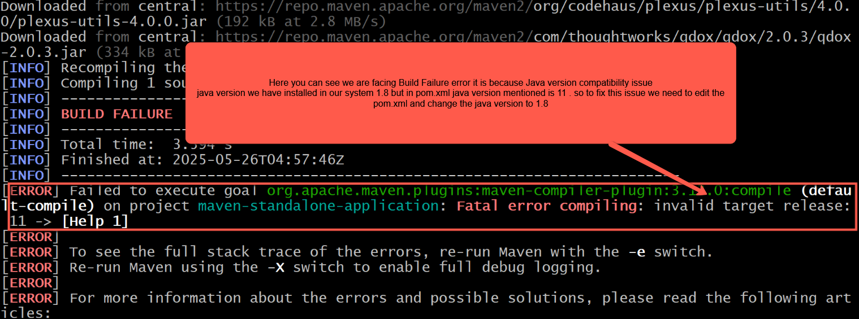

So lets open the pom.xml file and change the Java version from 11 to 1.8

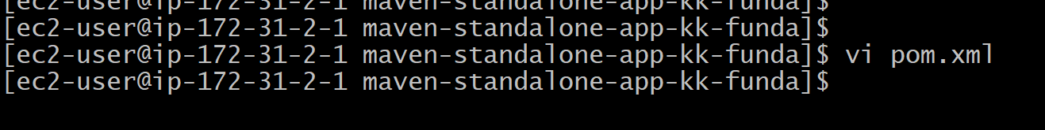

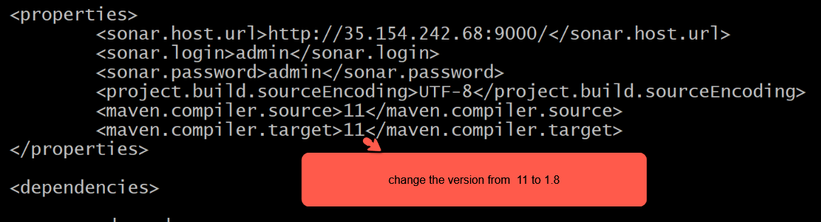

Changed to 1.8 version
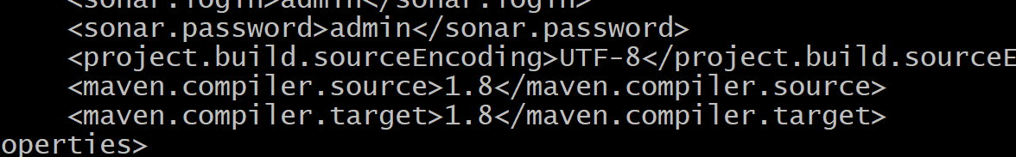

Now execute the maven command mvn package again
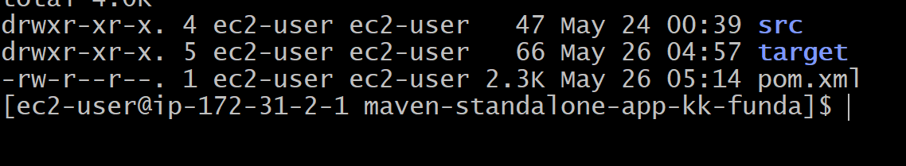
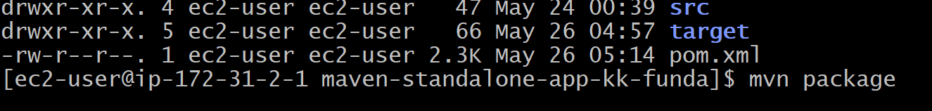
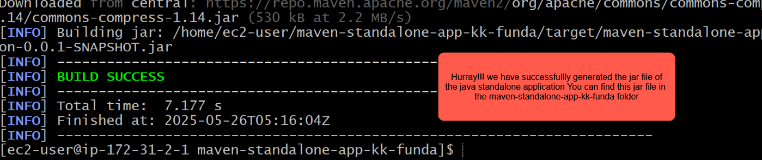

Let’s execute the command clear and then ls –lrth you will newly created target directory in maven-standalone-app-kk-funda and you will find the application jar file in target directory
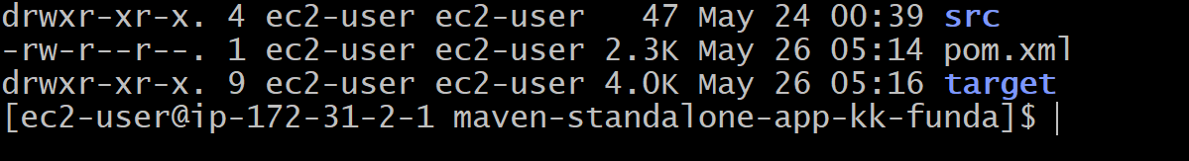
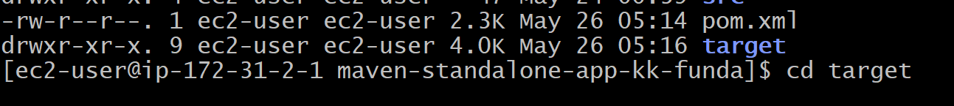
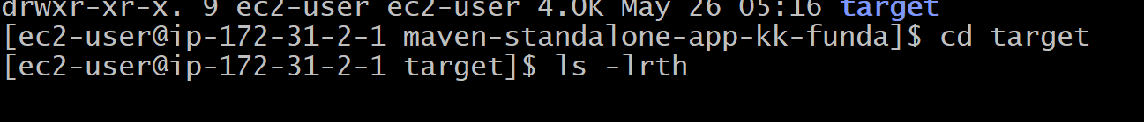

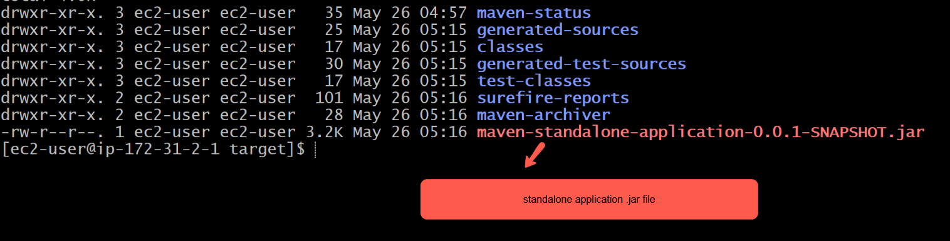

Lets run this maven-standalone-application-0.0.1-snapshot.jar using the below command
To run a jar file we have to use the below command
java –jar maven-standalone-application-0.0.1-snapshot.jar

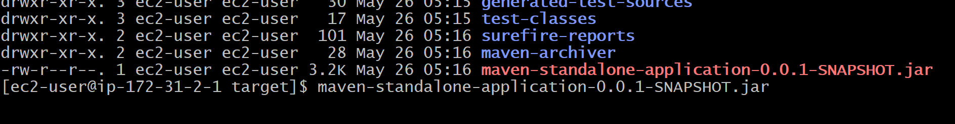

As you can see we have successfully executed the jar file application

Now execute the command mvn install .jar file will get copied into our local .m2/repository
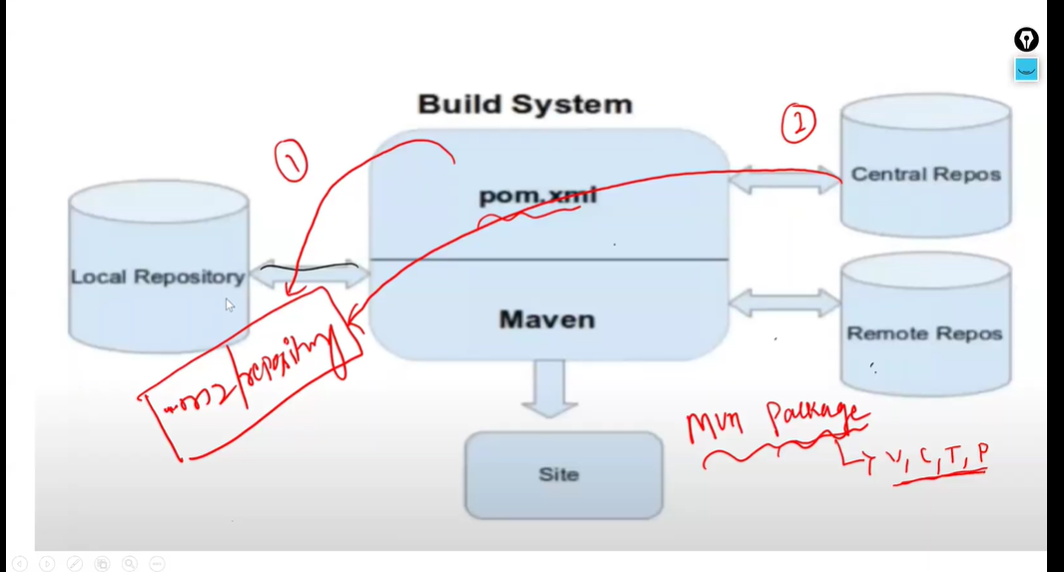

Execute the command mvn install
Jar file Build Successfully and got copied the artifact in to .m2/repository
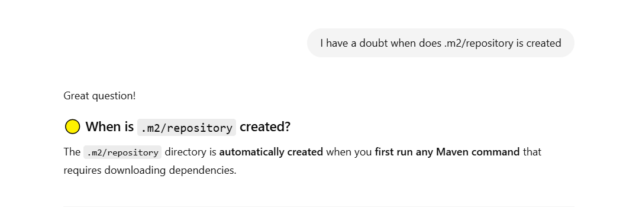
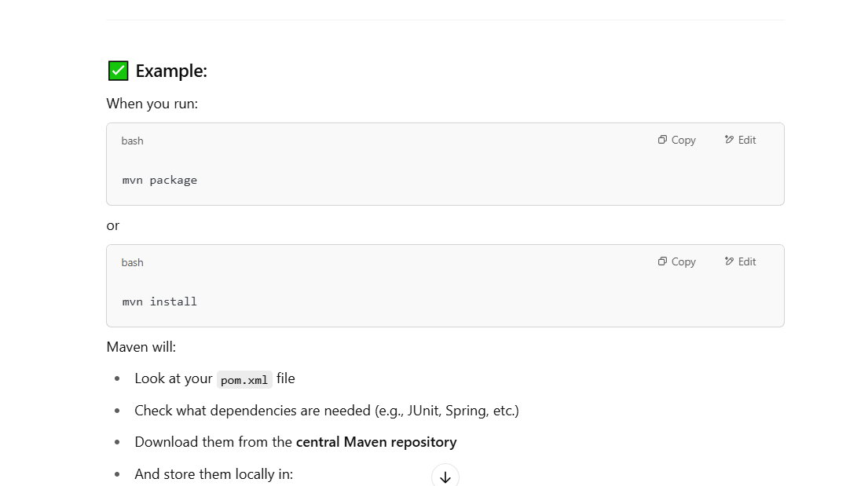
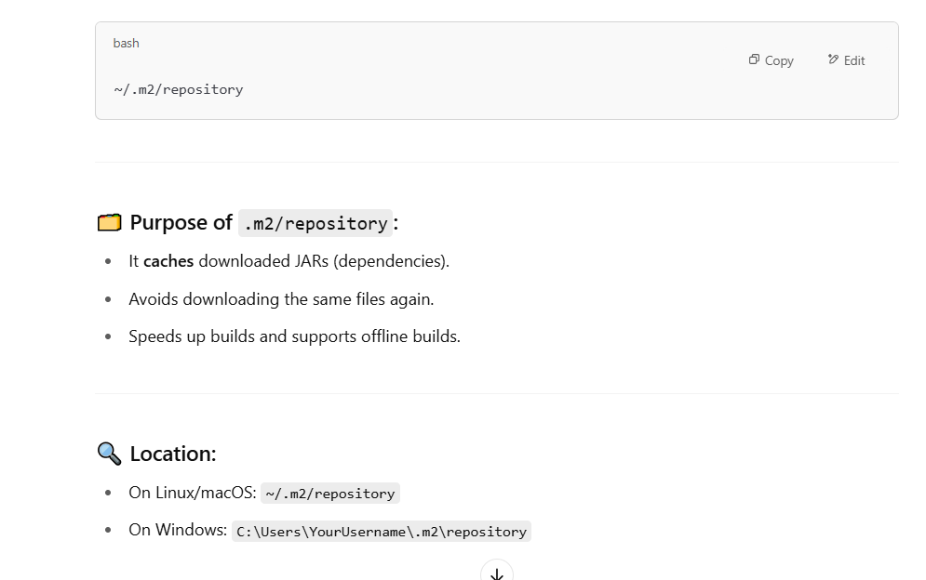
Now open check the .m2/repository which is in the Home directory (ec2-user)
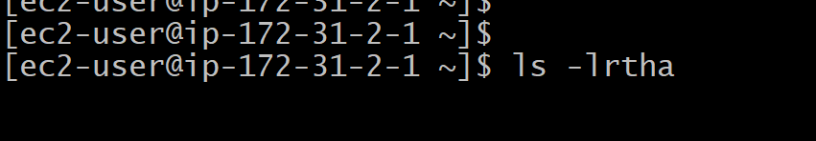
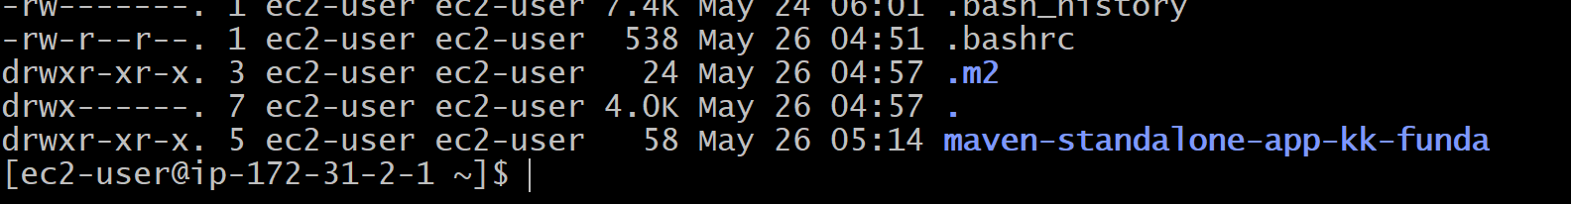

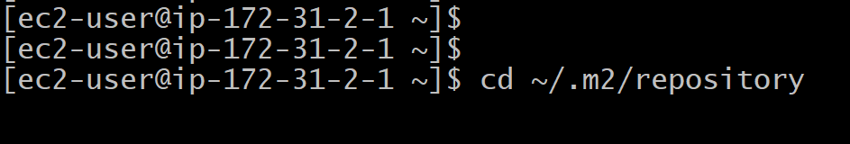
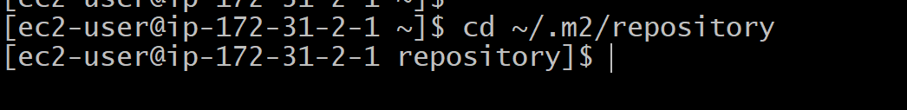
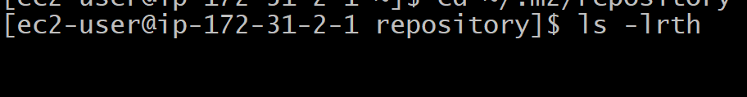
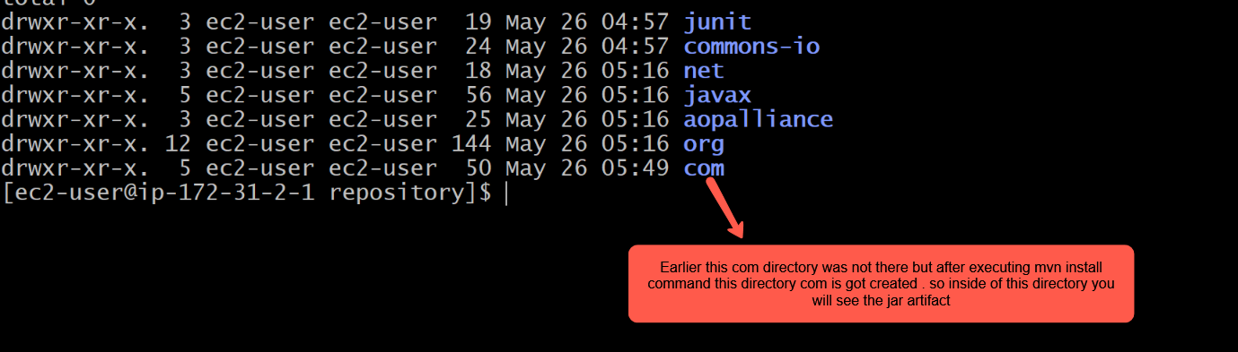

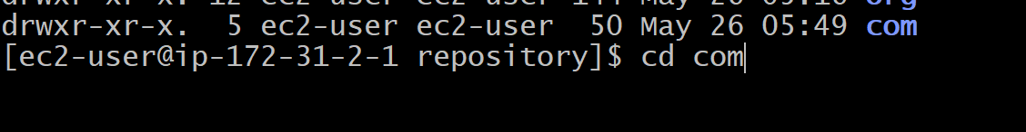
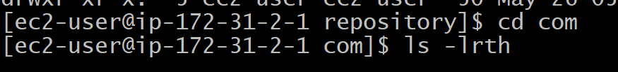

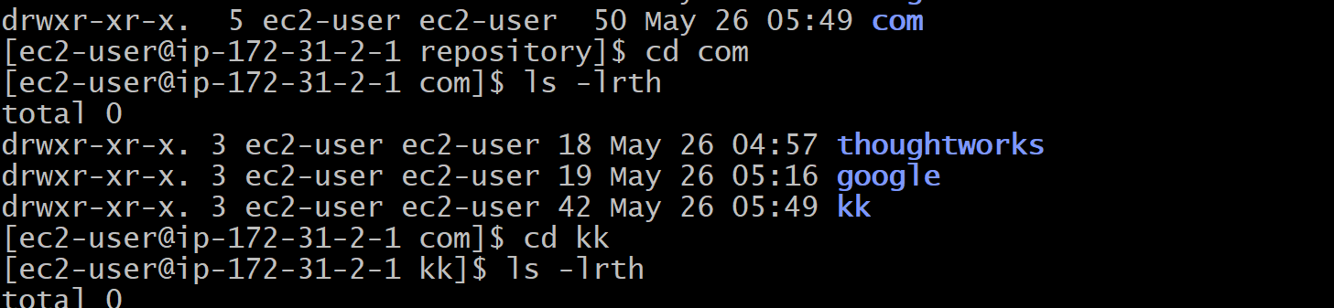
Naviagte to kk folder
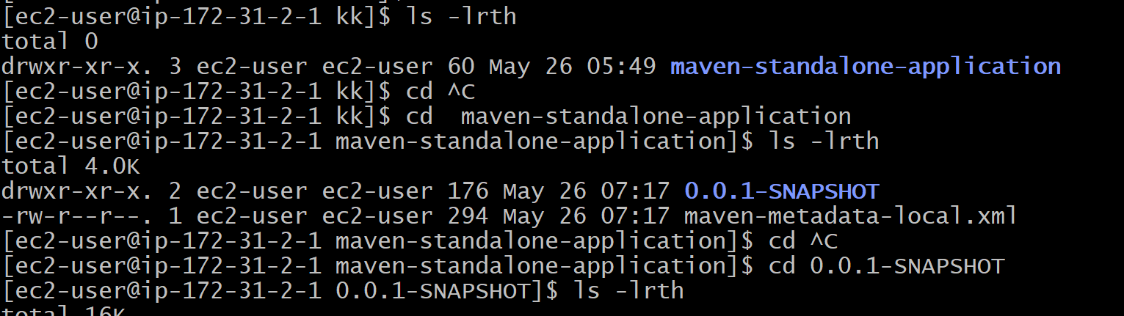
In the below image you can see a copy jar artifact has copied in to m2 -repo –com repo
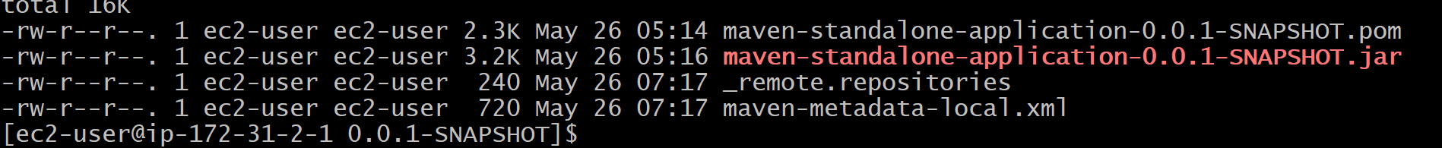

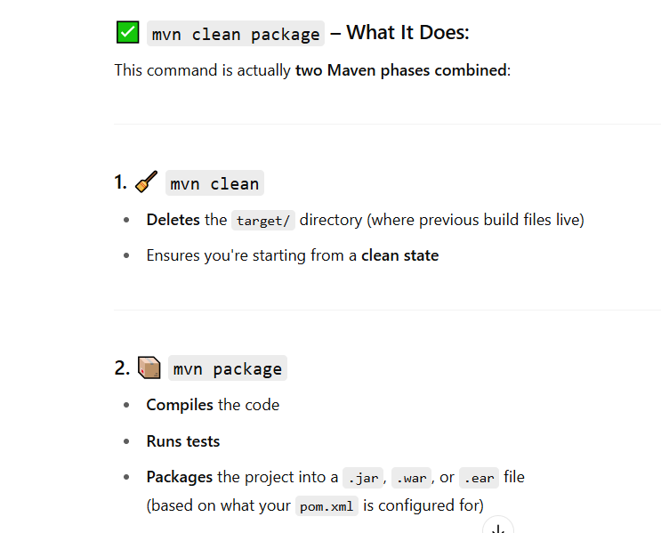
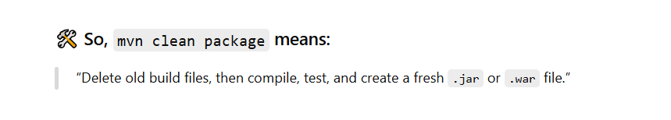

Lets execute the mvn clean command
The Target directory will get deleted
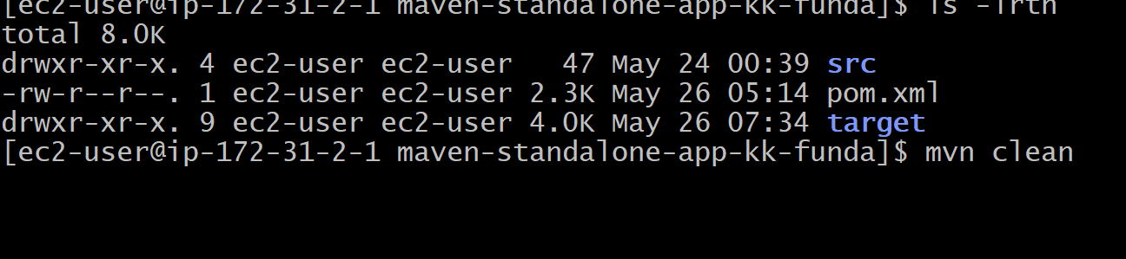
As you can see in the below image after executing the mvn clean command the Target directory has been deleted
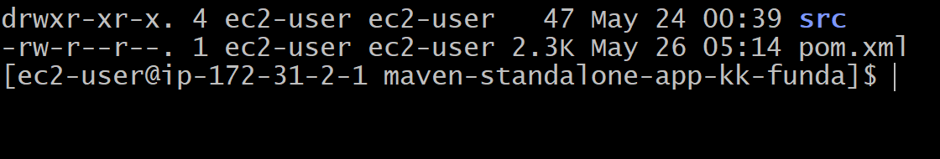

Now execute mvn package command the target directory will get added

End of the class
Q & A starts at 1:16:00

