In Today’s class we will discuss about AWS EC2
EC2 means Elastic compute Cloud
Inside the AWS account we have the EC2 Instance . In the upcoming classes we will about EC2 only
especially the below Topics
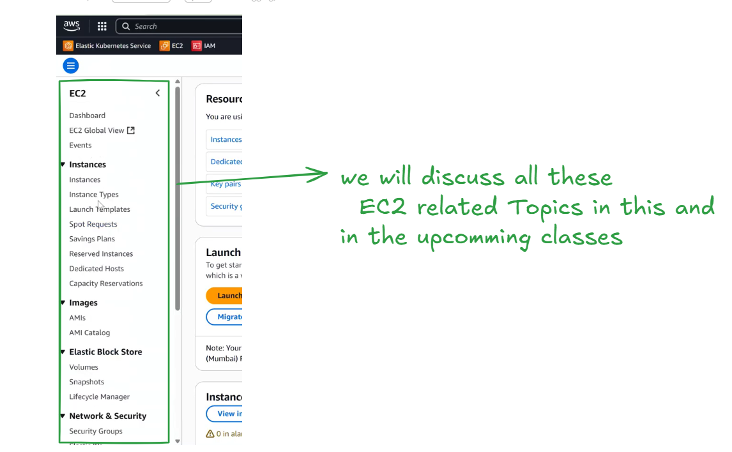
Let’s discuss about Ec2 Instance in detail. So far we have only worked on launching the EC2 instances right, But in this class we are going to discuss about the EC2 in detail.
What is an Ec2?
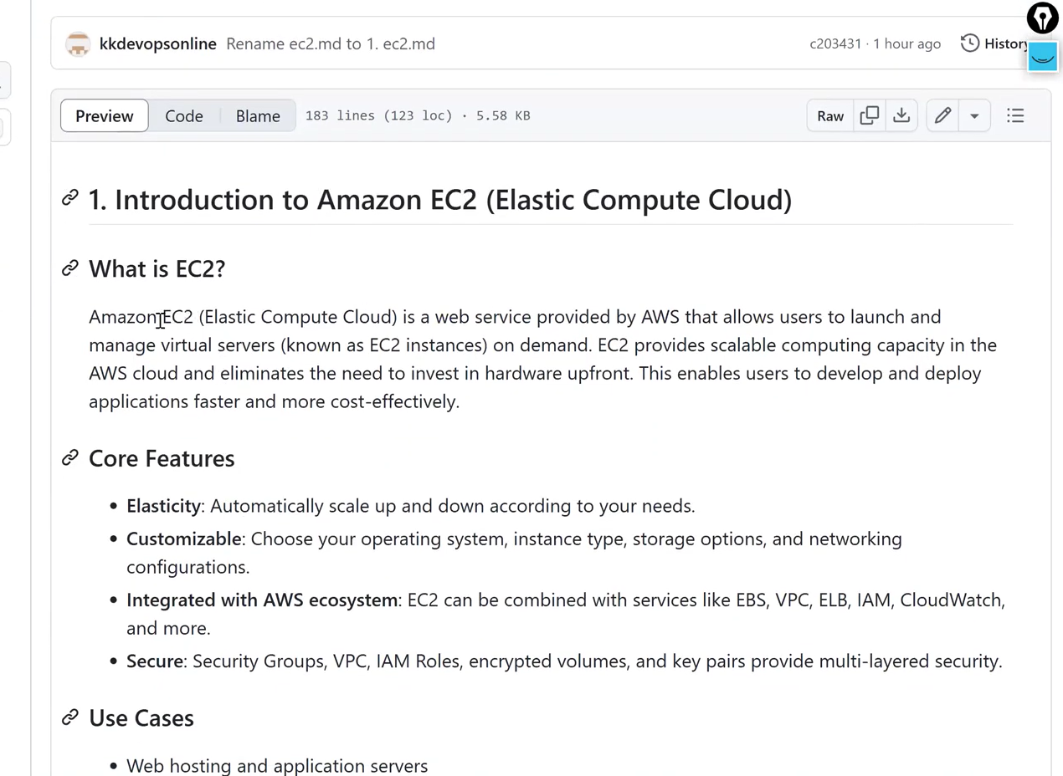
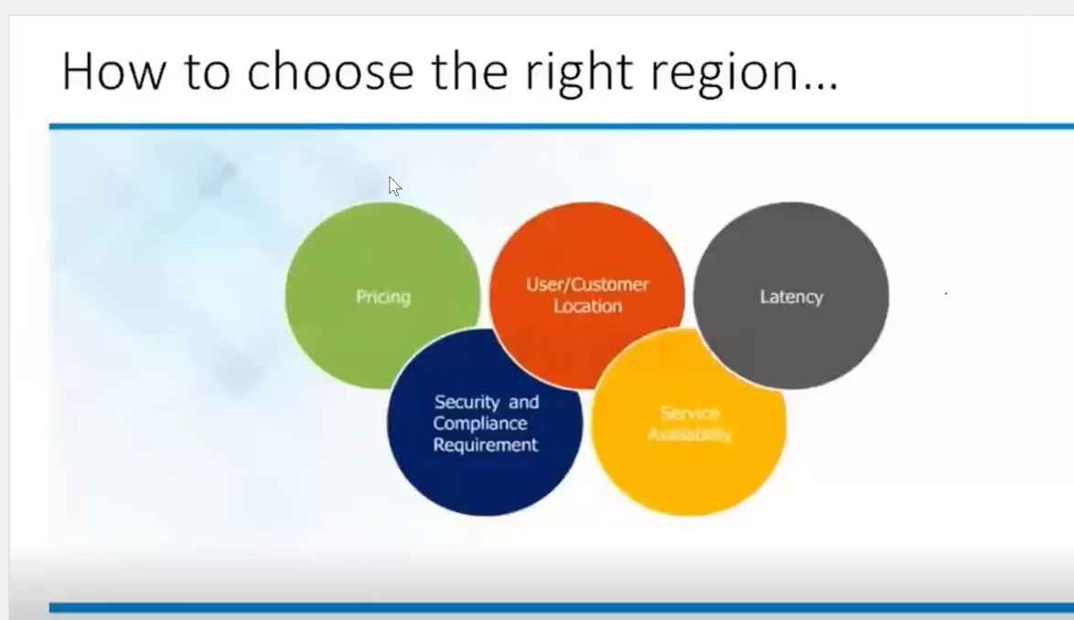
Before launching an EC2 instance, we must consider the key factors shown in the image, such as pricing, user/customer location, latency, service availability, and security & compliance requirements, to choose the right AWS region.
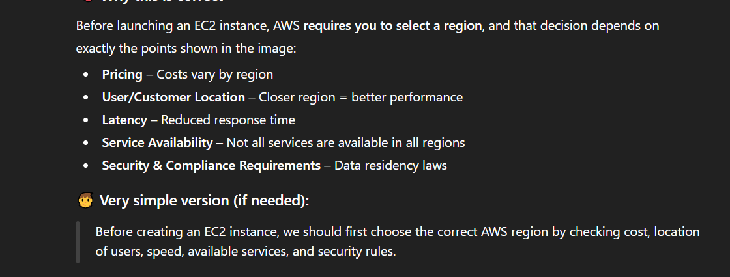
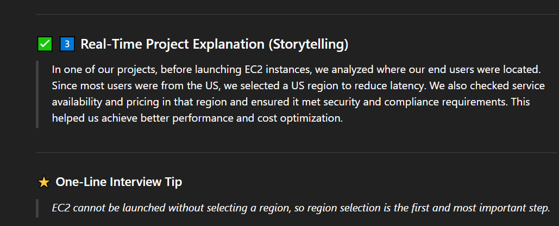
Ec2 Basics well explained in the below image
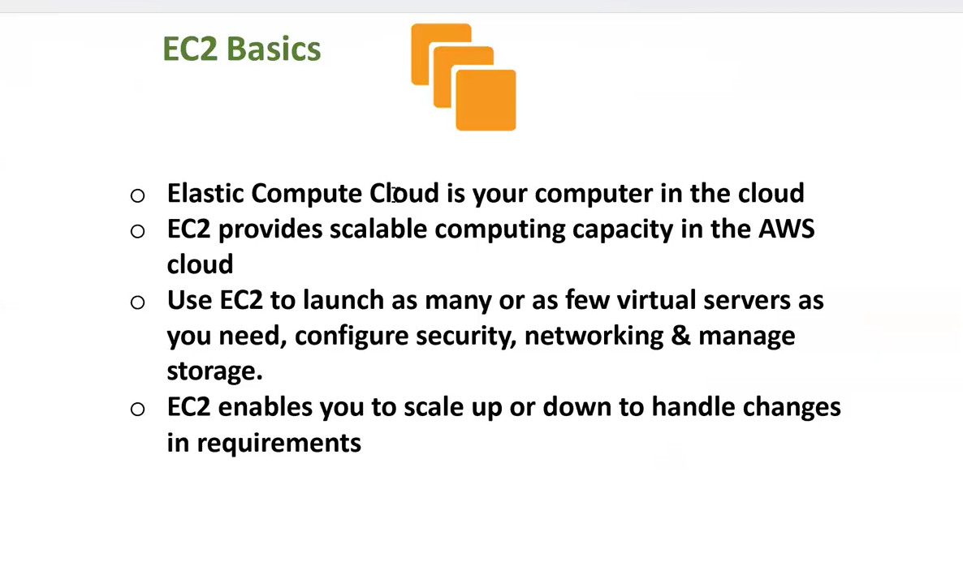
The image shows a conceptual comparison between a local computer system and an AWS EC2 instance by mapping basic computer components to EC2 instance components.
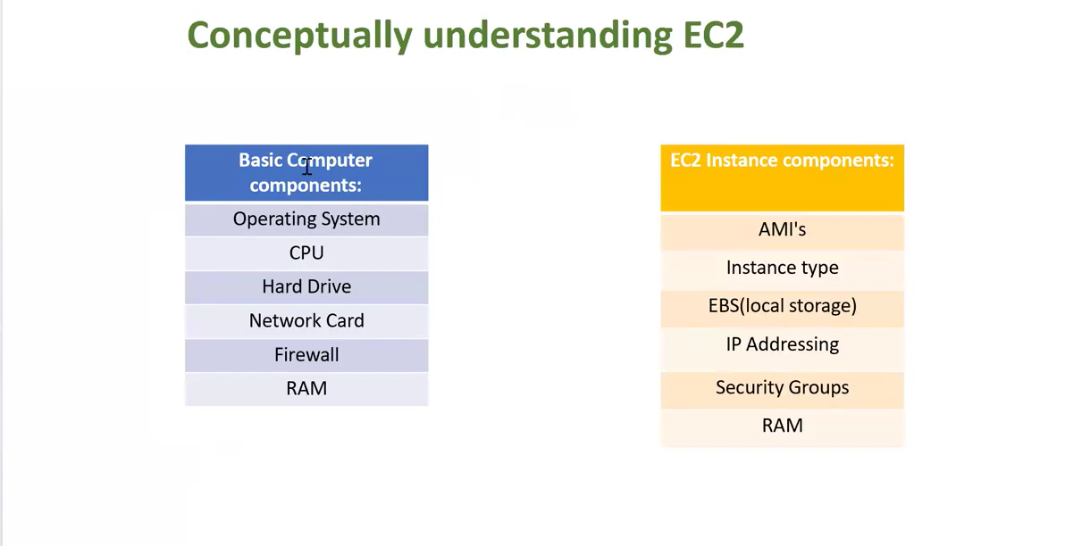
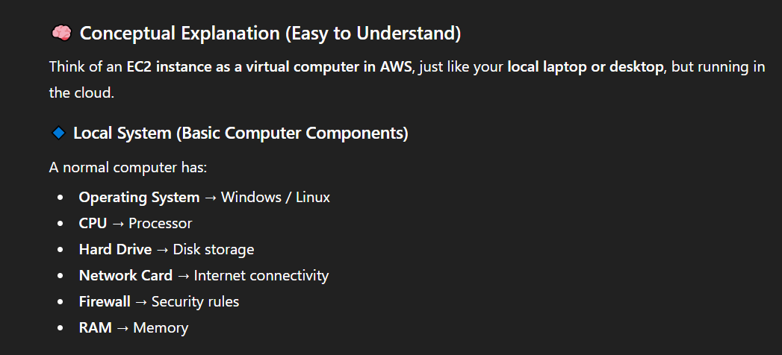
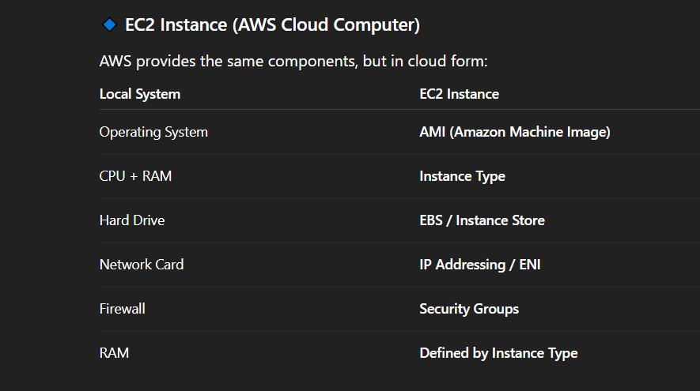
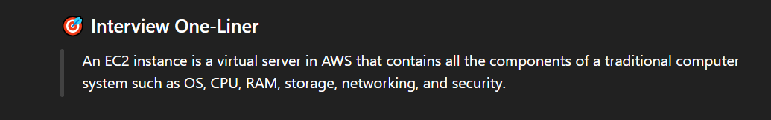
The core features of EC2 is mentioned in the below image have a look
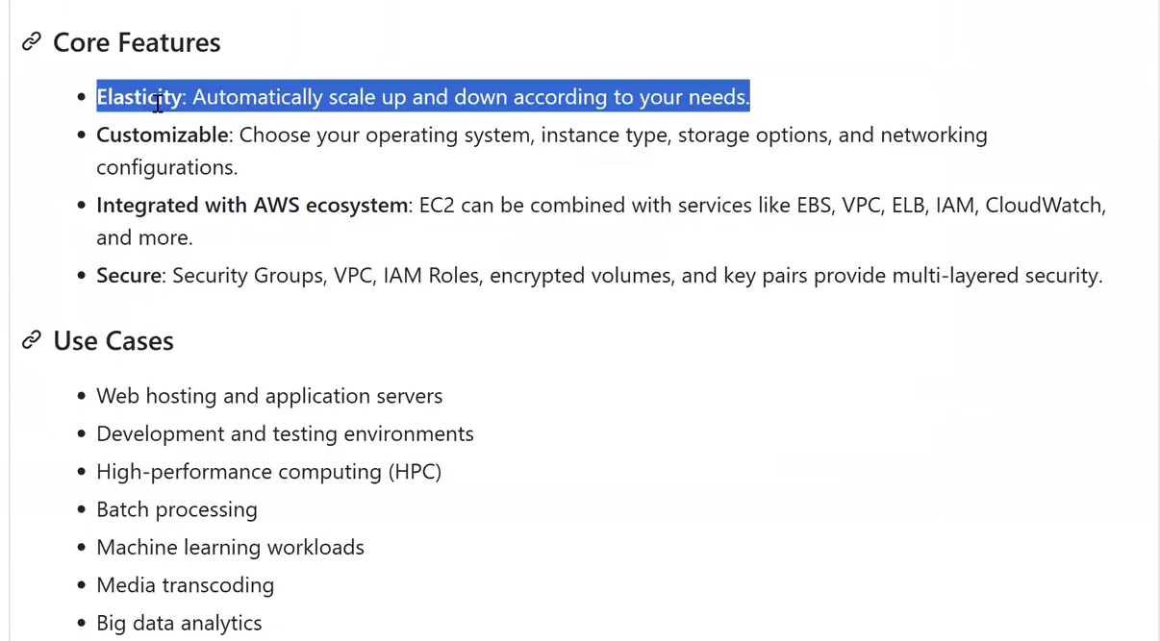
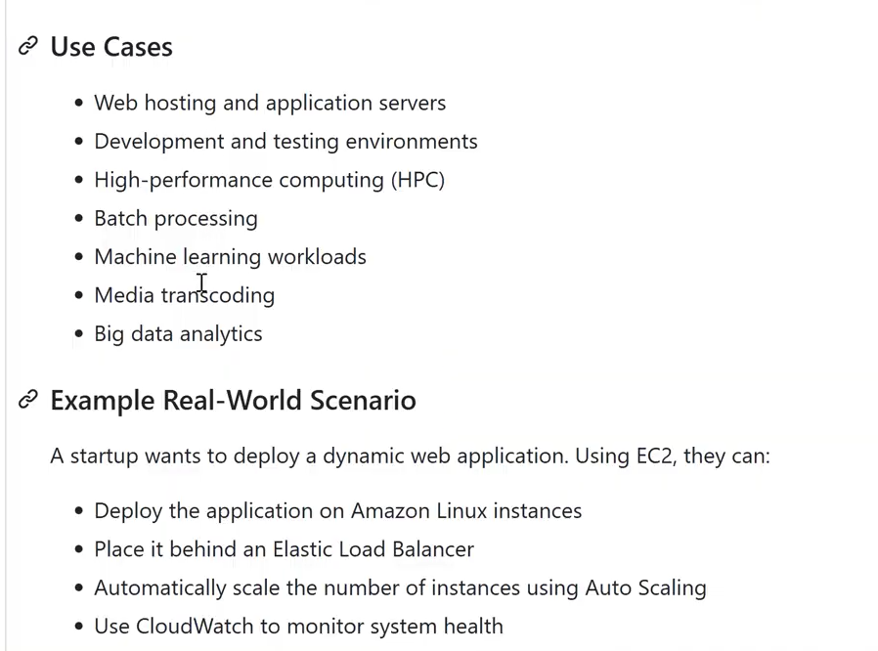
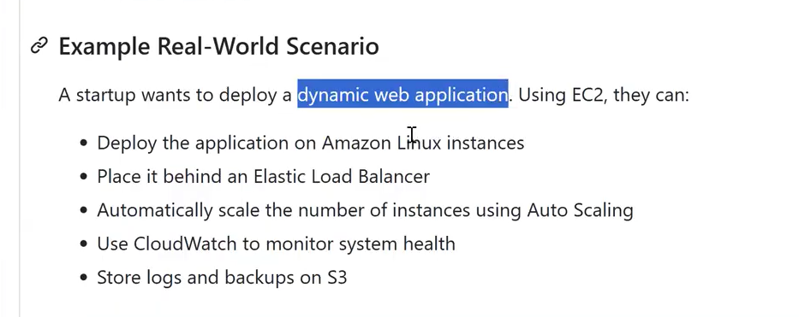
In the below Image we will discuss about Ec2 Instance Types – Deep Dive
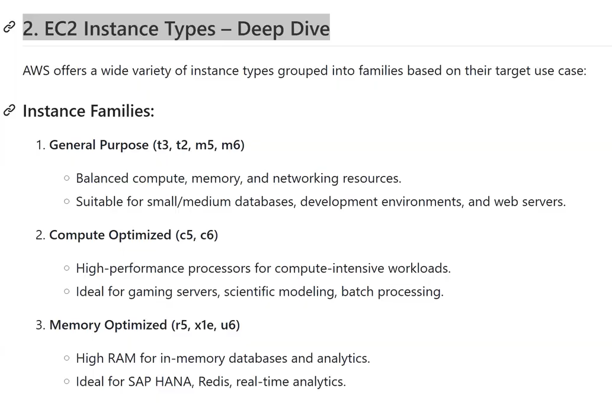 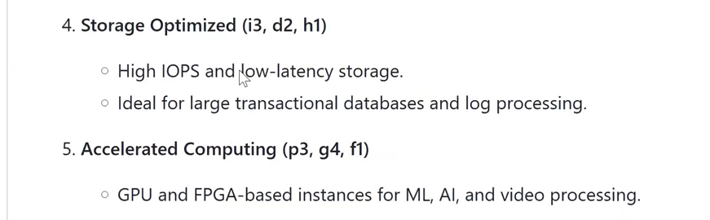 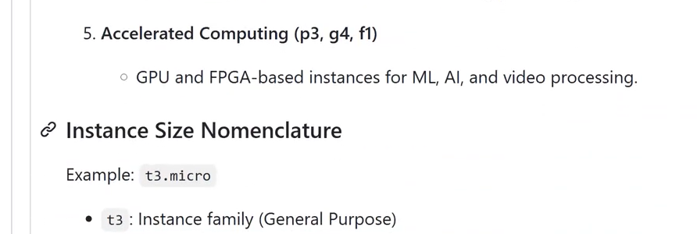
In the above we have seen different types if Instance Families . let’s check the 1) General purposes Instances(t2,t3,m5,m6) in our Aws account going to discuss below
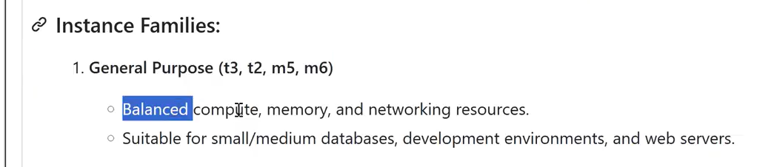
check about the General purpose Instances from AWS documentation as shown in the below Image
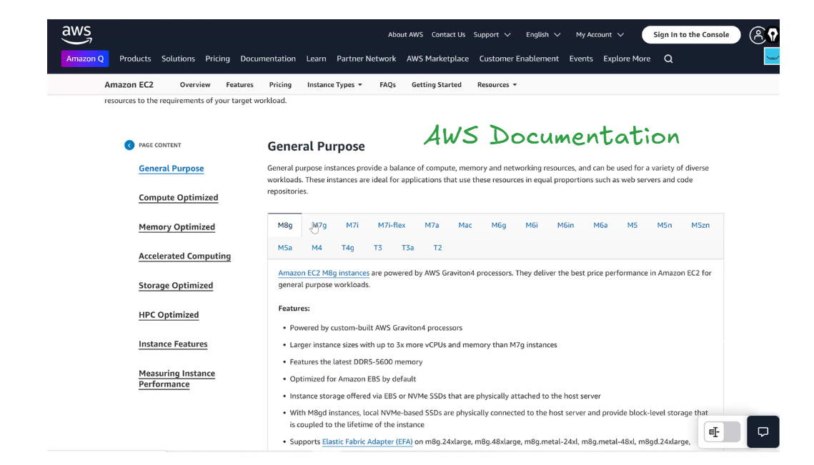
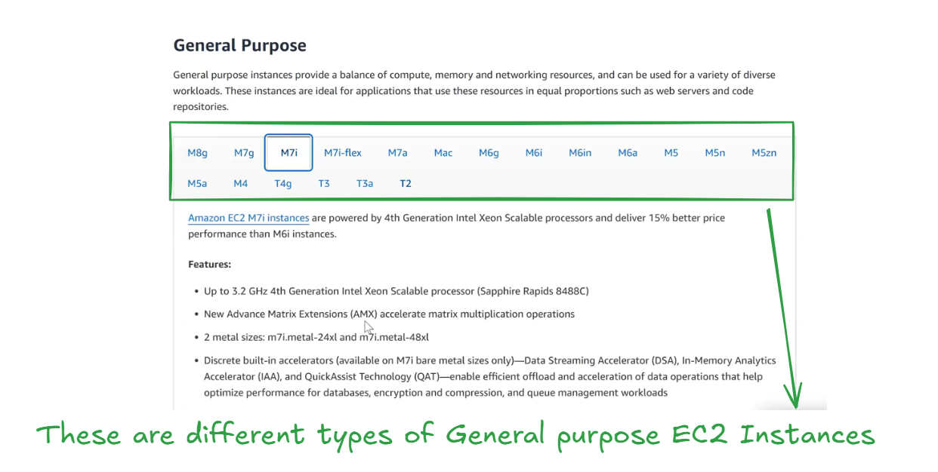
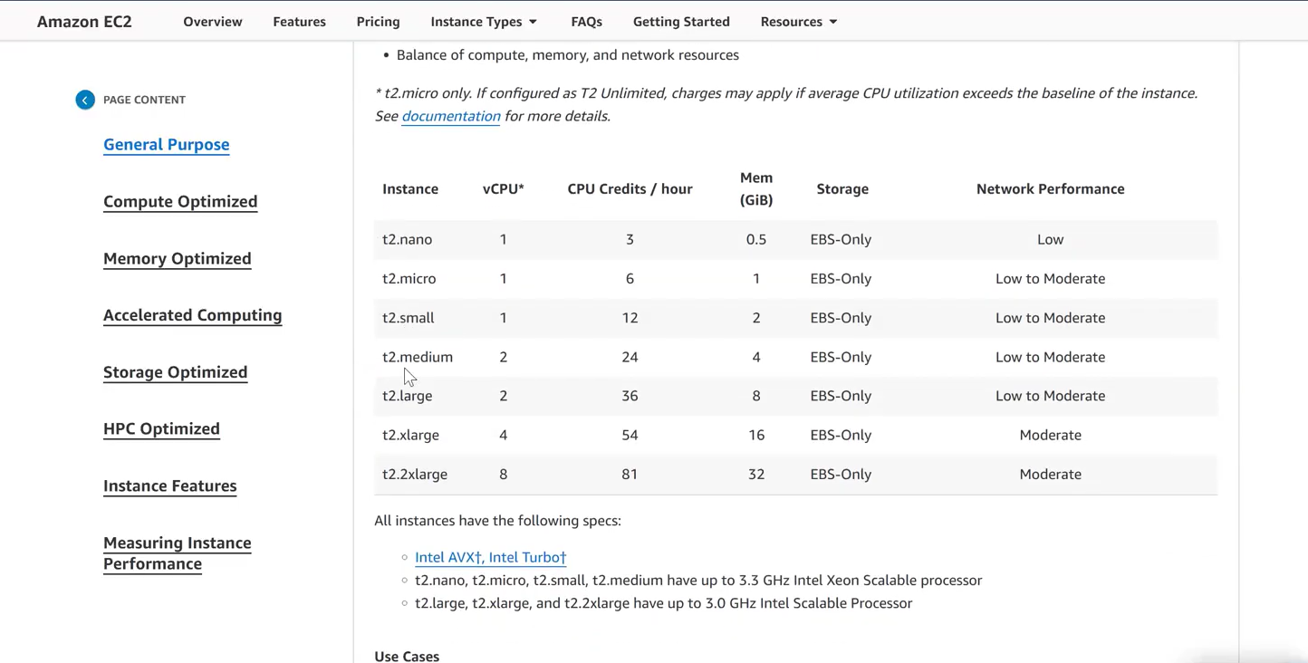
In real-time production environments, we usually avoid using very small EC2 instance types like T2 for application workloads.
T2 instances are burstable and suitable for low workloads, but for real-time production environments, we generally use M, C, or R series instances for consistent performance.
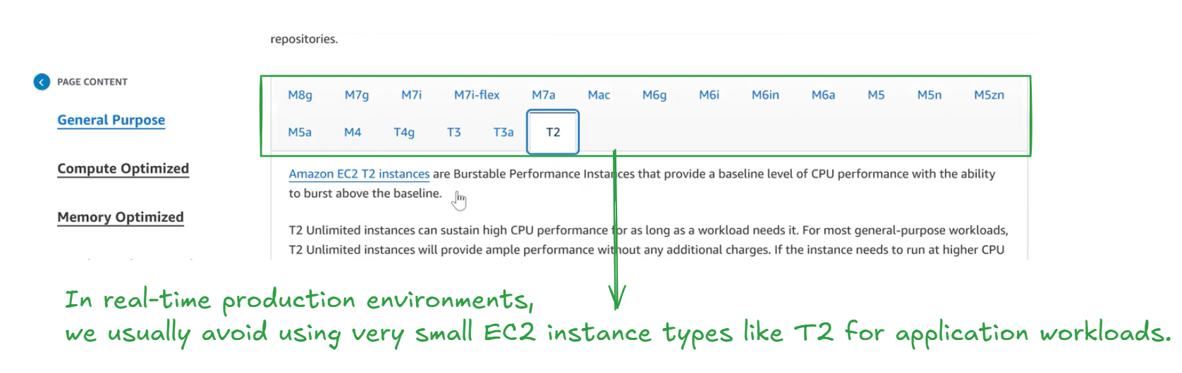
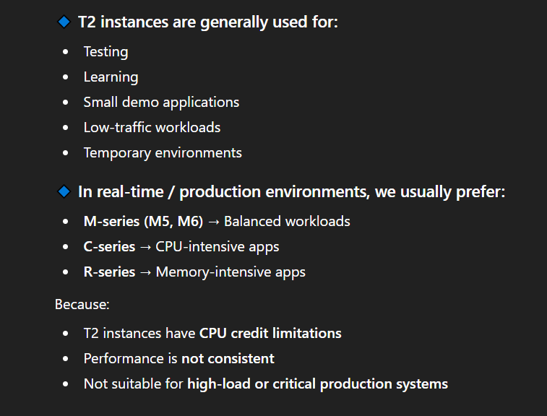
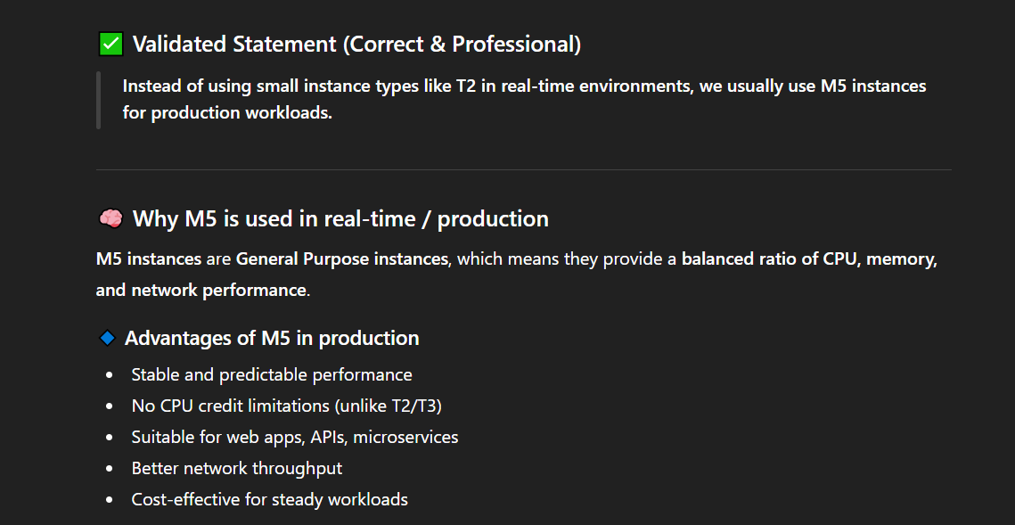
The below Image showcases the details of M5 EC2 instances, including vCPU, memory, storage type, and network/EBS bandwidth, which are commonly used for real-time production workloads.
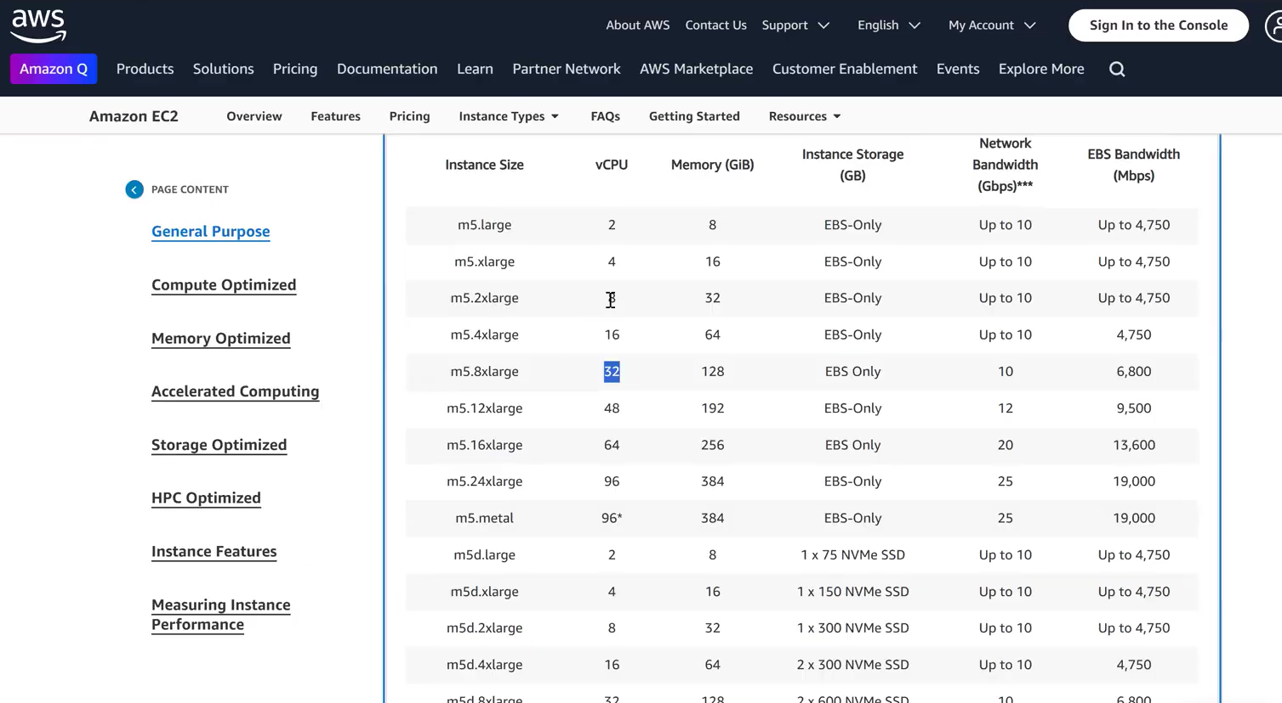
Next, we discuss Compute Optimized EC2 instances, which start with the C series.
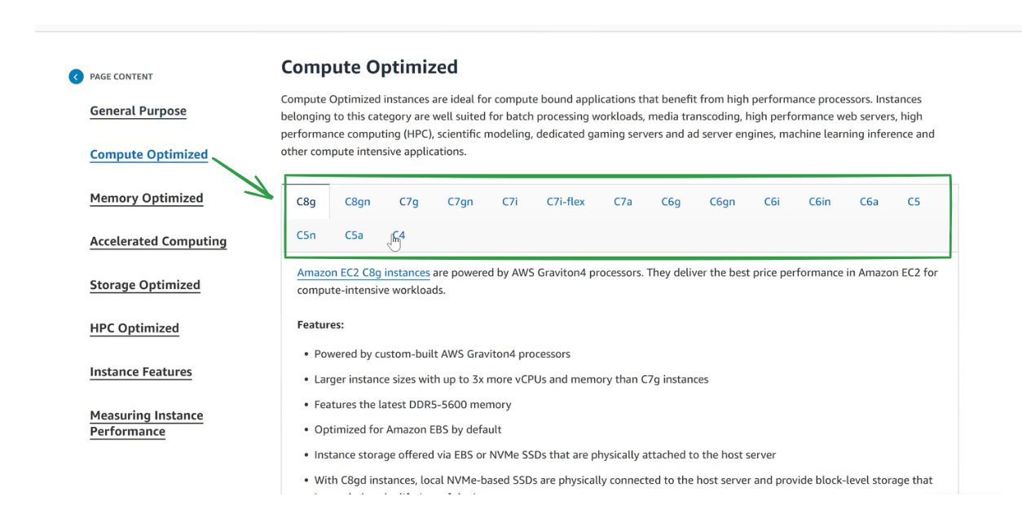
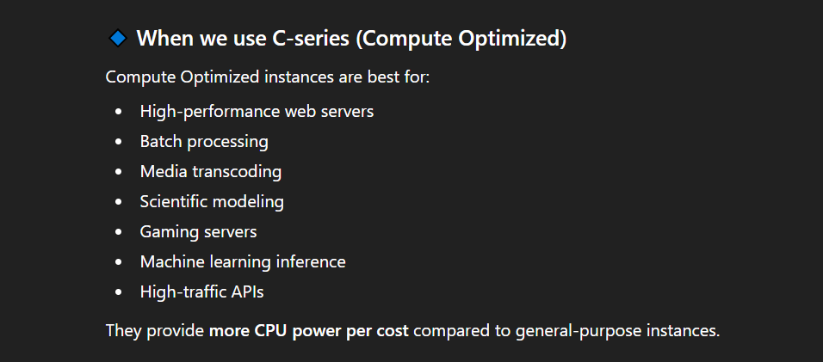
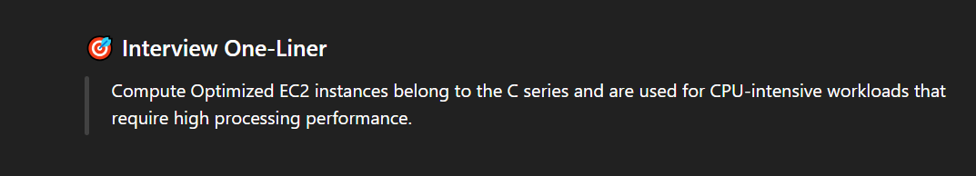
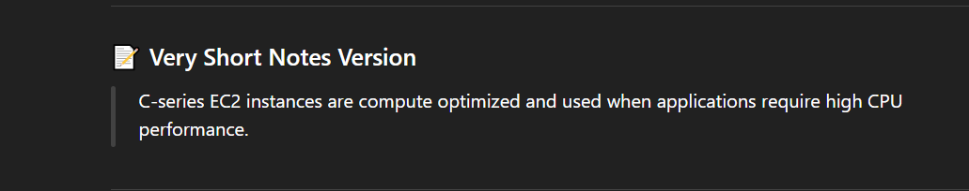
C4 instances are suitable for CPU-intensive game servers, but they are not the best choice today; newer C-series instances are preferred for modern gaming workloads.
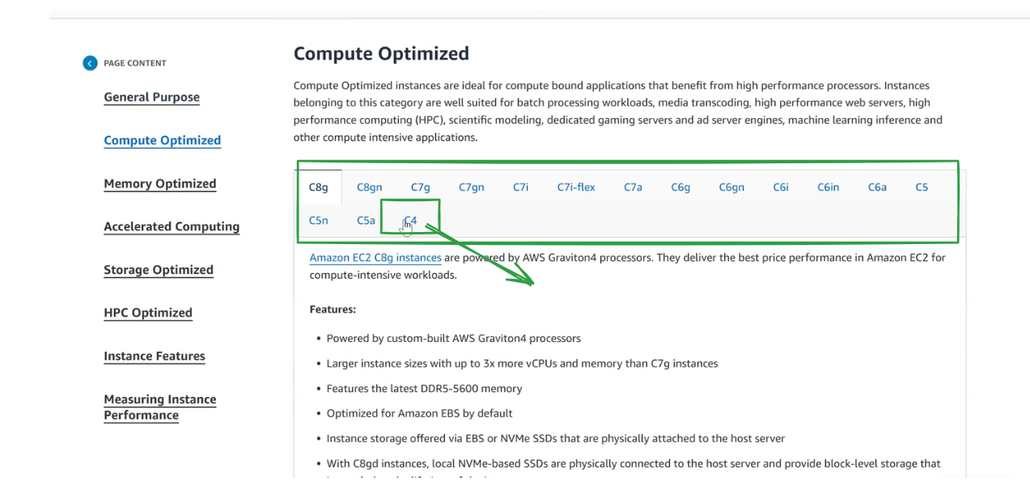
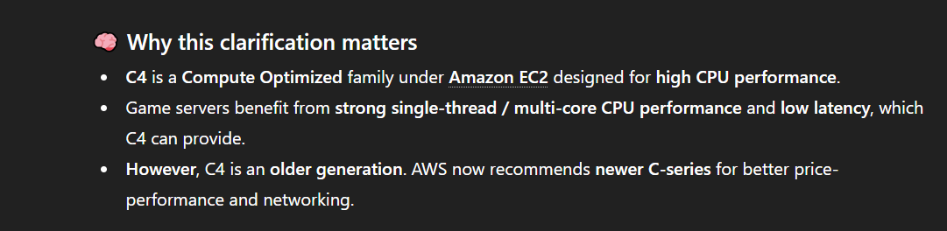
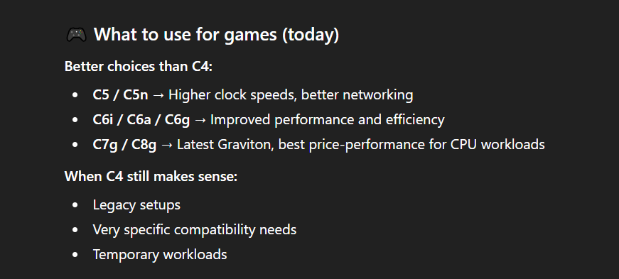
Time stamp 18:00
So Far we have discussed about different type of Instances also shown types of Instances in the below image
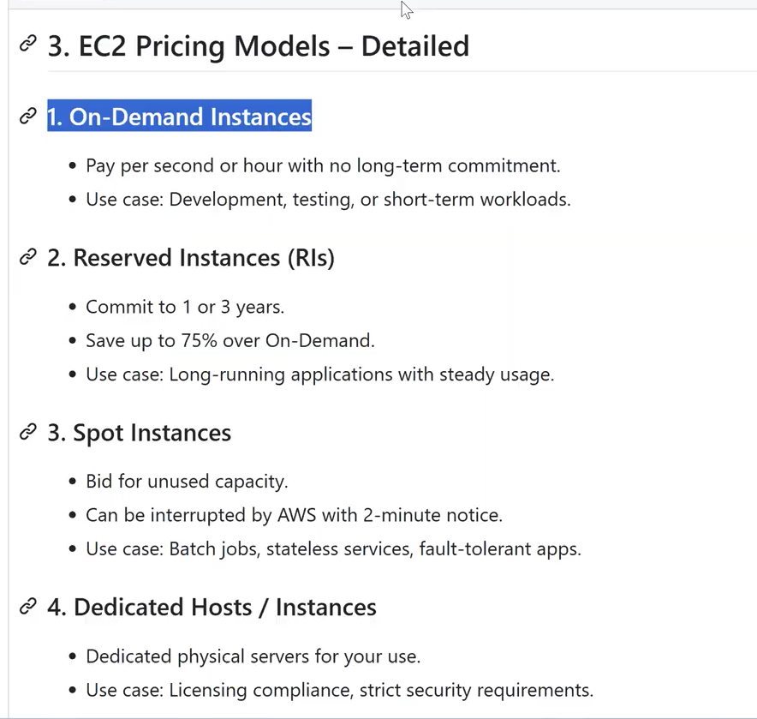
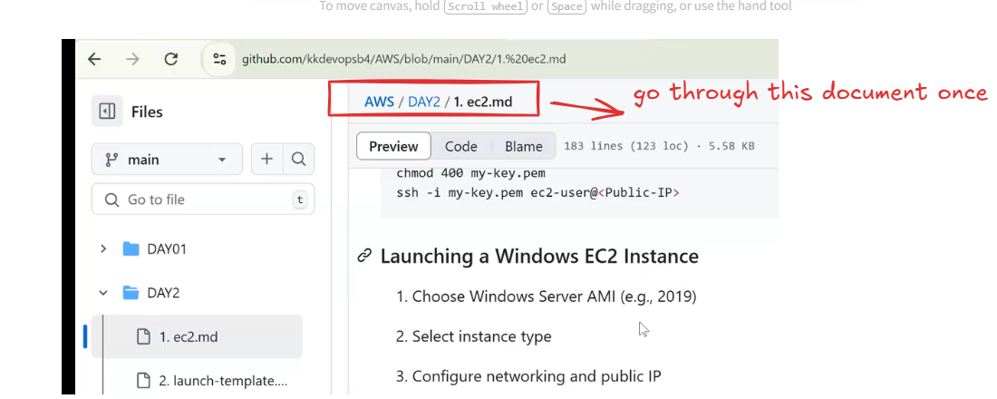
were discussed on how to launch the Instances.
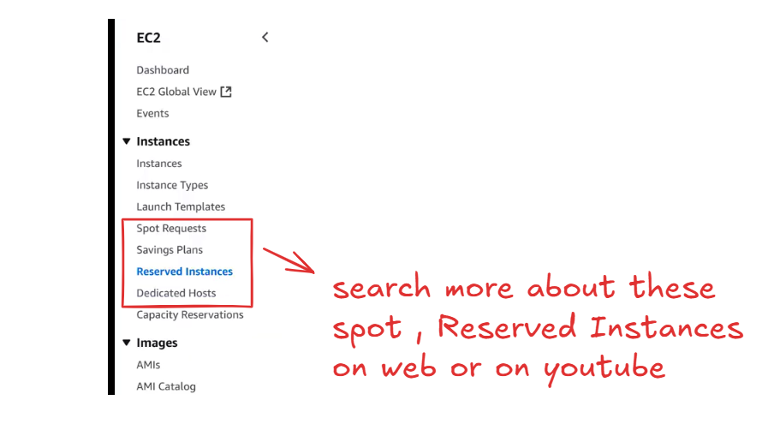
- After purchasing a Reserved Instance, we still need to manually launch an EC2 instance; the Reserved Instance does not create an EC2 instance automatically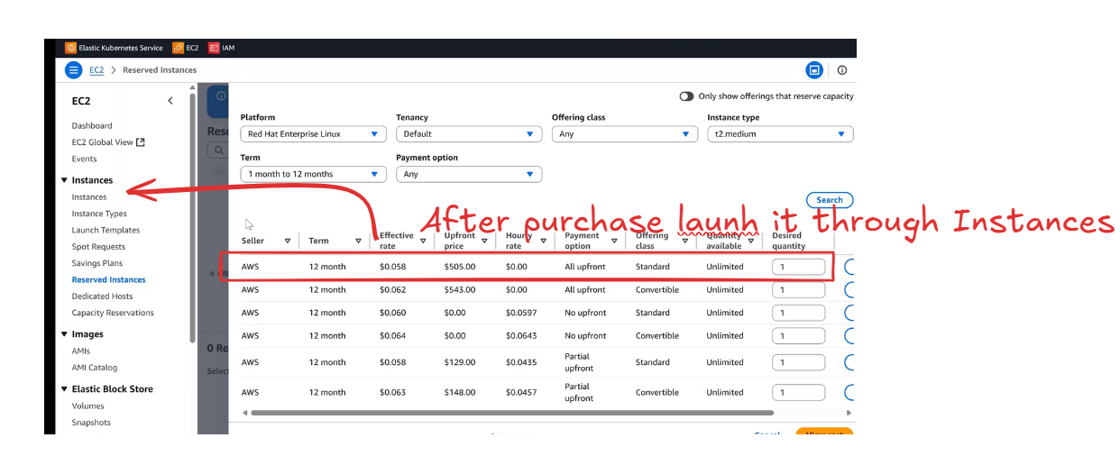
A Reserved Instance (RI) is not a virtual machine
- It is a billing discount + capacity reservation
- AWS does not automatically create or start an EC2 instance when you buy an RI
- You must manually launch an EC2 instance with:
  - Same region
  - Same instance family and size
  - Same OS / tenancy
Only then will the Reserved Instance discount apply.
In order to launch an EC2 instance, AWS / The company provides proper documentation and guidance. The documentation specifies the required configuration such as the instance capacity, instance type, and the region where the instance should be launched. After understanding these launch requirements, we can provision the instance either manually through the AWS Console or automatically using Infrastructure as Code tools like Terraform.
As a DevOps engineer, we don’t often launch instances manually because most of the work is automated.
Let’s see How to launch an Instance
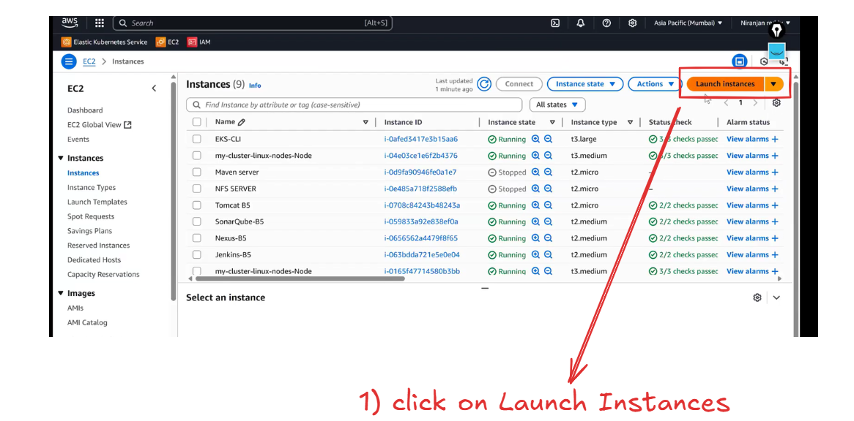
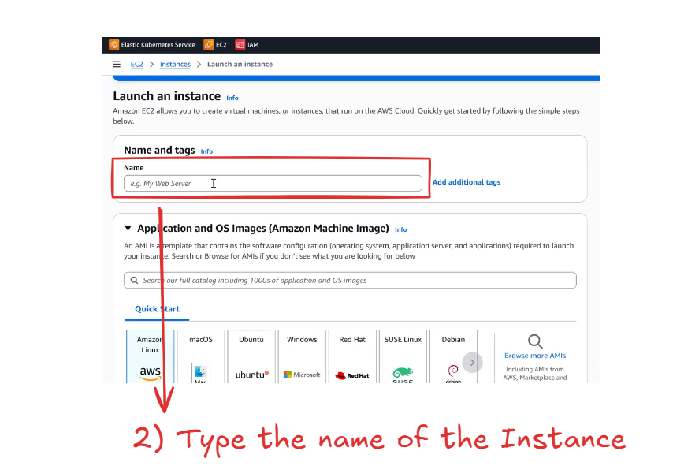
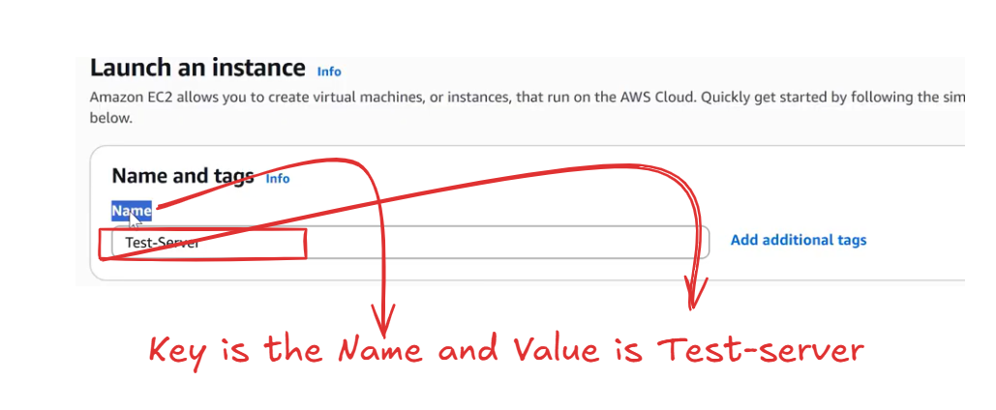
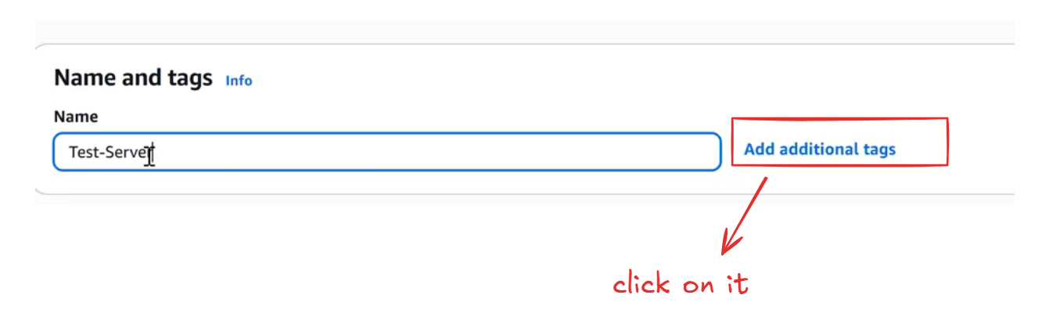
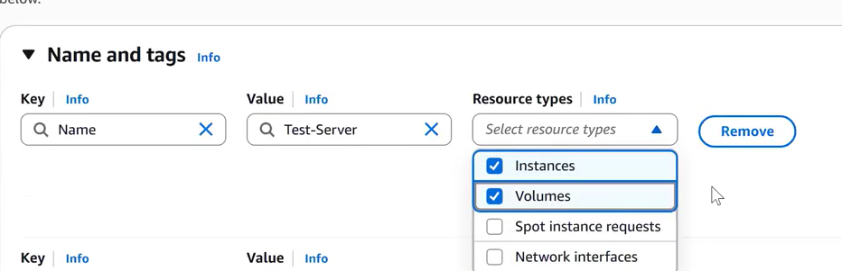
A tag is a key–value pair used to organize AWS resources.

Example from the image:
- Key: Name
- Value: Test-Server
- Resource types applied to:
  - ✅ Instances
  - ✅ Volumes
This means the same tag will be applied to:
- The EC2 instance
- The attached EBS volumes
When we launch an EC2 instance, a root EBS volume is created automatically. If we add an additional tag and select the resource type as “Volume,” the same tag will be applied to the EBS volume as well.
-----------------------------------------------------------------------------------------------------------------------------
Next Topic is AMI (Amazon Machine Image)
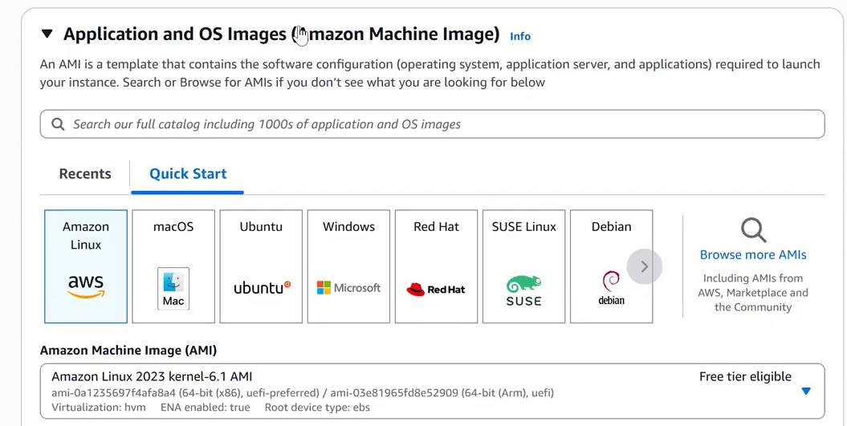
select Ubuntu AMI
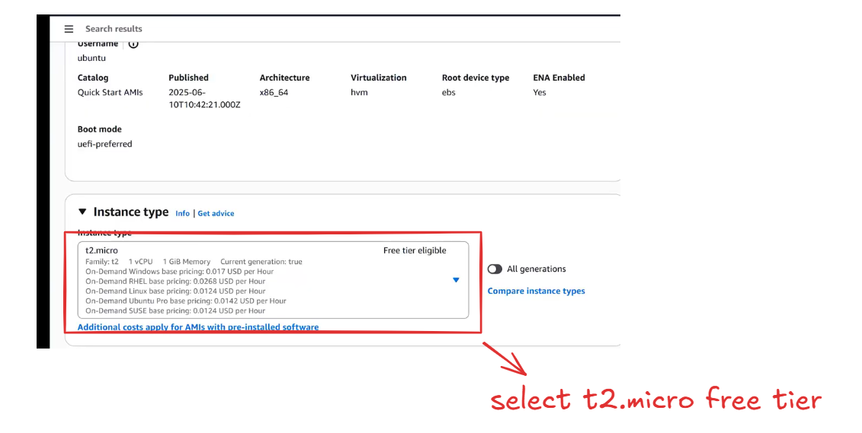
select the key-pair
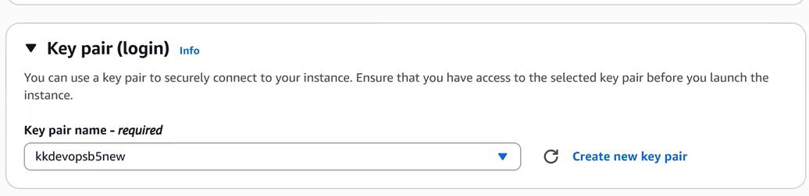
The key pair selected during EC2 launch is used to securely authenticate and log in to the instance using SSH.
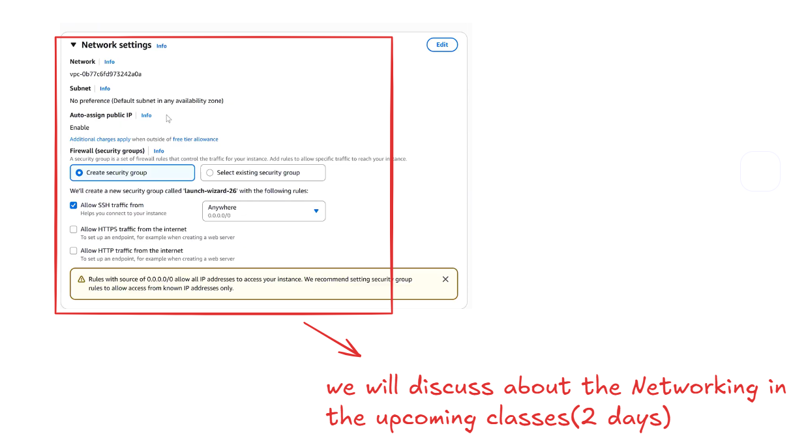
In the Network settings, we can either create a new security group or select an existing security group while launching an EC2 instance.
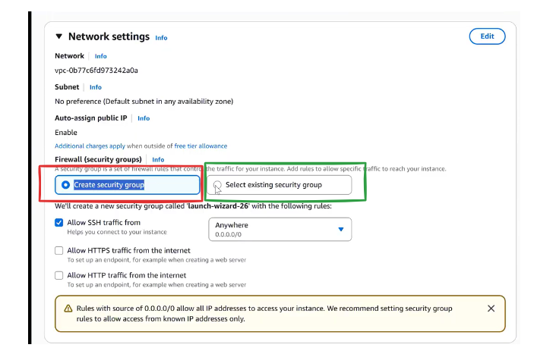
Let’s create a New Security group
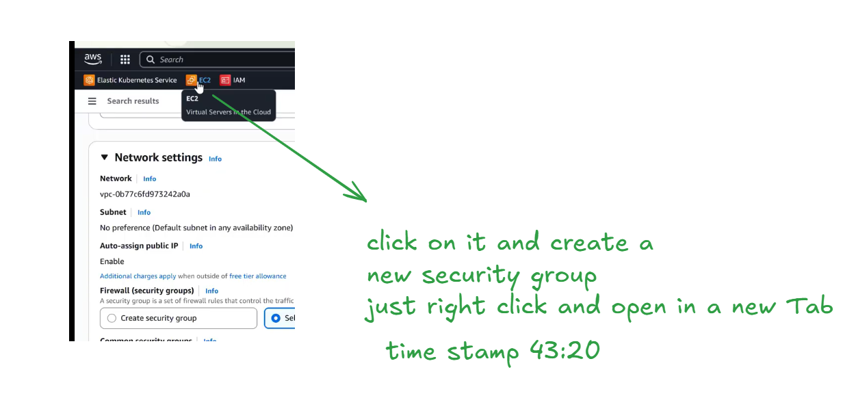
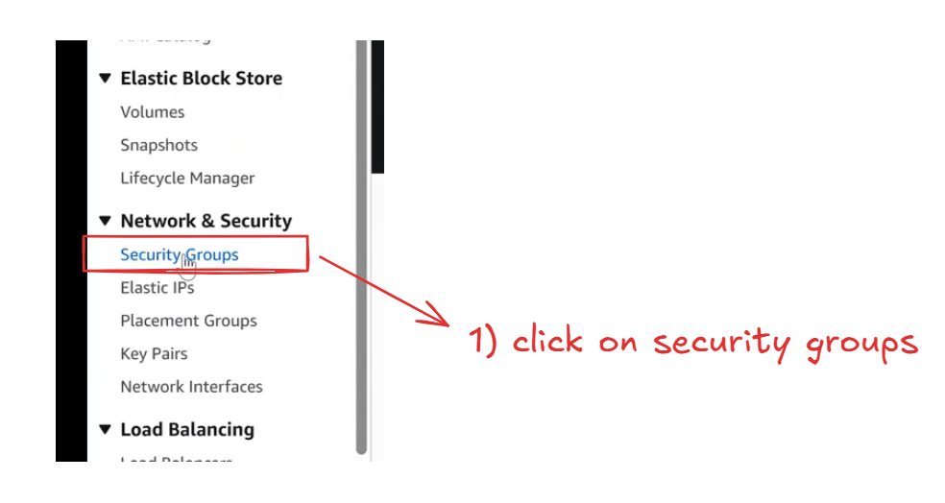
Every time we can use the same security group before launching any new instance
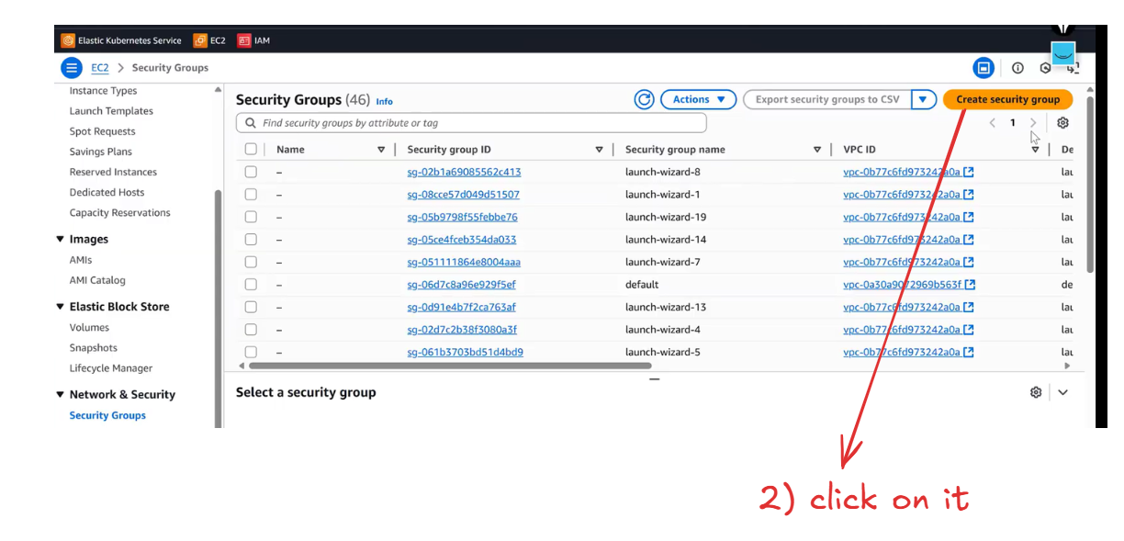
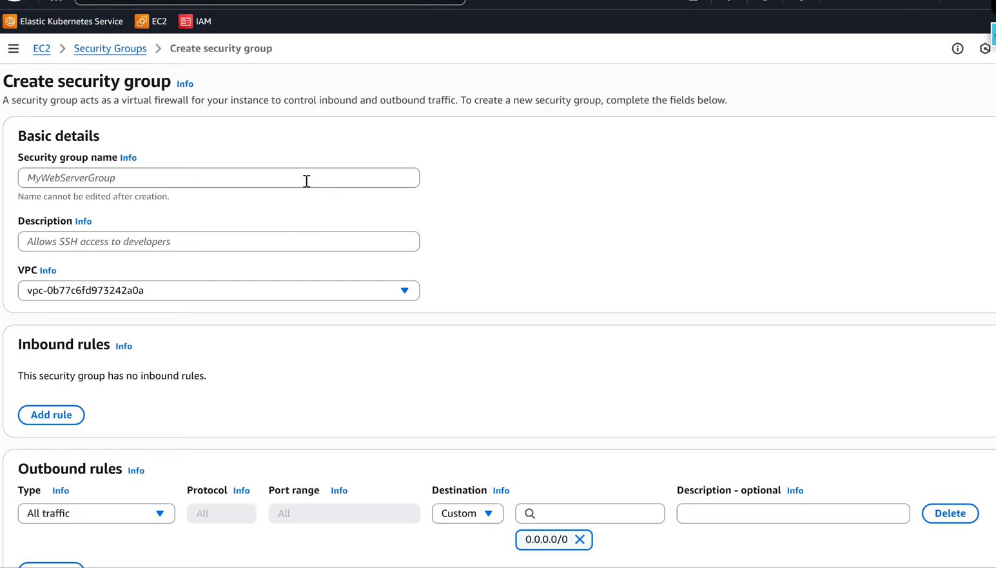
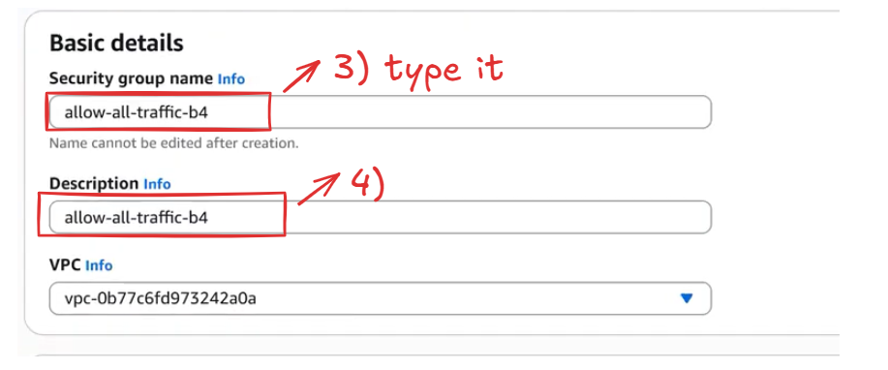
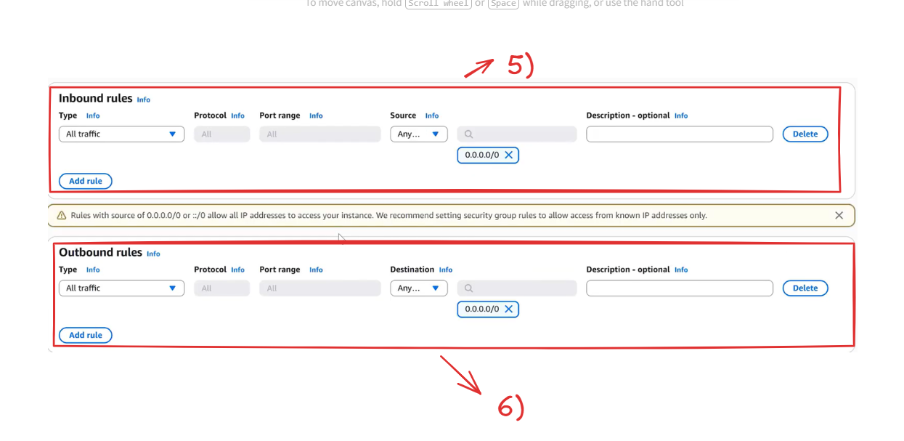
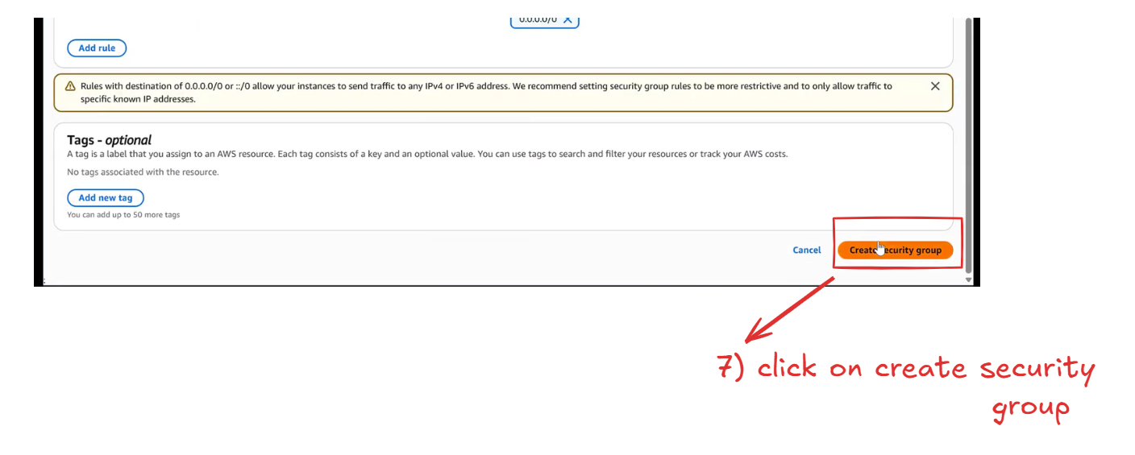
Now go to the ec2 tab and refresh the page and select the newly created security group as shown in the
below image
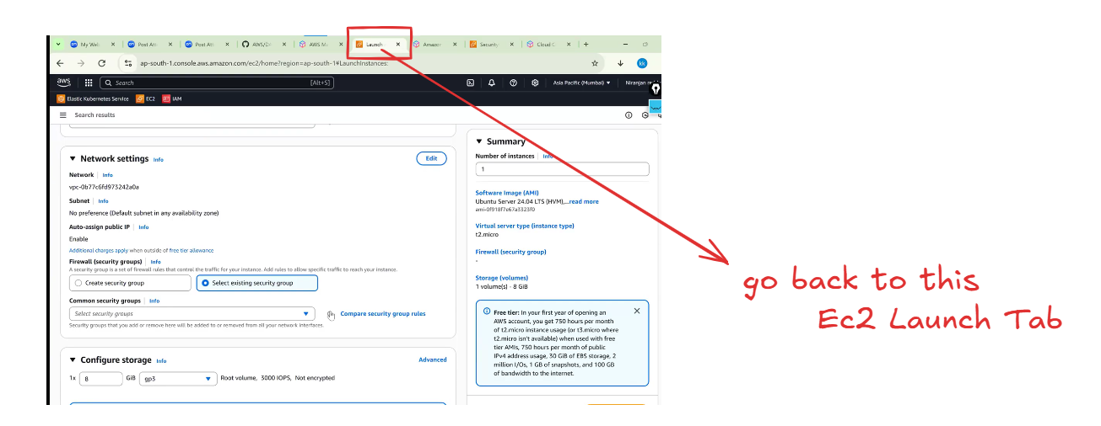
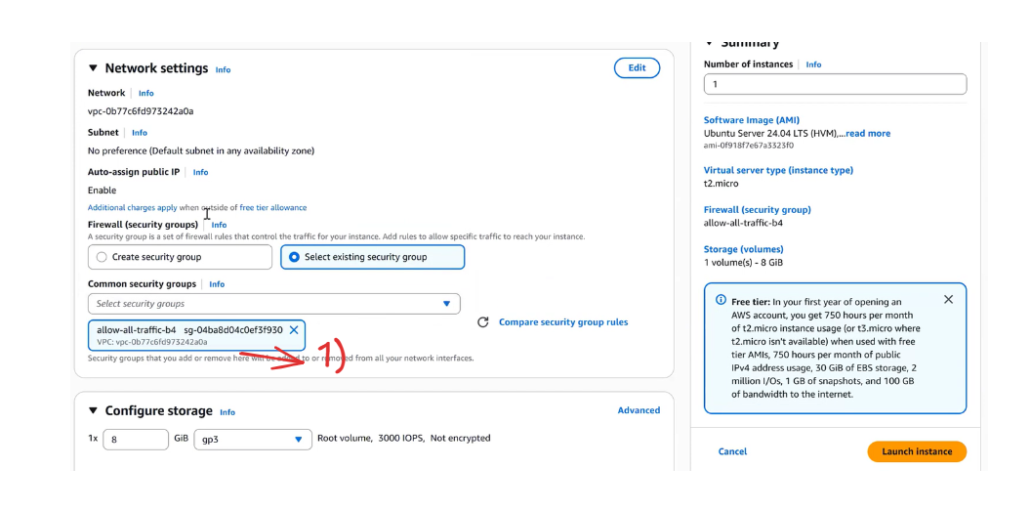
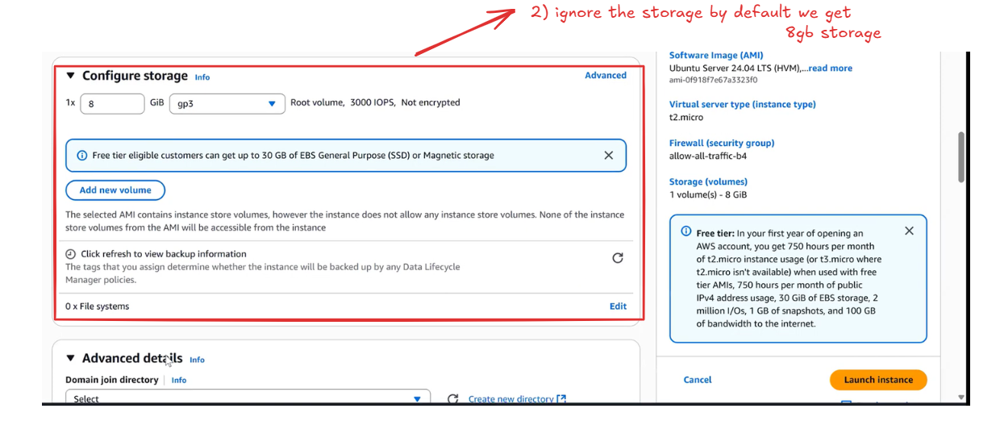
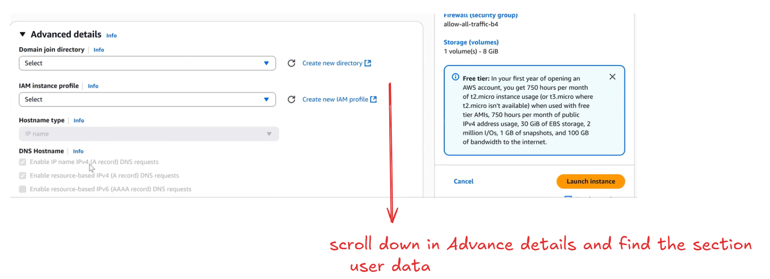
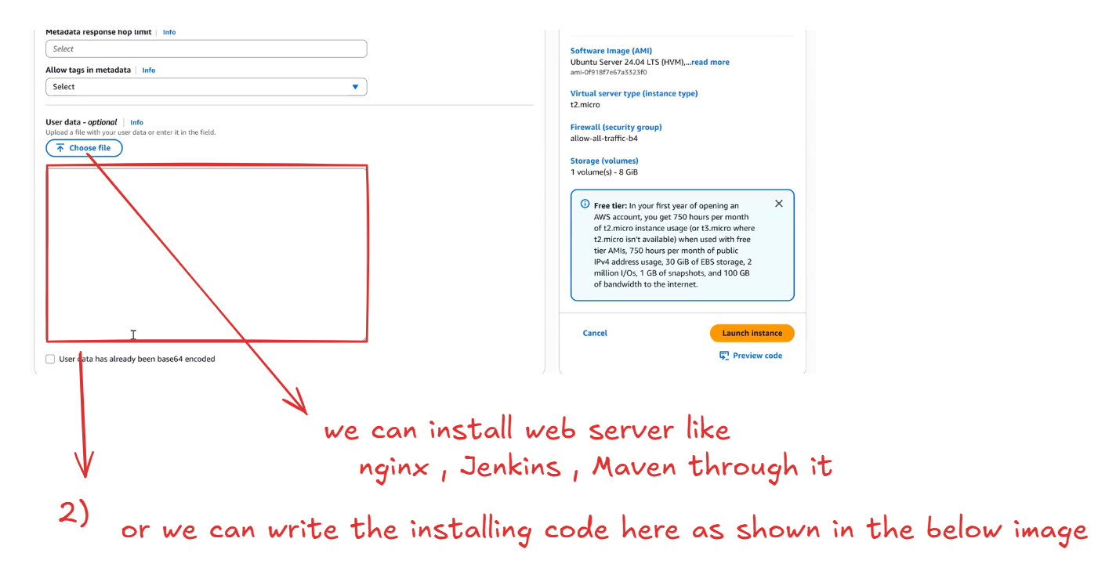
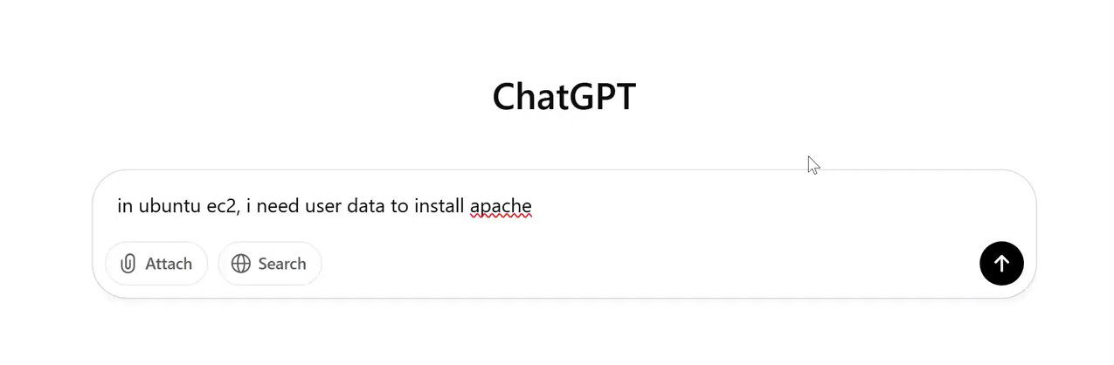
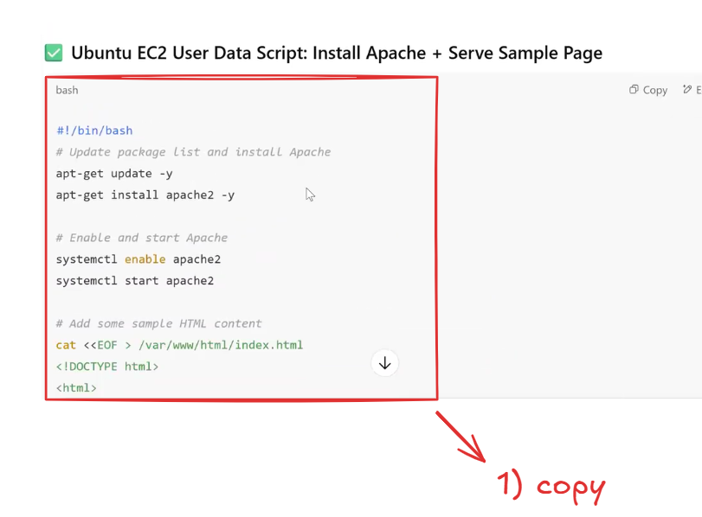
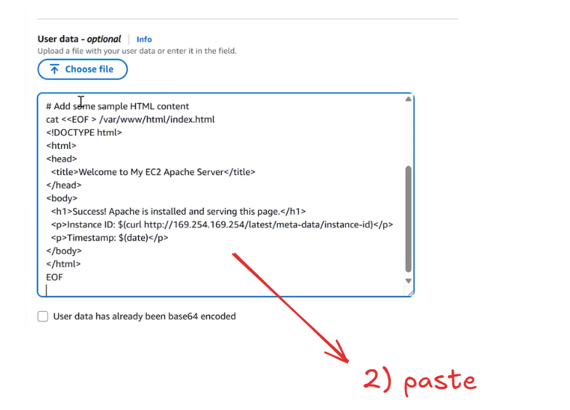
we have Launch the Instance
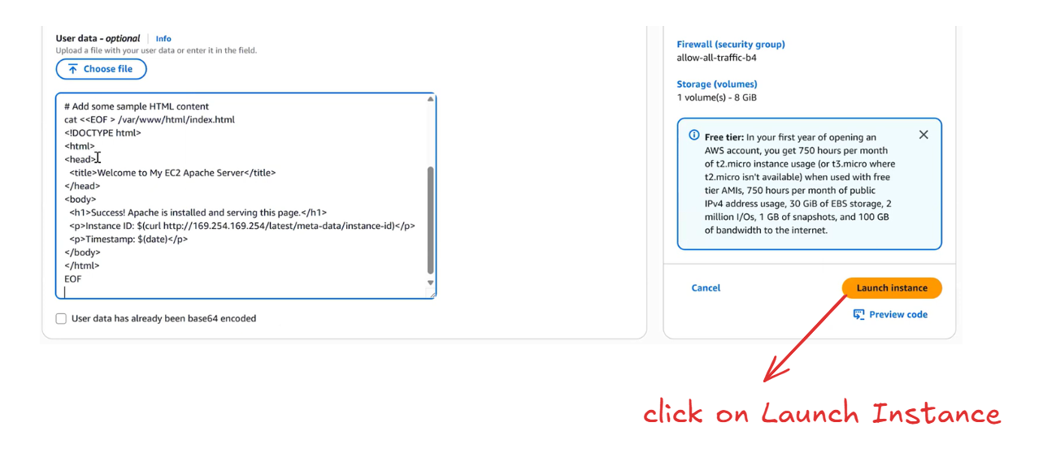
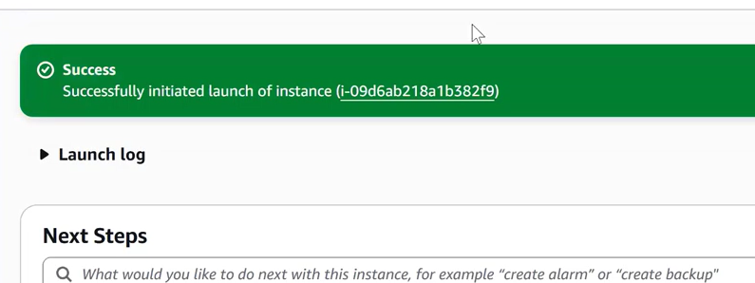
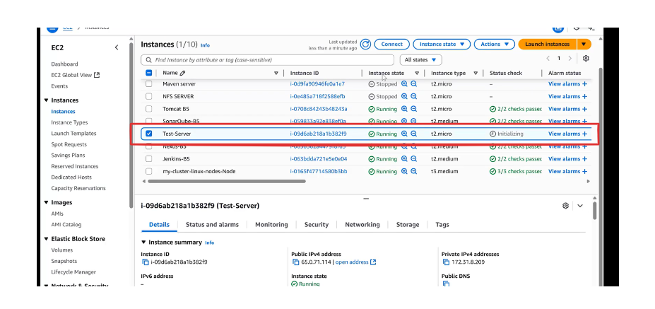
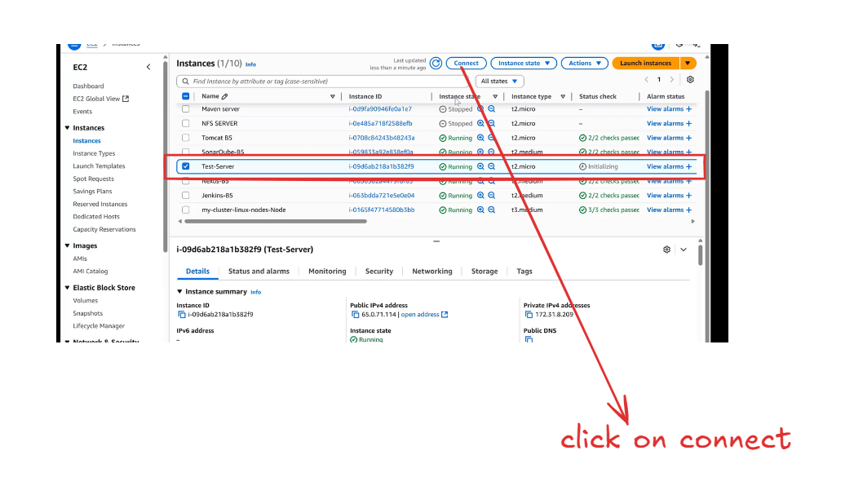
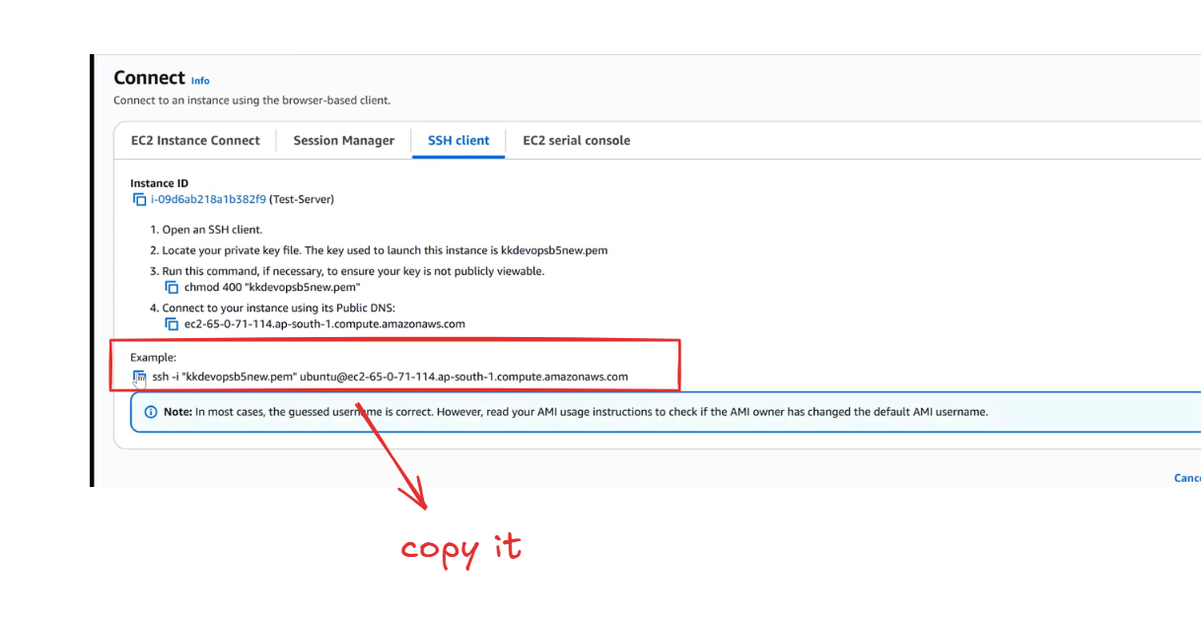
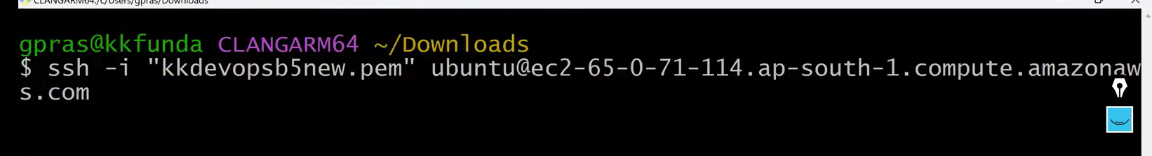
Let’s check the Apache server status whether it’s running or not
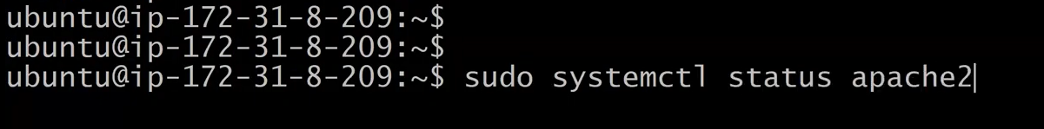
As you can see in the below image The Apache server is successfully Installed through User Data
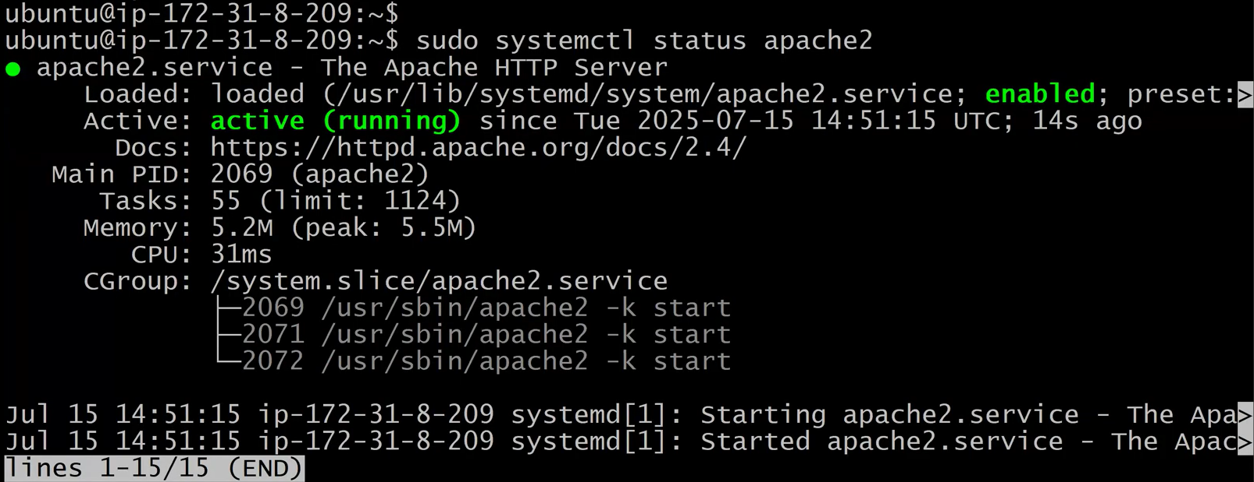
Time stamp 50:00:00

