In this class we will see how to make Jenkins communicate with our team through Slack by integrating Slack channels with Jenkins jobs, allowing us to receive instant build notifications and updates directly inside Slack.
We also learned how to secure the Jenkins server by creating users and applying role-based access control so that admins, DevOps engineers, and developers each get the appropriate permissions. Together, these configurations help us build a system that is both collaborative and secure, ensuring smooth communication and safe CI/CD operations.
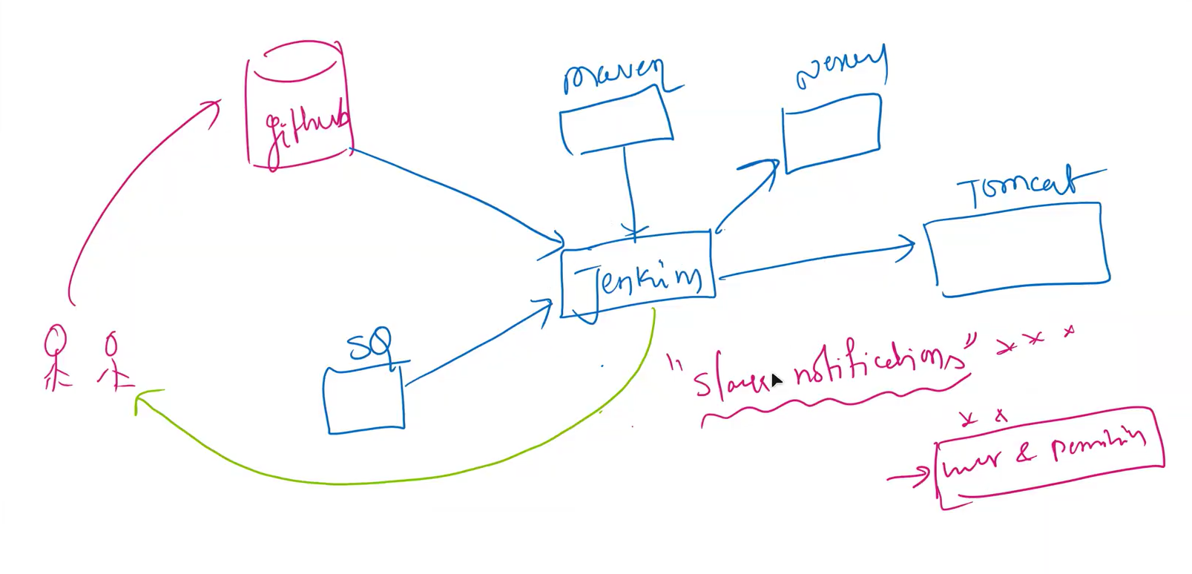

Signup with Slack , Login and create a workspace and then crate a channel and send invite to the users or Team to join in the workspace as shown in the below image
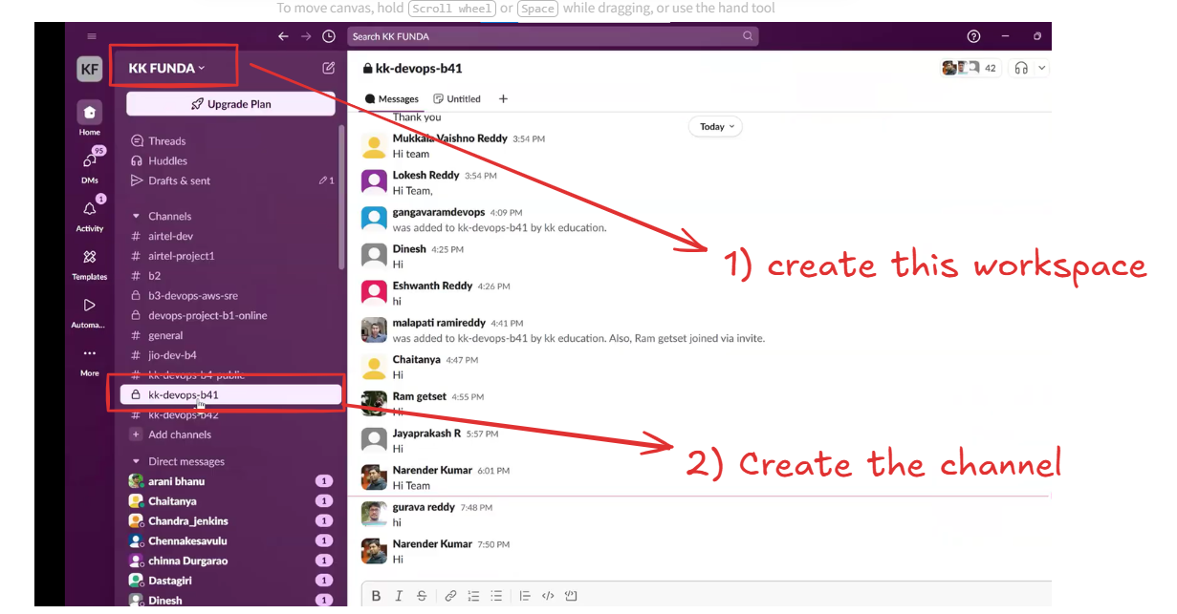
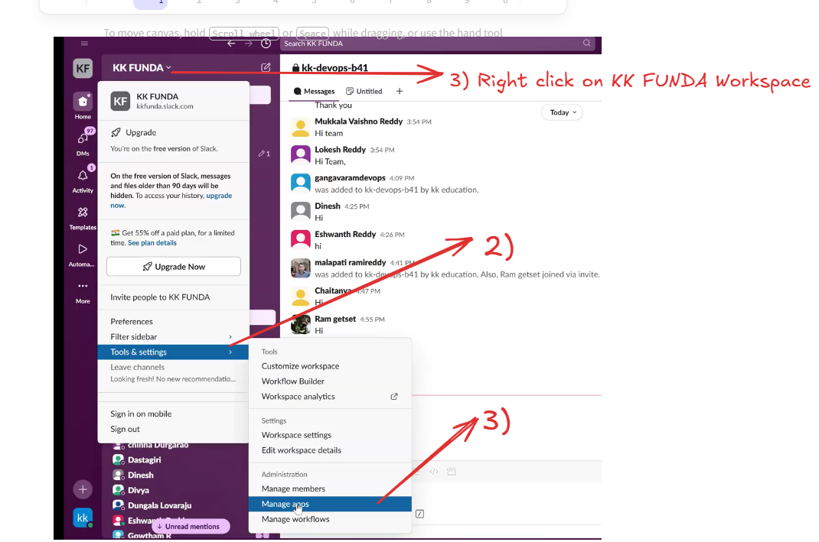
Please practice the below Slack Integration and Configuration
Check the video from 19:00:00 to 40:00:00 where the trainer discusses how to install the Jenkins CI app on Slack, assign the Jenkins CI application to a specific Slack channel, download the Slack plugin in Jenkins, and configure the Slack plugin inside the Jenkins server. This section also covers integrating Slack with the Jenkins server and enabling real-time notification messages to appear in the Slack channel.
Next Topic is Jenkins Security Like creating the user in the Jenkins server’s Host machine and enabling security to the user Time Stamp (41:00:00)
Jenkins Security refers to the process of protecting the Jenkins server by controlling who can access it, what actions each user can perform, and how jobs, credentials, and system configurations are secured.
It ensures that only authorized users can log in, manage pipelines, modify jobs, install plugins, or view sensitive data.
In simple words:
👉 Jenkins Security = Protecting your CI/CD server from unauthorized access and restricting permissions based on roles.

🧒 Explained Like a 10-year-old
Imagine Jenkins is a big computer lab.
If everyone can enter the lab and press any button, things will break.
So, Jenkins Security acts like:
- A security guard (login authentication)
- A teacher who gives different permissions (RBAC)
- A lock on important cupboards (credential protection)
It decides who can enter and what they can do inside.
Let’s connect to the Jenkins instance or server and switch to root user as shown in the below image
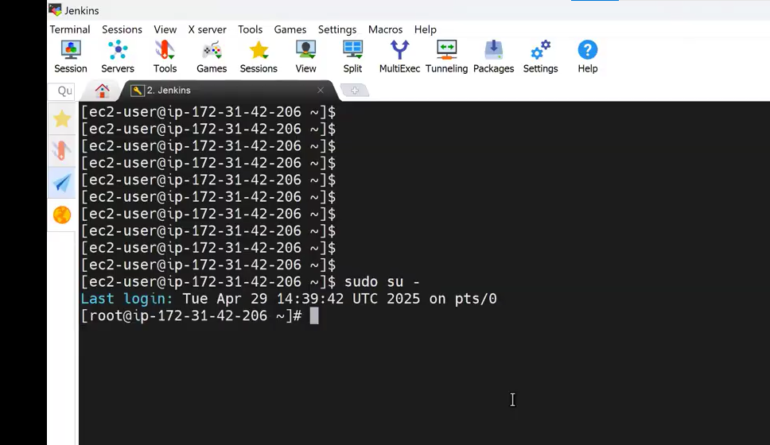
Navigate to Jenkins Default Directory cd var/lib/Jenkins
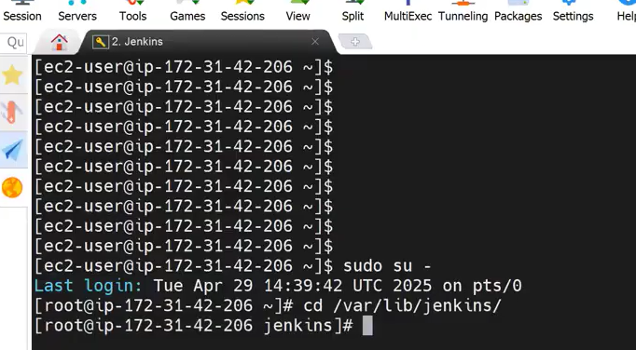
Inside the Jenkins directory we have another directory called users so Let’s navigate to user Directory
as shown in the below Image
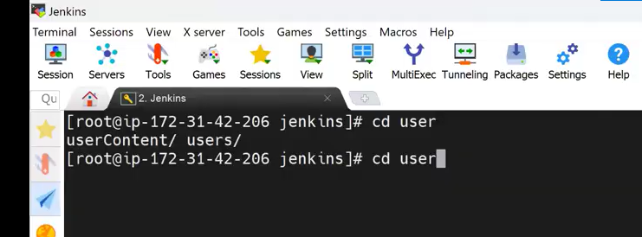
Inside the Users directory You will see uers.xml file as shown in the below Image
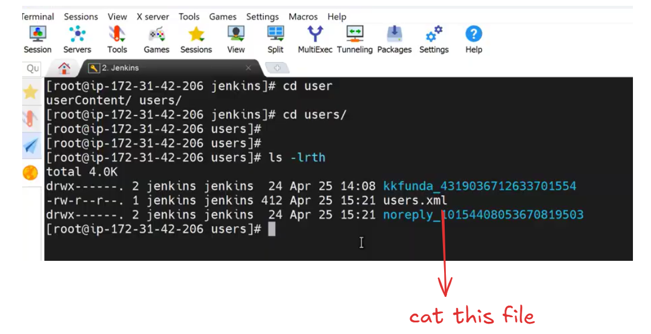
All Jenkins users account details are stored inside the users.xml file
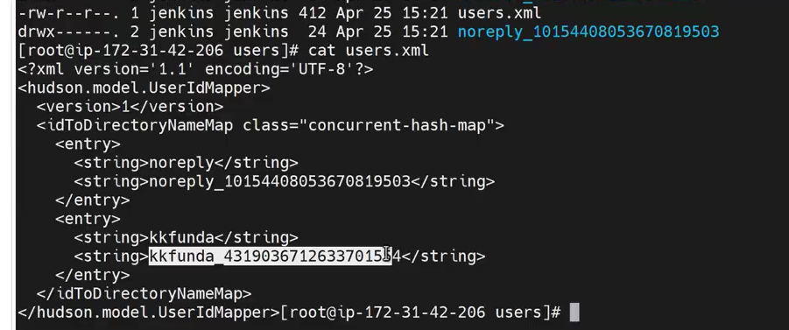
execute the clear command and then execute top command
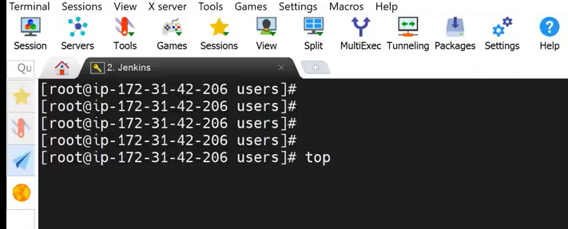
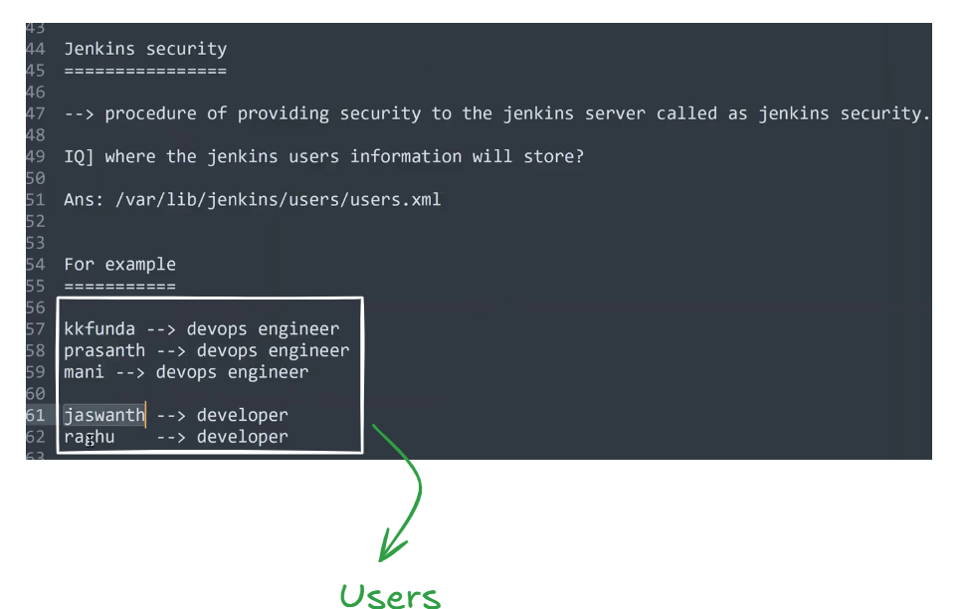
Let’s Try to create a user using Jenkins GUI as shown in the below image
1. Login to Jenkins
Open the Jenkins URL in the browser (example: http://<IP>:8080).
2. Navigate to Manage Jenkins
Click on Manage Jenkins from the left-side menu.
3. Open Manage Users
Inside the Manage Jenkins dashboard, click on Manage Users.
4. Select Create User
Click on the Create User option to open the user creation form.
5. Enter User Details
Fill in the following fields:
- Username
- Password
- Confirm Password
- Full Name
- Email Address
6. Create the User
Click on the Create User button to complete the process.
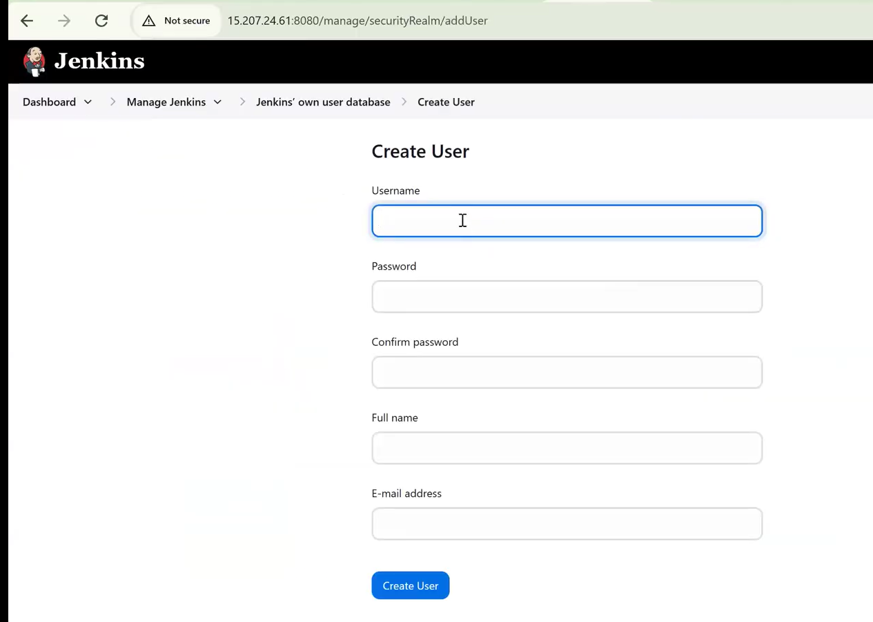
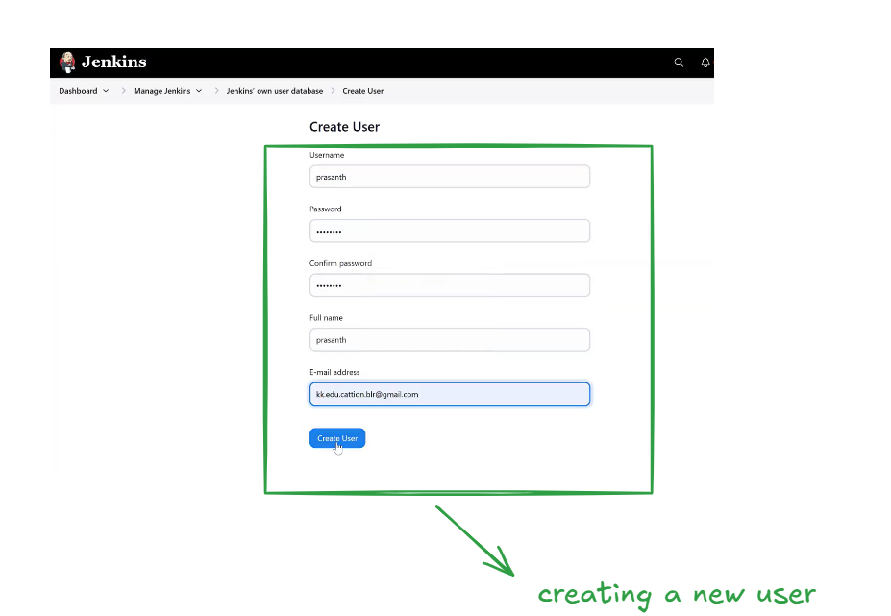
So far we have two Jenkins user as shown in the below image
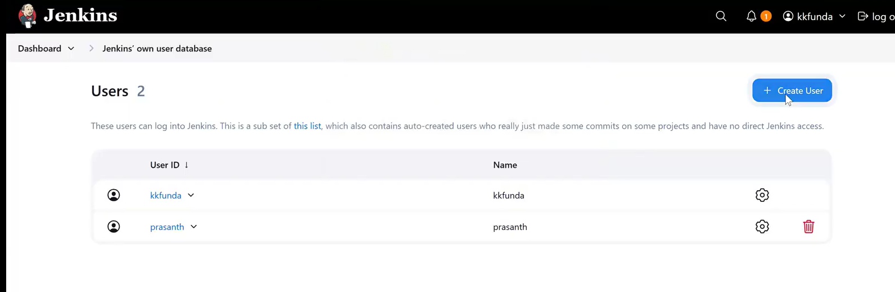
Let’s create few more users as shown in the below
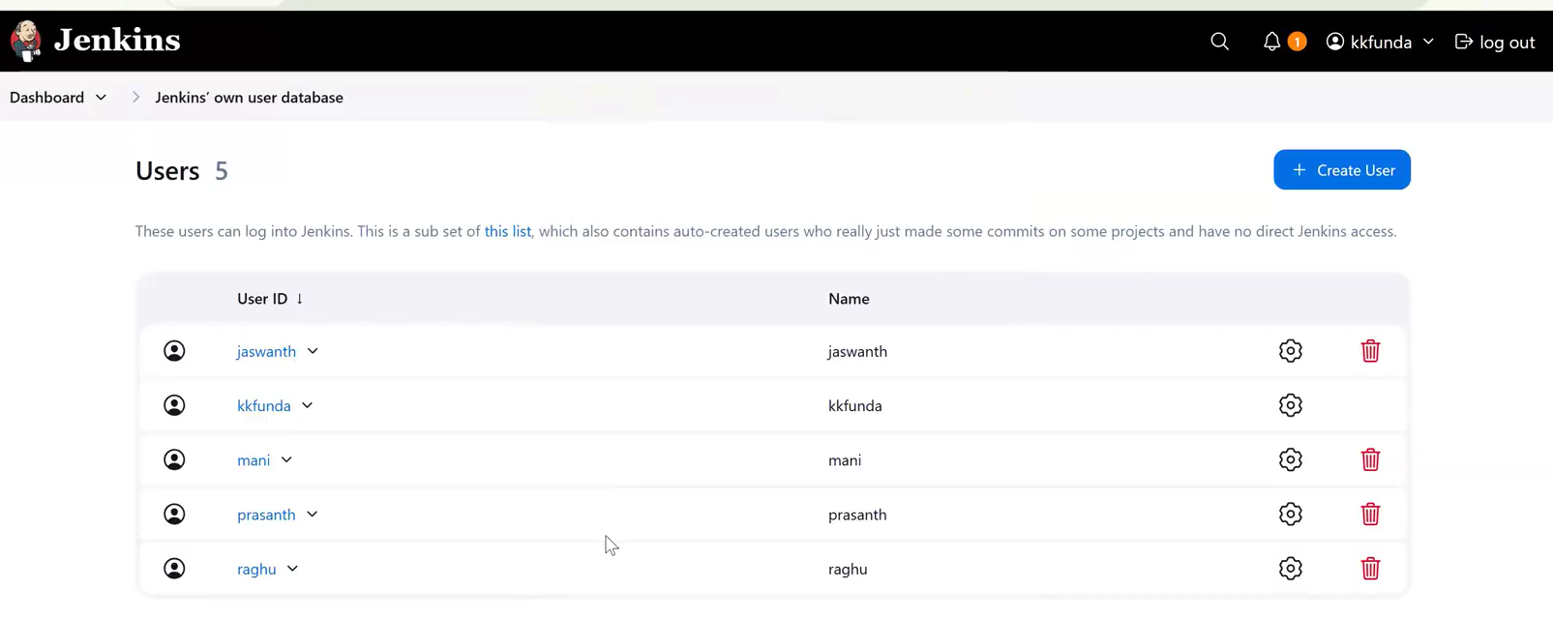
So far we have created the Jenkins users
By default, all these users will have Admin access, which means they can perform full CRUD operations (Create, Read, Update, Delete) on Jenkins. To restrict their permissions, we need to install and configure the Role-Based Authorization Strategy plugin as shown in the below image
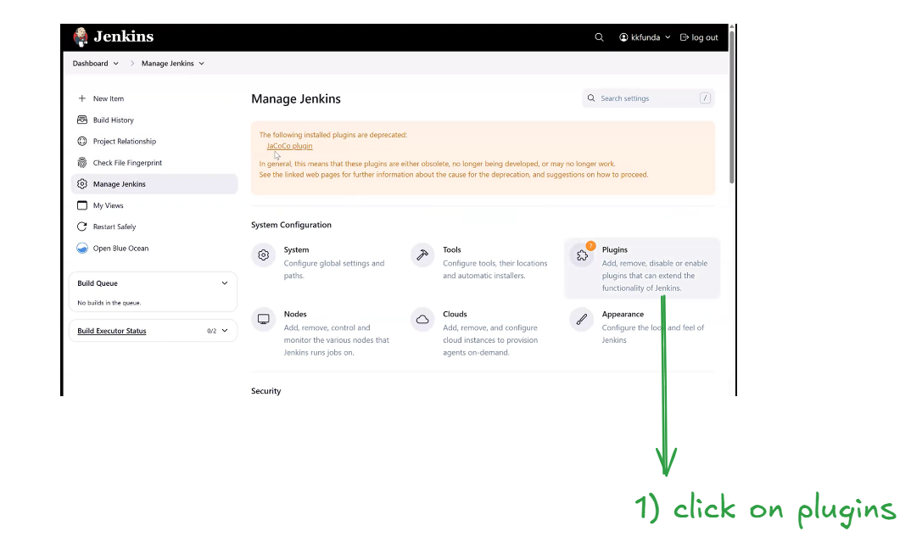
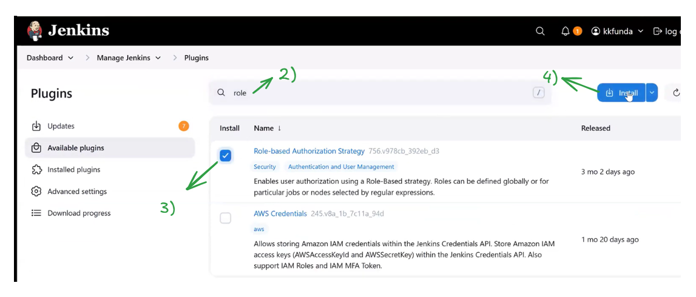
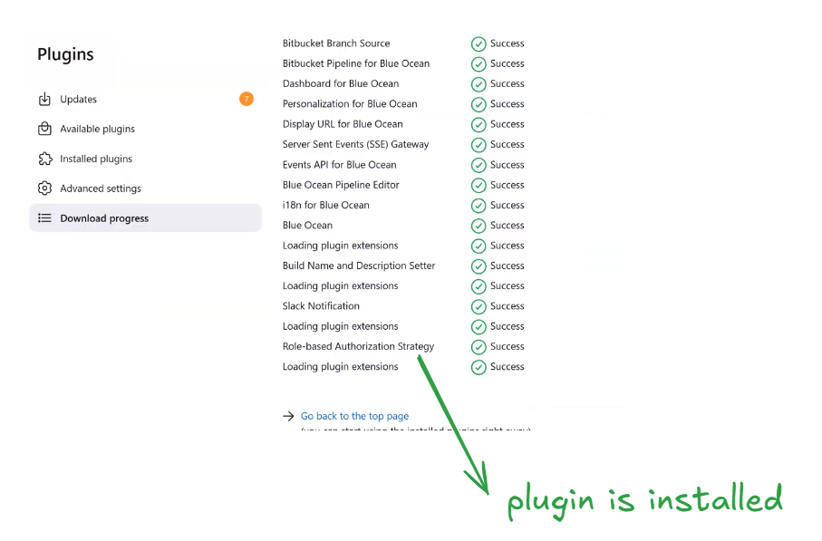
Next follow the below step as shown in the below image
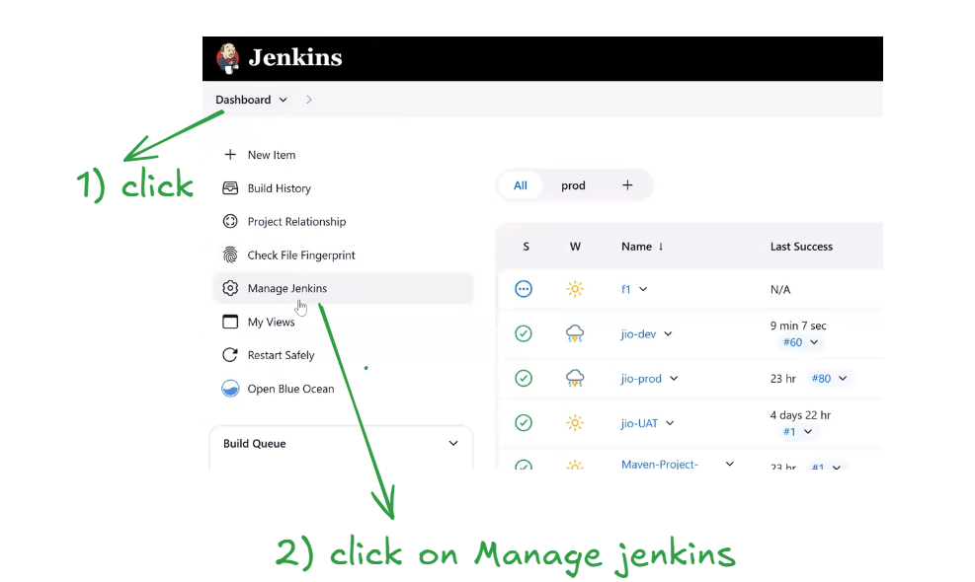
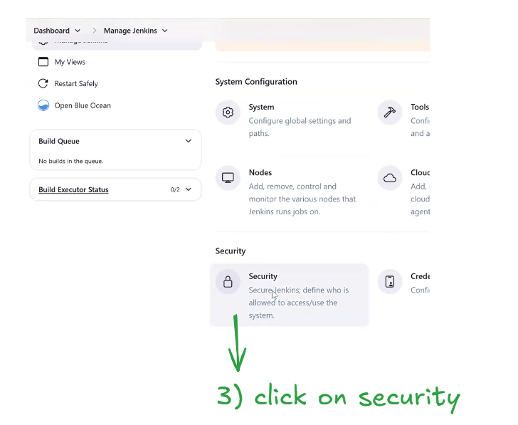
Time stamp 48:42
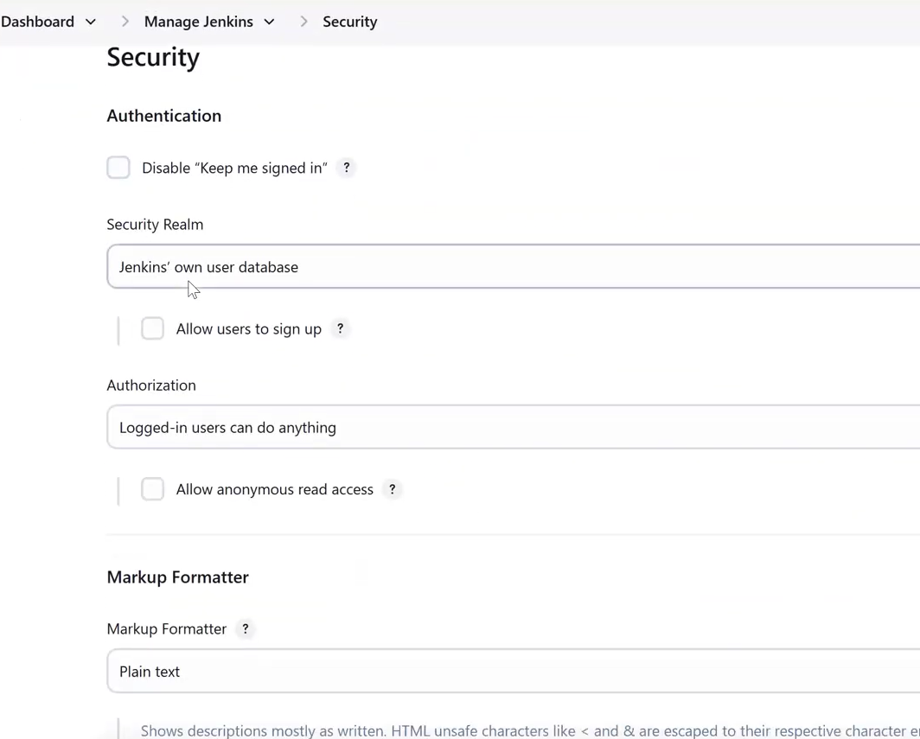
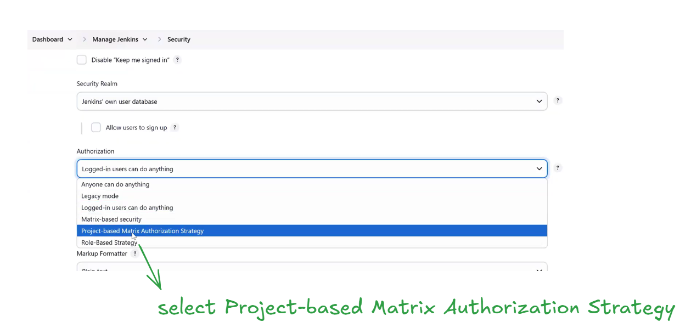
Time stamp 50:00:00
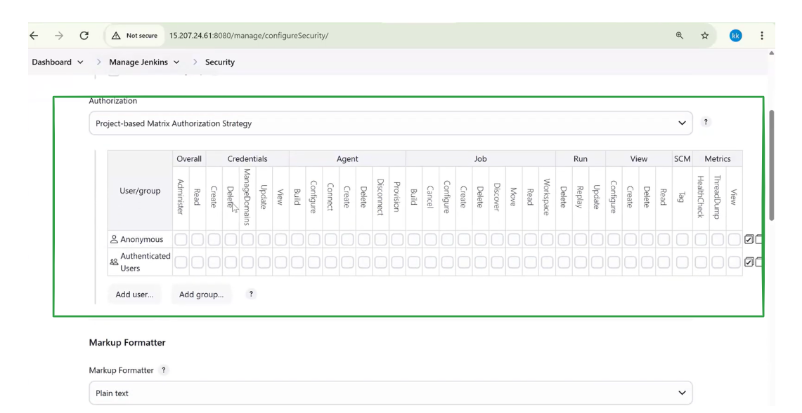
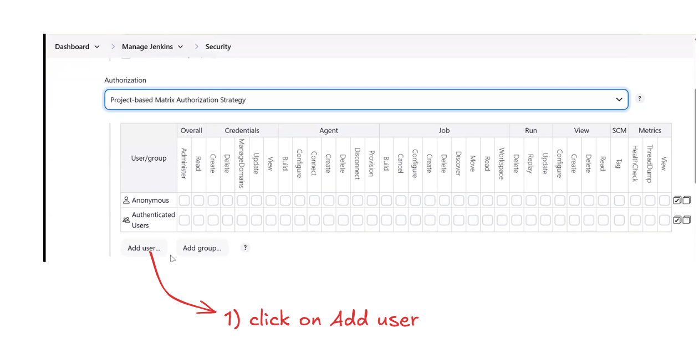
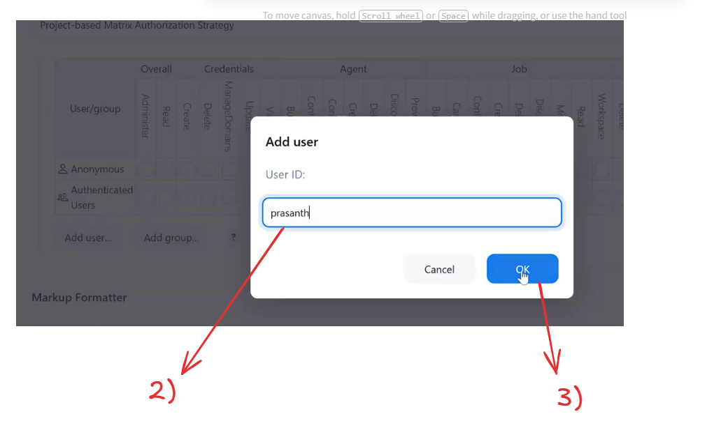
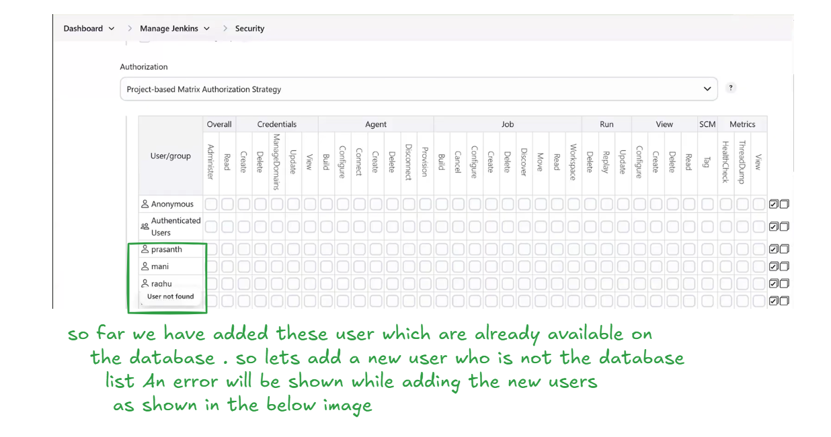
Let’s try to add a new user name Krishna . It will throw an error as Krishna is not registered in the database as shown in the below image
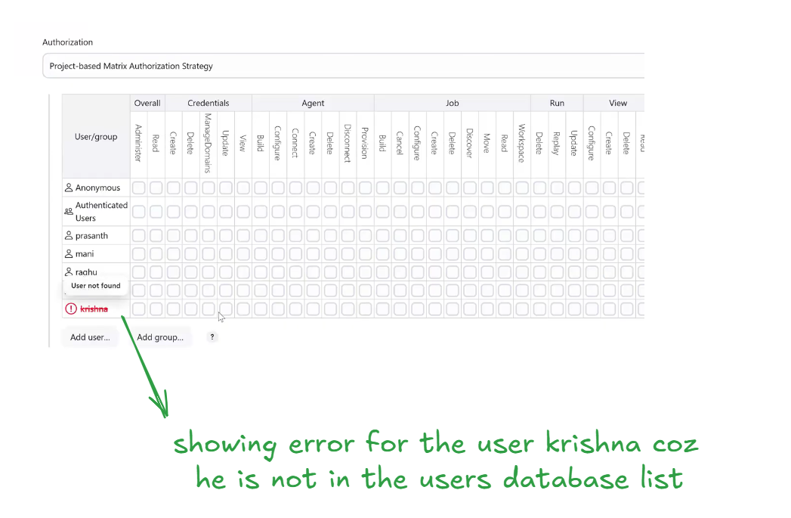
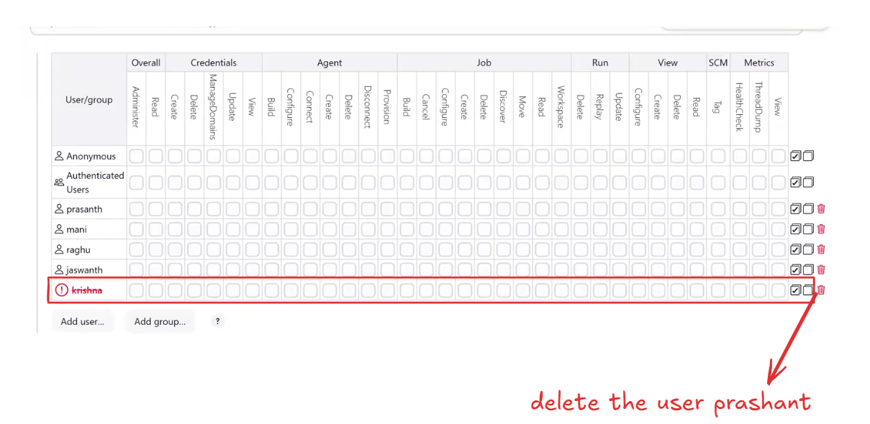
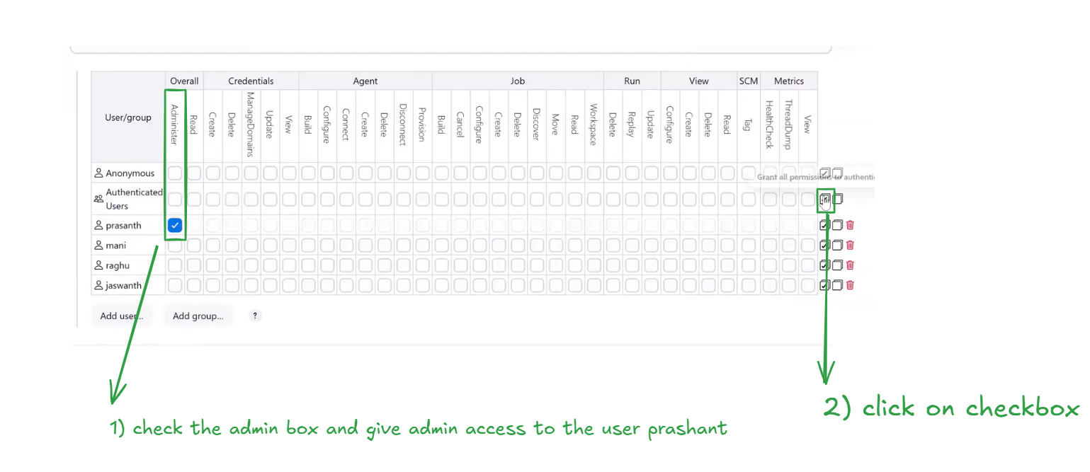
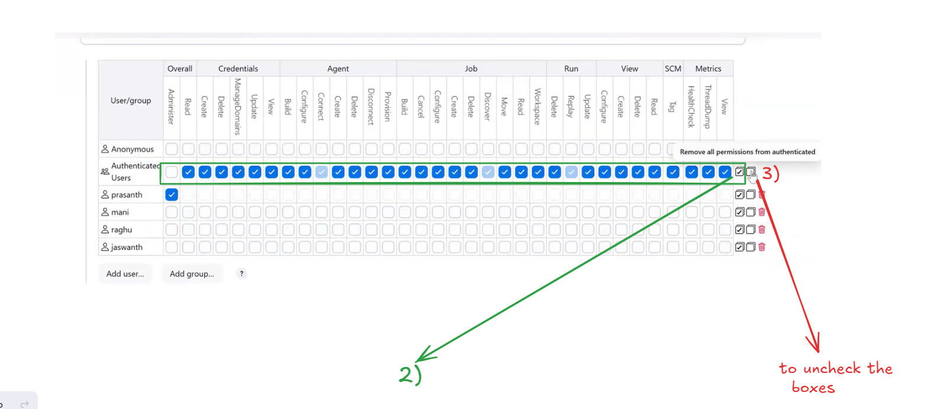
Let’s give the read access to Raghu and Jaswanth as shown in the below image
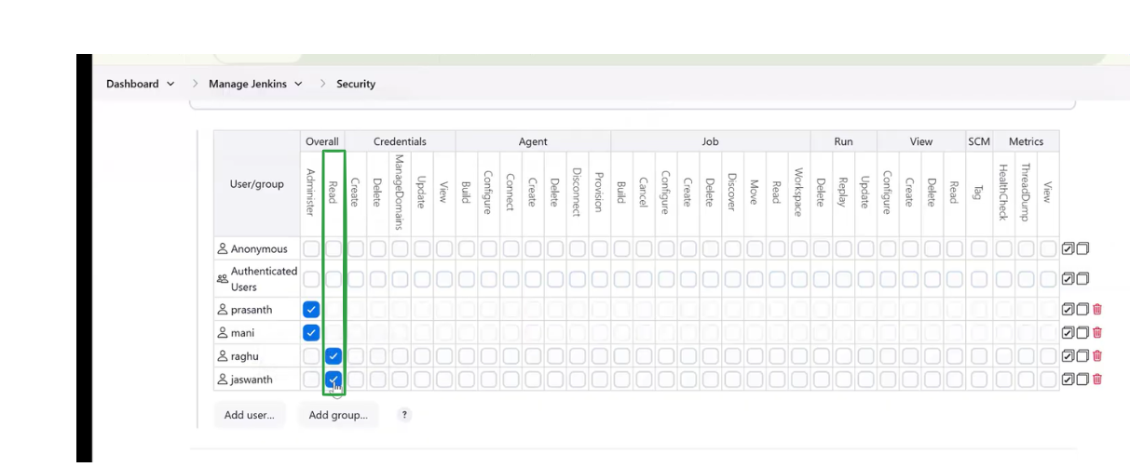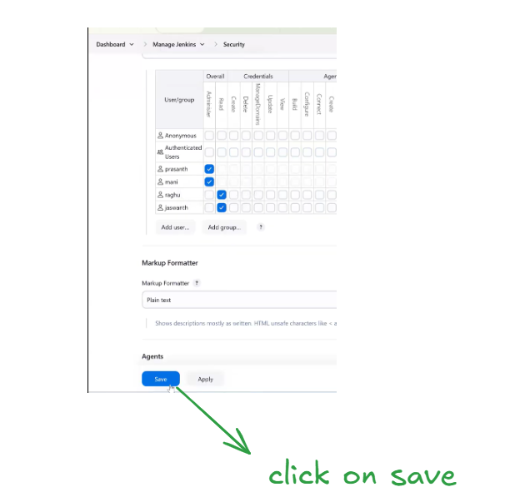
oops after clicking on save we are getting the below error. Saying that KKFunda user is not an admin becoz we gave admin access to only prashant as shown in the below image
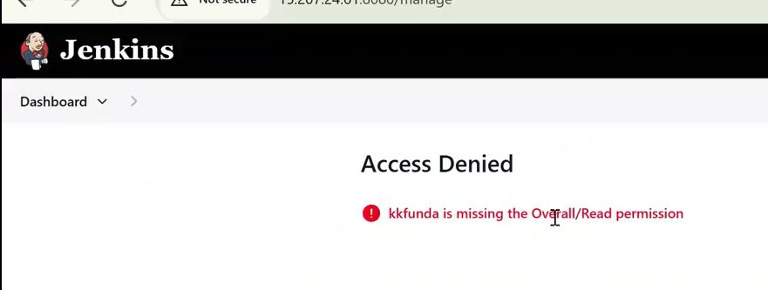
Lets login in to Jenkins as Prashant user as shown in the below image
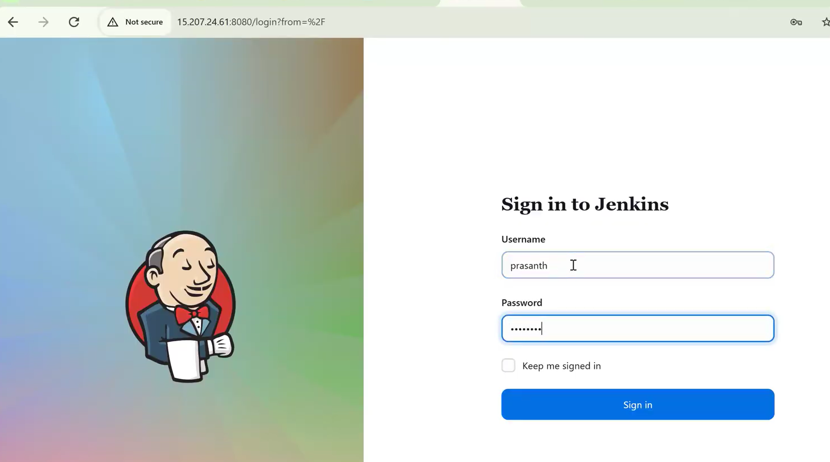
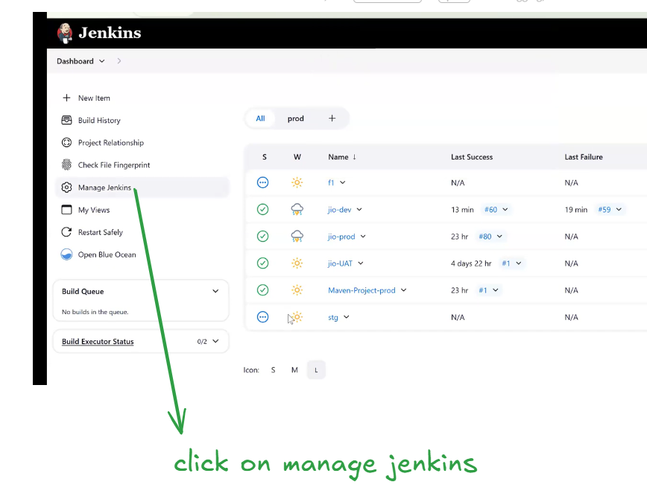
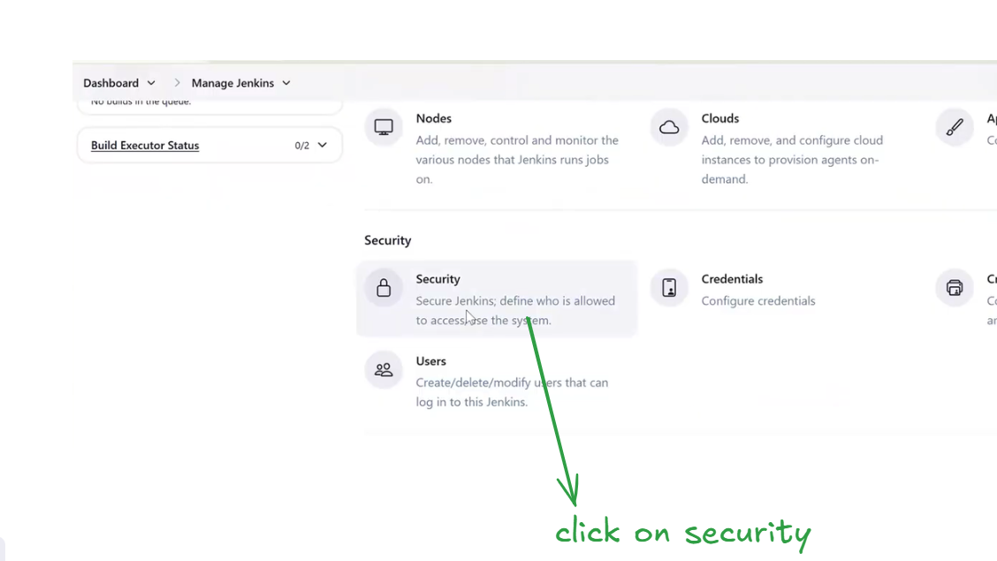
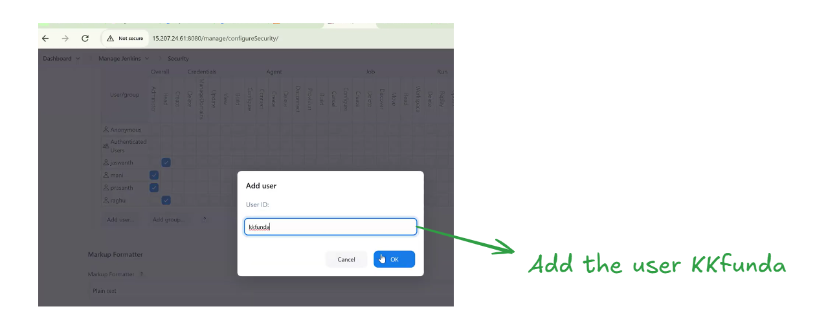
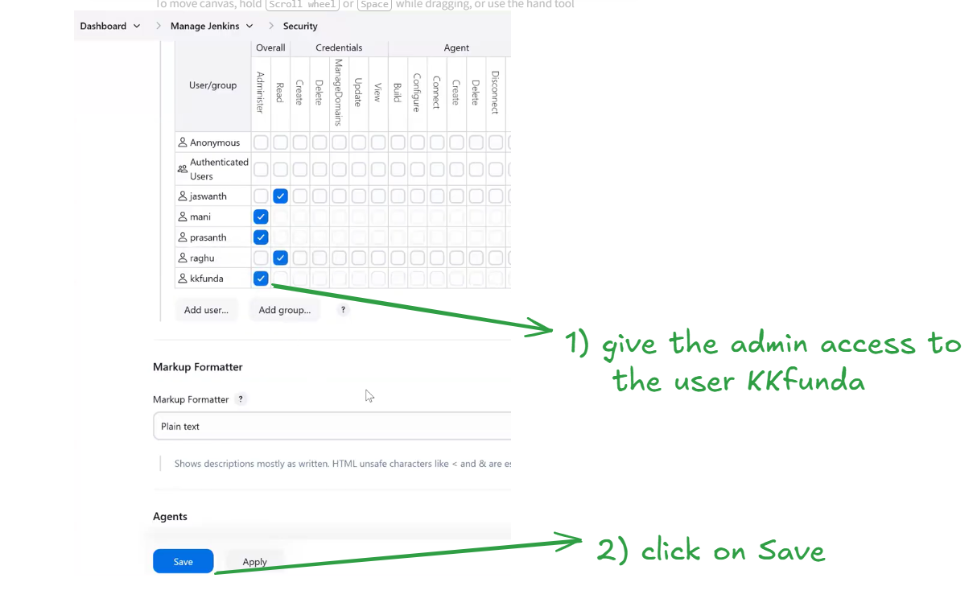
Let’s login the Jenkins with the user Jashwanth . we gave only read access to this user as shown in the below image
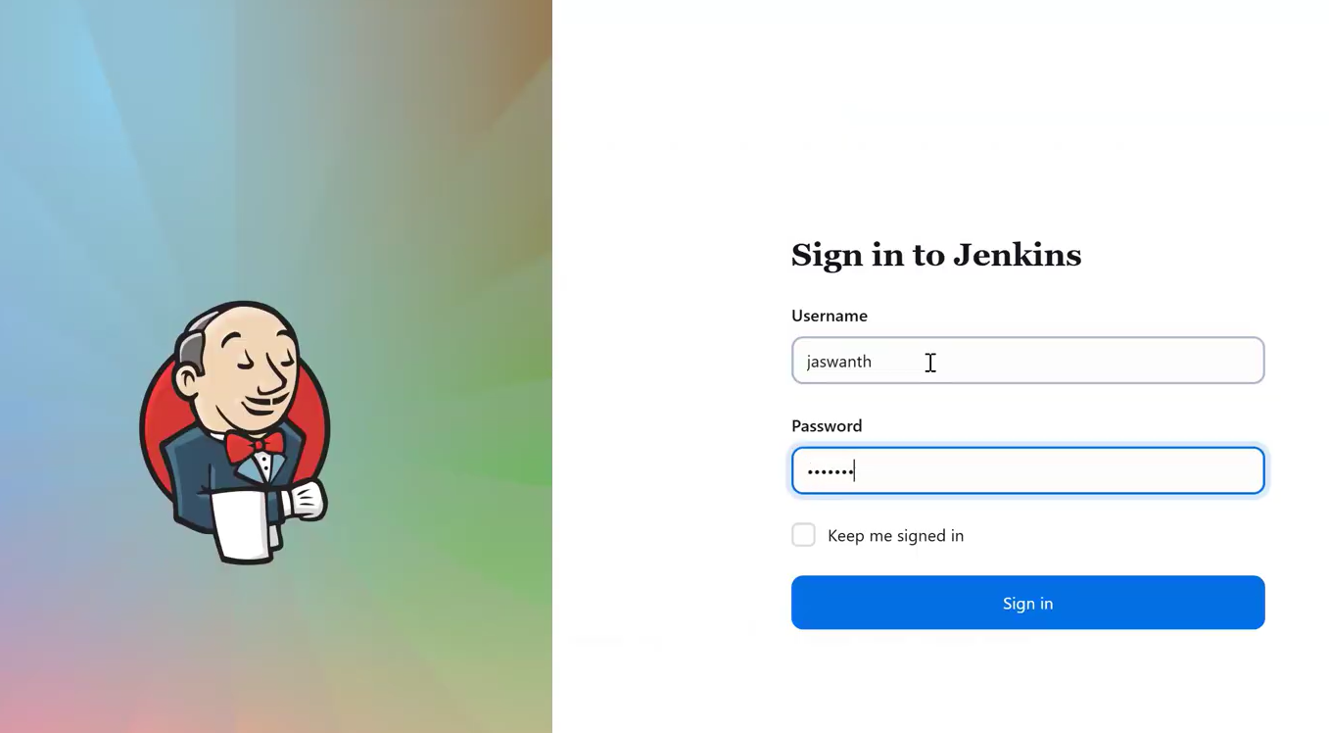
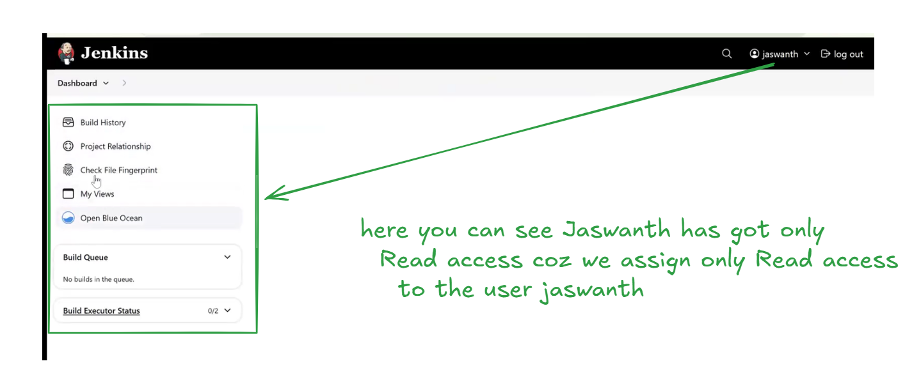
Let’s grant CRUD access to Jashwanth using the admin account Prashant as shown in the screenshot.
Please log in to the Jenkins UI with the kkfunda admin user and assign the required CRUD permissions to Jashwanth, as demonstrated in the image.
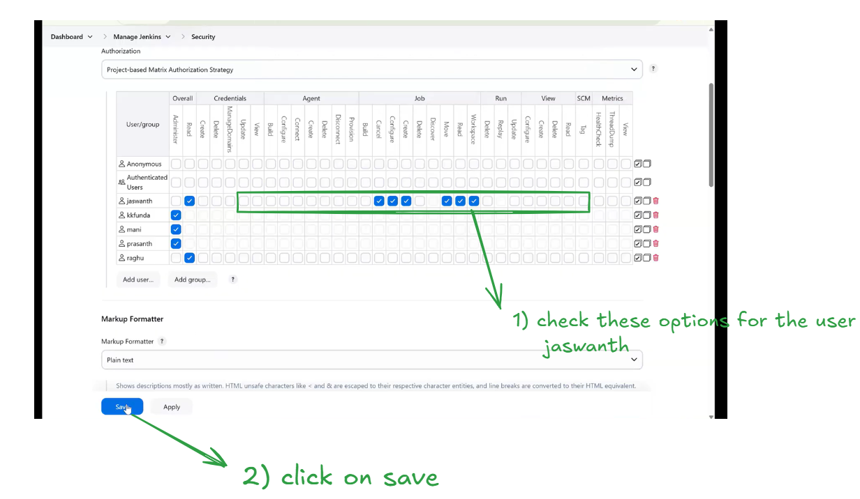
Let’s Logout from Jenkins UI as Prashant admin user and login with the user Jaswanth and check the
Jenkins operation activities assigned to him as shown in the below image
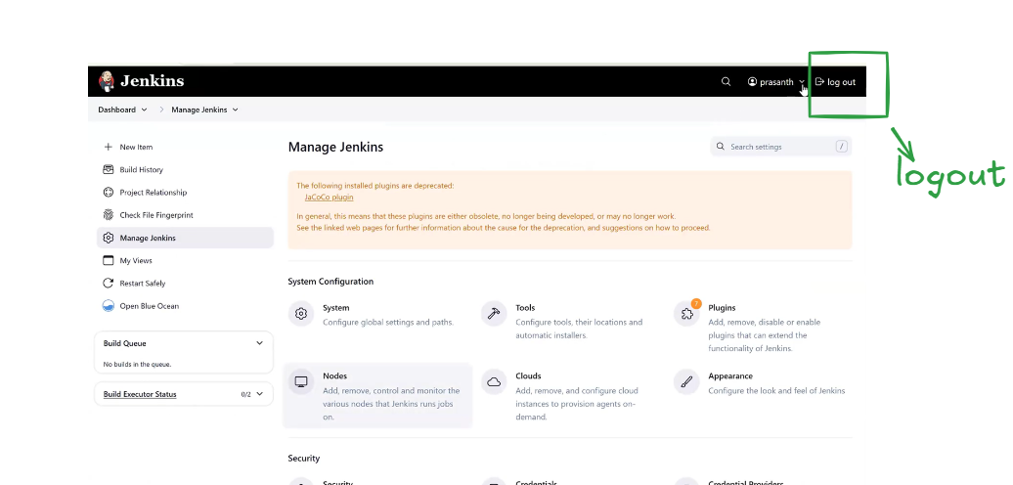
Let’s Login the Jenkins with the Jaswanth user as shown below
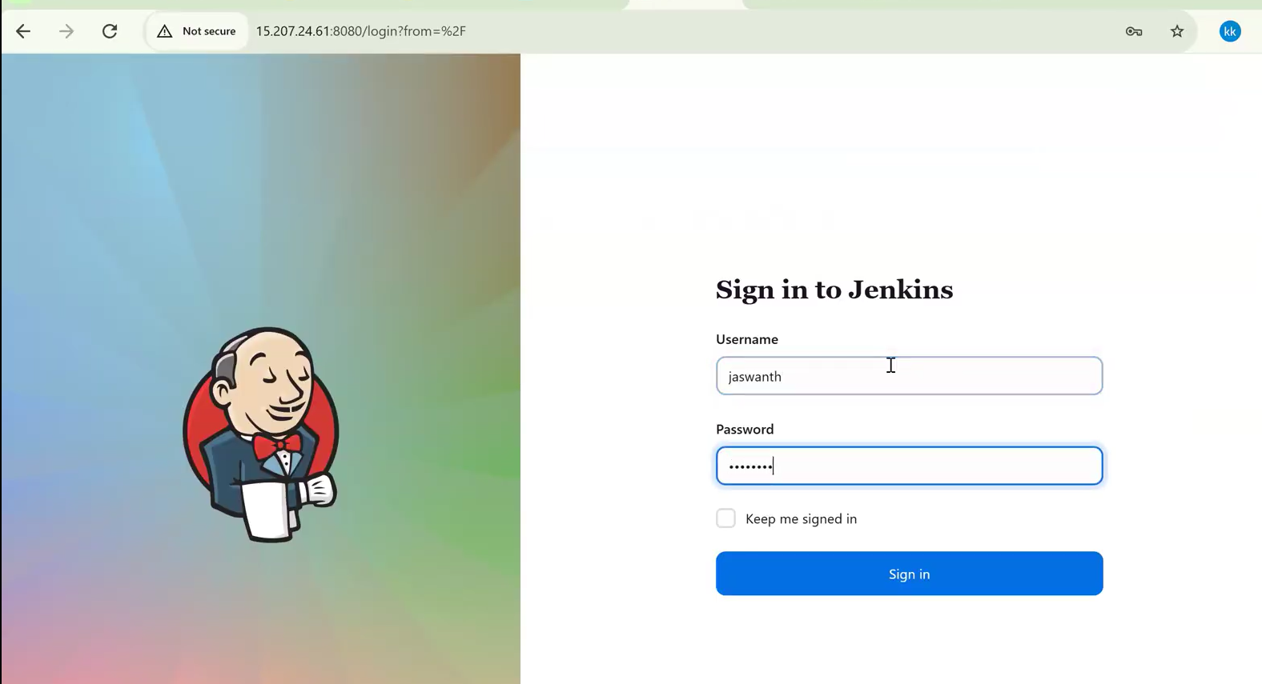
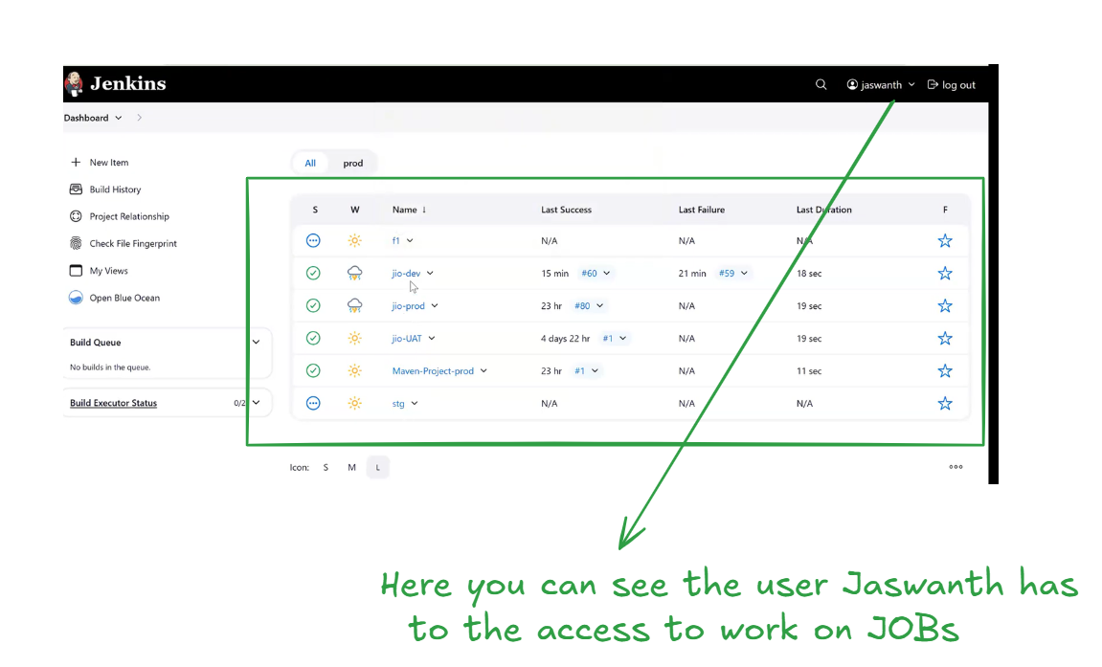
click on any one of the job for suppose click on jio-dev job as shown in the below image
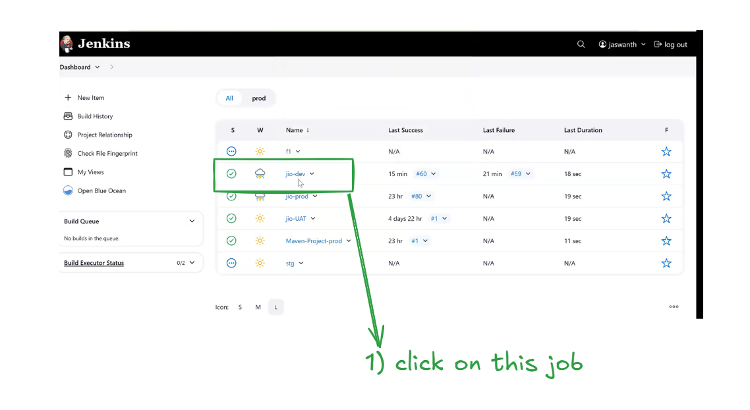
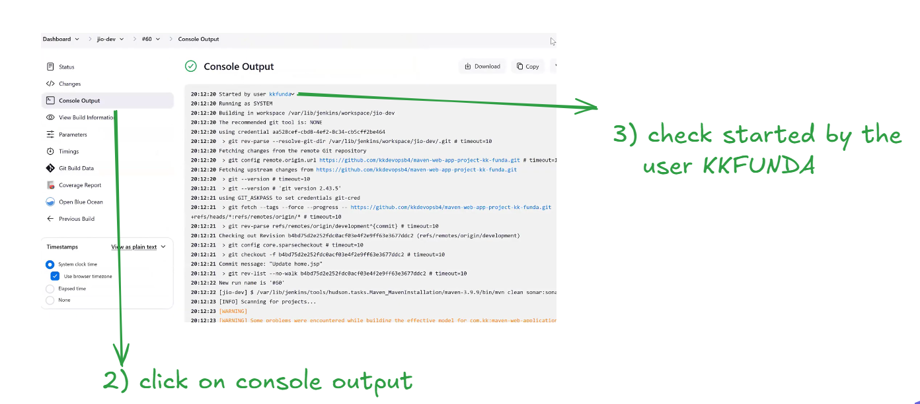
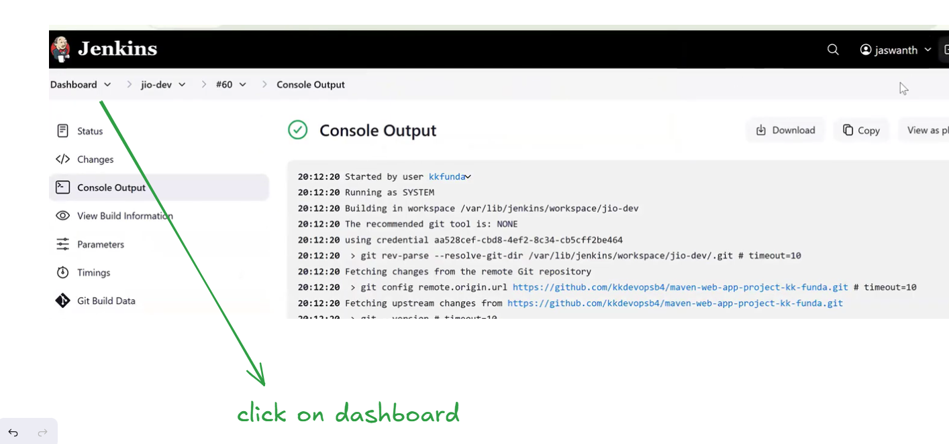
Jashwanth, as a normal Jenkins user, can create jobs but does not have permission to create views.as shown in the below image
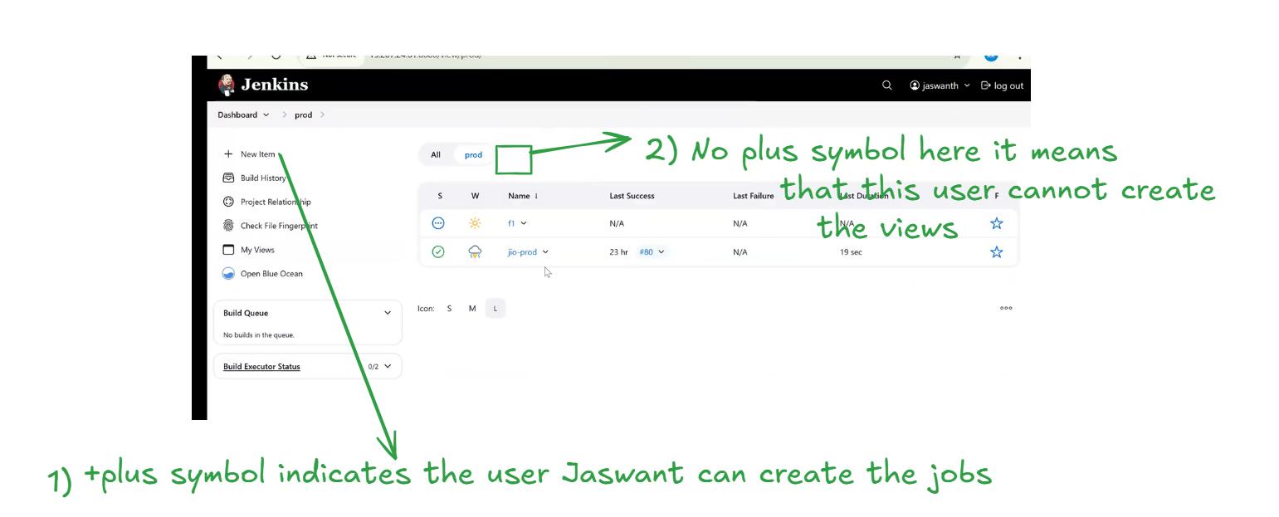
Let’s logout from the user jaswanth and login again with admin credentials kkfunda as shown in the below image
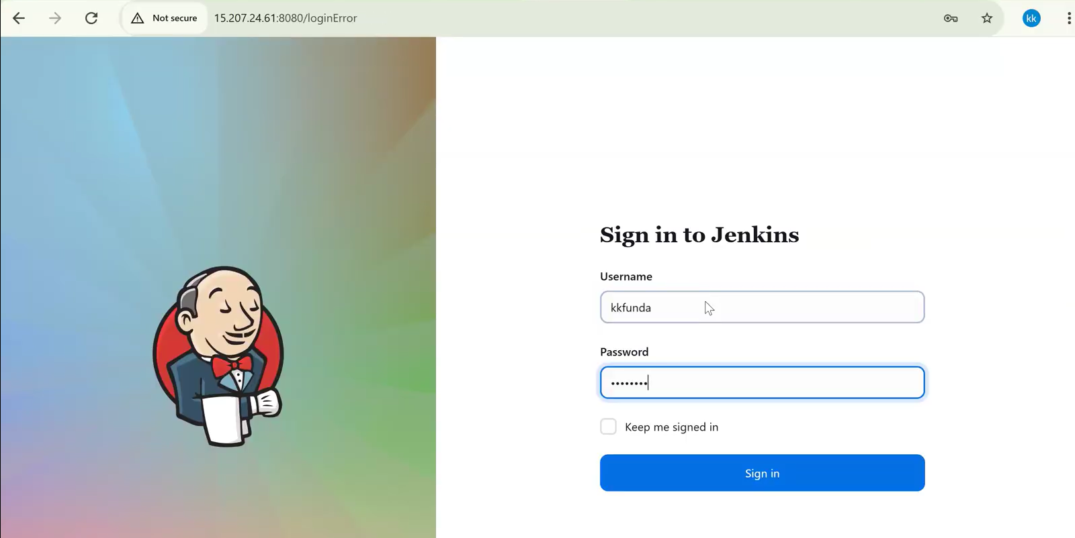
Go to Dashboard----->> Manage Jenkins----->> Security
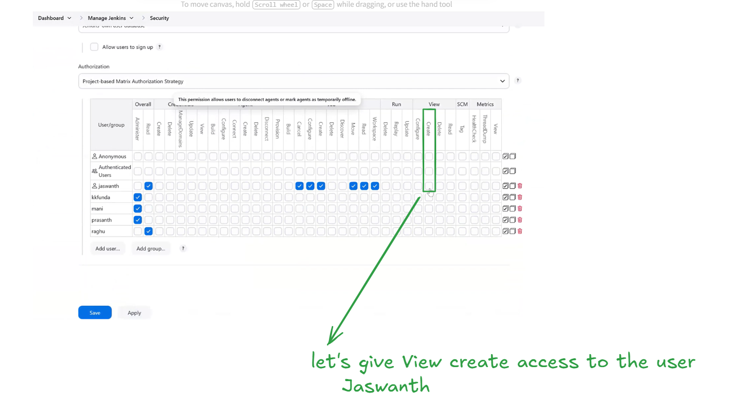
This is how we should work with Jenkins users , granting access
we can give one complete job access to a specific user as explained below
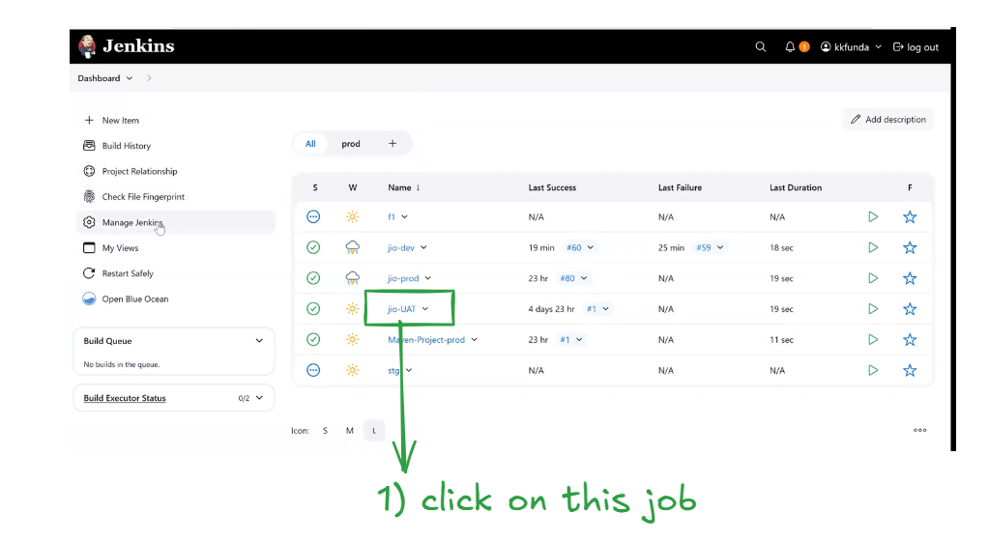
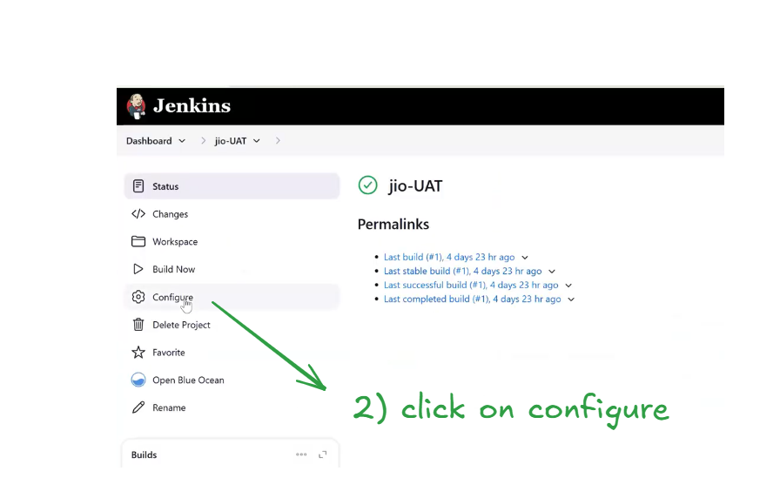
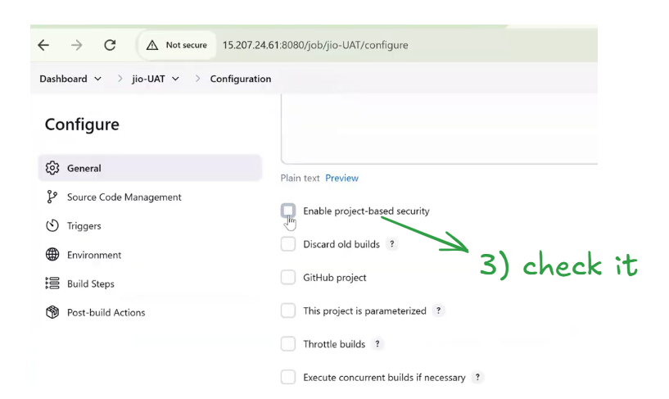
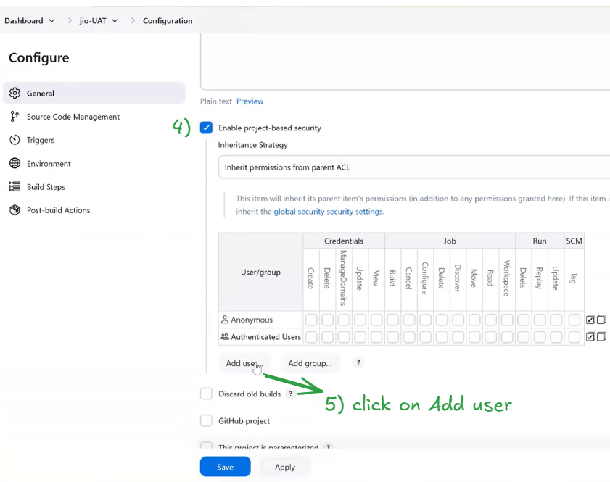

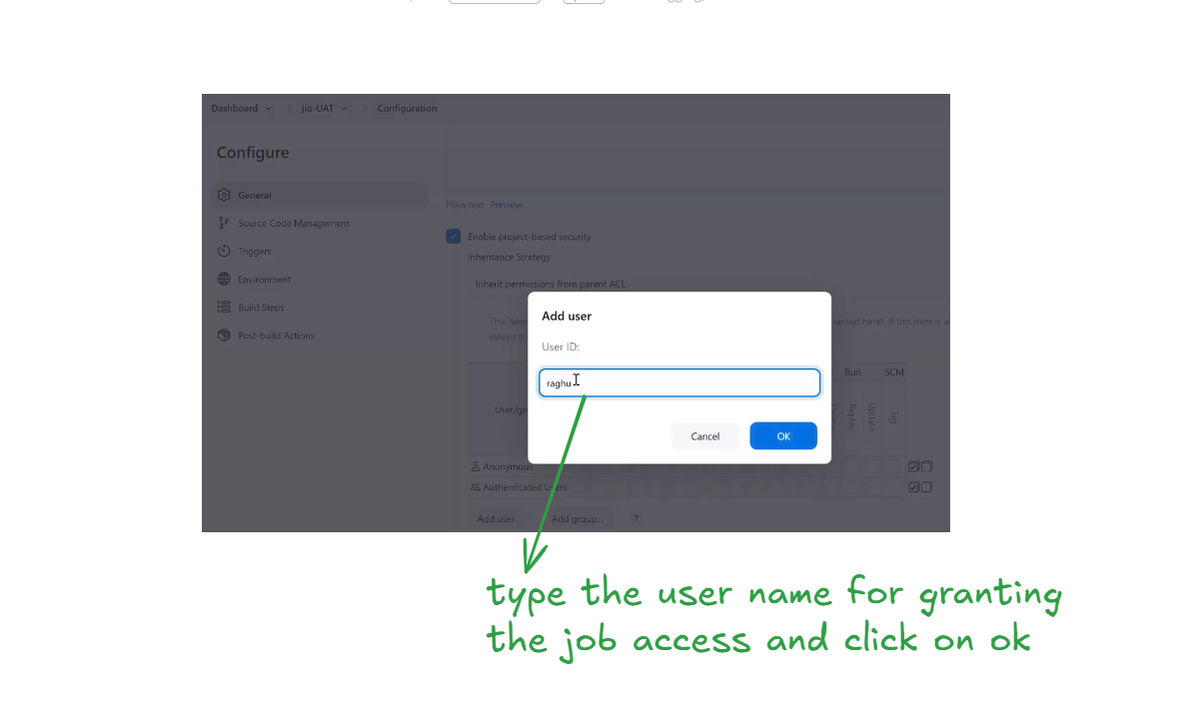
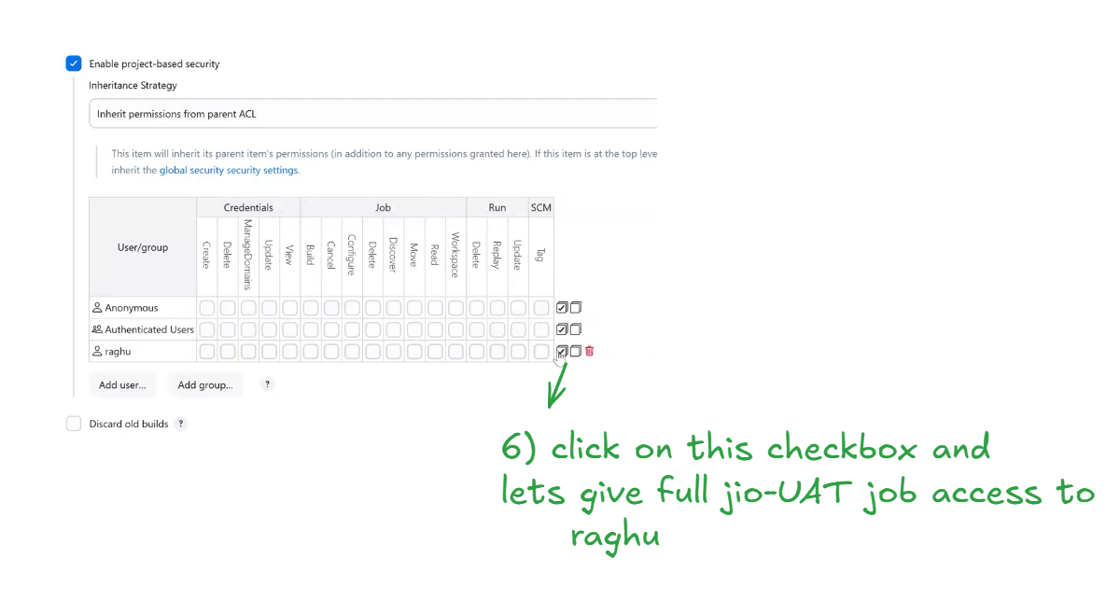
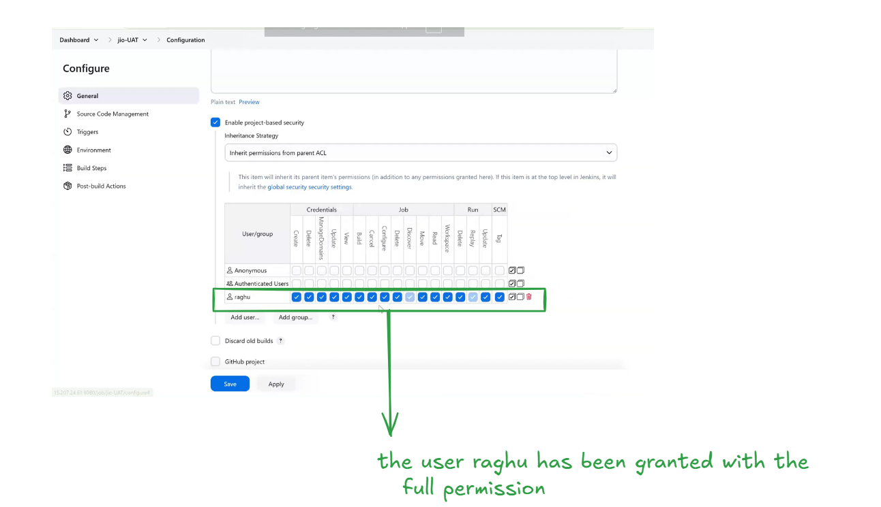
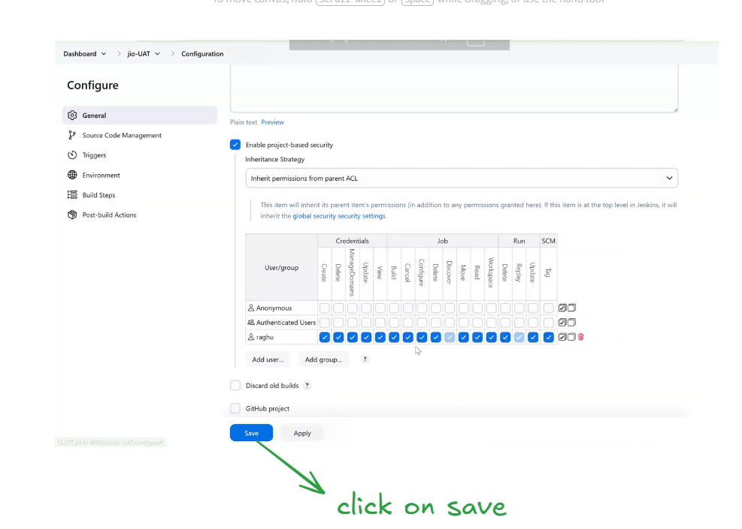
Let’s login the Jenkins with the user Raghu as shown below
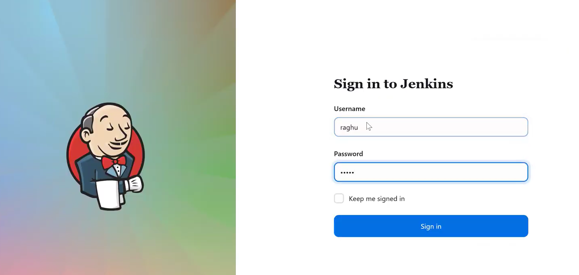
As you can see in the below screenshot, the user Raghu has been successfully granted access to the jio-UAT job.
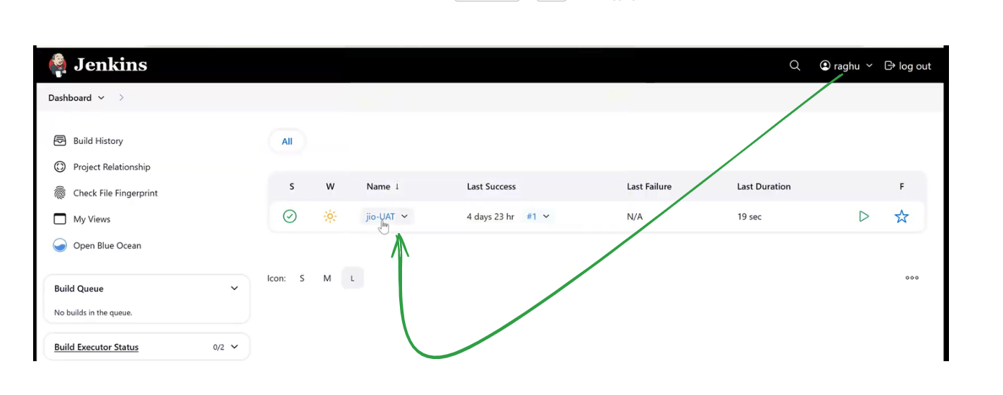
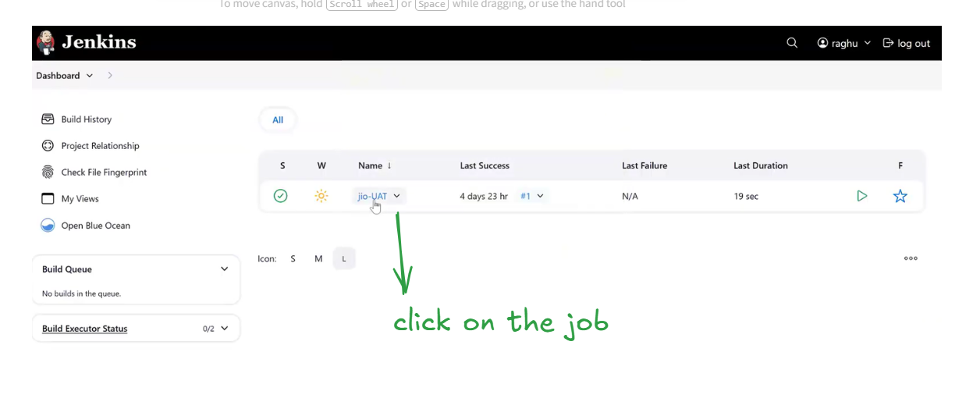
As shown in the below screenshot, the user raghu now has full CRUD permissions for the jio-UAT job and can perform all job-level operations.
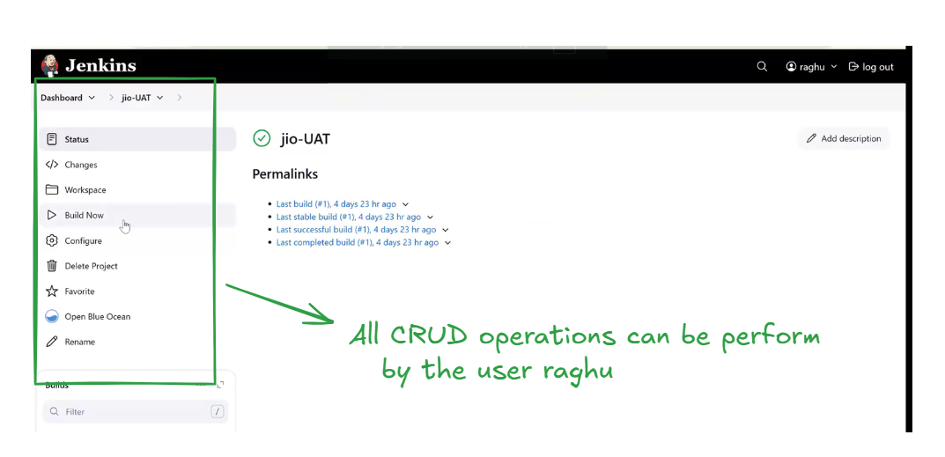
Interview-Ready Version
In my role, I used to assign access to users based on the ticket requests we received. I verified the requirement, checked the appropriate permission level, and then granted the exact access needed—nothing more, nothing less.
A Junior DevOps Engineer is given only job-level access in Jenkins, not full administrator access. This means they can work on specific assigned jobs but cannot access or modify global Jenkins configurations.
Questions and Answers starts at 1:03:00
In the Next classes we will see how to write the Jenkins pipelines

