- Topics that we are going to cover in this notes is listed below
• Basic Nexus Flow Diagram
  - Introduction to Nexus
  - Purpose and Features of Nexus
  - Types of Repository Managers (Nexus, JFrog)
  - Difference Between GitHub and Nexus
  - Nexus Installation Prerequisites
  - Hardware Requirements
  - Nexus Archive Structure (nexus3 & sonatype-work)
  - Step-by-Step Nexus Installation on EC2
  - Installing Java (JDK 1.8)
  - Downloading Nexus Using wget
  - Extracting and Moving Nexus Files
  - Creating a Dedicated nexus User
  - Setting Permissions for Nexus Directories
  - Editing nexus.rc to Set run_as_user
  - Creating Nexus as a System Service
  - Creating Custom nexus.service File
  - Enabling & Starting Nexus Service via systemctl
  - Accessing Nexus in Browser
  - Default Admin Password Location
  - Troubleshooting Nexus Startup Issues
  - Unable to Access Nexus URL (Security Group/Port)
  - Changing Nexus Port and Context Path
  - Disabling Anonymous Access
  - Changing the Admin Password
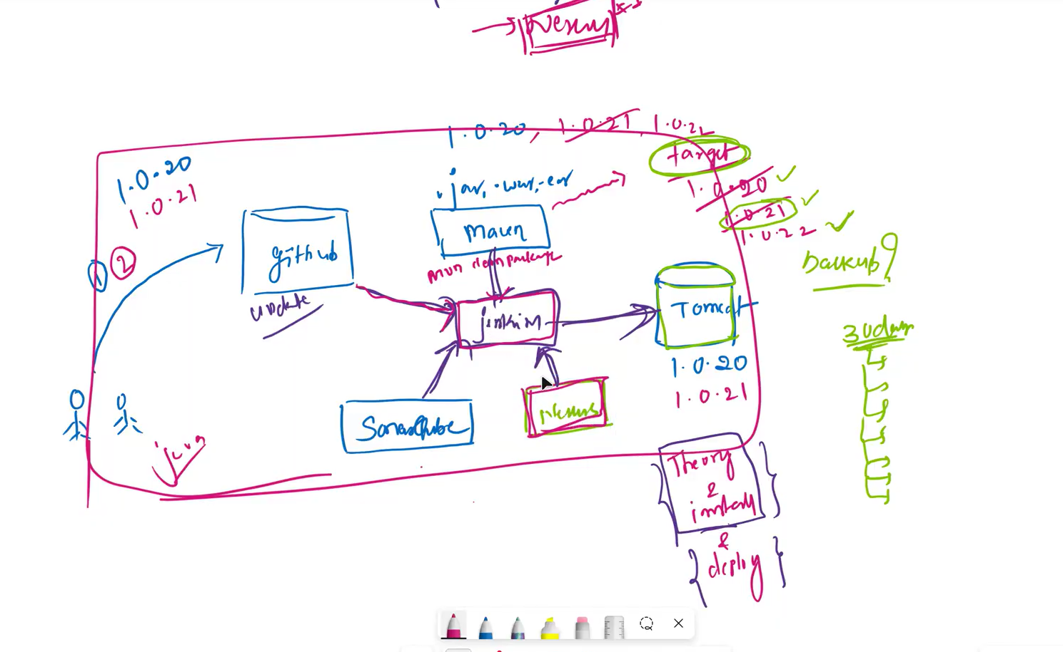
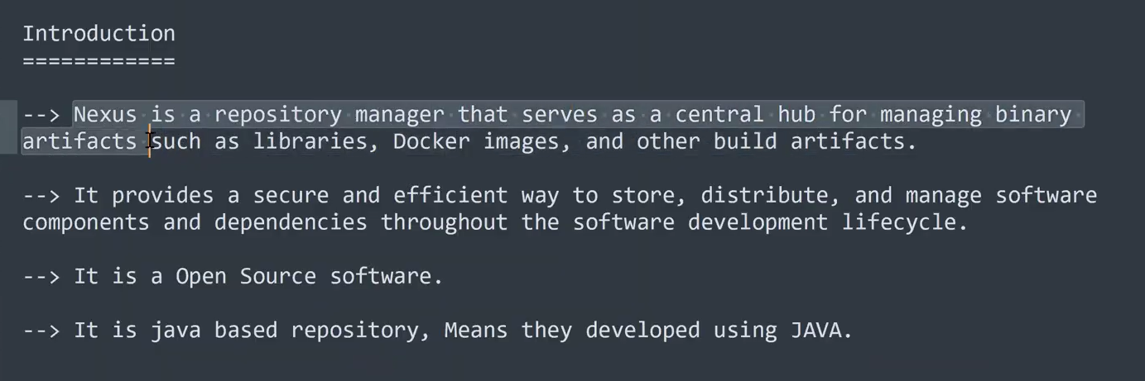
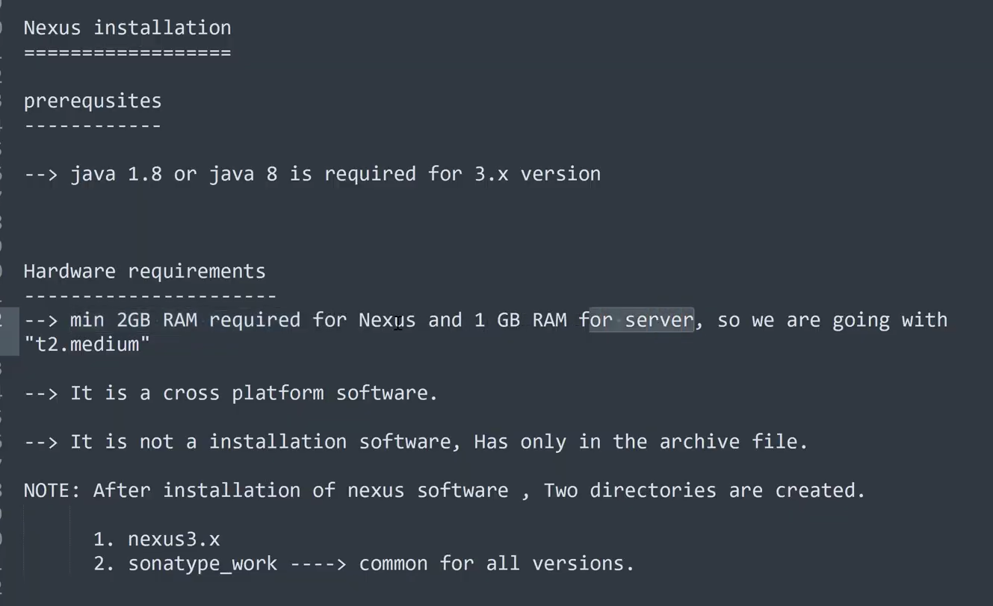
Prashant has created a new separate server ec2 instance with the name Nexus as shown in the below image
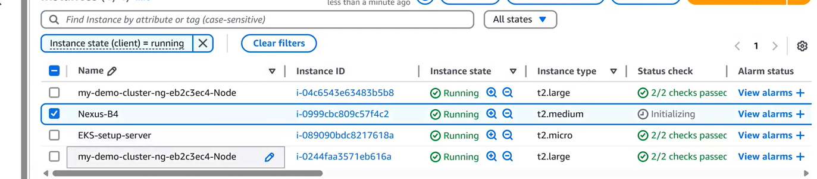
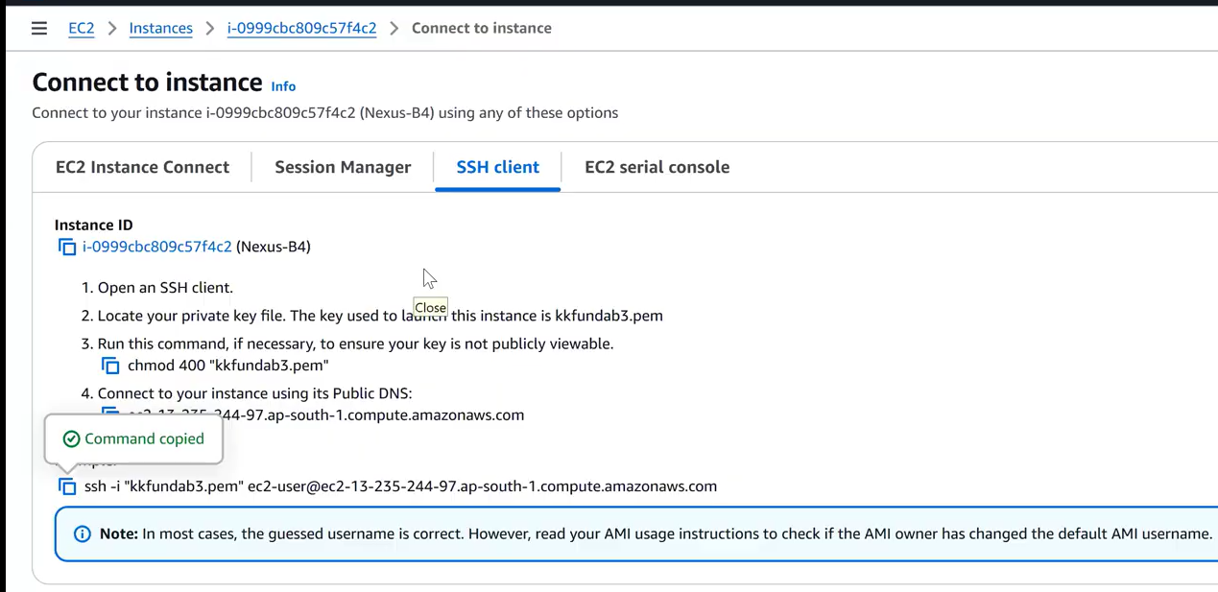
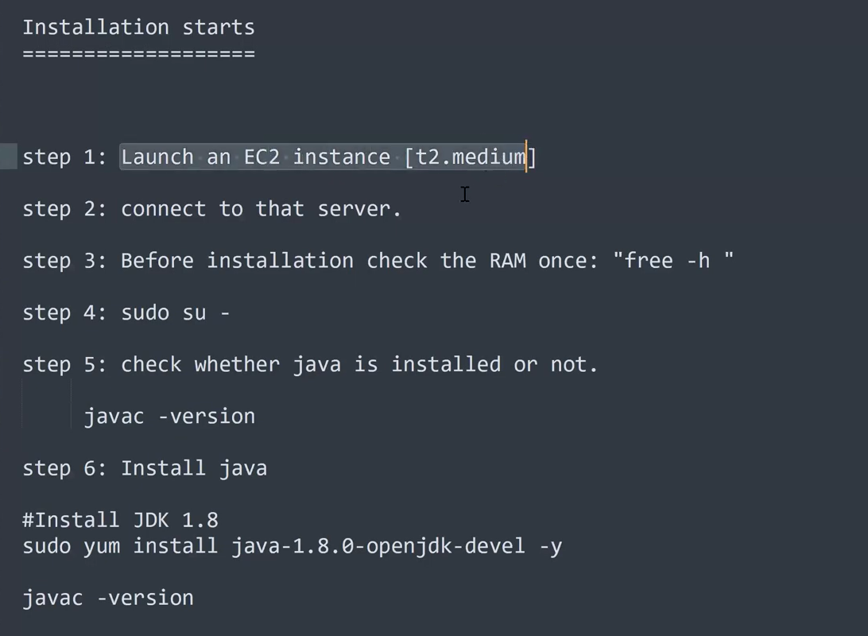
Lets download the Nexus as shown in the below image
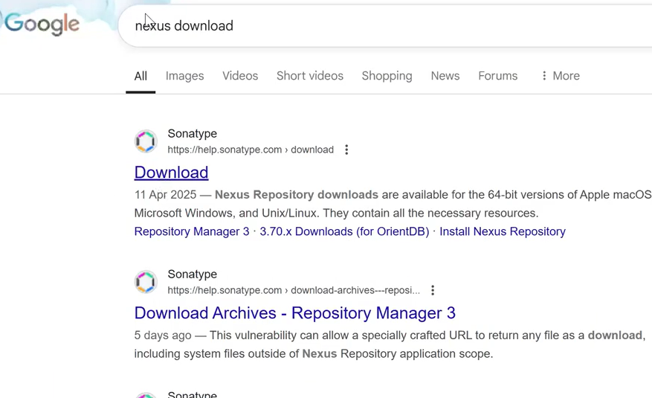
We can install the Nexus in multiple ways like shown in the below image
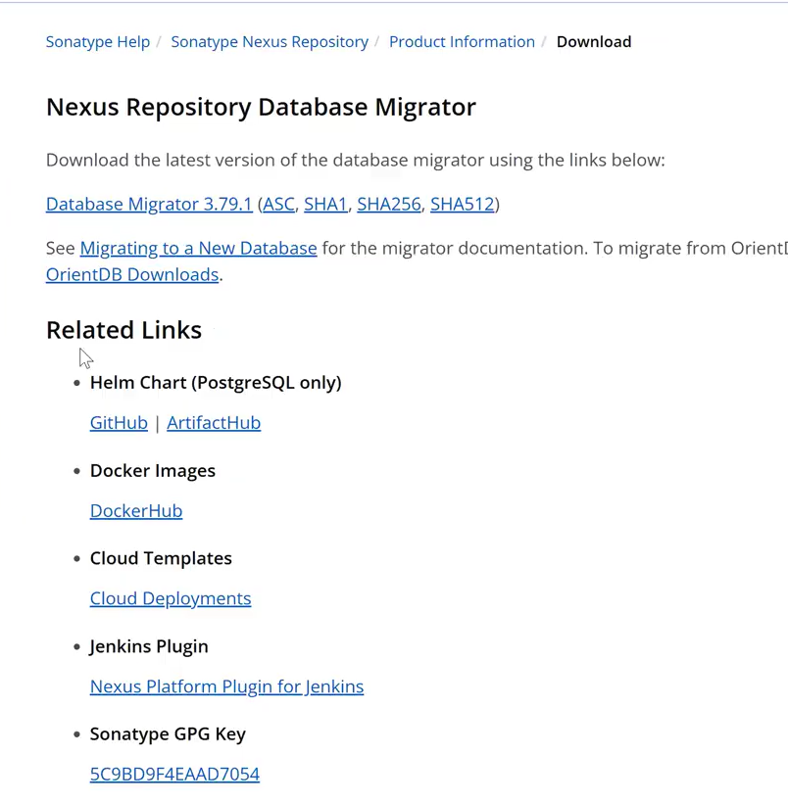
Use the below link to install the Nexus in Linux Server
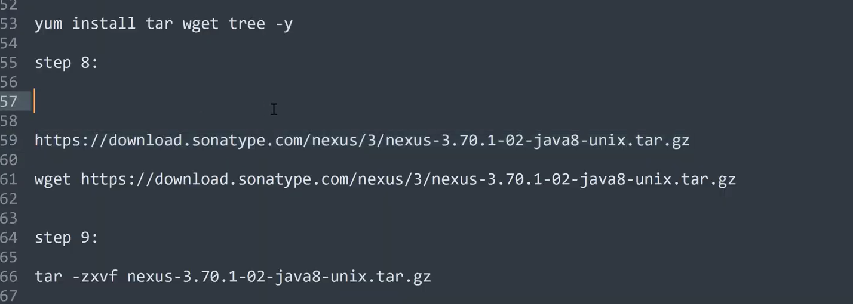
Downloaded the nexus as shown in the below image
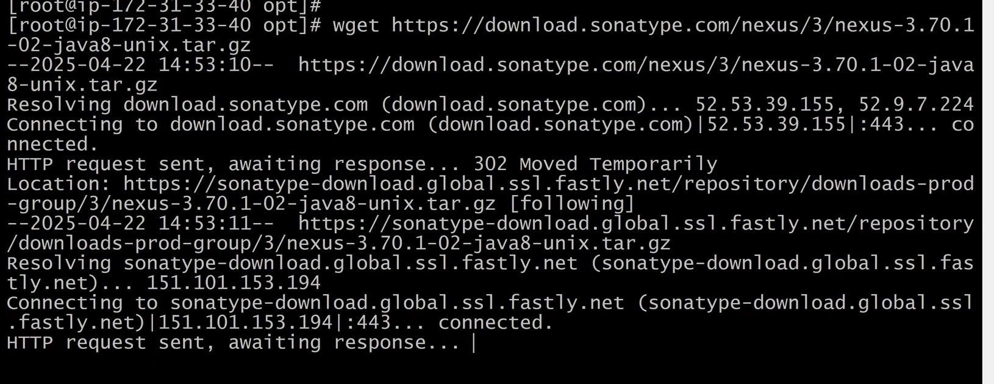
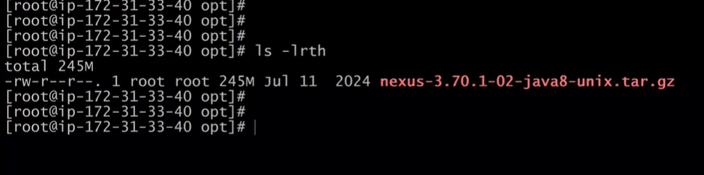
Next step shown in the below image
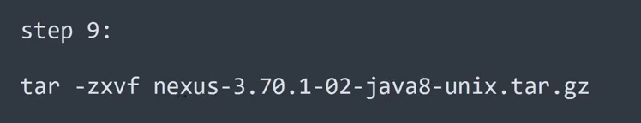
Lets extract the TAR by using the below tar command
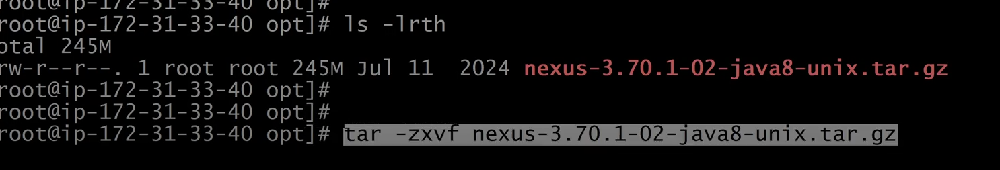
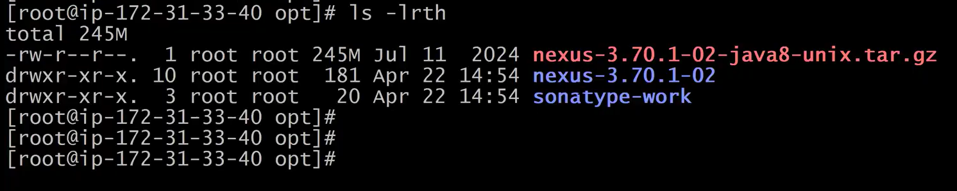
Next is to rename the nexus-3.70.1-02 to nexus by executing the below command
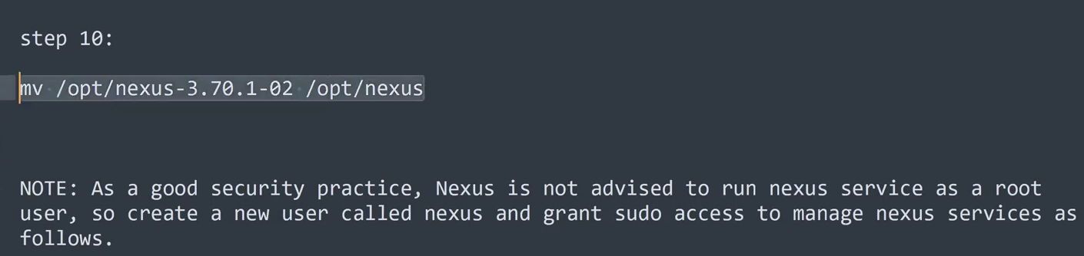
as you can see in the below image it has been renamed as nexus
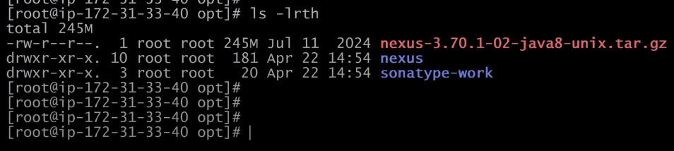
Next is very important Note read it carefully
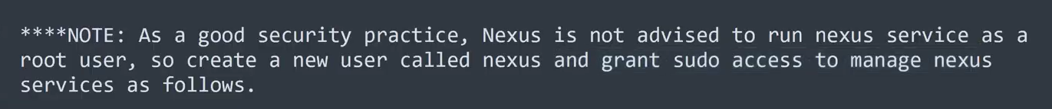
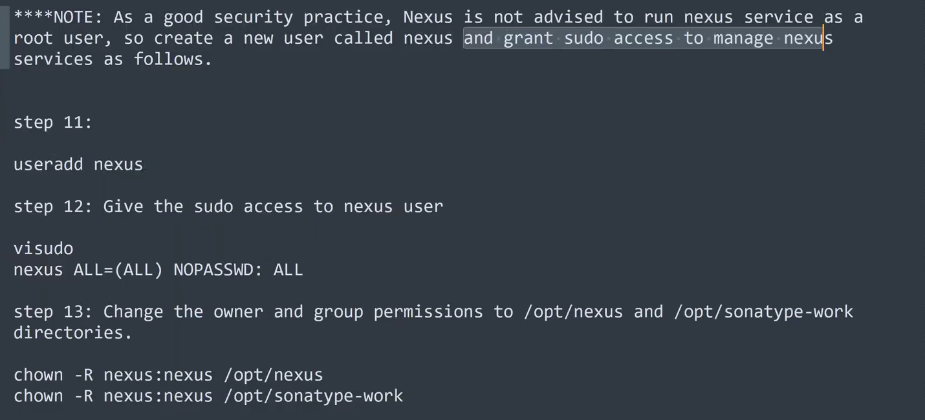
In the below img you can we are a creating a user with name nexus and then we will grant sudo access to this nexus user to manage nexus software.
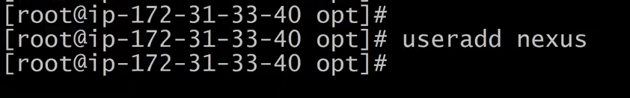
Lets give the sudo permission to the Nexus user tha we have created
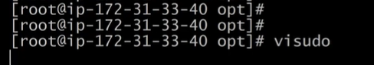
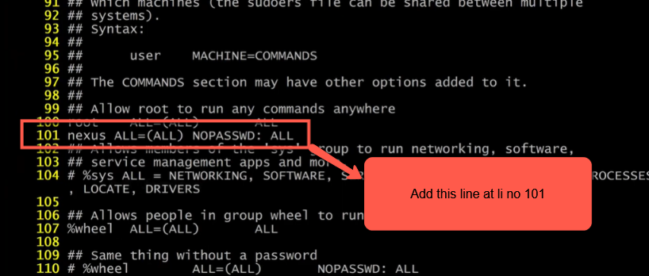
Next change user : group from root to nexus:nexus for the nexus folders and also give 775 permissions to the the both foolders
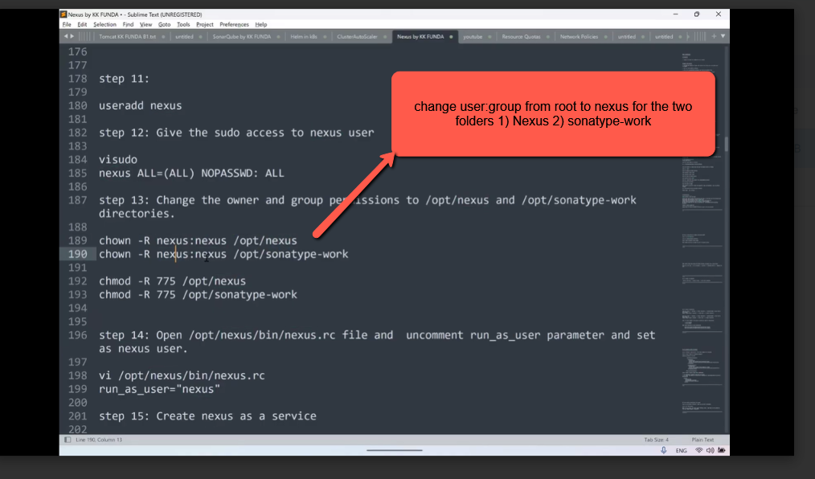
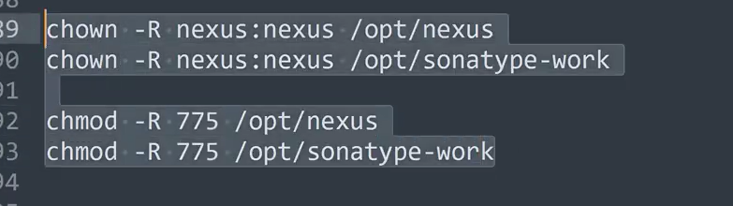
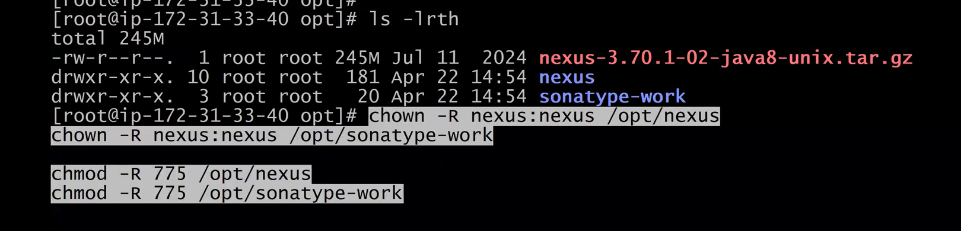
After executing the above 4 chown commands you can see the in the below img the user(root):group(root) changed to nexus(user):nexus(group)
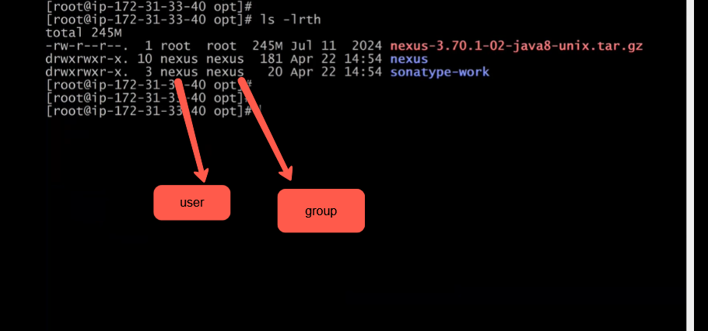
Next step
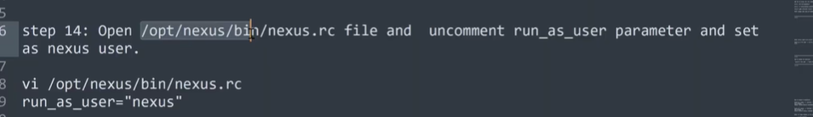
open the file nexus.rc and give permission to run as nexus user so lets open the file nexus.rc
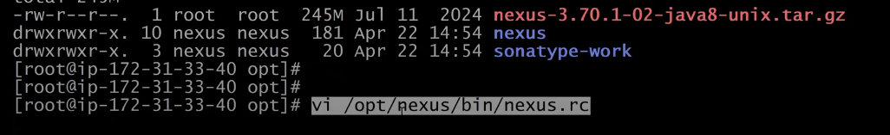
After opening the file you will see a line as shown in the below img which is commented you have to uncomment it and add the user ‘nexus’and save the file
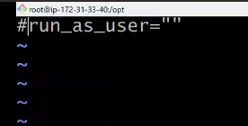
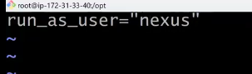
Next step : To run the Nexus server in background automatically we have to execute the below command .
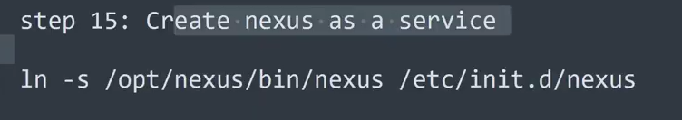
prashant skipped the step15 and said that he will execute the above step later
Lets see the next step
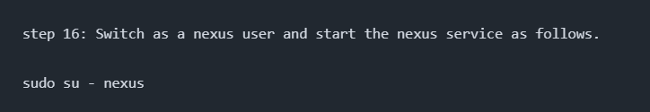
after switching to nexus user enable the nexus service as shown in the below image
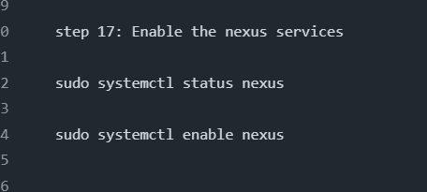
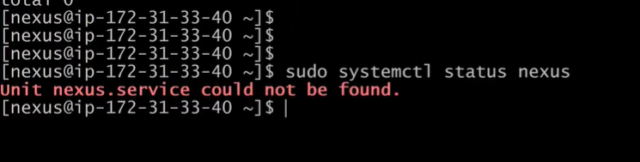
nexus services is not available so we have to enable it using the below command
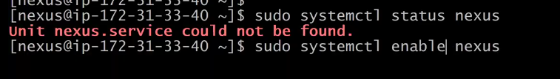
In the below imge you can see while enabling the nexus service facing an issue saying that nexus.service does not exit
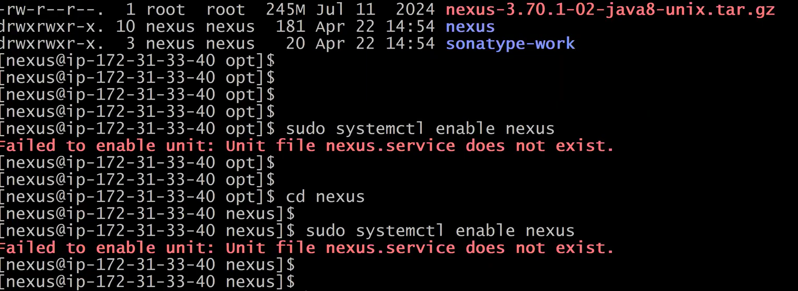
execute the below to overcome the above issue
we have to create a file sudo vi /etc/systemd/system/nexus.service
then add the below data in to the new file nexus.service
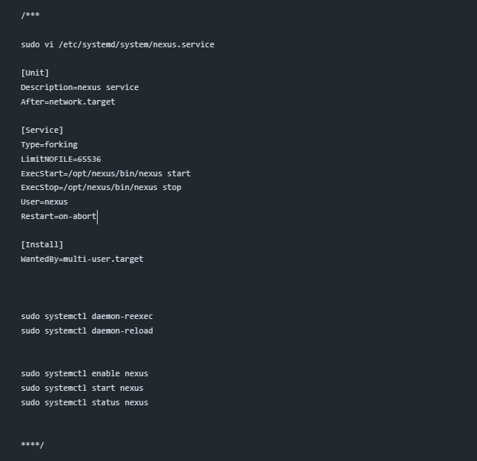
Then execute the below commands related nexus.service file to run the nexus
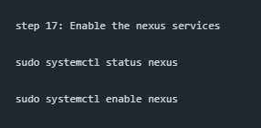
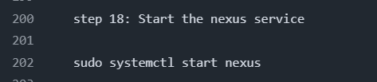
video time 55:00
now check the status of the nexus server
by executing the below command it should be in Running state
As you can see in the below the nexus server has been started and in Running mode
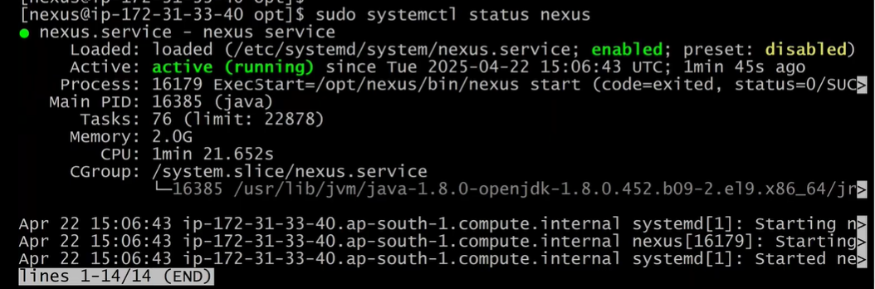
Access the Nexus server from browser but before accessing it we have add the port no 8081 in the Ec2 instance
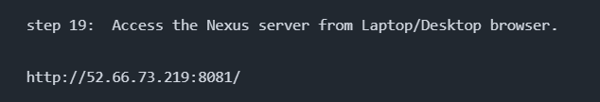
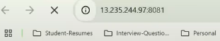
Ec2 instance public IP address along with the port no 8081
In the instance group of ec2 instance add the custom port number 8081 and click on edit
click on security group of the ec2 instance and then click on edit inbound rules
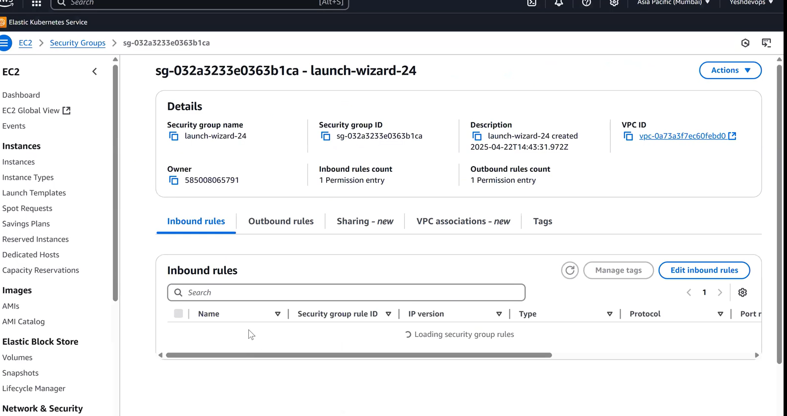
click on Add rule and custom TCP with port range 8081 and then click on save
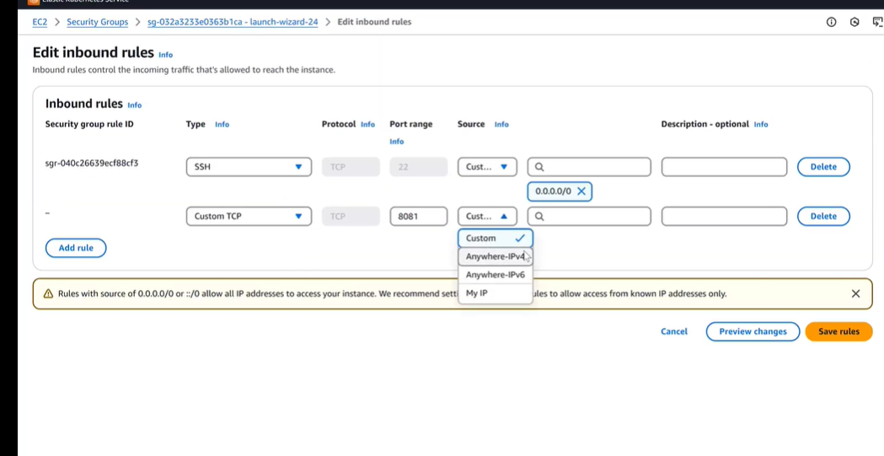
so the inbound traffic is done Now lets try to referesh the ip address with port no 8081 as shown in the below image the Nexus server is loading
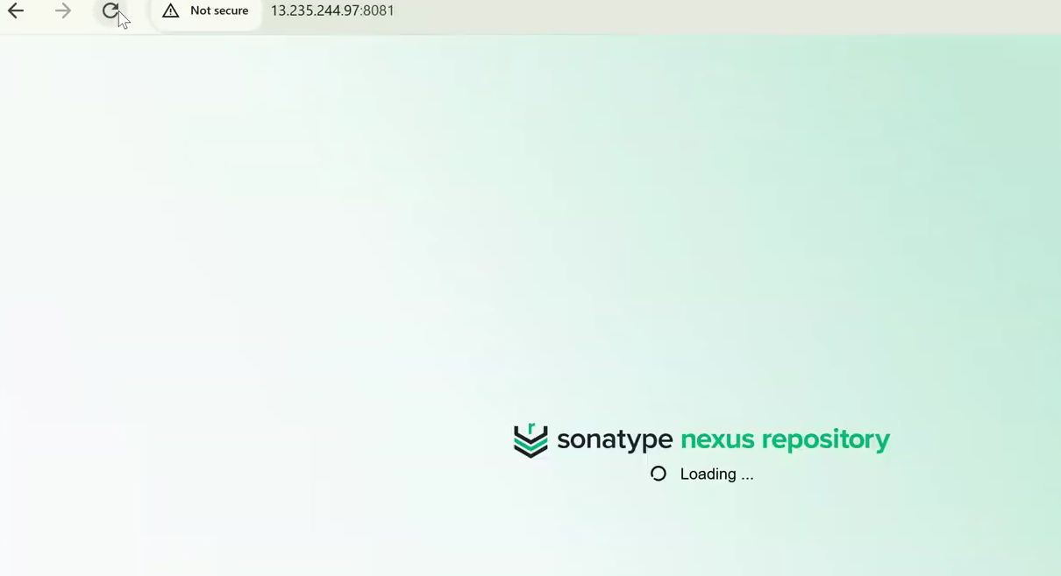
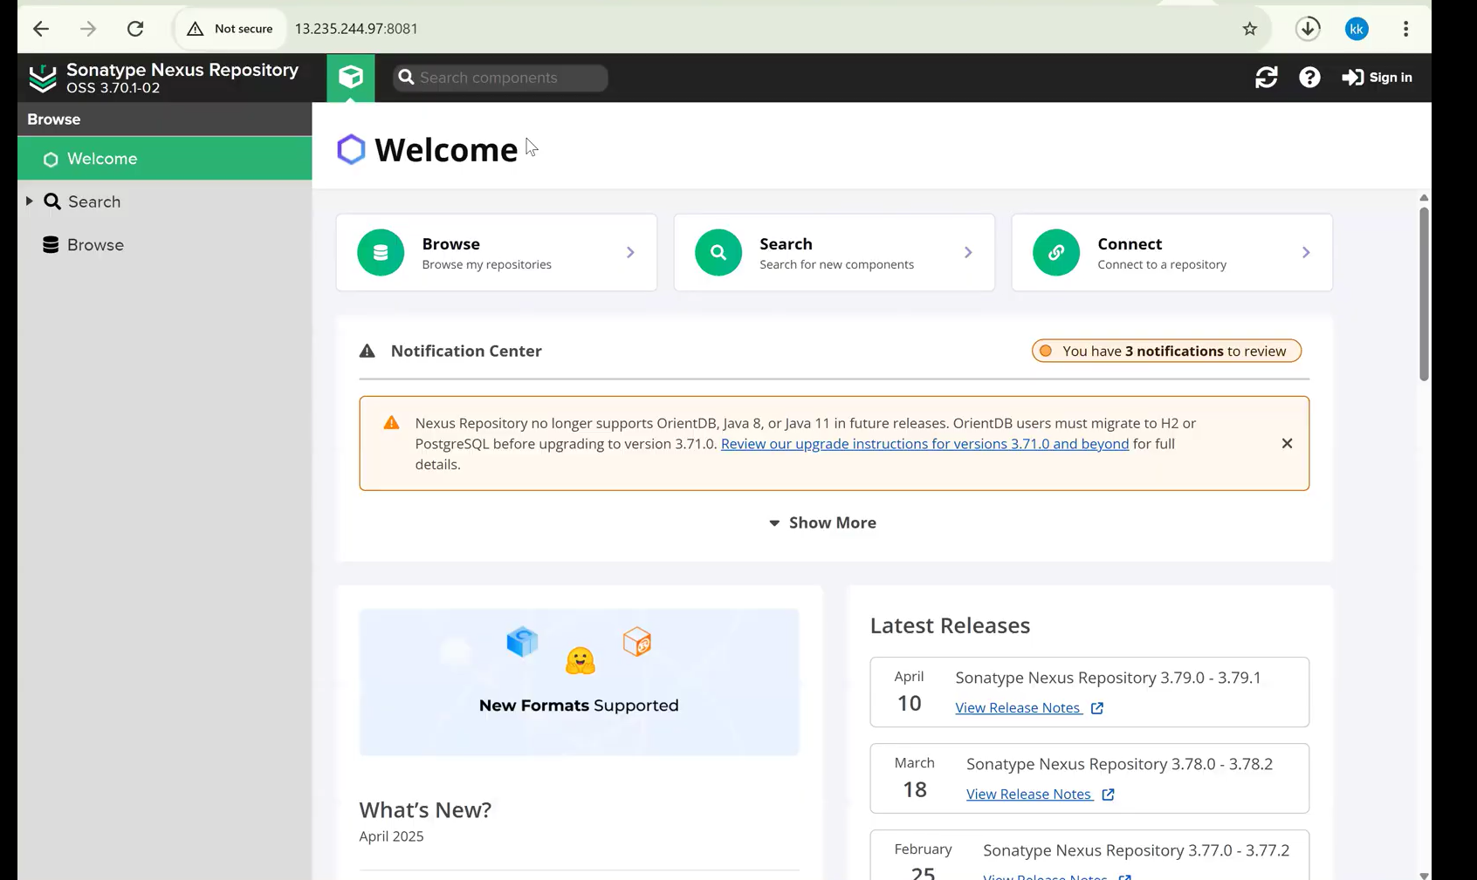
click on signin
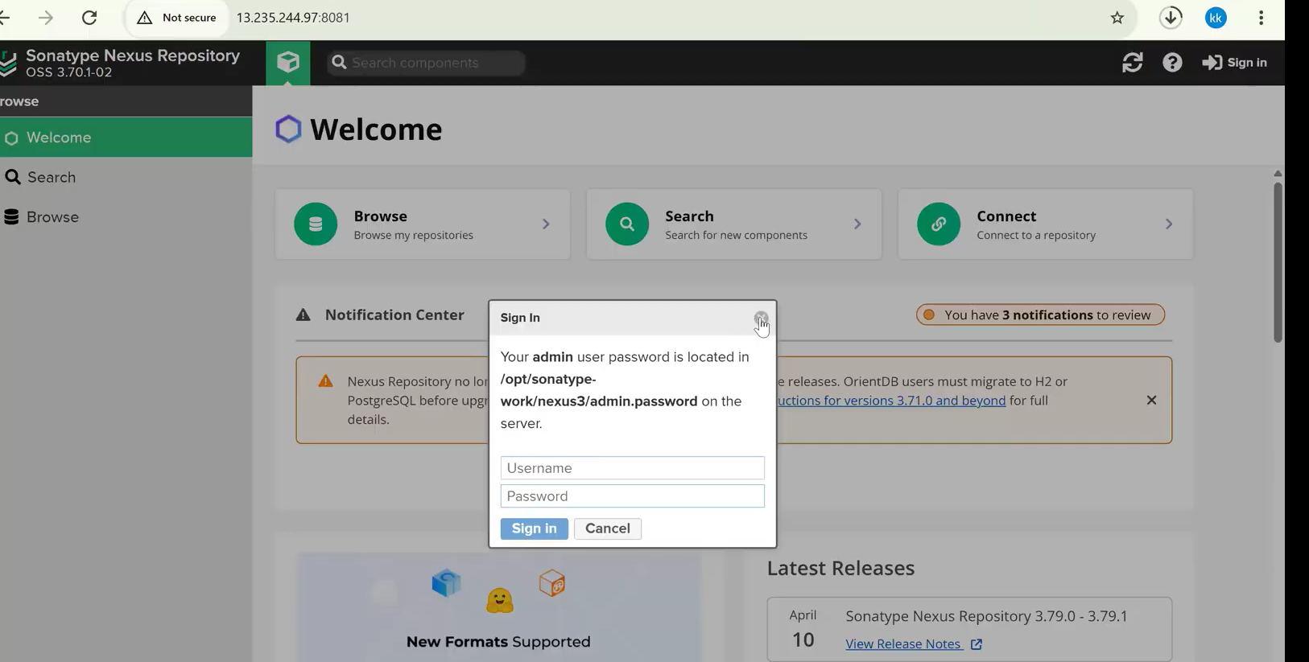
Next step 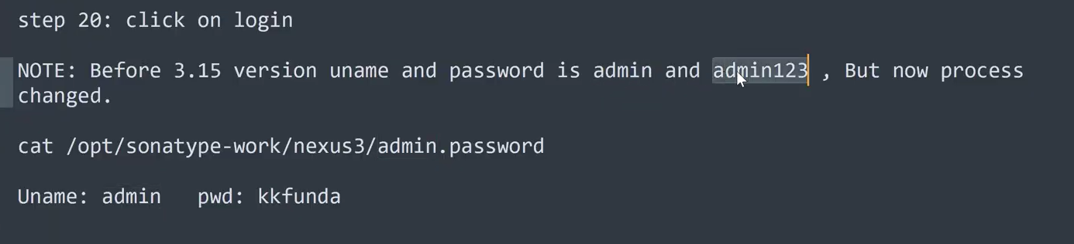
Ignore the pwd : kkfunda in the above image
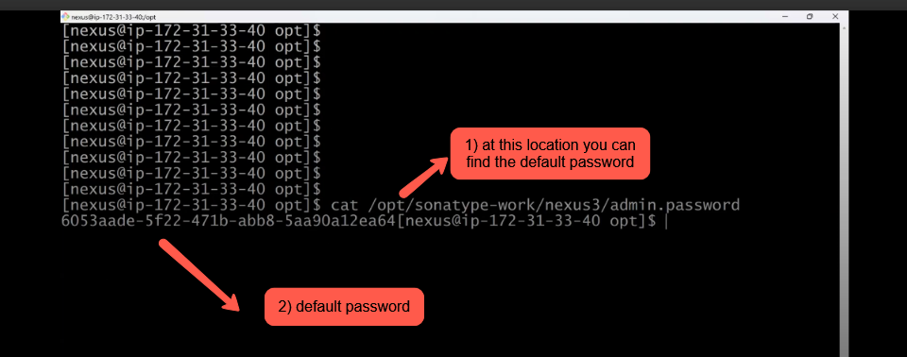
add a new password as shown in the below
copy the password and paste it in the login credentials as shown in the below img
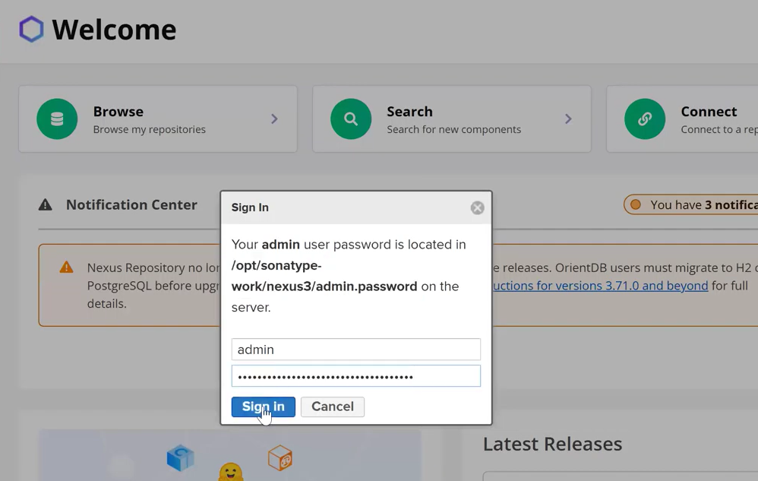
change the password to welcome123
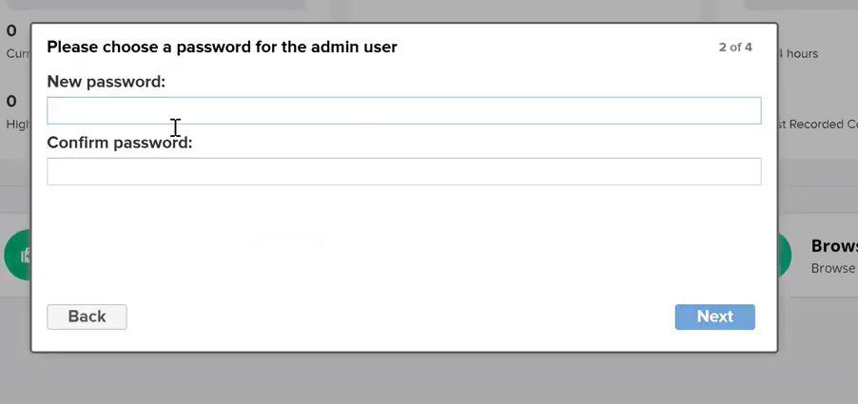
Next click on browse as shown in the below img
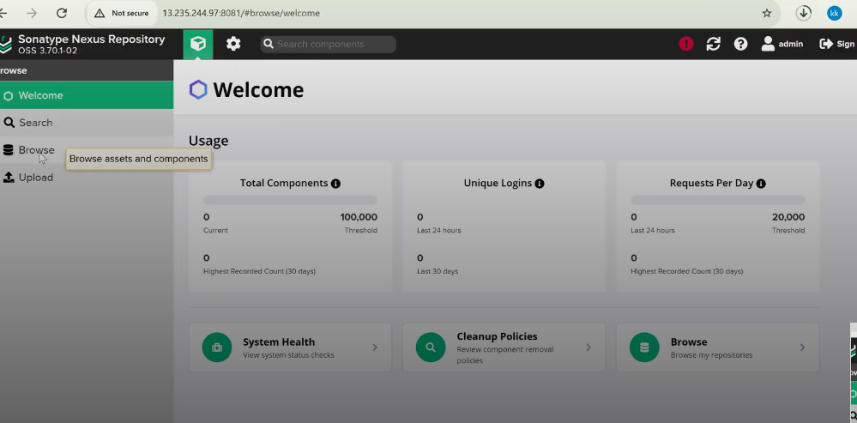
In the browse section you will find all the default repositories details as shown in the below img. In the next class we will create a custom Repo and we will backup or store our artifact (.war,.ear file) in the custom repo
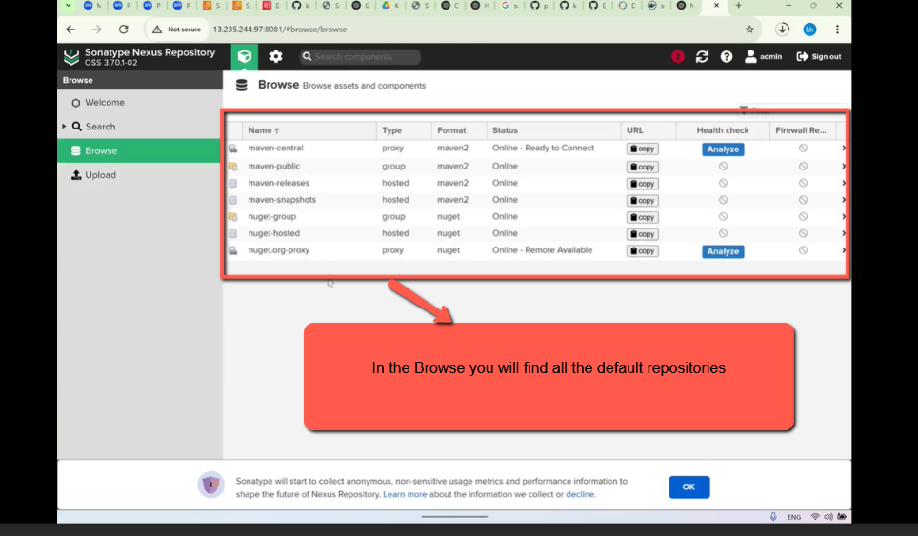
Next step is restricting Anonymous Access
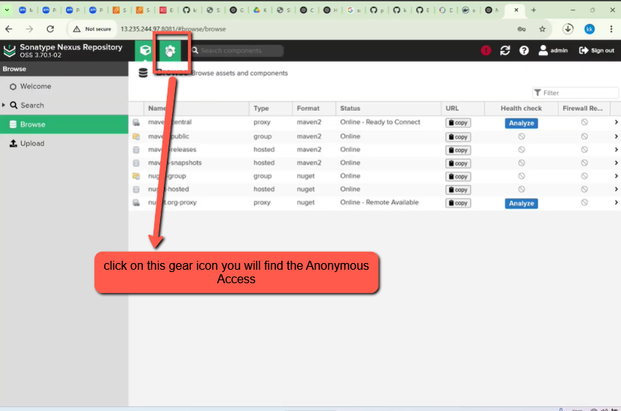
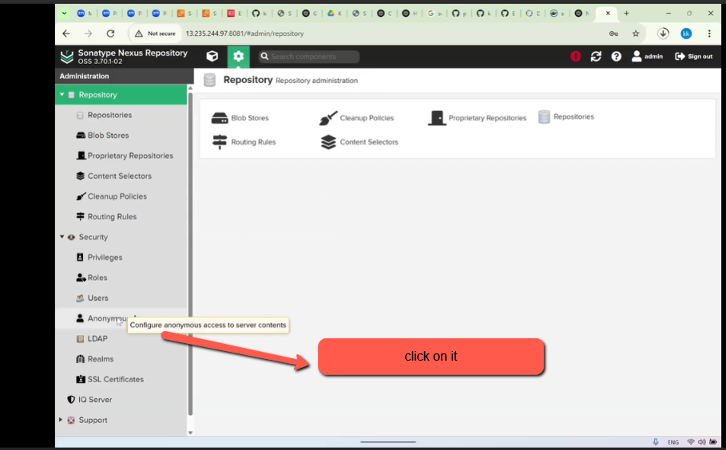
uncheck the Allow anonymous users
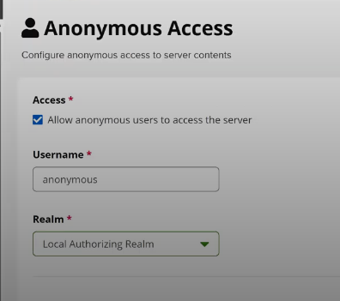
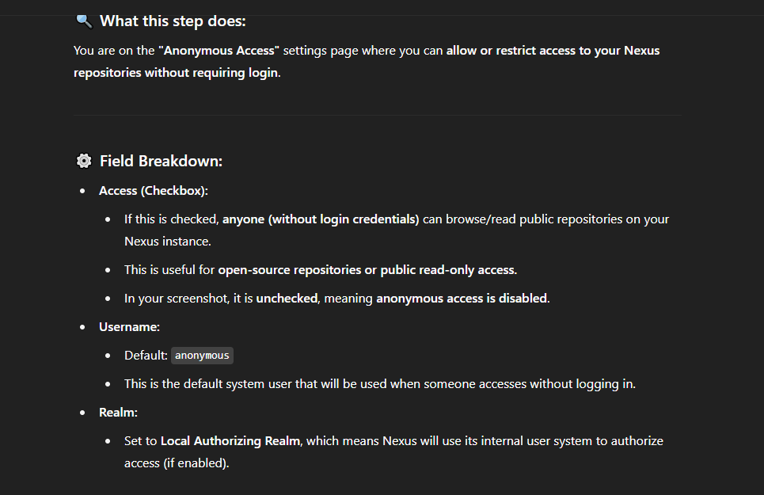
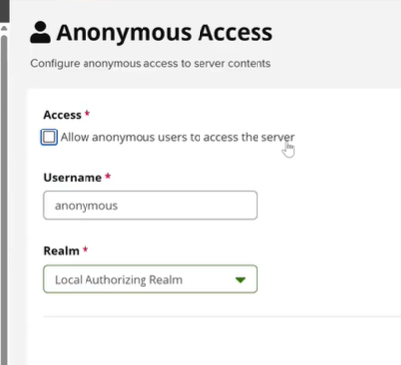
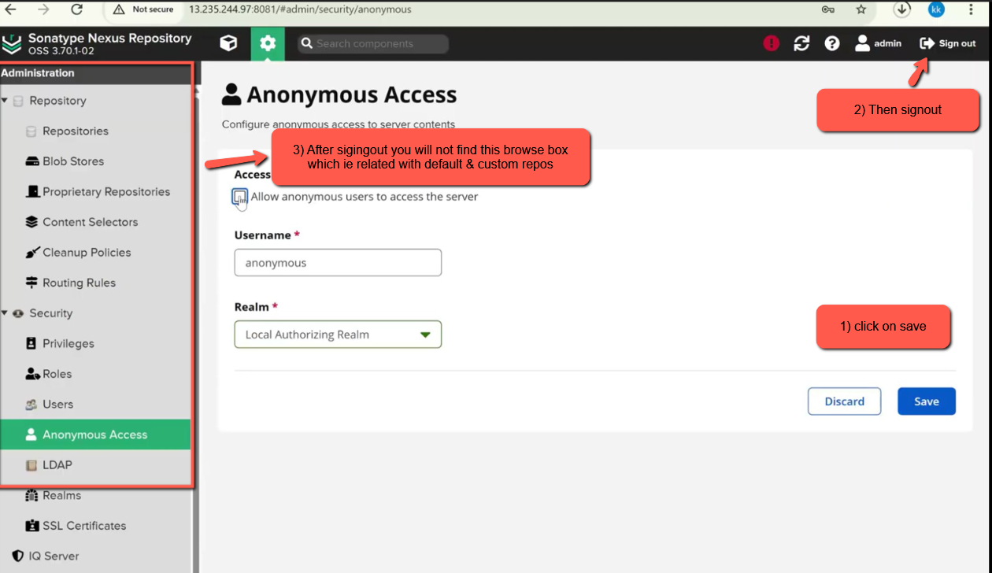
As you can see in the below image there browse section menu
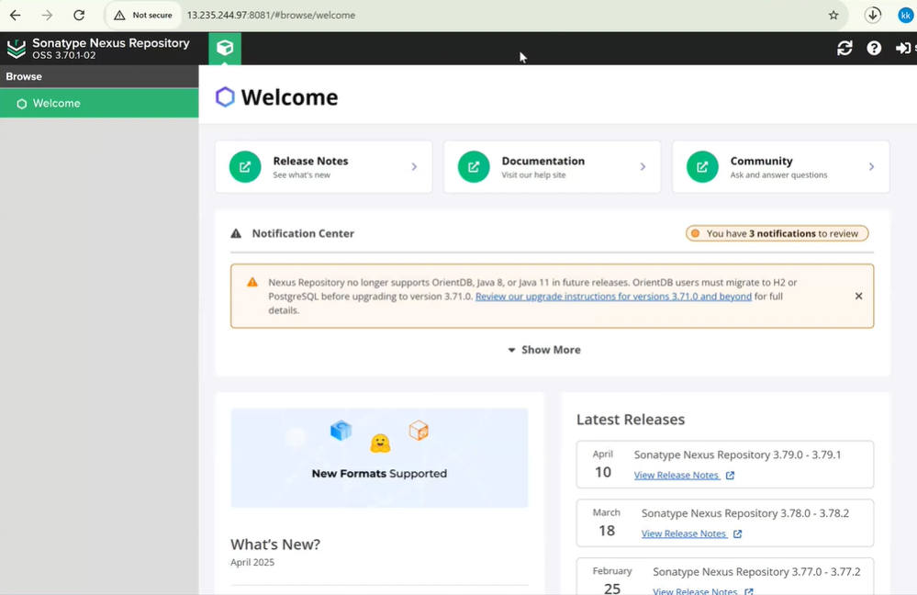
To acess the Nexus server only myself through my laptop Then we have to add our computer ip address Then add youripaddress/32 in the 8081 nexus server TCP.
check the video at 1:5:00
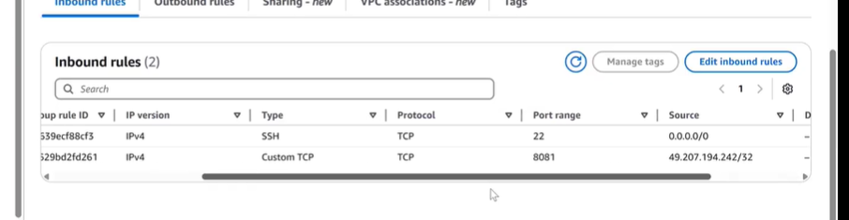
Next is the Interview Question
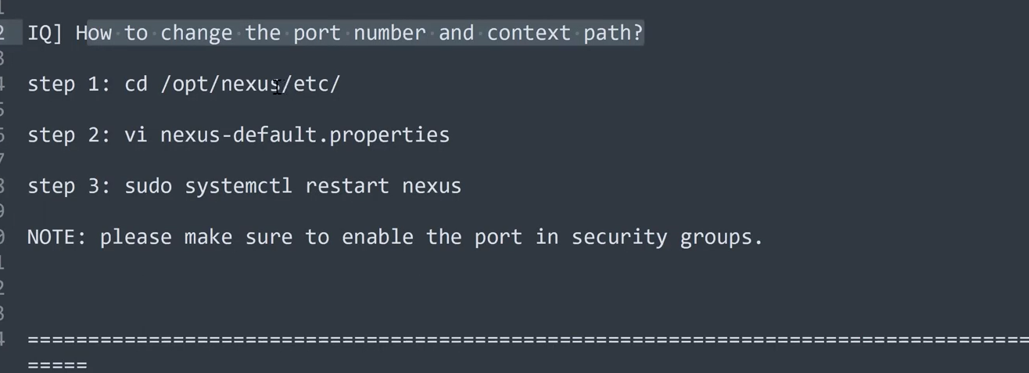
class is completed

