In this class we will see how to create a custom Nexus repository
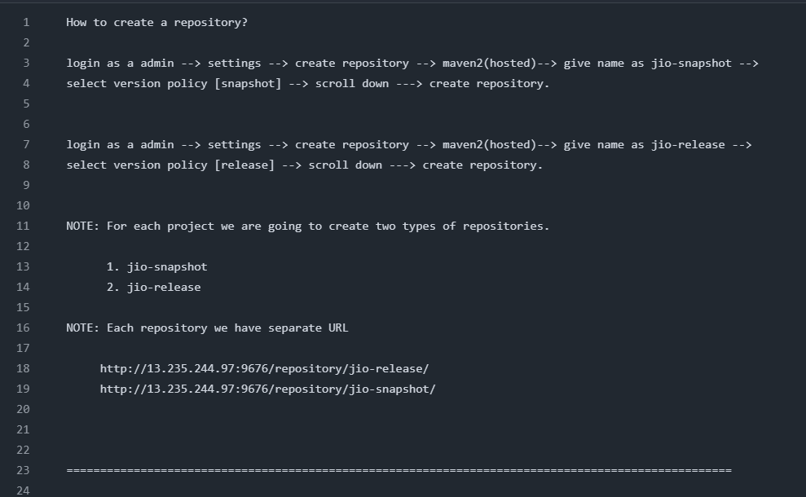
How to Integrate Nexus with Maven build Tool
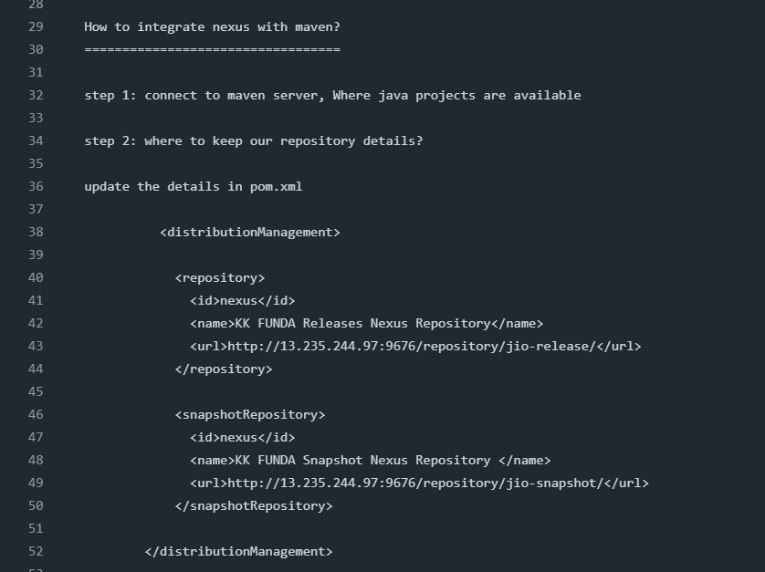
where we need to keep the Nexus credentials
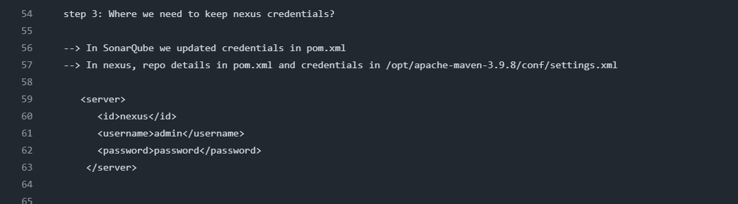
To Integrate Nexus in Maven we have to add the Nexus url in pom.xml file and we have to add Nexus username and password in server.xml file of maven server.
Next we have to execute the mvn clean deploy command after executing the mvn clean deploy command a copy of artifact .war file which is present in Maven server will get stored in Nexus server. Inorder to store the artifact in Nexus server we have to create some repos like 1) snapshot repo 2) release repo as shown in the below second image
After creating the repos snapshot and release in Nexus we have to register these repos urls in distribution tag of pom.xml of maven server Then execute mvn clean deploy command
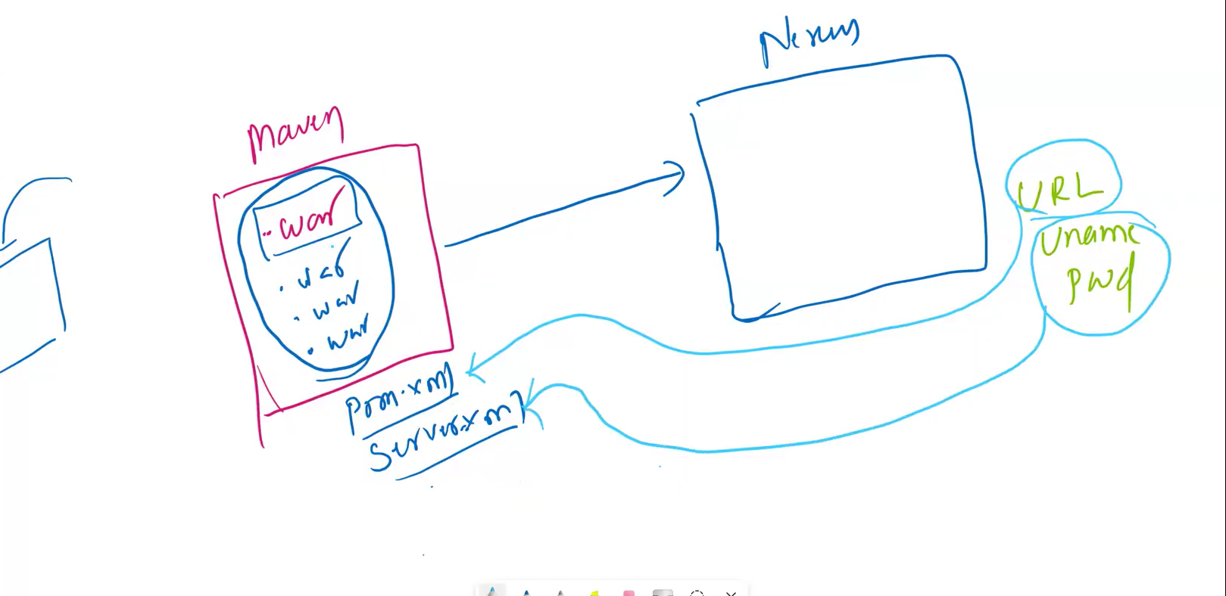
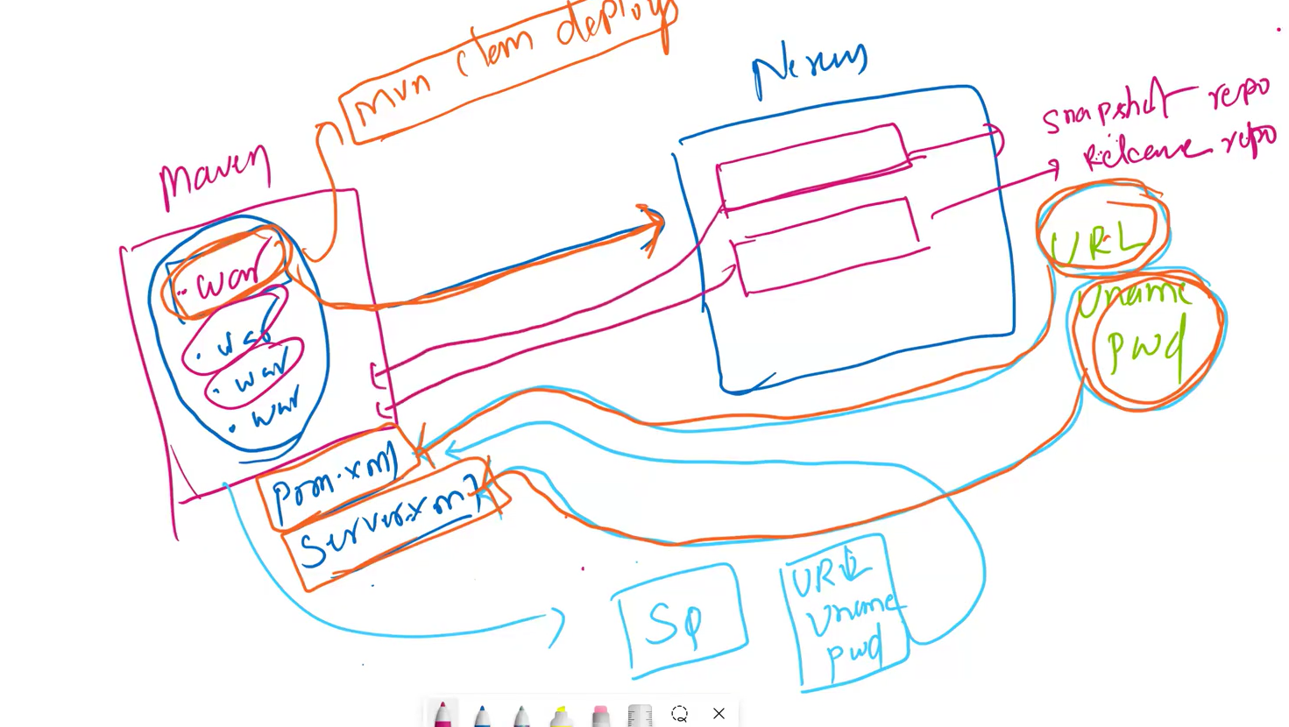
In the below image Prashant is opening the Maven server
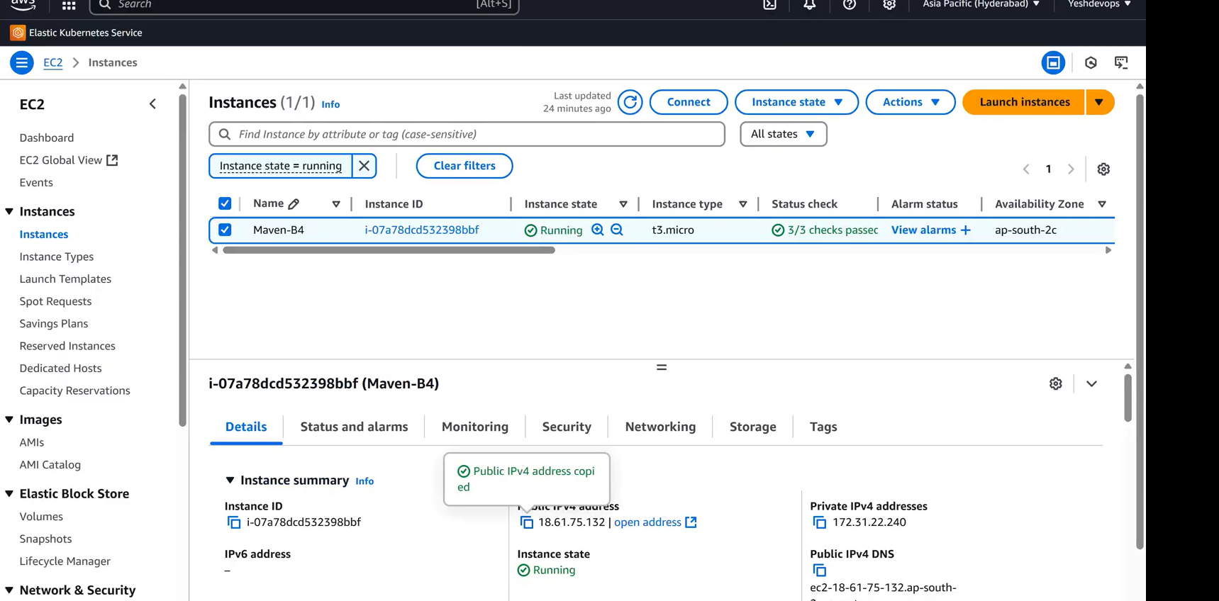
successfully connect to maven server
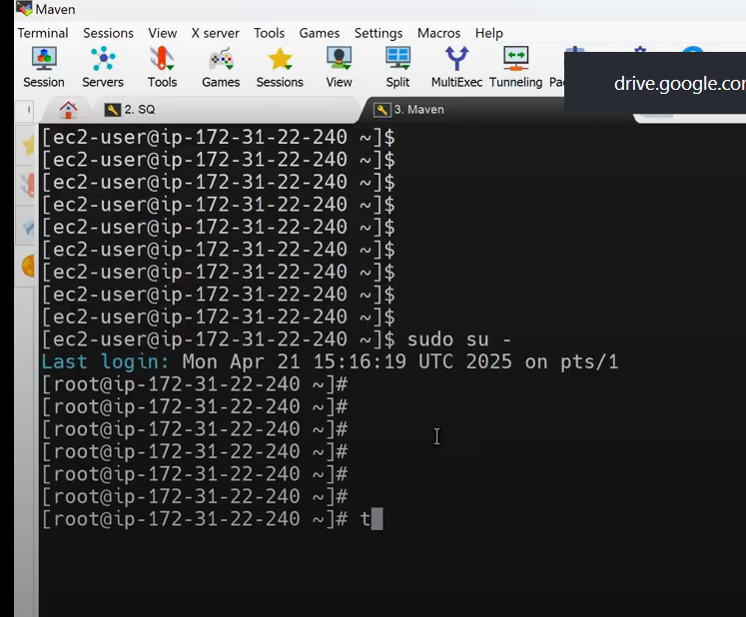
prashant is opening the Nexus ec2 instance in the below image
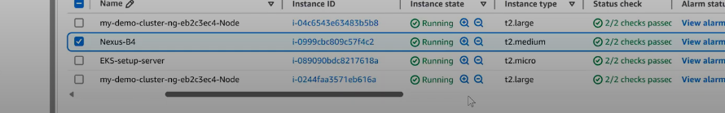
Nexus Instance
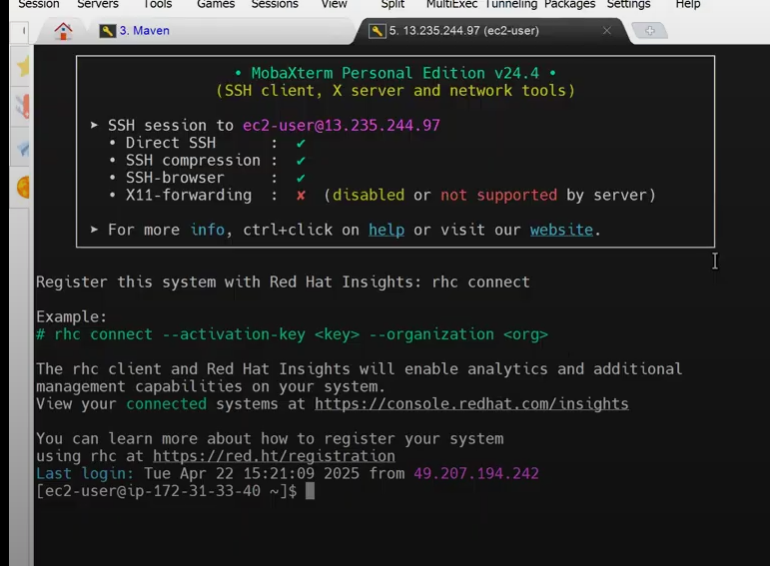
Now go to Nexus server Instance and switch to nexus user by using the command su - nexus
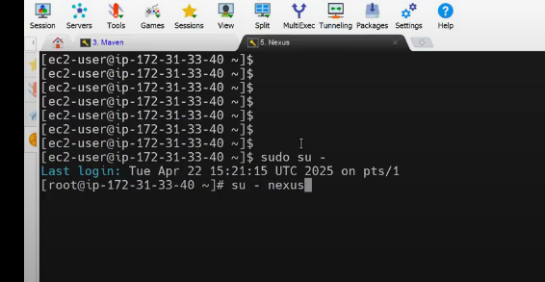
Now lets open the nexus server on the browser
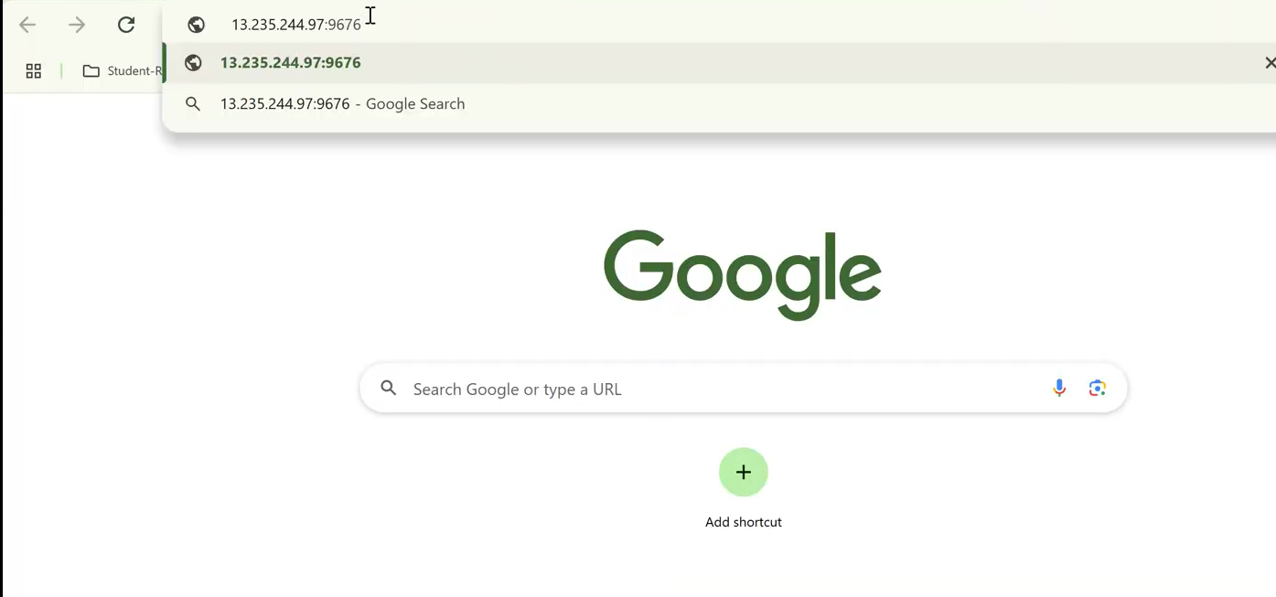
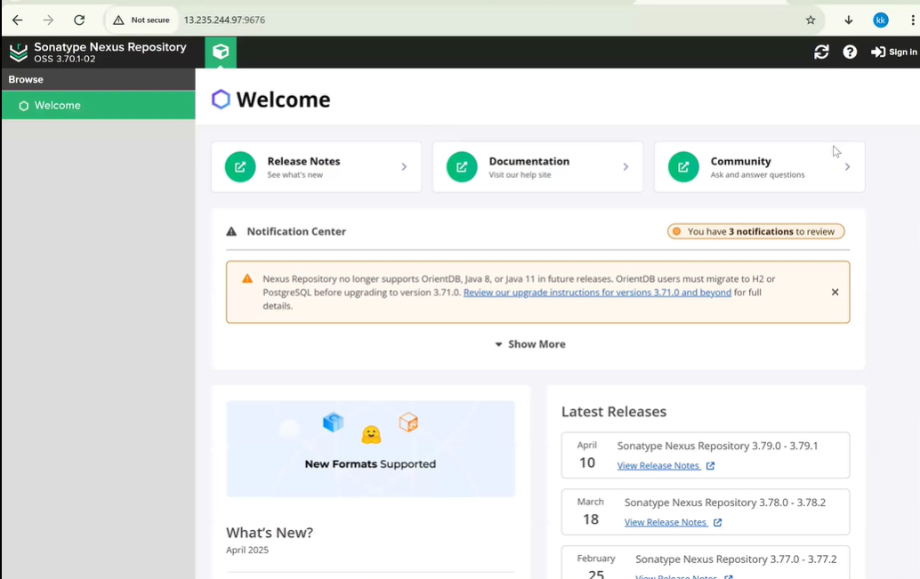
click on sign in
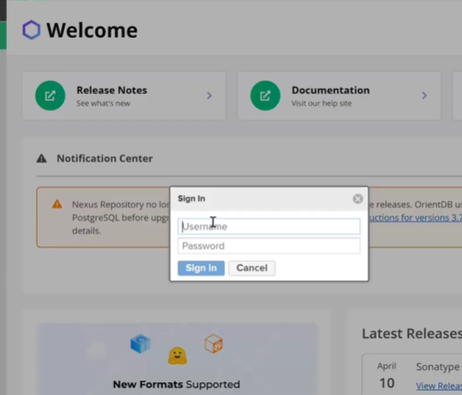
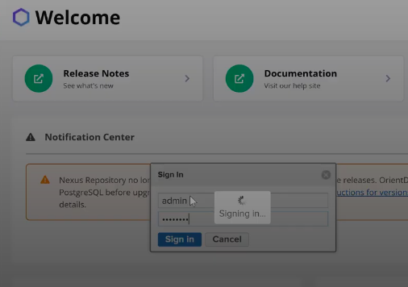
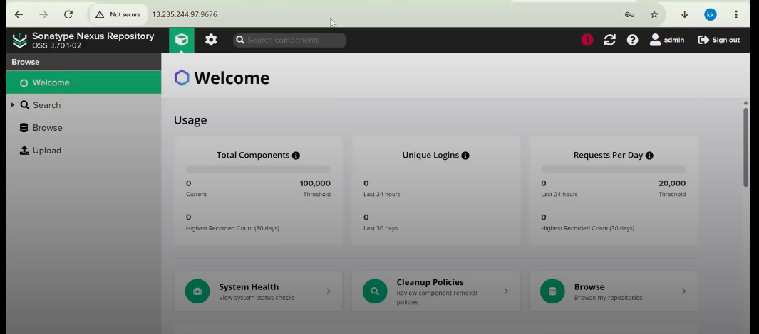
In nexus server ui if you want perform any administration operations then click on setting tab and for any kind of search click on Browser tab
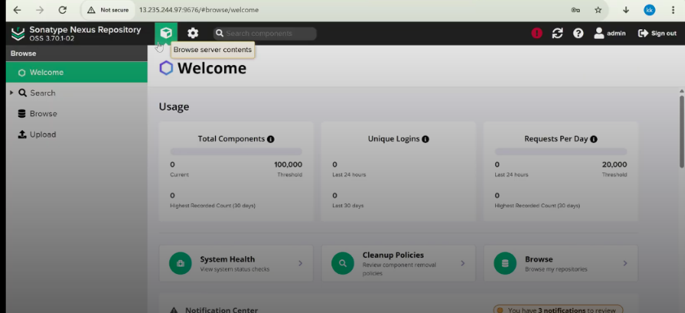
Now lets add Nexus server url and uname , pass in Maven’s pom.xml , server.xml file as shown below
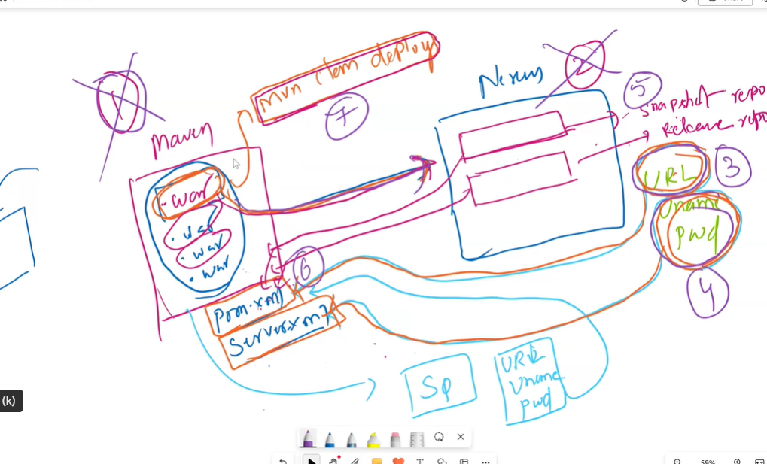
Let’s create the repository
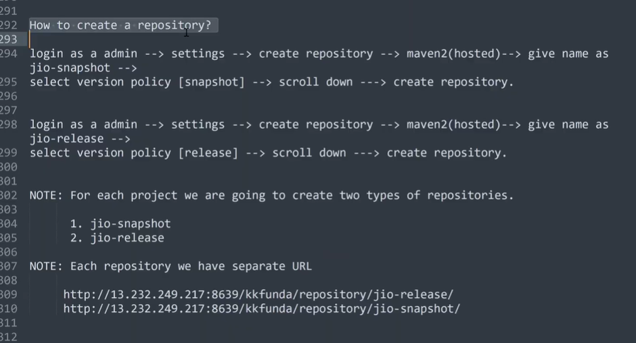
Lets go to the Maven server 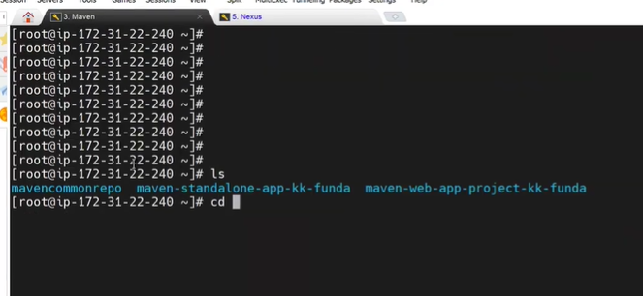
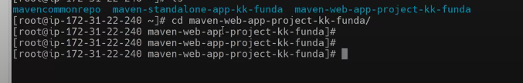
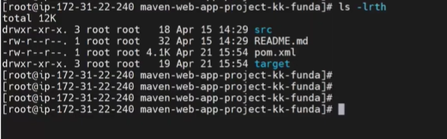
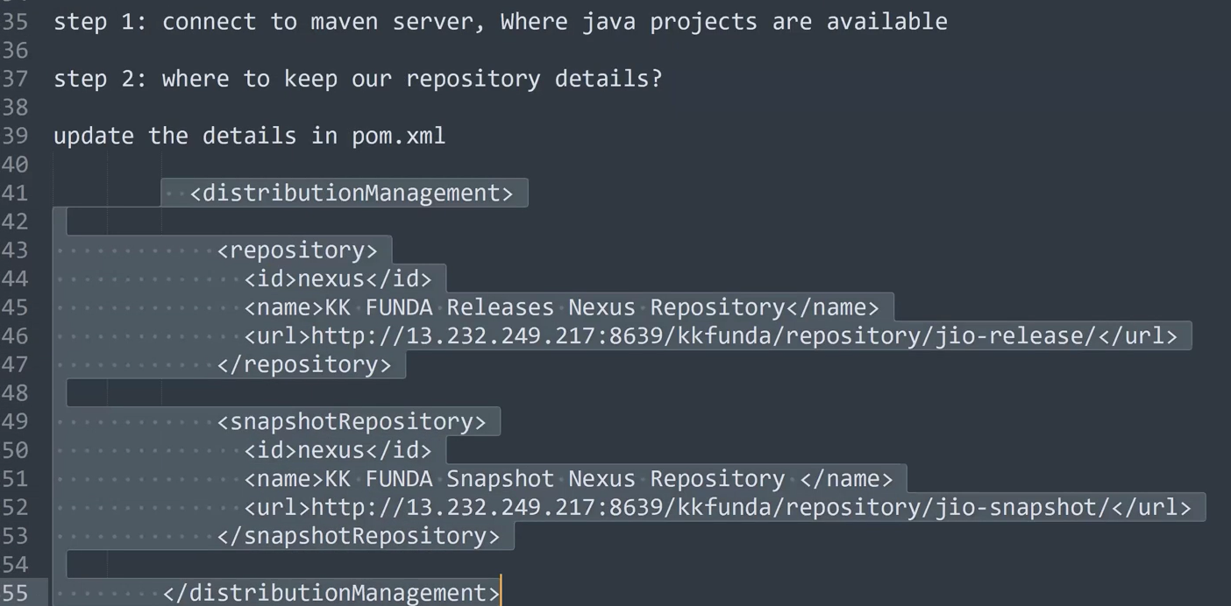
but before we should execute step 3 as shown in the below img
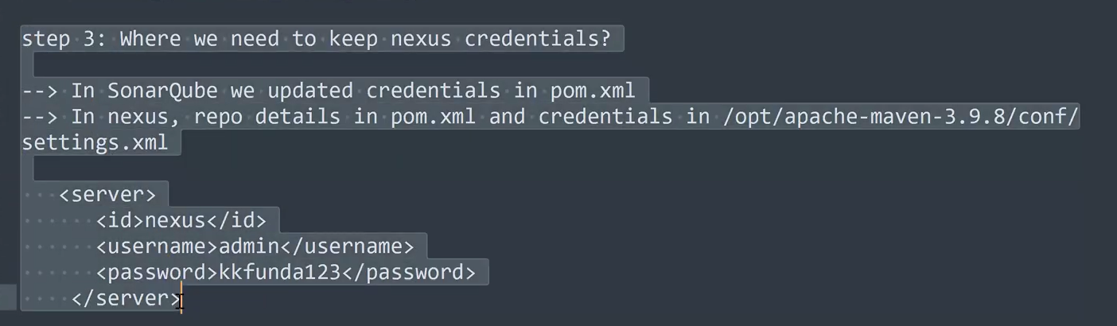
Go to settings.xml file and search for <servers> tag in settings.xml file inside the this tag add the above Nexus server tag with credentials of our Nexus server 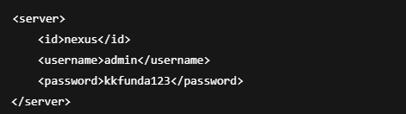
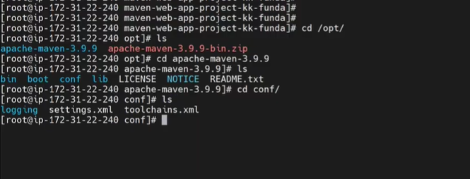
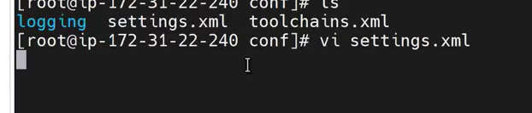
After opening the seetings.xml file add the Nexus server details in the <Servers >Tag as shown in the below image
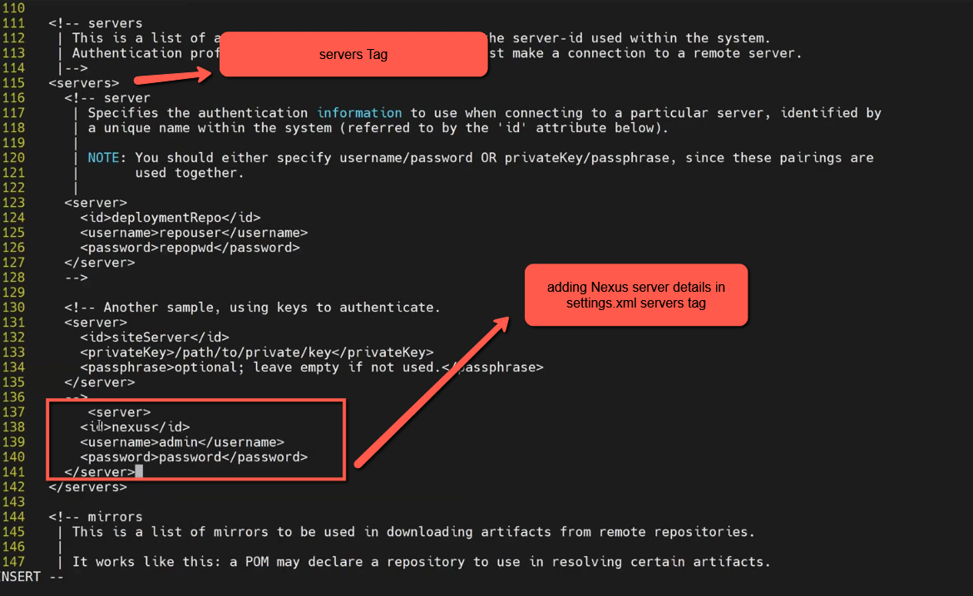
So far we have added/Registered the Nexus server uname and pass in Maven settings.xml/server.xml file
Now the Next step is to add Nexus (Repositories) urls in pom.xml file of Maven server before that lets create some repositories in Nexus server and register them in pom.xml file of Maven server.
so lets to Nexus server GUI
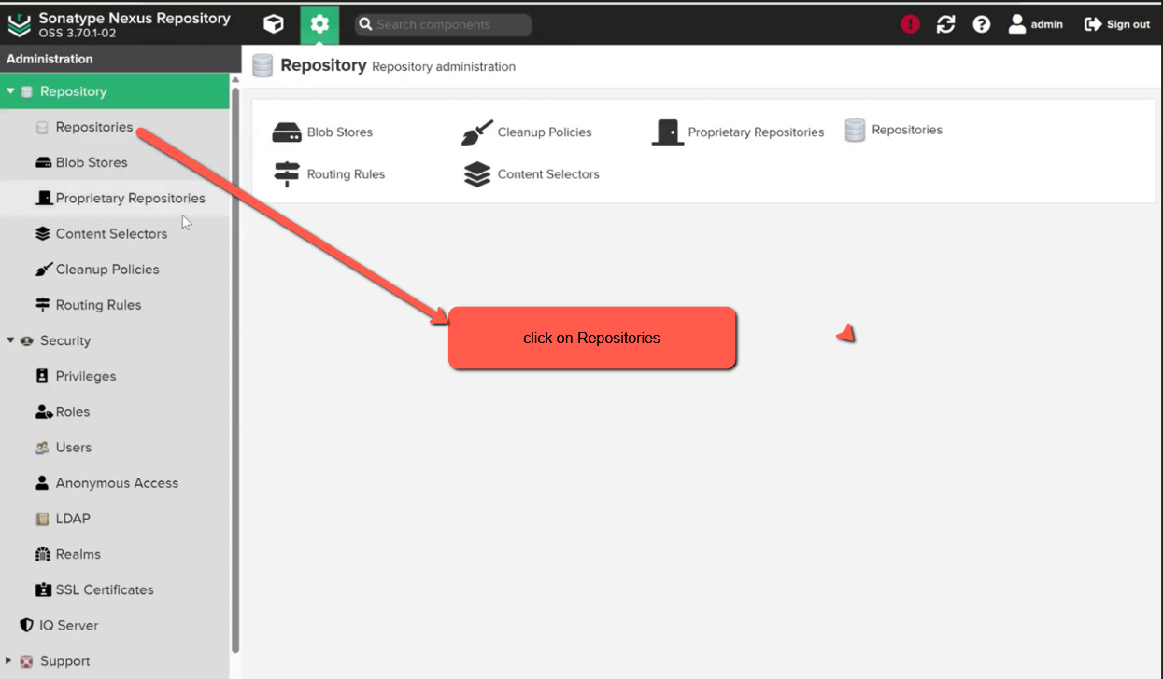
Next
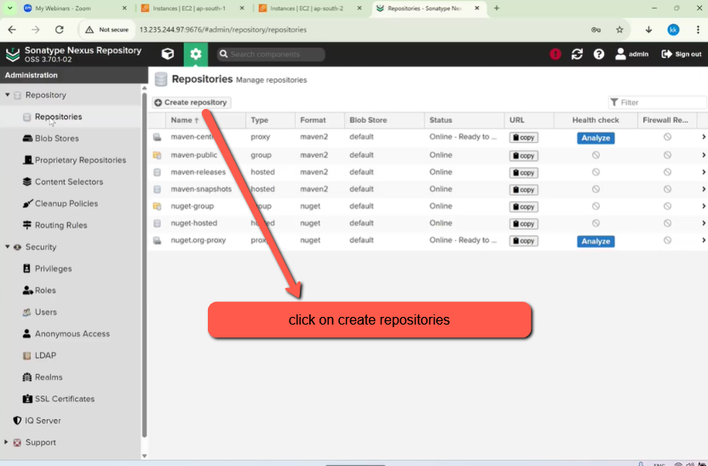
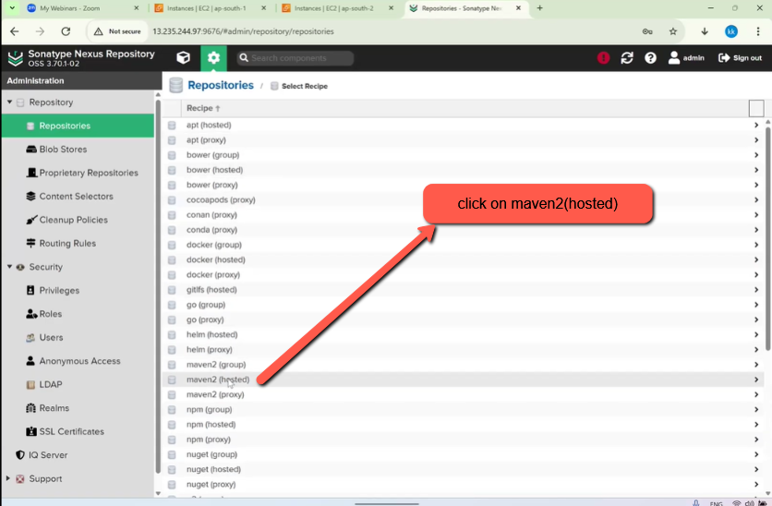
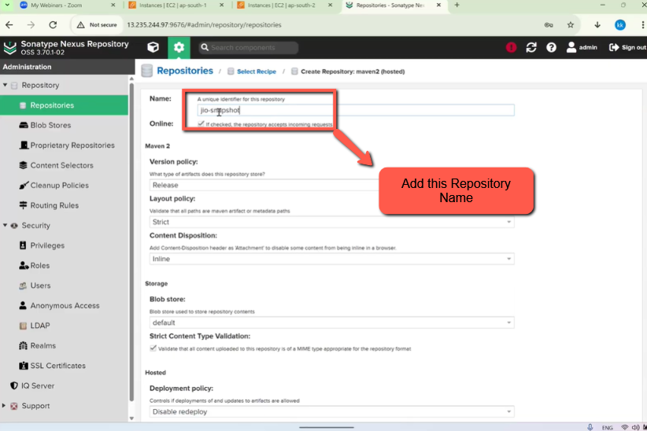
Next
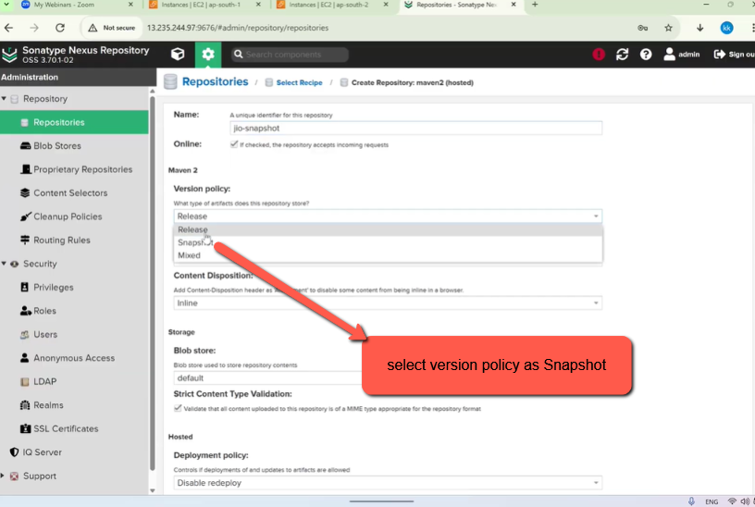
Next
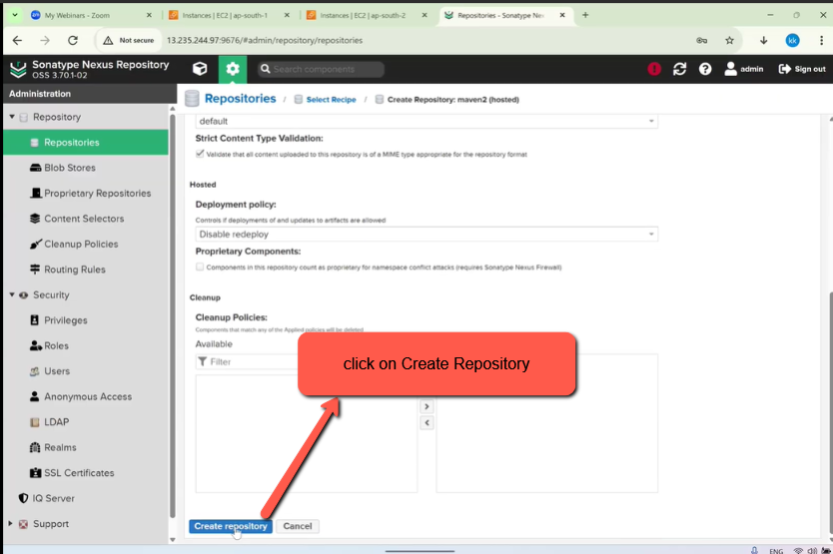
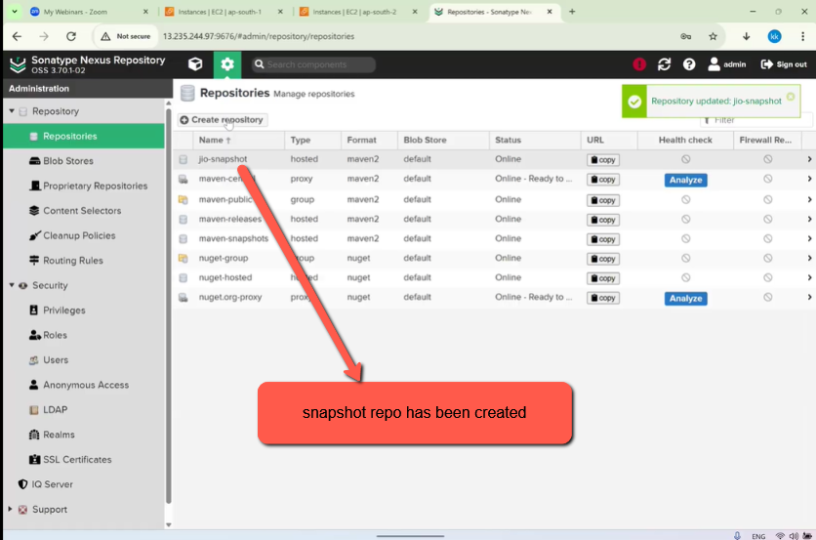
Next lets create Release Repo
click on create repo and then
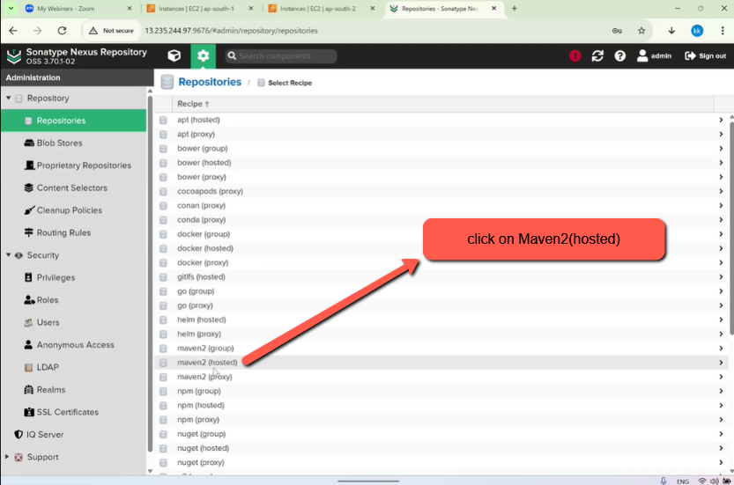
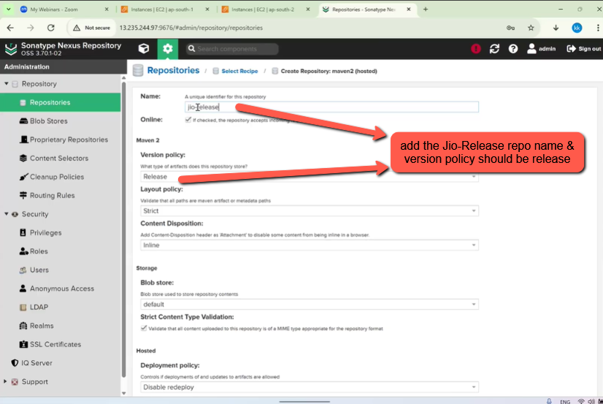
Next
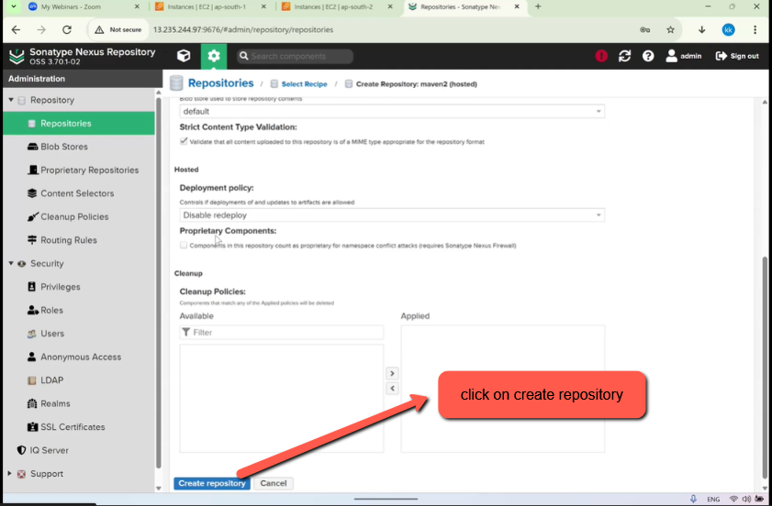
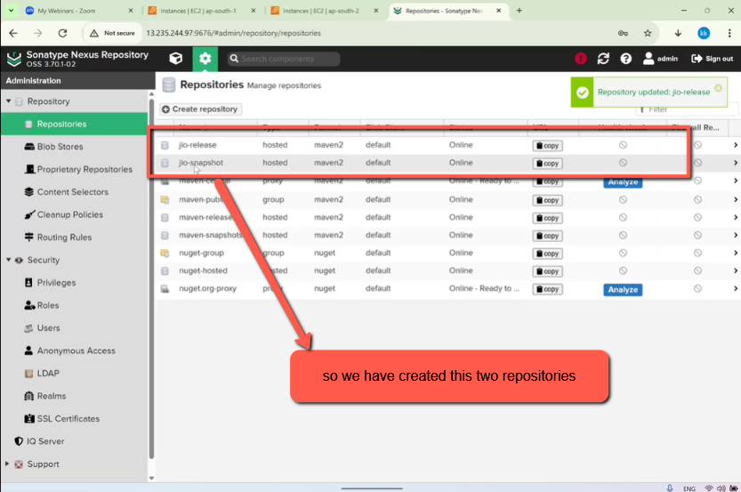
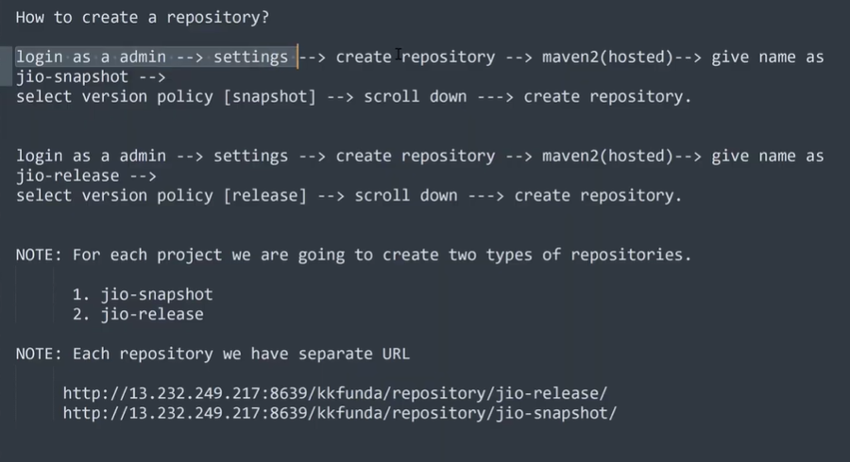
Lets copy of the url of the repos as shown in the below images
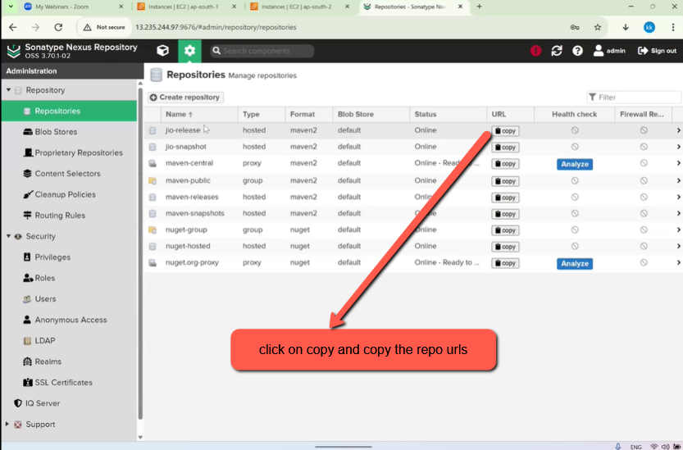
copy the url
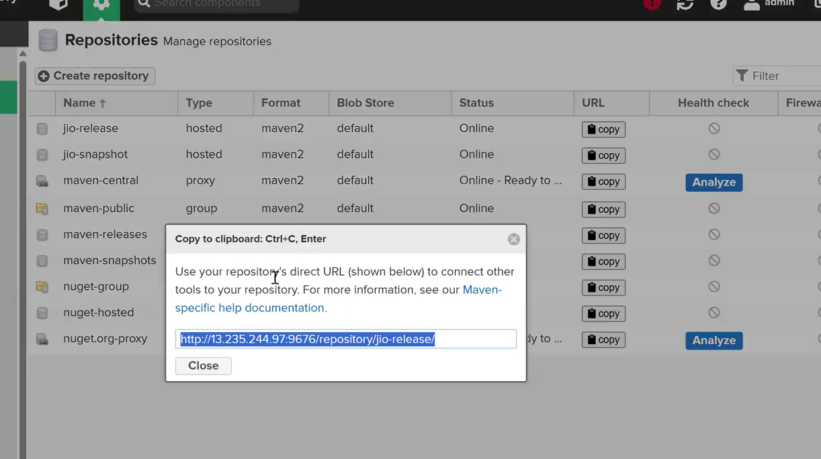
save the snapshot & release urls in a notepad
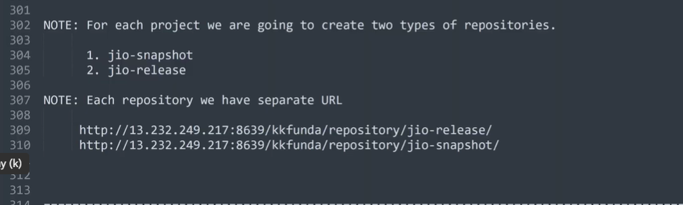
Next add the above repo urls(snapshot,release) in <distributionManagement> tag of pom.xml file of Maven 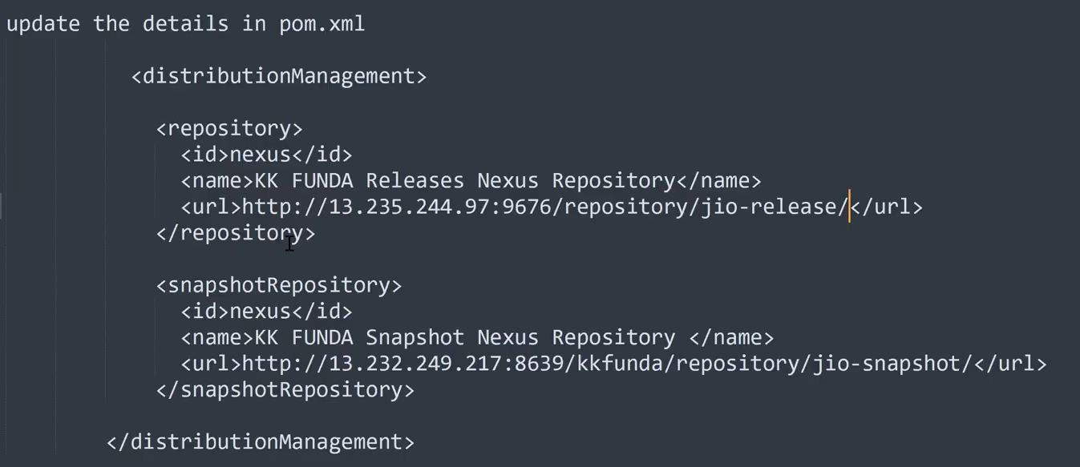
To check whether there is data in repos we have to click on Browse as shown in the below images
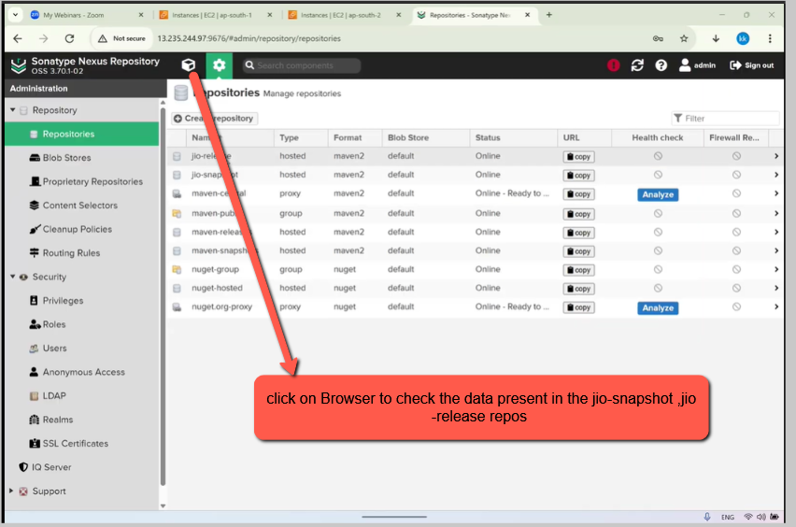
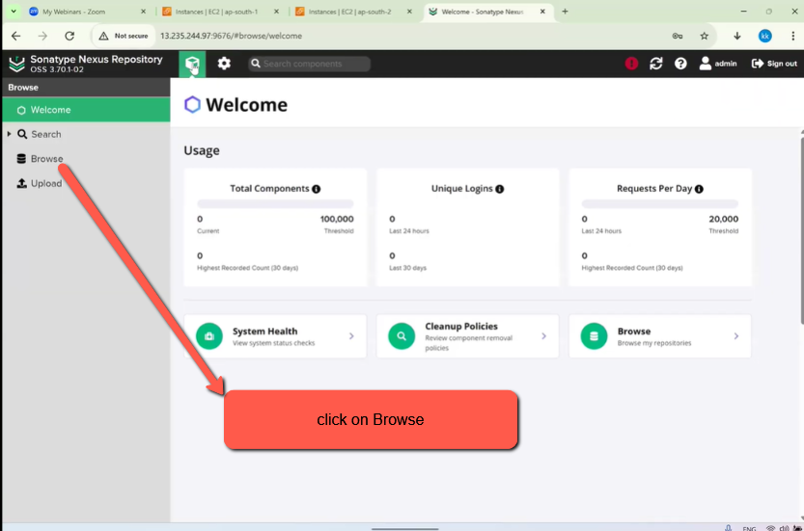
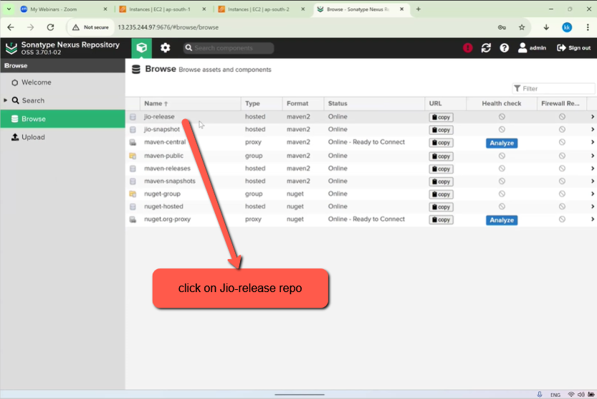
As you can see in the below image there is no data Jio-Release repo and in Jio-snapshot repo
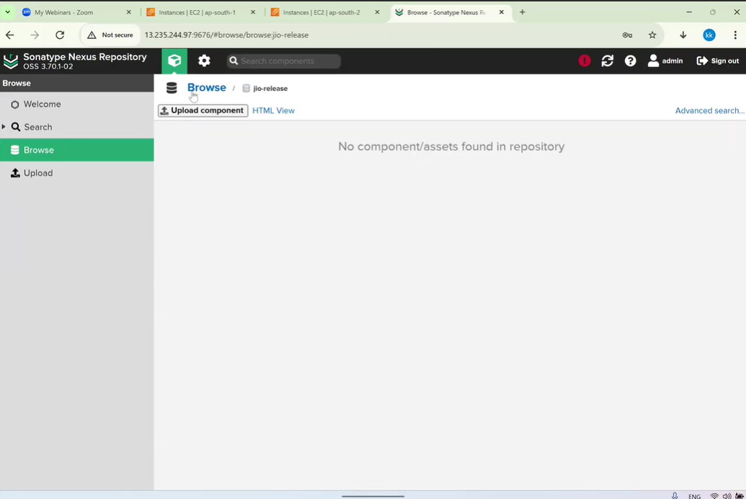
Add the repo urls in the pom.xml file as shown below
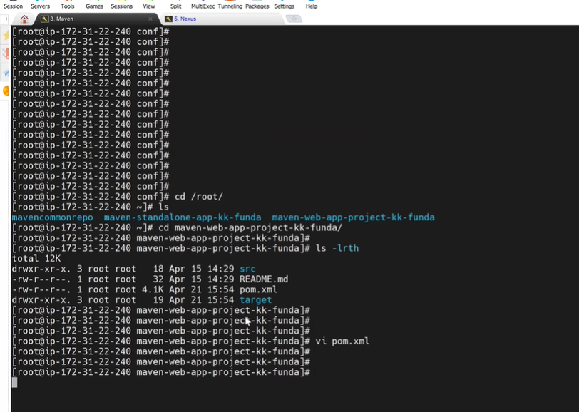
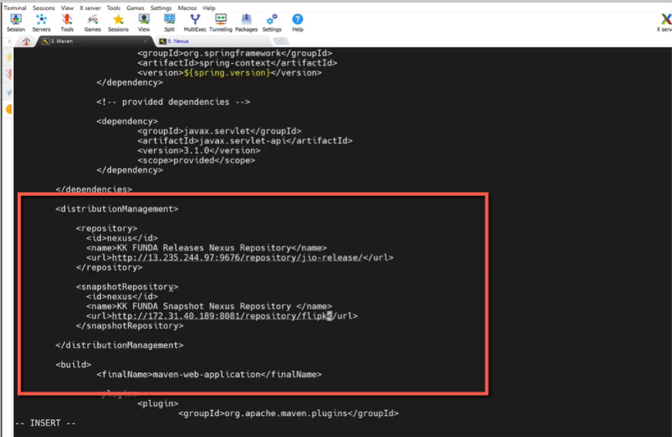
Next run the mvn clean deploy command
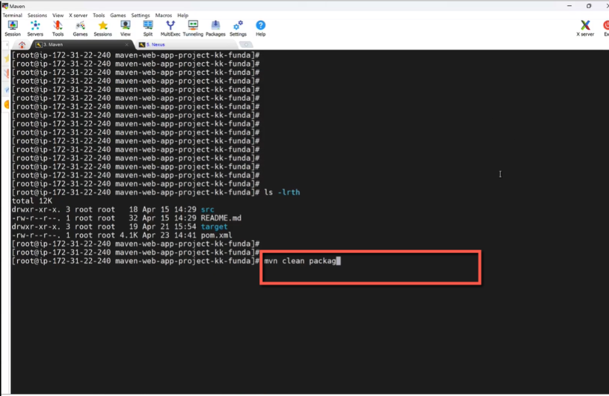
video check 42:00
Afetr executing the mvn clean package an Artifact will be generated . In the below an issue is occurred in after executing the command mvn clean package due to Java version compatible issue. In nexus we have 1.8 Java version but in pom.xml we have java 11 version
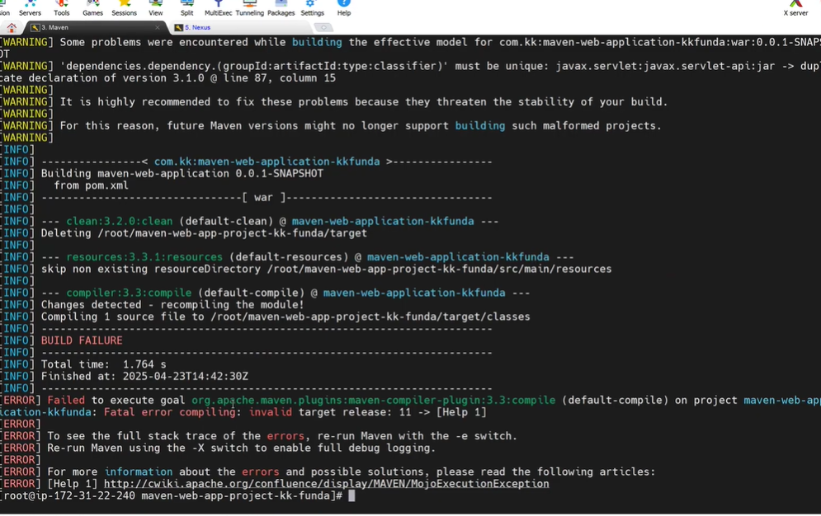
In pom.xml in the below image
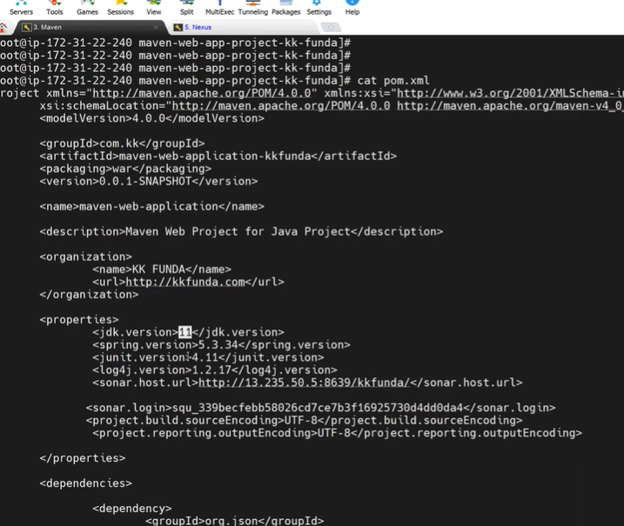
After updating Java 1.8 to Java 11 execute the mvn clean package and you will the result in the below image. An Atifact will get stored in Target directory.
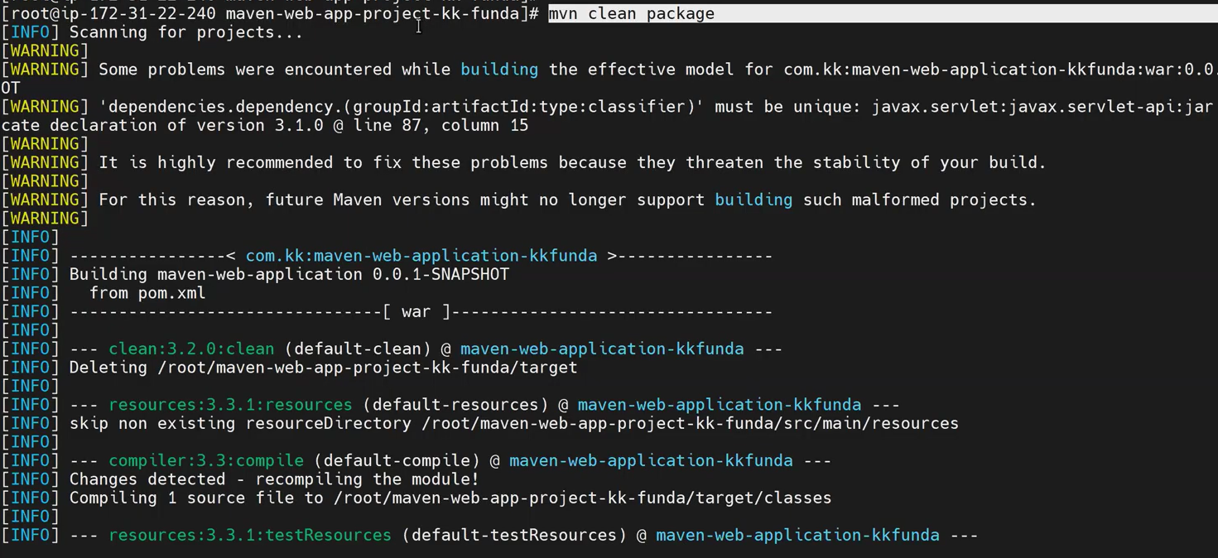
Next clear the screen and check the target directory latest update
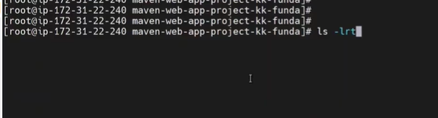
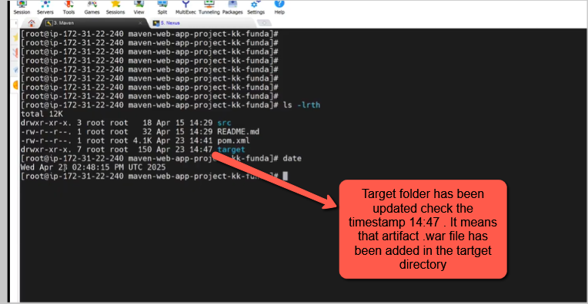
To store the current artifact (i.e., the .war file) in the Nexus repository, run the command mvn clean deploy.
This command uploads a copy of the artifact to Nexus for future reference.
Later, when you execute mvn clean package, it will generate a new artifact, replacing the old one locally.
However, the previously deployed version remains available in the Nexus repository since it was saved using the mvn clean deploy command.
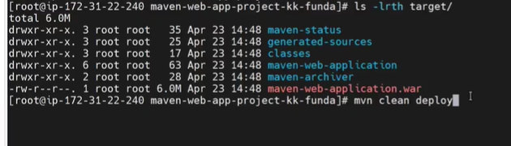
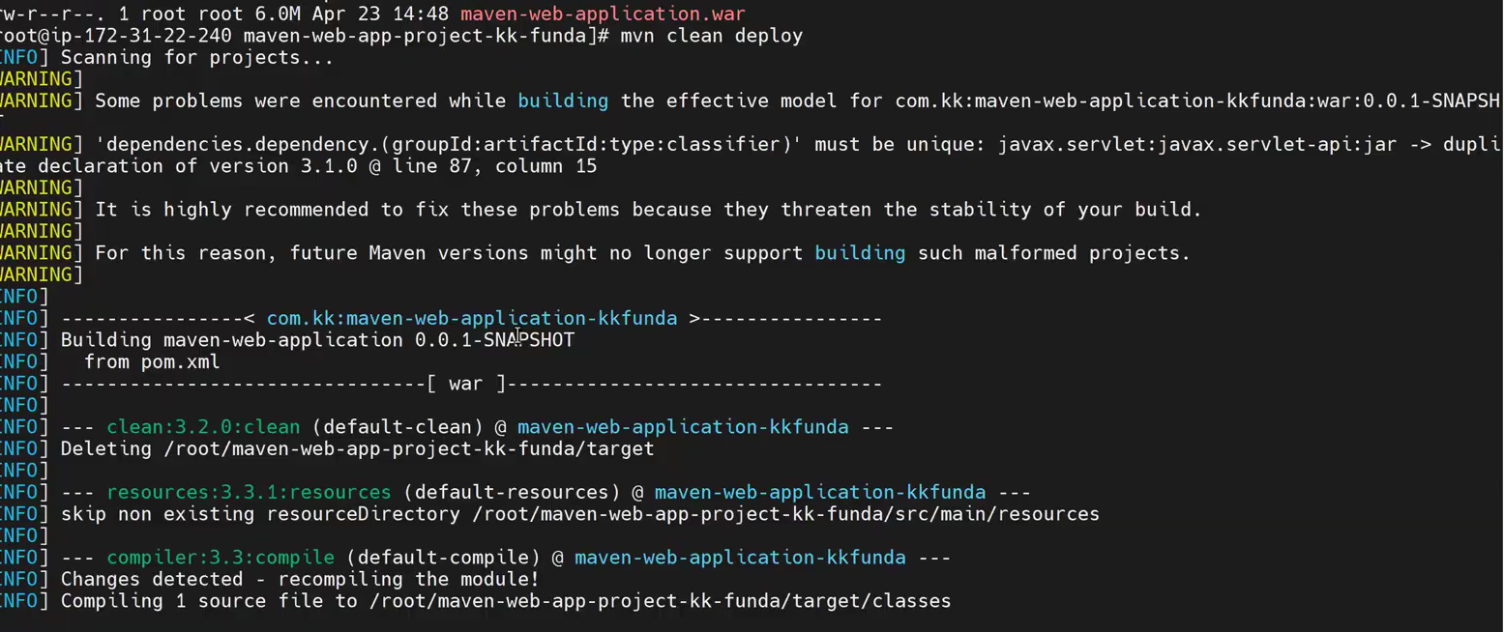
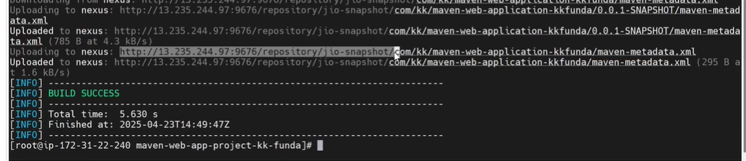
Now go the Nexus server and click on snapshot repository you will find the artifact
