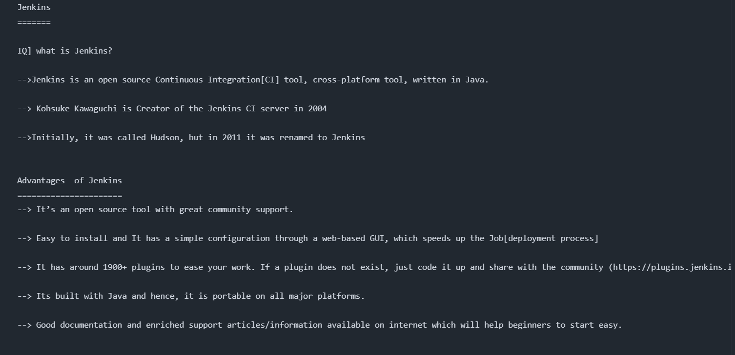
Jenkins by KK FUNDA
====================

Explain the flow diagram : developer --> GitHub --> maven --> SonarQube --> Nexus --> Tomcat --> mail

Jenkins
=======

IQ] what is Jenkins?

-->Jenkins is an open source Continuous Integration[CI] tool, cross-platform tool, written in Java.

--> Kohsuke Kawaguchi is Creator of the Jenkins CI server in 2004

-->Initially, it was called Hudson, but in 2011 it was renamed to Jenkins

Advantages of Jenkins
======================
--> It’s an open source tool with great community support.

--> Easy to install and It has a simple configuration through a web-based GUI, which speeds up the Job[deployment process]

--> It has around 1900+ plugins to ease your work. If a plugin does not exist, just code it up and share with the community (https://plugins.jenkins.io/).

--> Its built with Java and hence, it is portable on all major platforms.

--> Good documentation and enriched support articles/information available on internet which will help beginners to start easy.

Continuous Integration[CI]:
==========================

---> explain diagram

Continuous Integration (CI) is the process of automating the build and testing of code every time a team member commits changes to version control.

(OR)

Continuous Integration is a development practice where developers integrate their code into a shared remote repository frequently, preferably several times a day. Each integration is verified by an automated build (including test) to detect integration errors as quickly as possible.

CI Advantages
-------------
--> Immediate bug detection
--> Less Merge Conflicts
--> Deploy an application at any given point
--> Improved Code Quality [Consistent Testing, Code Reviews]
--> Developers receive immediate feedback on their code changes, allowing them to address issues promptly.

Continuous Delivery:
====================
every successful build that has passed all the relevant automated tests and quality gates can potentially be deployed in to production via fully automated one click process.

diagram
-------

code done --> unit tests --> Integrate --> Acceptance Test ---> Deploy into production
AUTO AUTO AUTO MANUAL

NOTE: Once we get the approval from the client and the sign-off mail from the QA team then we are going to deploy

Continuous Deployment:
======================

The practicing of automatically deploying every successful build directly into production without any manual steps knows as Continuous deployment.

code done --> unit tests --> Integrate --> Acceptance Test ---> Deploy into production
AUTO AUTO AUTO AUTO

IQ] Which one you are using continuous delivery or continuous deployment ?

ANS: I involved in many projects so we are using continuous deployment in "IN-HOUSE PROJECTS"

EX: Company internal Project : HR --->

Coming to continuous delivery , We used for "client (external) projects"

EX: jio, flipkart, amazon, etc
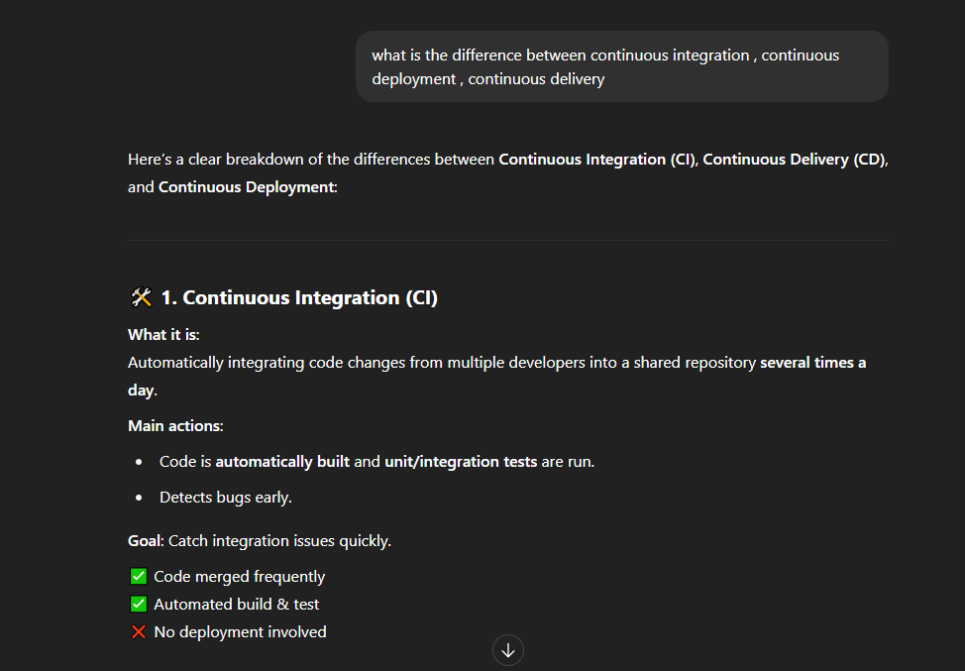
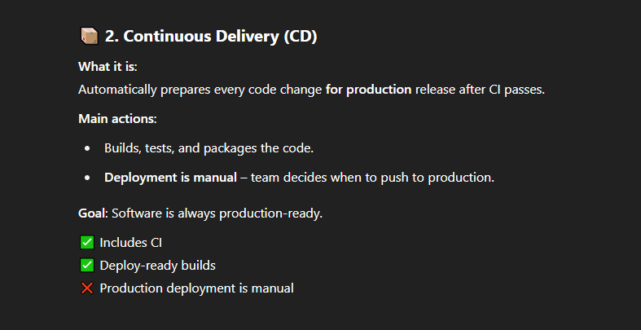
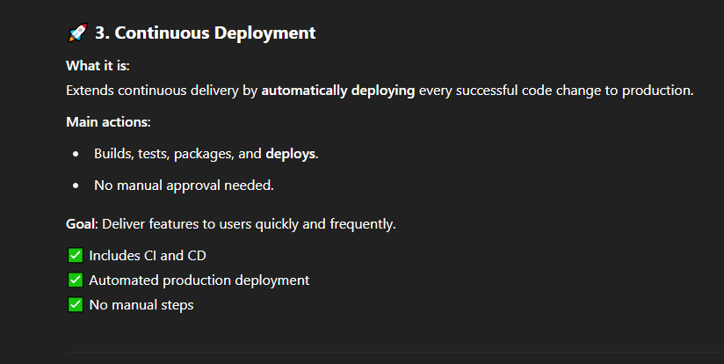
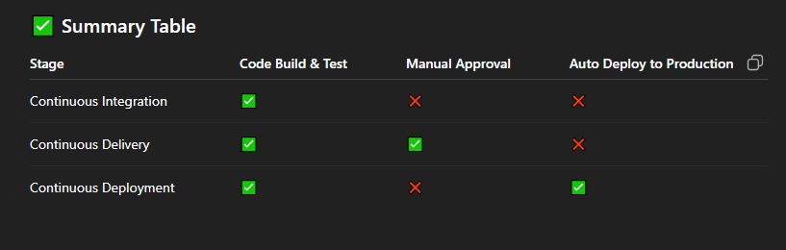
Example for ci(continuos Integration) ,cd(continuous delivery), cd(continuos deployment)

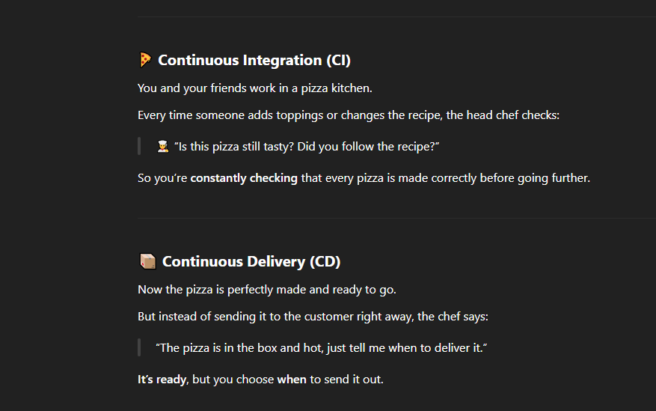
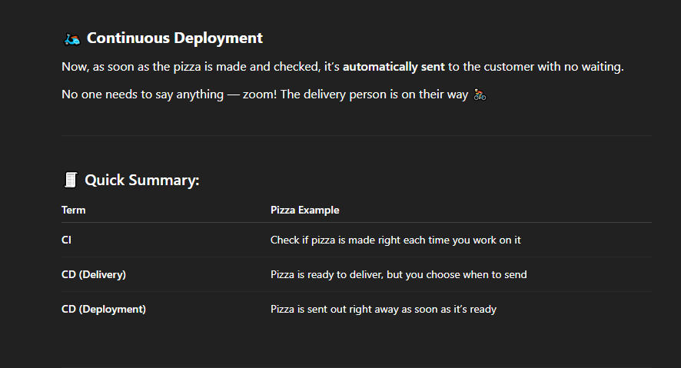
for below image check the video at 40:00 explaiining the Difference between continuos delivery and continuos deployment in Real Time Interview question
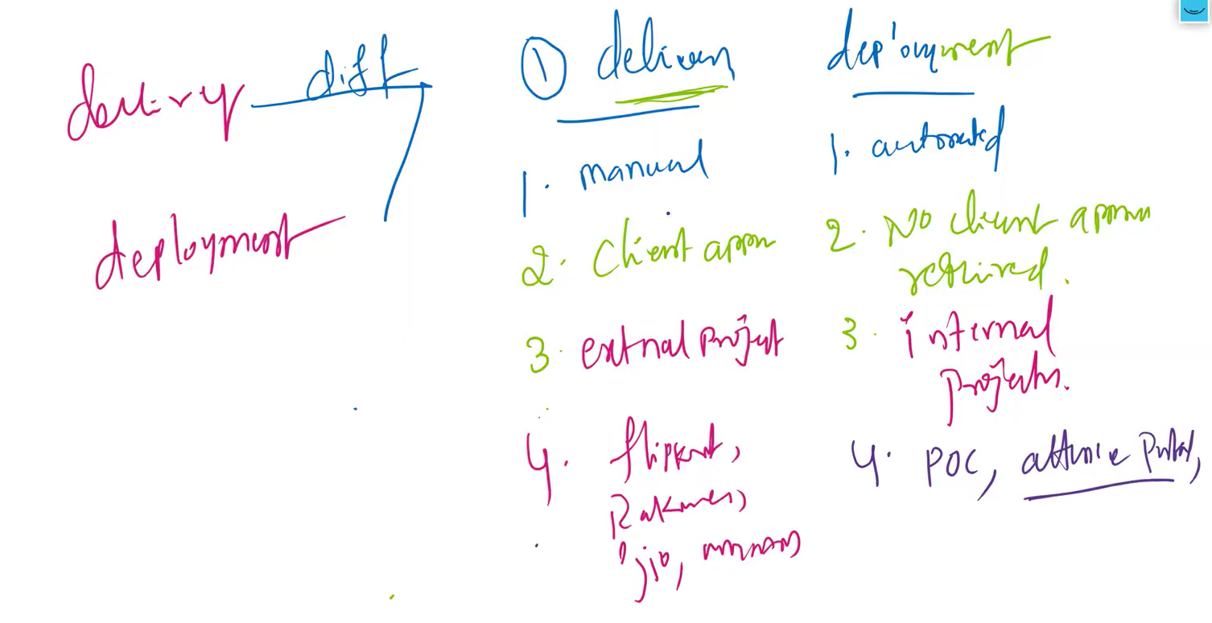

What Jenkins can do?

• Integrate with many different Version Control Systems (GitHub, BitBucket , GitLab, ...)
• Generate test reports (JUnit)
• Push the builds to various artifact repositories[nexus/jfrog]
• Deploys directly to production or test environments
• Notify stakeholders of build status (Through Email/slack,etc)

List of popular Continuous Integration tools
============================================

SNO Product Is Open Source?
===========================================
1 Jenkins Yes [community edition]
2 Cloudbees Jenkins No [Enterprise edition]
2 Bamboo No
3 Cruise Control Yes
4 Travis CI Yes and Paid also
5 Circle CI Yes and Paid also
6 GitLab CI Yes and Paid
7 TeamCity Yes and Paid

NOTE: default port for jenkins: 8080

Jenkins Installation
====================
prerequsite : JAVA, min: t2.medium

JAVA Installation
-----------------

step 1: launch an ec2 machine(t2.medium), connect to that machine

step 2: switch to root user [sudo su - ]

JENKINS Installation
====================

--> LTS[Long Term Support] ---> stable version without any issues.
--> search on google [ download jenkins ] --> LTS --> Redhat/fedora/centos

step 1: sudo su -

step 2:

yum install wget tree -y

sudo wget -O /etc/yum.repos.d/jenkins.repo \
https://pkg.jenkins.io/redhat-stable/jenkins.repo
sudo rpm --import https://pkg.jenkins.io/redhat-stable/jenkins.io-2023.key
sudo yum upgrade
# Add required dependencies for the jenkins package
sudo yum install fontconfig java-21-openjdk
sudo yum install jenkins
sudo systemctl daemon-reload

step 3:

systemctl enable jenkins

step 4:

systemctl status jenkins
systemctl start jenkins
systemctl status jenkins

step 5:

http://13.201.93.75:8080/ --> please make sure to enable 8080 port

cat /var/lib/jenkins/secrets/initialAdminPassword

step 6:

click on suggested plugins

step 7:

user_name: kkfunda
password: kkfunda
confirm password: kkfunda
Full Name: KK FUNDA

save And Continue --> Save and finish --> start using Jenkins
-------------------------------------------------------------------------------------------------------------------------------------------------------------------------------------------------------------------------------------------------------------------------------------------------------------------------------------------------------------------------------------------------
Lets start the Installation of Jenkins in a new ec2 instance named as ‘Jenkins-Server’ check the installation video at 49:00
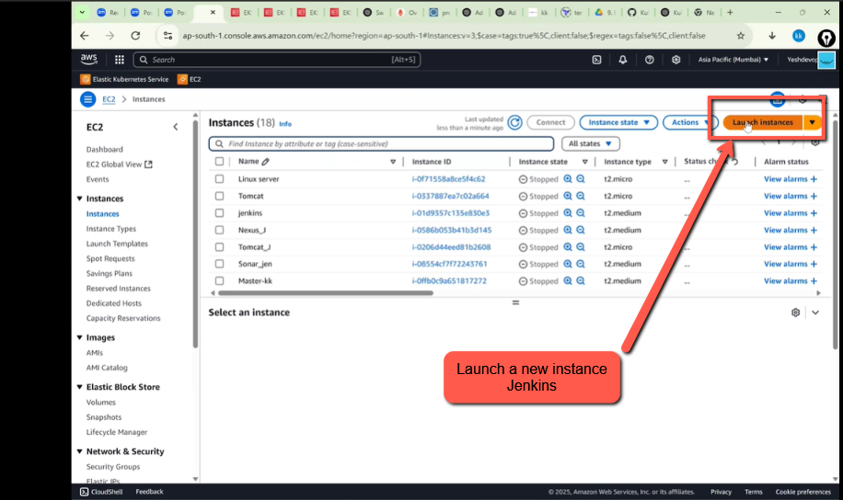
Next give the instance Name as shown in the below image
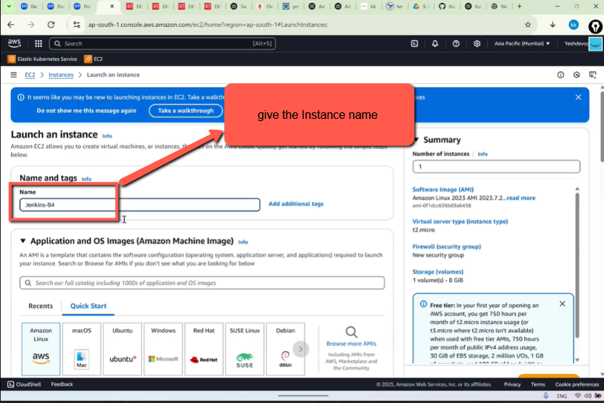
Next select RedHat Linux as shown in the below img
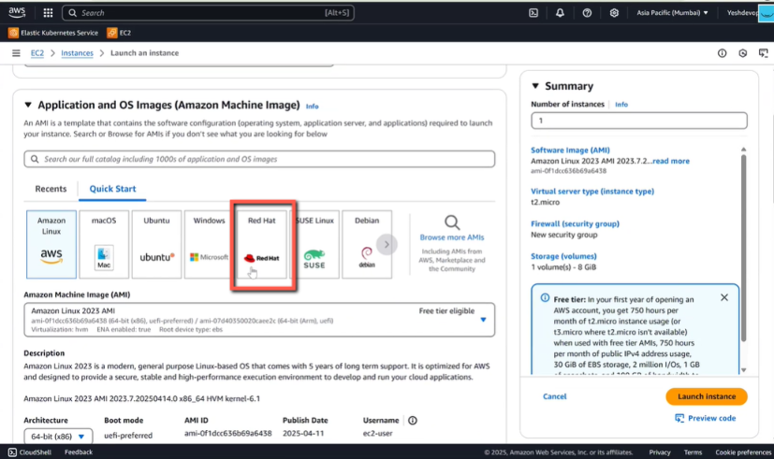
Next select Instance Type it should t2.medium but I have selected t2.micro because it’s free
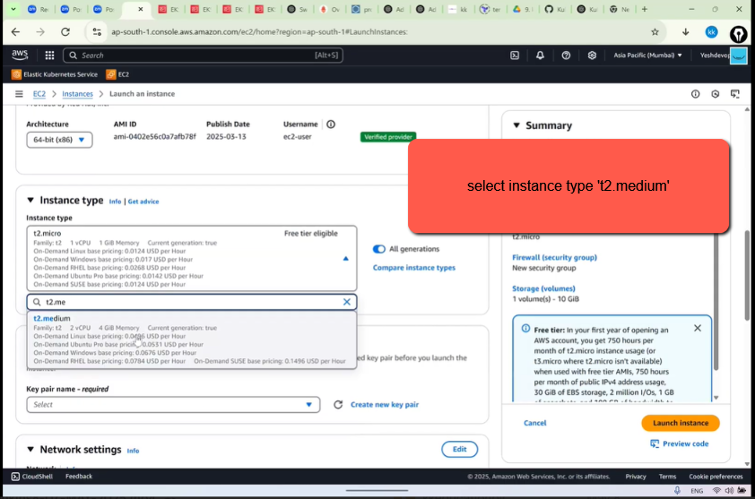
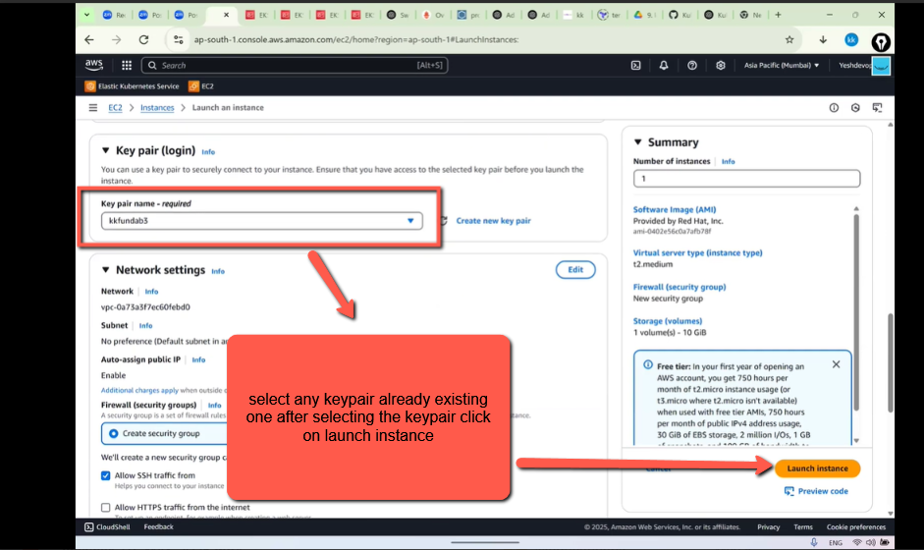
Instance has been Launched successfully as shown in the below img
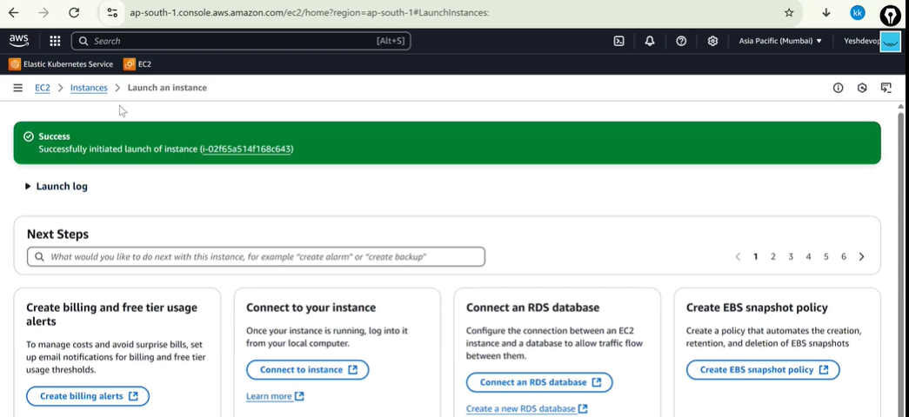
Lets connect with the new instance ‘Jenkins’ as shown in the below img
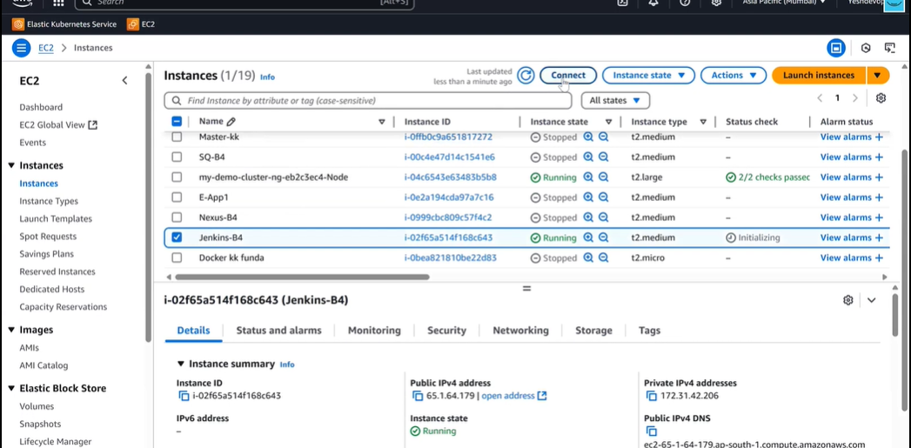
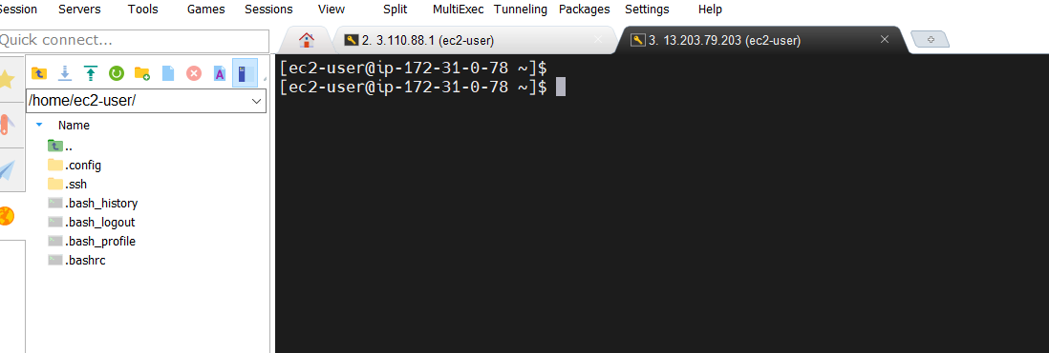
Lets install java first in our Jenkins-server instance as shown in the below image
first install sudo yum install wget tree –y . Installed successfully
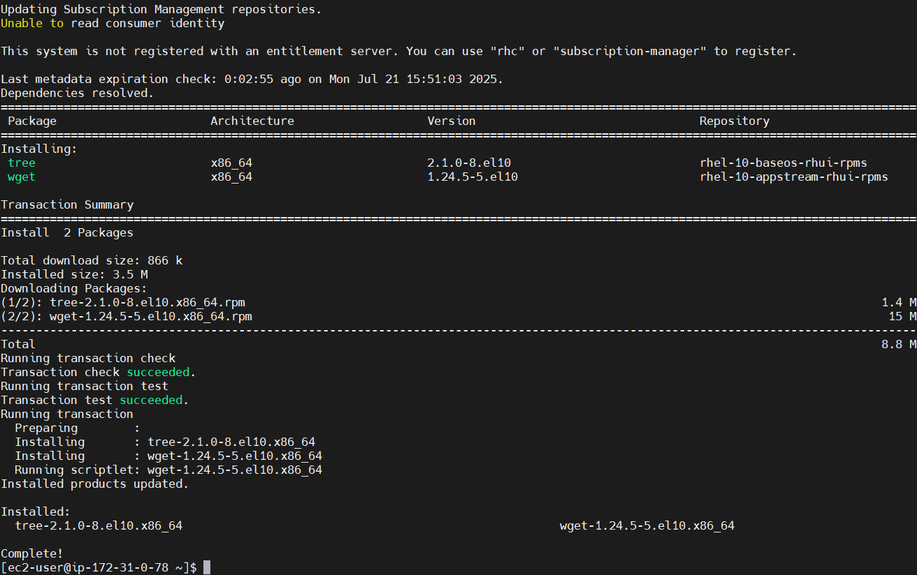
Installing Java a shown in the below image
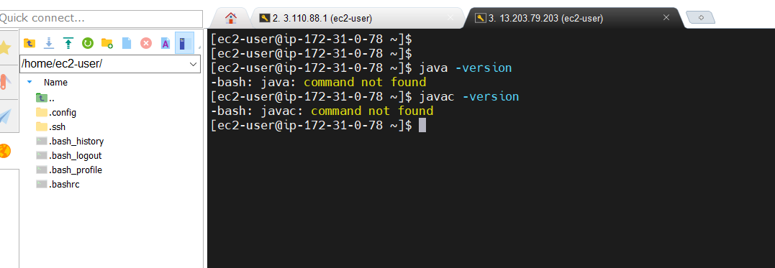
so open the url Jenkins.io/downloads/ in the browser and select Red Hat Enterprise Linux as shown in the below img
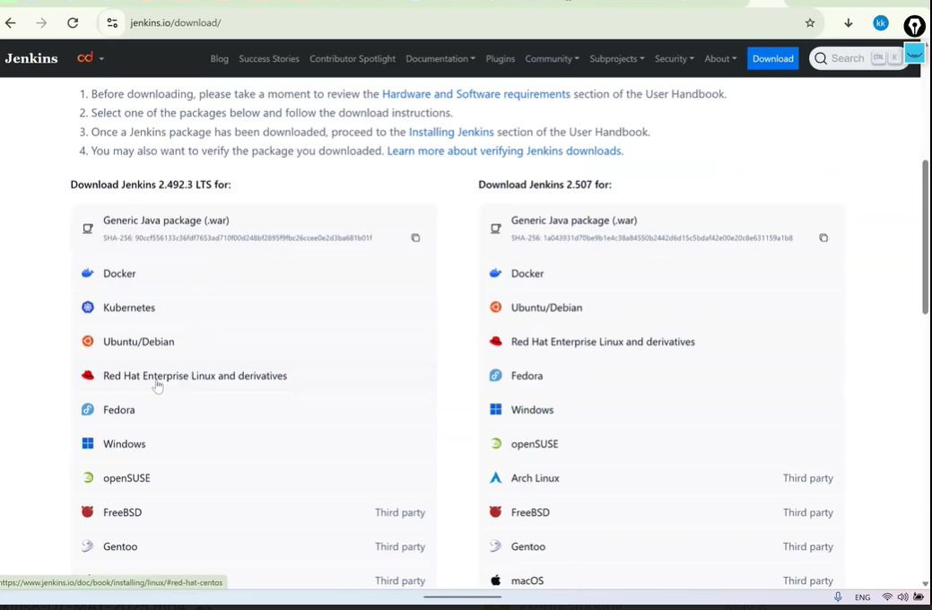
copy the commands present in Term Support Release as shown in the below img
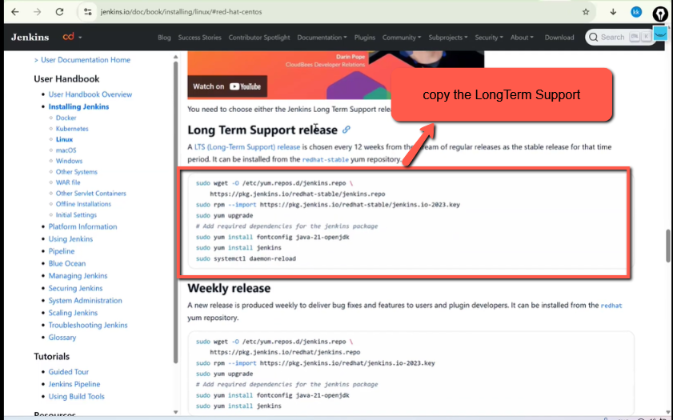
below are the commands
sudo wget -O /etc/yum.repos.d/jenkins.repo \
https://pkg.jenkins.io/redhat-stable/jenkins.repo
sudo rpm --import https://pkg.jenkins.io/redhat-stable/jenkins.io-2023.key
sudo yum upgrade
# Add required dependencies for the jenkins package
sudo yum install fontconfig java-21-openjdk
sudo yum install jenkins
sudo systemctl daemon-reload
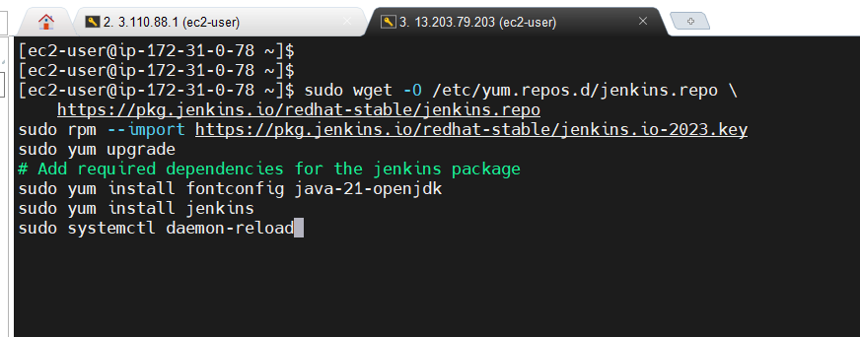
As you can see the Jenkins server is successfully Launched as shown in the below image
