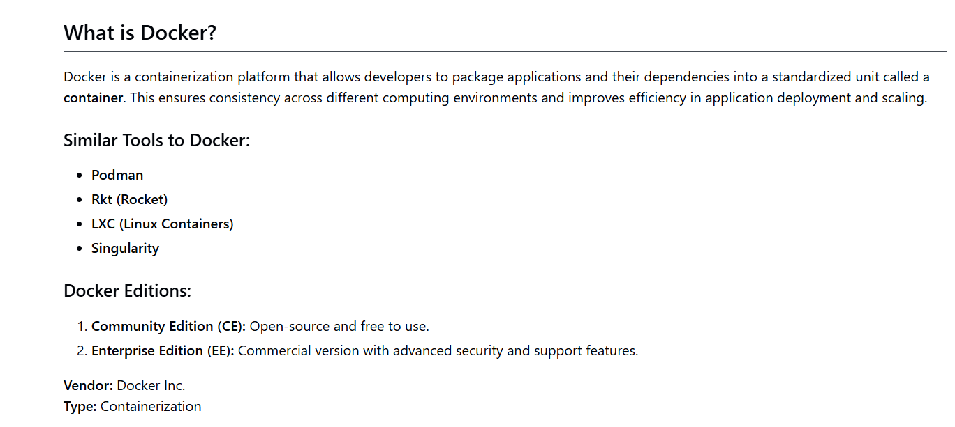
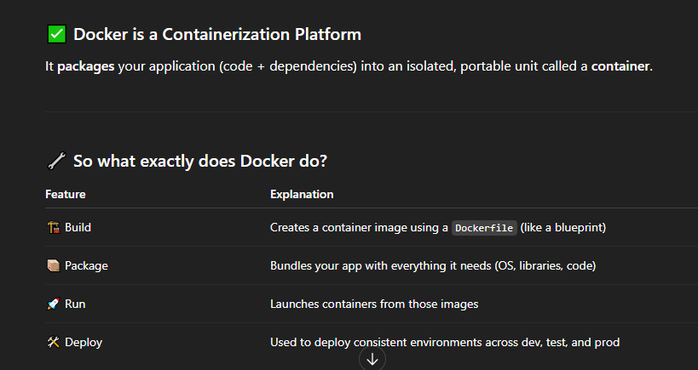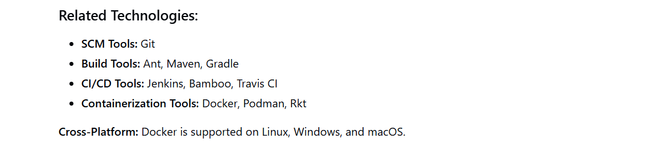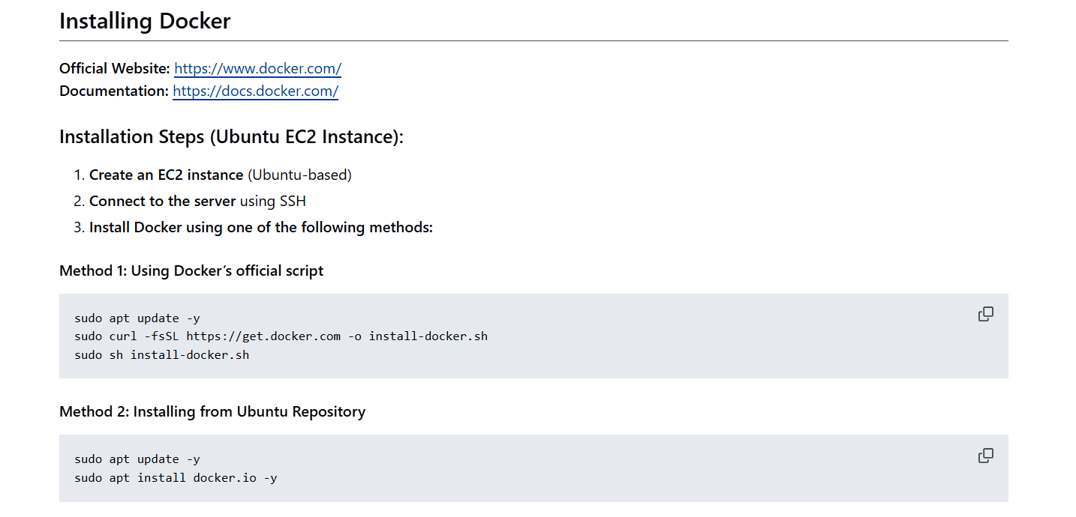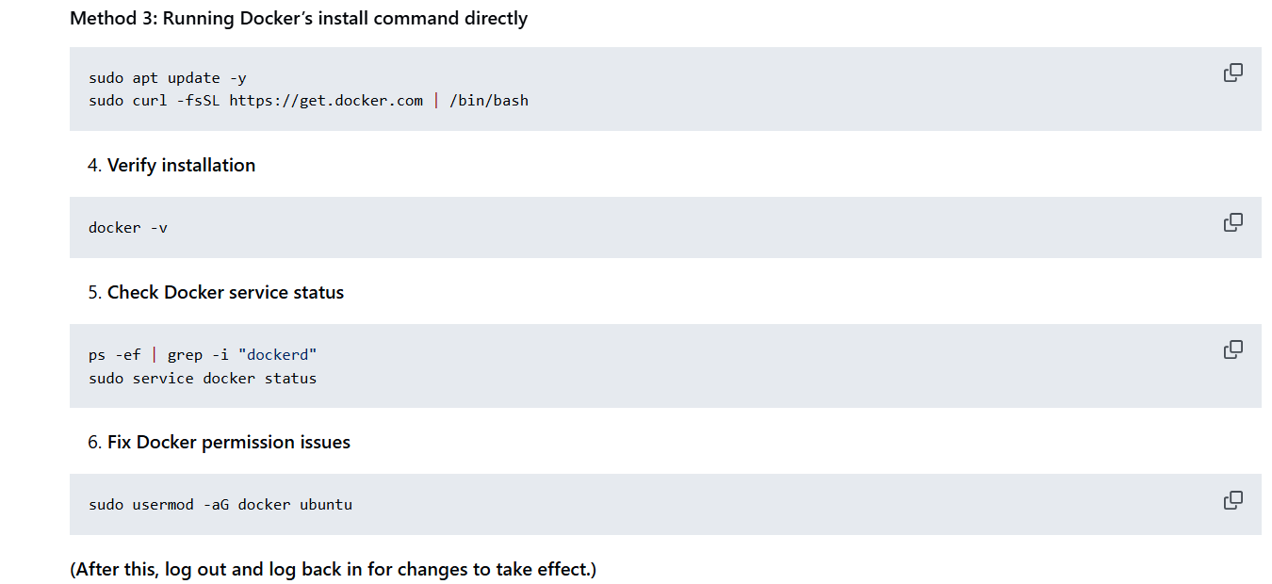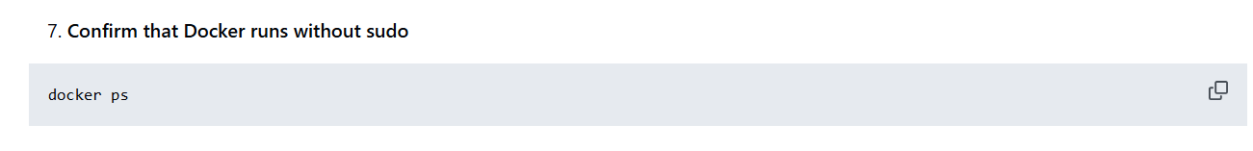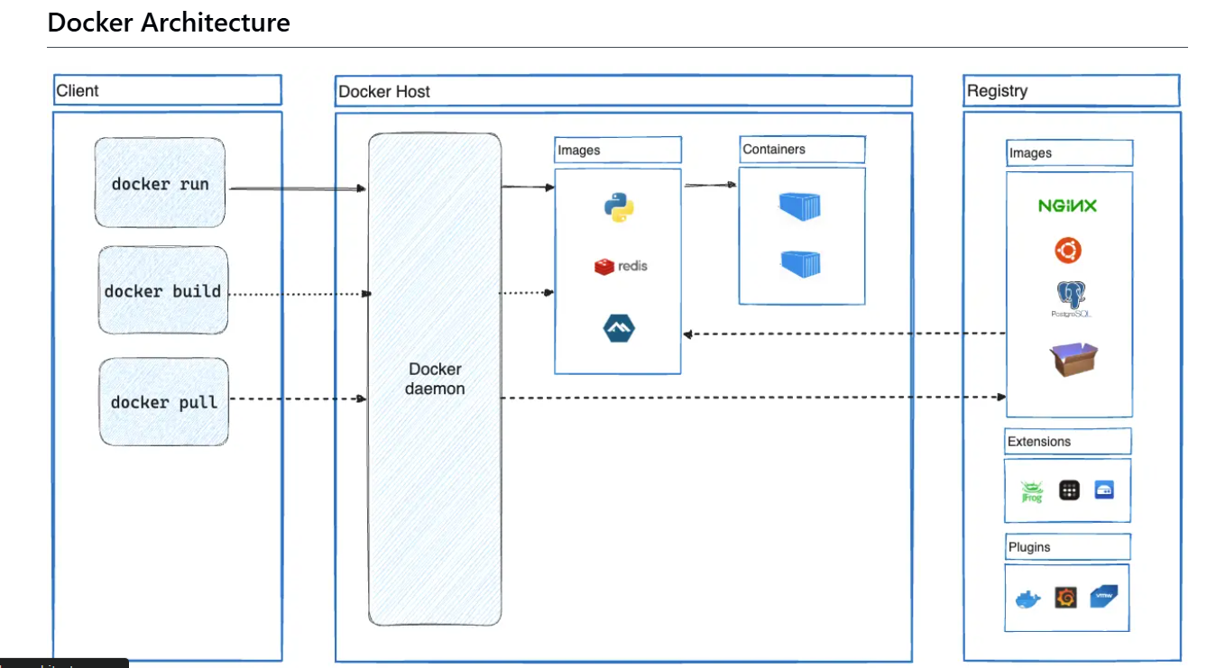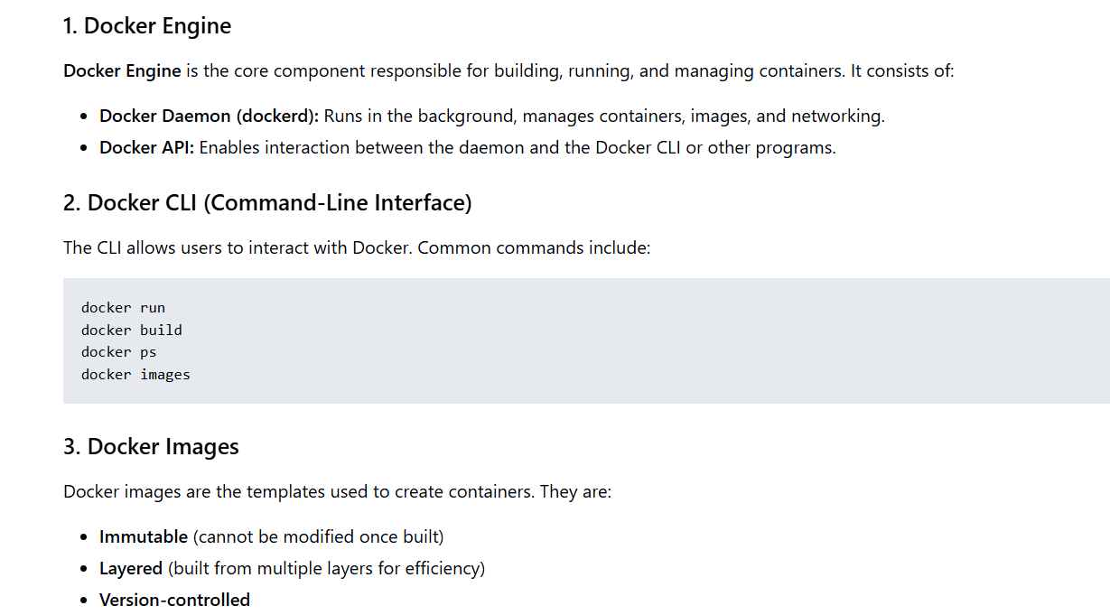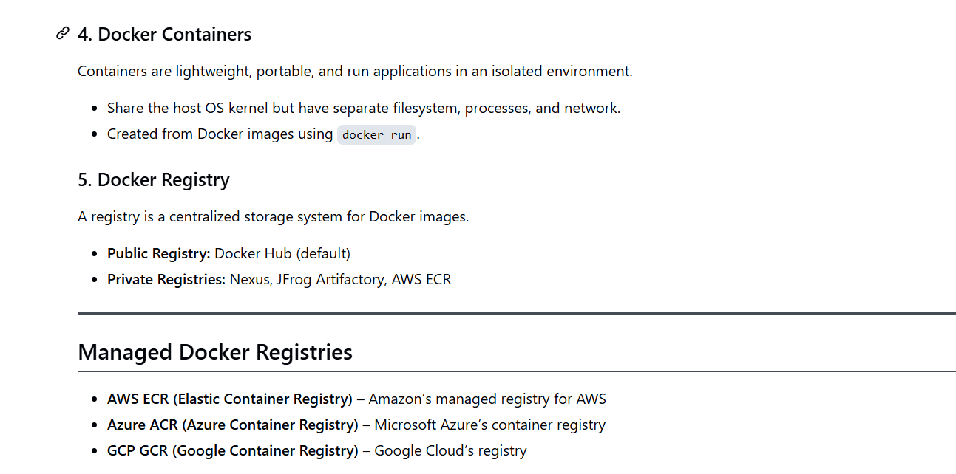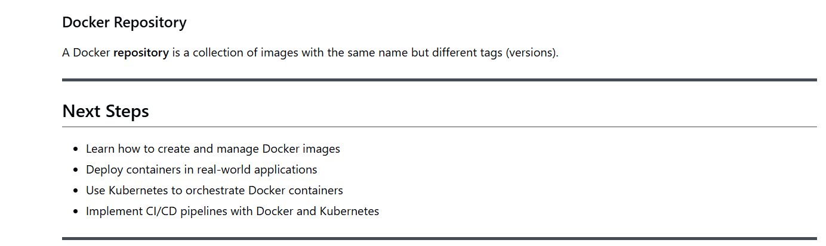
Before installation of Docker we should discuss some important point about Docker
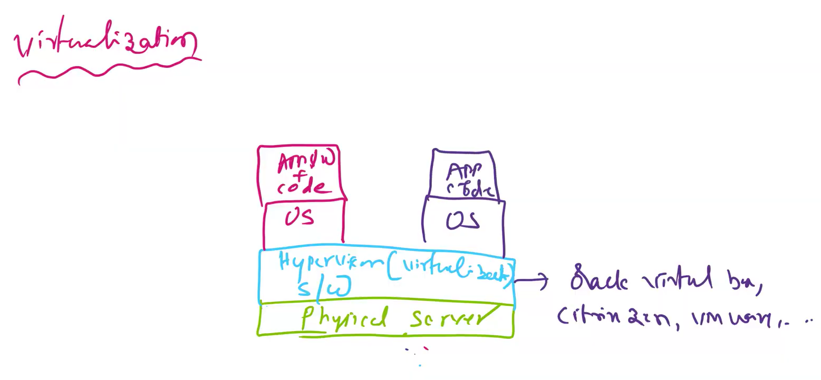
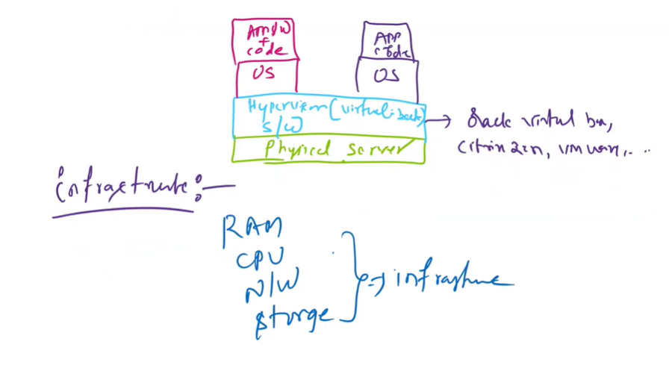
from the above image you can see that we can deploy multiple application on the same server on different operating system
Disadvantge of Virtualization is that it is a heavy weight.It means it requires more system resuorces and takes lot of startup time.
Another disadvantage of virtualization is that we can port or transfer the application from one virtual os to another virtual os
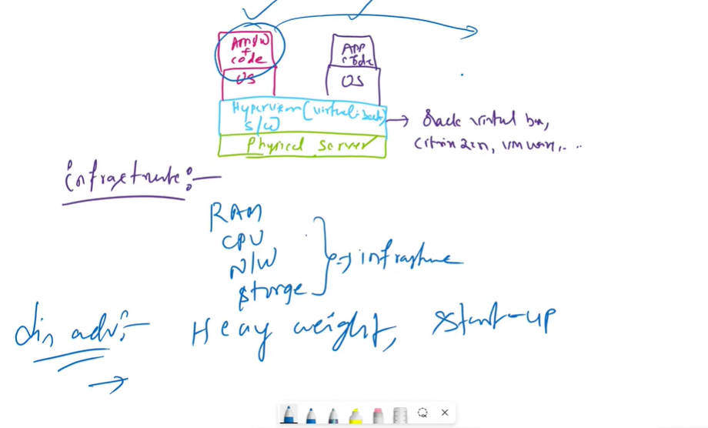
To overcome these disadvantages we use containeraization(Docker). The below Image shows what docker containeraization would do 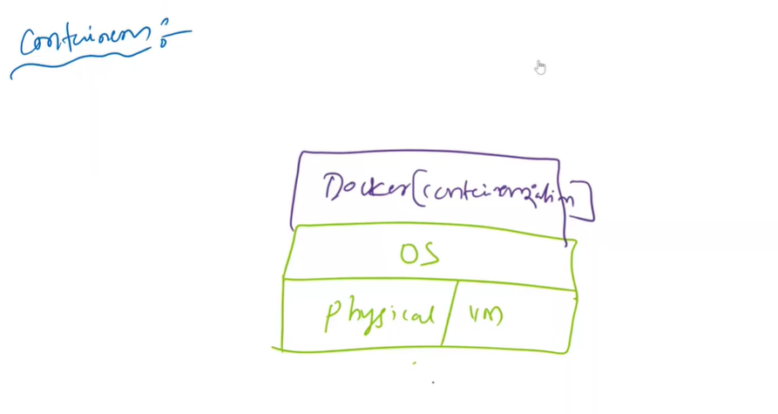
You can deploy multiple no of containers in Docker containerization as shown in the below image
Tomcat container , Java container , Database Conatiner
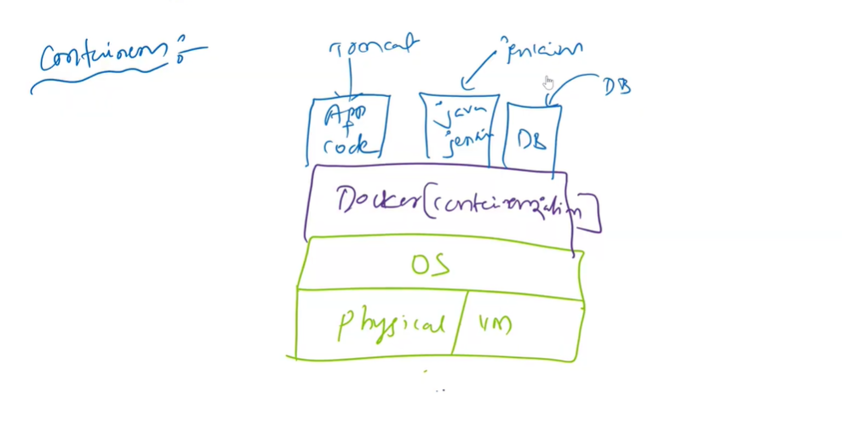
on top of single os(operating system) in Docker we can isolate multiple process like Tomcat server , Janekins server , DB server
Each App in Docker has it own container and each container has it won Network and storage.
Below are the Advantages of Containeraization
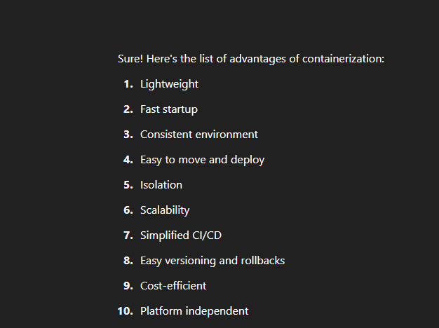
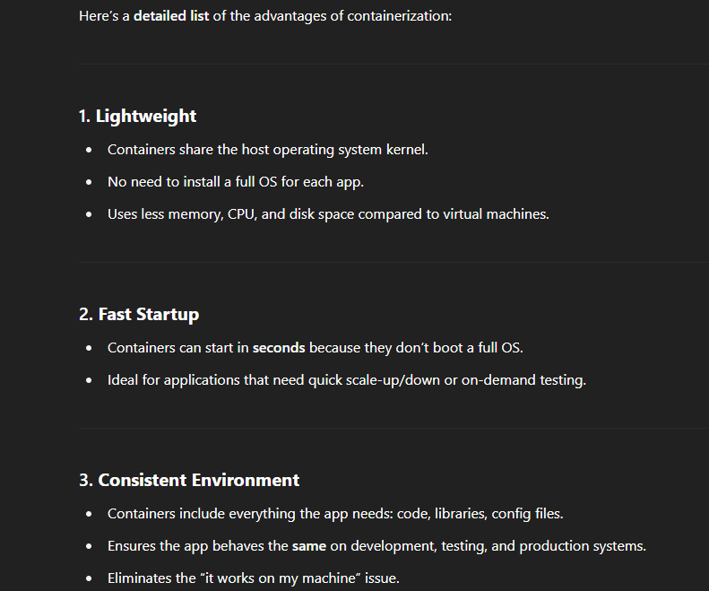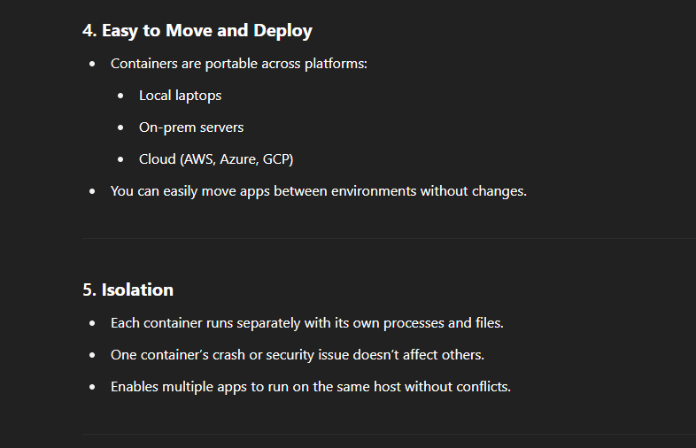
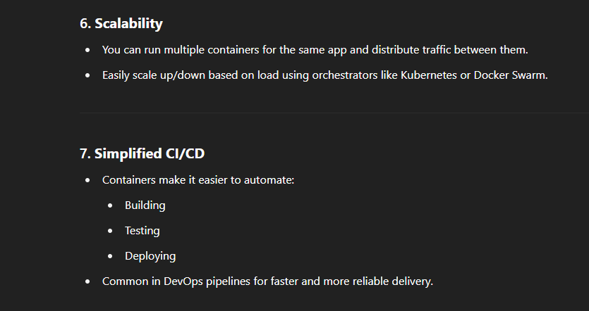
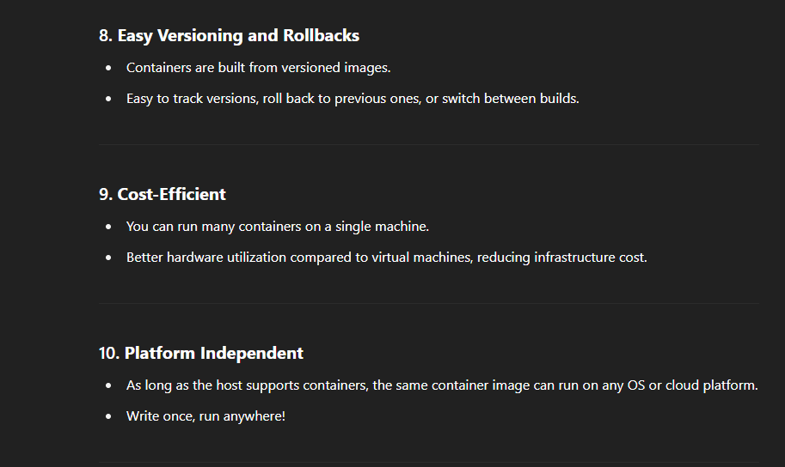
Difference between Containerization and Virtual Machine
The memory sharing is not possible in Virtual Machines whereas in containerization memory sharing is possible
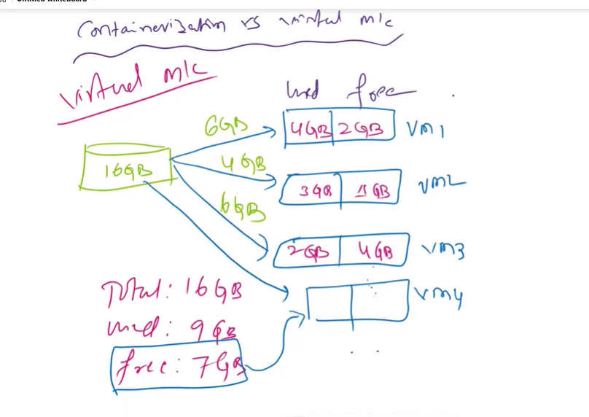
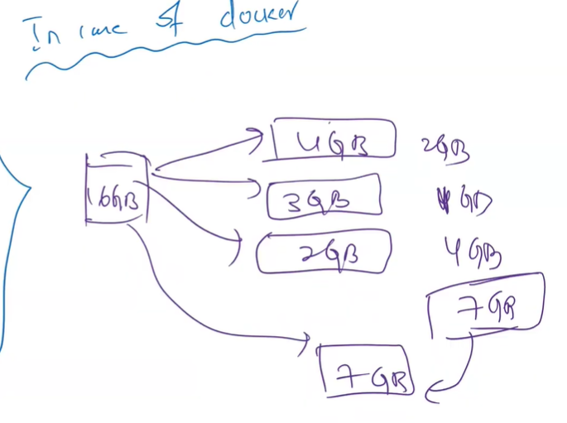
The slogan for Docker Container is ‘Build once and Deploy it Anywhere’
Below image shows the issues use to face when there is no docker . It was version compatability issue while deploying the Artifact or Application on the servers
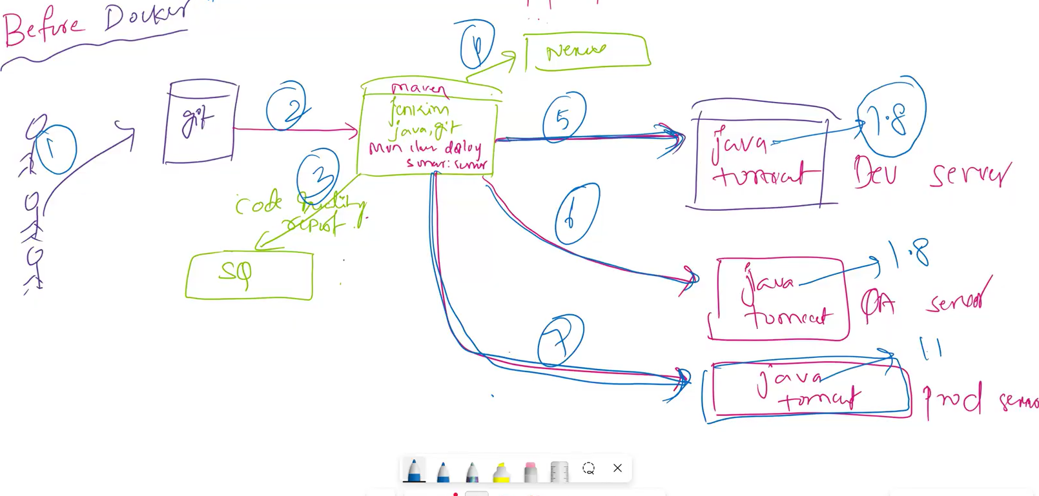
After Docker the results as shown in the below image video check at 28:00
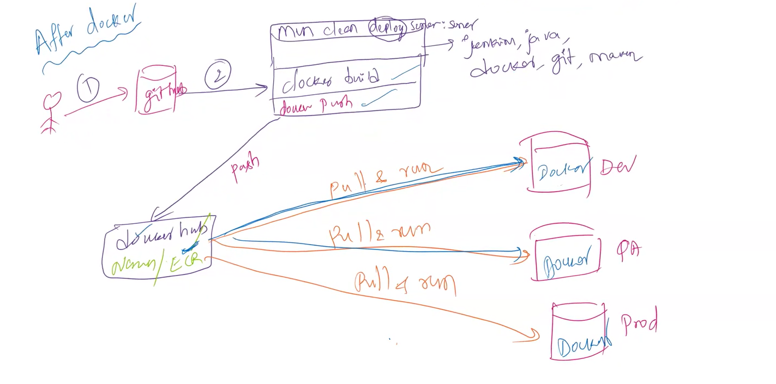
Below is the Docker Flow :
To build docker image from docker file we have to use dockerbuild command
To create docker container from Docker image we have to use Dockercreate or run command
To push Docker Image in to Docker Hub/Nexus/Jfrog/ECR we have to use Docker Push command
To download the Docker Image from DockerHub we have to use the Docker Pull command
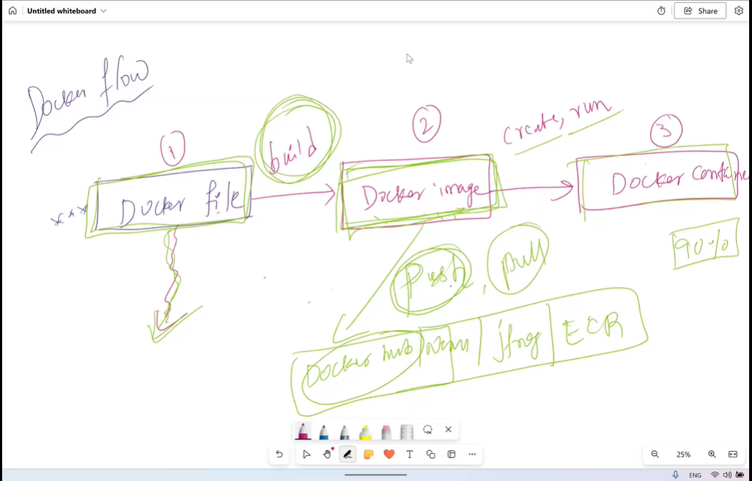
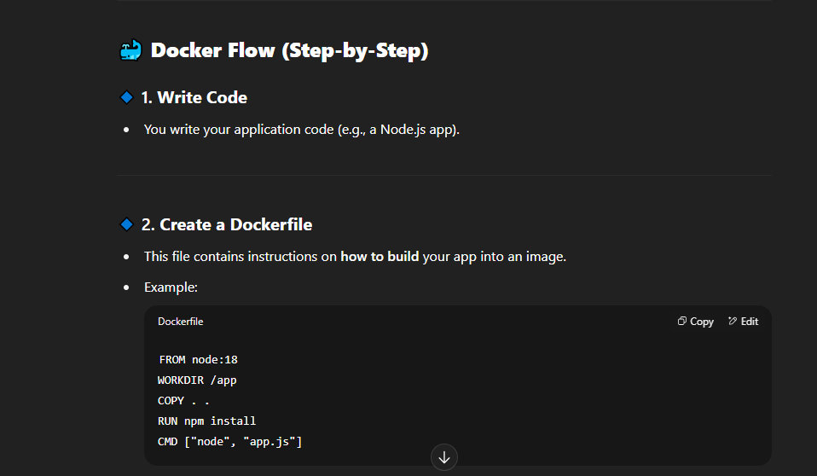
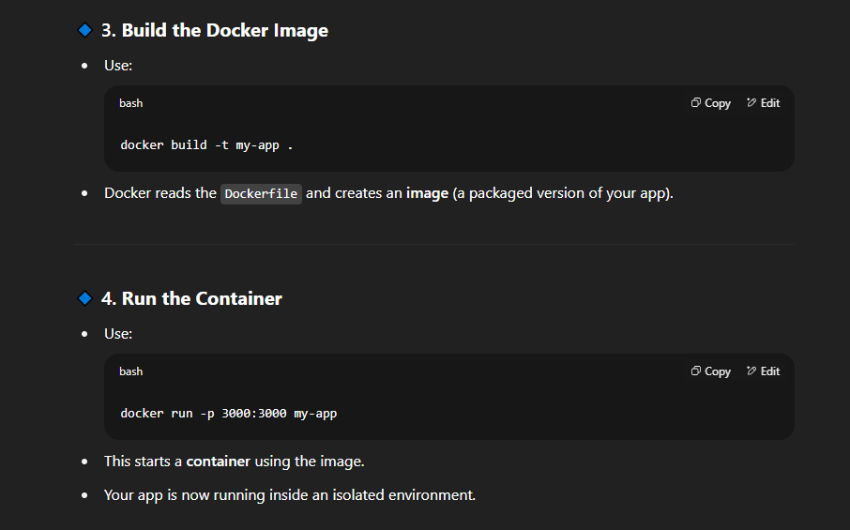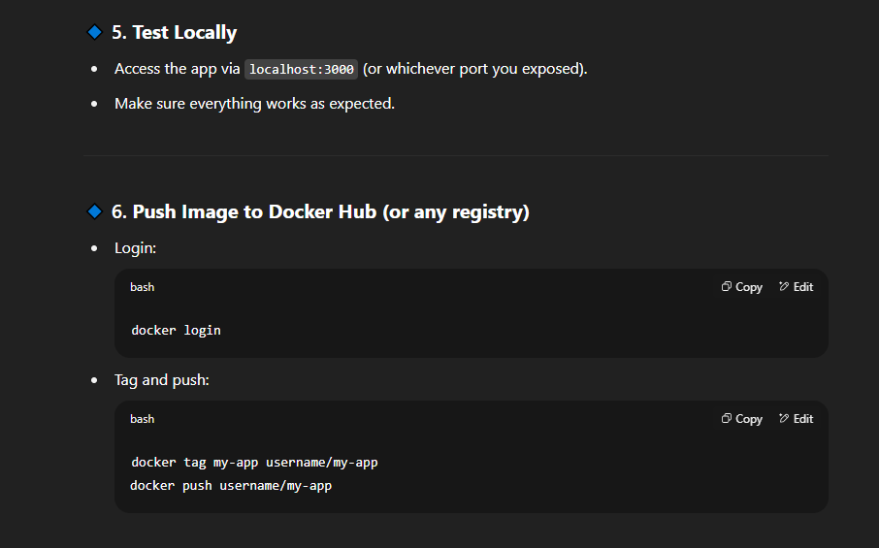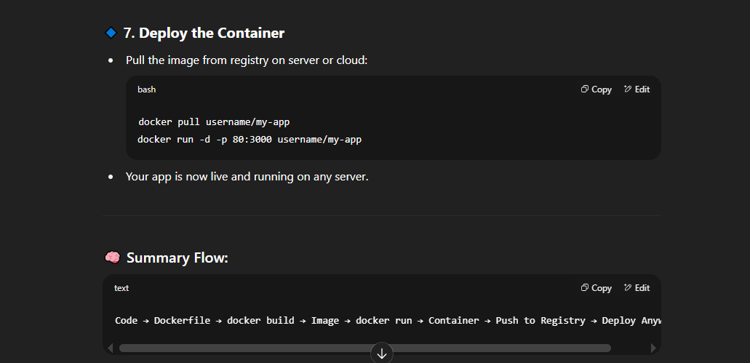
Lets start working with docker
important point before downloading the docker we should Launch ecamp instance with Ubuntu Linux os but not with Red Hat Linux.
It is highly recommended to use Ubuntu
Lets create the Docker server Intance with Ubuntu os
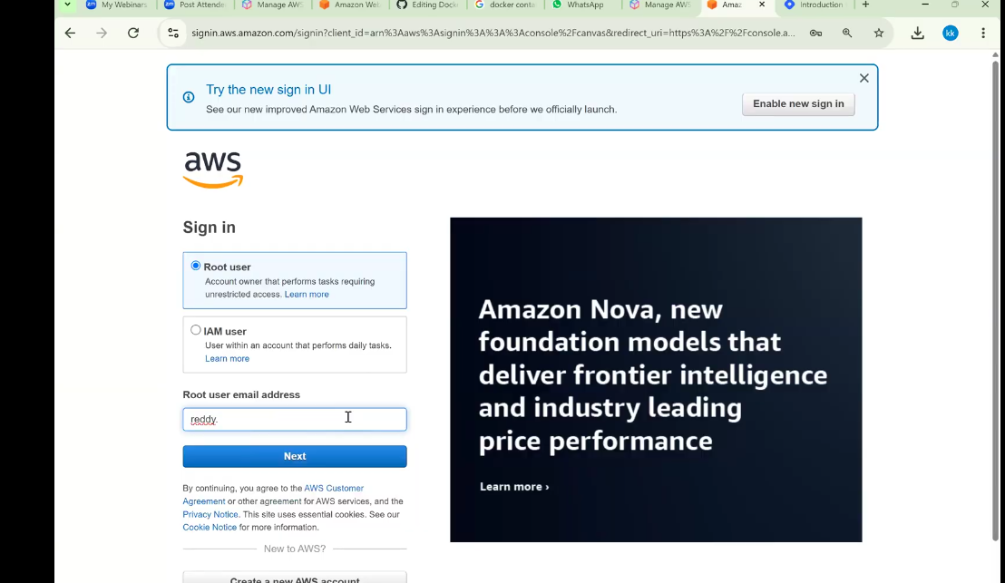
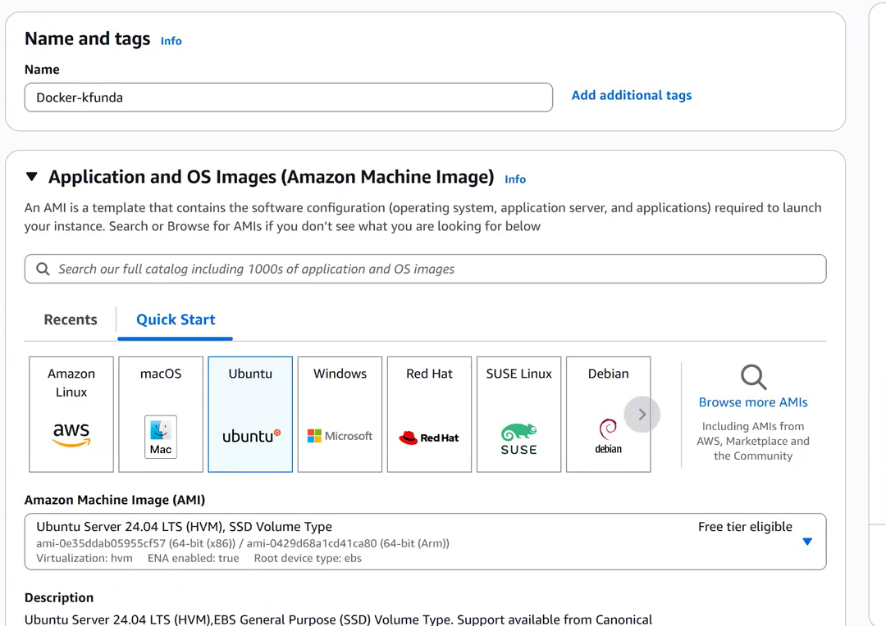
The Default username for RedHat os is ec2-user but for Ubuntu Linux os its Ubuntu user
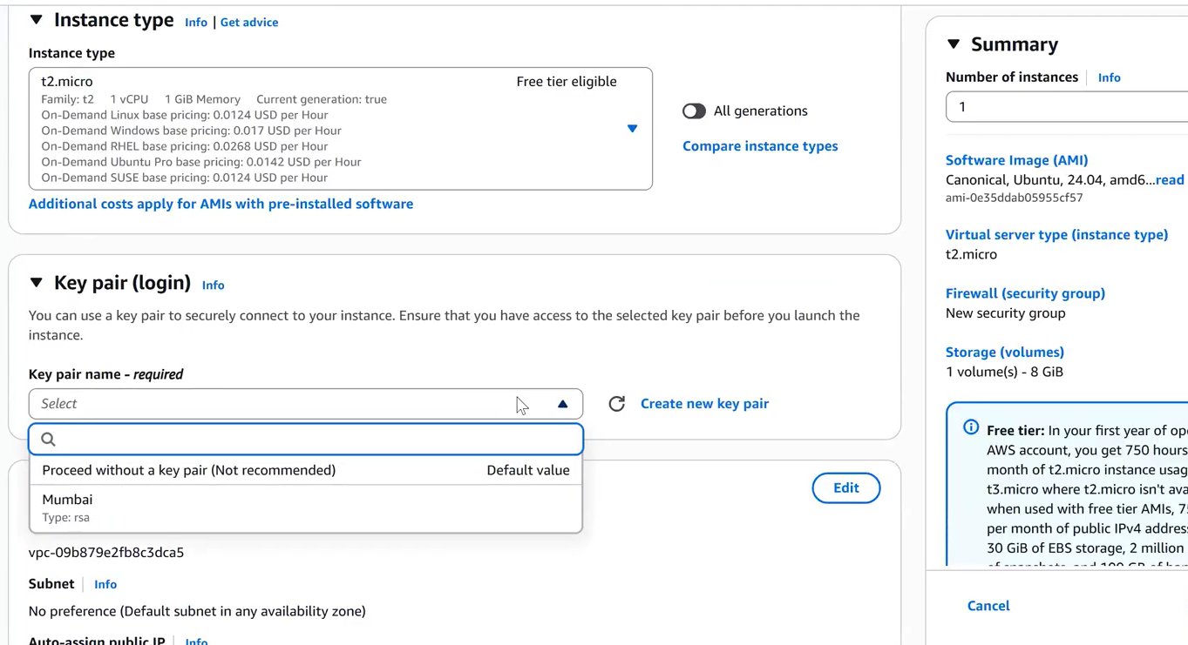
instance Type select t2.micro
and create a new key pair 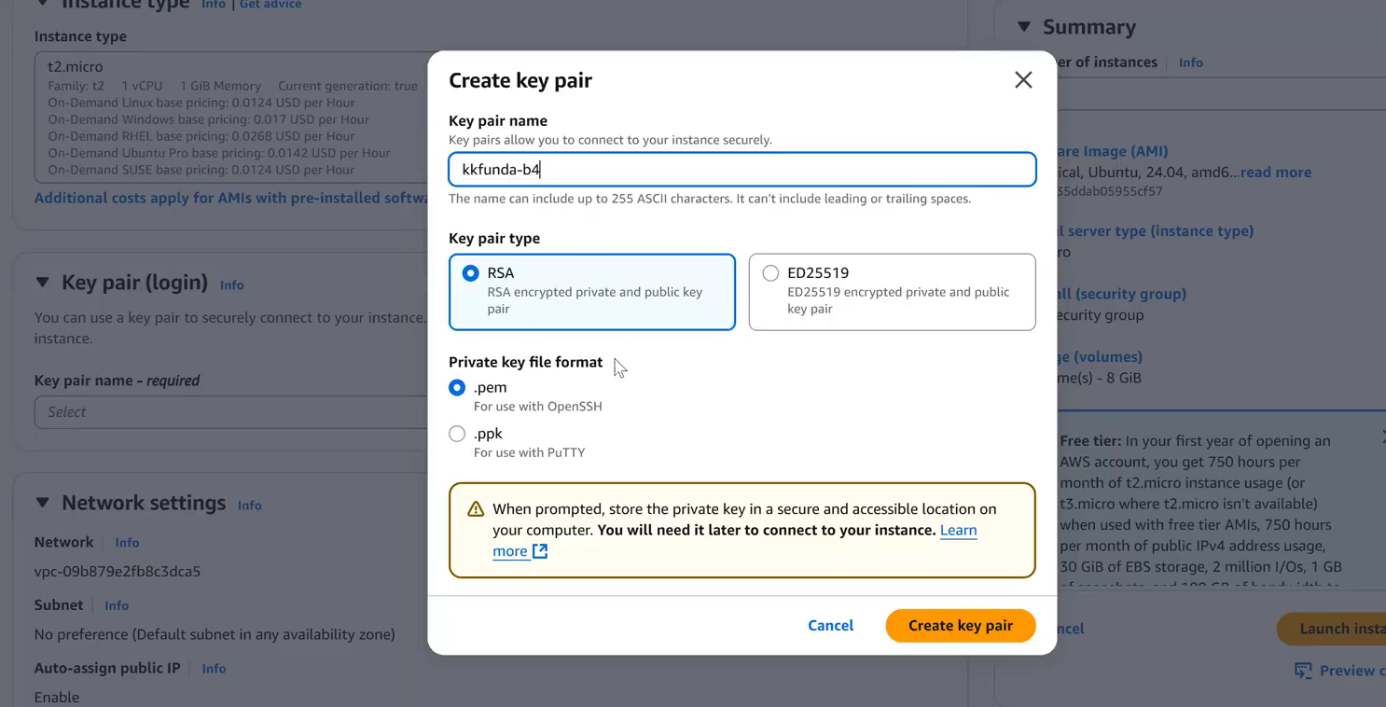
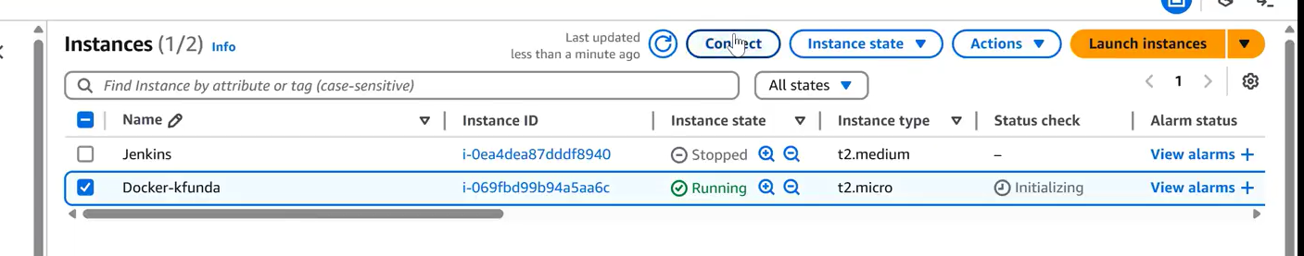
copy the ssh key
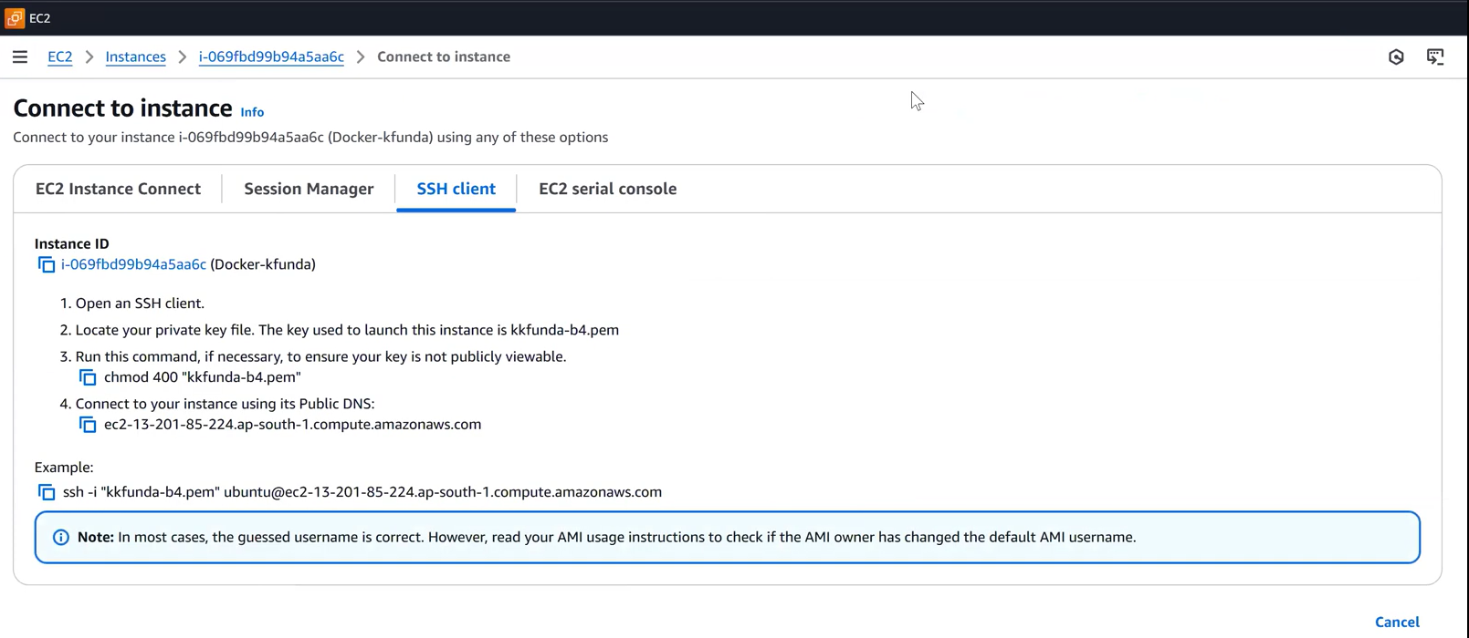
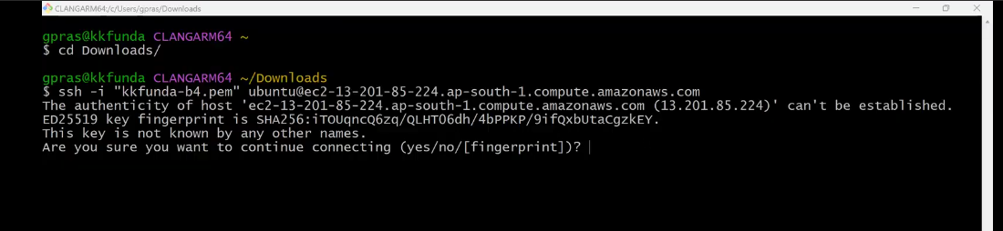
As you can see in the below image the default username is Ubuntu
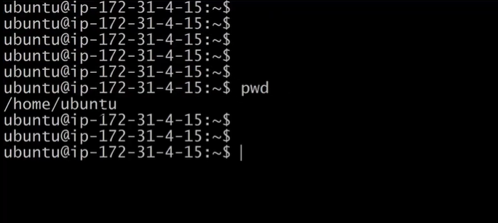
Note : If you are trying to connect Ubuntu instance via Mobaxterm then we have to add user as Ubuntu
In RedHat we use sudo yum but in Ubuntu os we have sudo apt
Just testing wheather the Docker is installed or not in the below image . It is saying no docker is not installed
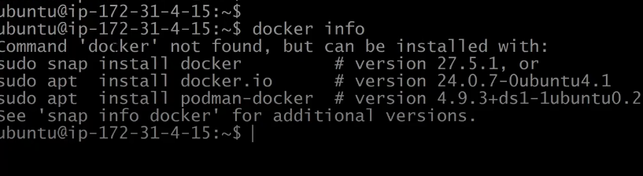
To install the docker we have to execute the sudo apt install docker.io
we are unable to install Docker because we have update the system package by using the command sudo apt update -y
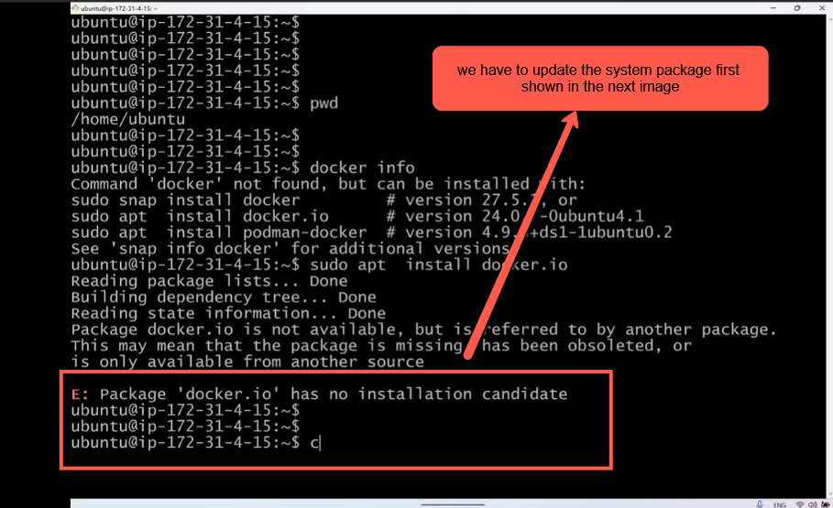
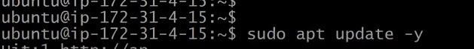
The system package update is done Now try to install Docker as shown in the below Imge
Docker has been successfully downloaded and installed as shown in the below img
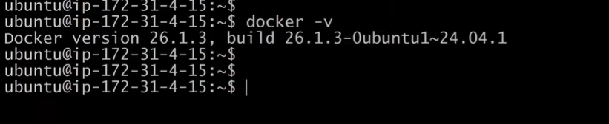
To check Docker’s client side information we have to execute he command ‘docker info’ as shown in the below image but for checking the info permission is denied
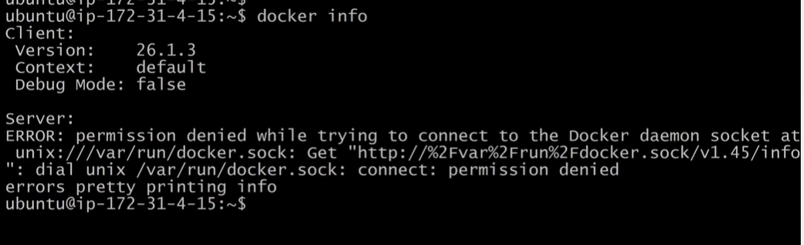
even to check the available Docker Images present permission would be denied as shown ij=n the below image
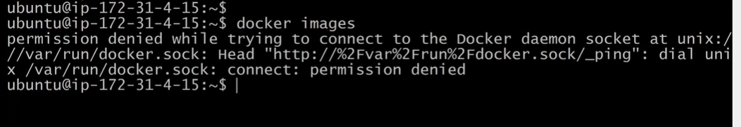
Q) Why it is showing the permission denied when we execute the docker info & docker images ?
A) Because we have installed the Docker with the help of Root user . So to overcome this issue we have to Ubuntu user in the Docker Group.
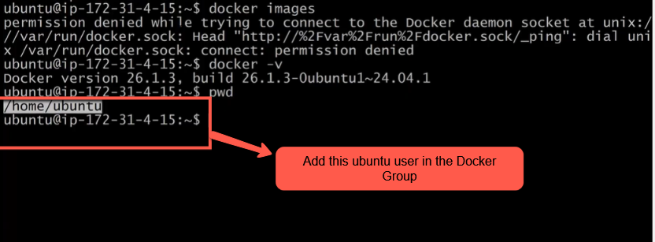
By executing this command sudo usermod –ag docker Ubuntu we can add the Ubuntu user in the Docker Group. –ag(append to group)
Even after adding the ubuntu user in the Docker group still we are getting the Error as shown in the below image
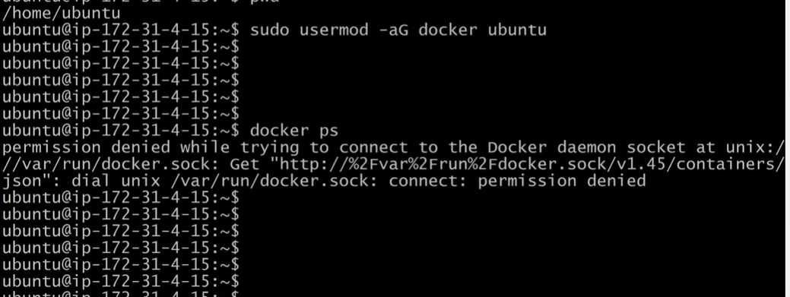
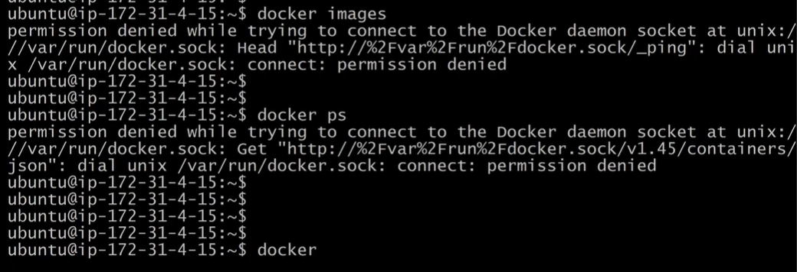
To resolve the issue please disconnect from the Terminal and reconnect to the Docker instance as shown in the below image
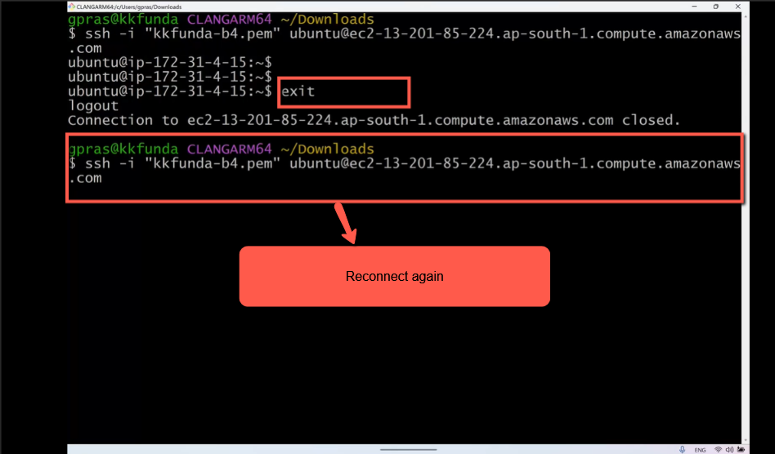
Reconnected as shown in the below image
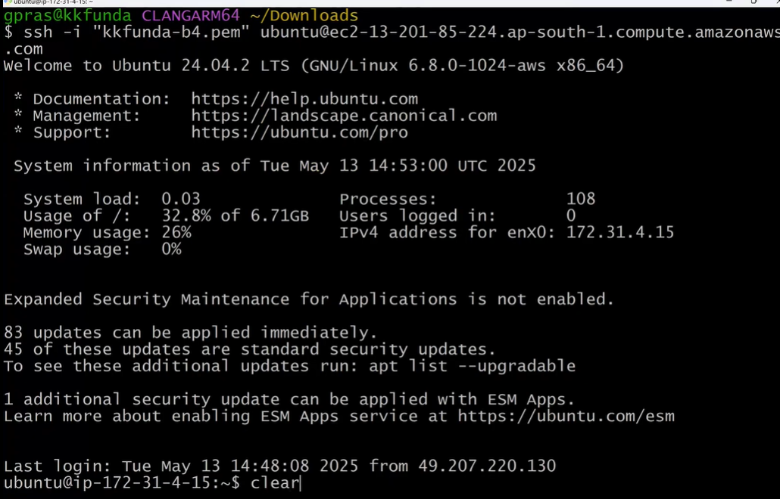
Now execute the Docker(ps,info,images) commands It would be successfully connected as shown in the below image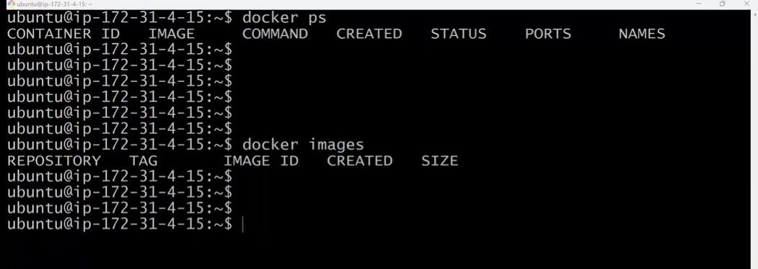
Let’s discuss about the Docker Architecture It’s very Important
The entire Docker session would be discussed based on the below Docker Architecture
Docker Architecture is very important in Interview perspective.
In Docker Architecture there are three main components
1) Docker CLI(client)
2) Docker Host
3) Docker Registry
All the Docker commands are present in Docker client when ever we execute any docker commands (docker run , docker build , docker pull) The request would be sent to Docker Daemon processor which is present in the Docker Host . So the Docker commands would be processed or executed by Docker Daemon.
command to build an image is docker build and to pull the docker image from docker resgitry we use the command docker pull.but first the command request would go to the docker daemon which is present in the Docker host
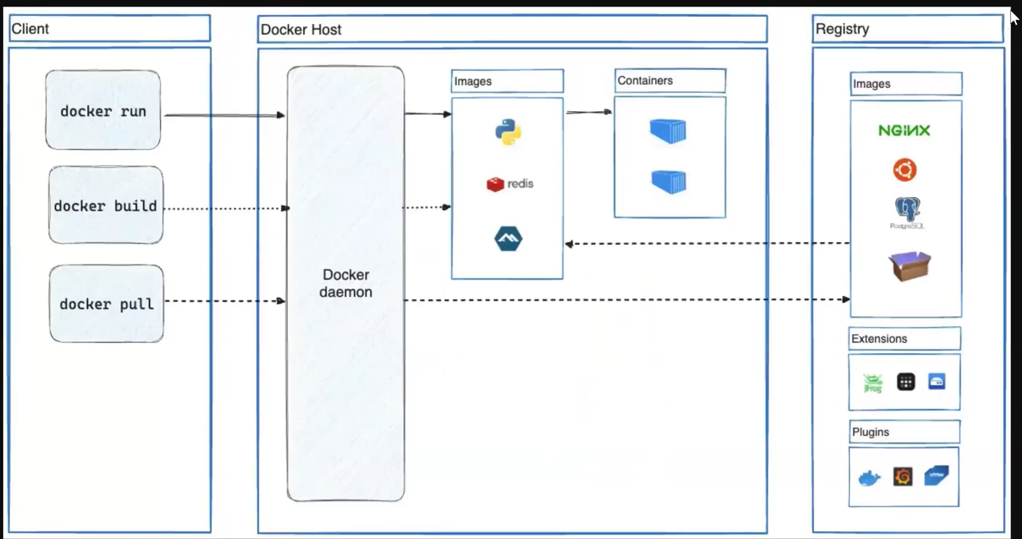
To create a container we have to execute the command docker run or docker create.
docker run ---- > docker daemon ---- > build the Image ---- > build the container of that image
If the image is not available in the local computer then docker will try pull that Image from registry
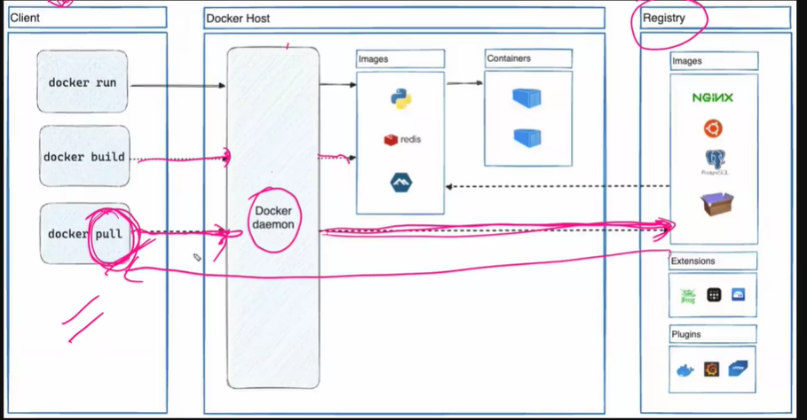
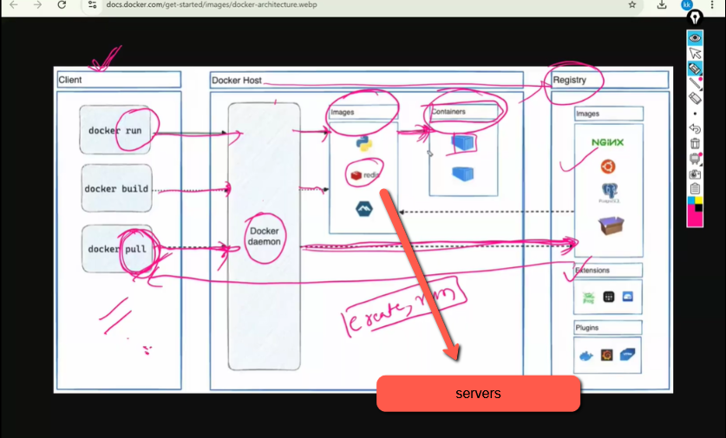
If you want to know or search about docker commands you just have to execute the command Docker as shown in the below image
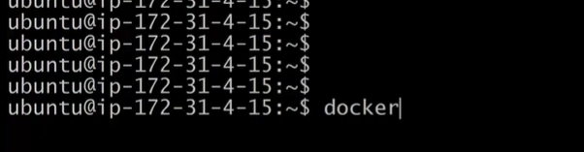
docker commands
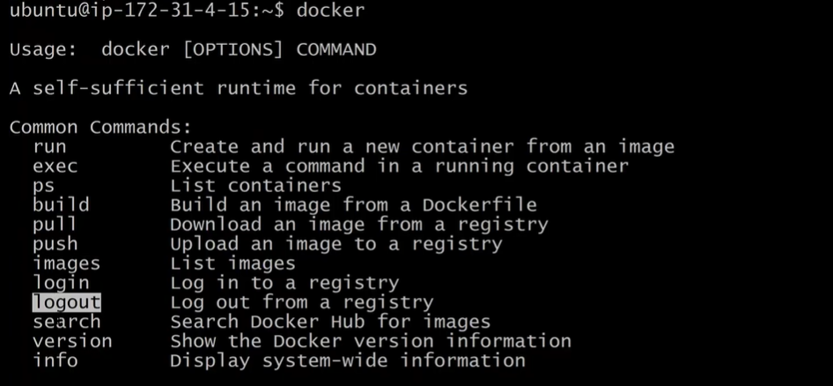
so the Docker has big list of commands to copy and paste the commands present in the Docker we have to create a txt file . execute the command docker > command.txt (all the docker commands will get copy in to the command.txt file )
But when we cat command.txt the commands from docker are not being copied in tot command.txt file
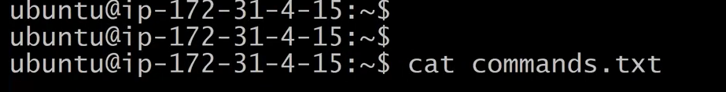
Any how we will see it later
Interview Question that would be asked
1) what type of docker version you are using in your current system
2) Difference between Virtualization and Docker containerization.
3) Explain abour Docker Architecture(very very Important)
4) what is Docker Daemon
class is completed

