In the Late class we discuss docker File , Docker image creation , container creationand aslo docker command related with Container & Image.
In This class we will discuss what kind of Interview questions would be ask related to Image related commands and container related commands
Let’s discuss about Image commands , Container commands in Brief
To display all the Docker Images we have to execute the command
1) Docker Images (or) docker images ls
To display all the running containers we have to execute the command
2) docker ps
To display all the running containers and stopped containers we have to execute the command
3) docker ps –a
Lats class activity shown in the below image
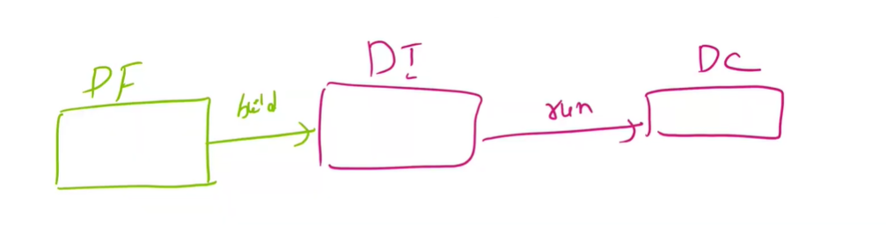
So far in the last class we build an Application image using a docker file
and we push the Application image in to the Docker registry
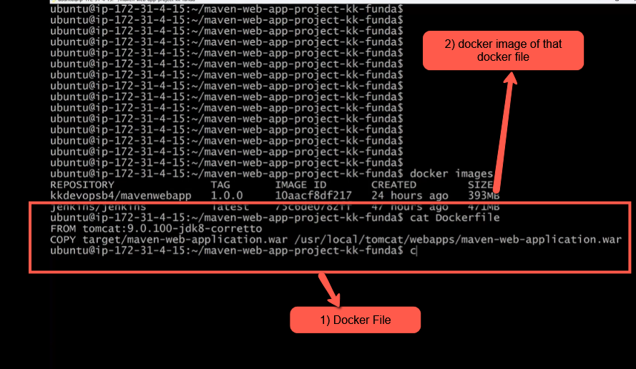
Now lets build the Container based on the docker image (kkdevops/mavenwebapp)
In two ways(coomands) we can create the container
1)docker create -p 8080 : 8080 --name one kkdevops/mavenwebapp:1.0.0
1.0.0(this the version of the app)
In the last class we have created docker container using docker run command but in this class we are using the docker create command for creating the container
So lets create the container by executing the above container command.
After executing the container command execute the command docker ps to check the created container with running status as shown in the below image
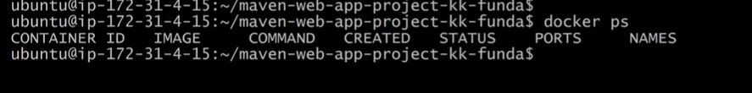
To check the all the running and stopped container we have to execute the command docker ps –a shown in the below img
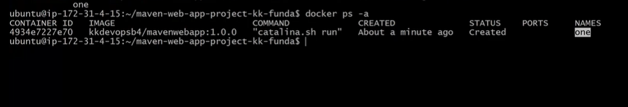
in the above img the status of our container with the name one is still in Created state to run the container we have to execute the below command
docker start <container name / container ID>
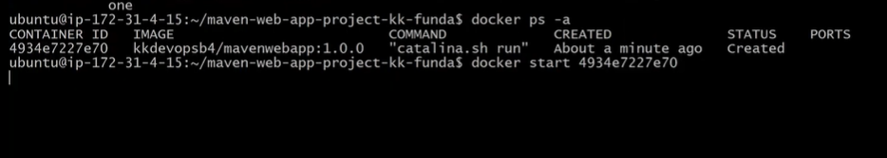
Now After executing the above docker start command the status of the container one will change from created state to running state shown in the below image.
execute docker ps and check the status column of the container . it would up and running
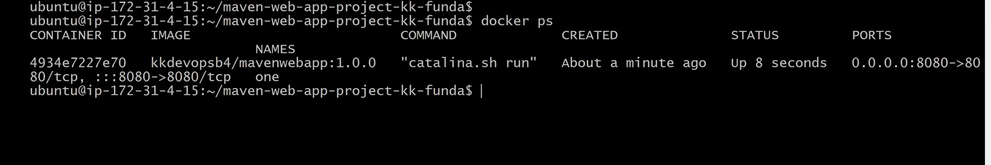
Now lets once create the Docker container using the docker run command in the above we have created the container using the command docker create
now lets create the same container using docker run command
so execute the below docker command
2)docker run -d -p 9000: 9000 --name two kkdevops/mavenwebapp:1.0.1
The port to access the application has changed to 9000:900 and also change the container name to two and version of the application from 1.0.0 to 1.0.1 shown in the below img
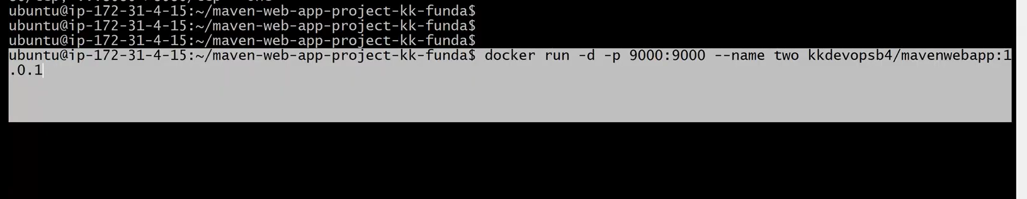
But we don’t have the image kkdevopsb4/mavenwebapp with the version 1.0.1
kkdevopsb4/mavenwebapp:1.0.1 we have different version of application image
when we execute the command docker run -d -p 9000: 9000 --name two kkdevops/mavenwebapp:1.0.1image not available
docker will look for the image kkdevops/mavenwebapp:1.0.1 in the docker host locally If it is not available in docker host then it will show the error as shown in the below img saying unable to find the image locally shown in the in the below img 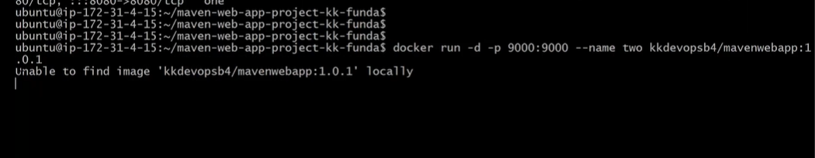
when the Applicationimage(kkdevopsbe/mavenwebapp:1.0.1) is not available locally then docker will search the image in the online Docker Hub . and it will download the image from docker hub and runs it as shown in the below image
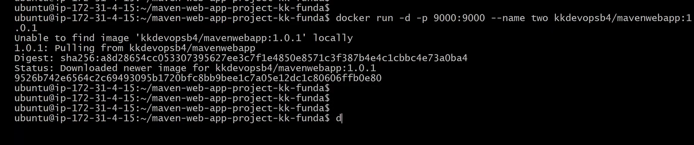
If the image kkdevops/mavenwebapp:1.0.1 is not available in the docker hub then the message would show up shown in the above img saying Image not found or Unable to find image kkdevopsb4/mavenwebapp:1.0.01
Execute the command docker ps the container two will be in Running status shown in the below img
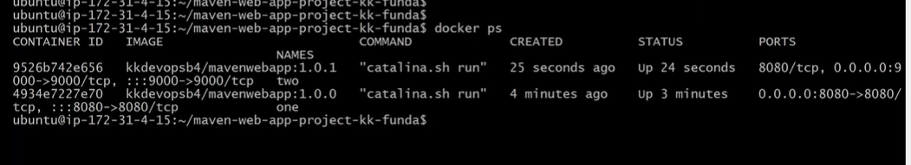
Interview question
Q) what is difference between docker run and docker create container commands
A) "docker create only creates the container, while docker run creates and immediately starts the container. So docker run is a combination of docker create and docker start."
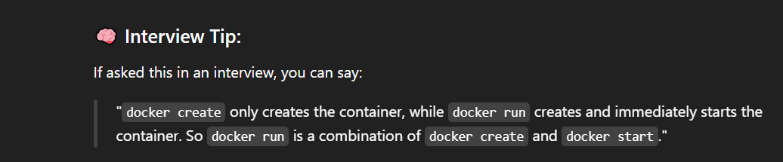
The two commands docker images (to display the images) and docker ls(to display the conatiners) as shown in the below img
In order to know more about any image in detail we have to execute the docker inspect command discussed in the last class.
sometime the Interviewer may ask about the container like based on which image the container (two) is created .
for example lets modify or change the code in the below maven web application project after modifying source code of the application we will create an image
with the new version
Navigate to src directory as shown in the below img and navigate to src/main/webapp/jsps/
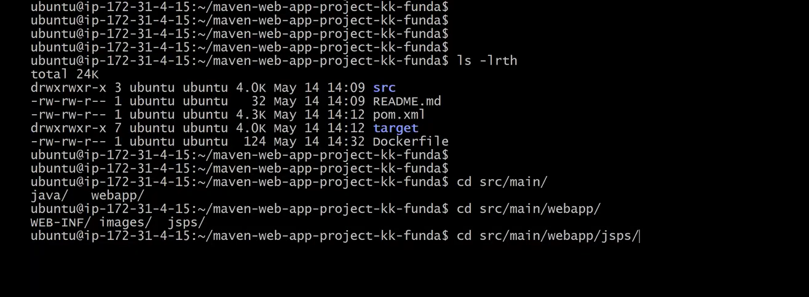
Inside jsps directory open home.jsp file as shown in the below img
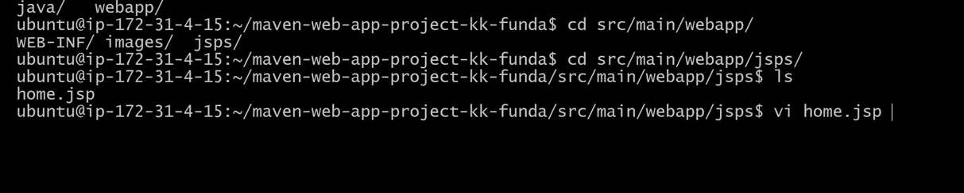
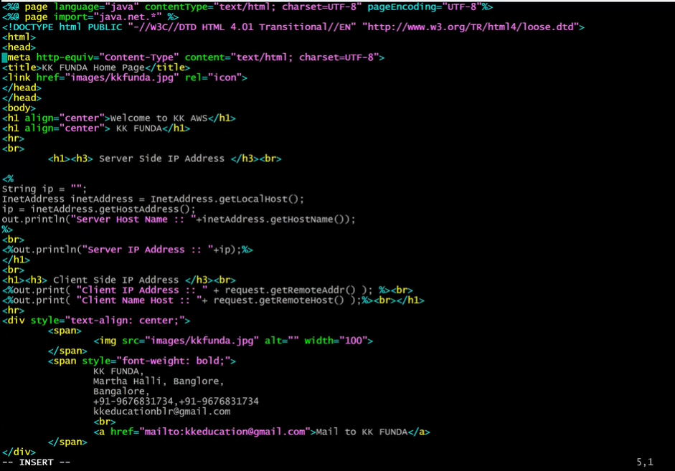
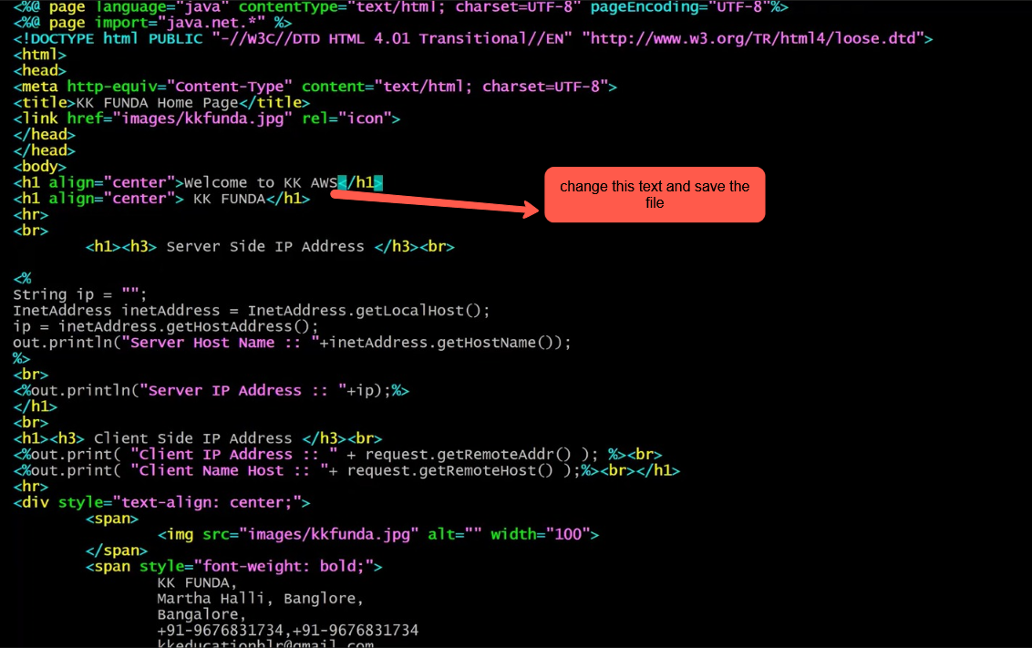
The text has been changed as shown in the below Img
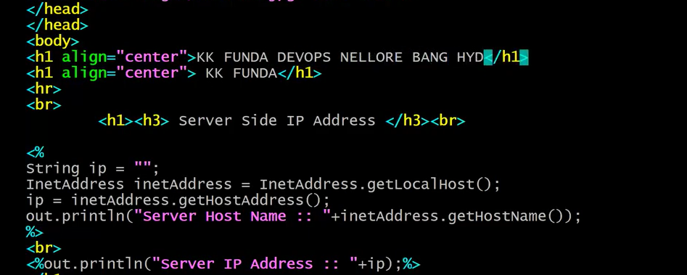
Assume it like the developer has updated the code in home.jsp via Github by the developer
Lets go back to Home directory as shown in the below img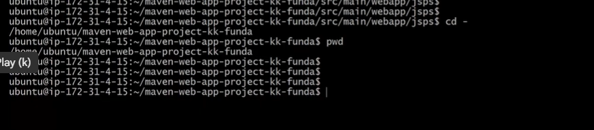
As we have modify the source code lets rebuild the application again by executing the mvn command ‘maven clean package’ so the Target directory will get updated with a new .war file(mavenwebapplication) as shown in the below img
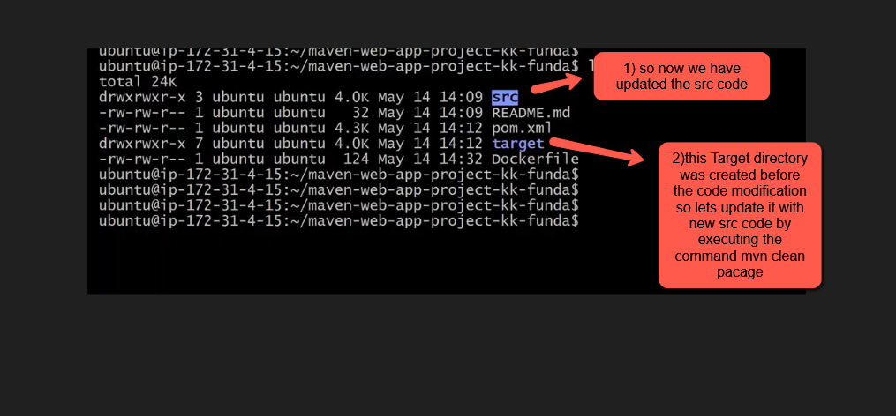
To generate the war file execute the maven clean package due to this the existing target folder will be deleted and the new Target directory will be generated
so lets execute the command ‘mvn clean package’
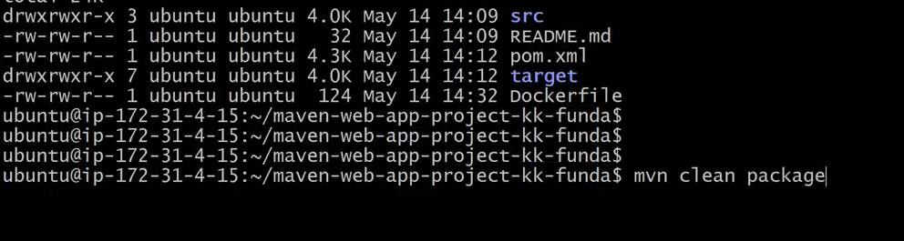
we have successfully build the war file as shown in the below img
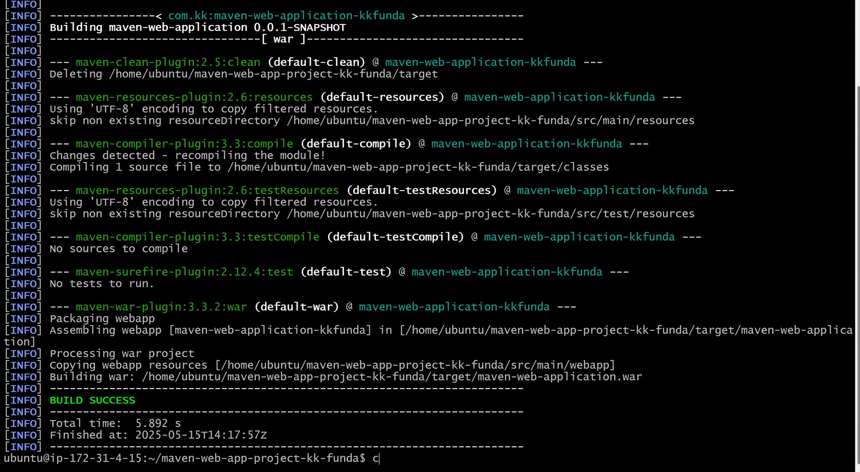
Next build the Tomcat server image with inside this web application(.war file) using the docker file
clear the screen
execute ls –lrth
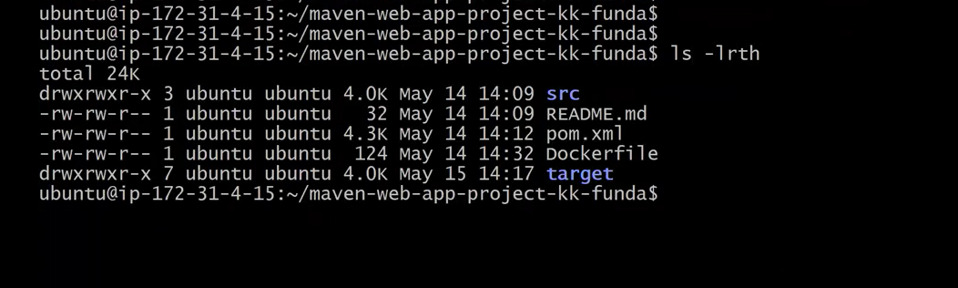
cat the docker file as shown in the below img
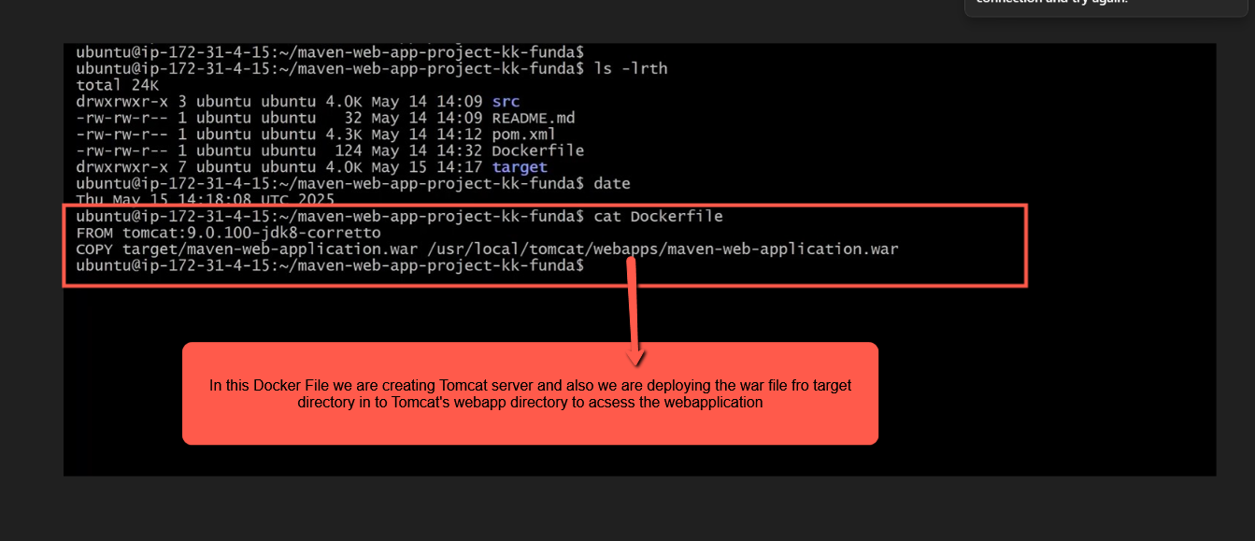
Let’s create the docker image for the Tomcat server mentioned in the Docker File
execute the command docker build -t kkdevopsb4/mavenwebapp:1.0.2 . (dot represent the current directory location where the docker file is avaiable)
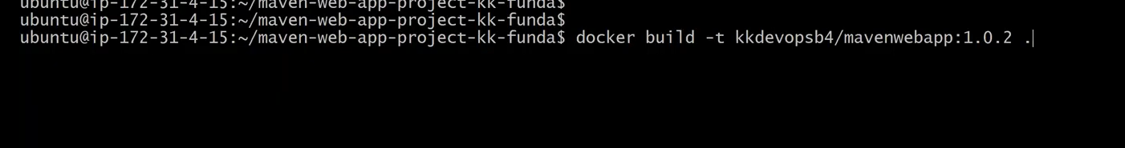
Execute it
The Tomcat server image with mavenweb application inside it successfully created as shown in the below img
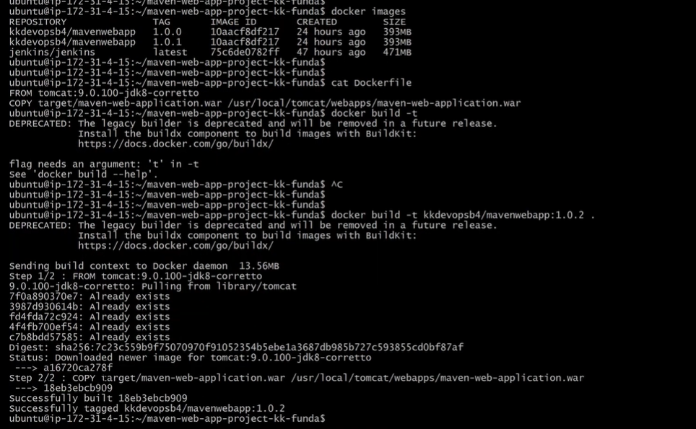
Now find the Tomcat server image by executing the docker images command as shown in the below img
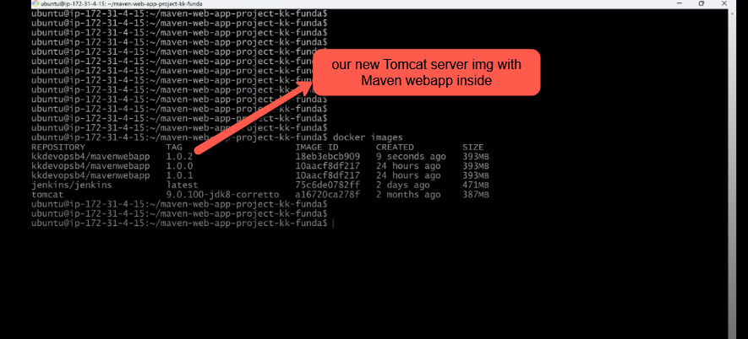
Now let push this image kkdevopsb4/mavenwebapp:1.0.2 in to my docker hub account.
using push command docker push kkdevopsb4/mavenwebapp:1.0.2
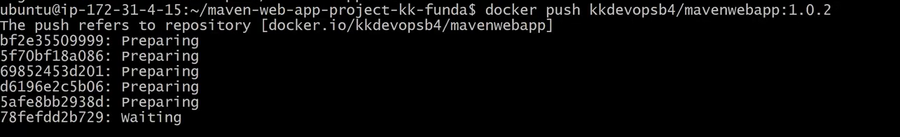
before pushing the image make sure you are logged in to your GitHub account
we have successfully pushed the Tomcat server image(mavenwebapp:1.0.2) in to the docker hub as shown in the below img
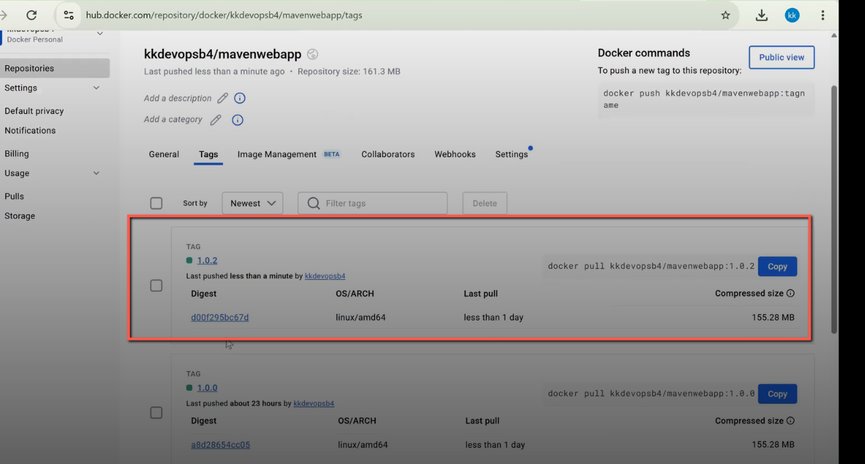
Now check the Docker containers execute the command docker ps as shown in the below img
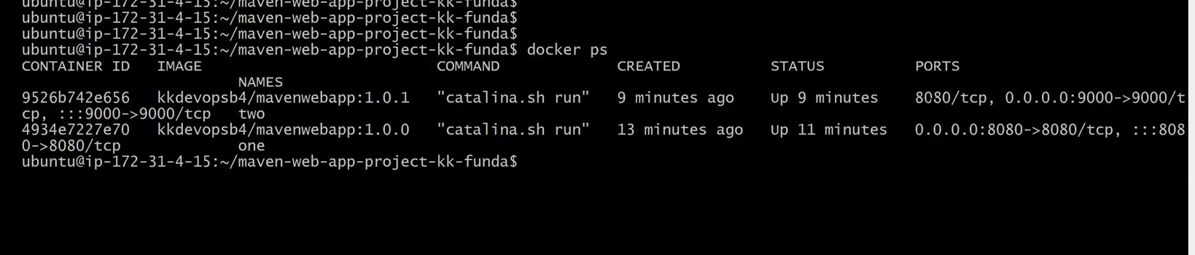
There two containers are running

