Today we will discuss about docker volumes
before starting docker volumes lets discuss few things
In a docker server we deployed multiple applications as containers
for example I have created a network called Jio inside the docker server
inside or under this Jio container we have created two containers
1) App container
2) DB container
So both containers App & DB will be connected inside the Jio Network as shown in the below img
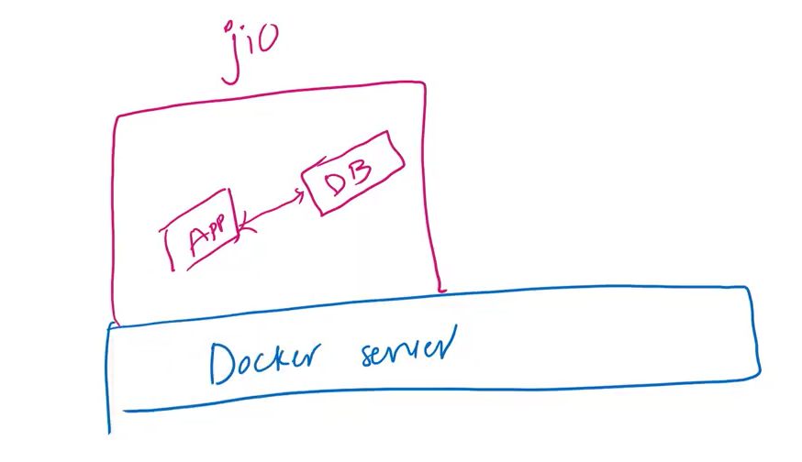
Statefull Application : An application that can store data is called Statefull Application
Stateless Application : An application that cannot store any data is called Stateless Application
All of sudden if Db container get restarted then the content inside the container will get deleted to
overcome this issue we have to use docker volume
Let see this container data loss issue with an example below
Lets try to clone a web application from git as shown below
Let clone an application from github as shown in the below img
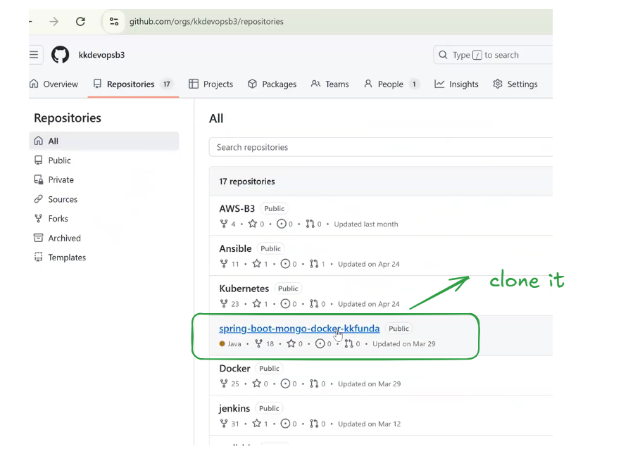
Lets connect with the ec2 instance as shown below
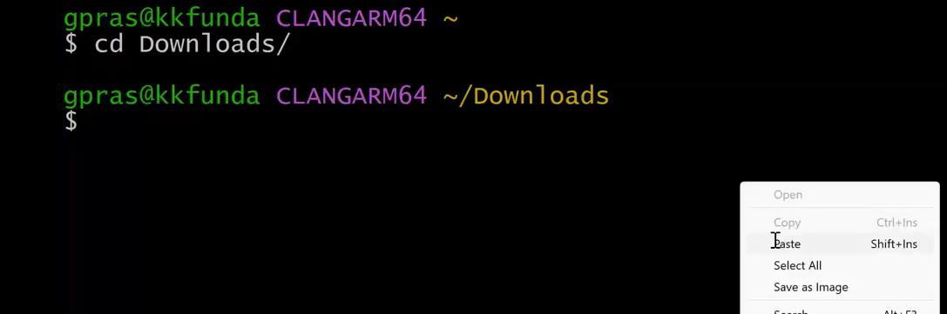
After connecting with the ec2 instance check the docker images as shown below
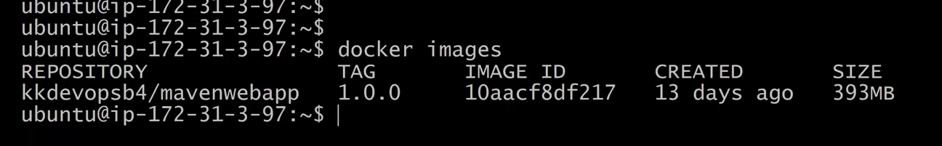
remove the image and check the available containers as shown below
docker image 1 , No containers
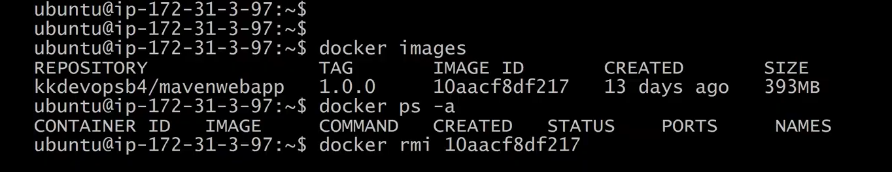
At present the docker server is empty
clone the below repos in to the ec2 imstance as shown in the below img
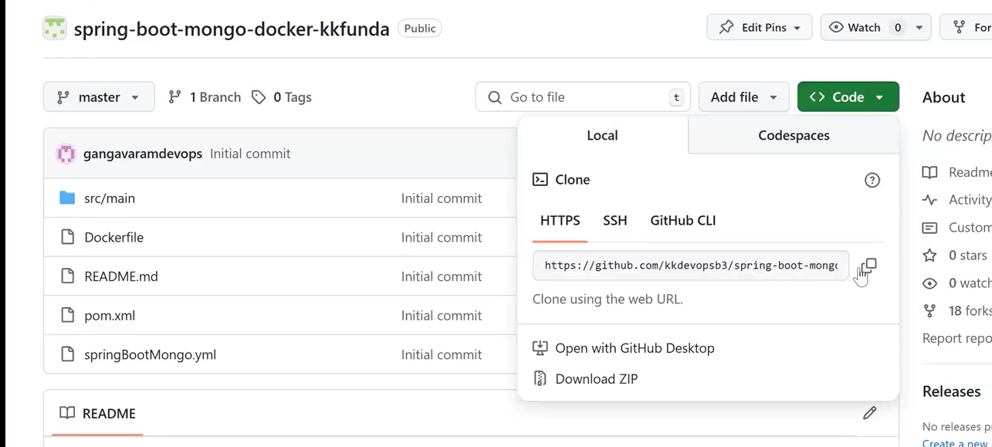
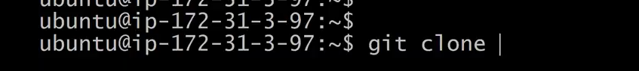
clone the code as shown in h=the below img
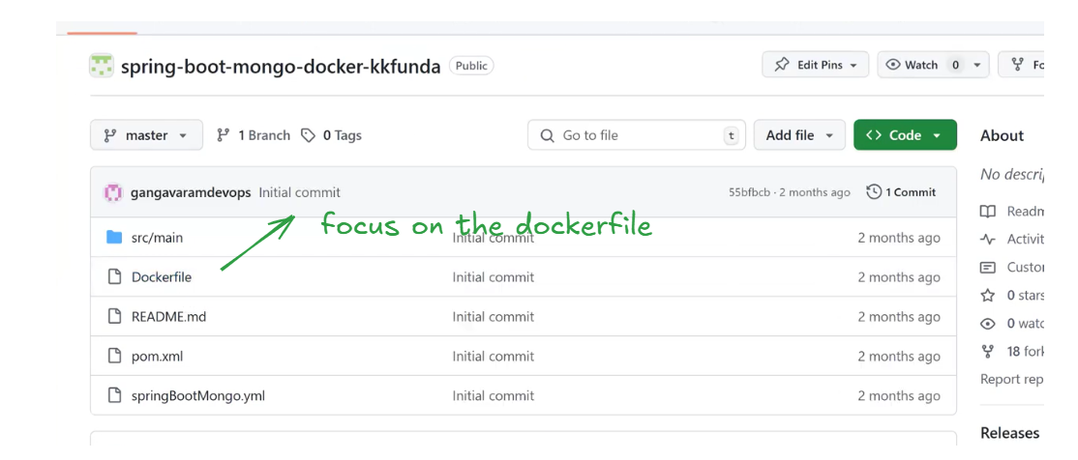
Lets discuss some theory points as shown below
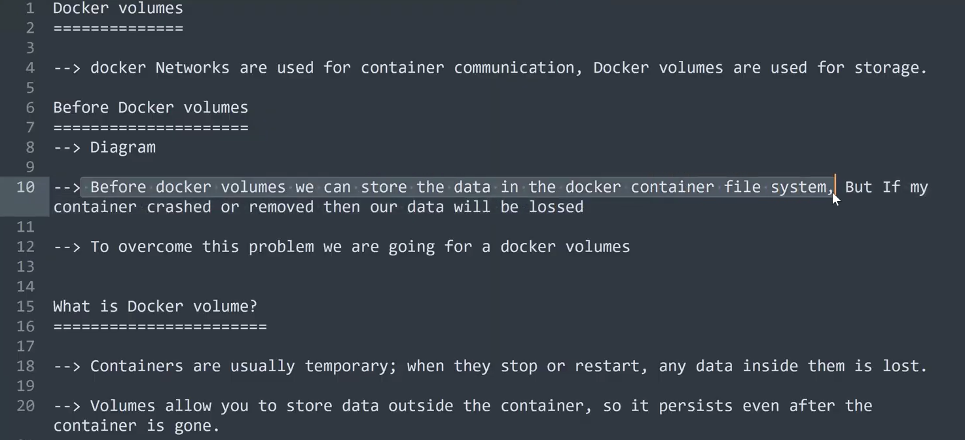
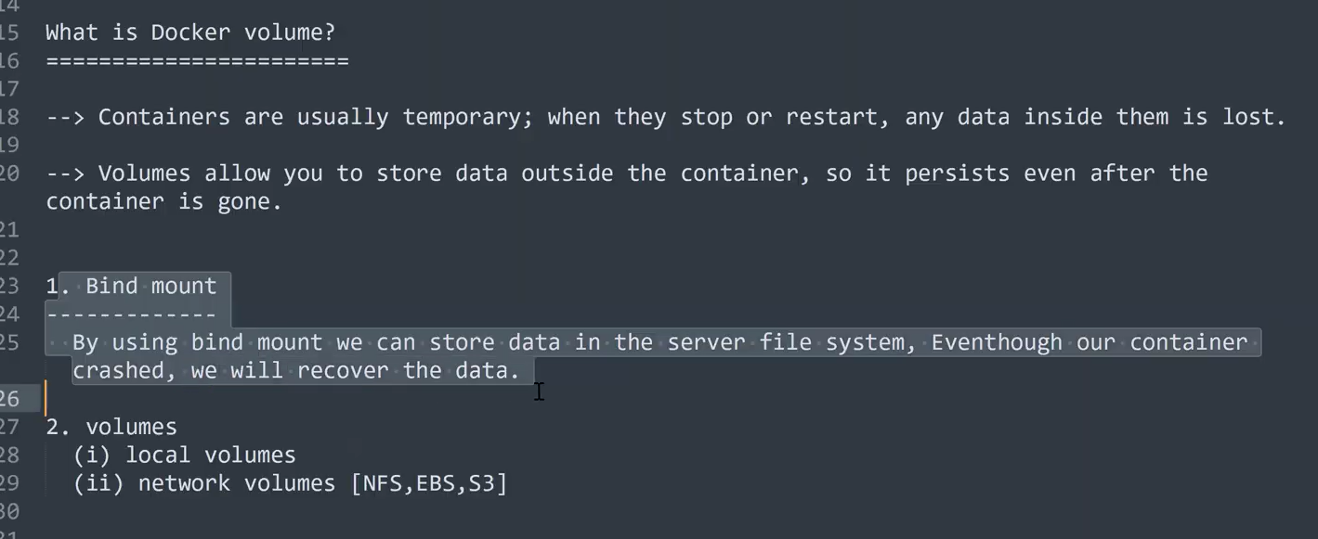
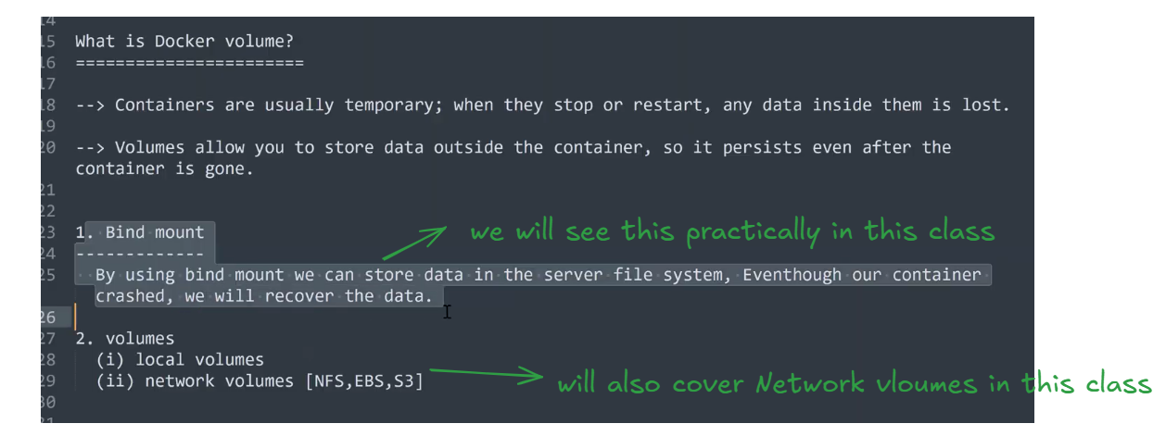
In this class we will discuss about Bind mount volume and volumes(local volumes)
clone the application code from github as shown below as we already did that
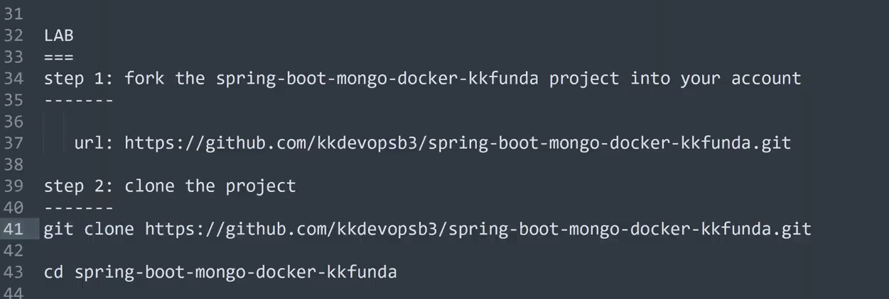
with the help of pipeline we will execute the above process in the upcoming classes
so far we have clone the code as shown below
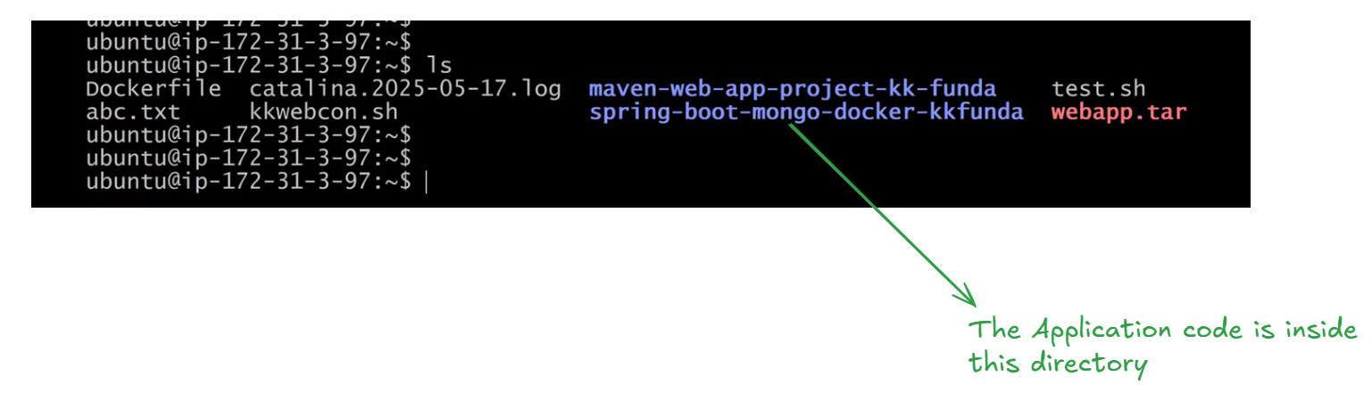
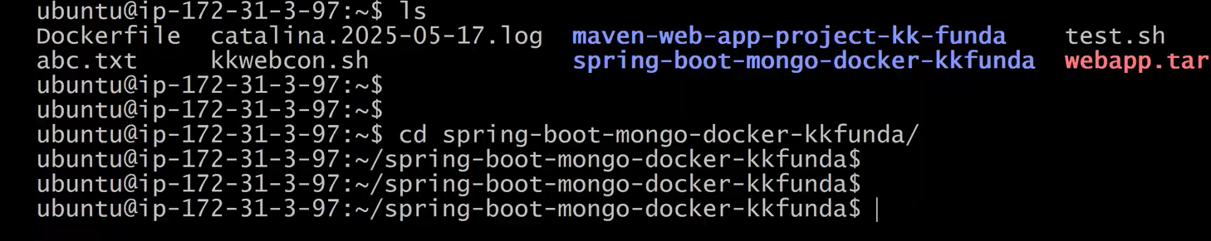
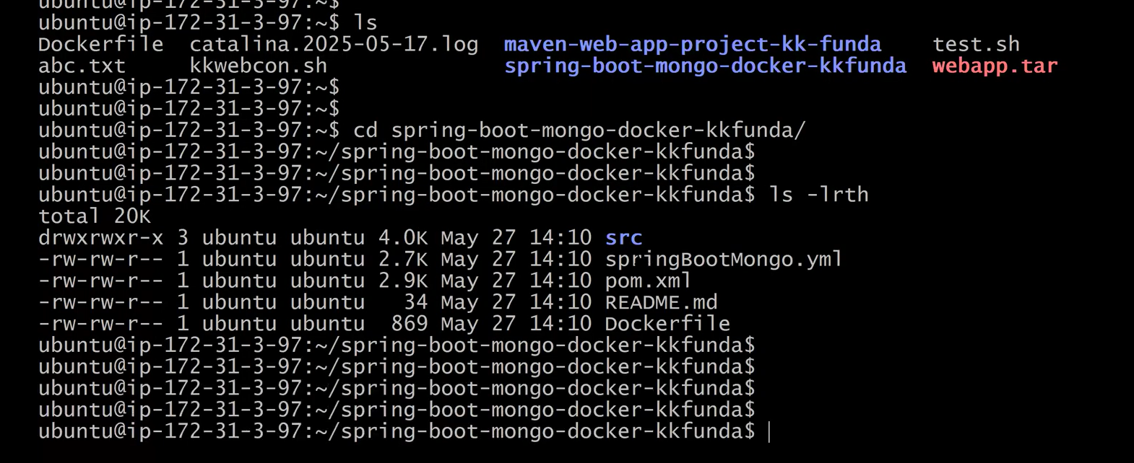
check the dockerfile and try to understand it as shown below
clear the screen (clear)
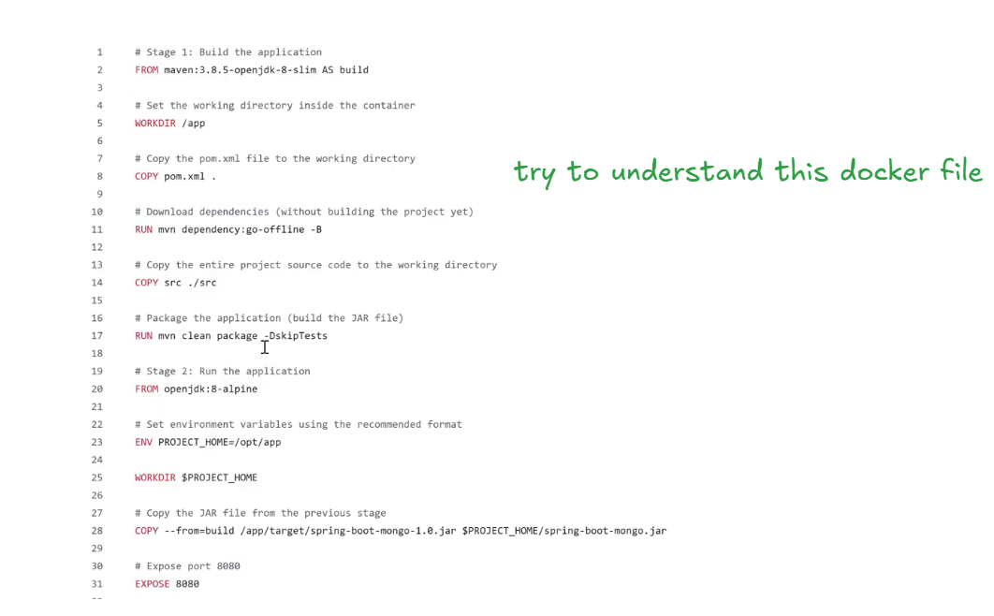
You may not able to understand the above dockerfile especially the three concept of docker file Multi stage , ECR , Docker Compose we will discuss about these topics in tomorrows session
Install maven
Make sure Maven is installed
Let’s build the docker image
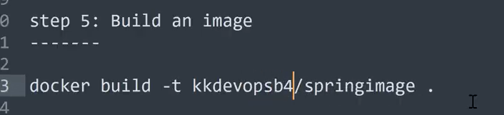
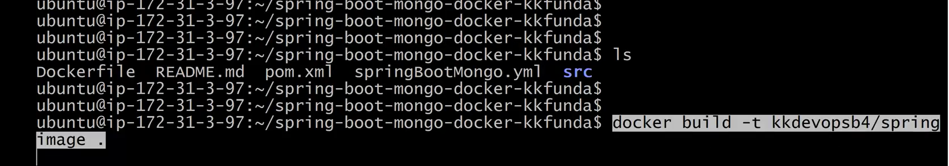
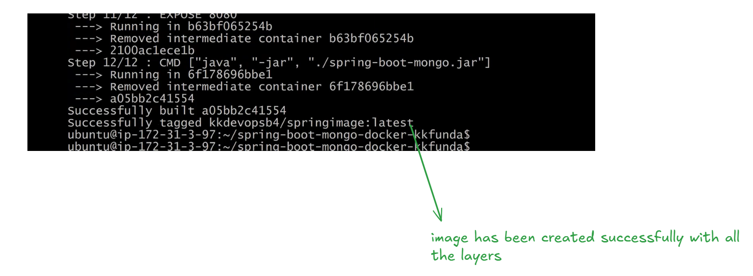
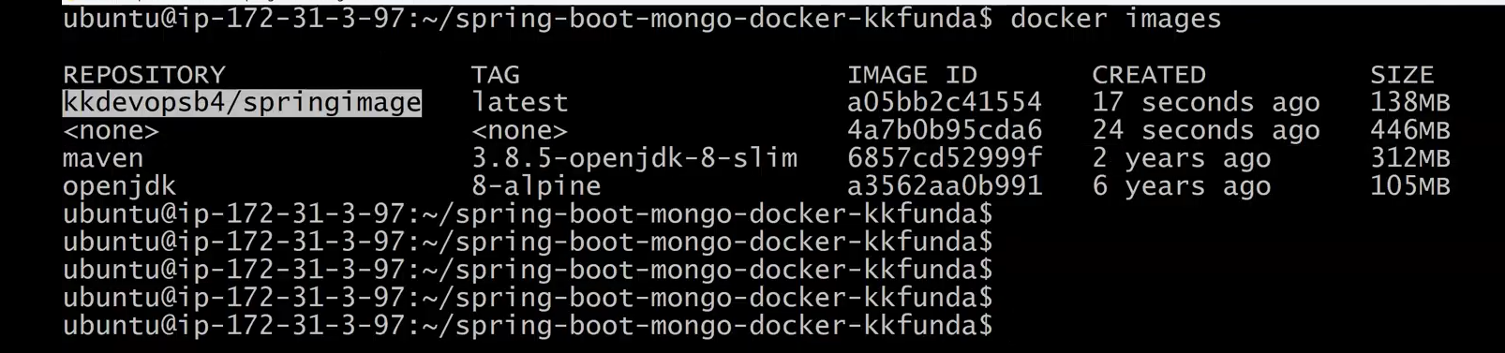
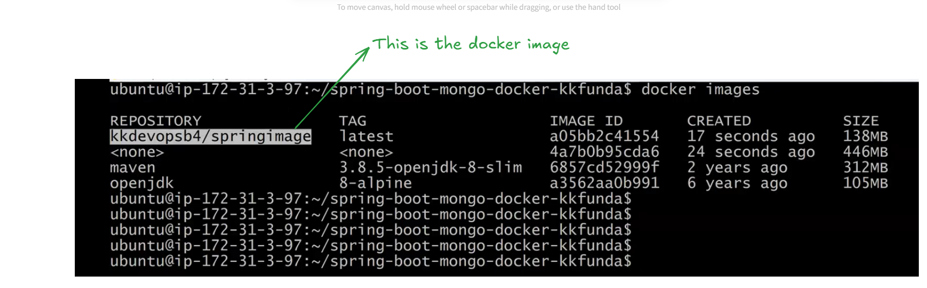
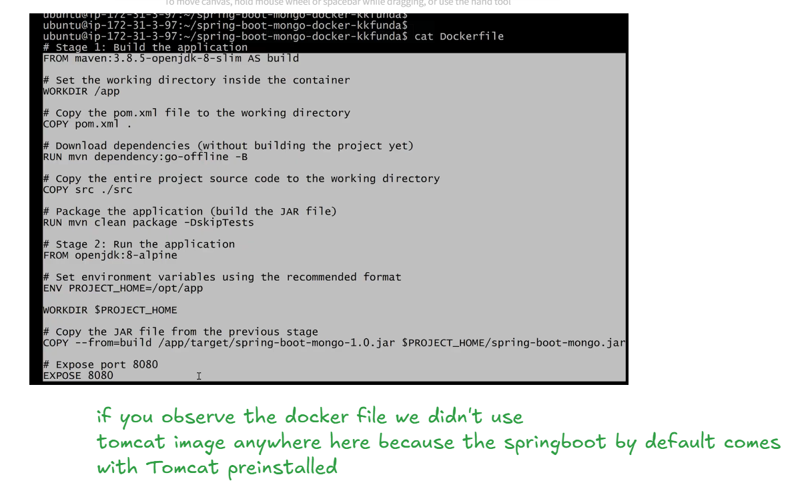
Let’s create a container based on this docker image kkdevopsb4/springimage before
creating the container lets create a custom bridge network and add the container inside the custom bridge network
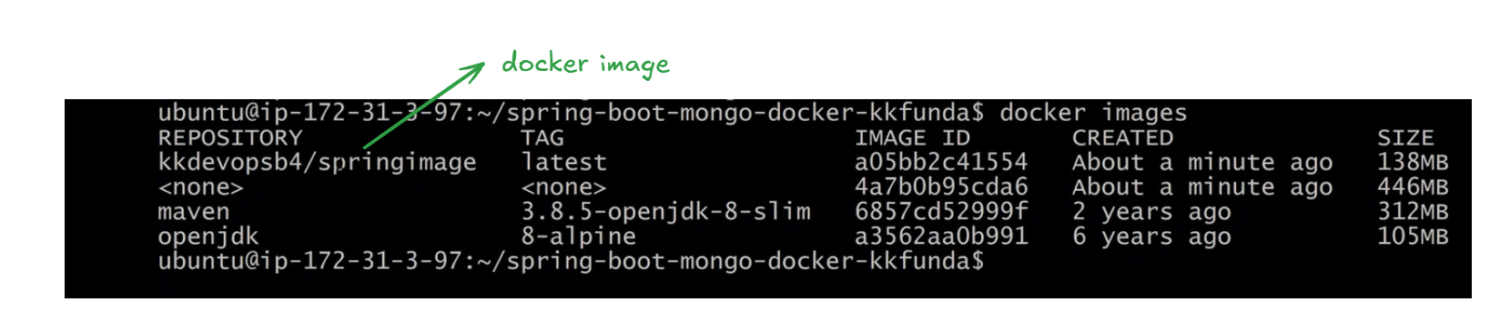
creating the docker network as shown below
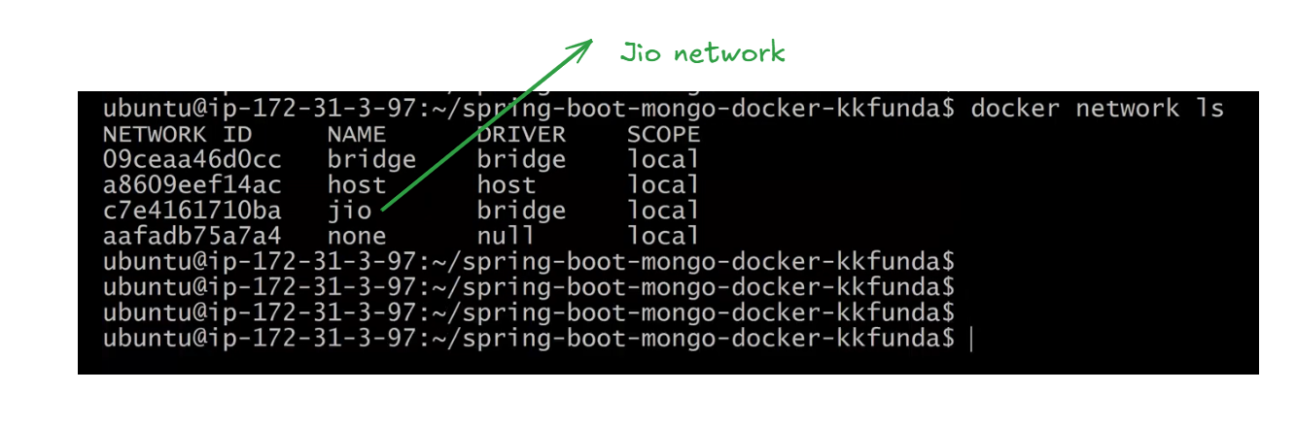
execute the below command for creating container(springapp) inside the docker custom network (jio) as shown below
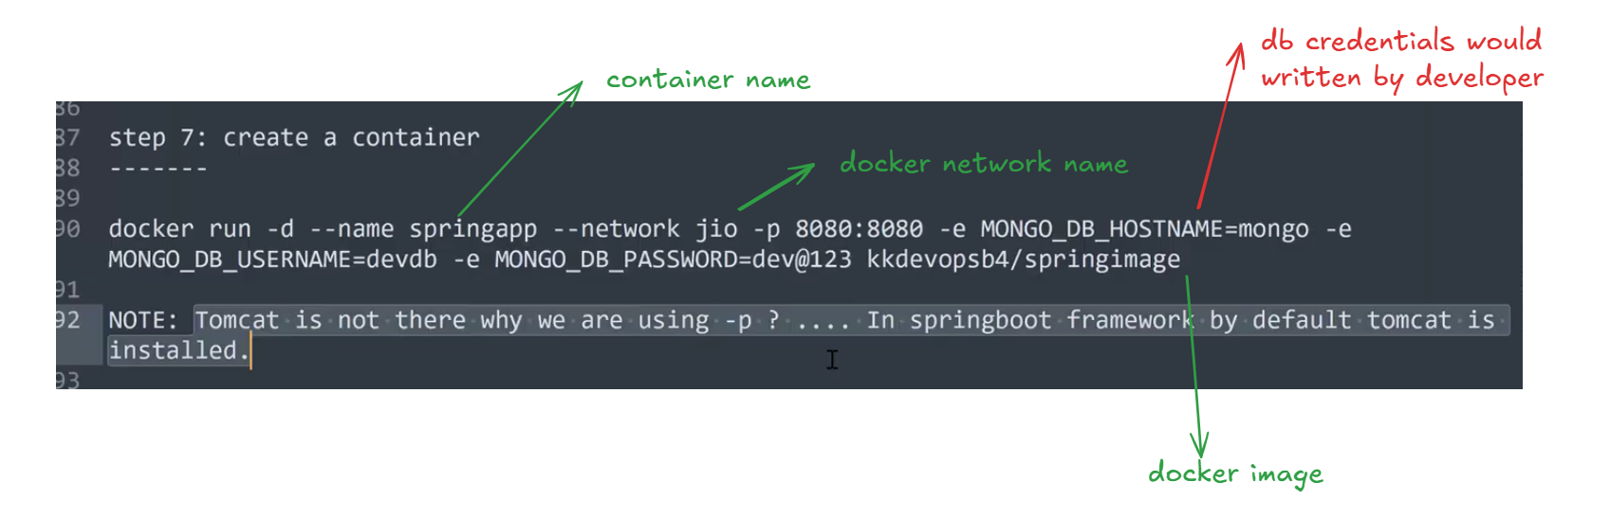
You can find the Mongodb credentials from the src code as shown below
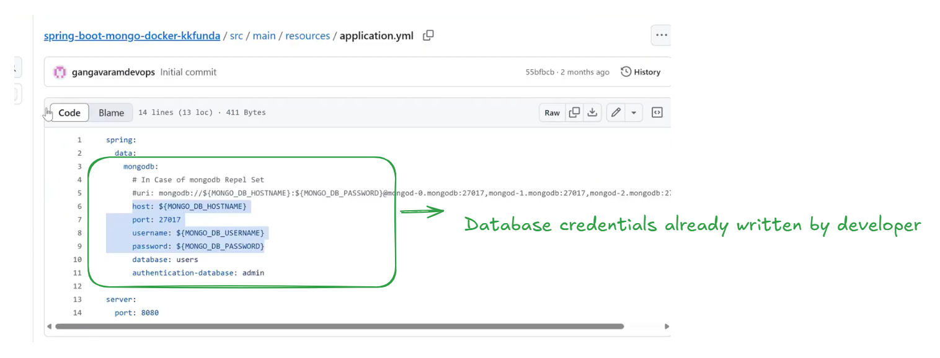
we have to ask the database credentials to the developer
The container has been created Let’s access the application via web as shown below before that make sure to allow the inbound traffic
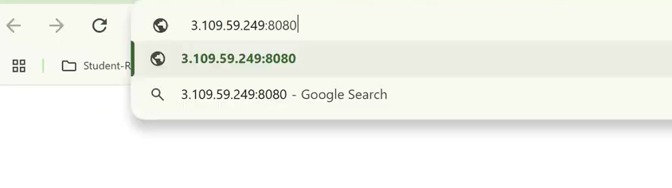
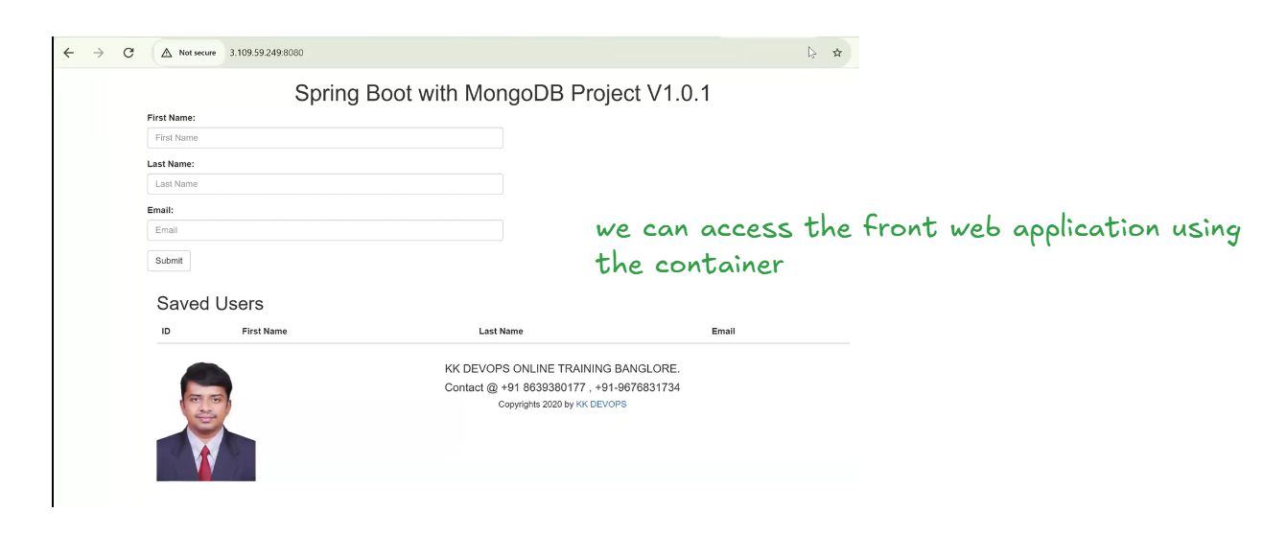
The web application is loaded let try to fill the form and submit
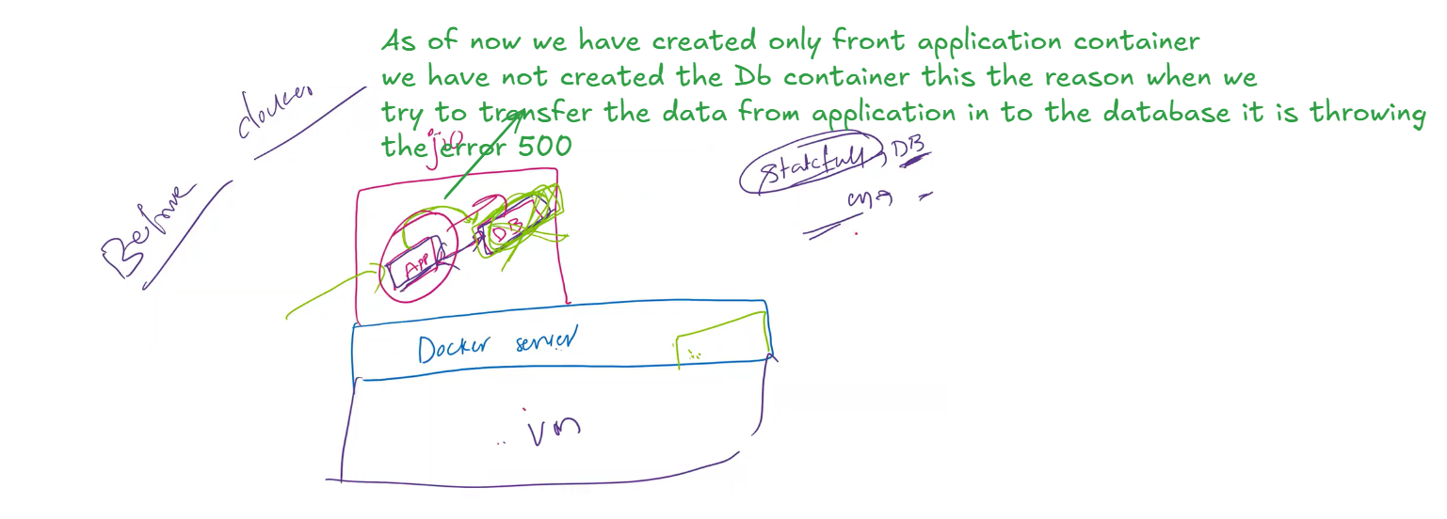
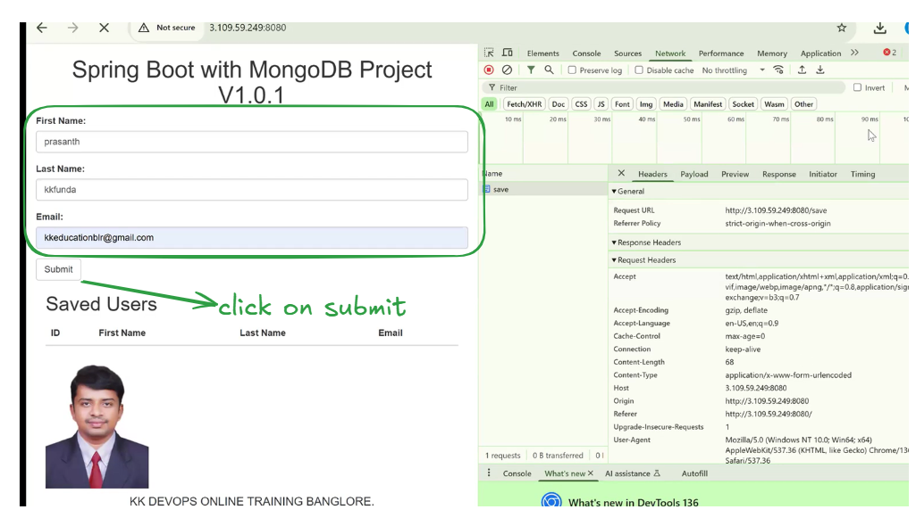
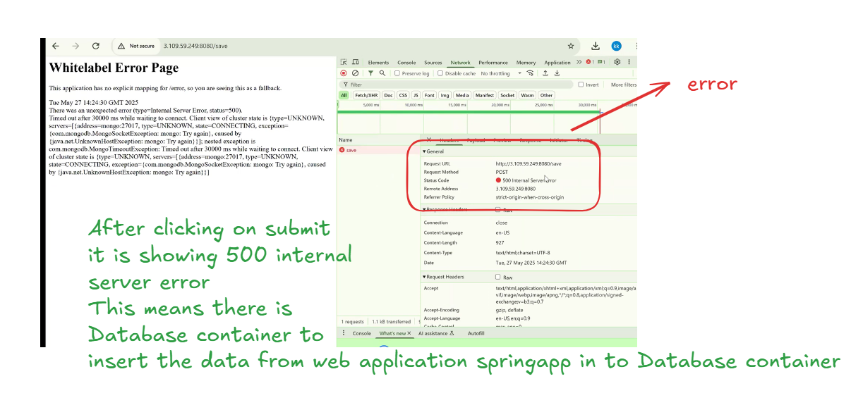
Let’s create the Database container as shown below
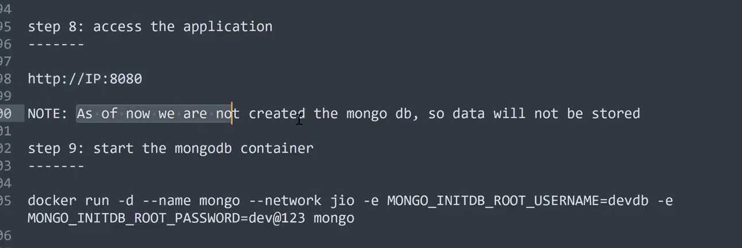
before creating the container mongo lets create the mongo docker image
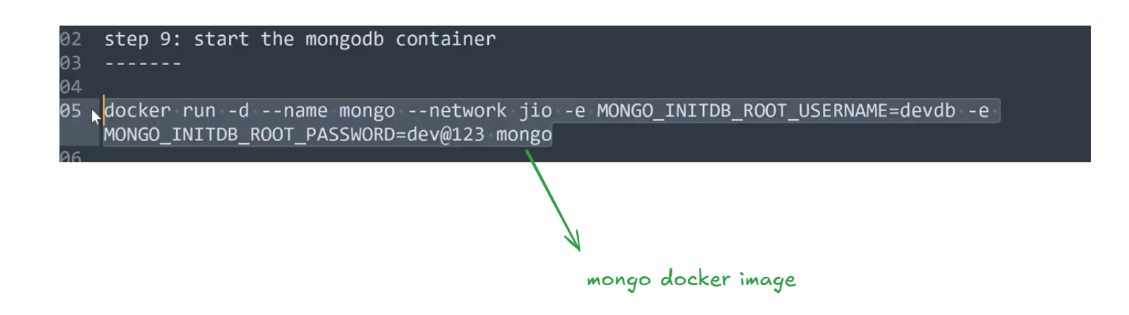
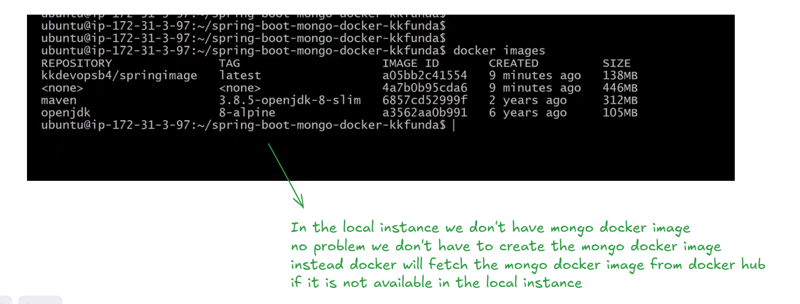
lets execute the mongo container creation command in the instance as shown below
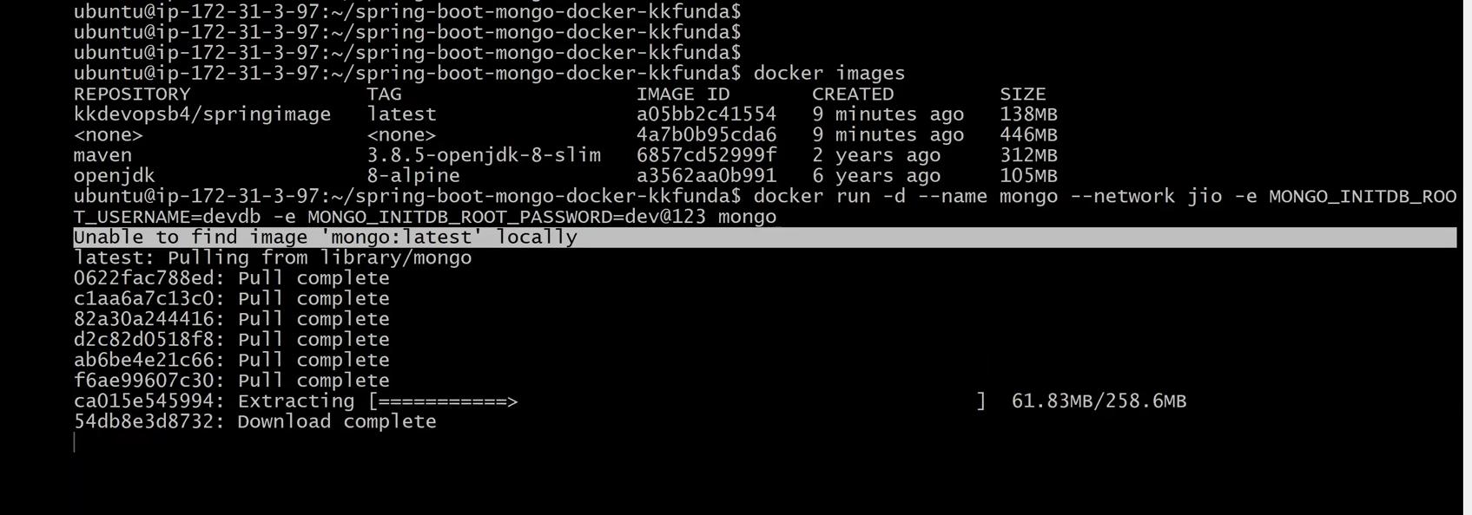
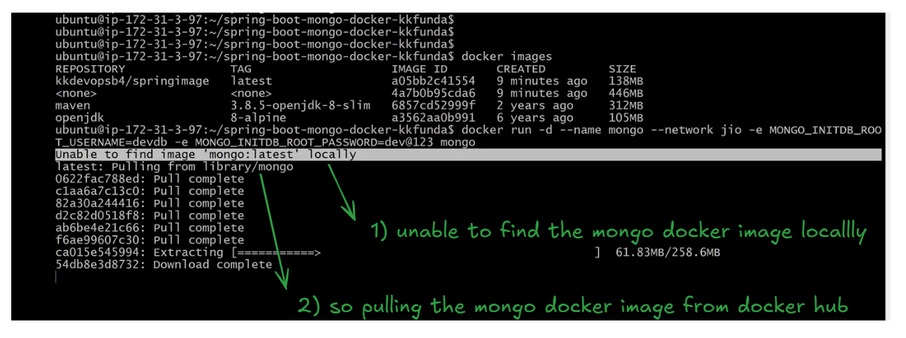
Alhumdulillah The mongo container has been created and it is up and running as shown below
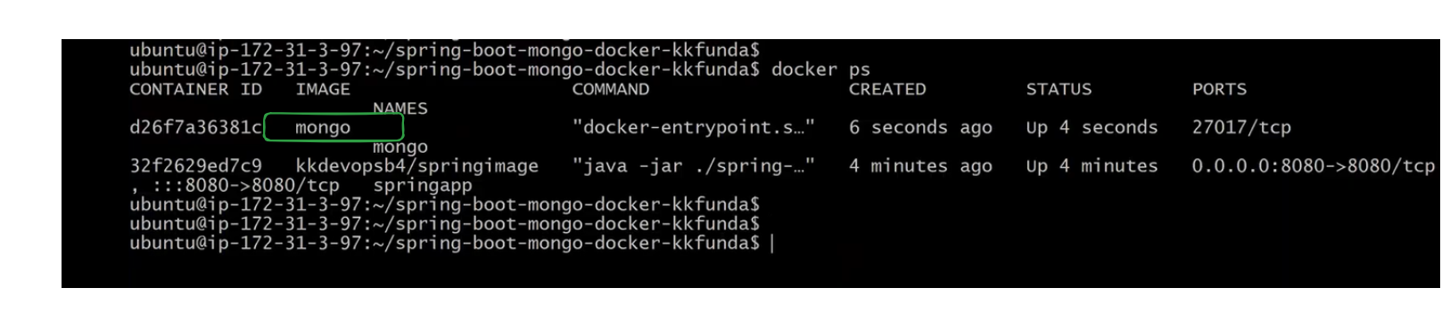
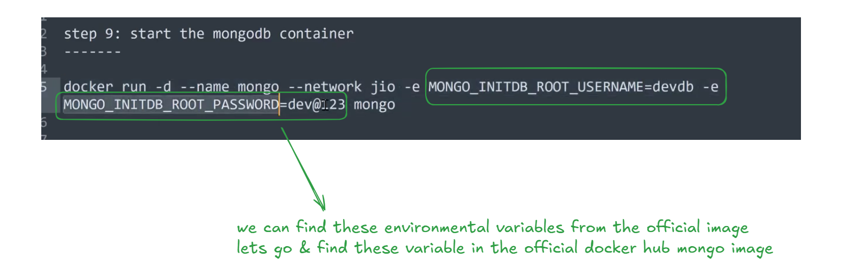
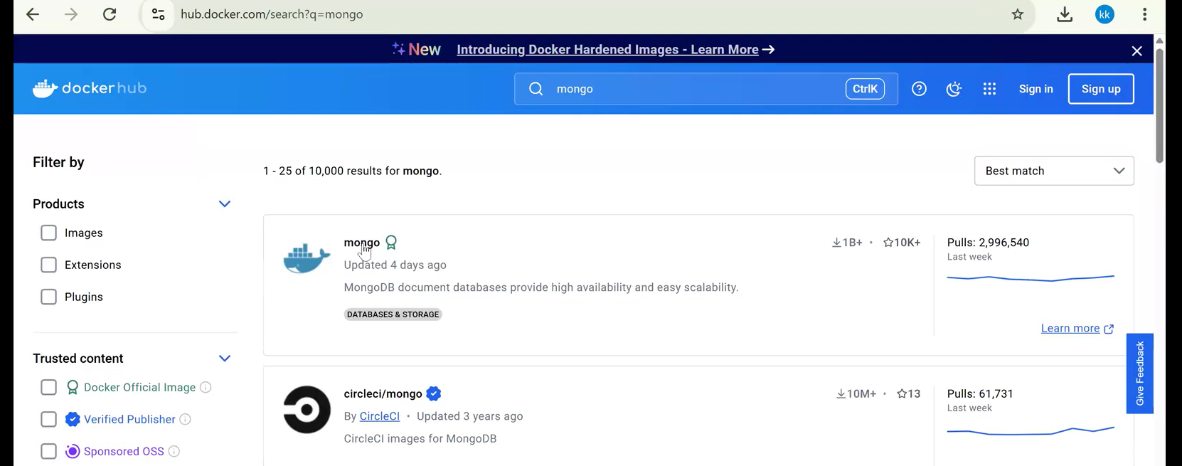
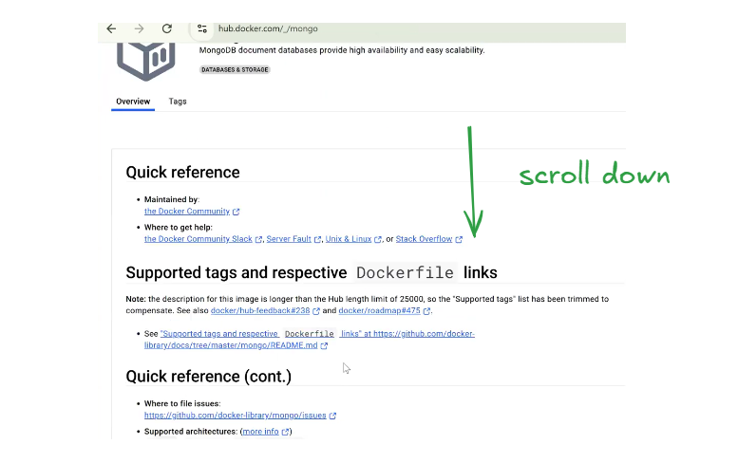
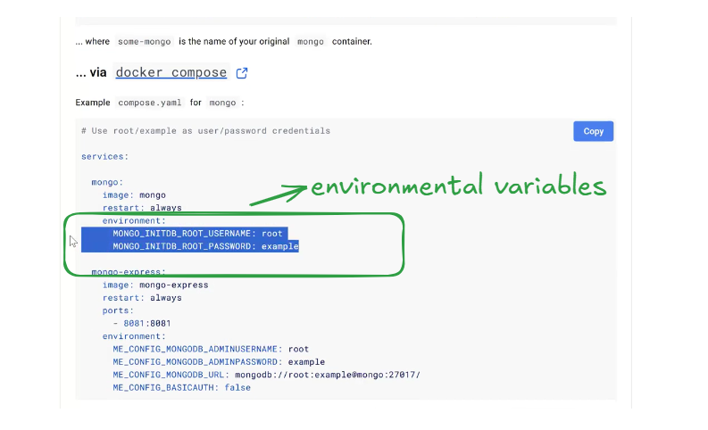
both applications spring and mongo db are up and running as shown in the below img
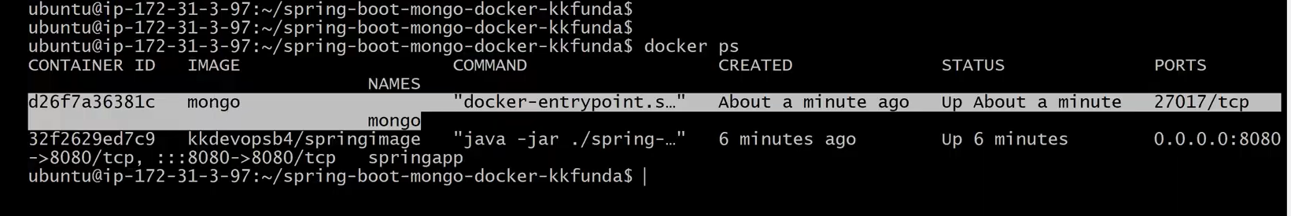
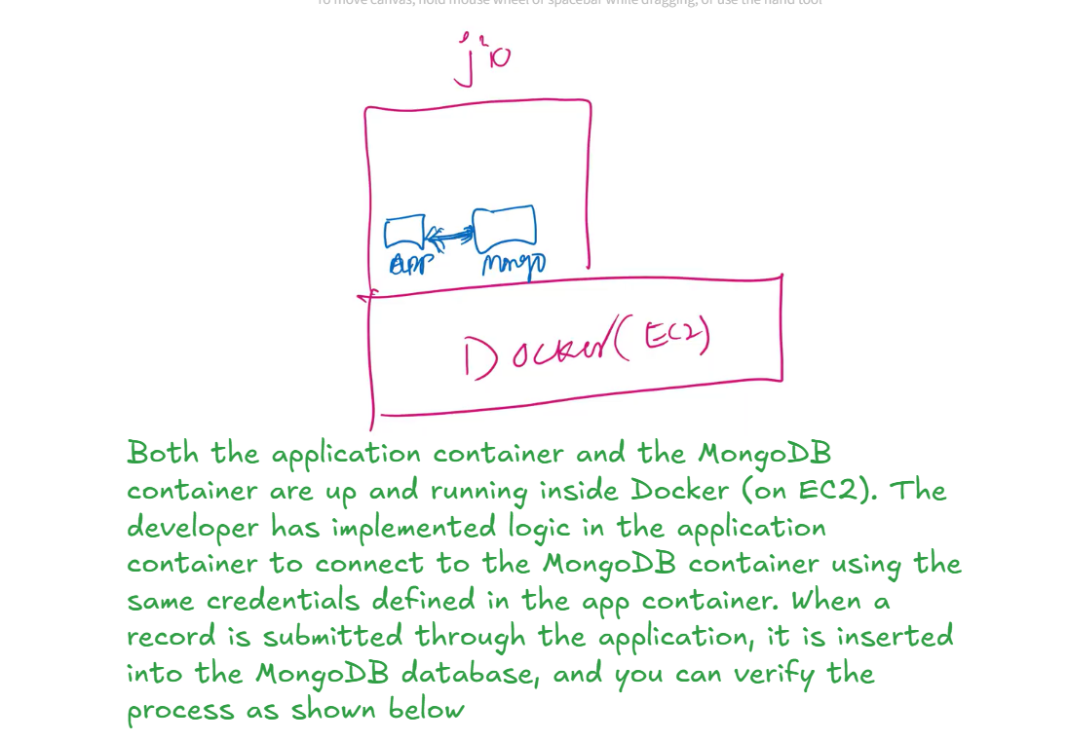
Let try to add some records in the Application container UI as shown below
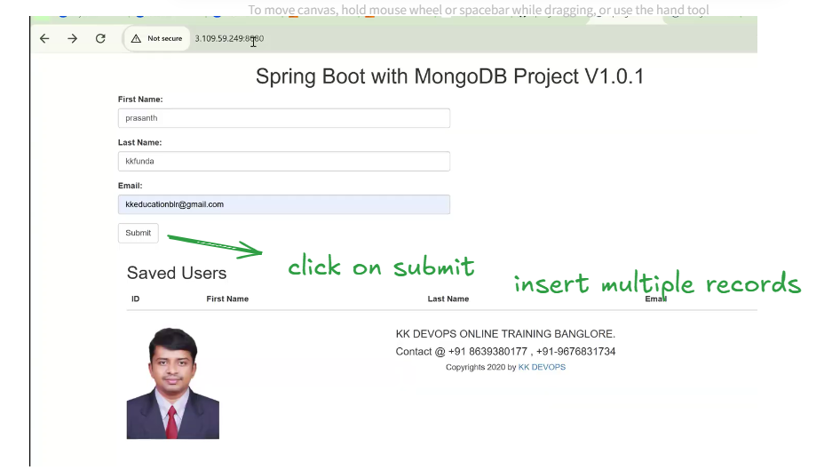
This Spring Boot application is running in a Docker container on an EC2 instance. It connects to a MongoDB container using defined credentials. When a user submits data through the web form, the record is stored in MongoDB and is immediately displayed under the ‘Saved Users’ section, confirming that the application and database integration is functioning correctly
