In this class we will discuss about docker file commands
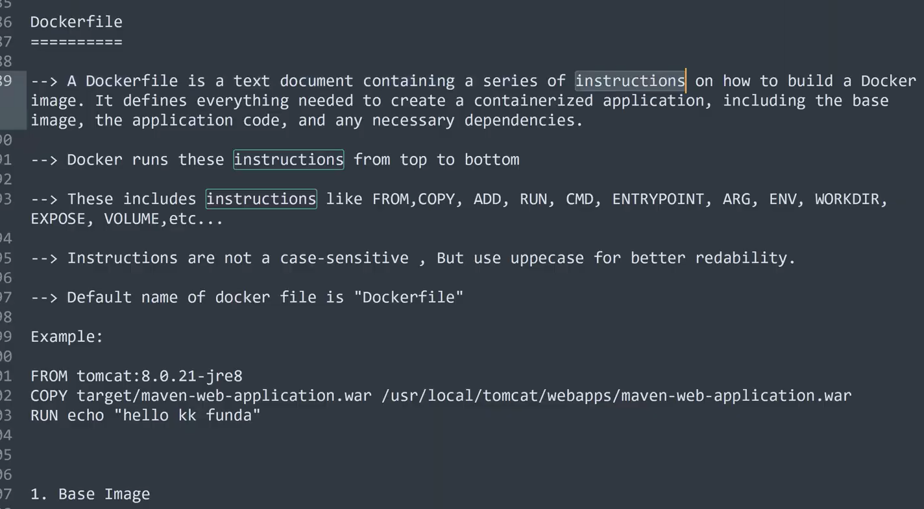
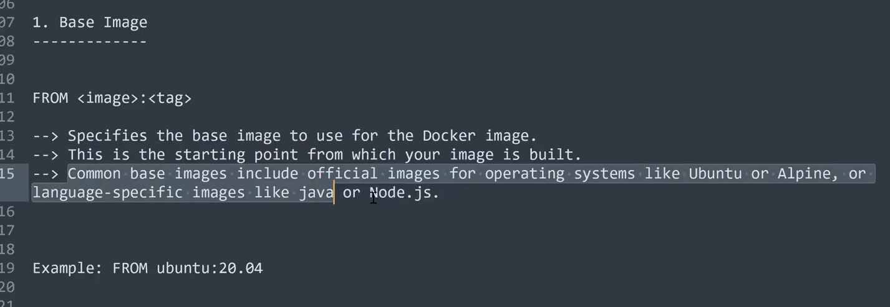
How to delete all the docker containers shown in the below img
execute the command rm –f $(docker ps -aq) to delete all the containers
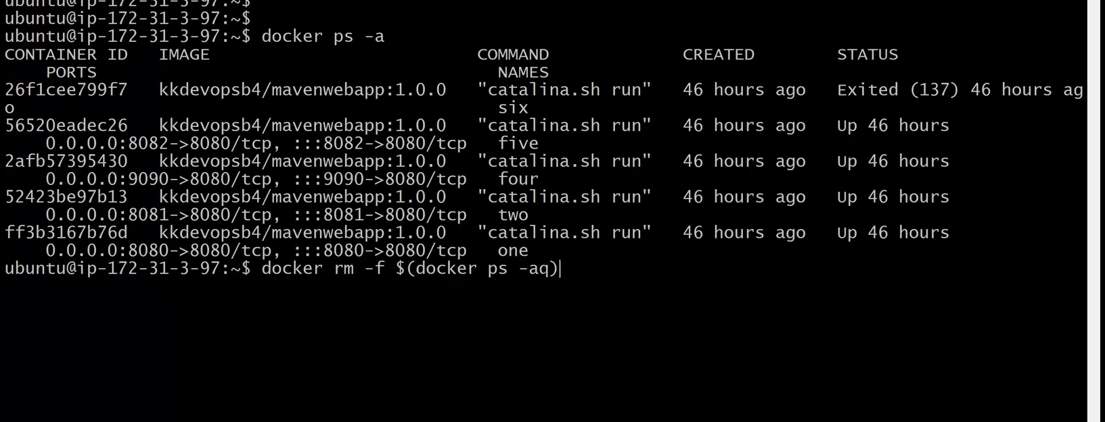
All the containers have been deleted as shown in the below img
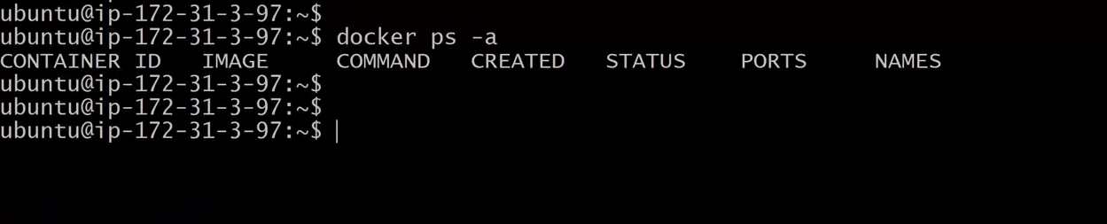
In today’s class we will discuss about theory related with Docker File commands(instructions)
So far we discussed about
docker introduction
docker Architecture
docker flow
docker Image related commands
docker container related commands
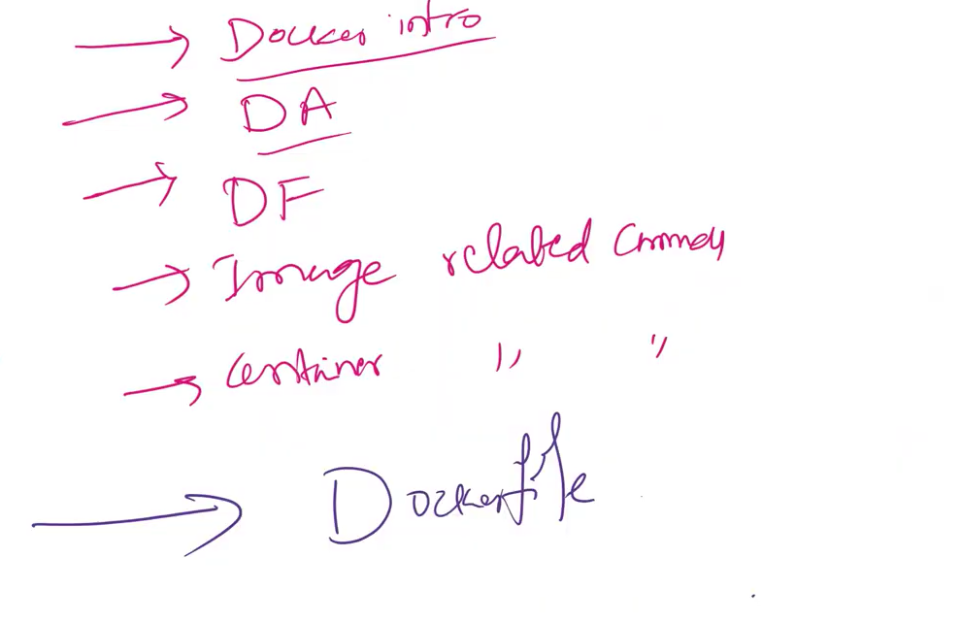
Let’s see how to create a docker file and discuss about docker file commands
Before we discuss about docker file let see how to create a docker container using docker image as shown in the below img execute the command
docker run -d -p 8080:8080 kkdevopsb4/mavenwebapp:1.0.0
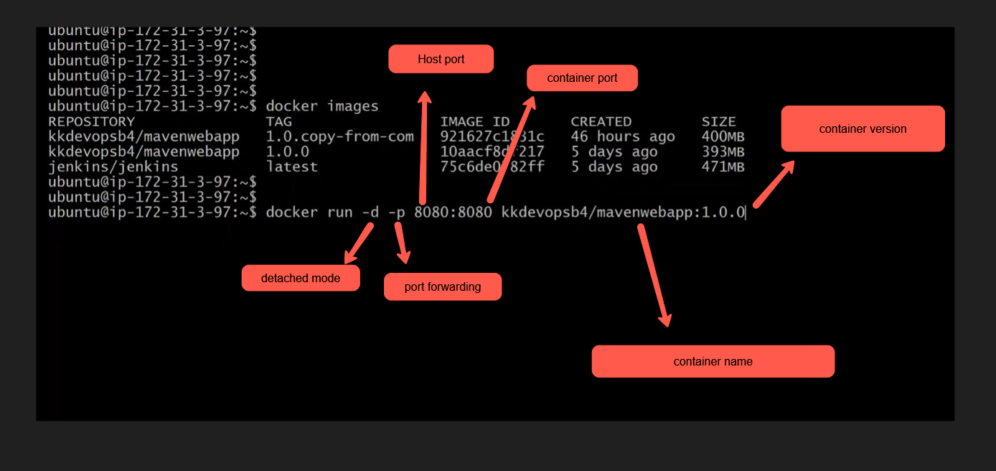
Docker File Flow shown in the below img
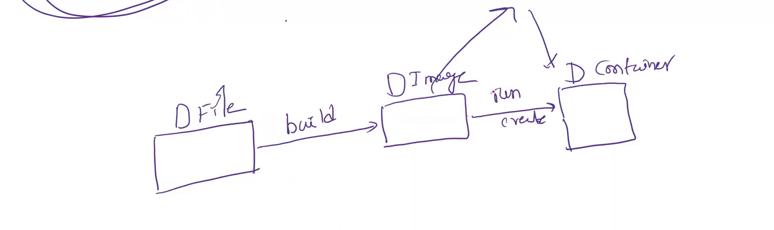
Let’s discuss about Docker File instructions
The collections of Instructions are called as docker File
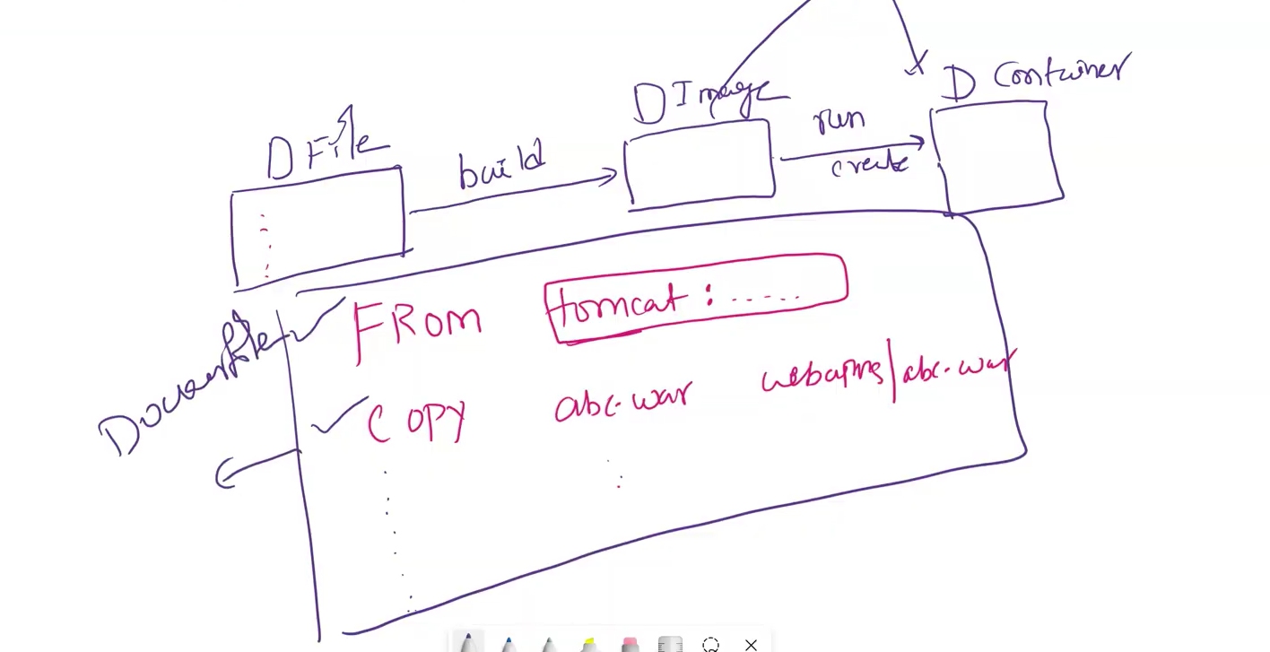
1) From Tomcat : version ---> base image with version
2) copy webapp.war /user/webapps
The base image Tomcat is built on the Java image as shown in the below img
open Docker Hub and search Tomcat Image(you will find it is build on Java base img)
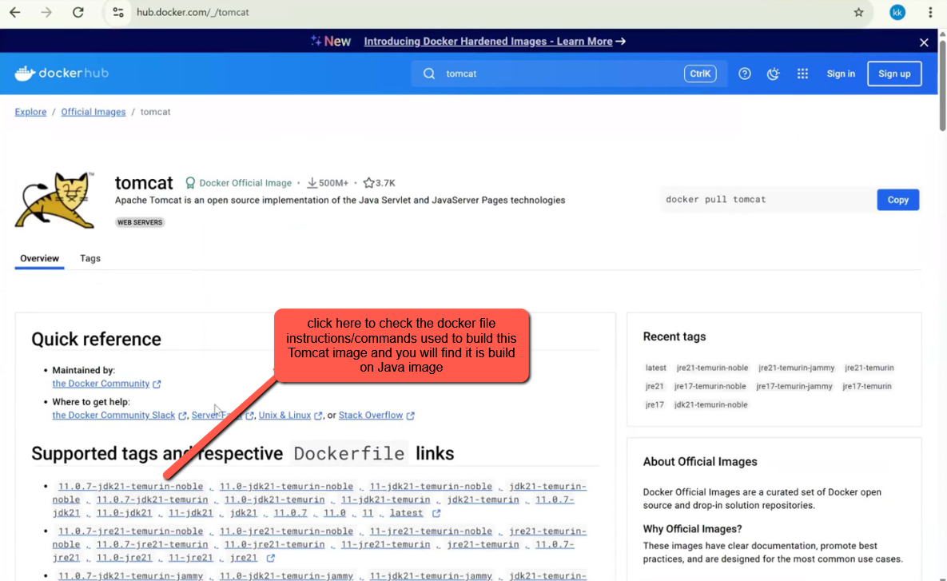
You can see in the below img the base image Java for Tomcat image
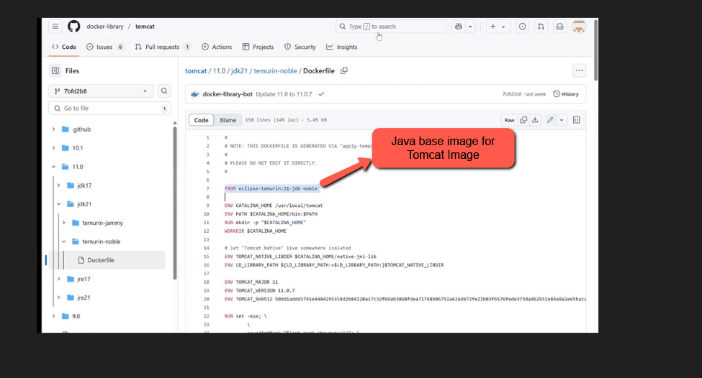
From command/instruction
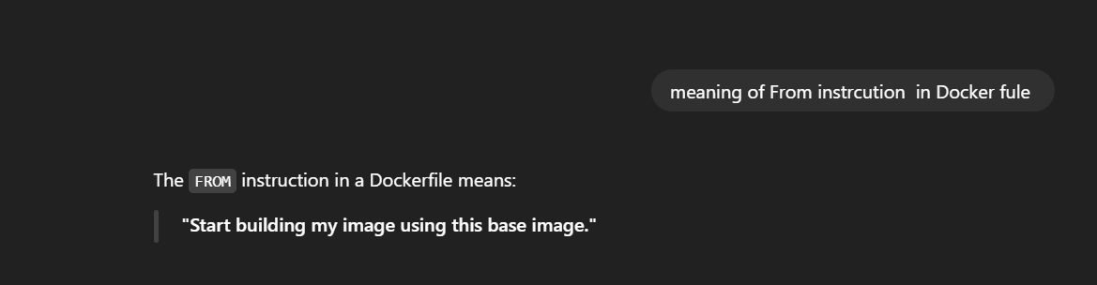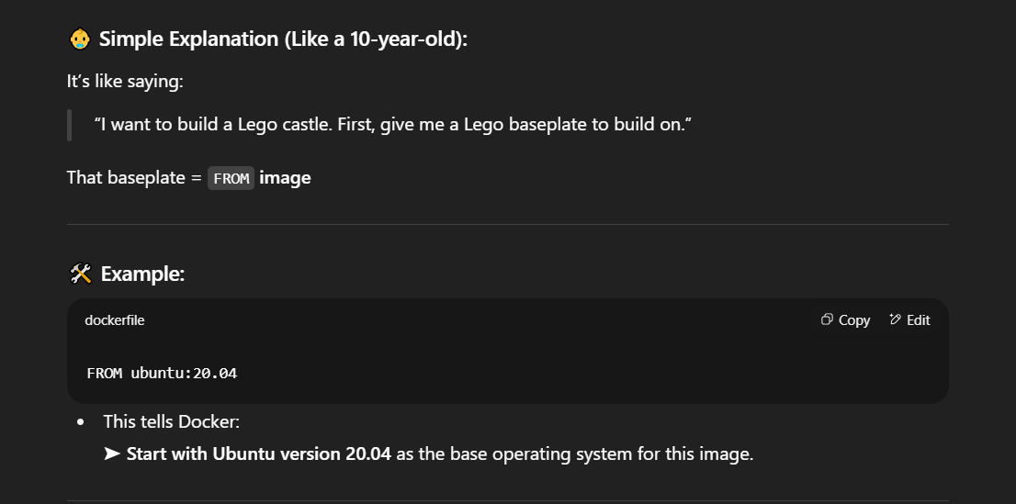
Q) What is copy instruction ?
A) The COPY instruction in a Dockerfile is used to copy files or folders from your computer (the build context) into the Docker image as shown in the below img.
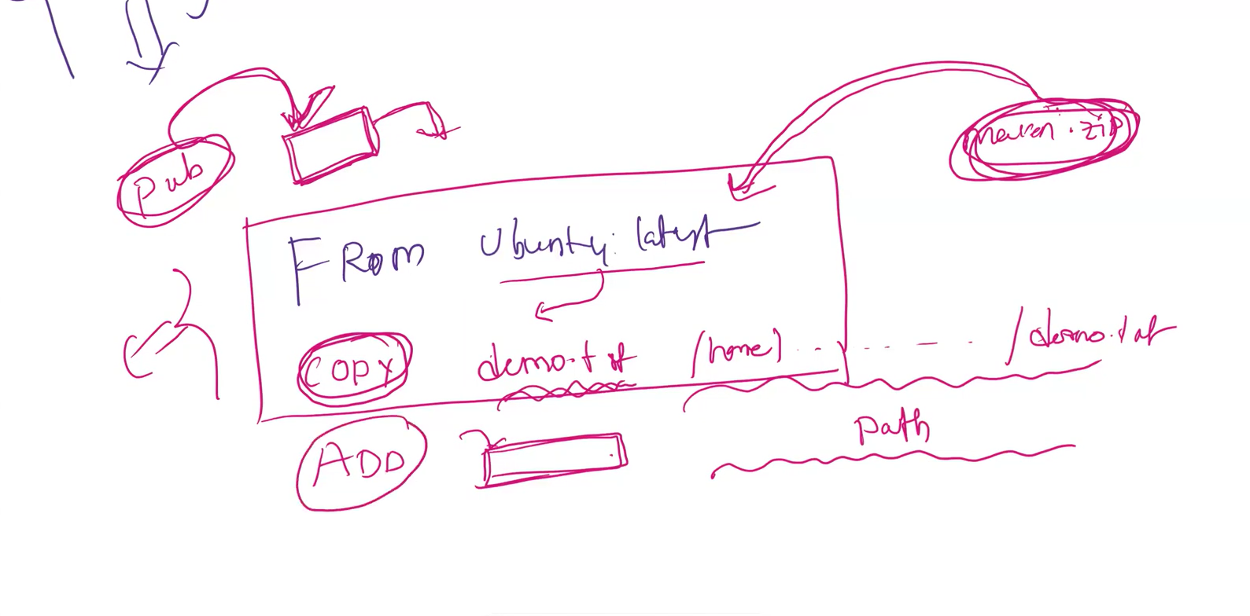
Q)what is Add instruction?
A) The ADD instruction in a Dockerfile is used to copy files into the Docker image — just like COPY — but it can also do a few extra things
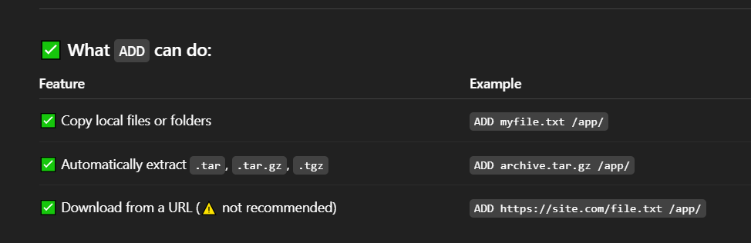
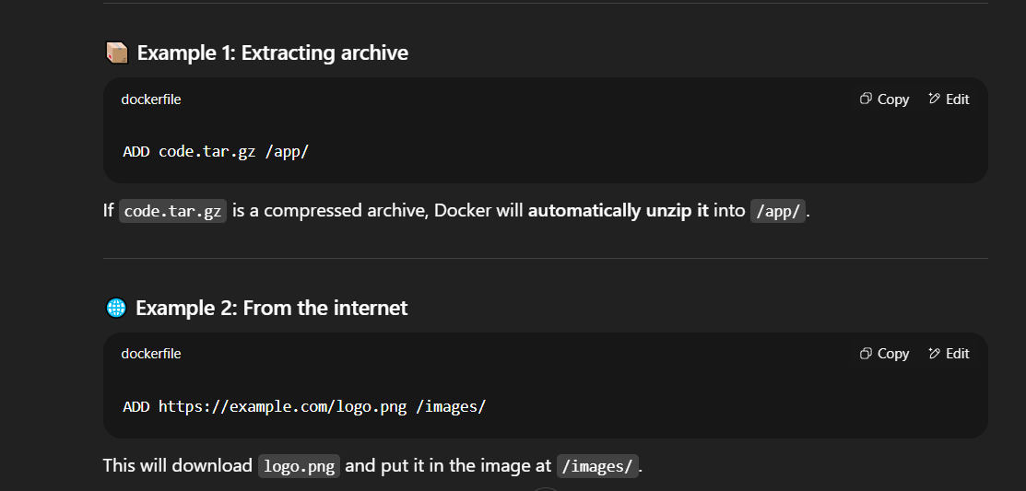
What is the difference between copy & Add instruction in Docker File?
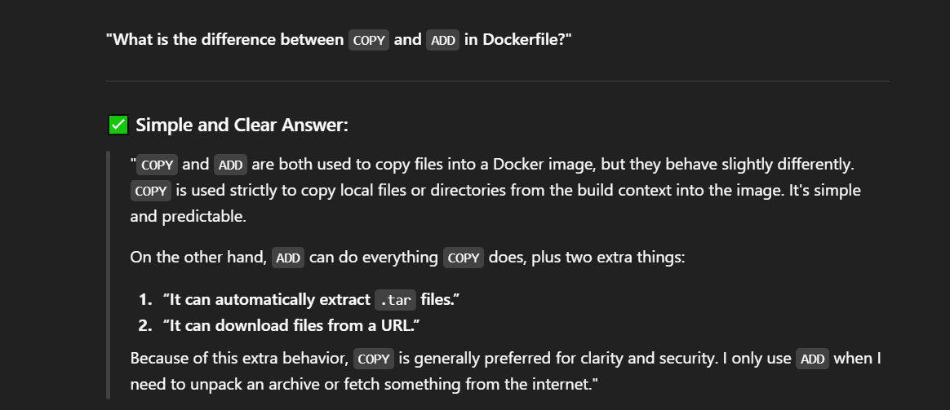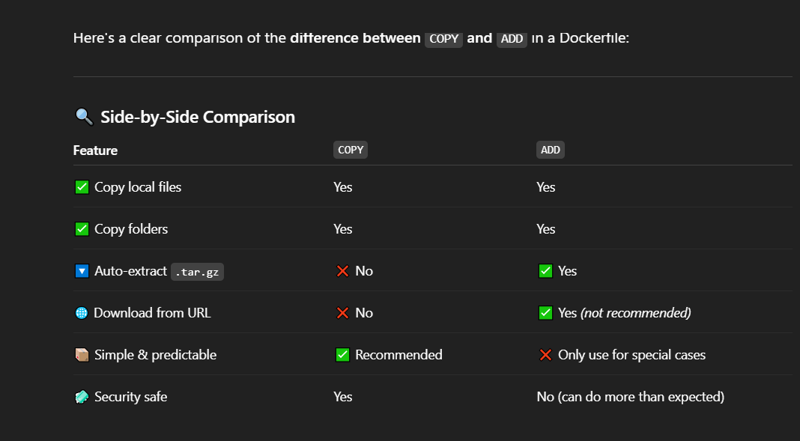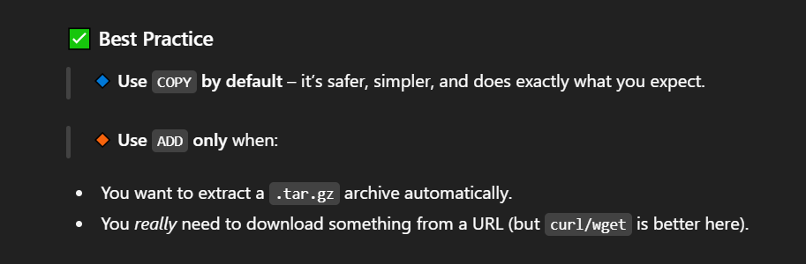
Very Important what is difference between Run , cmd , EntryPoint instrcutions asked in many interview questions
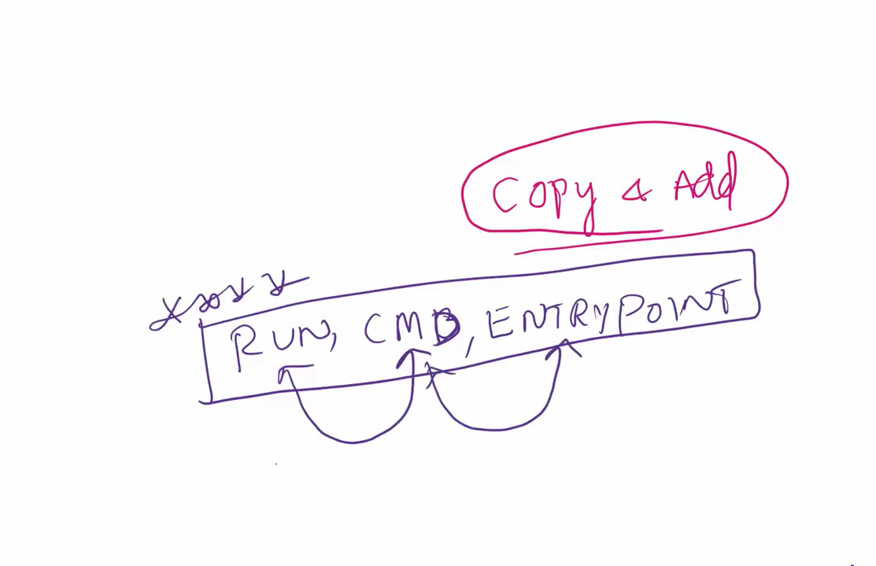
Q) In your project in which situation you have used Run ,CMD ,Entrypoint
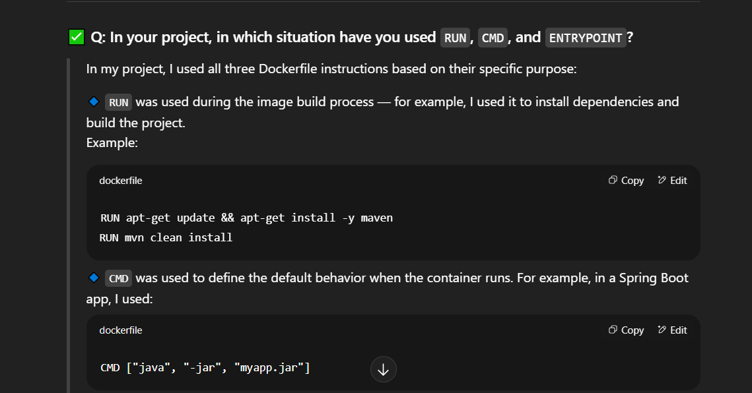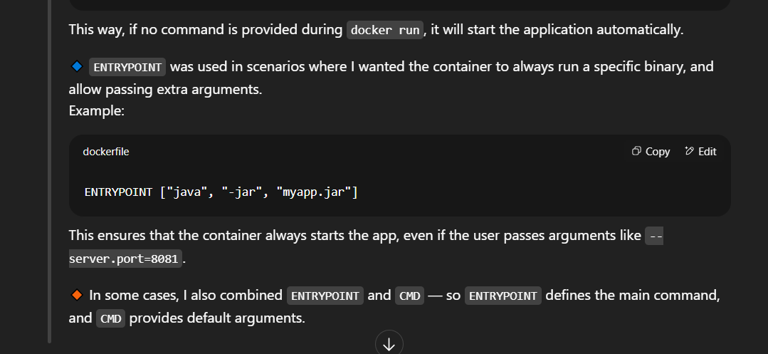
Run Instruction
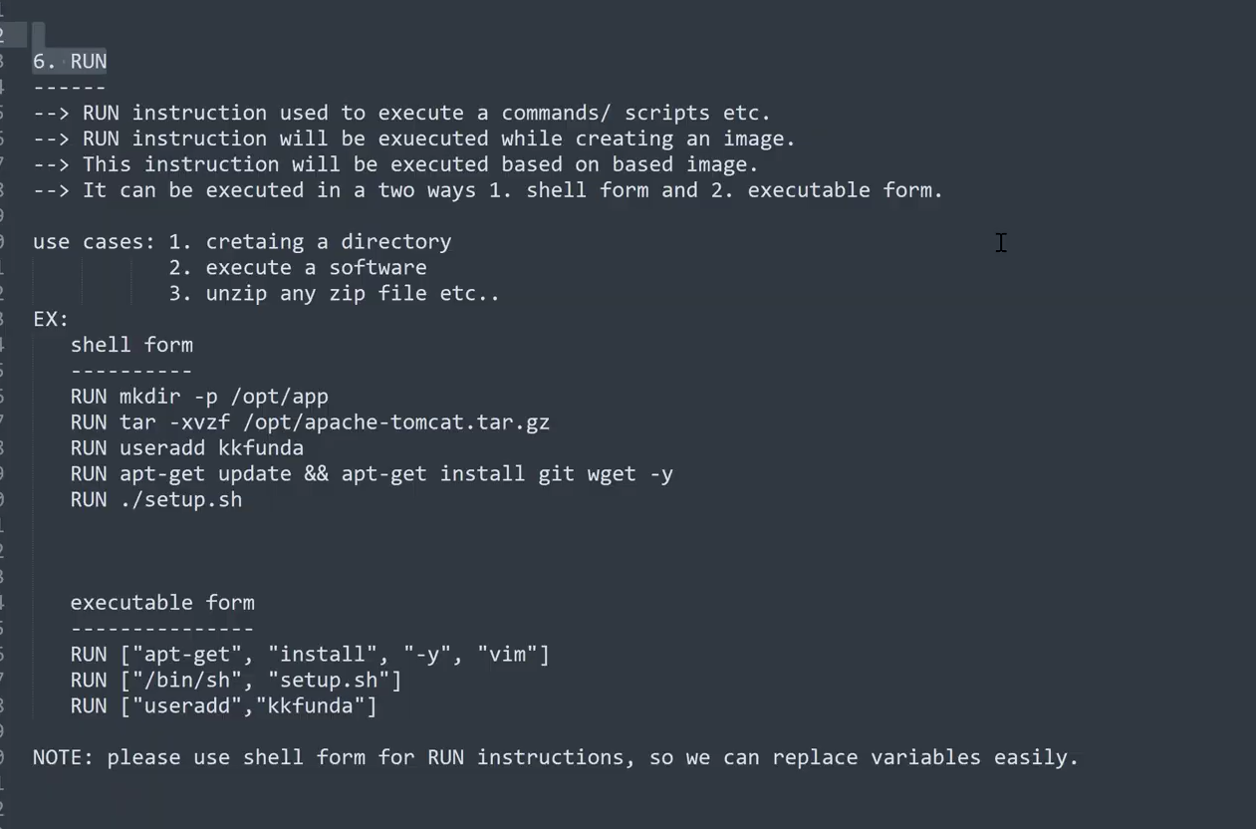
After copying any file(script) in to base image inorder to execute that file we have to manually run it by using 'Run' instruction as shown below
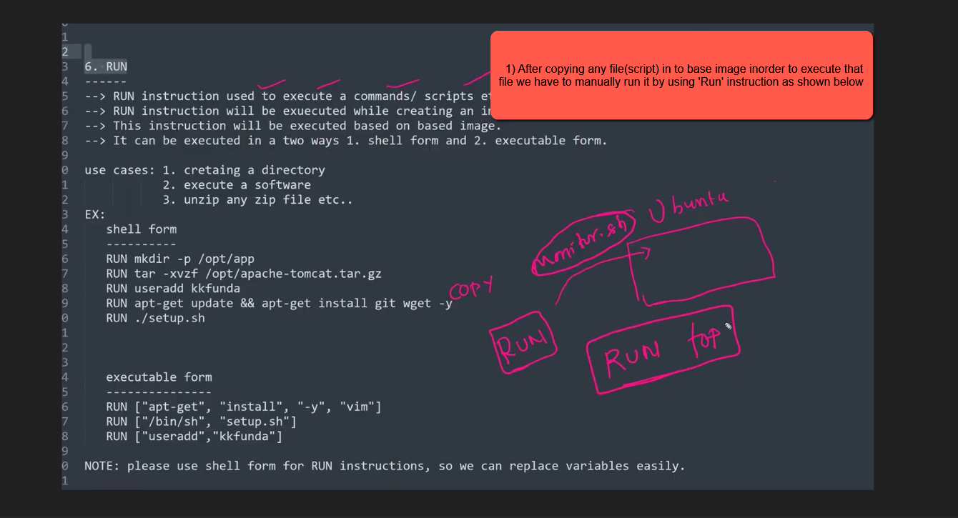
When we run the docker build command, all the RUN instructions in the Dockerfile are executed one by one. These commands help install software, set up the environment, or prepare files needed inside the image
The Run instruction can be executed in two ways as shown in the below image
shell form & executable form
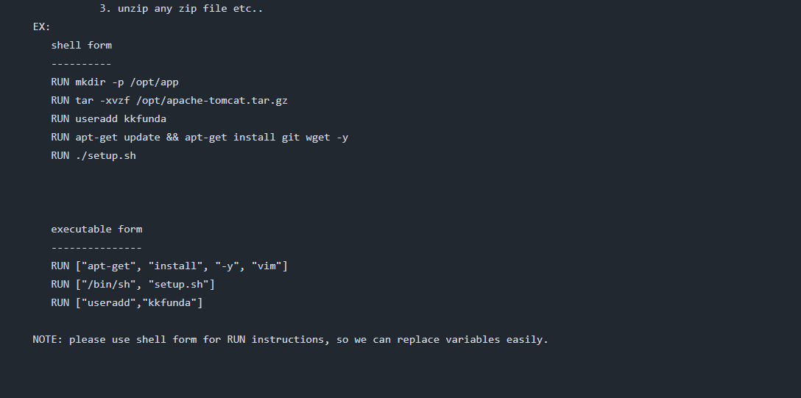
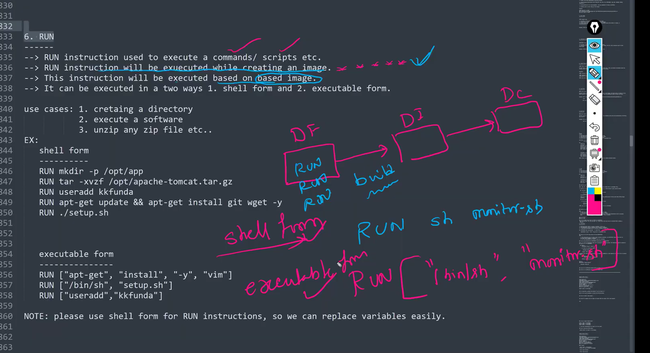
CMD instruction
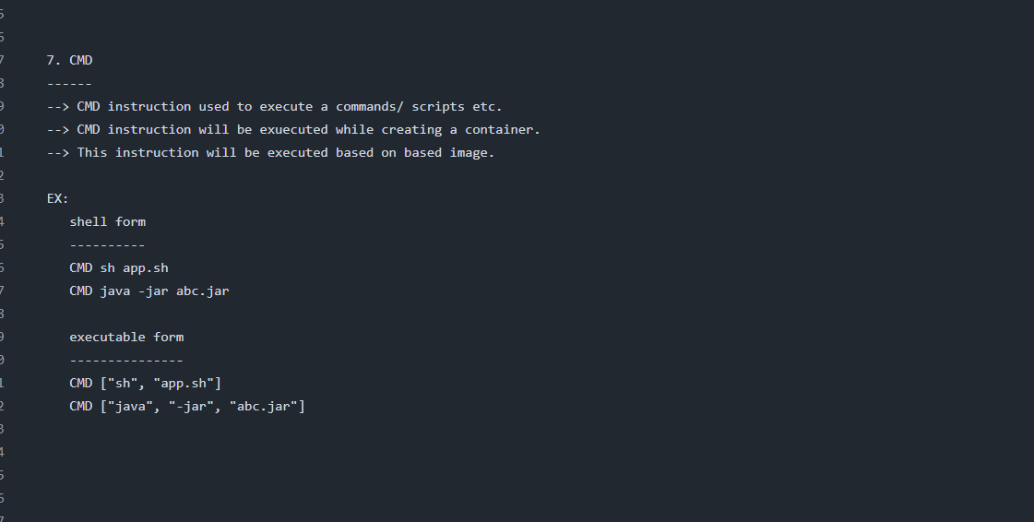
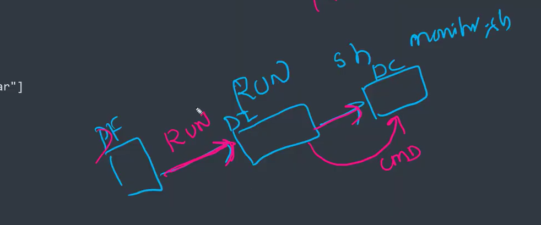
In a Dockerfile, the RUN instruction is executed during the image build process, whereas the CMD instruction is executed when a container is created from the image
Both Run and CMD instruction can be define in both ways shell form or executable form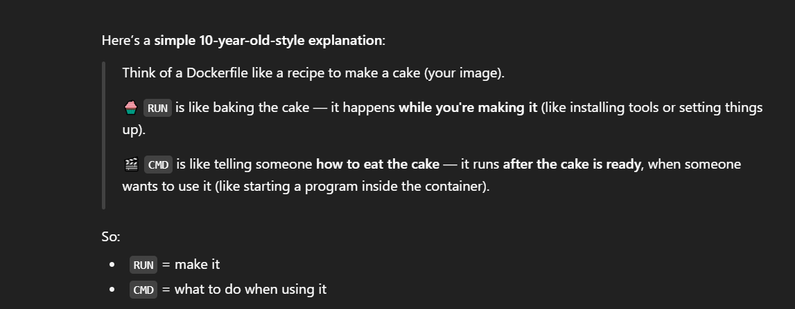
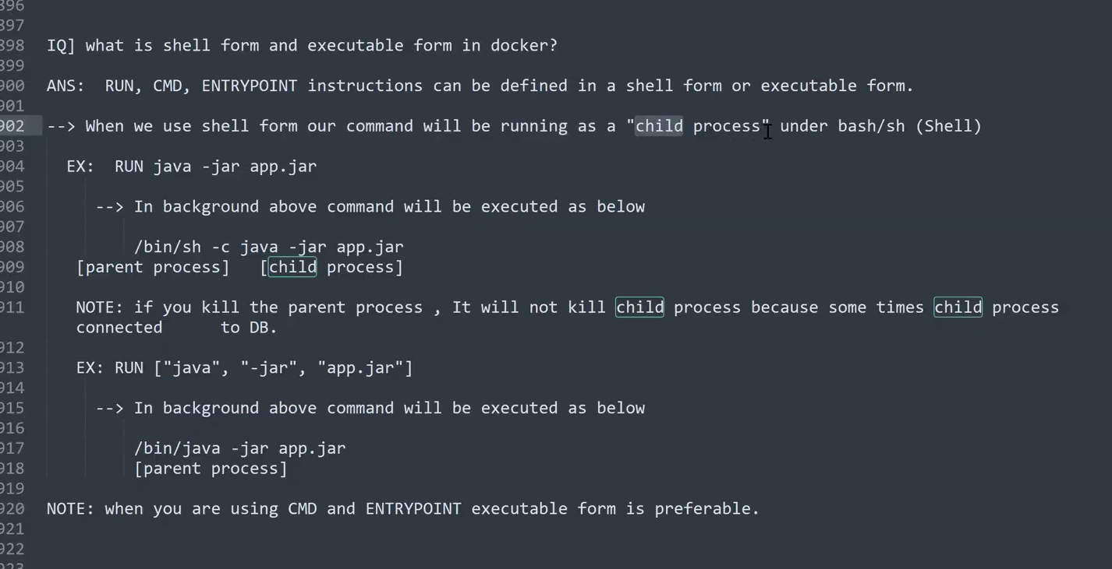
As a DevOps engineer, you should decide whether a Docker instruction needs to run while building the image (like RUN) or when starting the container (like CMD or ENTRYPOINT)
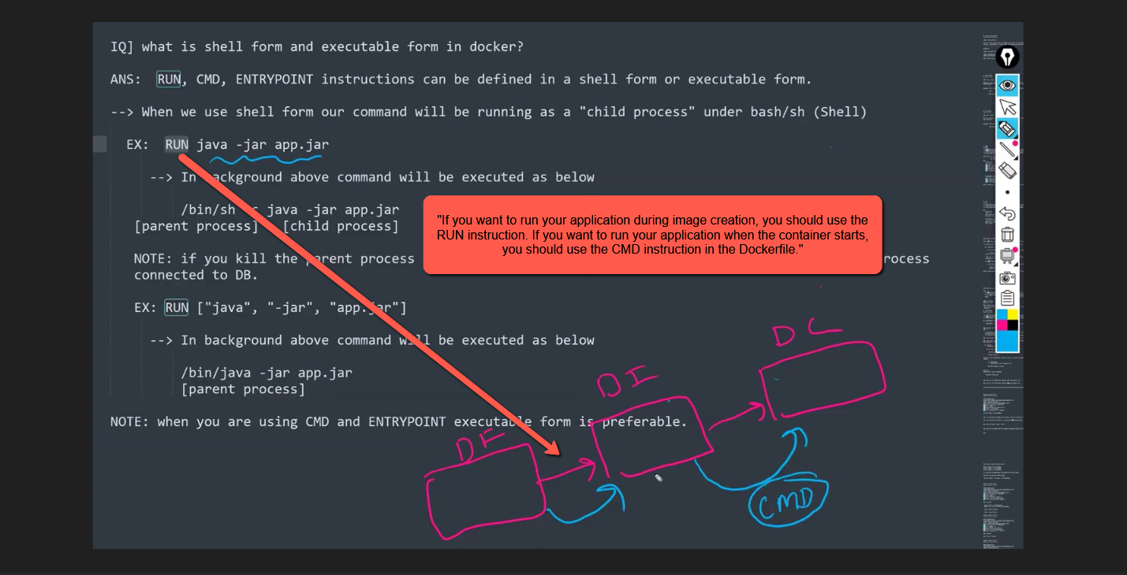

"If you want to run your application during image creation, you should use the RUN instruction. If you want to run your application when the container starts, you should use the CMD instruction in the Dockerfile."
"Using the RUN instruction to start an application during Docker image creation is not a good practice. The purpose of the RUN instruction is to execute commands that are needed to build the image, such as installing packages or creating directories—not to start long-running processes. To ensure the application runs when the container starts (not during image build), it's better to use the CMD instruction. This way, the application launches properly during container creation and runtime."
----------------------------------------------------------------------------------------------------------------------------------------------------------------------------------------------------------------------------------------------------------------------------------------------------------------------
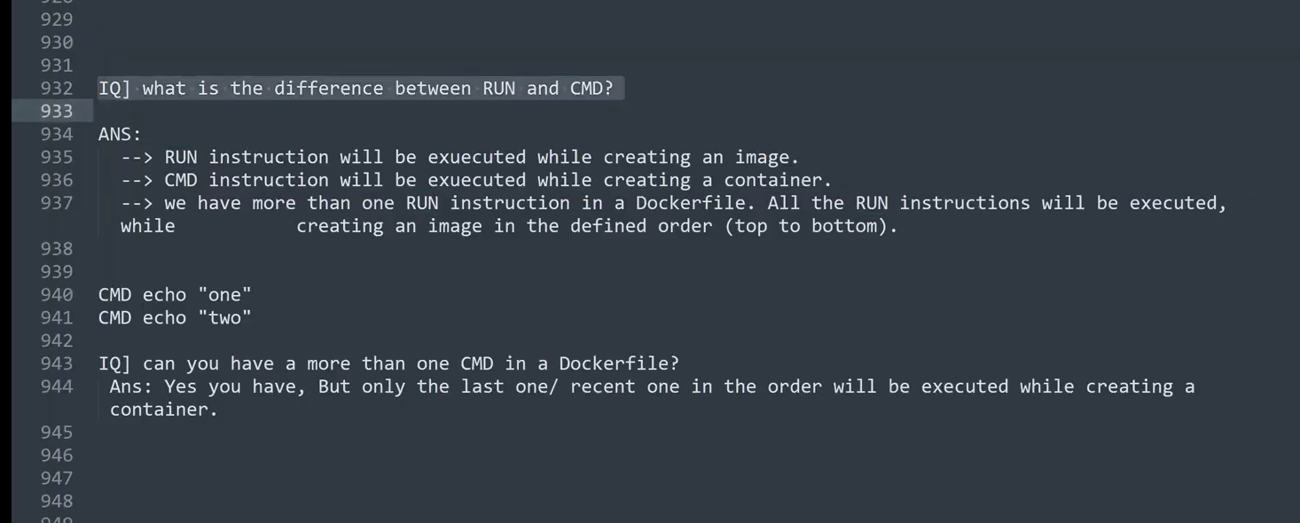
We will discuss about Entrypoint in the Next class
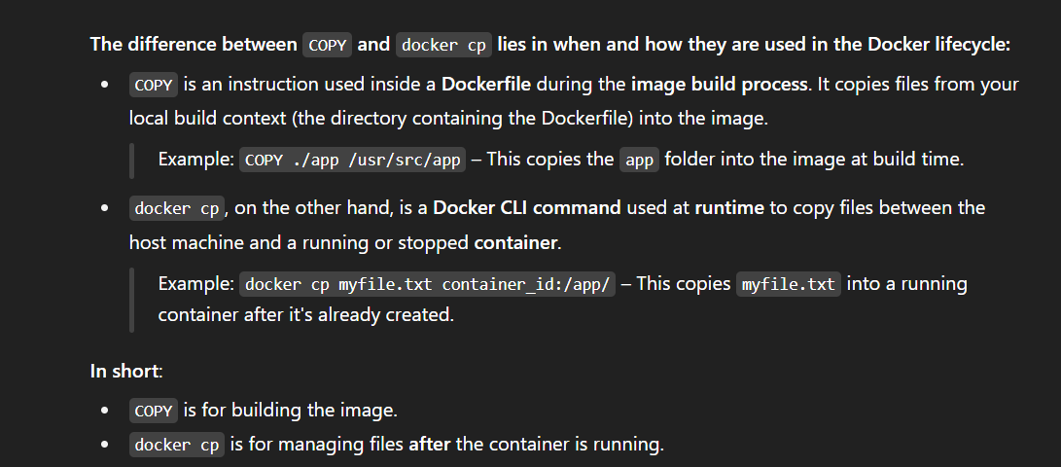
------------------------------------------------------------------------------------------------------------------------------------------------------------------------------------------------------------------------------------------------
-----------------------------------------------------------------------
Let’s write one sample Docker File with all the above discussed instructions:
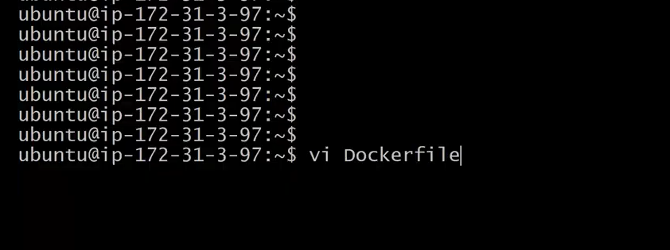
write the below Docker Instrcutions in the docker file
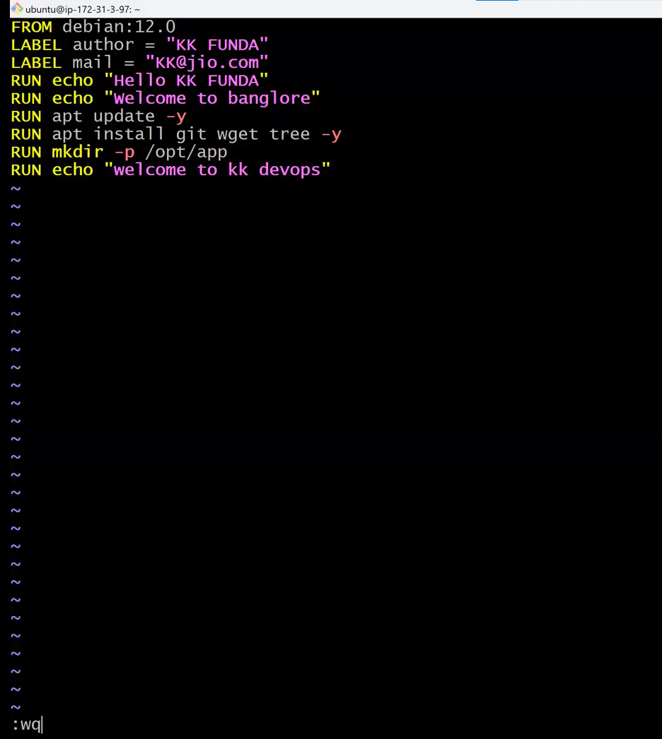
Now based on this docker file lets create a dcoker image as shown below
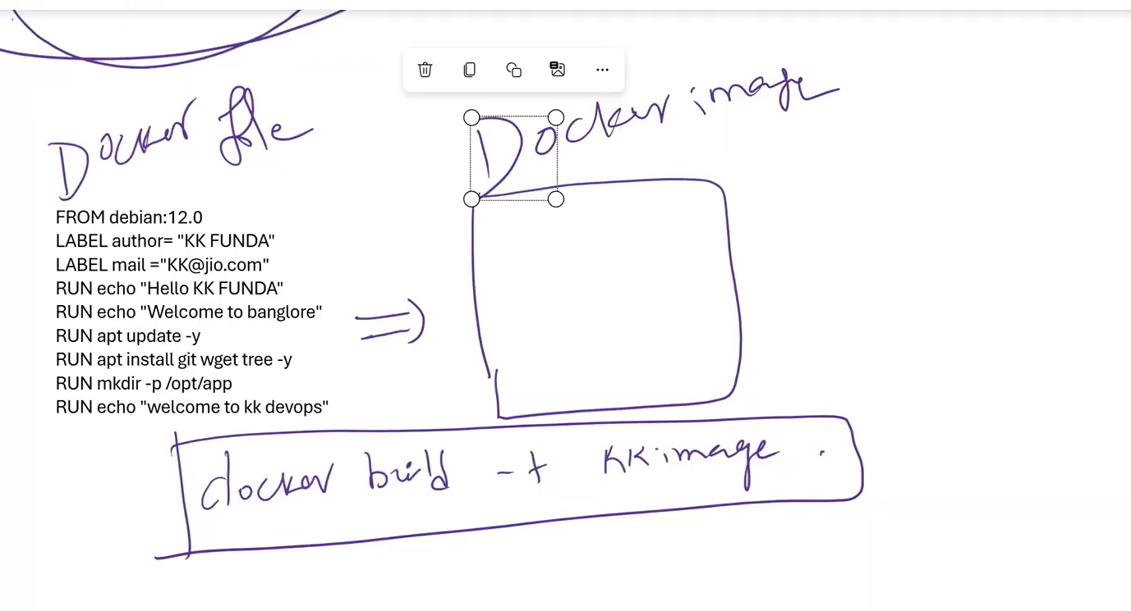
Let try to build the image from the docker file so execute the below command for creating an Docker Image
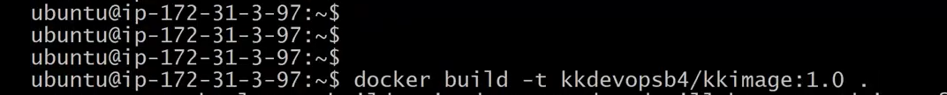
docker build -t kkdevopsb4/kkimage:1.0 .
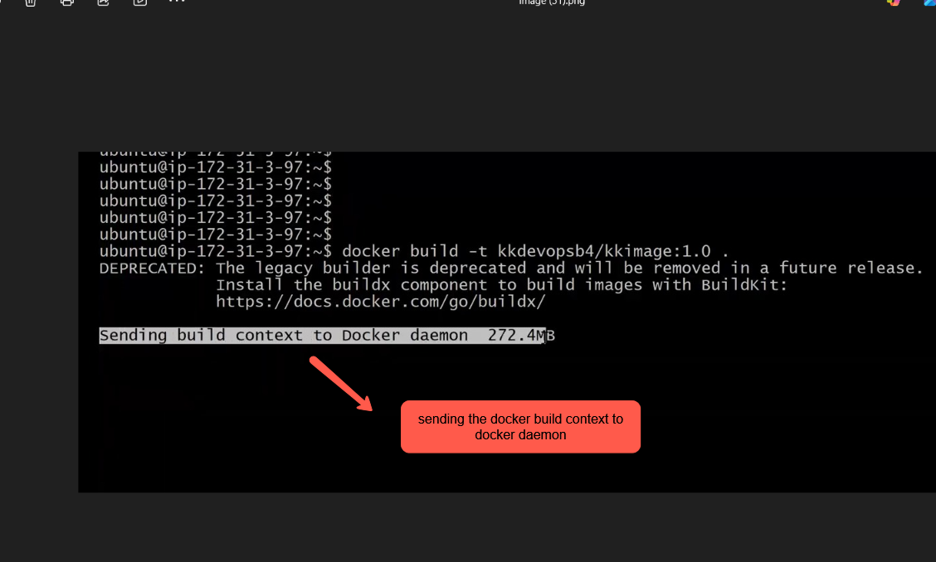
There are total 9 instrcutions are present in the docker file . so when execute docker build command total 9 Instructions would be executed in step format as shown in the below img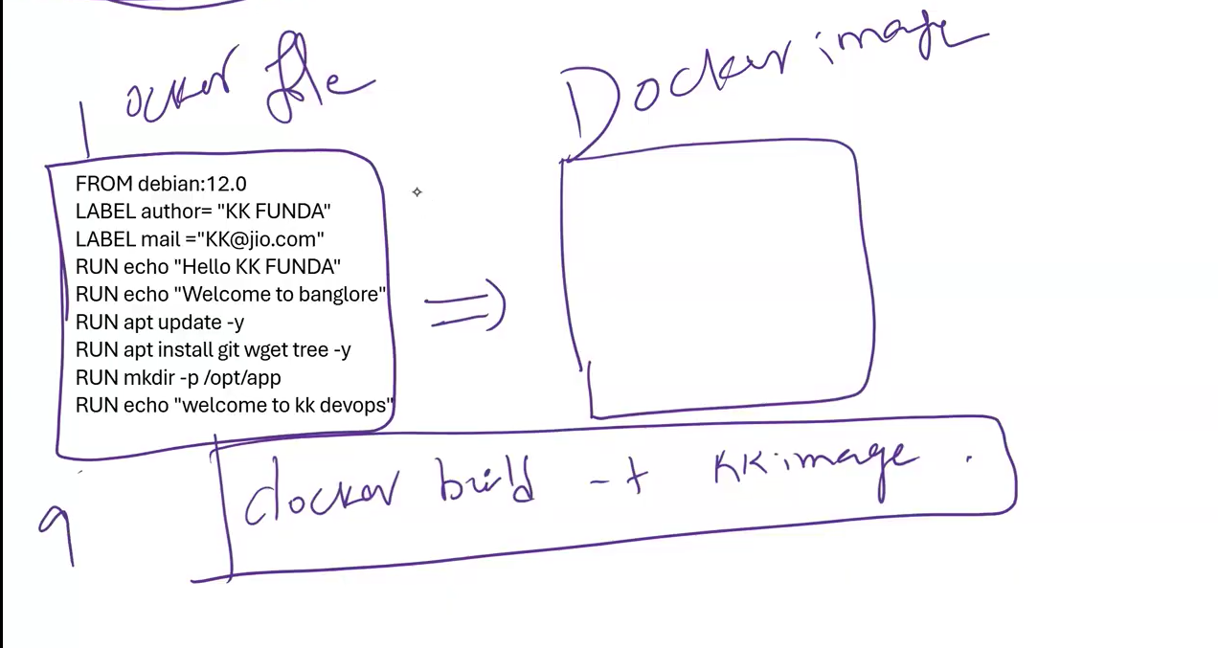
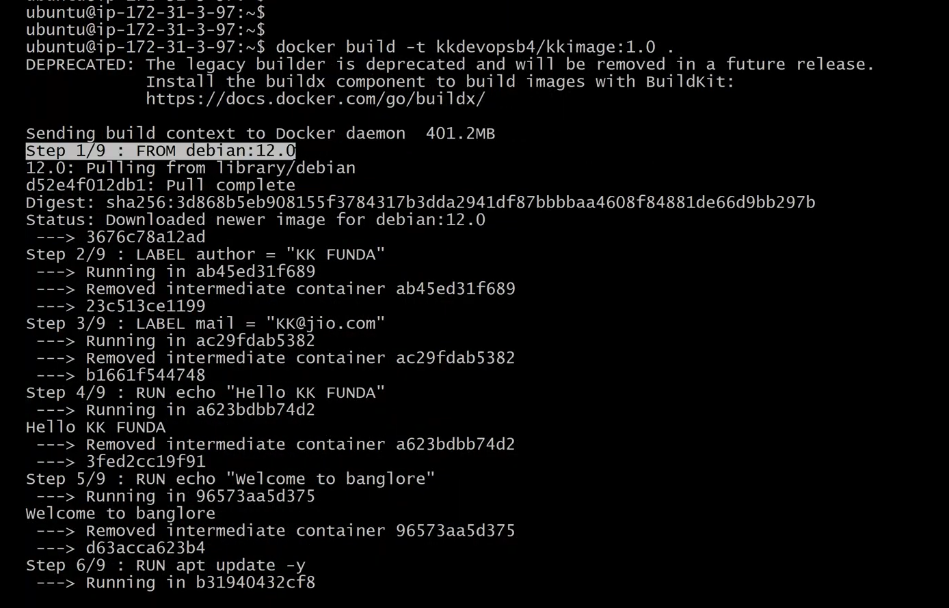
All the instructions in the Dockerfile are executed by the Docker Daemon. For each instruction (like FROM, RUN, LABEL, etc.), Docker creates a temporary intermediate container (which forms a layer), executes the instruction, and commits the result to a new image layer.
When we rebuild the same Dockerfile, Docker uses the cache of previously built layers (if there are no changes in the instructions) to speed up the image creation process, resulting in significantly reduced build time.
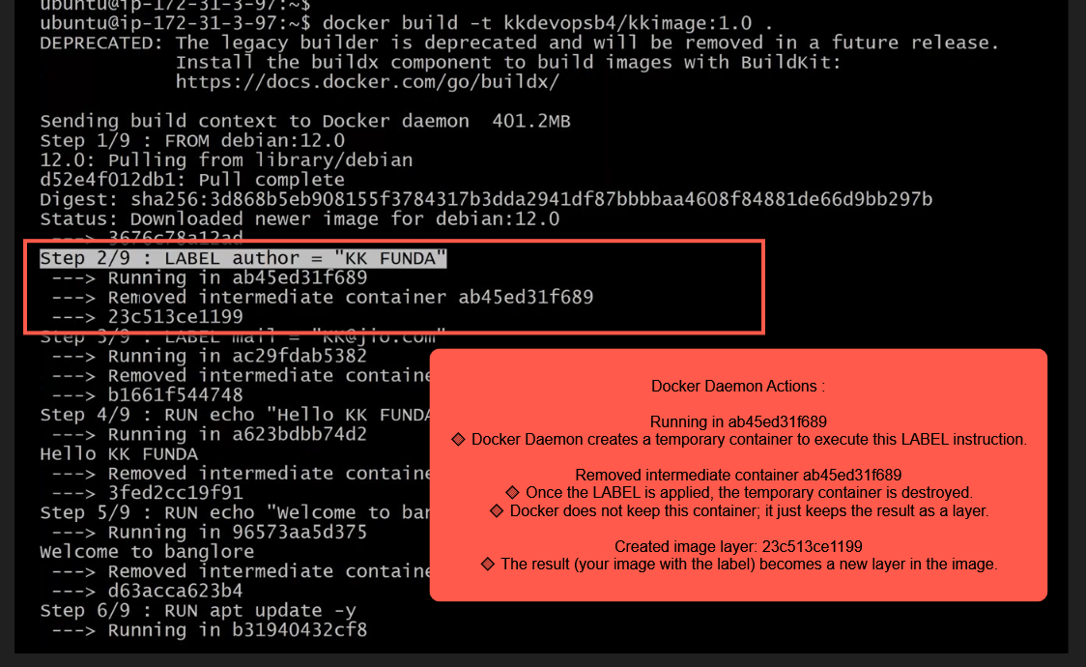
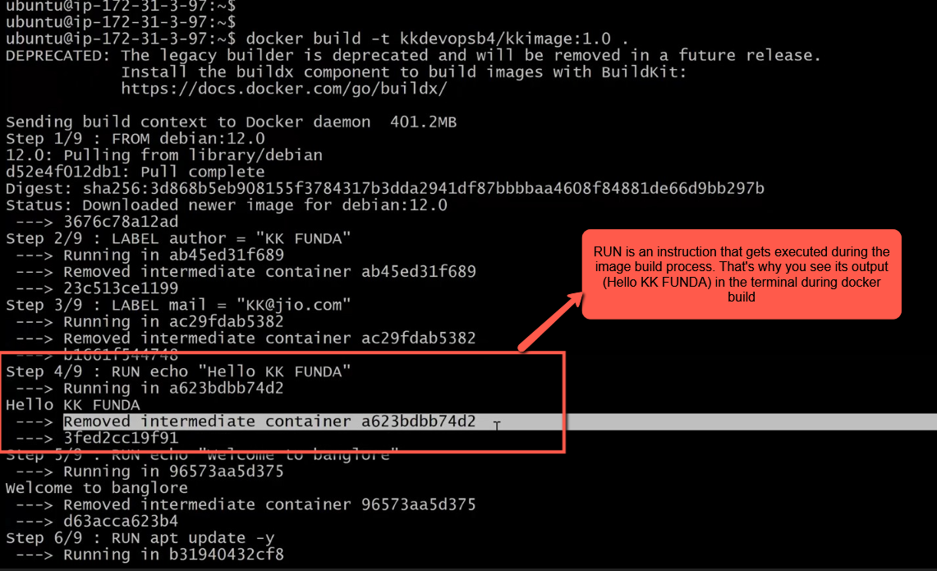
When we build the image again using the same Dockerfile, the Docker Daemon uses the cached layers from the previously built image. This allows it to build the image faster, as shown in the image below
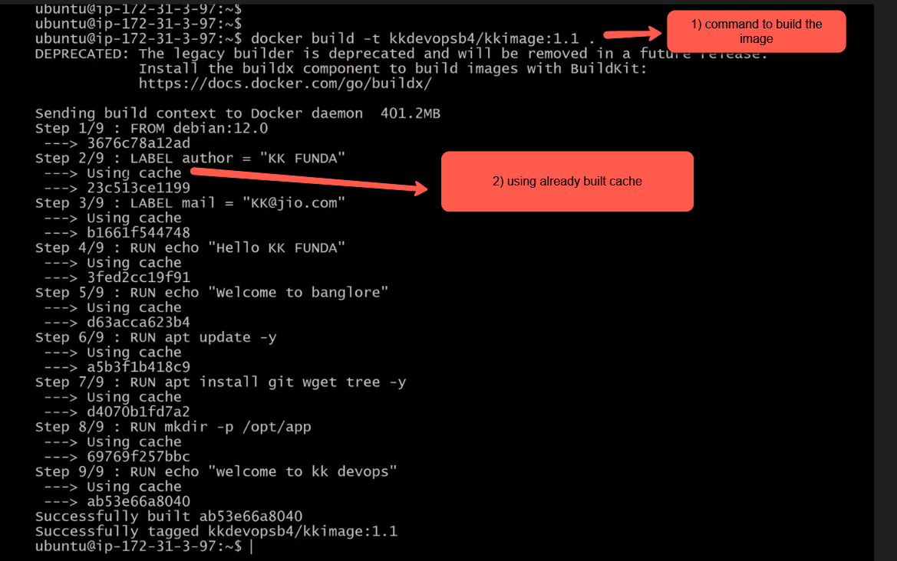
If we add any new instruction to the Dockerfile and rebuild the image, the Docker Daemon will reuse the cache for all previous instructions up to the point where the change occurs. From that point onward, it will invalidate the cache and rebuild the remaining instructions, including the newly added one
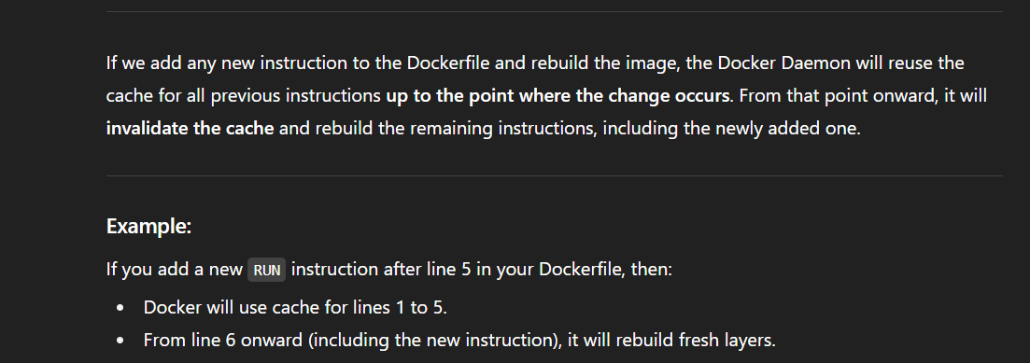
Let’s open the docker file and add a new instruction as shown in the below img
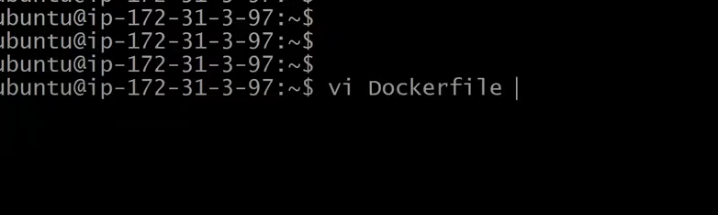
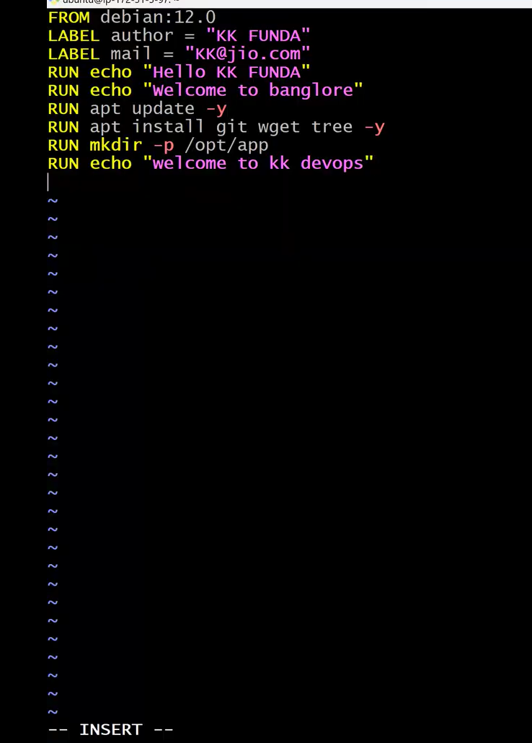
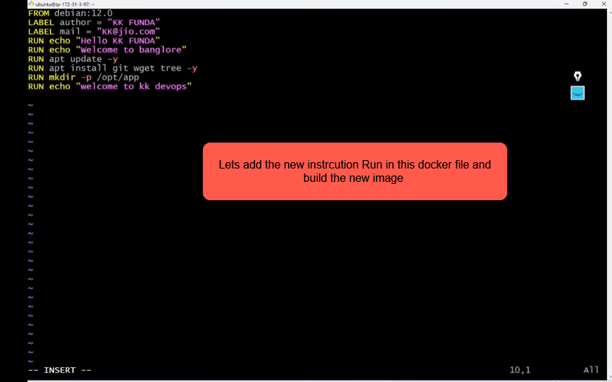
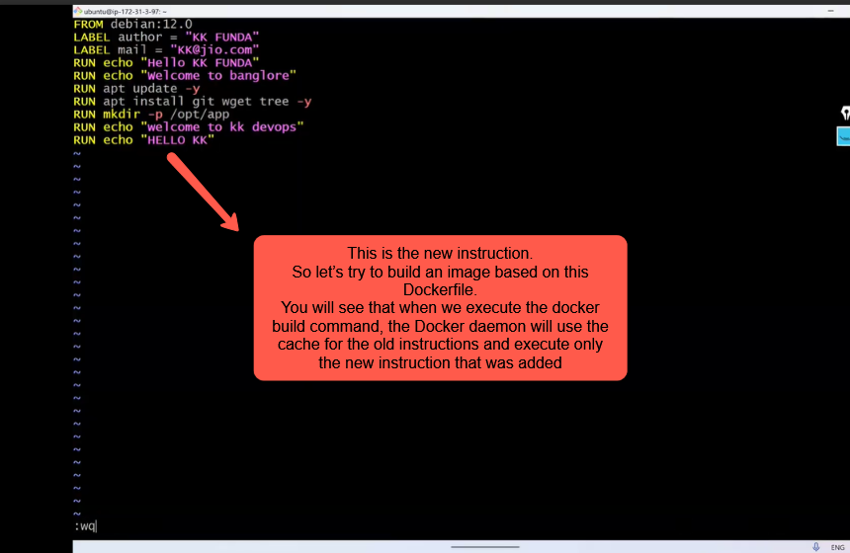
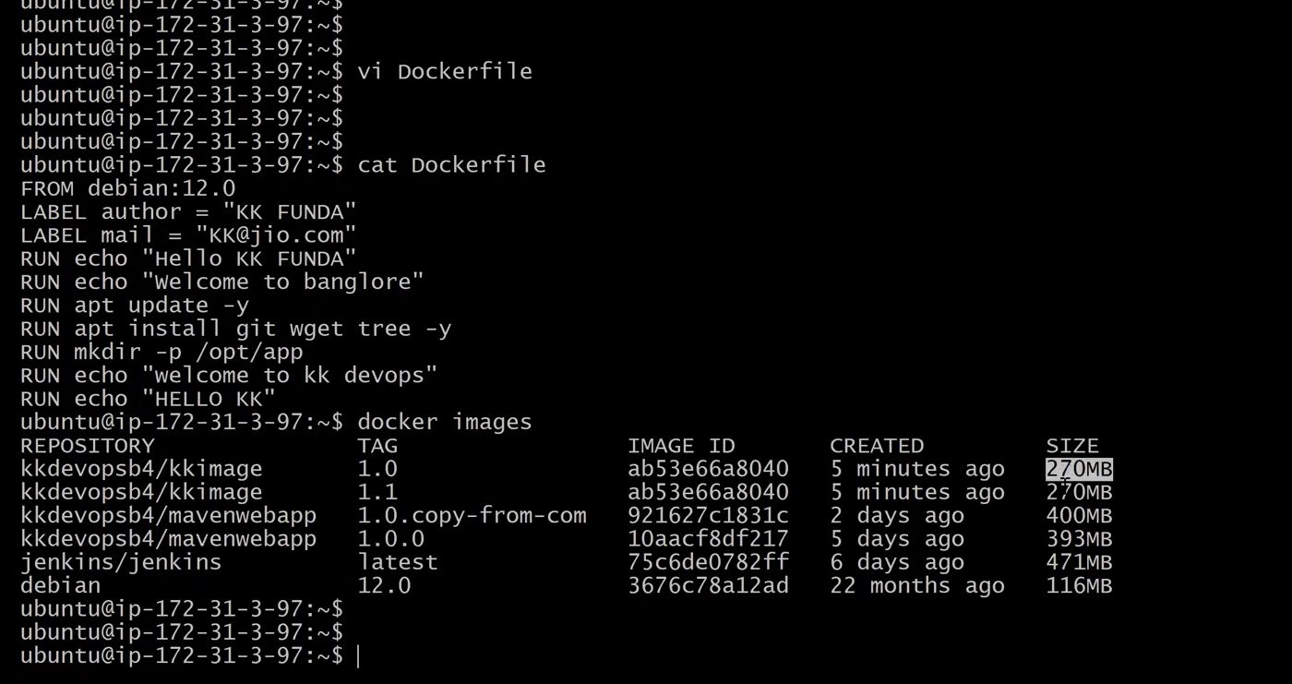
Let’s try to build a new image create one more image as shown below
what happens when you execute the build image command described in the below img
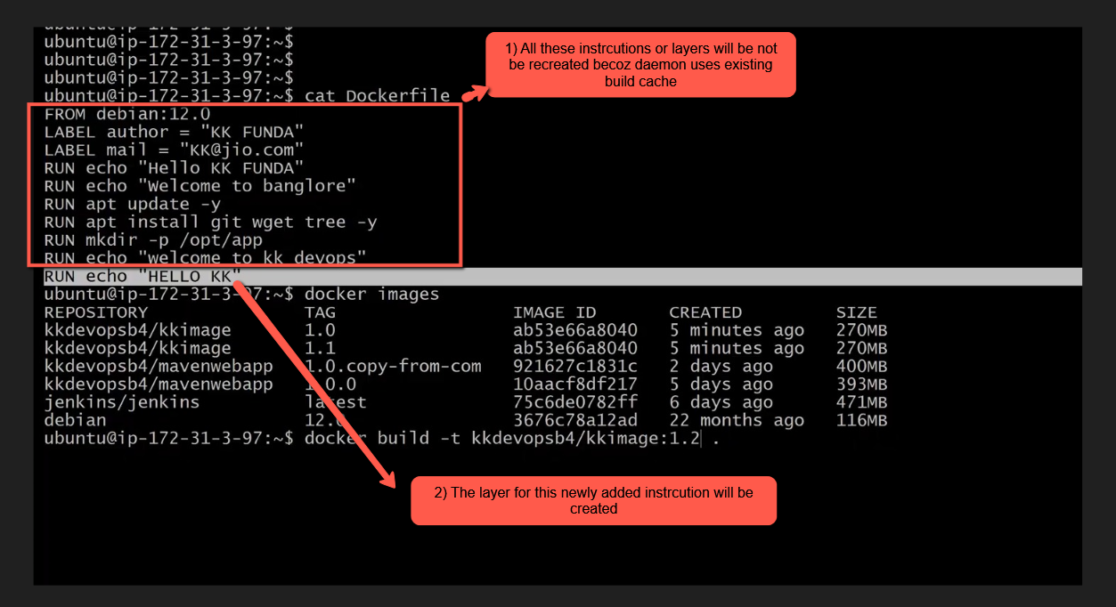
execute the below command
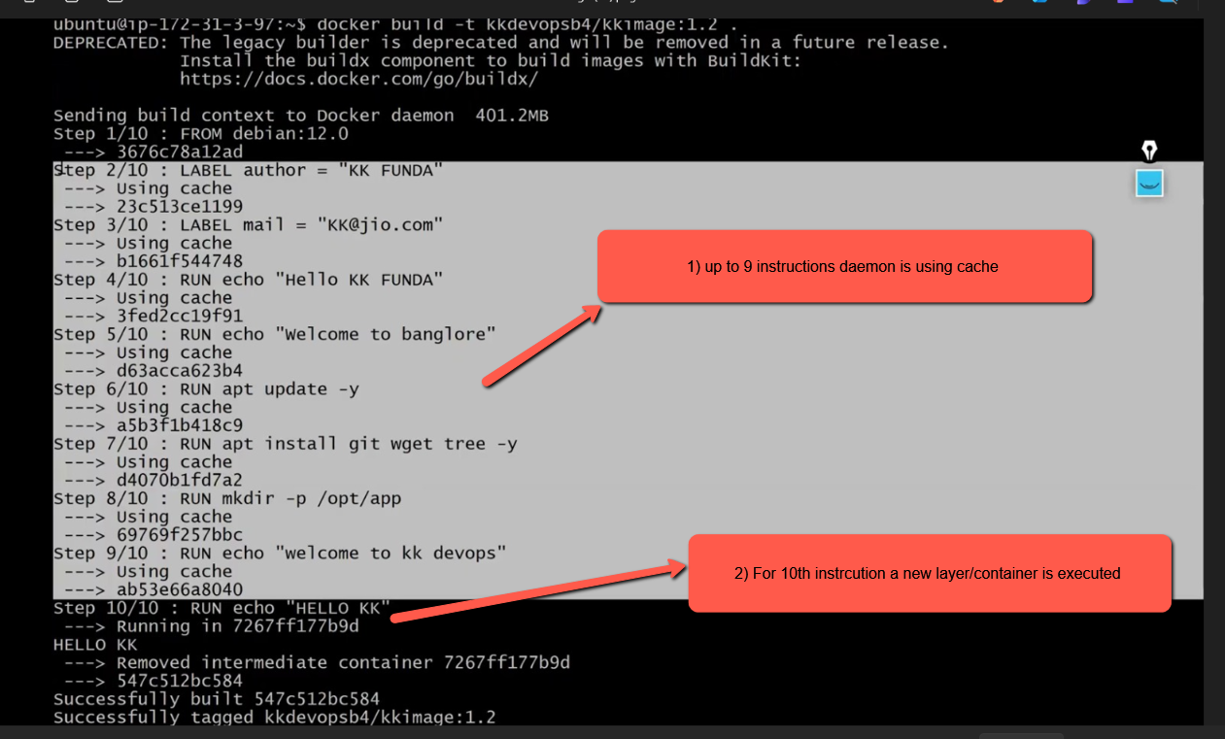
Now let try add a new instruction in between the existing docker file instructions as shown in the below img
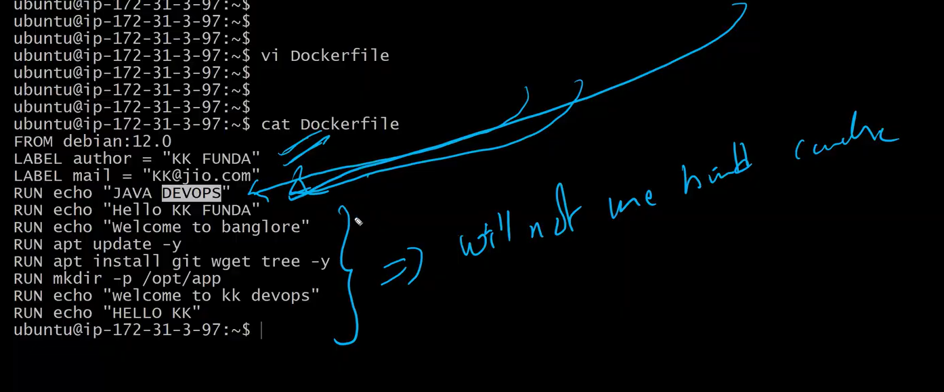
open the docker file
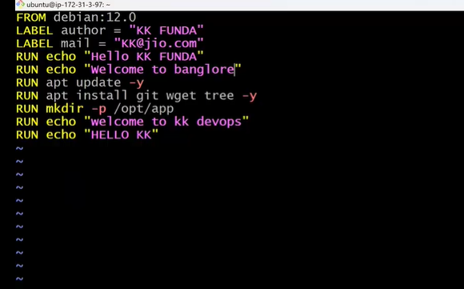
Add the new instruction line in the middle of the existing instruction lines as shown in the below img
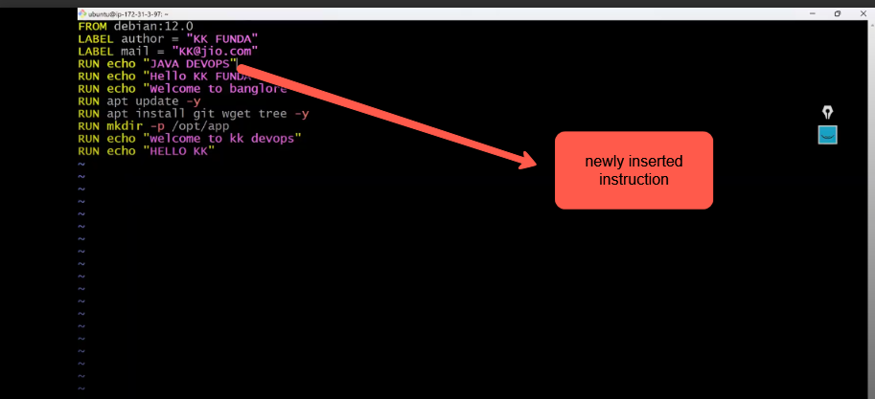
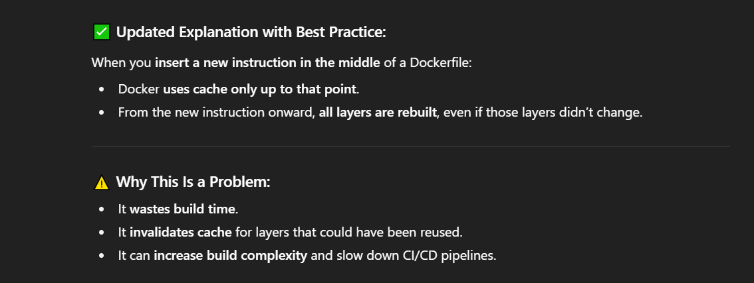
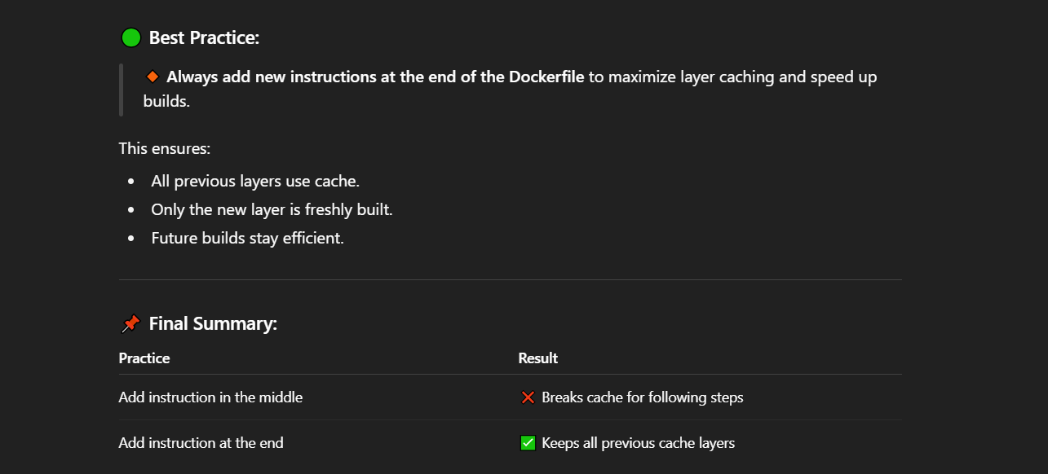
Let’s build the new image by executing the command docker build –t kkdevopsb4/kkimage:1.4 .
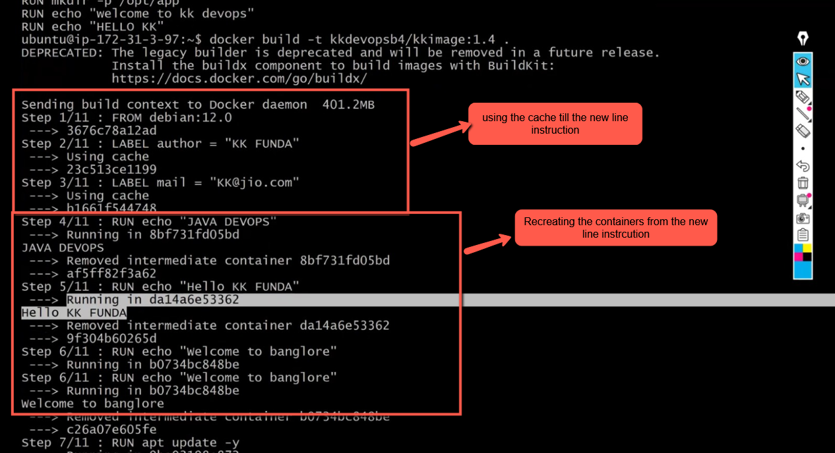
Let add a new instruction in the docker file at the end
cmd echo ‘this is cmd’
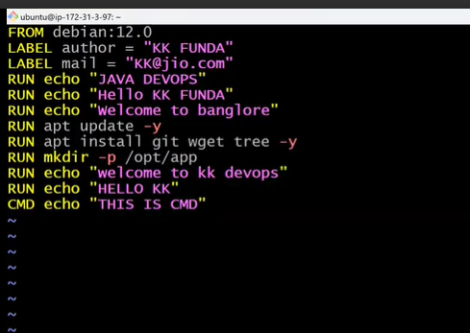
Lets build the new image as shown in the below img
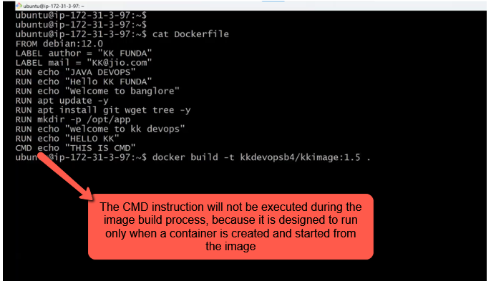
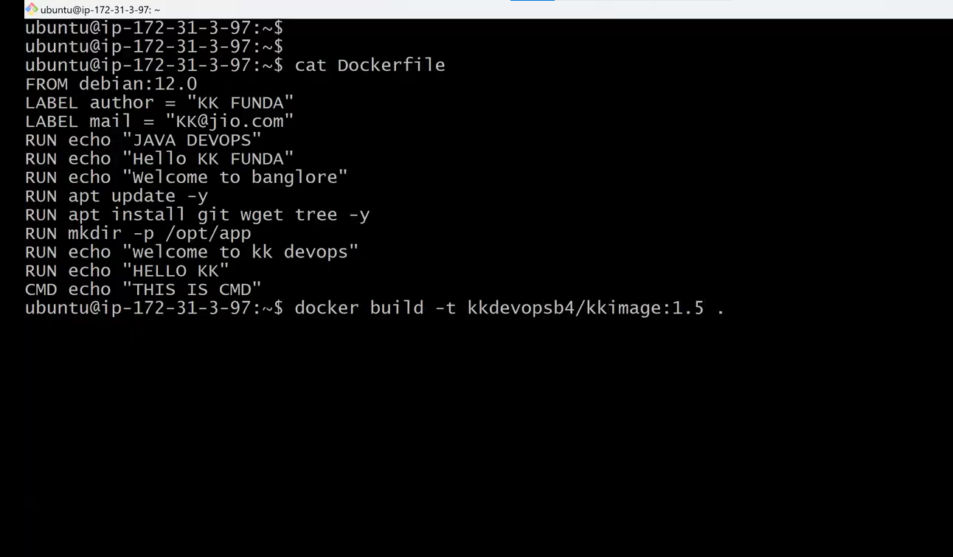
Build the image
